# Table 2.

Estimation results of the input distance function

## Column (1)

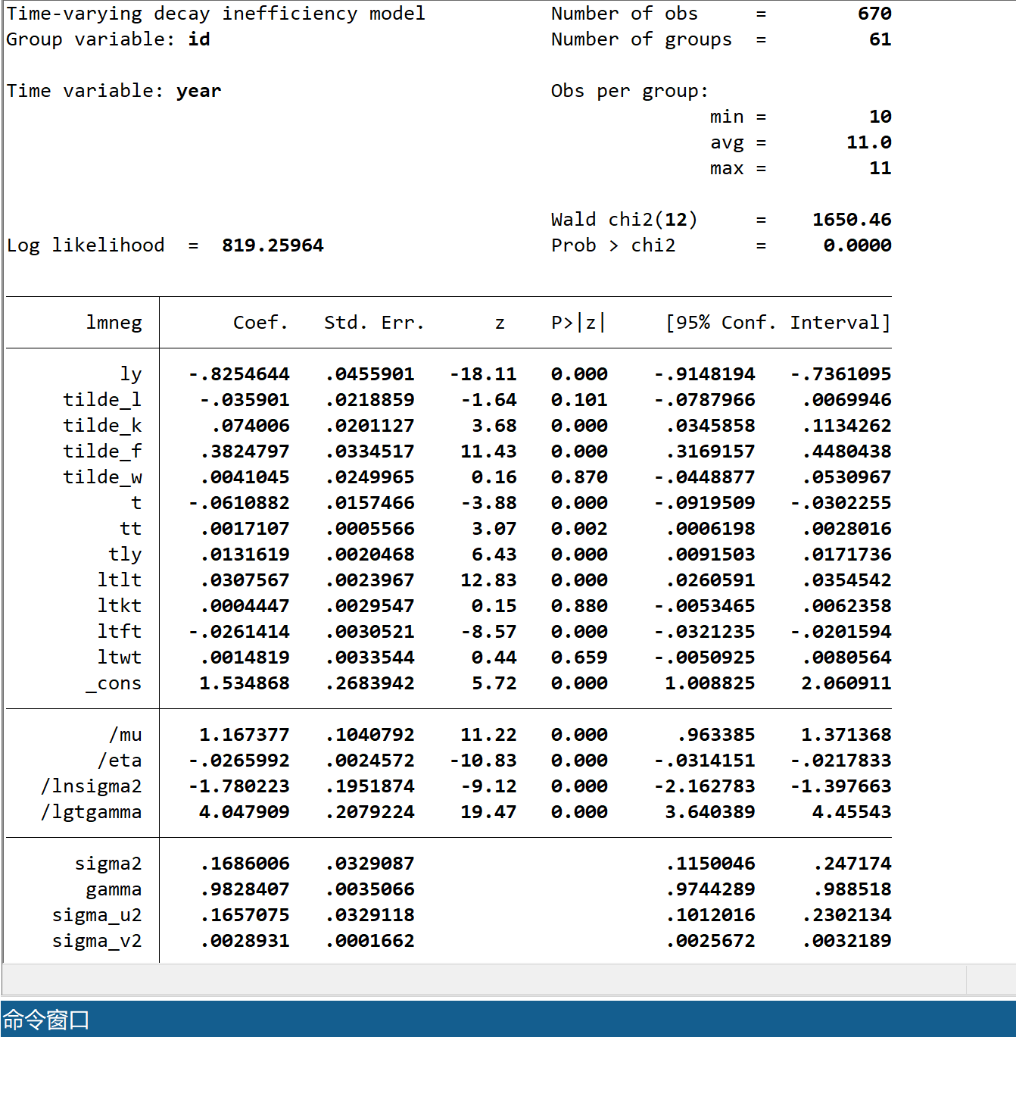

## Column (2)

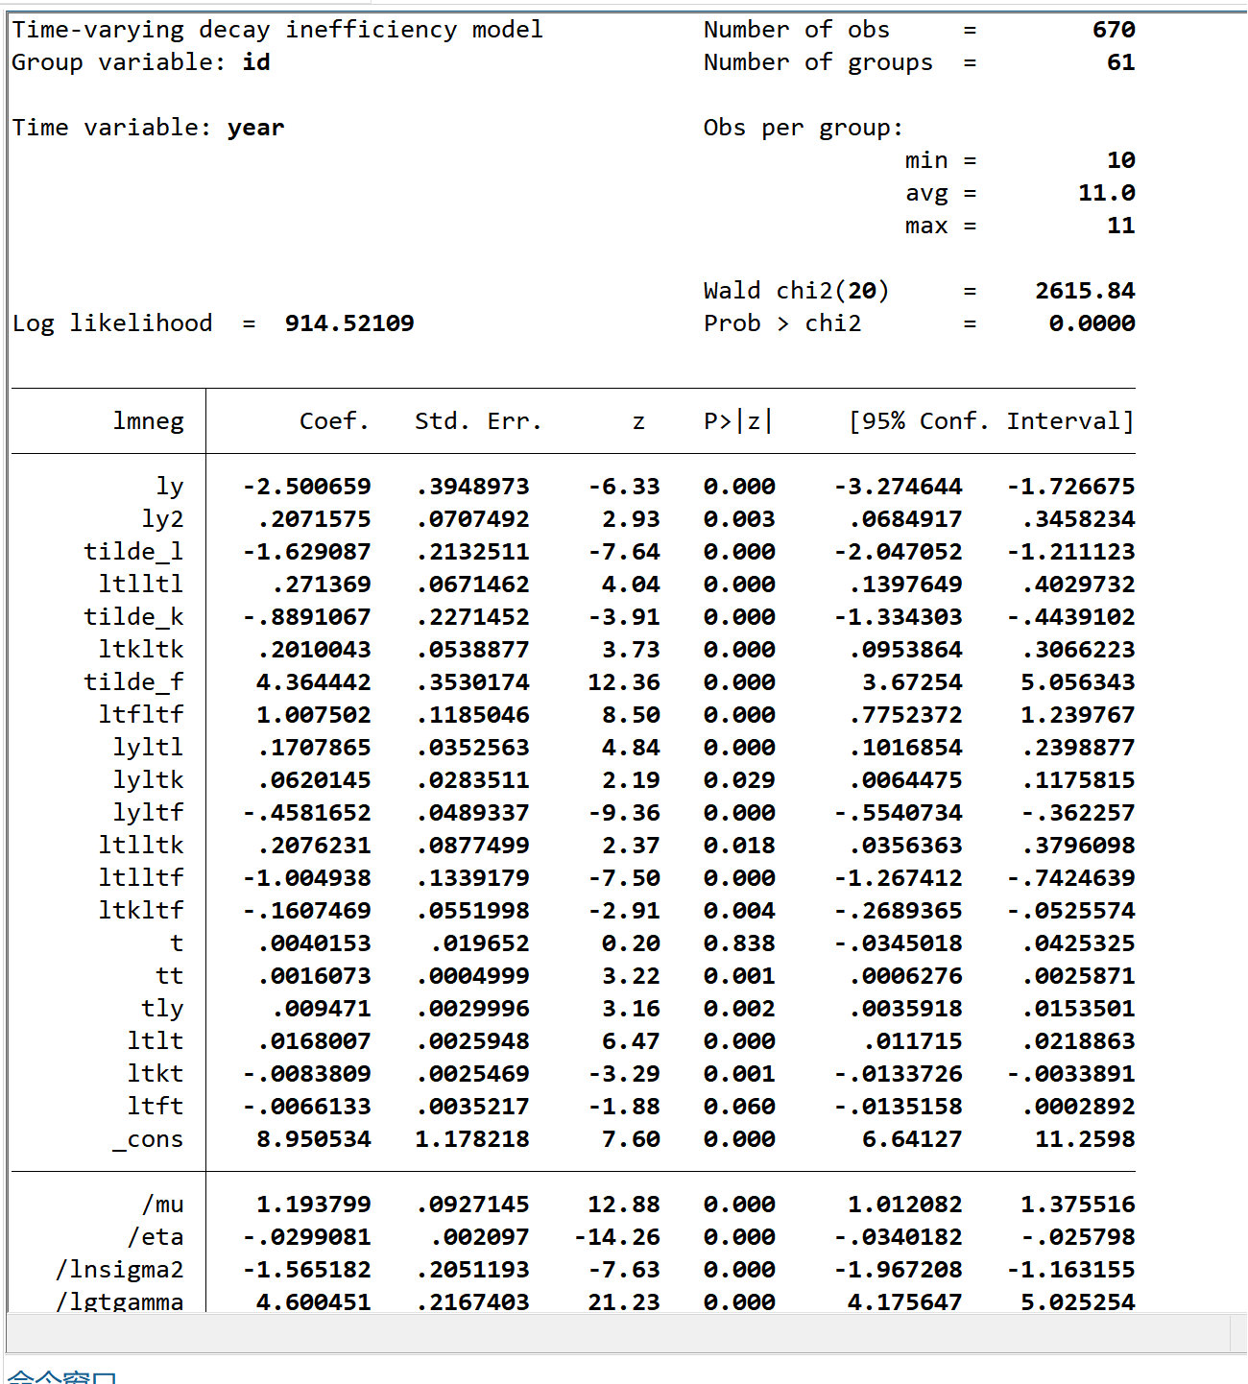

## Column (3)

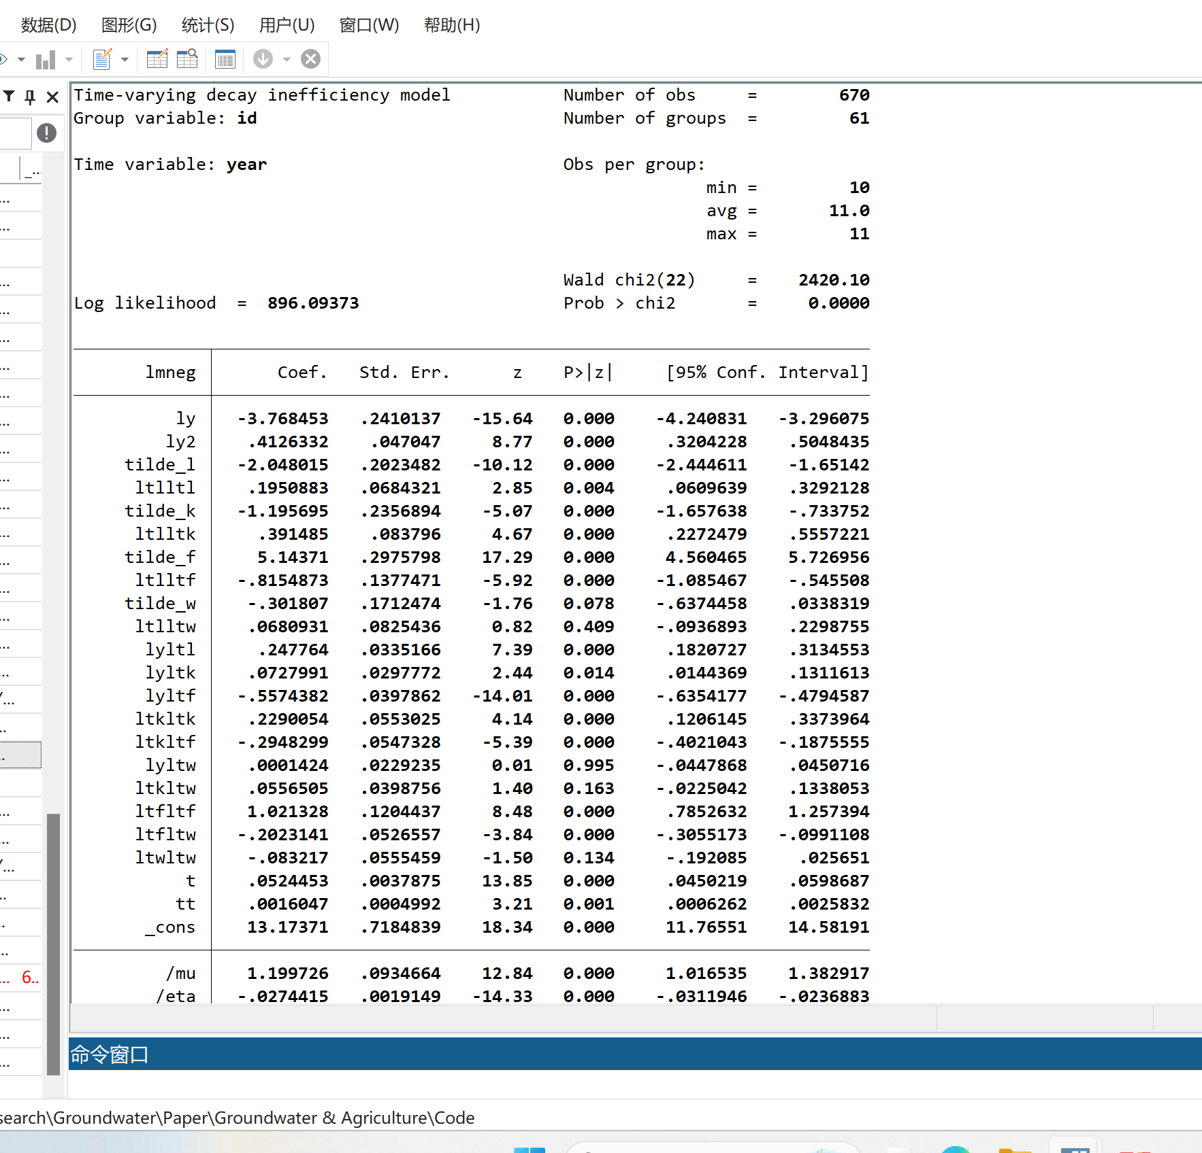

## Column (4)

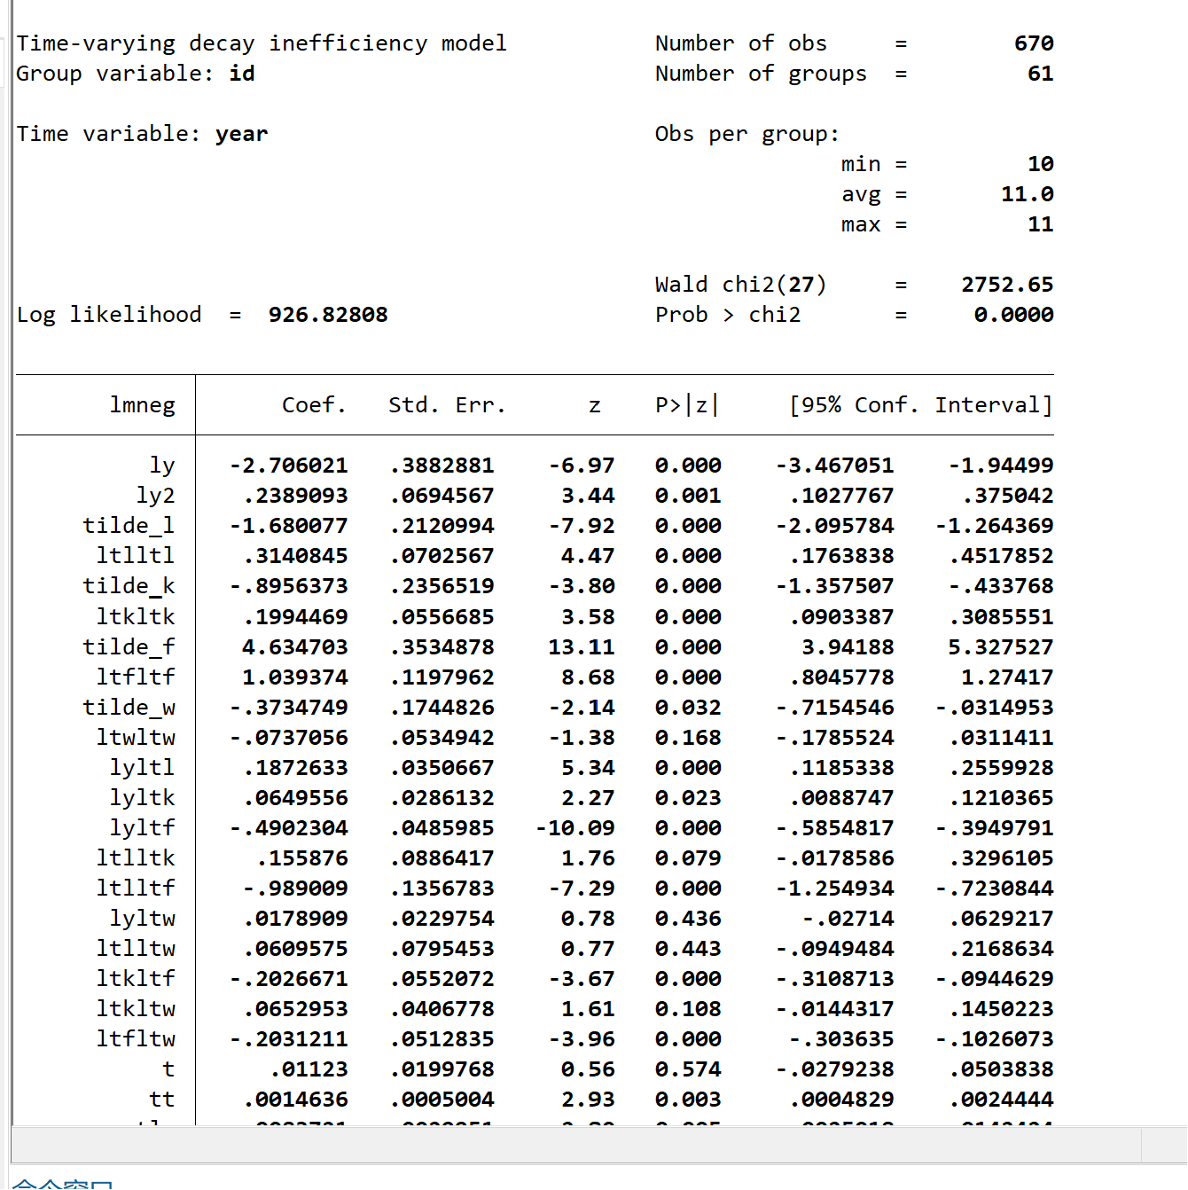

# Table 3.

 Panel estimates results

## Column (1)

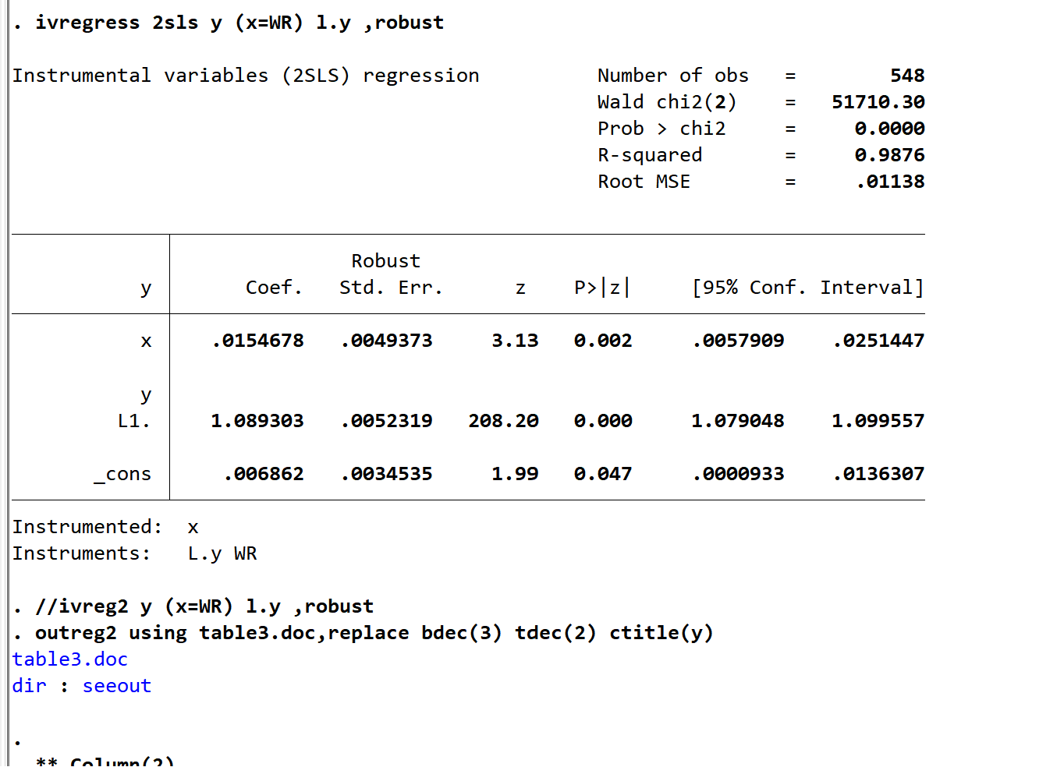

## Column (2)

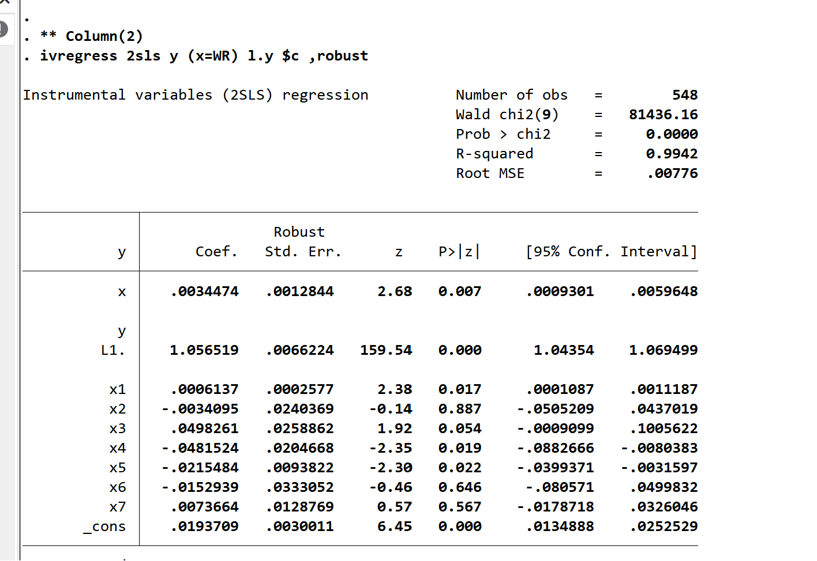

## Column (3)

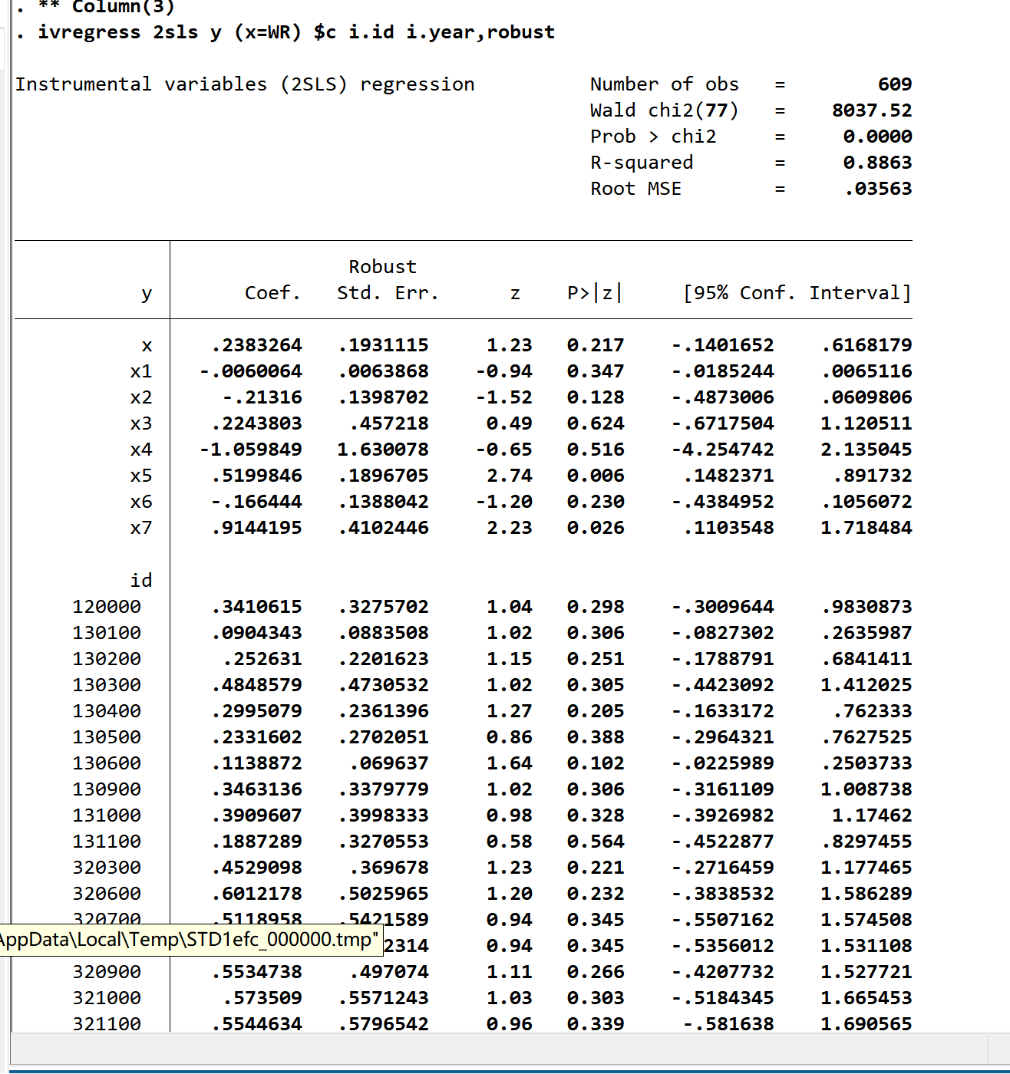

## Column (4)

## Column (5)

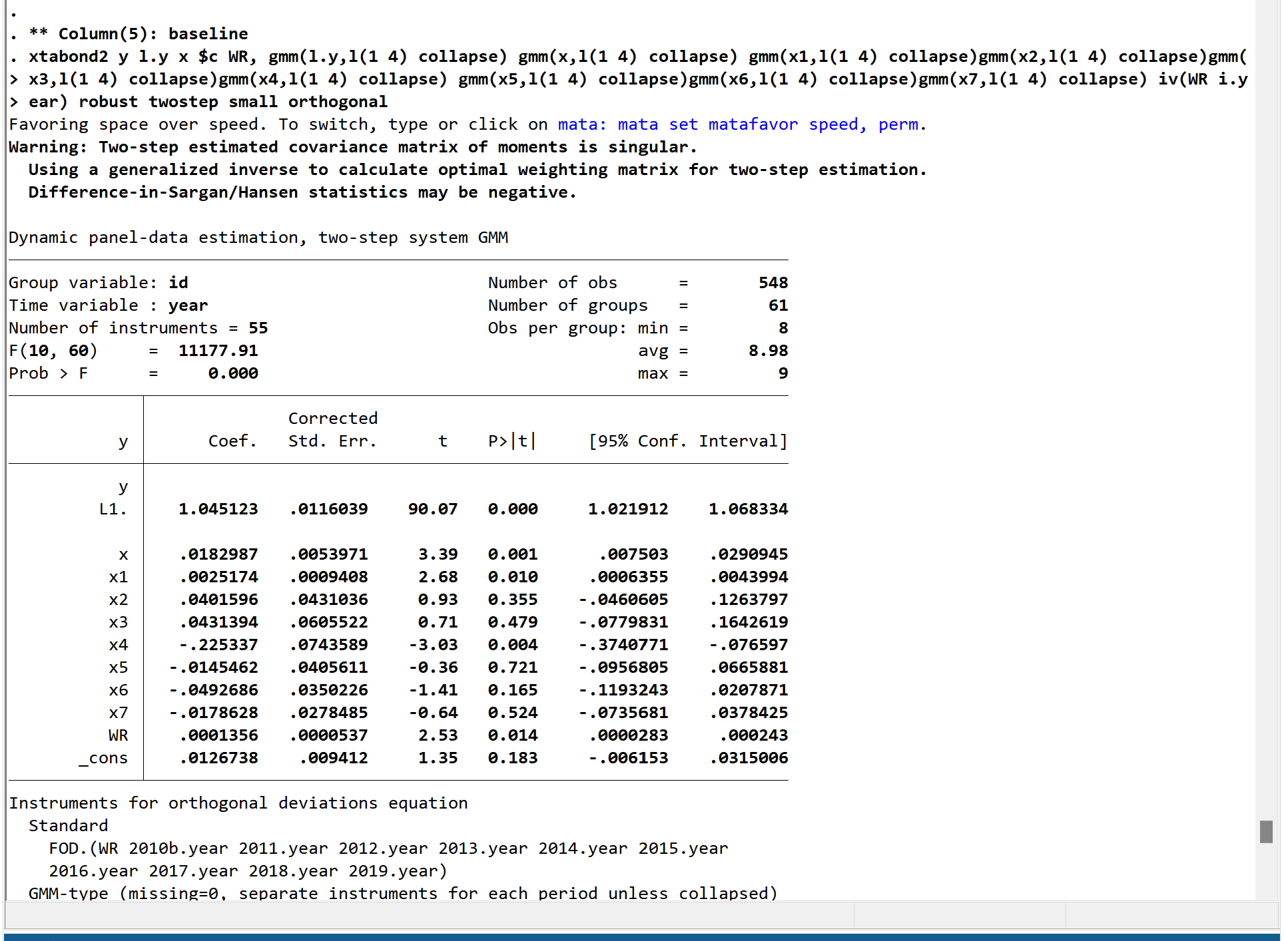

# Table 4.

The results of other ATFPs and land output values

## Column (1)

Baseline, TL-Water-nNeutral

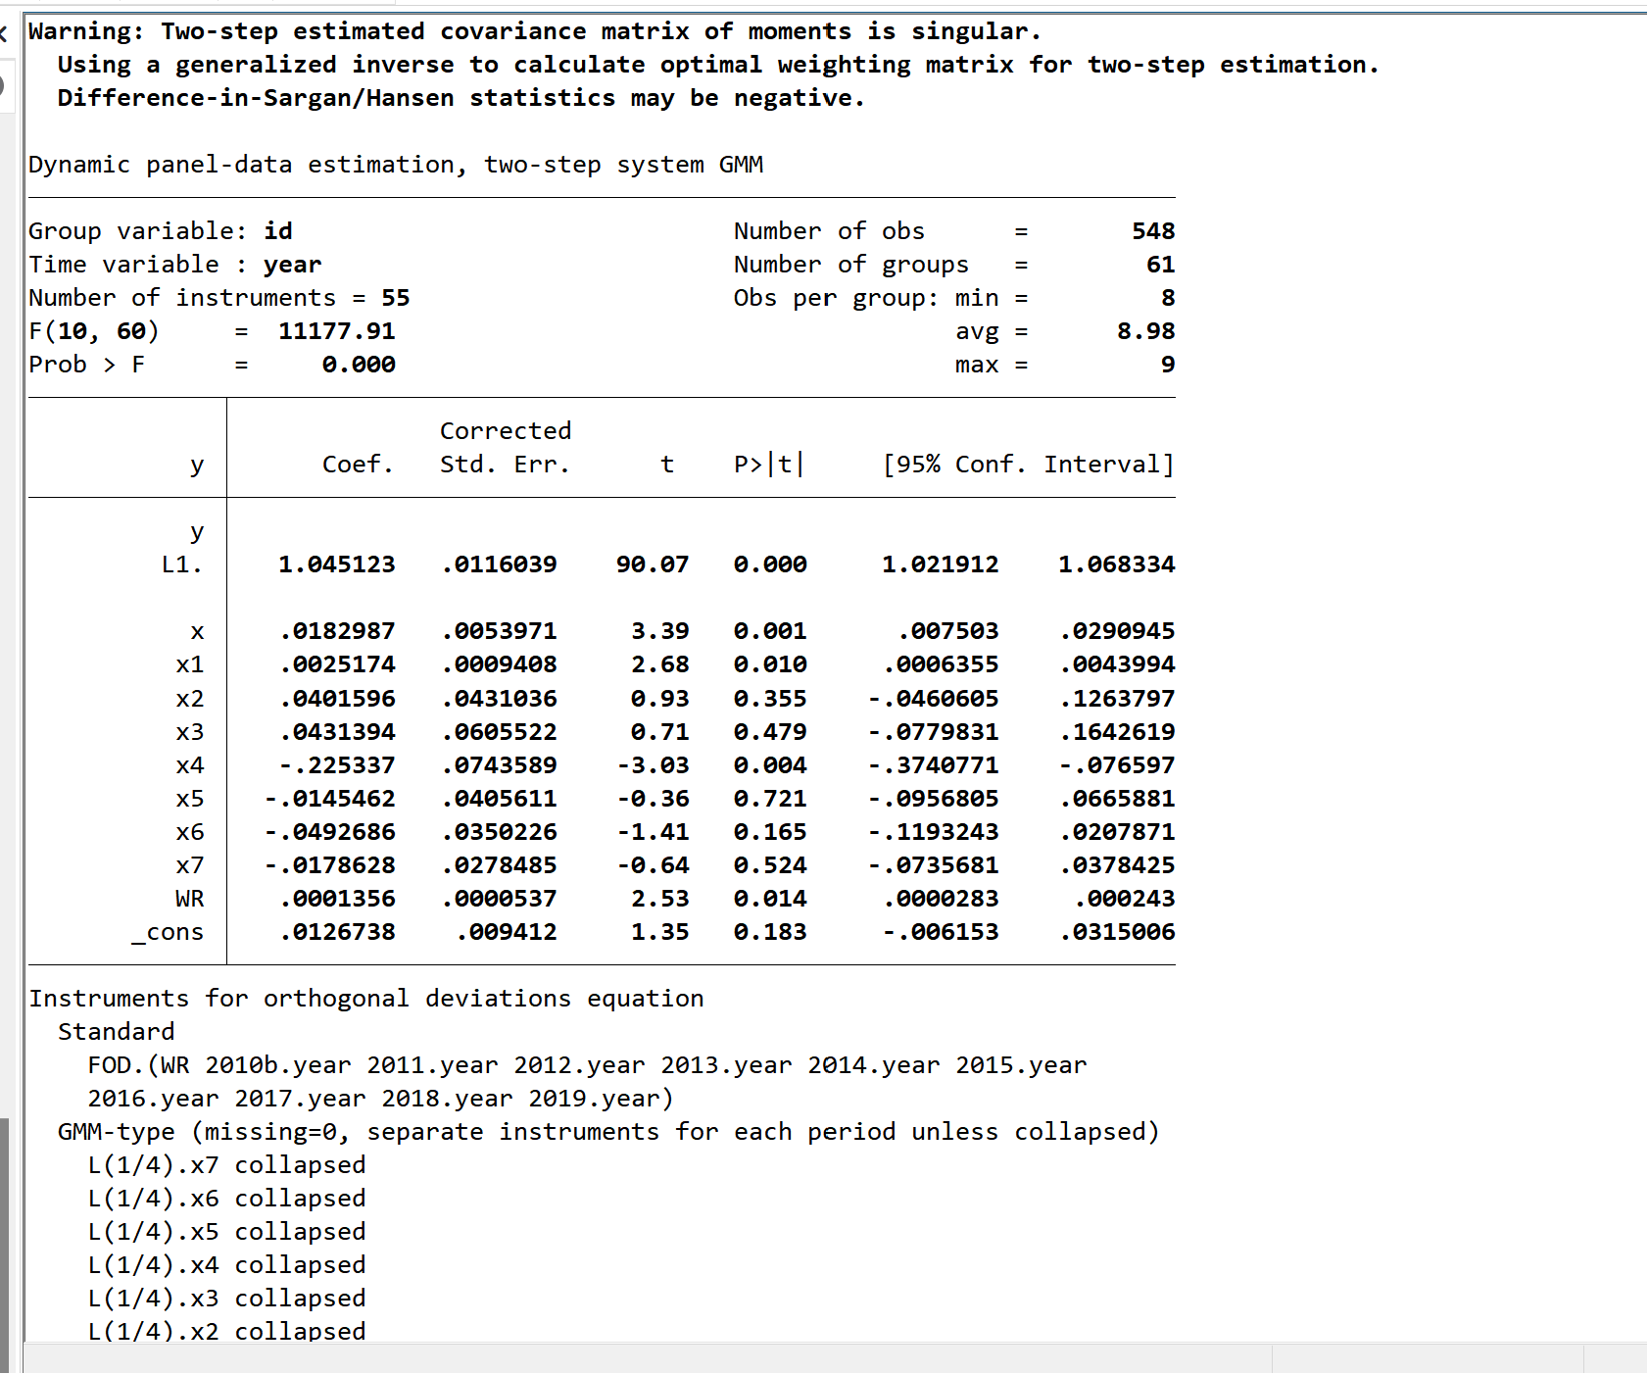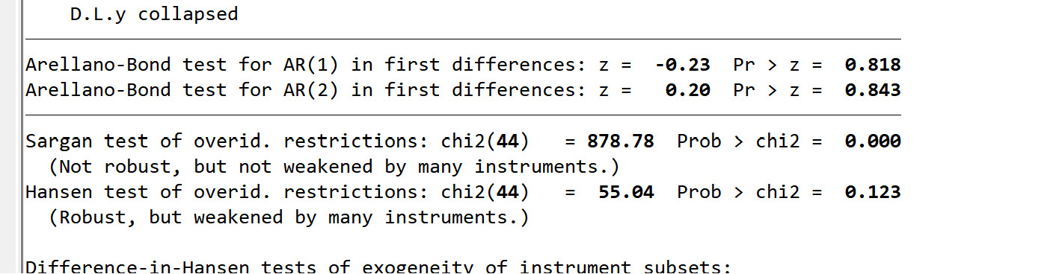

## Column (2)

CD-Water-nNeutral

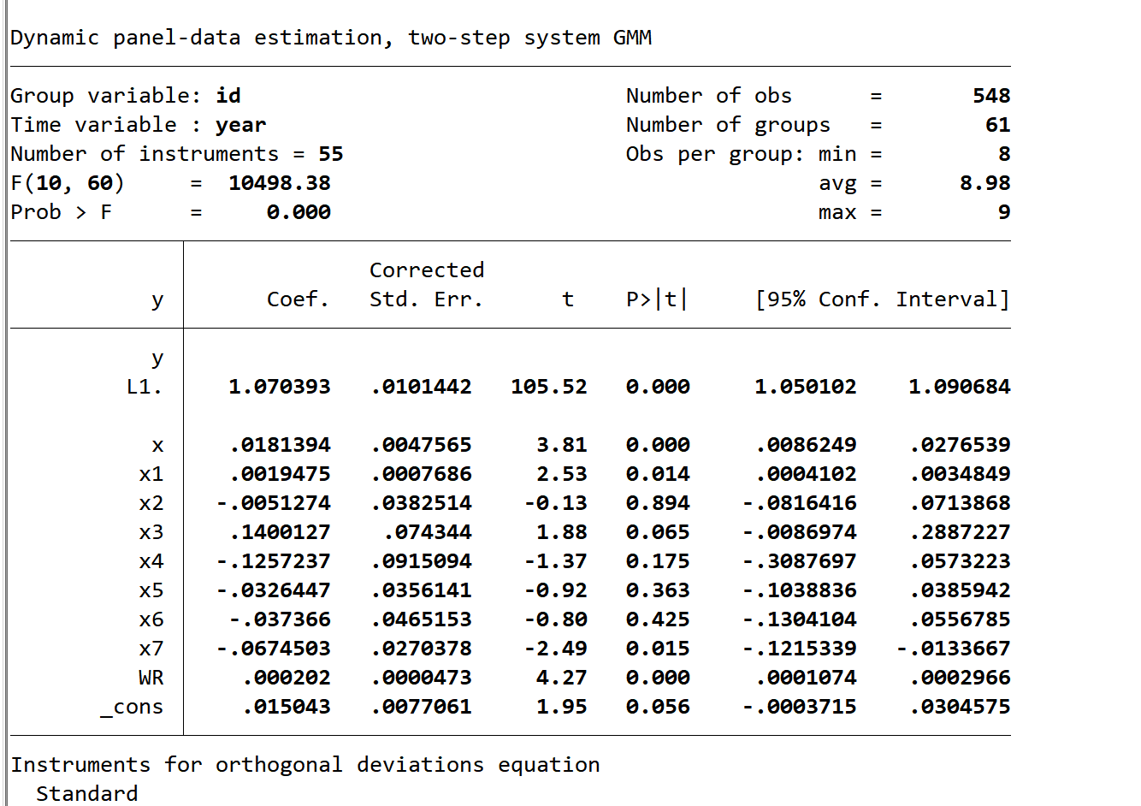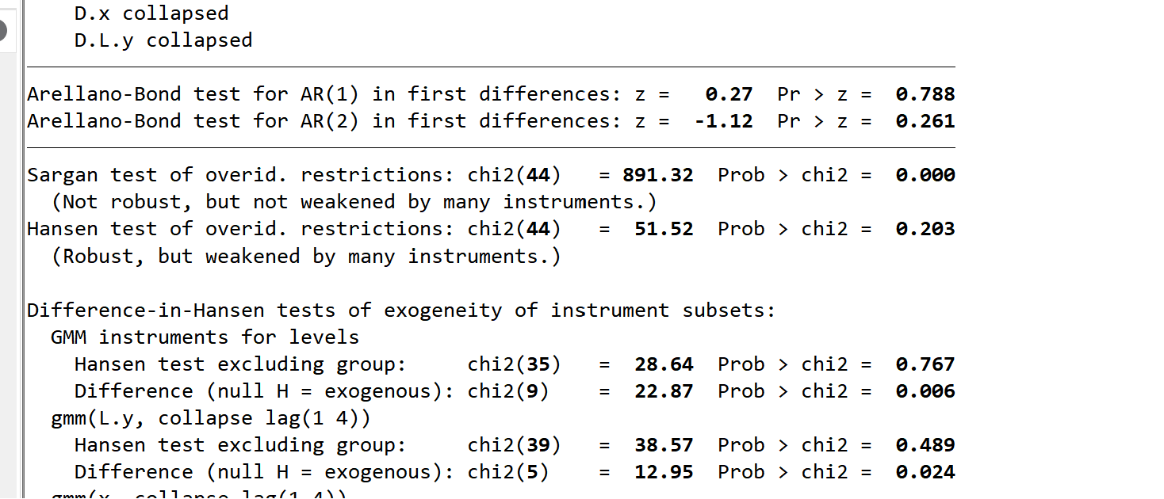

## Column (3)

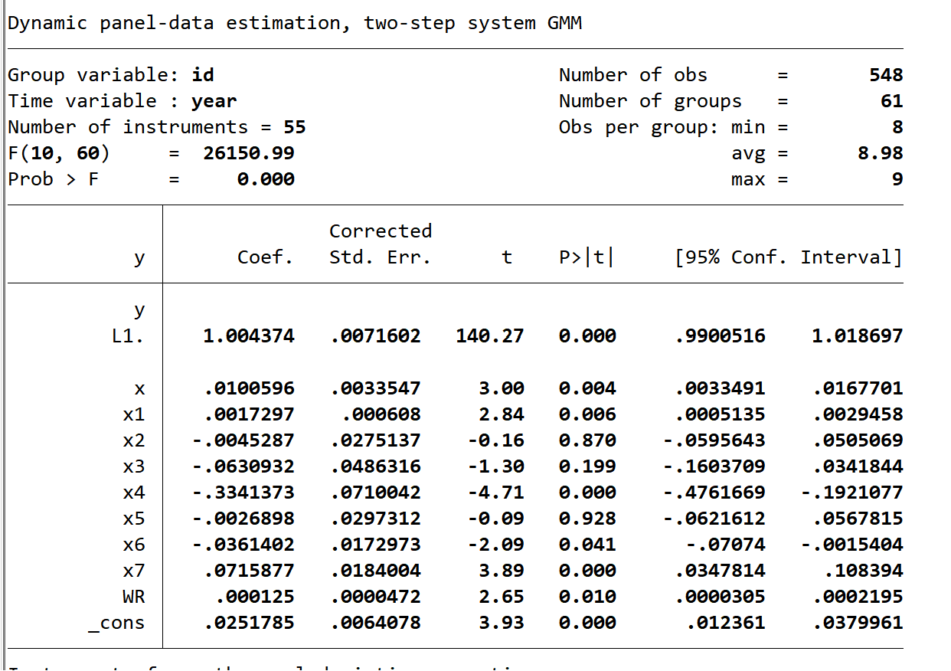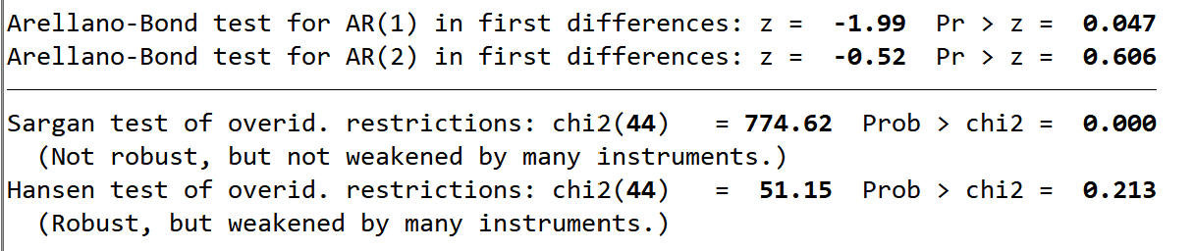

## Column (4)

## Column (5)

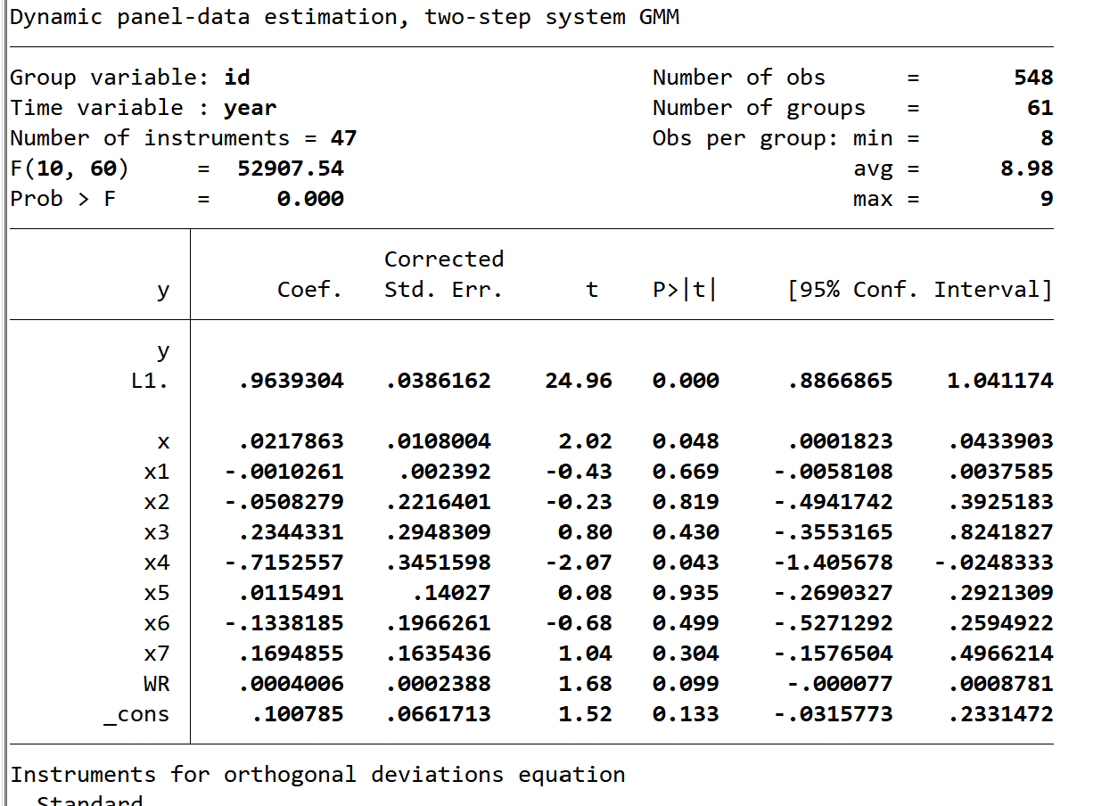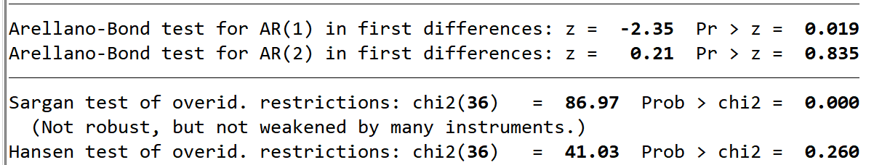

# Table 5.

Long-difference estimates results

## Column (1)-(3)

TL-Water-nNeutral

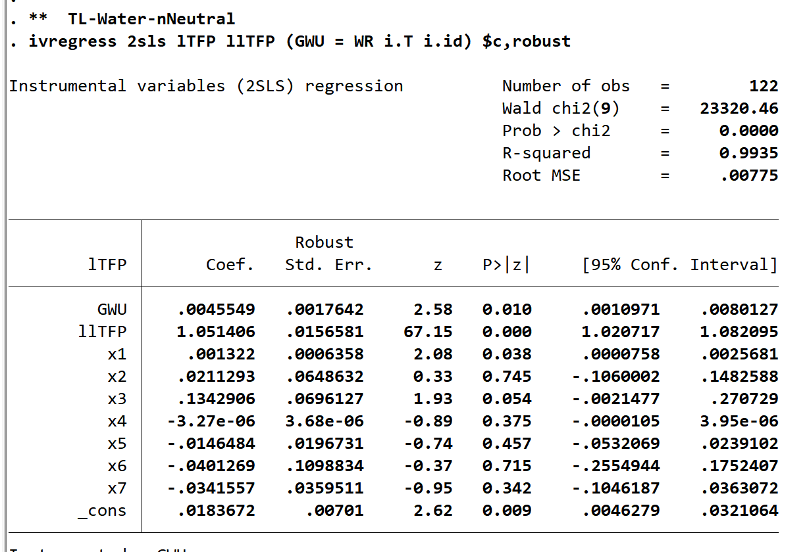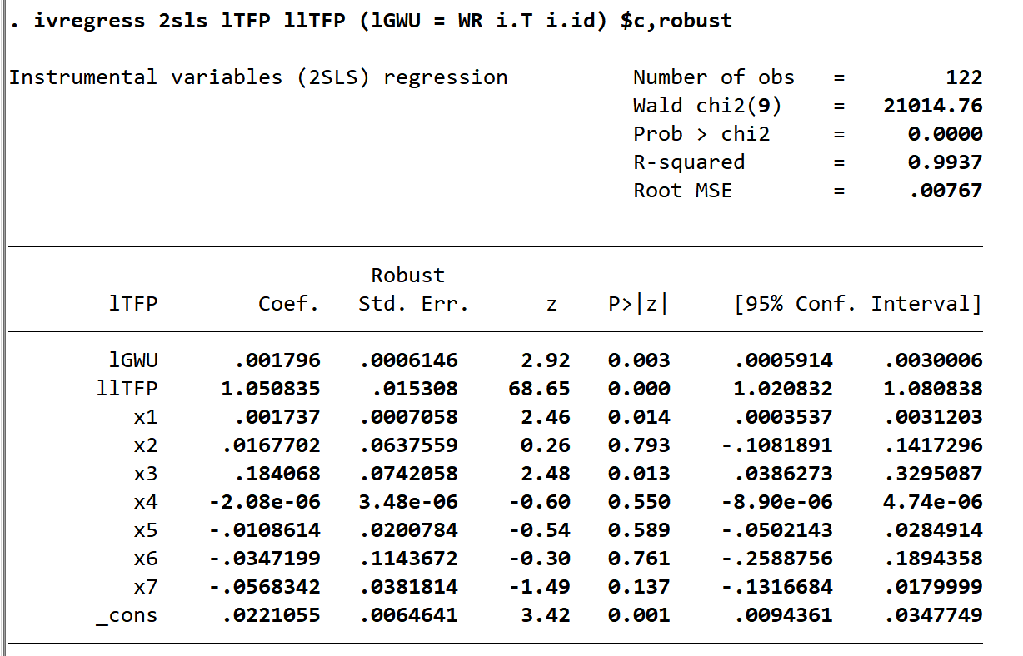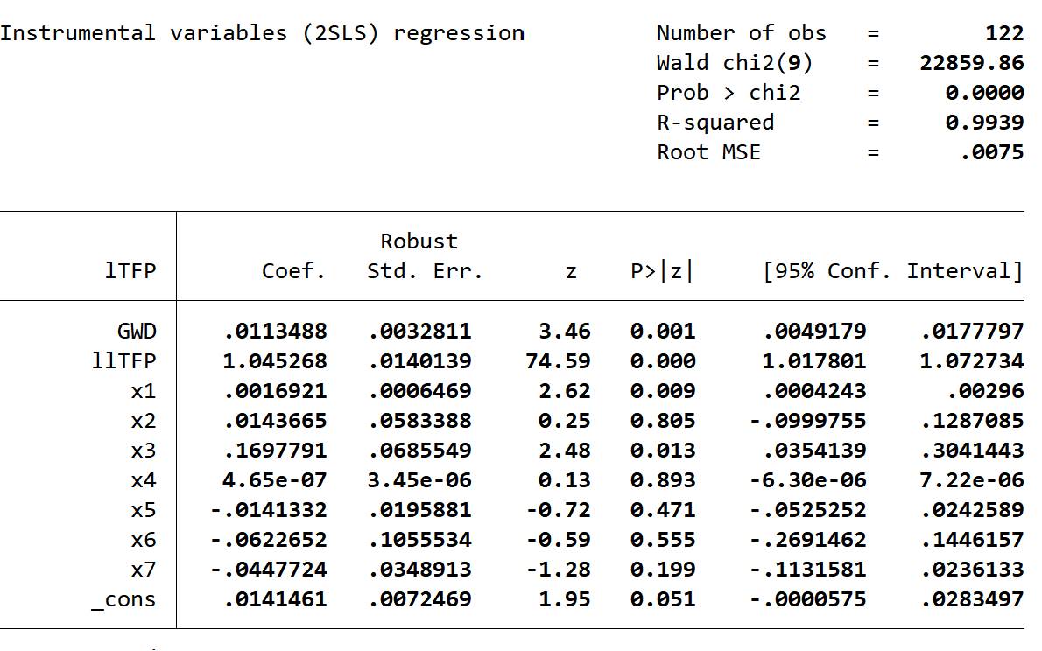

## Column (4)

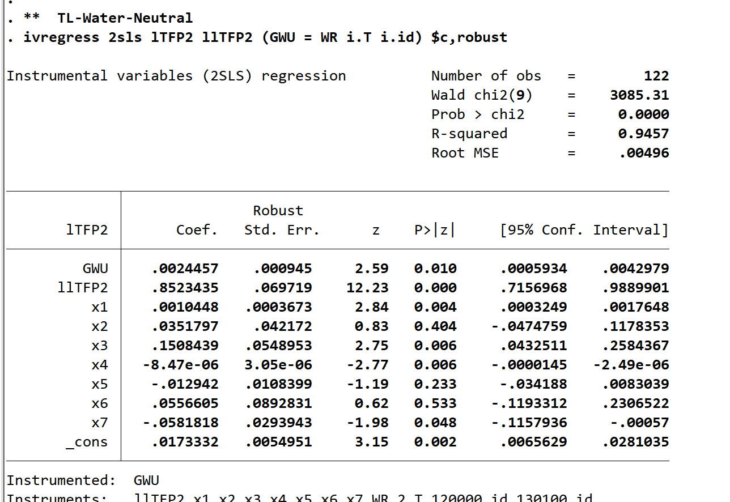

## Column (5)

## Column (6)

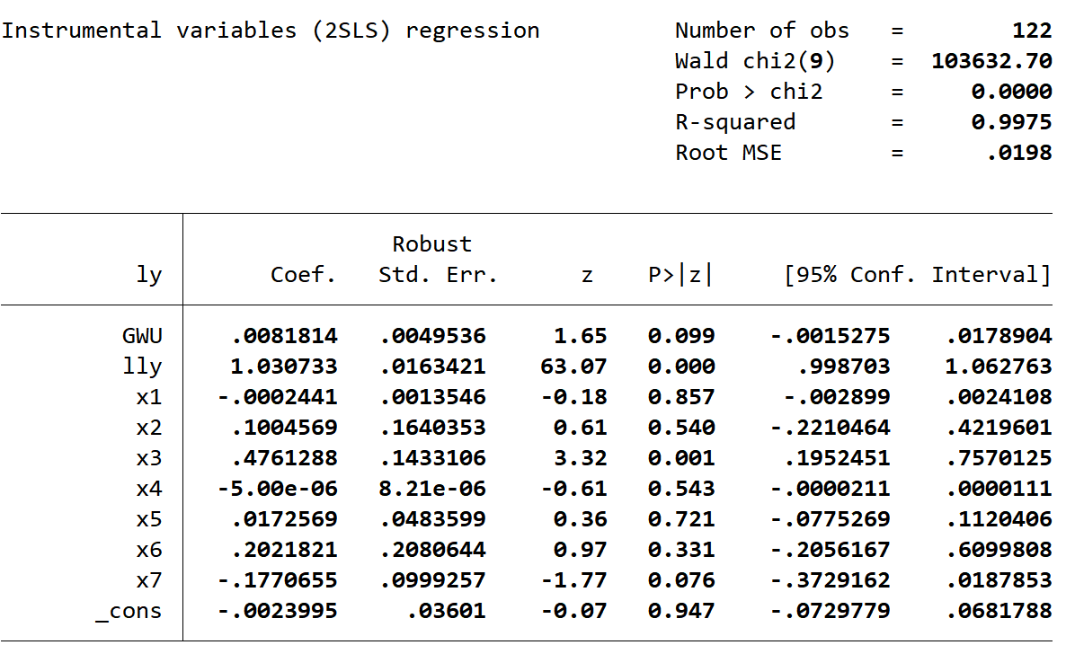

# Table A2.

Panel estimates of the impacts of groundwater exploitation on ATFP

## Column (1)-(3)

y=TFP (TL-Water-nNeutral)

①x=GWU

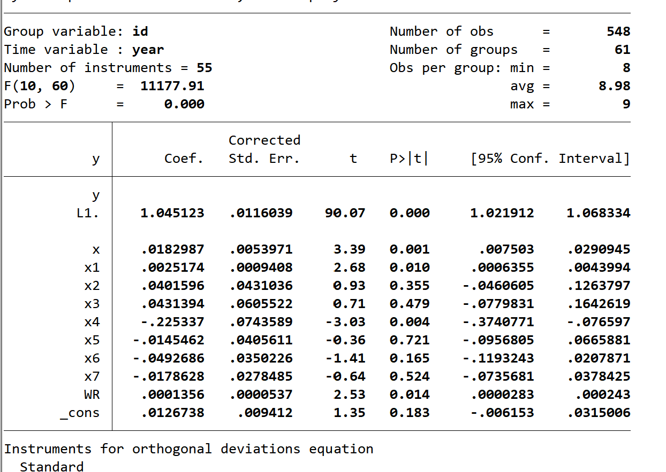

②x=ln(GWU)

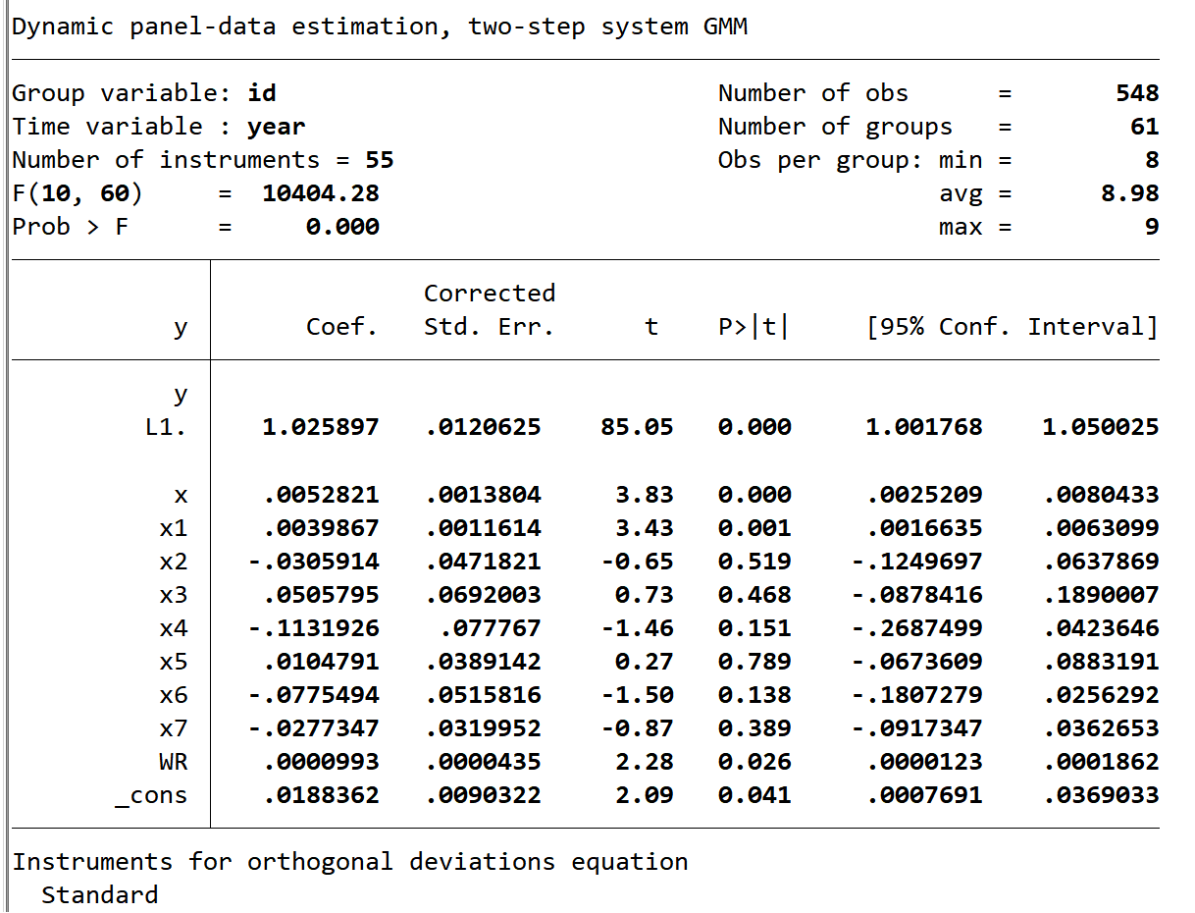

③x=GWD

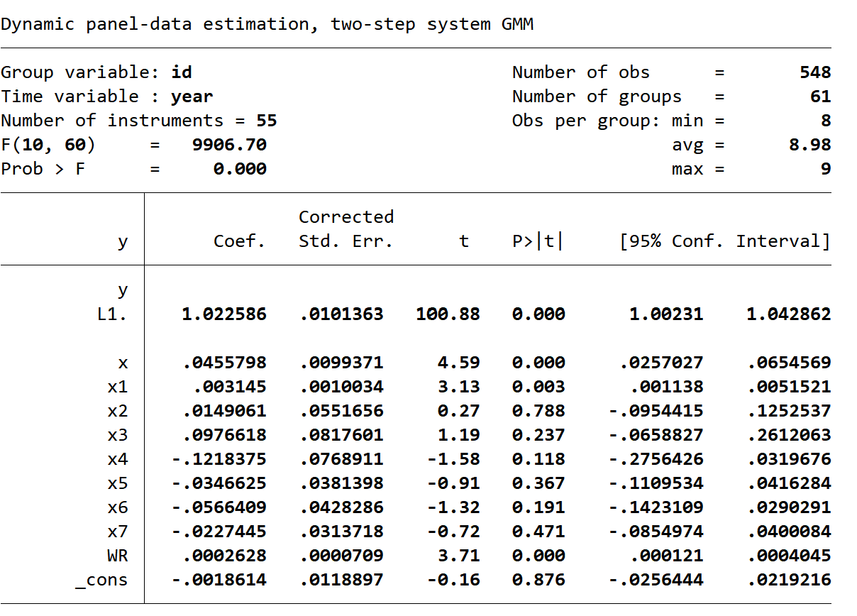

## Column (4)-(6)

y=TFP4 (TL-nWater-nNeutral)

①x=GWU

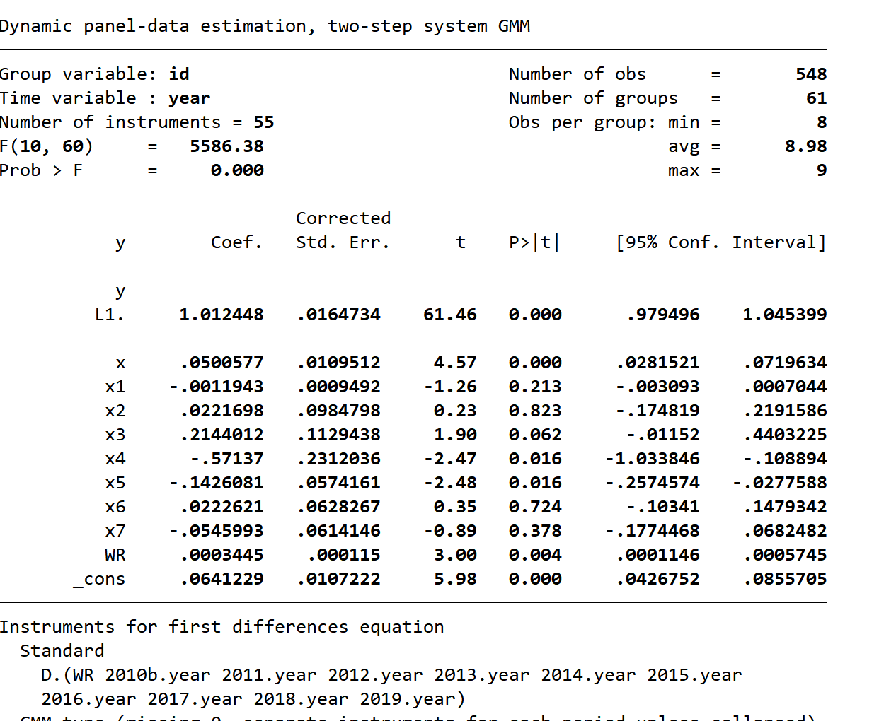

②x=ln(GWU)

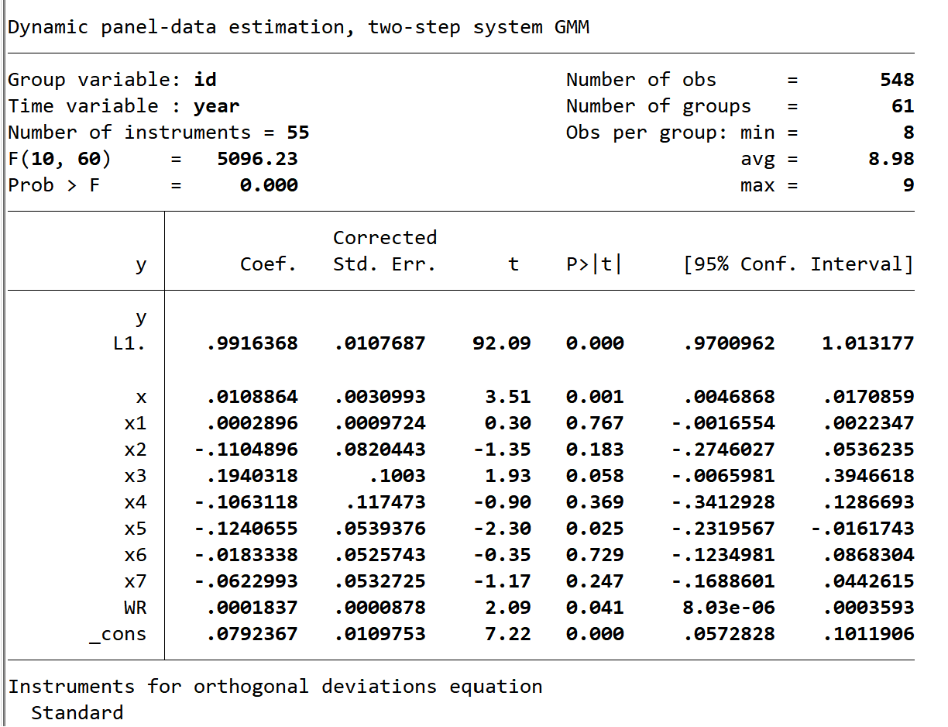

③x=GWD

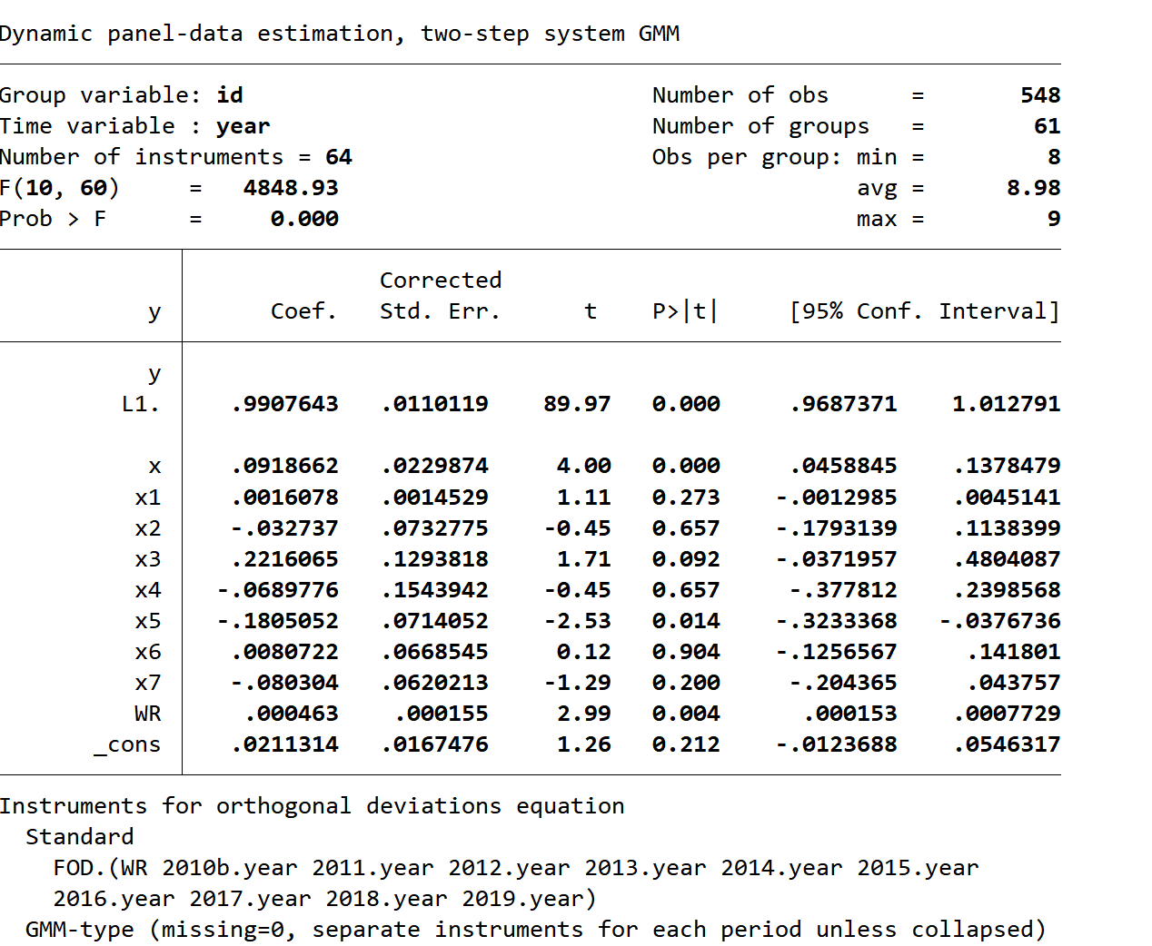

# Table A3.

## Column (1)

(1) 5-year

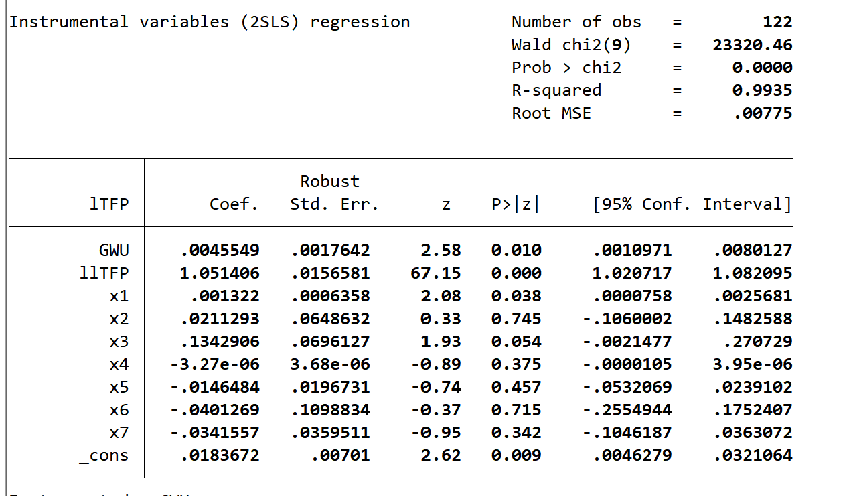

## Column (2)

1. 2-year

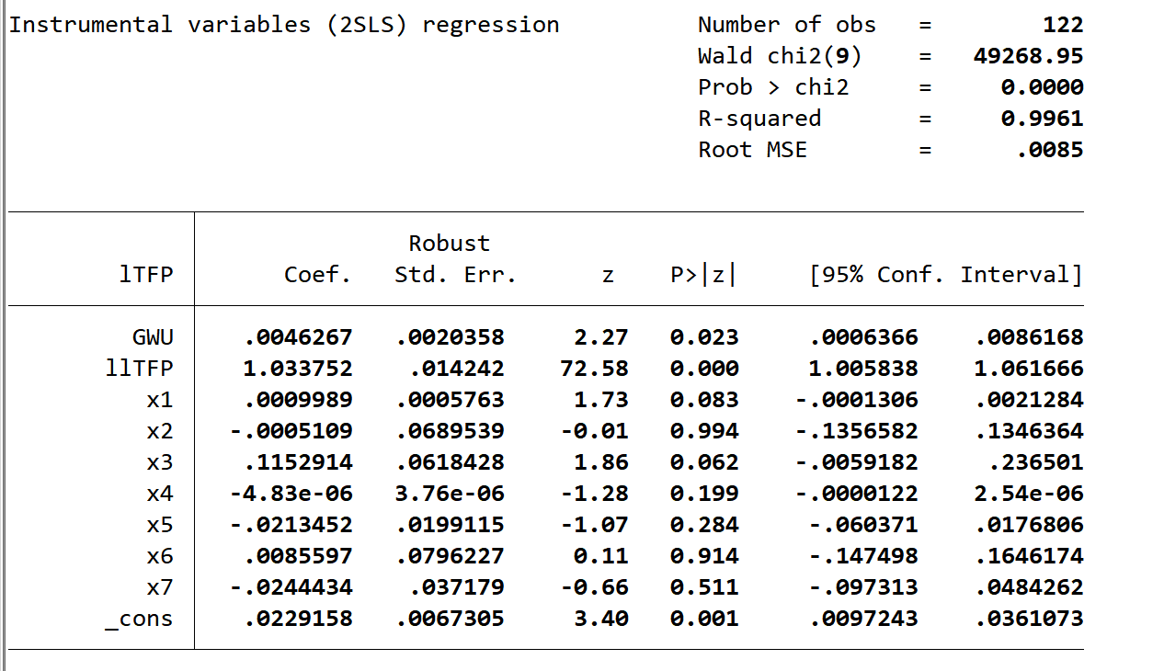

## Column (3)

(3)2010 and 2018

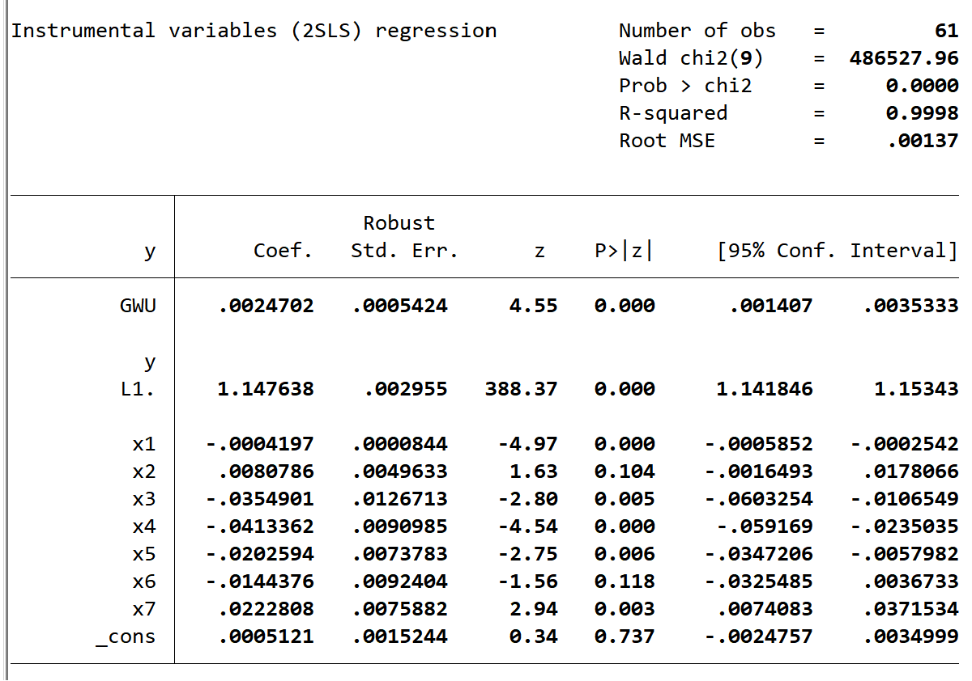

## Column (4)

(4)2010 and 2019

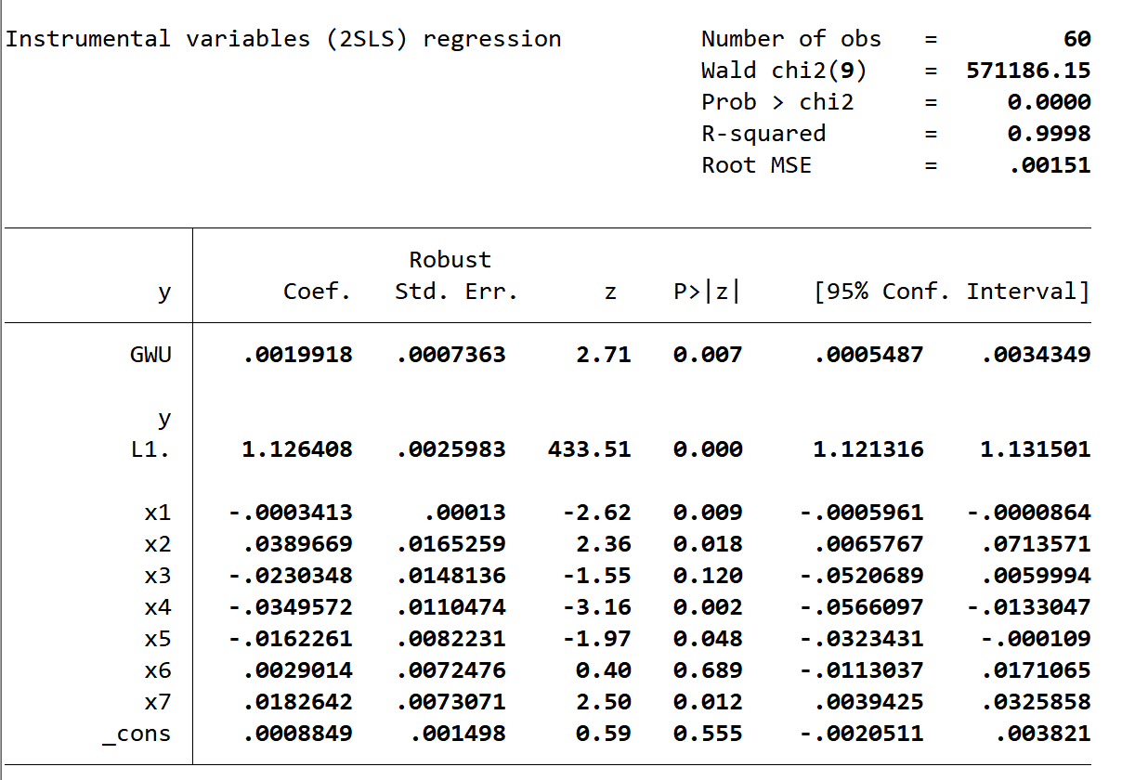

## Column (5)

(5)2011 and 2018

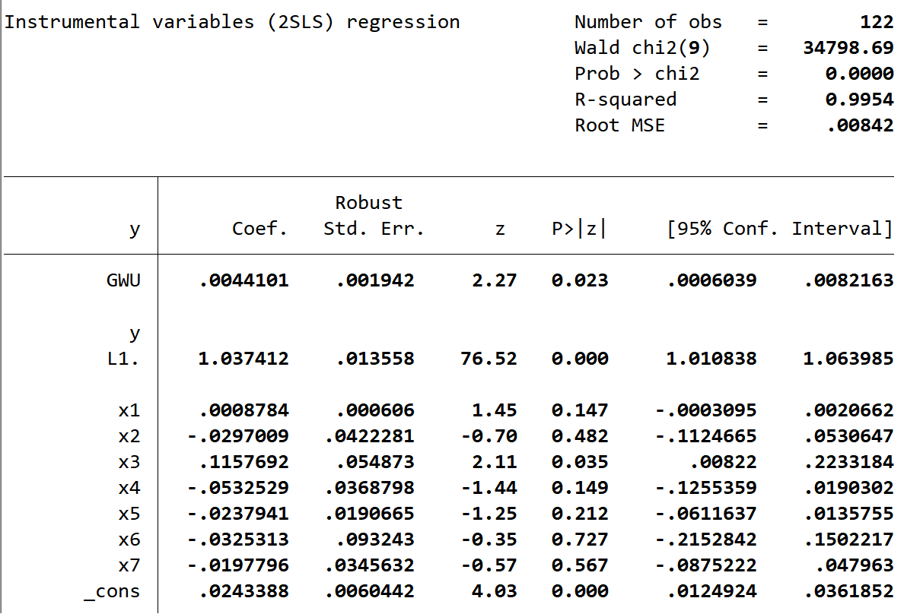

## Column (6)

(6)2011 and 2019

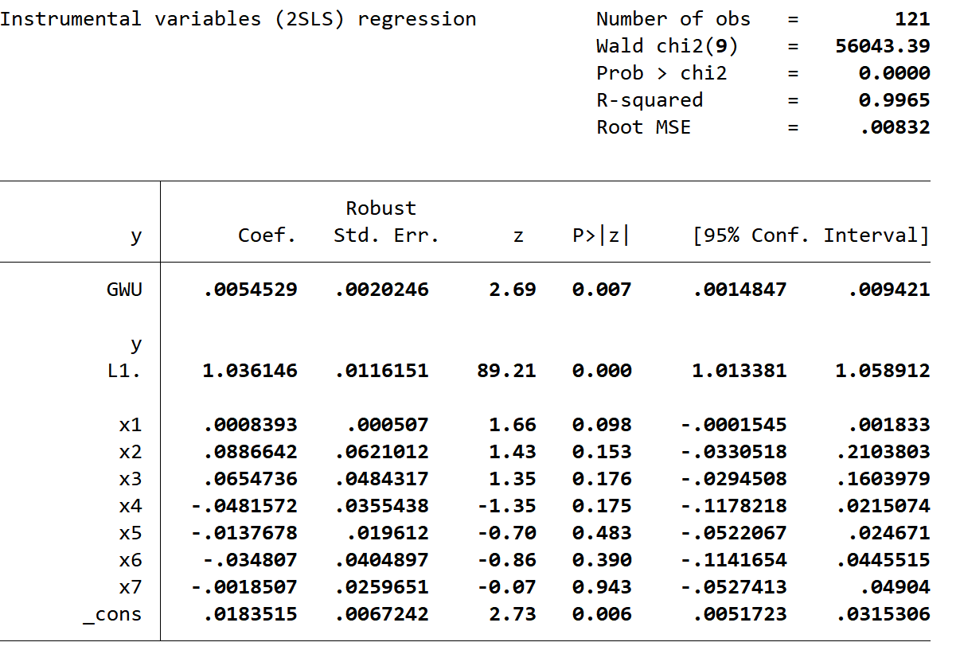

# Table A.4.

## Table A.4.A

### output

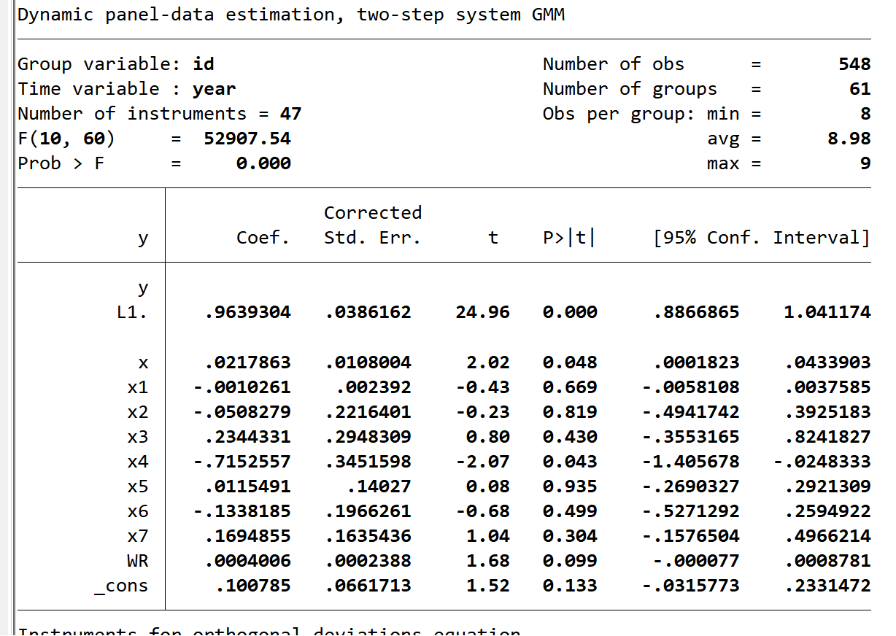

### TFP

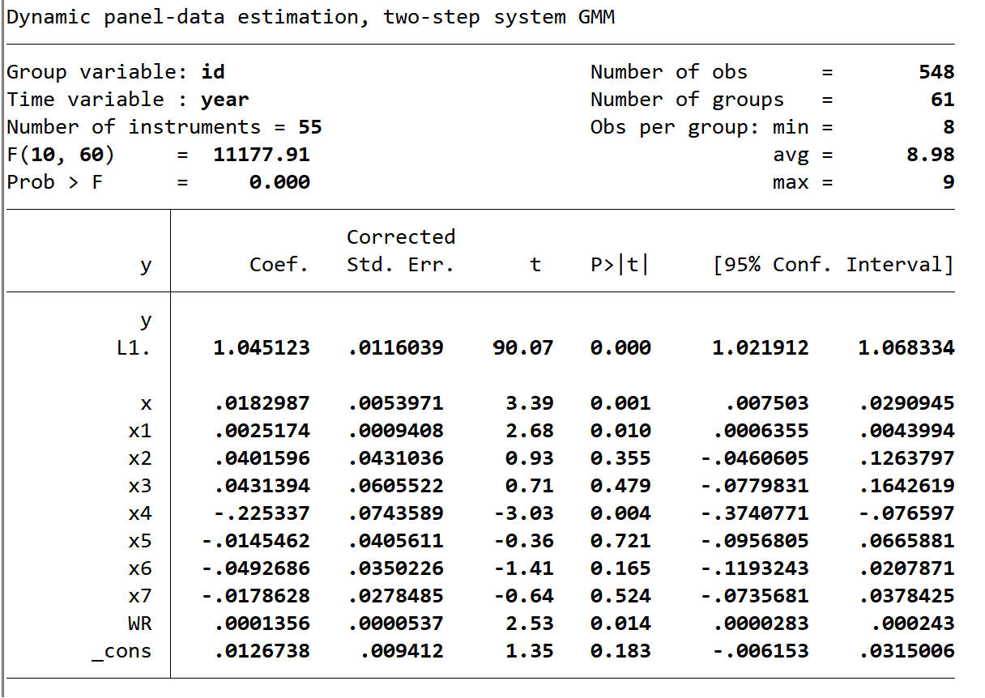

### input

#### /*Machinery*/

#### /*Fertilizer*/

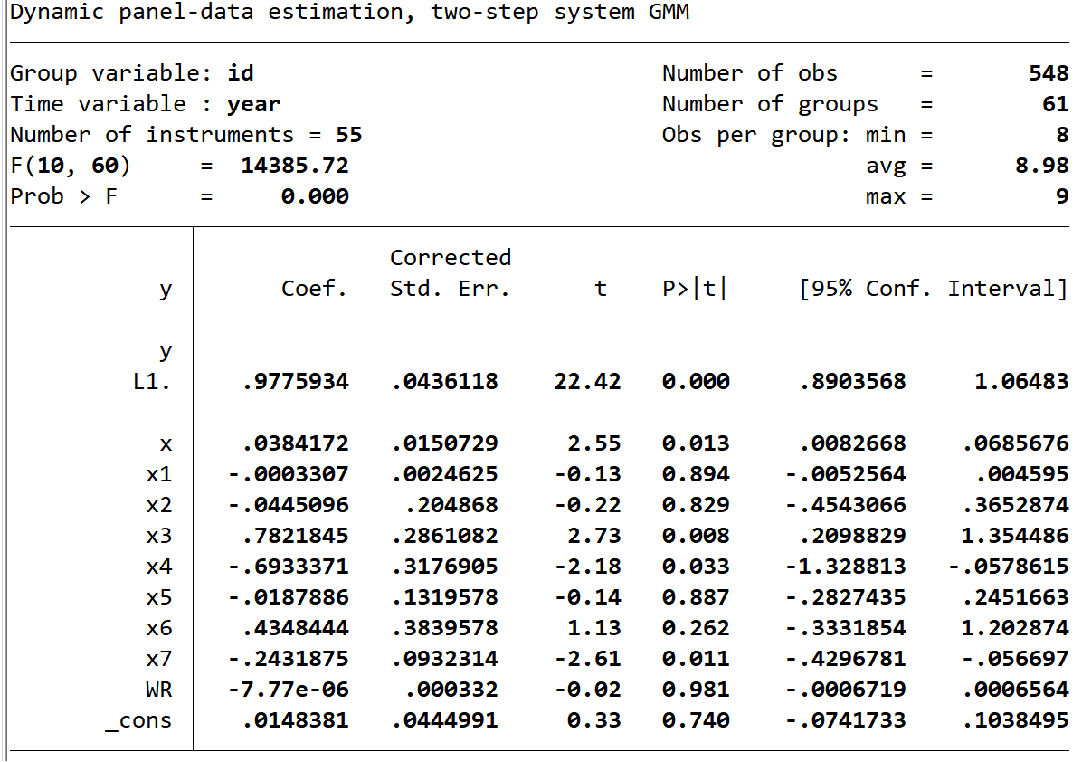

#### /*AgriWater*/

## Table A.4.B.

### output

### TFP

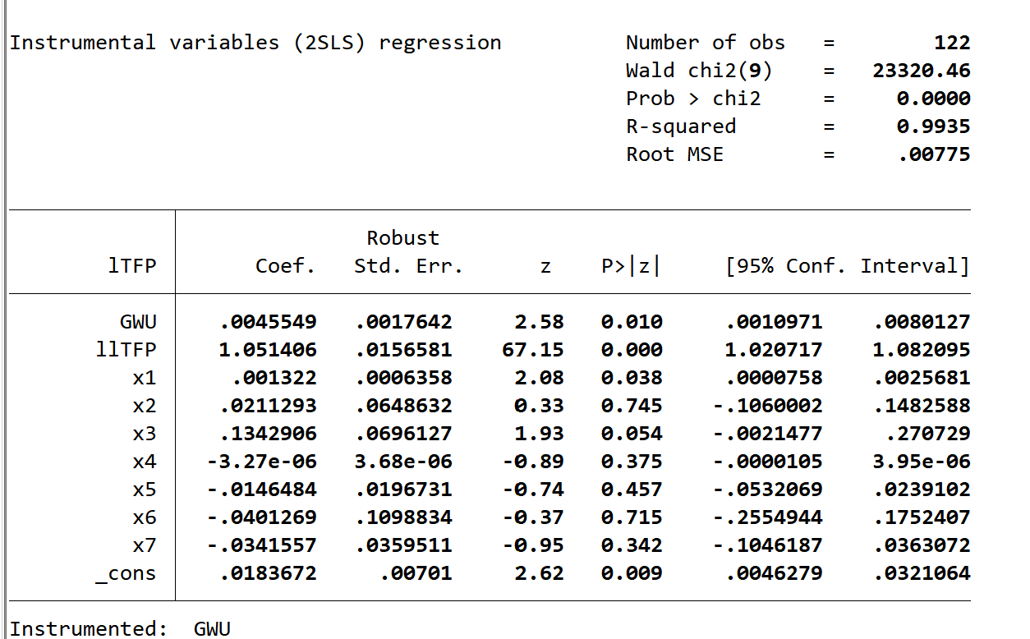

### input

#### /*Machinery*/

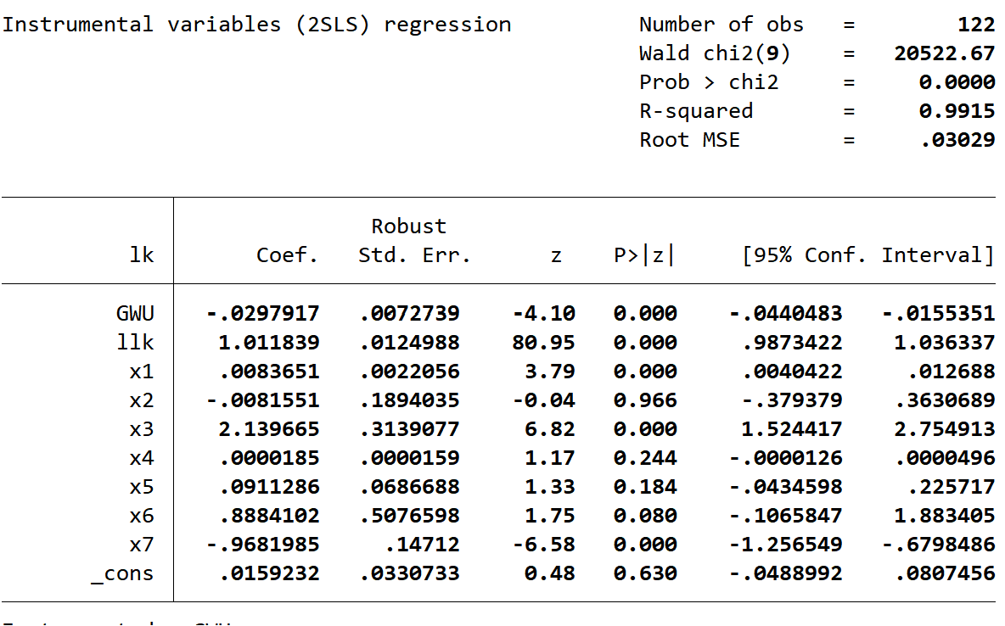

#### /*Fertilizer*/

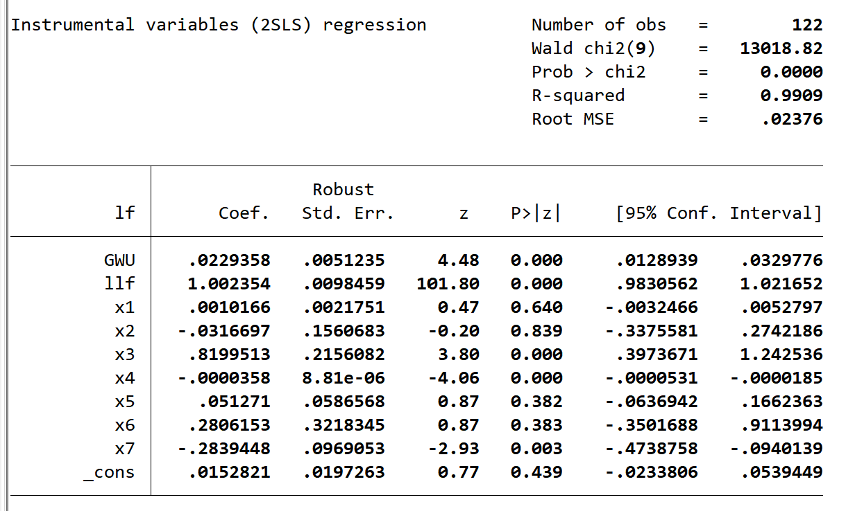

#### /*AgriWater*/