1. Sentiment API:
http://9.186.91.141:5000/api/sentiment/v1
Test Example:
{“utterance”:”您好”}
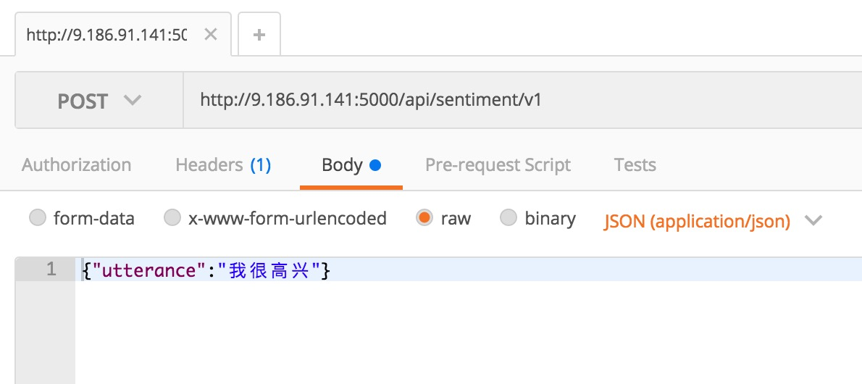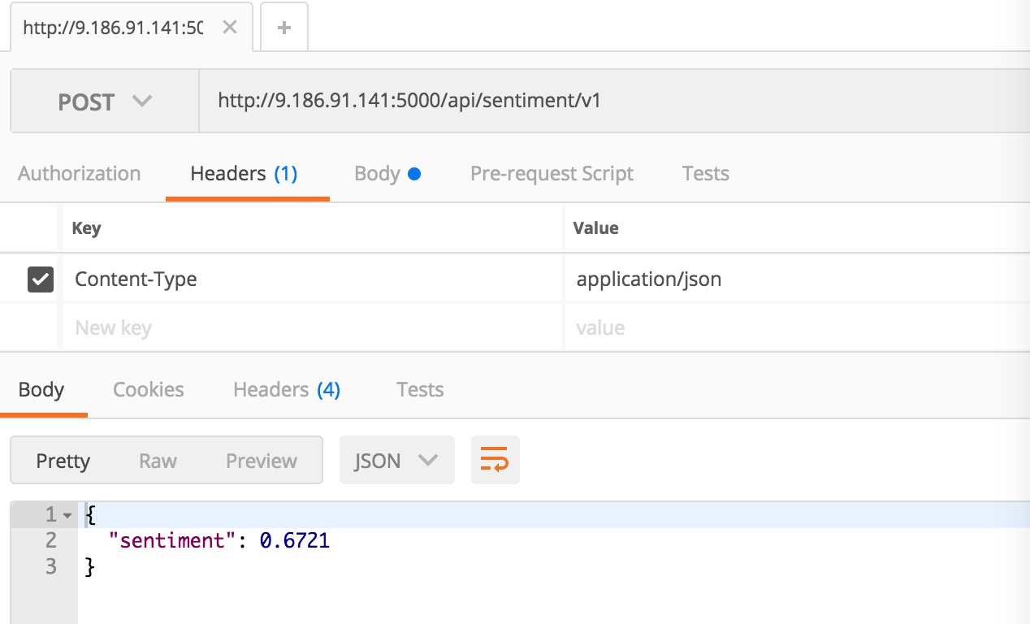

2. OCR API:
http://9.186.91.141:5001/api/ocr/v1
form-data
key: ocr_file
Test File:
链接: https://pan.baidu.com/s/1gfBrWkV 密码: 1bkt
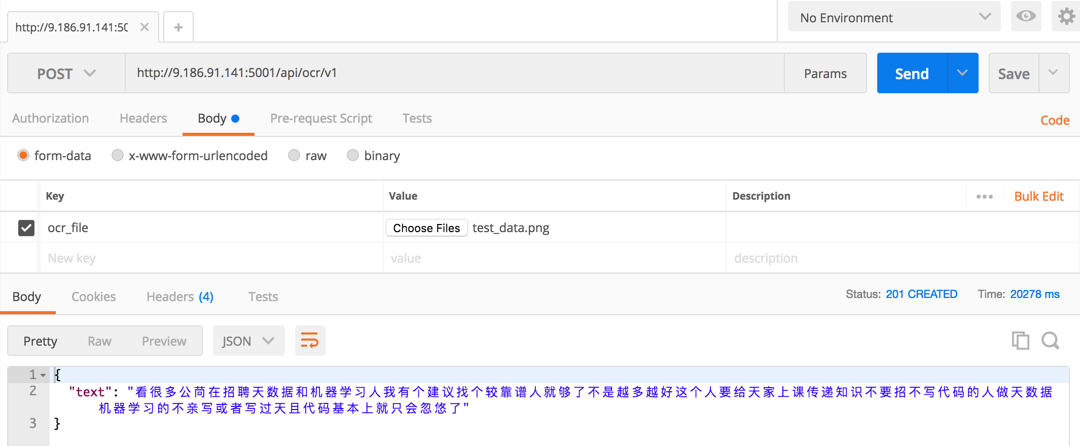

3. Music API:
http://9.186.91.141:5002/api/music/v1
form-data
key: music_file
Test File:
链接: https://pan.baidu.com/s/1gfBrWkV 密码: 1bkt
