[http://bdp.jd.com/jrdw/jrctask/storm/listStorm.html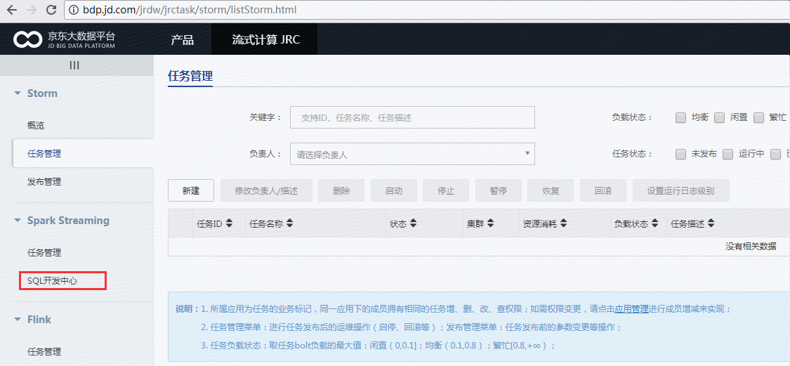](http://bdp.jd.com/jrdw/jrctask/storm/listStorm.html#)

