## 获取标签的value值

$("#venderId").val() //venderId是标签的id值

## Form表单提交

1. Button

<button type="submit" class="btn btn-primary">搜索</button>

1. Form的Id

$("#query").submit();

## 使页面中表单提交后搜索框保留原值

使用spring，在处理完数据后往页面中设置

mv.addObject("ouchMap",getOuchInfoList());

mv.addObject("venderId", emptySearchEntity.getVenderId());

mv.addObject("depAirportCode", emptySearchEntity.getDepAirportCode());

mv.addObject("arrAirportCode", emptySearchEntity.getArrAirportCode());

## form中button

默认类型是type=submit，所以点击按钮会刷新页面，当指定type=button时，不会刷新页面。

**function** addWhite(){  
 $("#type").val("white");  
  
 $.get('/base/risk/emptySearch/addWhite',  
 $('#air-emptySearch-list').serialize(),  
 **function** (data) {  
 **if** (data == **true**) {  
 alert("操作成功");  
 } **else** {  
 alert("操作失败:" + data);  
 }  
 }  
 );  
}

CacheKeyConstant.AIR_DICT_CACHE_TIME

## 下拉框Map

<#assign nfdTypeMap={"1":1,"2":2,"3":3,"4":4,"5":5,"6":6,"7":7,"8":8}/>

<div class="form-group">  
 <label class="control-label col-sm-3">NFD类型</label>  
 <div class="controls col-sm-7">  
 <select name="nfdType" class="form-control required">  
 <option value="0" selected="selected">普通</option>  
 **<#list** nfdTypeMap?keys **as** key**>** <option value="**${**nfdTypeMap[key]!**}**" **<#if** key == (airline.nfdType?string)!**>**selected**</#if>**>热门**${**nfdTypeMap[key]!**}**</option>  
 **</#list>** </select>  
 </div>  
 </div>

<select name="airCorpCode" class="form-control">  
 <option value="">全部</option>  
 **<#list** corpMap **as** corp**>** <option value="**${**corp.code**}**" **<#if** corp.code == (airCorpCode?string)!**>**selected**</#if>**>**${**corp.code**}**(**${**corp.name**}**)</option>  
 **</#list>**</select>

## 单元格不换行

<td class="text-center" style=”word-wrap:break-word;word-break:break-all;”>

## 下拉多选框

[纯JS打造多选下拉框select+模糊查询功能](https://blog.csdn.net/leq3915/article/details/81257506)

获取select中option的值放在数组中：[Jquery 动态增加option及获取值 遍历option相关方法](https://blog.csdn.net/liq816/article/details/78029367)

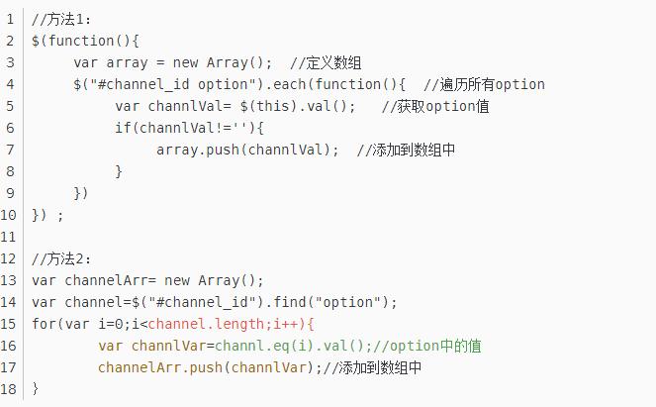

## Jquery+validate

[jQuery Validate](http://www.runoob.com/jquery/jquery-plugin-validate.html)

在js中自定义：[封装jQuery Validate扩展验证方法](https://www.cnblogs.com/linjiqin/p/3433635.html)

optional(element)：用于表单控件的值不为空时才触发验证

