## Air_base_server

门面服务RuleFacadeService extends ActivityService

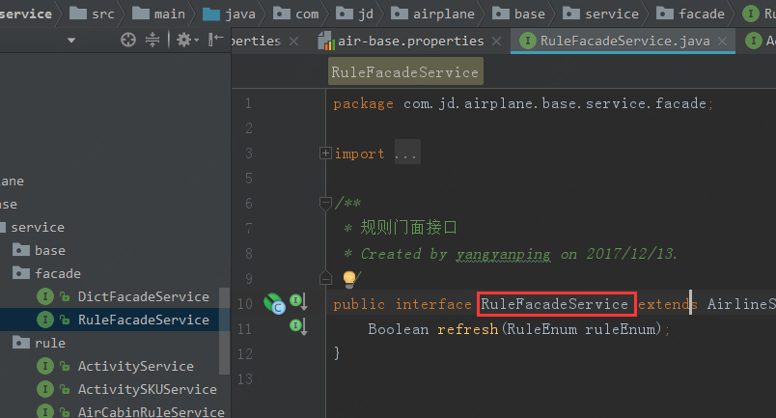

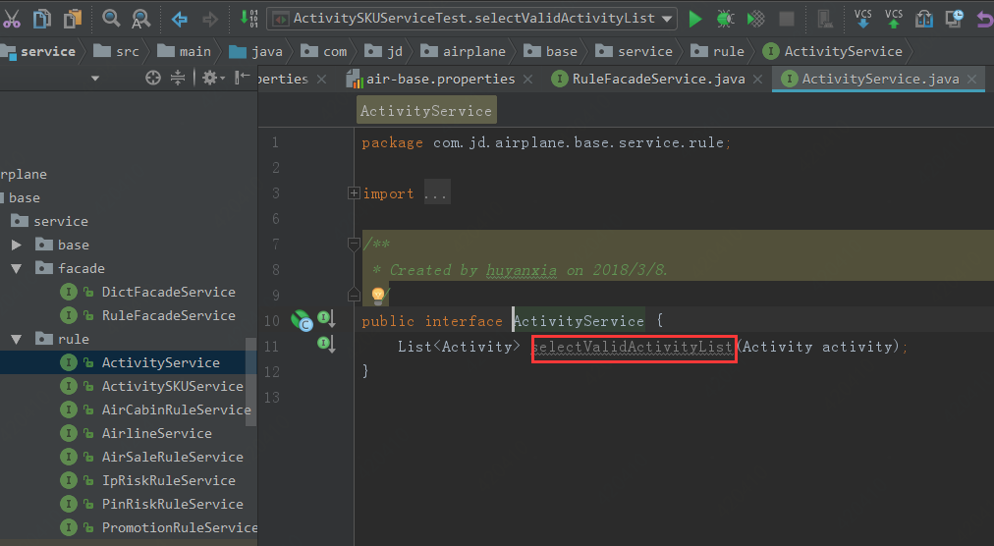

增加枚举

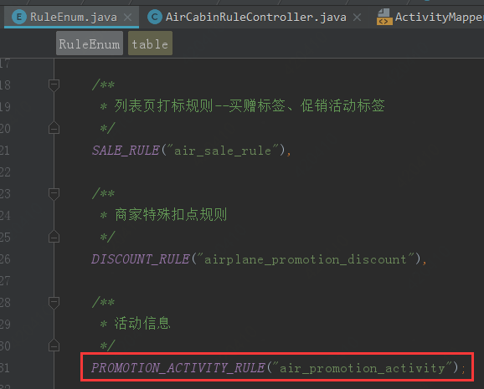

门面服务实现类中实现查询有效活动的方法

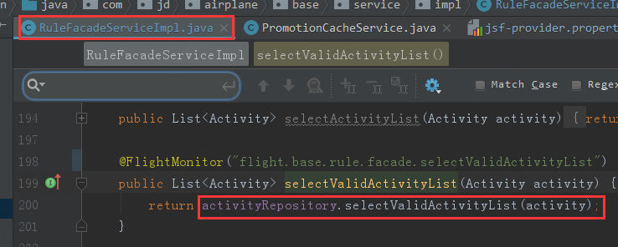

Man端  
当有数据库更新时，手动调用refresh方法，通知zk节点有更新。

## Jipiao

监听zk节点有更新时，调用selectValidActivityList方法拉取有效活动数据

## Controller

将host切换到

172.22.102.78 airbase.jd.com

浏览器中地址：

<http://airbase.jd.com/base/rule/rule/refresh?ruleEnum=PROMOTION_ACTIVITY_RULE>

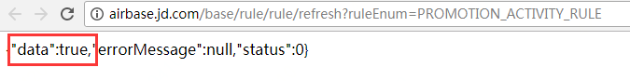

## 后台“发布数据”

手动调用 ，通知zk节点有更新。参数是：枚举PROMOTION_ACTIVITY_RULE

ruleFacadeService.refresh(ruleEnum);

## 后台活动MQ模拟

创建活动消息体

{"uuid":"983_66262_1000412602","content":{"acId":983,"orderType":35,"popId":1000412602,"venderId":66262,"mqType":1}}

{"orderType":35,"mqType":4,"venderId":59042,"acId":960,"popId":1000397602},"uuid":"960_59042_1000397602"}

{"content":{"orderType":35,"mqType":4,"venderId":59042,"acId":960,"popId":1000397602},"uuid":"960_59042_1000397602"}

## 京米建活动

### 测试环境jsf

去test.jsf.jd.com中看哪个可用

**com.jd.jmi.promo.client.service.activity.JmiPromoSoaActivityService**

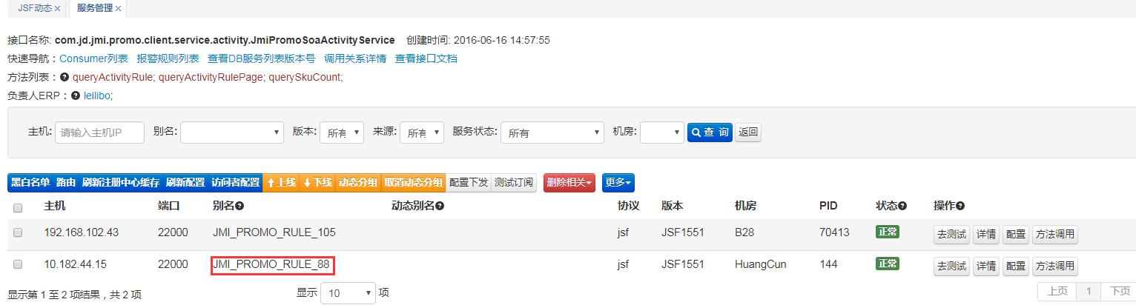

将这个jsf别名配置到程序中

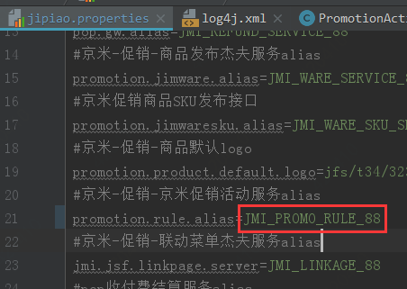

Host：192.168.102.49 promo.jmi.jd.com

创建一个sku，然后建活动

### 测试环境jmq主题确认

问题：测试环境创建活动，消费到线上主题。

沟通结果：现在线上和测试都用的是相同的主题：jmiPromoRulePushNew

### 部署后还需要京米授权

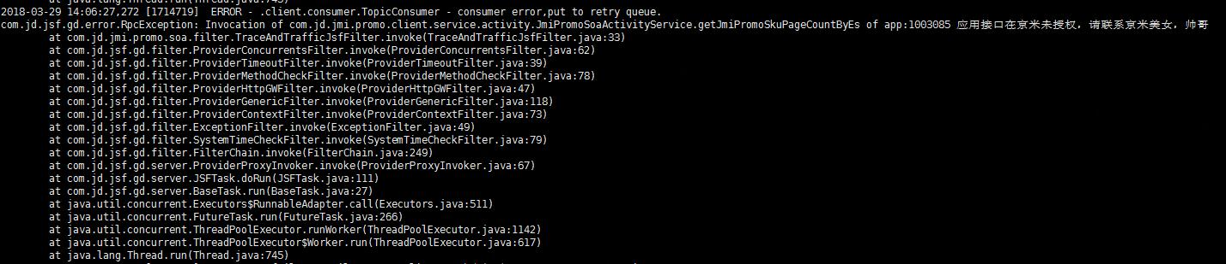

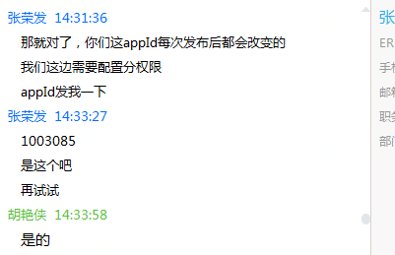

## 活动创建异常

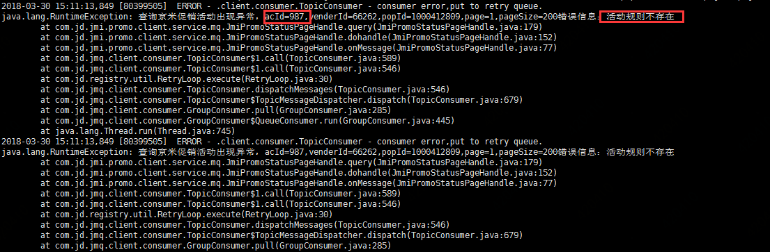

出现上面异常，导致mq消息一直重试。

{"content":{"orderType":35,"mqType":2,"acId":987},"uuid":"aed7018b-e8f5-4bd2-b8da-e35e7aea4b73"}

#### 通知zk异常

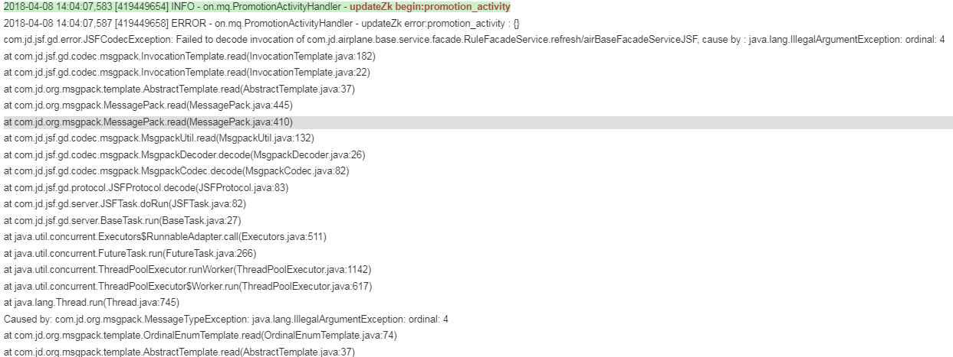

原因：man线上机器上配置的base-server是线上的，没有活动的枚举

man预发机器配置的base-server是预发的，预发经常上线，所以有枚举，会成功。

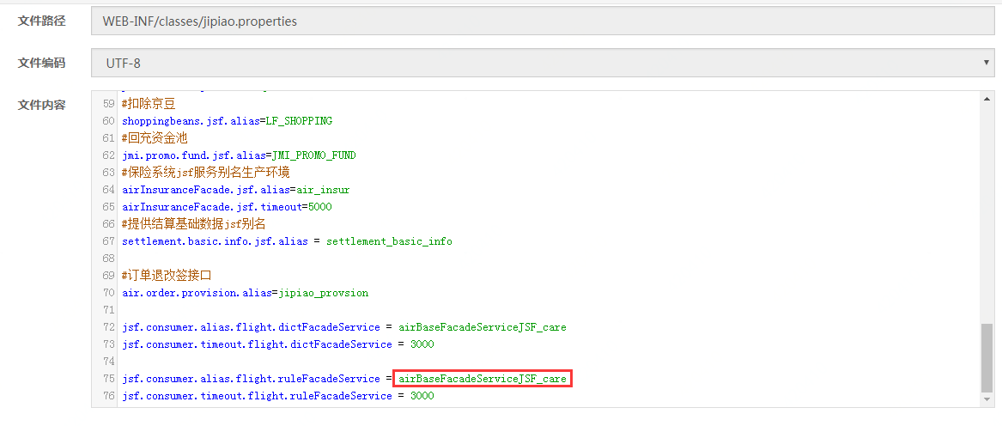

* 2018-03-29 16:01:35 INFO pool-4-thread-10 com.jd.airplane.base.background.service.promotion.PromotionCacheService run:248 - after delete temp, key : air_base_rule_prom_act_sku_temp_138669_CA1714_T, value : null
* 2018-03-29 16:01:35 INFO pool-4-thread-10 com.jd.airplane.base.background.service.promotion.PromotionCacheService run:253 - after delete, key : air_base_rule_prom_act_sku_138669_CA1714_T, value : null
* 2018-03-29 16:01:35 INFO pool-4-thread-10 com.jd.airplane.base.background.service.promotion.PromotionCacheService run:248 - after delete temp, key : air_base_rule_prom_act_sku_temp_138669_CA1222_C, value : null
* 2018-03-29 16:01:35 INFO pool-4-thread-10 com.jd.airplane.base.background.service.promotion.PromotionCacheService run:253 - after delete, key : air_base_rule_prom_act_sku_138669_CA1222_C, value : null
* 2018-03-29 16:01:35 INFO pool-4-thread-10 com.jd.airplane.base.background.service.promotion.PromotionCacheService run:248 - after delete temp, key : air_base_rule_prom_act_sku_temp_138669_CA1967_S1, value : null
* 2018-03-29 16:01:35 INFO pool-4-thread-10 com.jd.airplane.base.background.service.promotion.PromotionCacheService run:253 - after delete, key : air_base_rule_prom_act_sku_138669_CA1967_S1, value : null
* 2018-03-29 16:01:35 INFO pool-4-thread-10 com.jd.airplane.base.background.service.promotion.PromotionCacheService run:248 - after delete temp, key : air_base_rule_prom_act_sku_temp_138669_CA4153_B, value : null
* 2018-03-29 16:01:35 INFO pool-4-thread-10 com.jd.airplane.base.background.service.promotion.PromotionCacheService run:253 - after delete, key : air_base_rule_prom_act_sku_138669_CA4153_B, value : null
* 2018-03-29 16:01:35 INFO pool-4-thread-10 com.jd.airplane.base.background.service.promotion.PromotionCacheService run:248 - after delete temp, key : air_base_rule_prom_act_sku_temp_138669_CA3343_V1, value : null
* 2018-03-29 16:01:35 INFO pool-4-thread-10 com.jd.airplane.base.background.service.promotion.PromotionCacheService run:253 - after delete, key : air_base_rule_prom_act_sku_138669_CA3343_V1, value : null
* 停止查看实时日志：/export/Logs/air.base.background/promotion-cache.log
* 开始查看实时日志：/export/Logs/air.base.background/promotion-cache.log
* 2018-03-29 16:01:35 INFO pool-4-thread-10 com.jd.airplane.base.background.service.promotion.PromotionCacheService run:248 - after delete temp, key : air_base_rule_prom_act_sku_temp_138669_CA1714_T, value : null
* 2018-03-29 16:01:35 INFO pool-4-thread-10 com.jd.airplane.base.background.service.promotion.PromotionCacheService run:253 - after delete, key : air_base_rule_prom_act_sku_138669_CA1714_T, value : null
* 2018-03-29 16:01:35 INFO pool-4-thread-10 com.jd.airplane.base.background.service.promotion.PromotionCacheService run:248 - after delete temp, key : air_base_rule_prom_act_sku_temp_138669_CA1222_C, value : null
* 2018-03-29 16:01:35 INFO pool-4-thread-10 com.jd.airplane.base.background.service.promotion.PromotionCacheService run:253 - after delete, key : air_base_rule_prom_act_sku_138669_CA1222_C, value : null
* 2018-03-29 16:01:35 INFO pool-4-thread-10 com.jd.airplane.base.background.service.promotion.PromotionCacheService run:248 - after delete temp, key : air_base_rule_prom_act_sku_temp_138669_CA1967_S1, value : null
* 2018-03-29 16:01:35 INFO pool-4-thread-10 com.jd.airplane.base.background.service.promotion.PromotionCacheService run:253 - after delete, key : air_base_rule_prom_act_sku_138669_CA1967_S1, value : null
* 2018-03-29 16:01:35 INFO pool-4-thread-10 com.jd.airplane.base.background.service.promotion.PromotionCacheService run:248 - after delete temp, key : air_base_rule_prom_act_sku_temp_138669_CA4153_B, value : null
* 2018-03-29 16:01:35 INFO pool-4-thread-10 com.jd.airplane.base.background.service.promotion.PromotionCacheService run:253 - after delete, key : air_base_rule_prom_act_sku_138669_CA4153_B, value : null
* 2018-03-29 16:01:35 INFO pool-4-thread-10 com.jd.airplane.base.background.service.promotion.PromotionCacheService run:248 - after delete temp, key : air_base_rule_prom_act_sku_temp_138669_CA3343_V1, value : null
* 2018-03-29 16:01:35 INFO pool-4-thread-10 com.jd.airplane.base.background.service.promotion.PromotionCacheService run:253 - after delete, key : air_base_rule_prom_act_sku_138669_CA3343_V1, value : null

