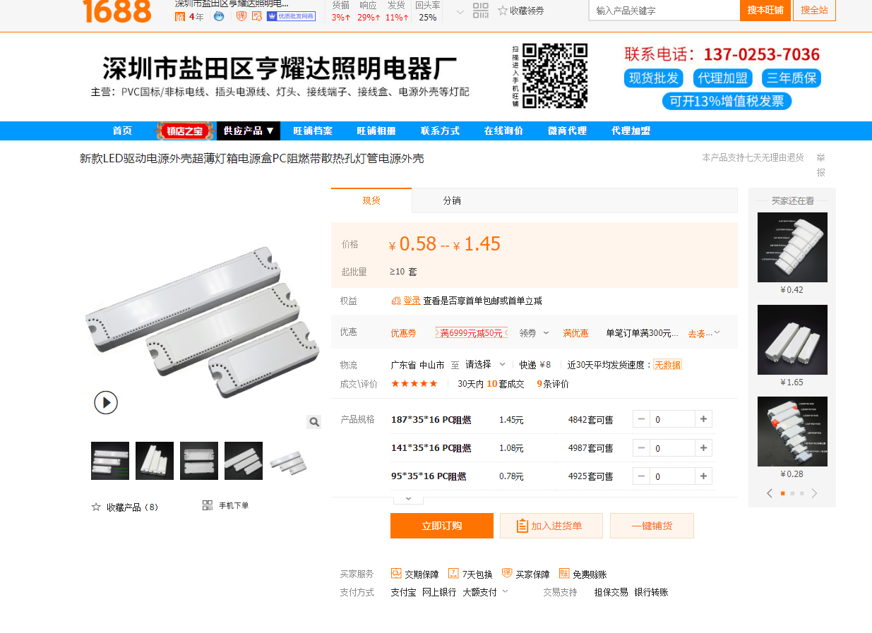

链接：

https://detail.1688.com/buyer/offerdetail/581517405552.html?spm=a26286.10576602.0.0