FX Call Option BS Formula (in term of the forward):
$$C=DF_{JPY}\left[F⋅N\left(d_{1}\right)-K⋅N\left(d_{2}\right)\right]$$
whereas
$$Fwd_{USDJPY}\left(T\right)={Spot}_{USDJPY}\left(T\right)\frac{DF_{USD}(T)}{DF_{JPY}(T)}$$
Alternatively
$$DF_{JPY}\left(T\right)=\frac{DF_{USD}\left(T\right)}{Fwd_{USDJPY}\left(T\right)/Spot_{USDJPY}}$$
$$d_{1}=\frac{\ln\left(F/K\right)+\frac{1}{2}σ^{2}T}{σ\sqrt{T}}$$
$$d_{1}=d_{2}-σ\sqrt{T}$$

How the forward spots are determined:
The forward spots are market quoted and it determines $DF_{JPY}\left(T\right)$ the using the formula above.
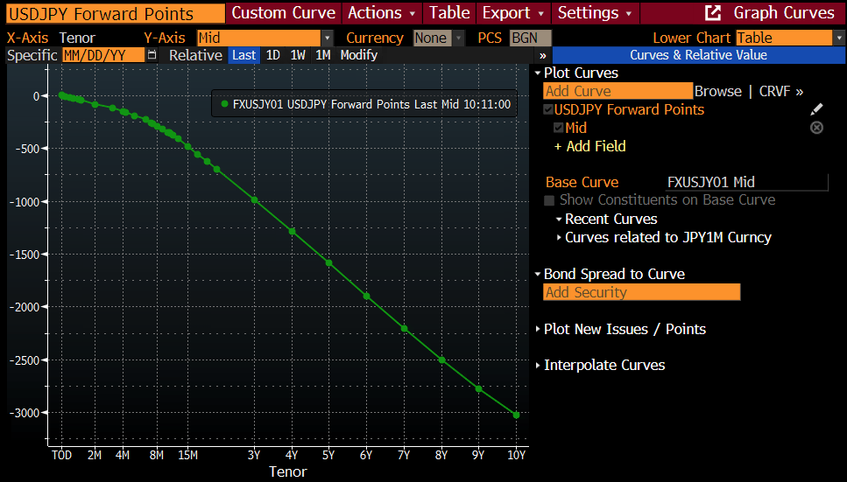
For example, as shown in the graph,
USDJPY Forward Spot = USDJPY Spot + USDJPY Forward Points (observed on the market)
The following is how the Implied JPY DF is constructed,
Tenor | USD DF | Fwd Spot  (directly quoted and tradable) | Fwd Spot / Spot | Implied JPY DF
6M | 0.9753 | 154.3 | 0.99548 | 0.9797
1Y | 0.9493 | 153.5 | 0.99032 | 0.9586
2Y | 0.9048 | 151.8 | 0.97935 | 0.924

Python output:
Option Premium (JPY)=2,958,382.43
Bloomberg output:
