$$DF_{JPY}\left(T\right)=\frac{DF_{USD}\left(T\right)}{Fwd\left(T\right)/Spot}$$
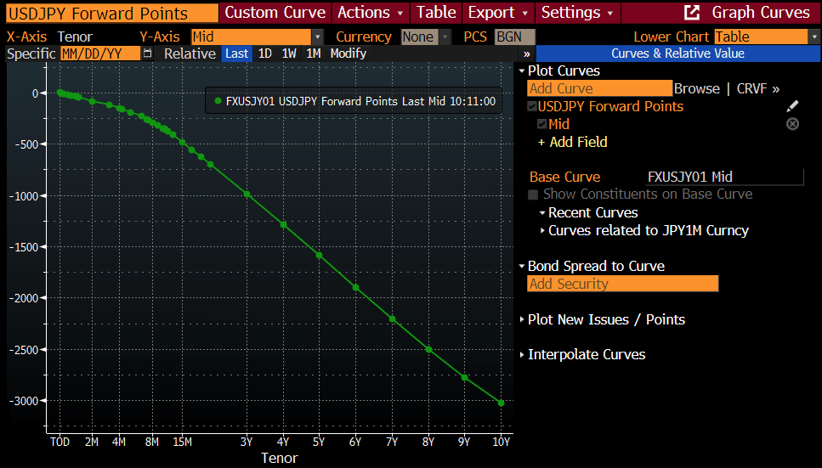
USDJPY Forward Spot = USDJPY Spot + USDJPY Forward Points
For example, the following is how the Implied JPY DF is constructed,
Tenor | USD DF | Fwd Spot  (directly quoted and tradable) | Fwd Spot / Spot | Implied JPY DF
6M | 0.9753 | 154.3 | 0.99548 | 0.9797
1Y | 0.9493 | 153.5 | 0.99032 | 0.9586
2Y | 0.9048 | 151.8 | 0.97935 | 0.924

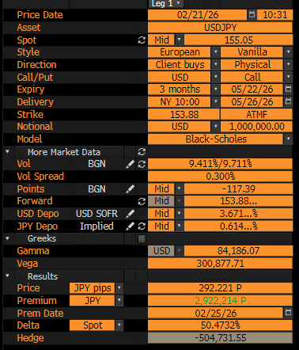
FX Call Option BS Formula:
$$C=DF_{JPY}\left[FN\left(d_{1}\right)-KN\left(d_{2}\right)\right]$$
$$F=S_{0}\frac{DF_{USD}}{DF_{JPY}}$$
$$d_{1}=\frac{\ln\left(F/K\right)+\frac{1}{2}σ^{2}T}{σ\sqrt{T}}$$
$$d_{1}=d_{2}-σ\sqrt{T}$$

