该代码在3.8环境下更稳定，官方文档没有及时更新。在开始前下载anaconda，并右键以管理员模式进入powershell
红色的字不要复制进去
新建环境：
conda create -n deeppurpose python=3.8 -y
conda activate deeppurpose

安装rdkit：
conda install -c conda-forge rdkit -y
测试：python -c "import rdkit; print('RDKit OK')"

安装cuda（gpu跑的快一点）
pip install torch torchvision torchaudio --index-url https://download.pytorch.org/whl/cu118
测试：python -c "import torch; print(torch.__version__)"
如果没有 GPU
安装 CPU版：pip install torch torchvision torchaudio

安装 descriptastorus
pip install descriptastorus

安装 DeepPurpose
pip install DeepPurpose
第一次安装会自动安装 dgl / lifelines / scikit-learn 等依赖
时间可能稍长

安装 Notebook
conda install notebook
pip install ipykernel
python -m ipykernel install --user --name deeppurpose --display-name "Python (deeppurpose)"
jupyter notebook
然后在 Notebook 右上角：
Kernel → Change kernel
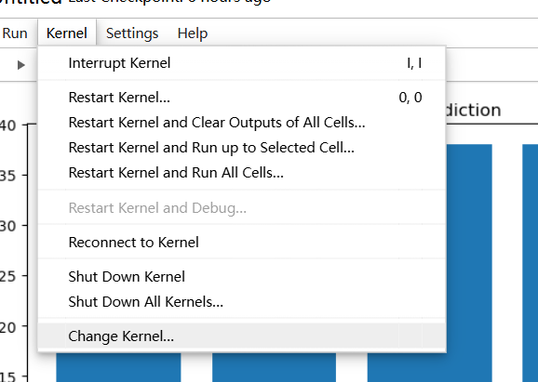

测试（在jupyternotebook中进行：）
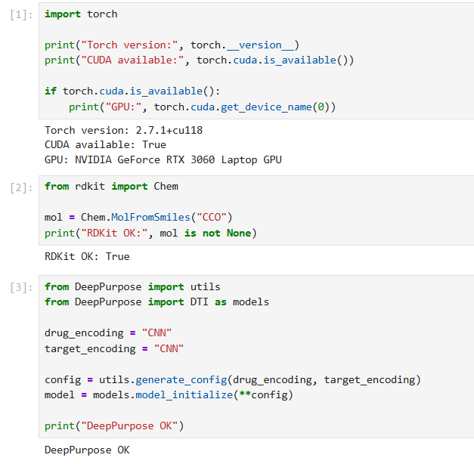
import torch

print("Torch version:", torch.__version__)
print("CUDA available:", torch.cuda.is_available())

if torch.cuda.is_available():
print("GPU:", torch.cuda.get_device_name(0))
print(torch.cuda.get_device_name(0))

from rdkit import Chem

mol = Chem.MolFromSmiles("CCO")
print("RDKit OK:", mol is not None)

from DeepPurpose import utils
from DeepPurpose import DTI as models

drug_encoding = "CNN"
target_encoding = "CNN"

config = utils.generate_config(drug_encoding, target_encoding)
model = models.model_initialize(**config)

print("DeepPurpose OK")

