Editing Notes
Contents
Protocol for Assuring Correct Naming
Editing Advice

Protocol for Ensuring Correct Naming
- Naming first requires that nuclei be edited through at least the 8 cell stage, this means not only that the 2-4 (if present) and 4-8 cell divisions exist and are correctly tracked, it also requires that any polar bodies (if present) are either present, and continuously tracked for that entire span of time, or have been deleted for that entire span of time . The same is true of false detections. To check for this click on the first few nuclei in the main cell list and make sure that besides the 2 or 4 cells in the first frame, no cells appear until after the 8 cell stage. (Polar bodies are typically not detected in green lineaging strains, but are in the red, if present they must be continuously tracked, or totally deleted, they cannot for example appear in frame 2, they must be present from frame 1 and remain through all the 4-8 cell divisions ). In addition Sulston naming will be turned off if start index is manually specified in the xml file as being anything other than 1, so don’t do this.
- This minimally edited lineage should be saved over the automatically generated version of the zip file with an _edited suffix.
- EVEN IF SULSTON NAMING APPEARS AT THIS POINT IT IS ALMOST CERTAINLY WRONG.
- Look at the <embryoname>_editedAuxInfo.csv to see if the program has succeeded in identifying the embryo orientation. If this file is not present run ‘java -Xmx500m -cp acebatch2.jar Measure1 <embryoeditedxmlfilename>’. Or copy and rename an auxinfo file and edit its contents as described below.
If it has succeeded in fully recognizing the orientation, the last entry in the file will be an orientation tag such as ADL (canonical orientation), if not it will end with XXX.
  - Even when everything is right the orientation tag is often missing and should be entered manually. Two things can cause broader failure, lingering errors that should have been corrected in step 1 or miscalculation of the embryo boundaries. The time field in the csv file indicates the timepoint where the embryo boundary is calculated. If excessive nuclei from adjoining embryos are present at this timepoint this will throw calculations off and the values in the auxinfo file will likely be wrong.
- EVEN IF THE AXIS IS AUTOMATICALLY SPECIFIED IT (AND OTHER AUXINFO VALUES) SHOULD BE MANUALLY DOUBLE CHECKED OR NAMING MAY BE INCORRECT.
- Sanity check/correct AuxInfo output
  - Open the file in Excel
  - The values most likely to be off are:
    - Xc,yc are the x and y center of embryo. Position the cursor at center of embryo, and read the x,y coordinate off the acetree info window and enter this in file if it is significantly different. (now unlikely to be wrong)
    - Maj, min are the length of the major and minor axis of embryo only very approximate values are necessary, eyeball the pixel length ~190 and 110 in many new images. (now unlikely to be wrong)
    - Ang the angle of the embryo from canonical A-P=X orientation, eyeballing is sufficient. The angle is always less than 90 degrees in absolute value. (wrong only in occasional near vertical embryos)
Ang= 45
Ang=- 45

    - Axis is the orientation of the embryo in the data volume
      - It is given by specifying the embryonic axis that is closer to being oriented toward your left, toward the top of the screen and toward you.
      - This can typically be identified manually at the 4 cell stage, just before the AB cells divide, at which point they are dramatically larger and in a very consistent configuration.
      - I do this by keeping a printout of the canonical embryo near me, and mentally rotating it in 3D till it lines up with the embryo image, then reading the left, up and toward me axis labels off the rotated canonical compass (see below)
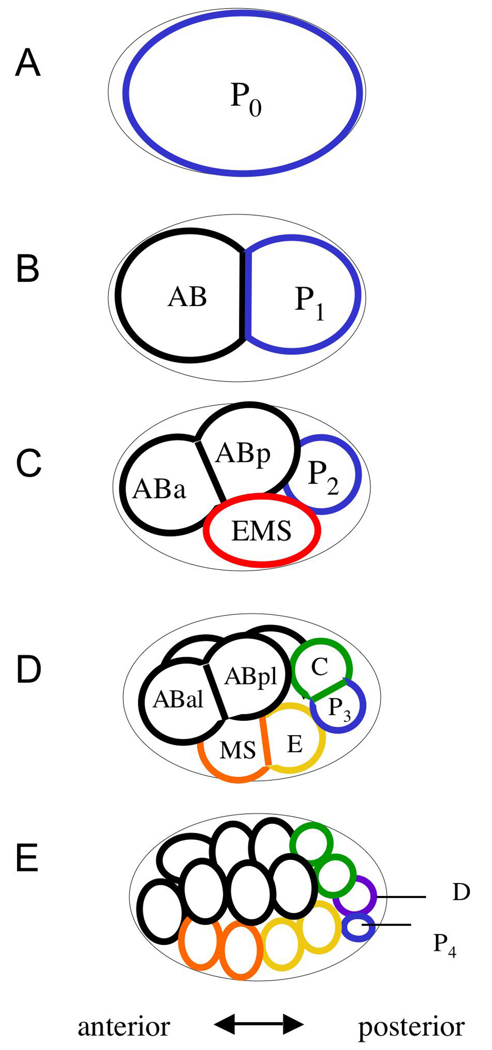
        - Canonical orientation or near is ADL
A
P
D
V
L
R

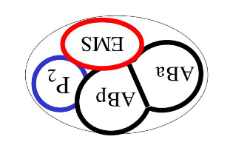
        - Extreme rotations in the image plane will flip AP and DV e.g. PVL
A
P
D
V
L
R
A
P
D
V
L
R
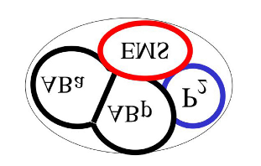
        - Rotations in Z will flip LR and DV e.g. AVR

- Once this has been manually corrected,
  - Save the csv file
  - Close and reopen Acetree (which does not correctly reread files when they have previously been opened). (alternatively open the unedited file, edit it, save over the edited file and then open the edited file, which will trigger a reading of the auxinfo file, re-opening the edited file will not do so)
  - Reopen the embryos xml file
- If naming is incorrect or Nuc names persist after the above steps
  - Check the csv file is correctly named/and loaded and the debugging output from Acetree matches its expected contents. The expected csv file contents should be output by acetree when loading series e.g.
Identity3.identityAssighment, entered
InitialID, measureCSV,
ZD_RW10105_skr-2_20100113_1_s1RW10105_SKR-2_Mir_emb2,0.8504,-.7861,340,333,200,152,-55.1681,15.4231,0,171,3.937,PRV
If instead of the contents ’,,,,,,,’ is output this means the file could not be found.
  - Double check that values in csv file are correct
  - Double check that no early unlinked nuclei are present
  - Double check that at 4-8 cell stage positions of daughter nuclei are accurate
  - Double check that the positioning at the division that is wrongly named is accurate.

Occasionally even after all this naming happens but is wrong or inconsistent, this is a bug with an unknown cause, closing, and reopening and resaving the file seems to fix it.
Editing Advice
In general the goal of editing is to make the computed purple circles match the underlying florescence data. Don’t try and understand the behavior of the circles, when they are wrong they can just be deleted, try and understand the data. When in doubt turn off the circles using the HideC button, and look at the GFP data itself to understand what is actually happening.
False Positives
Detections outside the embryo or multiple detections are often found as false divisions or Nuc cells unattached from the lineage. If you right click on a cell name in the browser window to go to its last timepoint, you can just hit delete (which will kill the cell and move to the next earlier timepoint) till the annotation matches an actual nucleus. Then you can rebuild the tree which is not updated when the delete key is used.

False Negatives
Correct False Negatives using the AddSeries dialogue rather than the relink dialogue.
Add a nucleus at the correct location individually at each missing time point, and then link the last added point to the first redetected point.

Mistaken Links
Use the relink dialogue only to change associations between nuclei at adjacent time points.
When relinking a nucleus to its precursor at the previous time point this nucleus might already have a successor, in which case relinking creates a false division, this division must then be removed, by relinking the incorrect successor of the pair to its correct parent.
An exception occurs when the correct predecessor of a nucleus already has two successors, one or both of which may be incorrect, in this case at least one of these false successors must be corrected first, because nuclei can not have more than two successors.

Deaths
Each Death should be examined using the Deaths and Adjacencies Dialogue (edit->deaths/adjacencies->deaths button)
Enter the final editing time, and one by one, click on each death on the list, confirming in the image that it is a genuine death, or correcting the error by linking the listed ‘dying’ cell to its correct successor.
Frequently a nucleus will be mislocated on a false positive for one or more time points before its death. In such cases the incorrect nuclei during these need to be deleted and the last good timepiont linked to the next appearance of the nucleus.

Divisions
Each division should be similarly examined (edit->Siamese->Divisions button)
Look at each division moving forward and backward in time to confirm it is correct and if not correct it. Make sure that not only is a real division occurring, but that the tracking has not positioned the division earlier or later in time than it really is. It is common for a cell to split into two multiple responses, and then genuinely divide, resulting in an early division. It is also common for one child after a division to be missing, and for the division to occur several time points later once the second child is redetected. This is why it is important to screen each division rather than rely on the lineage tree. Both of these errors are important to fix as they can cause flaws in cell naming, and later analysis.
If cells are not being named in the canonical fashion (matching what is seen if you choose, trees, Sulston tree from the file menu) then this kind of early or late cell division right before the naming error is the usual cause.

Mis-positioning
Wrong branches and mis-positioning of nuclei may still occur, check for these using the Overlaps Dialogue (edit->Overlaps->Overlaps button).
Genuine overlaps will most likely be dividing cells. Others should be examined to determine if both nuclei are well positioned, if they are mis-positioned this should be corrected. They also may both be the same nucleus, in which case one of the multiple responses should be deleted during time points where they are doubled up.

Displacements
Large displacements between nuclei should also be checked (edit->deaths/adjacencies->jumps button)
Each can be examined for swapped links or any other obvious errors.
After editing is believed complete, another pass through these lists should be done to catch any overlooked errors.
All cells not part of the lineage (named Nuc#) should also be examined to ensure that none exist during edited time points. These cells should be deleted if false positives and linked into the lineage correctly if they are not.
Landmarks of 10th round:
Proposed landmark for ~500 cell stage is all 10th round division in sublineage ofABplpap

