Note: these are instructions for the use of the semi-experimental auxinfo 2 format for specifying

Embryo orientation in uncompressed embryos where the lr/dv axes are arbitrary wrt to the image axes (in compressed embryos dv or lr are typically aligned with the axial direction at various stages). Working but seems to have issues in some embryos related possibly to the use of trained expected division angles based on compressed embryos. Use with caution.

1. Open the 4 cell time point

COMPRESSED EMBRYO EXAMPLES

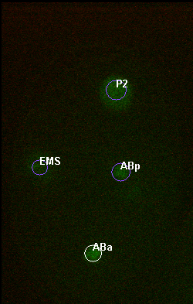

ABa

P2

EMS

ABp

Direction of A: <-0.05, 1.0, 0.0>

Direction of L:

<0.0, 0.0, -1.0>

(away from you)

+x

+z

(toward you)

+y

This corner is the TOP LEFT CORNER of your screen

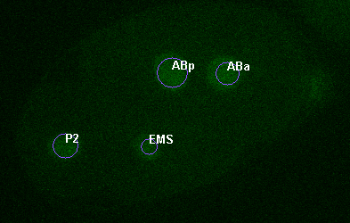

ABa

P2

EMS

ABp

Direction of A: <1.0 -0.35 0.0>

Direction of L:

<0.0, 0.0, -1.0>

(away from you)

+x

+z

(toward you)

+y

This corner is the TOP LEFT CORNER of your screen

UNCOMPRESSED EMBRYO EXAMPLE

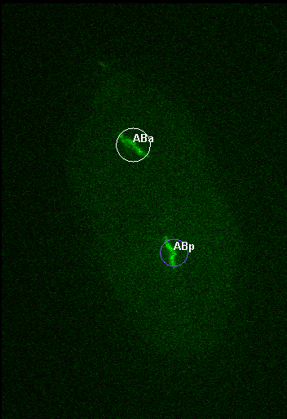

ABa

ABp

Direction of A: <-0.4, -1.0, 0.0>

Direction of L:

<0.0, 0.0, 1.0>

(toward you)

+x

+z

(toward you)

+y

This corner is the TOP LEFT CORNER of your screen

Signs of Axes and Corresponding Directions (all defined relative to the TOP LEFT CORNER of the screen):

+x = going away from (right) the top left corner

-x = going toward (left) the top left corner

+y = going away from (down) the top left corner

-y = going toward (up) the top left corner

*** NOTE on uncompressed embryos:

* It’s okay to ignore a slight tilt i.e. a few planes between cells and define your orientation vector as lying flat in image plane (as is the case above with the AP vector)
* Be cautious of names in embryos that don’t have a biologically induced rotation → ~8-256 cell stages

2. Defining the configuration vectors

First: Mentally place the coordinate axes over the image

Second: Look at the approximate centroid of the 4 cell diamond

Third: Approximate the vectors as follows -

* AP orientation: the direction of the ABa cell
* LR orientation: The L direction of the embryo (use the 4 cell stage image to visualize)

3. Setting up the AuxInfo file:

* *After completing step 2, you now have two vectors (3 components in each vector x,y,z) that define the orientation of your embryo*
* Take the entire name of your xml file before the .xml extension and append: AuxInfo_v2.csv
  + xmlFileNamePrefixAuxInfo_v2.csv
* Place the following header line at the top of your file (separated by commas), indicating the configuration fields
  + name,slope,intercept,xc,yc,maj,min,ang,zc,zslope,time,zpixres,AP_orientation,LR_orientation
* Add an entry for each of the first 12 fields such as in earlier versions of your AuxInfo (again, separated by commas)
* For the last two entries (AP_orientation, LR_orientation), put the 3 vector components you calculated above for each entry. Use decimal point precision and separate each component by a space, and the two entries by a comma. The entries for the above embryos would look like:
  + Example 1: …,-0.05 1.0 -.0, 0.0 0.0 1.0
  + Example 2: 1.0 -0.37 0.0, 0.0 0.0 -1.0