关于中国电信云计算内蒙古信息园项目部分地表堆土区域有关情况的说明
中国电信云计算内蒙古信息园项目位于内蒙古自治区呼和浩特市和林格尔县盛乐经济园区中国电信云计算内蒙古信息园，项目面积为210770平方米。为落实建设工程文物保护相关要求，我部已组织开展项目占地范围内文物考古相关工作。
根据现场核看及测绘标注情况，项目占地范围内部分区域存在地表堆土现状，相关地表堆土区域共5处，面积为10793平方米。上述区域主要为土方在现状地表堆置形成，地面可见堆土覆盖，无下挖扰动痕迹，不属于地下开挖、基槽开挖或基础施工区域。
特此说明。

附件：1. 中国电信云计算内蒙古信息园项目地表堆土区域示意图
- 中国电信云计算内蒙古信息园项目地表堆土区域坐标表

中国电信集团有限公司
云计算内蒙古信息园开发建设运营部
2026年6月9日

附件1
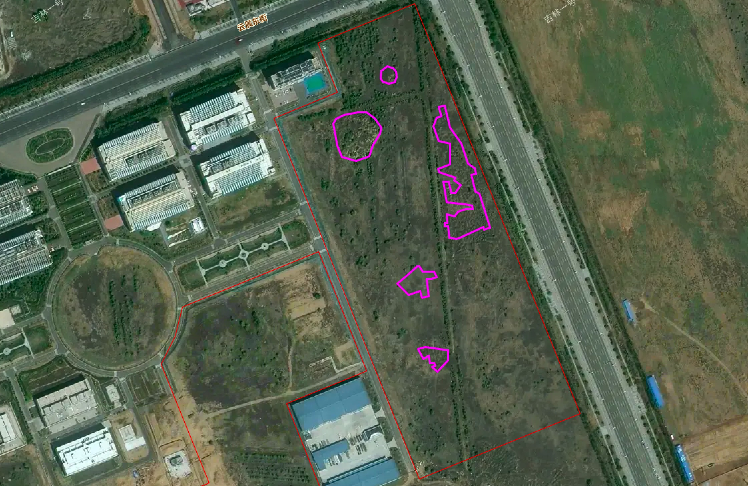
中国电信云计算内蒙古信息园项目地表堆土区域示意图

附件2
中国电信云计算内蒙古信息园项目地表堆土区域坐标表
名称 | 序号 | 经度 | 纬度
堆土1 | 1 | 111°50'01.7407" | 40°32'44.6282"
 | 2 | 111°50'02.0848" | 40°32'44.8153"
 | 3 | 111°50'02.4491" | 40°32'44.7367"
 | 4 | 111°50'02.5968" | 40°32'44.6076"
 | 5 | 111°50'02.6250" | 40°32'44.3538"
 | 6 | 111°50'02.5051" | 40°32'44.1163"
 | 7 | 111°50'02.1602" | 40°32'44.0568"
 | 8 | 111°50'01.8092" | 40°32'44.1455"
 | 9 | 111°50'01.7159" | 40°32'44.3146"
堆土2 | 1 | 111°49'58.9784" | 40°32'42.3180"
 | 2 | 111°49'59.1433" | 40°32'42.5166"
 | 3 | 111°49'59.5912" | 40°32'42.6821"
 | 4 | 111°50'00.3954" | 40°32'42.8138"
 | 5 | 111°50'00.9051" | 40°32'42.7981"
 | 6 | 111°50'01.3488" | 40°32'42.5324"
 | 7 | 111°50'01.7592" | 40°32'42.1431"
 | 8 | 111°50'01.6818" | 40°32'41.8538"
 | 9 | 111°50'01.2463" | 40°32'41.3297"
 | 10 | 111°50'01.0569" | 40°32'40.8677"
 | 11 | 111°50'00.2720" | 40°32'40.6735"
 | 12 | 111°49'59.4582" | 40°32'40.8286"
 | 13 | 111°49'59.2210" | 40°32'41.3425"
堆土3 | 1 | 111°50'02.6852" | 40°32'35.2522"
 | 2 | 111°50'03.1779" | 40°32'35.5825"
 | 3 | 111°50'03.8204" | 40°32'36.0131"
 | 4 | 111°50'03.9574" | 40°32'36.0122"
 | 5 | 111°50'04.1576" | 40°32'35.7810"
 | 6 | 111°50'04.8017" | 40°32'35.7764"
 | 7 | 111°50'04.9417" | 40°32'35.5552"
 | 8 | 111°50'04.6619" | 40°32'35.4521"
 | 9 | 111°50'04.3757" | 40°32'35.4542"
 | 10 | 111°50'04.4807" | 40°32'34.7166"
 | 11 | 111°50'04.1212" | 40°32'34.6321"
 | 12 | 111°50'04.0036" | 40°32'34.9232"
 | 13 | 111°50'03.3197" | 40°32'34.7625"
堆土4 | 1 | 111°50'05.6055" | 40°32'32.3240"
 | 2 | 111°50'05.6001" | 40°32'31.8841"
 | 3 | 111°50'04.9977" | 40°32'31.3756"
 | 4 | 111°50'04.6980" | 40°32'31.5822"
 | 5 | 111°50'04.8928" | 40°32'31.6559"
 | 6 | 111°50'04.8169" | 40°32'31.7726"
 | 7 | 111°50'04.5883" | 40°32'31.7743"
 | 8 | 111°50'04.4869" | 40°32'32.0842"
 | 9 | 111°50'04.1697" | 40°32'31.9552"
 | 10 | 111°50'03.8792" | 40°32'32.3710"
 | 11 | 111°50'04.3038" | 40°32'32.4792"
堆土5 | 1 | 111°50'06.0414" | 40°32'39.9395"
 | 2 | 111°50'05.9662" | 40°32'39.8016"
 | 3 | 111°50'06.3346" | 40°32'39.6183"
 | 4 | 111°50'06.0476" | 40°32'39.2515"
 | 5 | 111°50'05.8115" | 40°32'39.2532"
 | 6 | 111°50'05.6697" | 40°32'39.7500"
 | 7 | 111°50'05.3328" | 40°32'39.7524"
 | 8 | 111°50'05.5505" | 40°32'38.8558"
 | 9 | 111°50'06.6121" | 40°32'38.7396"
 | 10 | 111°50'06.9936" | 40°32'38.7057"
 | 11 | 111°50'07.0329" | 40°32'38.5368"
 | 12 | 111°50'06.6446" | 40°32'38.5594"
 | 13 | 111°50'06.1788" | 40°32'38.4264"
 | 14 | 111°50'06.0103" | 40°32'38.2150"
 | 15 | 111°50'05.5522" | 40°32'38.3063"
 | 16 | 111°50'05.5861" | 40°32'37.9321"
 | 17 | 111°50'05.4181" | 40°32'37.9233"
 | 18 | 111°50'05.4308" | 40°32'37.7835"
 | 19 | 111°50'05.6058" | 40°32'37.7822"
 | 20 | 111°50'05.6717" | 40°32'37.2726"
 | 21 | 111°50'06.0632" | 40°32'37.2129"
 | 22 | 111°50'06.2467" | 40°32'37.2703"
 | 23 | 111°50'07.6459" | 40°32'37.7500"
 | 24 | 111°50'07.6889" | 40°32'37.6410"
 | 25 | 111°50'08.0402" | 40°32'37.7215"
 | 26 | 111°50'07.4169" | 40°32'39.2101"
 | 27 | 111°50'07.1797" | 40°32'39.3233"
 | 28 | 111°50'06.9693" | 40°32'40.0438"
 | 29 | 111°50'07.2435" | 40°32'40.1152"
 | 30 | 111°50'07.1474" | 40°32'40.3300"
 | 31 | 111°50'06.7729" | 40°32'40.5296"
 | 32 | 111°50'06.3902" | 40°32'41.4383"
 | 33 | 111°50'05.7137" | 40°32'42.1313"
 | 34 | 111°50'05.4081" | 40°32'43.1025"
 | 35 | 111°50'05.0774" | 40°32'43.0419"
 | 36 | 111°50'05.2123" | 40°32'42.6132"
 | 37 | 111°50'04.9542" | 40°32'42.5825"
 | 38 | 111°50'04.7512" | 40°32'42.1831"
 | 39 | 111°50'05.0670" | 40°32'41.5418"
 | 40 | 111°50'05.7248" | 40°32'41.4382"
 | 41 | 111°50'05.7134" | 40°32'40.5192"
 | 42 | 111°50'05.0179" | 40°32'40.2989"
 | 43 | 111°50'05.0979" | 40°32'40.1520"

