计算机科学与技术学院 数据库系统 课程实验报告

实验题目：综合实验1 |  | 学号：202300130183
日期：2024/11/29 | 班级：23级人工智能 | 姓名：宋浩宇
Email：2367651943@qq.com
实验软件和硬件环境：
实验软件：
系统：Windows 11 家庭中文版23H2 22631.4317
编辑器：Visual Studio Code
数据库：SQL Server 2022
数据库管理工具：Microsoft SQL Server Management Studio 18
硬件环境：
CPU：13th Gen Intel(R) Core(TM) i9-13980HX 2.20 GHz
内存：32.0 GB (31.6 GB 可用)
磁盘驱动器：NVMe WD_BLACKSN850X2000GB
实验步骤：
实验分为四个部分，每个部分分为模式图和SQL，其中的模式图均是使用Microsoft SQL Server Management Studio 18中的Database Diagram工具生成的，SQL语句均使用Visual Studio Code进行辅助高亮处理。
- 哔哩哔哩：
模式图为：
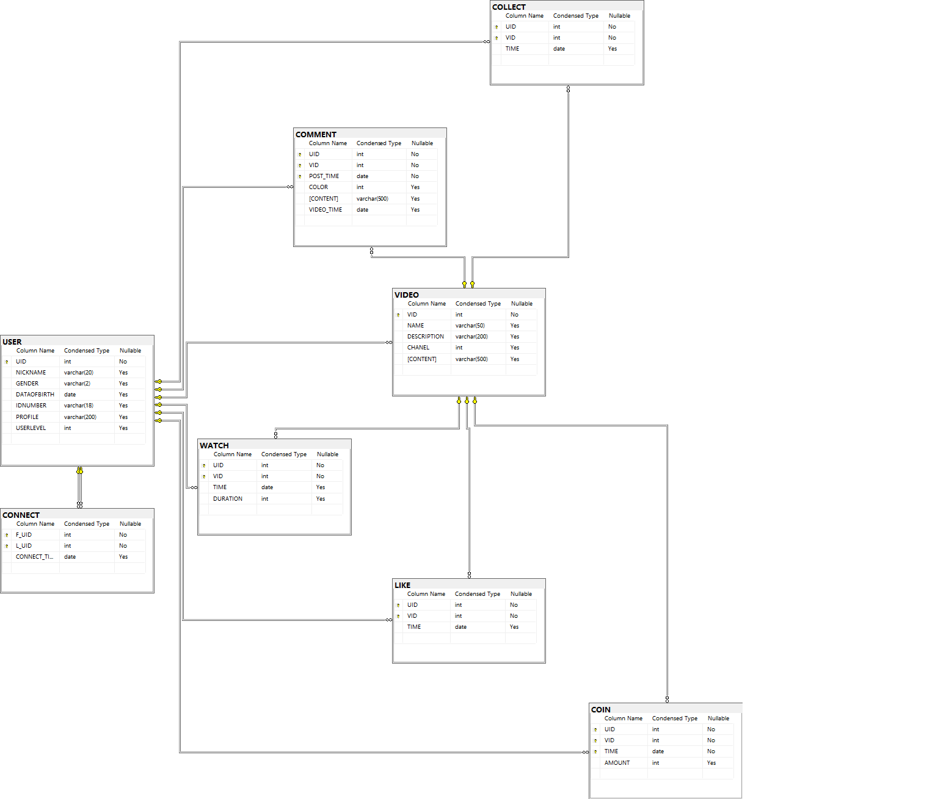
SQL为：
USE FOR_HOME_WORK;
GO

CREATE SCHEMA BILIBILI AUTHORIZATION "dbo";
GO

CREATE TABLE BILIBILI."USER"(
UID INT PRIMARY KEY,
NICKNAME VARCHAR(20),
GENDER VARCHAR(2),
DATAOFBIRTH DATE,
IDNUMBER VARCHAR(18),
PROFILE VARCHAR(200),
USERLEVEL INT
);
GO

CREATE TABLE BILIBILI."CONNECT"(
F_UID INT,
L_UID INT,
CONNECT_TIME DATE,
PRIMARY KEY (F_UID, L_UID),
FOREIGN KEY (F_UID) REFERENCES BILIBILI.[USER](UID),
FOREIGN KEY (L_UID) REFERENCES BILIBILI.[USER](UID)
);
GO

CREATE TABLE BILIBILI."VIDEO"(
VID INT PRIMARY KEY,
NAME VARCHAR(50),
DESCRIPTION VARCHAR(200),
CHANEL INT,
CONTENT VARCHAR(500),
FOREIGN KEY (CHANEL) REFERENCES BILIBILI.[USER](UID)
);
GO

CREATE TABLE BILIBILI."COIN"(
UID INT,
VID INT,
TIME DATE,
AMOUNT INT,
PRIMARY KEY (UID, VID, TIME),
FOREIGN KEY (UID) REFERENCES BILIBILI.[USER](UID),
FOREIGN KEY (VID) REFERENCES BILIBILI.VIDEO(VID)
);
GO

CREATE TABLE BILIBILI."COMMENT"(
UID INT,
VID INT,
POST_TIME DATE,
COLOR INT,
CONTENT VARCHAR(500),
VIDEO_TIME DATE,
PRIMARY KEY (UID, VID, POST_TIME),
FOREIGN KEY (UID) REFERENCES BILIBILI.[USER](UID),
FOREIGN KEY (VID) REFERENCES BILIBILI.VIDEO(VID)
);
GO

CREATE TABLE BILIBILI."LIKE"(
UID INT,
VID INT,
TIME DATE,
PRIMARY KEY (UID, VID),
FOREIGN KEY (UID) REFERENCES BILIBILI.[USER](UID),
FOREIGN KEY (VID) REFERENCES BILIBILI.VIDEO(VID)
);
GO

CREATE TABLE BILIBILI."COLLECT"(
UID INT,
VID INT,
TIME DATE,
PRIMARY KEY (UID, VID),
FOREIGN KEY (UID) REFERENCES BILIBILI.[USER](UID),
FOREIGN KEY (VID) REFERENCES BILIBILI.VIDEO(VID)
);
GO

CREATE TABLE BILIBILI."WATCH"(
UID INT,
VID INT,
TIME DATE,
DURATION INT,
PRIMARY KEY (UID, VID),
FOREIGN KEY (UID) REFERENCES BILIBILI.[USER](UID),
FOREIGN KEY (VID) REFERENCES BILIBILI.VIDEO(VID)
);
GO
- 淘宝：
模式图为：
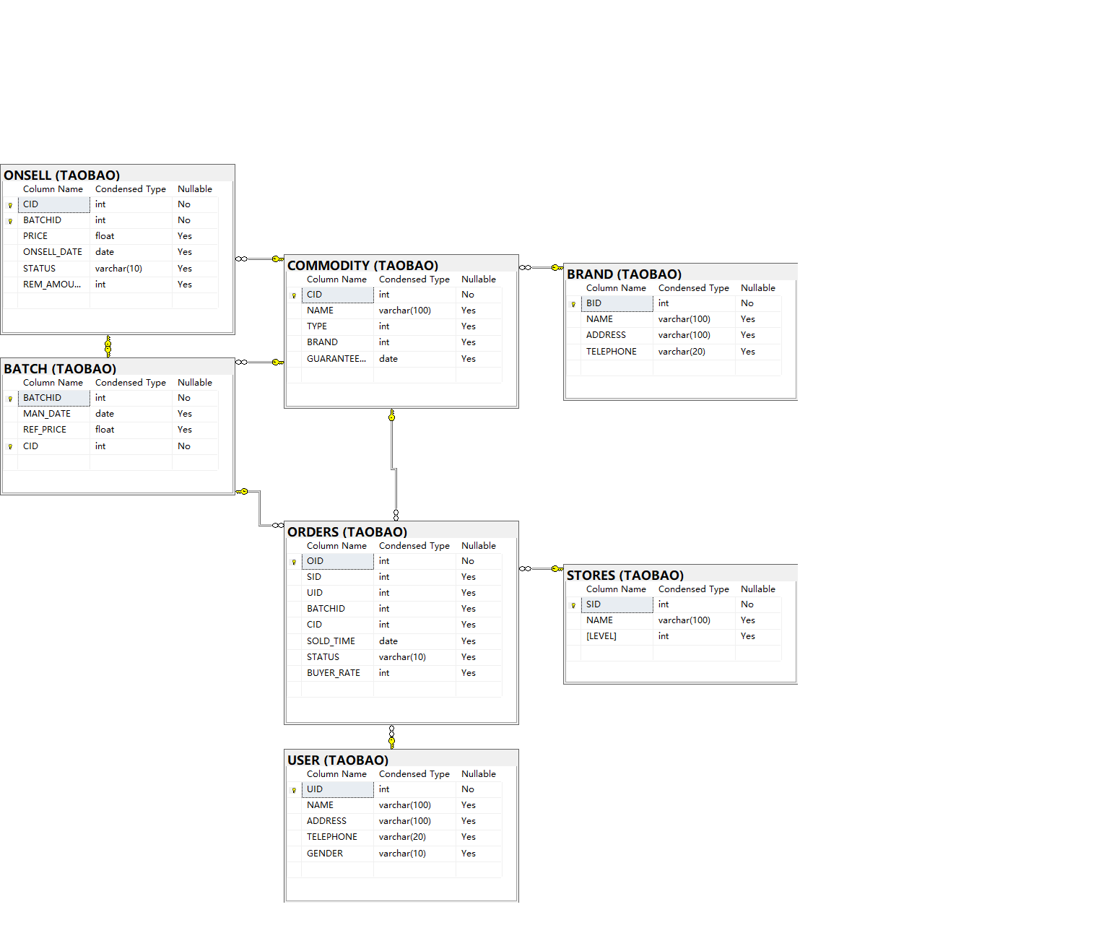
SQL为：
USE FOR_HOME_WORK;
GO

CREATE SCHEMA [TAOBAO] AUTHORIZATION DBO;
GO

CREATE TABLE TAOBAO.[BRAND] (
BID INT PRIMARY KEY,
NAME VARCHAR(100),
ADDRESS VARCHAR(100),
TELEPHONE VARCHAR(20)
);
GO

CREATE TABLE TAOBAO.[COMMODITY] (
CID INT PRIMARY KEY,
NAME VARCHAR(100),
TYPE INT,
BRAND INT,
GUARANTEE_PERIOD DATE,
FOREIGN KEY (BRAND) REFERENCES TAOBAO.BRAND(BID)
);
GO

CREATE TABLE TAOBAO.[BATCH](
BATCHID INT,
MAN_DATE DATE,
REF_PRICE FLOAT,
CID INT,
PRIMARY KEY(CID,BATCHID),
FOREIGN KEY(CID) REFERENCES TAOBAO.COMMODITY(CID)
);
GO

CREATE TABLE TAOBAO.[STORES](
SID INT PRIMARY KEY,
NAME VARCHAR(100),
LEVEL INT
);
GO

CREATE TABLE TAOBAO.[USER](
UID INT PRIMARY KEY,
NAME VARCHAR(100),
ADDRESS VARCHAR(100),
TELEPHONE VARCHAR(20),
GENDER VARCHAR(10)
);
GO

CREATE TABLE TAOBAO.[ONSELL](
CID INT,
BATCHID INT,
PRICE FLOAT,
ONSELL_DATE DATE,
STATUS VARCHAR(10),
REM_AMOUNT INT,
PRIMARY KEY(CID, BATCHID),
FOREIGN KEY(CID) REFERENCES TAOBAO.COMMODITY(CID),
FOREIGN KEY(CID,BATCHID) REFERENCES TAOBAO.BATCH(CID,BATCHID)
);
GO

CREATE TABLE TAOBAO.[ORDERS](
OID INT PRIMARY KEY,
SID INT,
UID INT,
BATCHID INT,
CID INT,
SOLD_TIME DATE,
STATUS VARCHAR(10),
BUYER_RATE INT NULL,
FOREIGN KEY(UID) REFERENCES TAOBAO.[USER](UID),
FOREIGN KEY(CID, BATCHID) REFERENCES TAOBAO.BATCH(CID, BATCHID),
FOREIGN KEY(CID) REFERENCES TAOBAO.COMMODITY(CID),
FOREIGN KEY(SID) REFERENCES TAOBAO.STORES(SID)
);
GO
- 王者荣耀联赛：
模式图为：
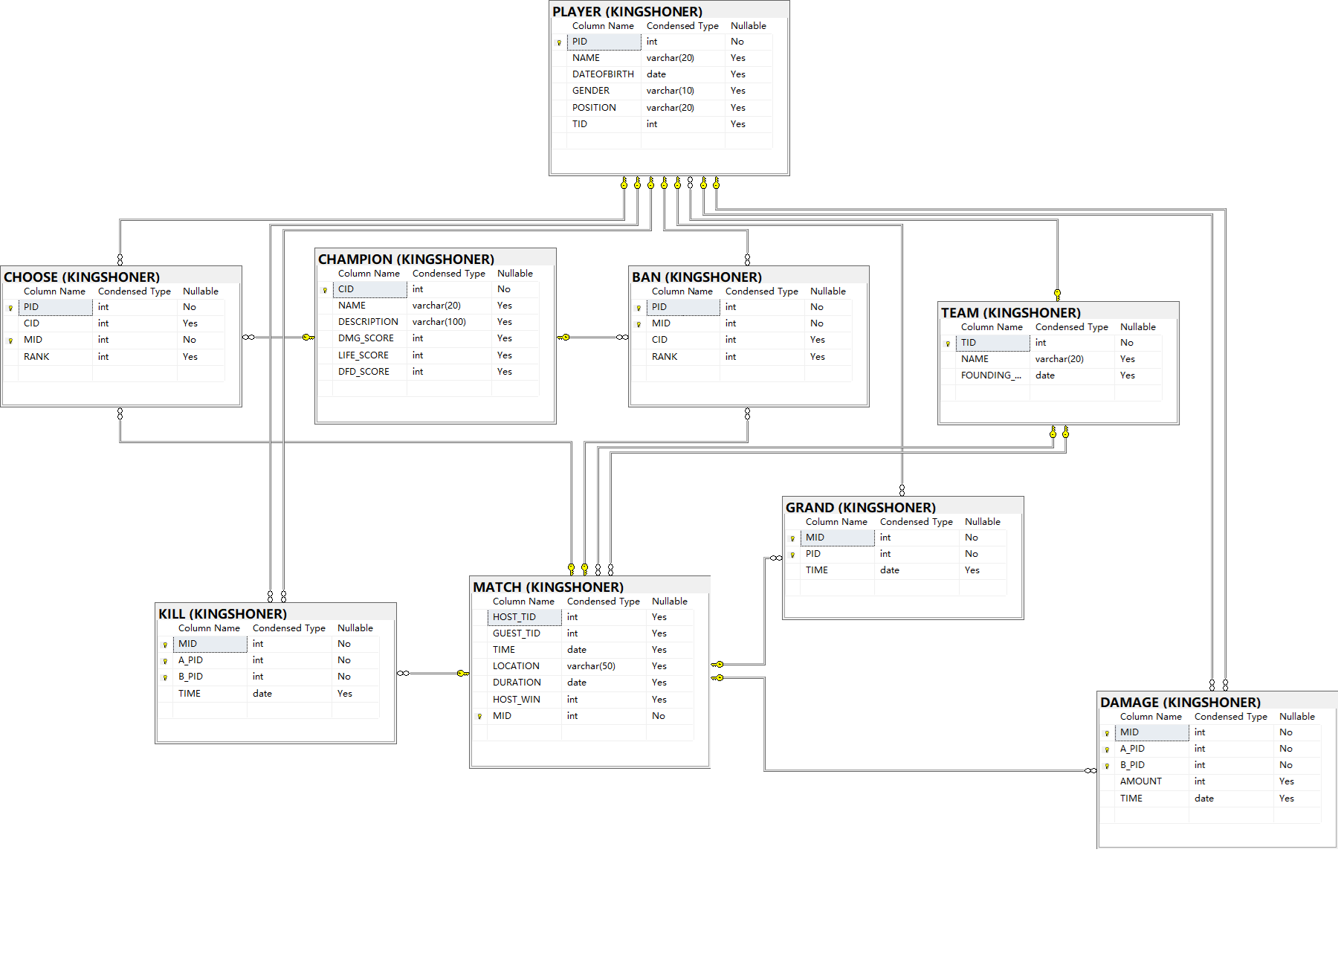
SQL为：
USE FOR_HOME_WORK;
GO

CREATE SCHEMA [KINGSHONER] AUTHORIZATION DBO;
GO

CREATE TABLE KINGSHONER.[TEAM](
TID INT PRIMARY KEY,
NAME VARCHAR(20),
FOUNDING_DATE DATE
);
GO

CREATE TABLE KINGSHONER.[PLAYER](
PID INT PRIMARY KEY,
NAME VARCHAR(20),
DATEOFBIRTH DATE,
GENDER VARCHAR(10),
POSITION VARCHAR(20),
TID INT,
FOREIGN KEY (TID) REFERENCES KINGSHONER.[TEAM](TID)
);
GO

CREATE TABLE KINGSHONER.[MATCH](
HOST_TID INT,
GUEST_TID INT,
TIME DATE,
LOCATION VARCHAR(50),
DURATION DATE,
HOST_WIN INT,
MID INT PRIMARY KEY,
FOREIGN KEY (HOST_TID) REFERENCES KINGSHONER.[TEAM](TID),
FOREIGN KEY (GUEST_TID) REFERENCES KINGSHONER.[TEAM](TID)
);
GO

CREATE TABLE KINGSHONER.[CHAMPION](
CID INT PRIMARY KEY,
NAME VARCHAR(20),
DESCRIPTION VARCHAR(100),
DMG_SCORE INT,
LIFE_SCORE INT,
DFD_SCORE INT
);
GO

CREATE TABLE KINGSHONER.[CHOOSE](
PID INT,
CID INT,
MID INT,
RANK INT,
PRIMARY KEY (PID, MID),
FOREIGN KEY (PID) REFERENCES KINGSHONER.[PLAYER](PID),
FOREIGN KEY (CID) REFERENCES KINGSHONER.[CHAMPION](CID),
FOREIGN KEY (MID) REFERENCES KINGSHONER.[MATCH](MID)
);
GO

CREATE TABLE KINGSHONER.[BAN](
PID INT,
MID INT,
CID INT,
RANK INT,
FOREIGN KEY (PID) REFERENCES KINGSHONER.[PLAYER](PID),
FOREIGN KEY (MID) REFERENCES KINGSHONER.[MATCH](MID),
FOREIGN KEY (CID) REFERENCES KINGSHONER.[CHAMPION](CID),
PRIMARY KEY (PID, MID)
);
GO

CREATE TABLE KINGSHONER.[DAMAGE](
MID INT,
A_PID INT,
B_PID INT,
AMOUNT INT,
TIME DATE FOREIGN KEY (MID) REFERENCES KINGSHONER.[MATCH](MID),
FOREIGN KEY (A_PID) REFERENCES KINGSHONER.[PLAYER](PID),
FOREIGN KEY (B_PID) REFERENCES KINGSHONER.[PLAYER](PID),
PRIMARY KEY (MID, A_PID, B_PID)
);
GO

CREATE TABLE KINGSHONER.[KILL](
MID INT,
A_PID INT,
B_PID INT,
TIME DATE,
FOREIGN KEY (MID) REFERENCES KINGSHONER.[MATCH](MID),
FOREIGN KEY (A_PID) REFERENCES KINGSHONER.[PLAYER](PID),
FOREIGN KEY (B_PID) REFERENCES KINGSHONER.[PLAYER](PID),
PRIMARY KEY (MID, A_PID, B_PID)
);
GO

CREATE TABLE KINGSHONER.[GRAND](
MID INT,
PID INT,
TIME DATE,
FOREIGN KEY (MID) REFERENCES KINGSHONER.[MATCH](MID),
FOREIGN KEY (PID) REFERENCES KINGSHONER.[PLAYER](PID),
PRIMARY KEY (MID, PID)
);
GO
- 微信：
模式图为：
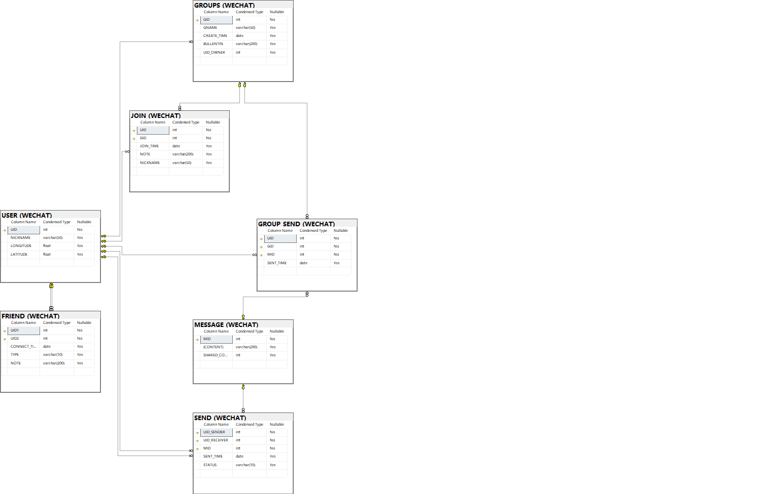
SQL为：
USE FOR_HOME_WORK;
GO

CREATE SCHEMA [WECHAT] AUTHORIZATION DBO;
GO

CREATE TABLE WECHAT.[USER](
UID INT PRIMARY KEY,
NICKNAME VARCHAR(50),
LONGITUDE FLOAT,
LATITUDE FLOAT
);
GO

CREATE TABLE WECHAT.[FRIEND](
UID1 INT,
UID2 INT,
CONNECT_TIME DATE,
TYPE VARCHAR(10),
NOTE VARCHAR(200),
PRIMARY KEY(UID1, UID2),
FOREIGN KEY(UID1) REFERENCES WECHAT.[USER](UID),
FOREIGN KEY(UID2) REFERENCES WECHAT.[USER](UID)
);
GO

CREATE TABLE WECHAT.[MESSAGE](
MID INT PRIMARY KEY,
CONTENT VARCHAR(200),
SHARED_COUNT INT DEFAULT 1,
);
GO

CREATE TABLE WECHAT.[SEND](
UID_SENDER INT,
UID_RECEIVER INT,
MID INT,
SENT_TIME DATE,
STATUS VARCHAR(10),
PRIMARY KEY(UID_SENDER, UID_RECEIVER, MID),
FOREIGN KEY(UID_SENDER) REFERENCES WECHAT.[USER](UID),
FOREIGN KEY(UID_RECEIVER) REFERENCES WECHAT.[USER](UID),
FOREIGN KEY(MID) REFERENCES WECHAT.[MESSAGE](MID)
);
GO

create trigger trg_UpdateSharedCount
on Wechat.[send]
AFTER INSERT
AS
BEGIN
UPDATE Wechat.[message]
SET SHARED_COUNT = SHARED_COUNT + 1
WHERE MID IN (SELECT MID FROM inserted)
END;
GO

CREATE TABLE WECHAT.[GROUPS](
GID INT PRIMARY KEY,
GNAME VARCHAR(50),
CREATE_TIME DATE,
BULLENTIN VARCHAR(200),
UID_OWNER INT,
FOREIGN KEY(UID_OWNER) REFERENCES WECHAT.[USER](UID)
);
GO

CREATE TABLE WECHAT.[JOIN](
UID INT,
GID INT,
JOIN_TIME DATE,
NOTE VARCHAR(200),
NICKNAME VARCHAR(50),
PRIMARY KEY(UID, GID),
FOREIGN KEY(UID) REFERENCES WECHAT.[USER](UID),
FOREIGN KEY(GID) REFERENCES WECHAT.[GROUPS](GID)
);
GO

CREATE TABLE WECHAT.[GROUP_SEND](
UID INT,
GID INT,
MID INT,
SENT_TIME DATE,
PRIMARY KEY(UID, GID, MID),
FOREIGN KEY(UID) REFERENCES WECHAT.[USER](UID),
FOREIGN KEY(GID) REFERENCES WECHAT.[GROUPS](GID),
FOREIGN KEY(MID) REFERENCES WECHAT.[MESSAGE](MID)
);
GO

CREATE TRIGGER TRG_UpdateGroupMessageCount
ON WECHAT.[GROUP_SEND]
AFTER INSERT
AS
BEGIN
UPDATE WECHAT.[GROUPS]
SET SHARED_COUNT = SHARED_COUNT + 1
WHERE MID IN (SELECT MID FROM inserted)
END;

CREATE TABLE WECHAT.[MOMENT](
MOID INT PRIMARY KEY,
UID INT,
CONTENT VARCHAR(200),
POST_TIME DATE,
TYPE VARCHAR(10),
FOREIGN KEY(UID) REFERENCES WECHAT.[USER](UID)
);
GO

