计算机科学与技术学院 数据库系统 课程实验报告

实验题目：综合实验2 |  | 学号：202300130183
日期：2024/12/10 | 班级：23级人工智能 | 姓名：宋浩宇
Email：2367651943@qq.com
实验软件和硬件环境：
实验软件：
系统：Windows 11 家庭中文版23H2 22631.4317
编辑器：Visual Studio Code
数据库：SQL Server 2022
数据库管理工具：Microsoft SQL Server Management Studio 18
硬件环境：
CPU：13th Gen Intel(R) Core(TM) i9-13980HX 2.20 GHz
内存：32.0 GB (31.6 GB 可用)
磁盘驱动器：NVMe WD_BLACKSN850X2000GB
实验步骤：
第一题
a)
SQL:
SELECT
*
FROM
VIDEO
WHERE
VID = 35;
结果：
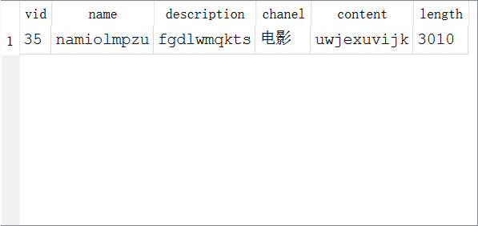
b)
SQL:
SELECT
[USER].*
FROM [USER]
JOIN POST ON [USER].UID = POST.UID
JOIN VIDEO ON POST.VID = VIDEO.VID
WHERE VIDEO.VID = 35;
结果：
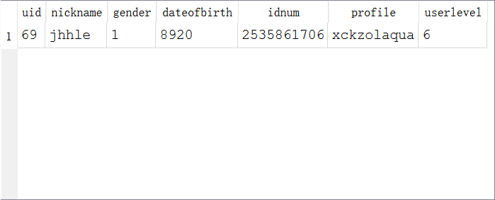
c)
SQL:
SELECT
COUNT(*) AS "Number of Watching Videos"
FROM
WATCH
WHERE
WATCH.VID = 35;
结果：

d)
SQL:
SELECT
COUNT(*) AS "Number of Liked Videos"
FROM
[LIKE]
WHERE
[LIKE].VID = 35;
结果：

e)
SQL:
SELECT
COUNT(*) AS "Number of Collect on Videos"
FROM
[COLLECT]
WHERE
[COLLECT].VID = 35;
结果：

f)
SQL:
SELECT
COALESCE(SUM(COIN.AMOUNT),0) AS "Number of Coins the Videos"
FROM
COIN
WHERE
COIN.VID = 35;
结果：

g)
SQL:
SELECT
*
FROM
[COMMENT]
WHERE
[COMMENT].VID = 35
ORDER BY VIDEO_TIME;
结果：
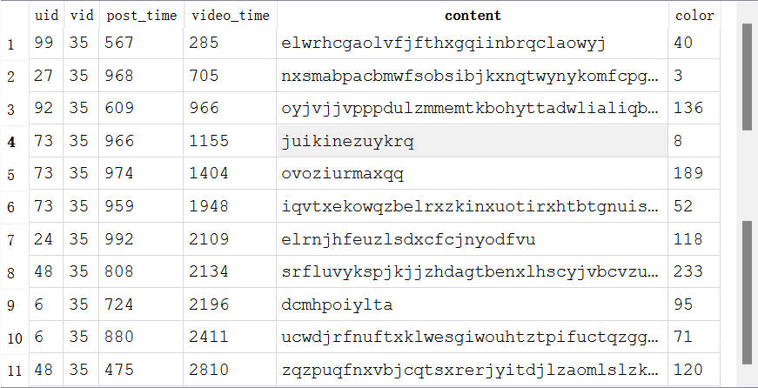
第二题：
SQL:
SELECT
*
FROM
(
SELECT
[NICKNAME],
COUNT(*) AS NUM
FROM
[USER]
JOIN POST
ON [USER].UID = POST.UID
GROUP BY
[USER].UID
)
ORDER BY
NUM DESC LIMIT 5;
结果：
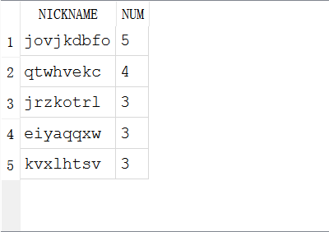
第三题：
SQL:
SELECT
NICKNAME,
PROFILE,
[USERLEVEL],
NUM
FROM
(
SELECT
UID_FOLLOWED,
COUNT(*) AS NUM
FROM
FOLLOW
GROUP BY
UID_FOLLOWED
),
[USER]
WHERE
UID_FOLLOWED = USER.UID
ORDER BY
NUM DESC LIMIT 10;
结果：
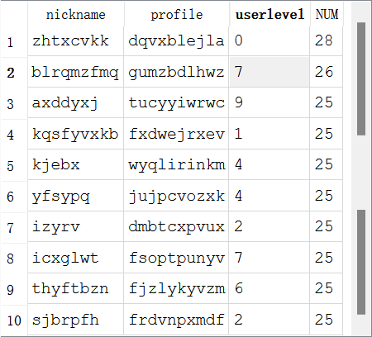
第四题：
SQL:
SELECT
VIDEO.[NAME],
VIDEO.CONTENT,
T.NUM
FROM
VIDEO,
(
SELECT
VID,
COUNT(*) AS NUM
FROM
WATCH
GROUP BY
VID
) AS T
WHERE
VIDEO.VID = T.VID
ORDER BY
T.NUM DESC LIMIT 10;
结果：
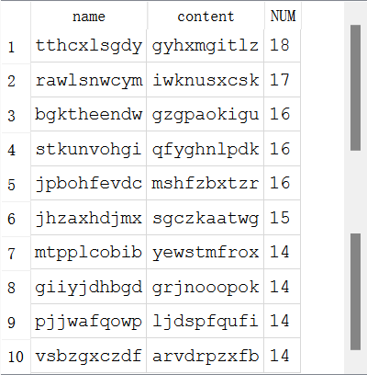
第五题：
SQL:
SELECT
VIDEO.CHANEL,
COUNT(*) AS [SUM]
FROM
VIDEO
JOIN WATCH
ON VIDEO.VID = WATCH.VID
GROUP BY
VIDEO.CHANEL;
结果：
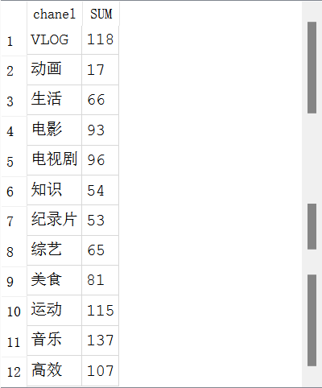
第六题：
SQL:
SELECT
VIDEO.[NAME],
VIDEO.CONTENT,
T.NUM
FROM
VIDEO,
(
SELECT
VID,
COUNT(*) AS NUM
FROM
WATCH
GROUP BY
VID
) AS T
WHERE
VIDEO.VID = T.VID
AND VIDEO.CHANEL = "美食"
ORDER BY
T.NUM DESC LIMIT 5;
结果：
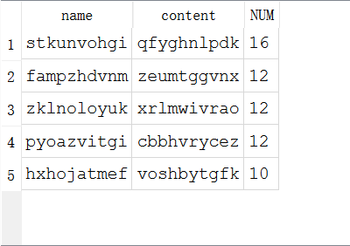
第七题：
SQL:
SELECT
VIDEO.CHANEL,
COUNT(*) AS SUM
FROM
VIDEO
JOIN WATCH
ON WATCH.VID = VIDEO.VID
JOIN [USER]
ON [USER].UID = WATCH.UID
WHERE
[USER].UID = 15
GROUP BY
CHANEL
ORDER BY
SUM DESC LIMIT 5;
结果：
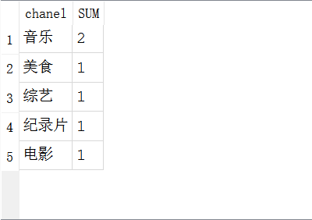
第八题：
SQL:
SELECT
VIDEO.NAME,
VIDEO.DESCRIPTION
FROM
VIDEO
JOIN WATCH
ON VIDEO.VID = WATCH.VID
WHERE
WATCH.UID = 15
AND WATCH.TIME > 900;
结果：
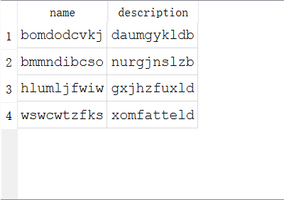
第九题：
SQL:
SELECT
[USER].NICKNAME,
[USER].PROFILE,
[USER].USERLEVEL
FROM
FOLLOW
JOIN [USER]
ON [USER].UID = FOLLOW.UID_FOLLOWER
WHERE
UID_FOLLOWED = 15;
结果：
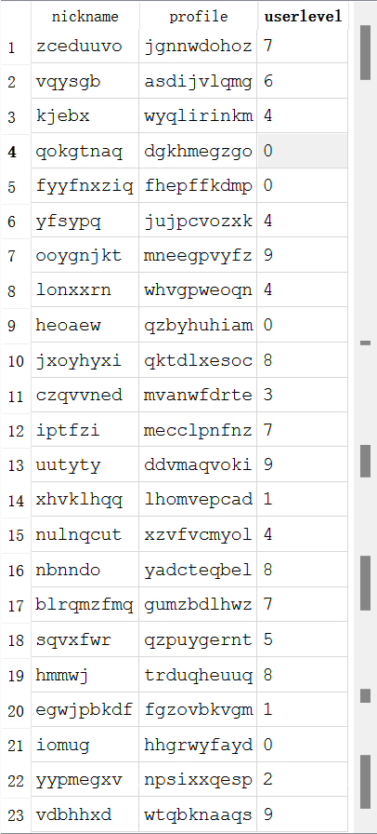
第十题：
SQL:
SELECT
VIDEO.NAME,
VIDEO.DESCRIPTION,
POST.POST_TIME
FROM
VIDEO
JOIN POST
ON POST.VID = VIDEO.VID
JOIN FOLLOW
ON FOLLOW.UID_FOLLOWED = POST.UID
WHERE
FOLLOW.UID_FOLLOWER = 15
ORDER BY
POST.POST_TIME DESC;
结果：
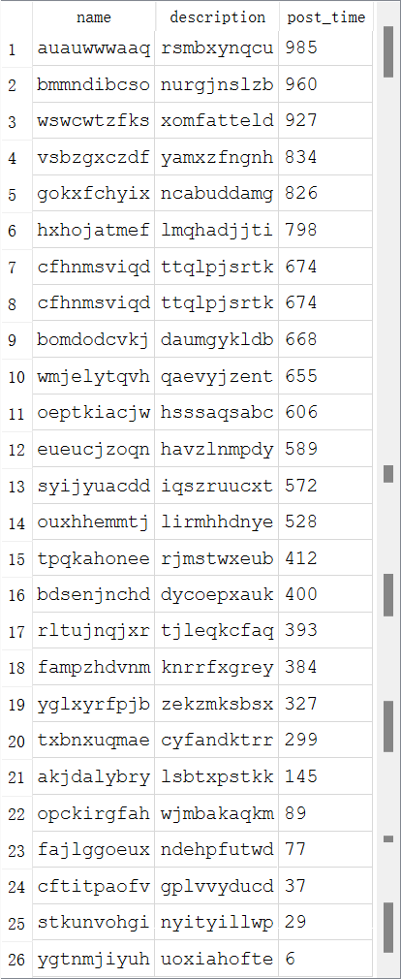
第十一题：
SQL:
SELECT
NICKNAME,
PROFILE,
USERLEVEL
FROM
[USER]
WHERE
(USER.UID, 15) IN (
SELECT
UID_FOLLOWER,
UID_FOLLOWED
FROM
FOLLOW
)
AND (15, USER.UID) IN (
SELECT
UID_FOLLOWER,
UID_FOLLOWED
FROM
FOLLOW
);
结果：
