计算机科学与技术学院 数据库系统 课程实验报告

实验题目：综合实验3 |  | 学号：202300130183
日期：2024/12/13 | 班级：23级人工智能 | 姓名：宋浩宇
Email：2367651943@qq.com
实验软件和硬件环境：
实验软件：
系统：Windows 11 家庭中文版23H2 22631.4317
编辑器：Visual Studio Code
数据库：SQL Server 2022
数据库管理工具：Microsoft SQL Server Management Studio 18
硬件环境：
CPU：13th Gen Intel(R) Core(TM) i9-13980HX 2.20 GHz
内存：32.0 GB (31.6 GB 可用)
磁盘驱动器：NVMe WD_BLACKSN850X2000GB
实验步骤：
第一题：
SQL：
SELECT
COMMODITY.NAME,
ONSELL.STATUS,
ONSELL.REM_AMOUNT,
CNT,
AV
FROM
ONSELL,
(
SELECT
COUNT(*) AS CNT,
AVG(BUYERRATE) AS AV
FROM
ORDERS
WHERE
SID = 251
AND CID = 669
)
JOIN COMMODITY
ON ONSELL.CID = COMMODITY.CID
WHERE
ONSELL.SID = 251
AND ONSELL.CID = 669;
结果：
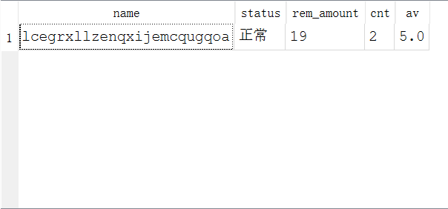
第二题：
SQL：
SELECT
STORES.NAME,
SUM(ONSELL.PRICE) AS MONEY
FROM
ORDERS,
COMMODITY
JOIN ONSELL
ON ORDERS.SID = ONSELL.SID
AND ONSELL.CID = ORDERS.CID
JOIN BRAND
ON COMMODITY.BID = BRAND.BID
JOIN STORES
ON ORDERS.SID = STORES.SID
WHERE
COMMODITY.CID = ORDERS.CID
AND BRAND.NAME = "蒂芙尼"
GROUP BY
ORDERS.SID
ORDER BY
SUM(ONSELL.PRICE) DESC LIMIT 5;
结果：
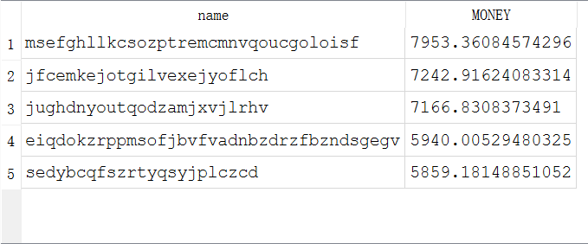
第三题：
SQL：
SELECT
COMMODITY.NAME,
ONSELL.PRICE,
COUNT(*) AS CNT
FROM
STORES,
ONSELL
JOIN ORDERS
ON STORES.SID = ORDERS.SID
AND ONSELL.CID = ORDERS.CID
JOIN COMMODITY
ON ONSELL.CID = COMMODITY.CID
WHERE
STORES.SID = 1
AND ONSELL.SID = STORES.SID
GROUP BY
ONSELL.CID
ORDER BY
COUNT(*) DESC LIMIT 10;
结果：
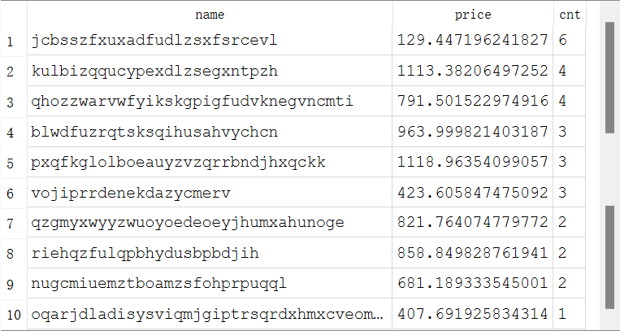
第四题：
SQL：
SELECT
COMMODITY.NAME,
SUM(ONSELL.PRICE) AS SM,
AVG(ORDERS.BUYERRATE) AS AV
FROM
BRAND,
ONSELL
JOIN COMMODITY
ON BRAND.BID = COMMODITY.BID
AND COMMODITY.CID = ONSELL.CID
JOIN ORDERS
ON ORDERS.CID = COMMODITY.CID
WHERE
BRAND.BID = 1
AND ORDERS.STATUS = "已完成"
GROUP BY
ORDERS.CID;
结果：
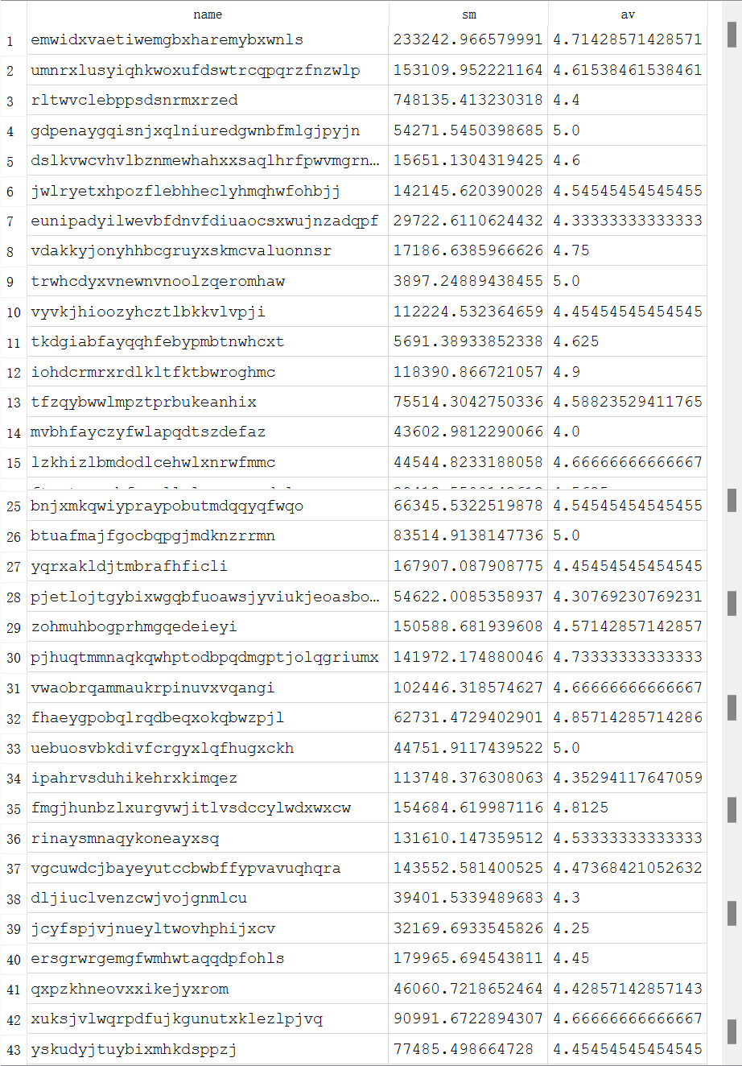
第五题：
SQL：
SELECT
STORES.NAME,
STORES.LEVEL,
SUM(ONSELL.PRICE) AS SM,
CNT,
AVG(ORDERS.BUYERRATE) AS AV
FROM
STORES,
(
SELECT
COUNT(*) AS CNT
FROM
ONSELL
WHERE
ONSELL.SID = 1
)
JOIN ONSELL
ON STORES.SID = ONSELL.SID
JOIN ORDERS
ON ONSELL.CID = ORDERS.CID
AND STORES.SID = ORDERS.SID
WHERE
STORES.SID = 1;
结果：
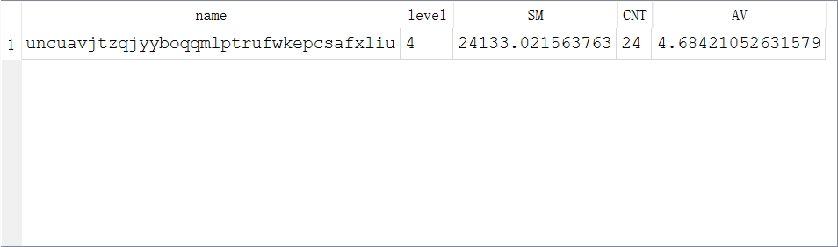
第六题：
SQL：
SELECT
COMMODITY.NAME AS CNAME,
BRAND.NAME AS BNAME,
STORES.NAME AS SNAME,
ONSELL.ONSELL_DATE,
ONSELL.REM_AMOUNT,
ONSELL.PRICE,
AVG(ORDERS.BUYERRATE) AS AV
FROM
COMMODITY,
ONSELL
JOIN ORDERS
ON COMMODITY.CID = ORDERS.CID
AND ONSELL.SID = ORDERS.SID
JOIN BRAND
ON COMMODITY.BID = BRAND.BID
JOIN STORES
ON STORES.SID = ONSELL.SID
WHERE
ONSELL.STATUS = "正常"
AND COMMODITY.TYPE = "女装"
GROUP BY
COMMODITY.NAME,
STORES.NAME
ORDER BY
AVG(ORDERS.BUYERRATE) DESC LIMIT 10;
结果：
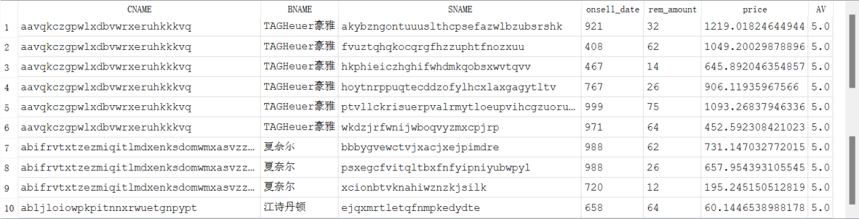
第七题：
SQL：
WITH RANKED AS (
SELECT
C.TYPE,
C.NAME,
COUNT(ORDERS.OID) AS CNT,
ROW_NUMBER() OVER (PARTITION BY C.TYPE ORDER BY COUNT(ORDERS.OID) DESC) AS RANK
FROM
ORDERS
JOIN COMMODITY C
ON ORDERS.CID = C.CID
WHERE
ORDERS.UID = 1
GROUP BY
C.TYPE,
C.NAME
)
SELECT
TYPE,
NAME,
CNT
FROM
RANKED
WHERE
RANK = 1;
结果：
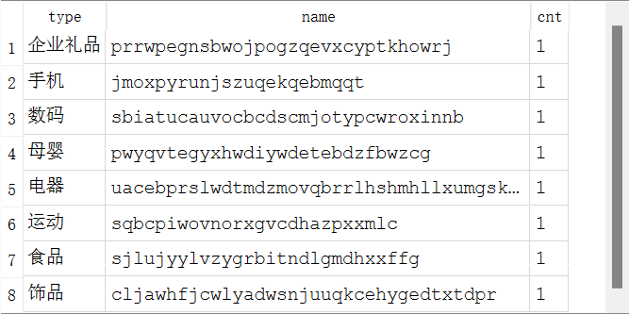
第八题：
SQL：
UPDATE ONSELL
SET
STATUS = "下架"
WHERE
STATUS = "正常"
AND EXISTS (
SELECT
1
FROM
COMMODITY
WHERE
ONSELL.CID = COMMODITY.CID
AND (COMMODITY.MAN_DATE + COMMODITY.GUARANTEE_PERIOD) < 1000
);
结果：
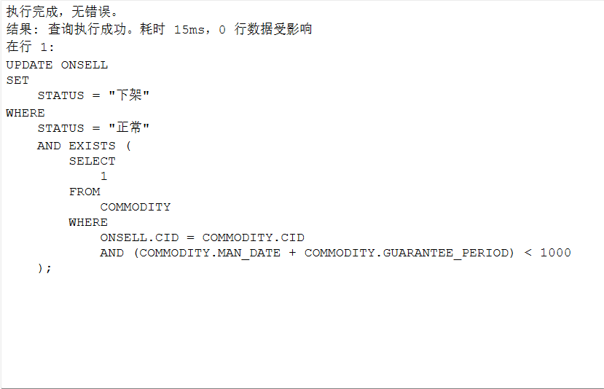
第九题（此为题目原本数据）：
a)
SQL：
-- a
INSERT INTO ORDERS(
UID,
SID,
CID,
SOLD_TIME,
STATUS
) VALUES(
1,
1,
1,
1000,
'待付款'
);
结果：
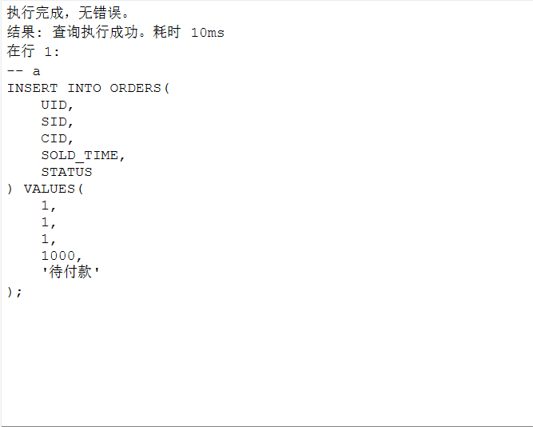
b)
SQL：
-- b
UPDATE ONSELL
SET
REM_AMOUNT = REM_AMOUNT - 1
WHERE
SID = 1
AND CID = 1;
结果：
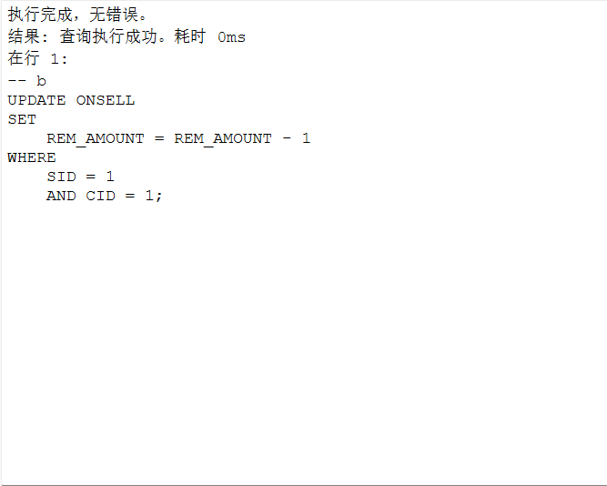
c)
SQL：
-- c
UPDATE ONSELL
SET
STATUS = "缺货"
WHERE
SID = 1
AND CID = 1
AND REM_AMOUNT = 0;
结果：
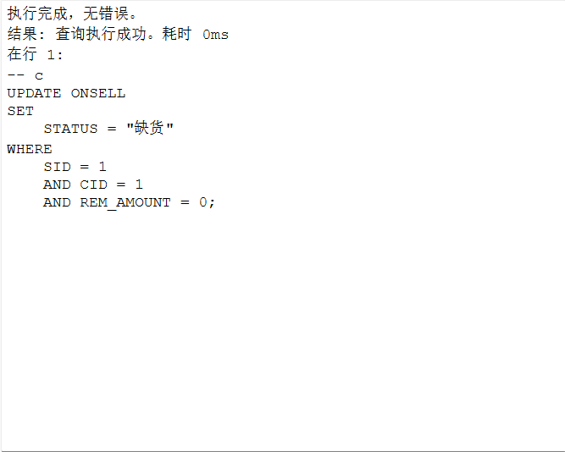
第九题（此为改后数据）：
a)
SQL：
INSERT INTO ORDERS(
UID,
SID,
CID,
SOLD_TIME,
STATUS
) VALUES(
1,
10,
3298,
1000,
'待付款'
);
结果：
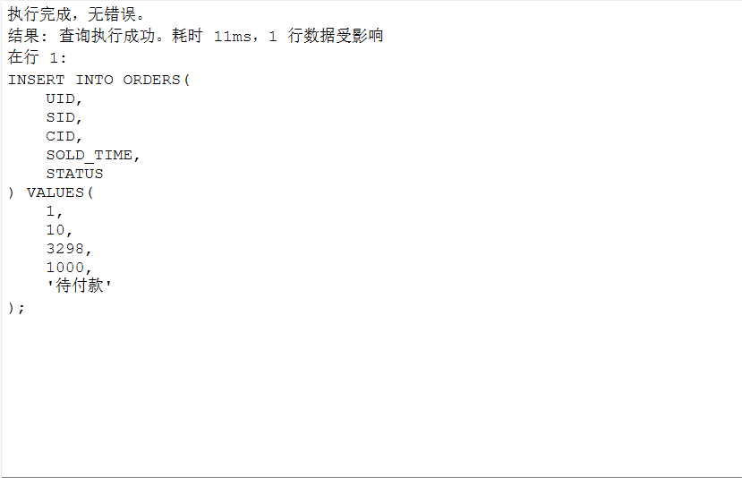
b)
SQL：
UPDATE ONSELL
SET
REM_AMOUNT = REM_AMOUNT - 1
WHERE
SID = 10
AND CID = 3298;
结果：
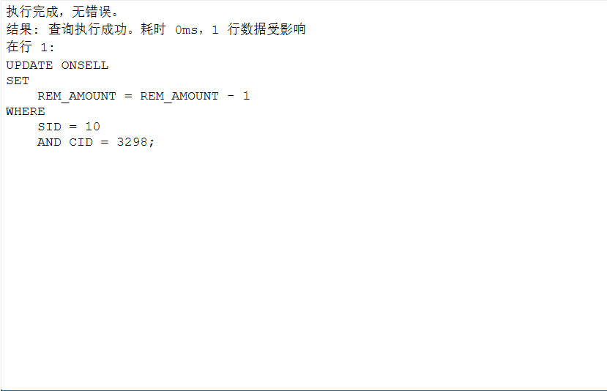
c)
SQL：
UPDATE ONSELL
SET
STATUS = "缺货"
WHERE
SID = 10
AND CID = 3298
AND REM_AMOUNT = 0;
结果：
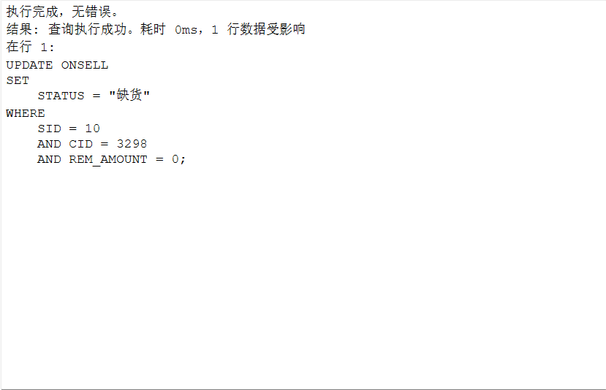
d)
SQL：
UPDATE ORDERS
SET
STATUS = '已完成',
BUYERRATE = 5
WHERE
STATUS != '已完成'
AND (SOLD_TIME + 100) < 1000;
结果：
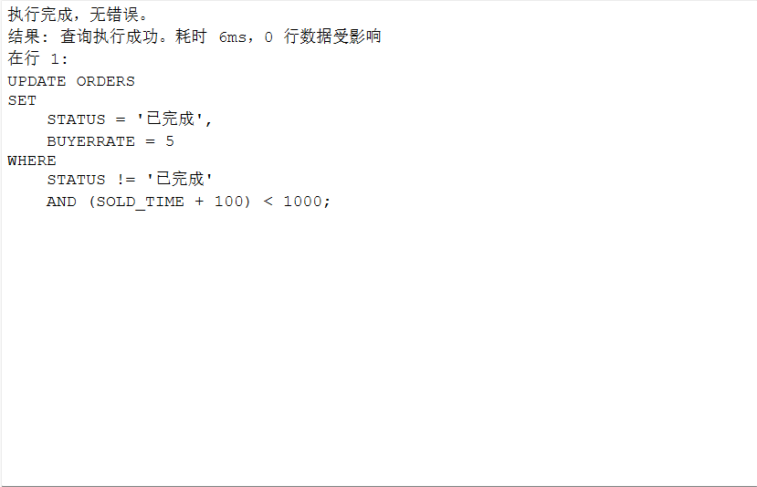
第十题：
删除顺序为：
DELETE FROM ONSELL,
DELETE FROM ORDERS,
DELETE FROM BRAND,
DELETE FROM STORES,
DELETE FROM USER,
DELETE FROM COMMODITY;

