计算机科学与技术学院 数据库系统 课程实验报告

实验题目：综合实验4 |  | 学号：202300130183
日期：2024/12/17 | 班级：23级人工智能 | 姓名：宋浩宇
Email：2367651943@qq.com
实验软件和硬件环境：
实验软件：
系统：Windows 11 家庭中文版23H2 22631.4317
编辑器：Visual Studio Code
数据库：SQL Server 2022
数据库管理工具：Microsoft SQL Server Management Studio 18
硬件环境：
CPU：13th Gen Intel(R) Core(TM) i9-13980HX 2.20 GHz
内存：32.0 GB (31.6 GB 可用)
磁盘驱动器：NVMe WD_BLACKSN850X2000GB
实验步骤：
第一题：
SQL：
CREATE VIEW USER1_FRIEND AS
SELECT
FRIEND.UID2 AS UID,
USER.NICKNAME,
FRIEND.NOTE,
FRIEND.TYPE
FROM
USER
JOIN FRIEND
ON USER.UID = FRIEND.UID2
WHERE
(USER.UID, 1) IN (
SELECT
UID1,
UID2
FROM
FRIEND
)
AND (1, USER.UID) IN (
SELECT
UID1,
UID2
FROM
FRIEND
)
AND FRIEND.UID1 = 1;
结果：
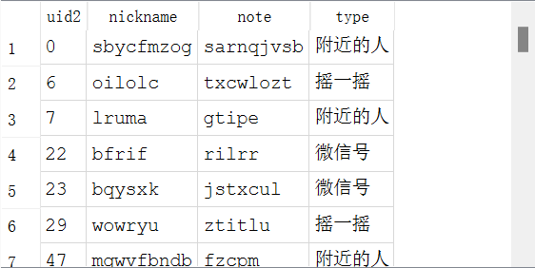
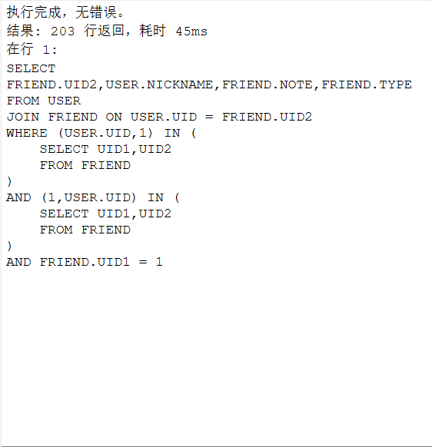
第二题：
SQL：
SELECT
USER1_FRIEND.NICKNAME,
MOMENT.CONTENT,
MOMENT.POST_TIME
FROM
USER1_FRIEND
JOIN MOMENT
ON MOMENT.UID = USER1_FRIEND.UID
WHERE
MOMENT.TYPE = "公开"
OR MOMENT.TYPE = "仅好友可见"
ORDER BY
MOMENT.POST_TIME DESC;
结果：
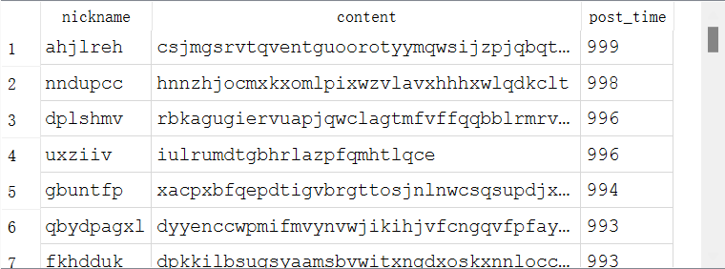
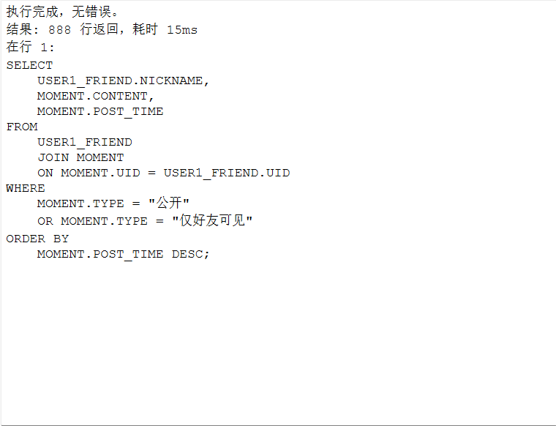
第三题：
SQL：
SELECT
GROUPS.GNAME,
MESSAGE.CONTENT,
GROUP_SEND.SENT_TIME
FROM
GROUP_SEND
JOIN MESSAGE
ON GROUP_SEND.MID = MESSAGE.MID
JOIN GROUPS
ON GROUPS.GID = GROUP_SEND.GID
WHERE
(1, GROUPS.GID) IN (
SELECT
UID,
GID
FROM
JOINGROUP
WHERE
UID = 1
)
ORDER BY
GROUPS.GNAME,
GROUP_SEND.SENT_TIME DESC;
结果：
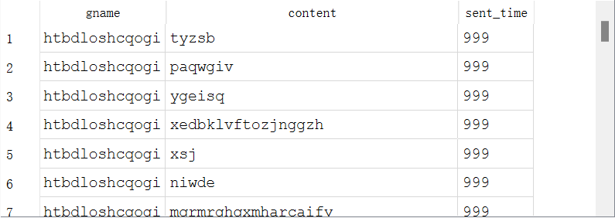
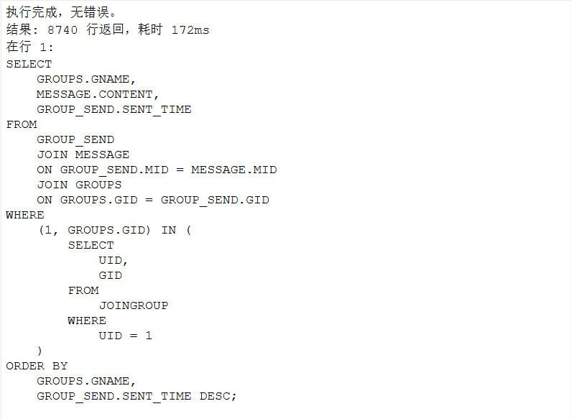
第四题：
SQL：
SELECT
USER.NICKNAME,
MESSAGE.CONTENT,
SEND.SENT_TIME
FROM
SEND
JOIN MESSAGE
ON SEND.MID = MESSAGE.MID
JOIN USER
ON SEND.UID_SENDER = USER.UID
WHERE
SEND.UID_RECEIVER = 1
AND STATUS = "待发送"
ORDER BY
USER.NICKNAME,
SEND.SENT_TIME DESC;
结果：
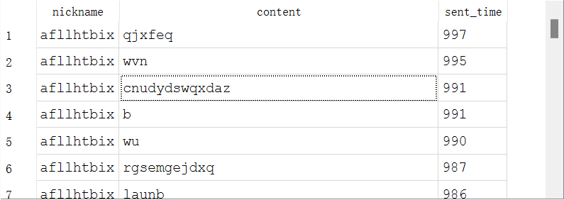
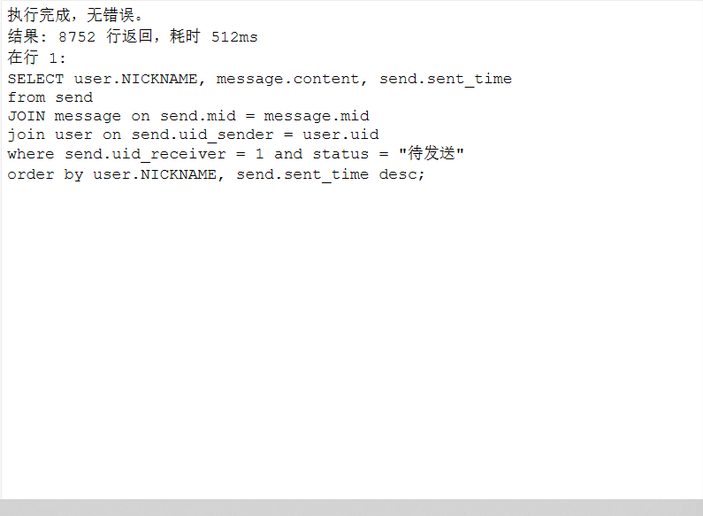
第五题：
SQL：
SELECT
MESSAGE.CONTENT,
USER.NICKNAME
FROM
MESSAGE
JOIN SEND
ON SEND.MID = MESSAGE.MID
JOIN USER
ON SEND.UID_SENDER = USER.UID
WHERE
MESSAGE.CONTENT LIKE "%晚安%"
AND( (SEND.UID_SENDER = 1
AND SEND.UID_RECEIVER = 6)
OR (SEND.UID_SENDER = 6
AND SEND.UID_RECEIVER = 1) )
AND SEND.STATUS = "已发送";
结果：
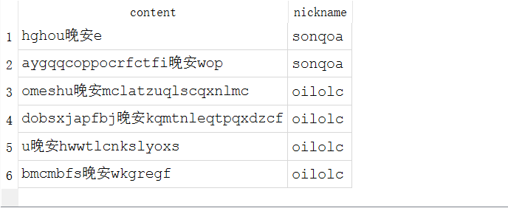
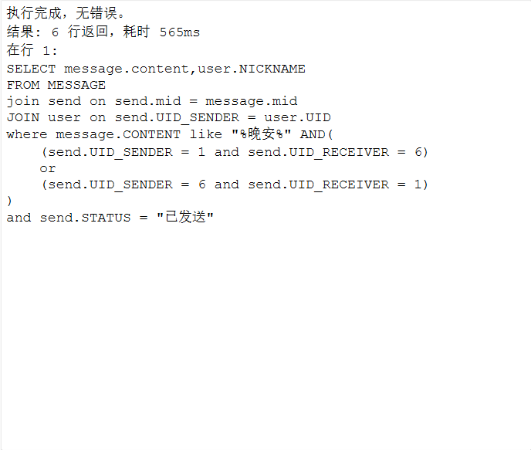
第六题：
SQL：
CREATE INDEX IDX_SEND_RECEIVER_STATUS ON SEND (UID_RECEIVER, STATUS);
结果：
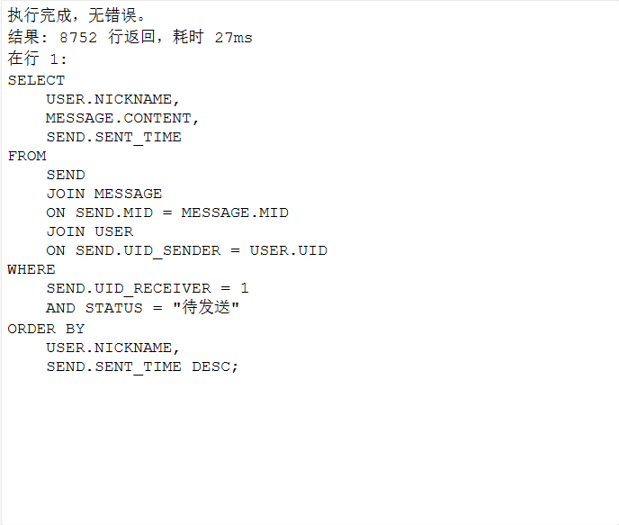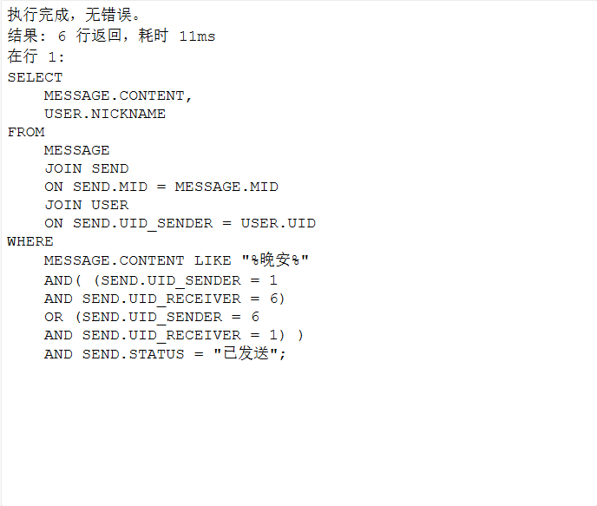
原因解释：我尝试了多种索引，原本的思路是找到这两个sql的共有的查询的部分，用那一部分的索引来同时加速两个查询，但实际上这么做对于两个sql的加速效果都不明显，但是使用这个索引，着重加速第二个查询，效果就非常显著了，因为本身第一个查询用的时间也并不长，把第二个查询最大限度加速，整体上省的时间就最多了。
第七题：
SQL：
SELECT
COUNT(*) AS CNT
FROM
GROUPS
JOIN JOINGROUP
ON GROUPS.GID = JOINGROUP.GID
WHERE
GROUPS.GID = '1'
AND JOINGROUP.UID IN (
SELECT
UID
FROM
USER1_FRIEND
);
结果：
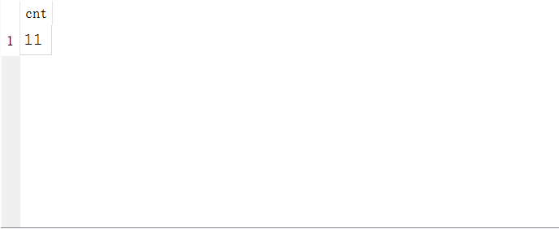
第八题：
SQL：
SELECT
USER.NICKNAME,
(USER.LONGITUDE - 309)*(USER.LONGITUDE-309) + (USER.LATITUDE-470)*(USER.LATITUDE-470) AS DISTANCE
FROM
USER
WHERE
(USER.LONGITUDE - 309)*(USER.LONGITUDE-309) + (USER.LATITUDE-470)*(USER.LATITUDE-470) < 100
AND USER.UID NOT IN (
SELECT
UID1
FROM
FRIEND
WHERE
UID2 = 1
UNION
SELECT
UID2
FROM
FRIEND
WHERE
UID1 = 1
);
结果：
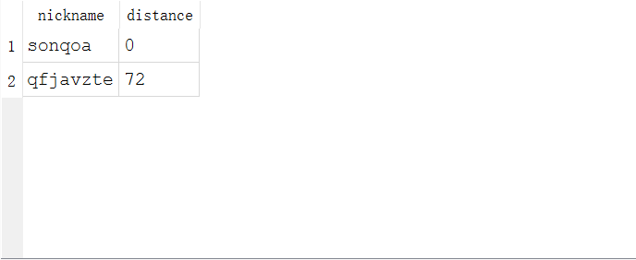
第九题：
a)
SQL：
UPDATE MESSAGE
SET
SHARED_COUNT = SHARED_COUNT - 1
WHERE
MID IN (
SELECT
MID
FROM
SEND
WHERE
uid_sender=0
AND uid_receiver = 1
UNION
SELECT
MID
FROM
SEND
WHERE
uid_sender=1
AND uid_receiver = 0
);
结果：
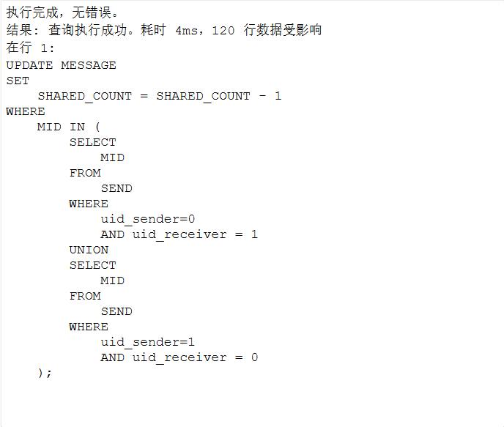
b)
SQL：
DELETE FROM MESSAGE
WHERE
SHARED_COUNT = 0;
结果：
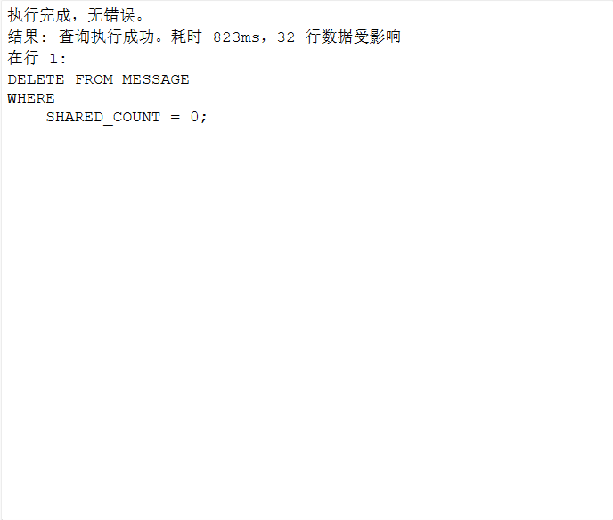
c)
SQL：
DELETE FROM SEND
WHERE
(uid_sender = 0
AND uid_receiver = 1)
OR (uid_sender = 1
AND uid_receiver = 0);
结果：
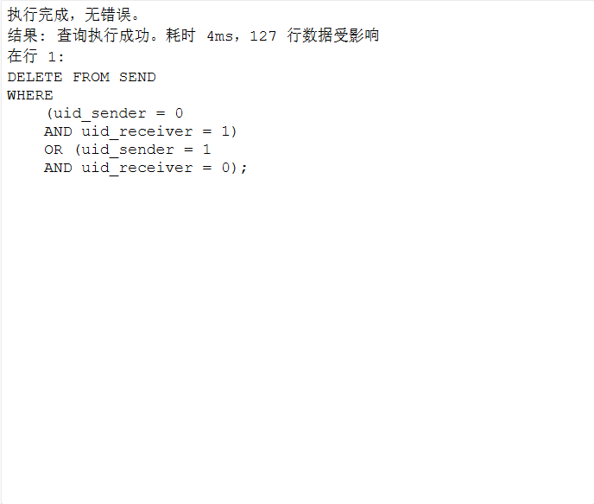
d)
SQL：
DELETE FROM FRIEND
WHERE
(UID1 = 0
AND UID2 = 1)
OR (UID1 = 1
AND UID2 = 0);
结果：
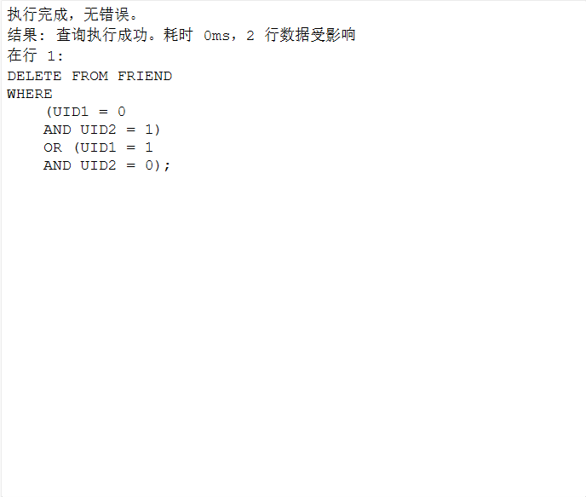
附加说明：由于表自带的外键约束，我们实际的删除过程是删除好友记录->删除消息发送记录->删除信息

