计算机科学与技术学院 数据库系统 课程实验报告

实验题目：综合实验5 |  | 学号：202300130183
日期：2024/12/20 | 班级：23级人工智能 | 姓名：宋浩宇
Email：2367651943@qq.com
实验软件和硬件环境：
实验软件：
系统：Windows 11 家庭中文版23H2 22631.4317
编辑器：Visual Studio Code
数据库：SQL Server 2022
数据库管理工具：Microsoft SQL Server Management Studio 18
硬件环境：
CPU：13th Gen Intel(R) Core(TM) i9-13980HX 2.20 GHz
内存：32.0 GB (31.6 GB 可用)
磁盘驱动器：NVMe WD_BLACKSN850X2000GB
实验步骤：
第一题：
SQL：
SELECT
HOST_TID,
CNT1 + CNT2 AS CNT
FROM
(
SELECT
HOST_TID,
COUNT(*) AS CNT1
FROM
MATCH
WHERE
HOST_WIN = "是"
GROUP BY
HOST_TID
),
(
SELECT
GUEST_TID,
COUNT(*) AS CNT2
FROM
MATCH
WHERE
HOST_WIN = "否"
GROUP BY
GUEST_TID
)
WHERE
HOST_TID = GUEST_TID;
结果：
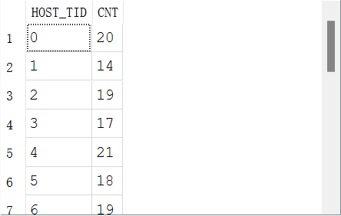
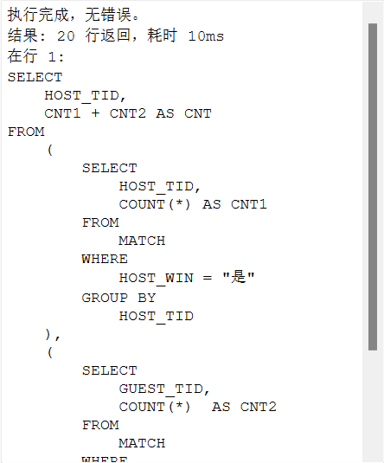
第二题：
SQL：
SELECT
PICK.CID,
PICK.MID,
MATCH.TIME
FROM
PICK
JOIN MATCH
ON PICK.MID = MATCH.MID
WHERE
CID = 1
ORDER BY
MATCH.TIME DESC LIMIT 1;
结果：
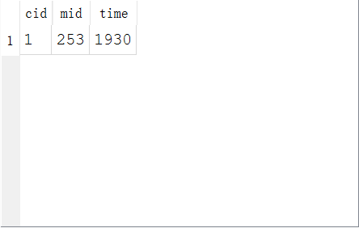
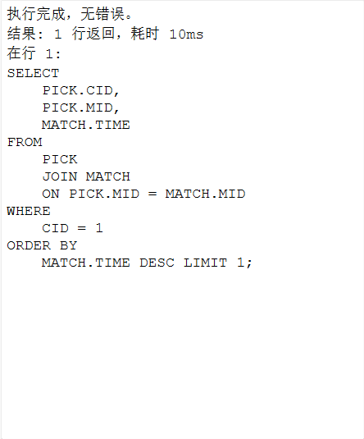
第三题：
SQL：
SELECT
*
FROM
CHAMPION
WHERE
CID NOT IN(
SELECT
DISTINCT CID
FROM
PICK
);
结果：
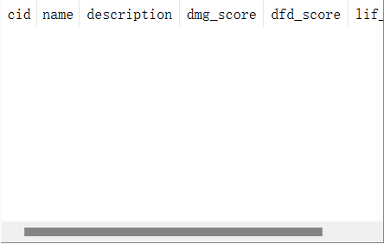
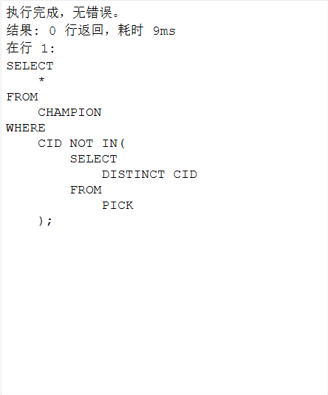
没有没被选择过的英雄
第四题：
SQL：
SELECT
NAME
FROM
(
SELECT
CHAMPION.NAME,
COUNT(
CASE RANK
WHEN 1 THEN
1
ELSE
NULL
END) AS TIMES
FROM
PICK
JOIN CHAMPION
ON PICK.CID = CHAMPION.CID
GROUP BY
PICK.CID
ORDER BY
COUNT(
CASE RANK
WHEN 1 THEN
1
ELSE
NULL
END) DESC LIMIT 1
);
结果：
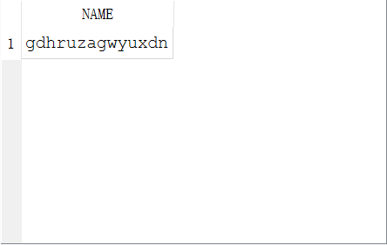
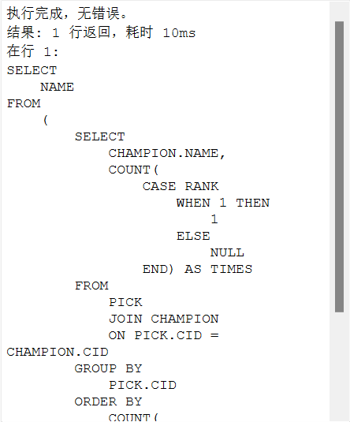
第五题：
SQL：
SELECT
PLAYER.NAME,
COUNT(*) AS CNT
FROM
KILL
JOIN PLAYER
ON KILL.PID_KILLER = PLAYER.PID
GROUP BY
PID_KILLER
ORDER BY
COUNT(*) DESC LIMIT 1;
结果：
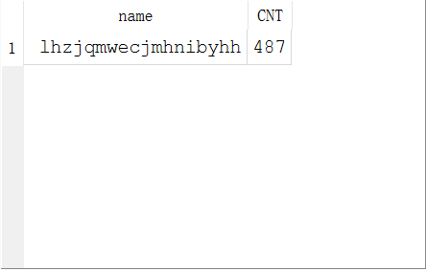
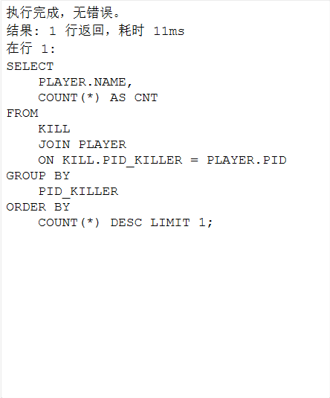
第六题：
SQL：
SELECT
TEAM.NAME,
COUNT(*) AS CNT
FROM
KILL
JOIN PLAYER
ON PLAYER.PID = KILL.PID_KILLER
JOIN TEAM
ON PLAYER.TID = TEAM.TID
GROUP BY
PLAYER.TID
ORDER BY
COUNT(*) DESC LIMIT 5;
结果：
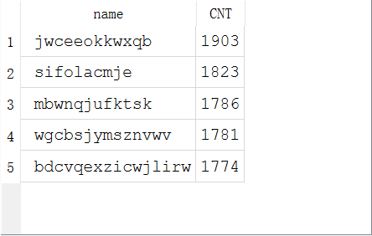
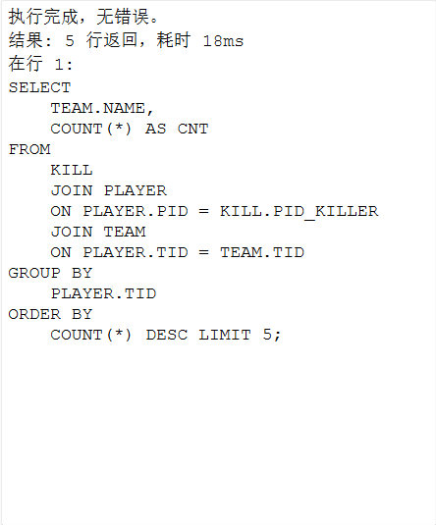
第七题：
SQL：
SELECT
ID1 AS TID,
(SUM_TIME1 + SUM_TIME2)/(CNT1+CNT2) AS AVG_TIME
FROM
(
SELECT
HOST_TID AS ID1,
COUNT(*) AS CNT1,
SUM(
CASE
WHEN DURATION IS NOT NULL THEN
DURATION
ELSE
0
END) AS SUM_TIME1
FROM
MATCH
GROUP BY
HOST_TID
),
(
SELECT
GUEST_TID AS ID2,
COUNT(*) AS CNT2,
SUM(
CASE
WHEN DURATION IS NOT NULL THEN
DURATION
ELSE
0
END) AS SUM_TIME2
FROM
MATCH
GROUP BY
GUEST_TID
)
WHERE
ID1 = ID2;
结果：
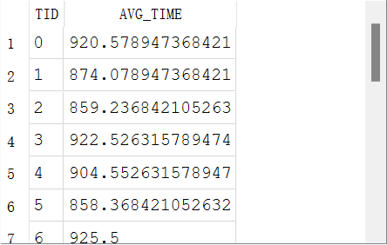
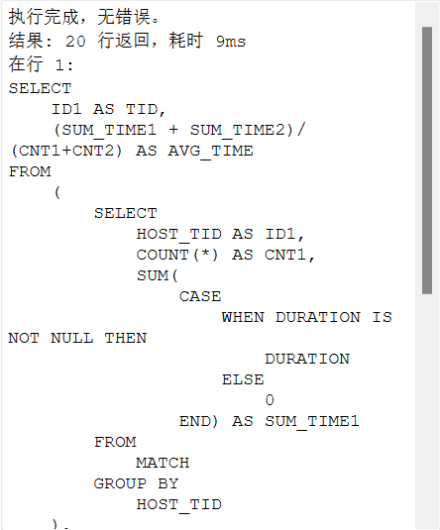
第八题：
SQL：
SELECT
PLAYER.NAME,
SUM(AMOUNT) AS SUM_DAMAGE
FROM
DAMAGE
JOIN PLAYER
ON PLAYER.PID = DAMAGE.PID_HITTER
GROUP BY
PID_HITTER
ORDER BY
SUM(AMOUNT) DESC LIMIT 1;
结果：
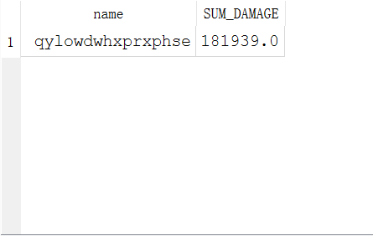
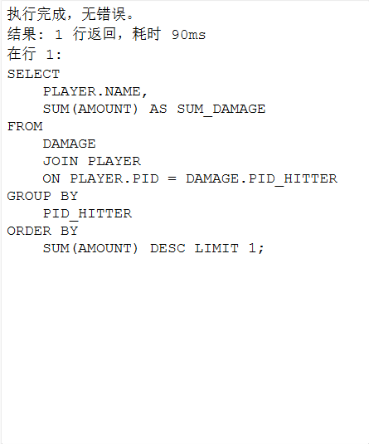
第九题：
SQL：
SELECT
PLAYER.NAME,
COUNT(DISTINCT CID) AS CNT
FROM
PICK
JOIN PLAYER
ON PLAYER.PID = PICK.PID
GROUP BY
PICK.PID
ORDER BY
COUNT(DISTINCT CID) DESC LIMIT 1;
结果：
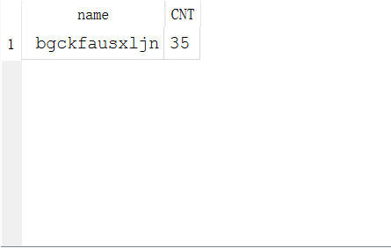
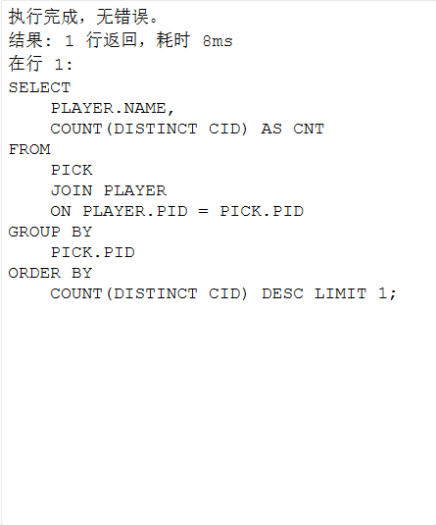
第十题
SQL：
SELECT
CHAMPION.NAME,
BP_CNT
FROM
(
SELECT
CID1,
PICK_CNT+BAN_CNT AS BP_CNT
FROM
(
SELECT
CID AS CID1,
COUNT(*) AS PICK_CNT
FROM
PICK
GROUP BY
CID
),
(
SELECT
CID AS CID2,
COUNT(*) AS BAN_CNT
FROM
BAN
GROUP BY
CID
)
WHERE
CID1 = CID2
ORDER BY
PICK_CNT+BAN_CNT DESC LIMIT 1
),
CHAMPION
WHERE
CHAMPION.CID = CID1;
结果：
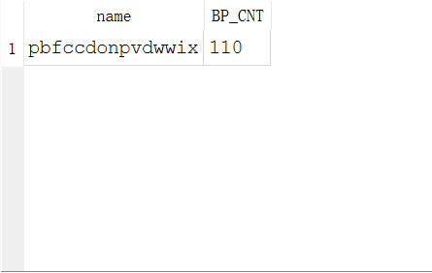
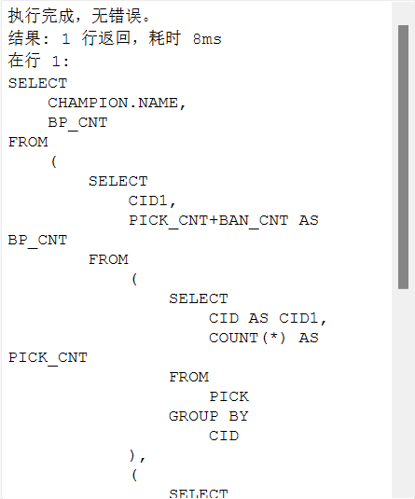
第十一题
SQL：
SELECT
MATCH.TIME,
MATCH.LOCATION,
PLAYER.NAME,
RATIO
FROM
(
SELECT
SUM_DAMAGE.MID,
SUM_DAMAGE.PID_HITTER AS PID,
SUM_DAMAGE.SUM_DAMAGE/SUM_MONEY.SUM_MONEY AS RATIO
FROM
(
SELECT
MID,
PID_HITTER,
SUM(AMOUNT) AS SUM_DAMAGE
FROM
DAMAGE
GROUP BY
MID,
PID_HITTER
) AS SUM_DAMAGE,
(
SELECT
MID,
PID,
SUM(AMOUNT) AS SUM_MONEY
FROM
GOLD
GROUP BY
MID,
PID
) AS SUM_MONEY
WHERE
SUM_DAMAGE.MID=SUM_MONEY.MID
AND SUM_DAMAGE.PID_HITTER=SUM_MONEY.PID
ORDER BY
SUM_DAMAGE.SUM_DAMAGE/SUM_MONEY.SUM_MONEY DESC LIMIT 1
) AS BEST_HITTER
JOIN MATCH
ON BEST_HITTER.MID=MATCH.MID
JOIN PLAYER
ON BEST_HITTER.PID=PLAYER.PID;
结果：
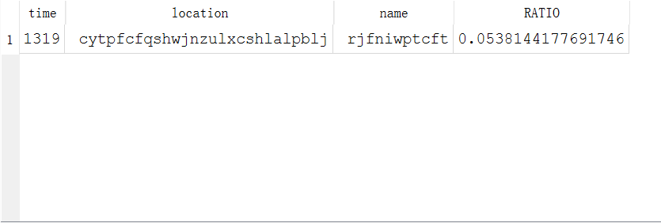
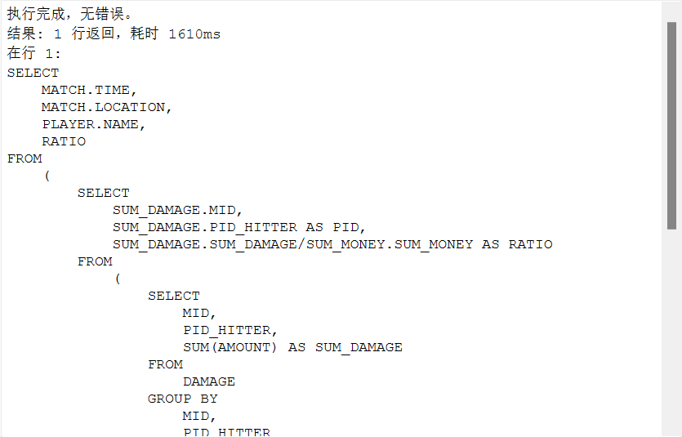
第十二题
SQL：
SELECT
PLAYER.NAME,
RATIO
FROM
(
SELECT
PLAYER_DAMAGE.PID,
PLAYER_DAMAGE.TID,
PLAYER_DAMAGE.SUM_DAMAGE/TEAM_DAMAGE.TOTAL_DAMAGE AS RATIO
FROM
(
SELECT
PLAYER.TID,
SUM(SUM_DAMAGE) AS TOTAL_DAMAGE
FROM
(
SELECT
PID_HITTER,
SUM(AMOUNT) AS SUM_DAMAGE
FROM
DAMAGE
GROUP BY
PID_HITTER
) AS DAMAGE_TABLE
JOIN PLAYER
ON DAMAGE_TABLE.PID_HITTER = PLAYER.PID
GROUP BY
PLAYER.TID
) AS TEAM_DAMAGE,
(
SELECT
PLAYER.TID,
PLAYER.PID,
SUM_DAMAGE
FROM
(
SELECT
PID_HITTER,
SUM(AMOUNT) AS SUM_DAMAGE
FROM
DAMAGE
GROUP BY
PID_HITTER
)
JOIN PLAYER
ON PLAYER.PID = PID_HITTER
) AS PLAYER_DAMAGE
WHERE
PLAYER_DAMAGE.TID = TEAM_DAMAGE.TID
ORDER BY
PLAYER_DAMAGE.SUM_DAMAGE/TEAM_DAMAGE.TOTAL_DAMAGE DESC LIMIT 1
) AS BEST_PLAYER
JOIN PLAYER
ON BEST_PLAYER.PID = PLAYER.PID;
结果：
