山东大学 计算机科学与技术 学院
机器学习与模式识别 课程实验报告

学号：202300130183 | 姓名： 宋浩宇 |  | 班级：23级人工智能班
实验题目：Linear Discriminant Analysis
实验学时：2 |  | 实验日期：2025/3/11
实验环境：
软件环境：
系统：Windows 11 家庭中文版23H2 22631.4317
计算软件：MATLAB 版本: 9.8.0.1323502 (R2020a)
Java 版本: Java 1.8.0_202-b08 with Oracle Corporation Java HotSpot(TM) 64-Bit Server VM mixed mode

硬件环境：
CPU：13th Gen Intel(R) Core(TM) i9-13980HX 2.20 GHz
内存：32.0 GB (31.6 GB 可用)
磁盘驱动器：NVMe WD_BLACKSN850X2000GB
显示适配器：NVIDIA GeForce RTX 4080 Laptop GPU
- 实验内容
In this exercise, you need to implement Linear Discriminant Analysis(LDA)
- 实验步骤
- 获取实验使用的数据。
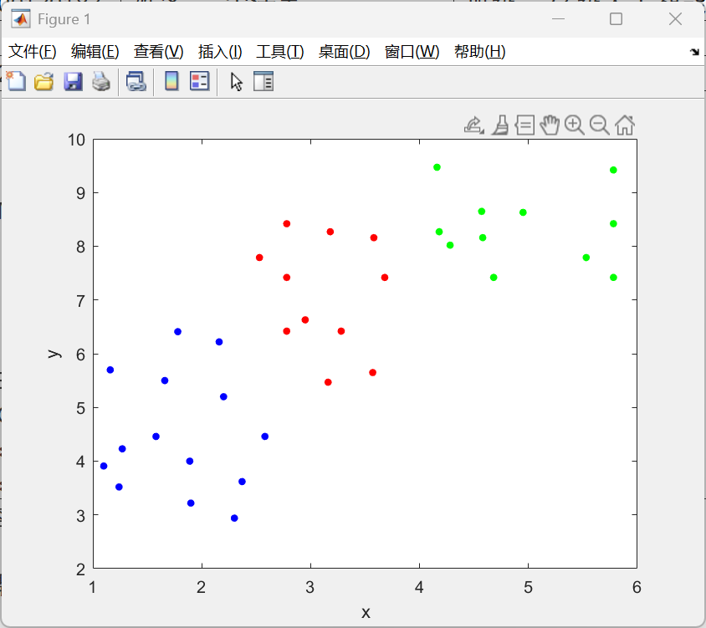
- 构造二分类LDA模型：
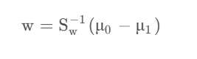
- 用matlab代码实现并进行计算。
- 完成结果的可视化。
- 构造多分类的LDA模型：

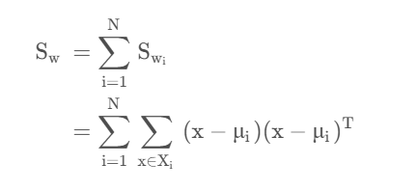
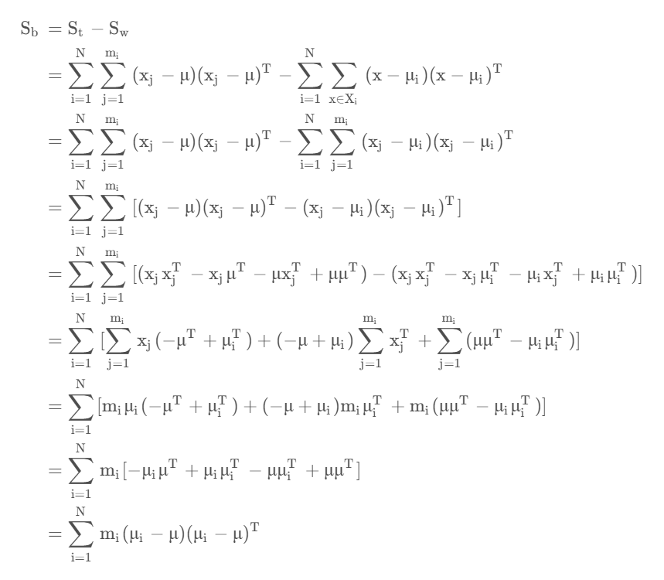
- 用matlab代码实现并进行计算。
- 完成结果的可视化。
- 测试结果
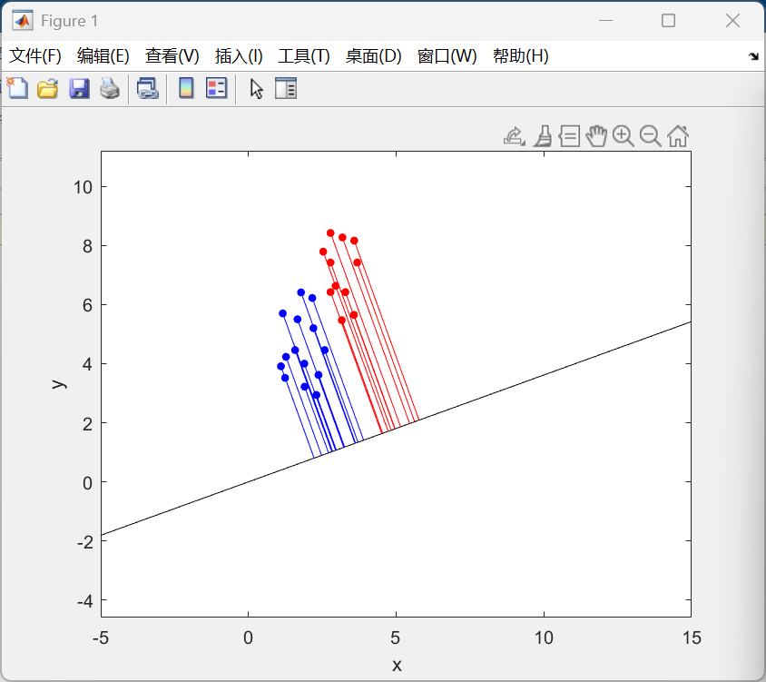
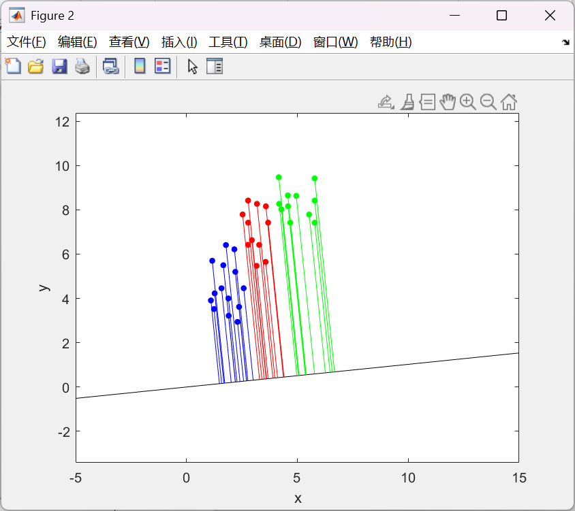
- 附录：实现源代码
%% 清空环境变量
clear;
clc;

%% 加载数据
redPoints = load('ex3Data/ex3red.dat'); % 红色点
bluePoints = load('ex3Data/ex3blue.dat'); % 蓝色点
greenPoints = load('ex3Data/ex3green.dat');% 绿色点
%% 绘制数据点
figure;
plot(redPoints(:, 1), redPoints(:, 2), 'r.', 'MarkerSize', 15);
axis equal;
hold on;
plot(bluePoints(:, 1), bluePoints(:, 2), 'b.', 'MarkerSize', 15);
% plot(greenPoints(:, 1), greenPoints(:, 2), 'g.', 'MarkerSize', 15);
xlabel('x');
ylabel('y');
%% 二分类LDA
% disp(redPoints);

mu0 = mean(redPoints);
mu1 = mean(bluePoints);
sum0 = cov(redPoints - mu0);
sum1 = cov(bluePoints - mu1);
sum_w = sum0+sum1;
w = inv(sum_w)*(mu0-mu1)';
% disp(w);
x = linspace(-5,15);
y = x * (w(2)/w(1));
plot(x,y,'k-');
for i = 1:size(redPoints, 1)
m = w(2) / w(1);
b = 0;
x0 = redPoints(i, 1);
y0 = redPoints(i, 2);
x1 = (m * (y0 - b) + x0) / (m^2 + 1);
y2 = (m^2 * y0 + m * x0 + b) / (m^2 + 1);
plot([x0 x1], [y0 y2], 'r-');
end
for i = 1:size(bluePoints, 1)
m = w(2) / w(1);
b = 0;
x0 = bluePoints(i, 1);
y0 = bluePoints(i, 2);
x1 = (m * (y0 - b) + x0) / (m^2 + 1);
y2 = (m^2 * y0 + m * x0 + b) / (m^2 + 1);
plot([x0 x1], [y0 y2], 'b-');
end
%% 多分类LDA
figure;
plot(redPoints(:, 1), redPoints(:, 2), 'r.', 'MarkerSize', 15);
axis equal;
hold on;
plot(bluePoints(:, 1), bluePoints(:, 2), 'b.', 'MarkerSize', 15);
plot(greenPoints(:, 1), greenPoints(:, 2), 'g.', 'MarkerSize', 15);
xlabel('x');
ylabel('y');
mu = mean([bluePoints;redPoints;greenPoints]);
disp(mu);
sb = size(bluePoints, 1) * cov(mean(bluePoints) - mu) + size(greenPoints, 1) * cov(mean(greenPoints) - mu) + size(redPoints, 1) * cov(mean(redPoints) - mu);
sw = cov(bluePoints - mean(bluePoints)) + cov(greenPoints - mean(greenPoints)) + cov(redPoints - mean(redPoints));
S = inv(sw) * sb;

[eigvecs, eigvals] = eig(S);
disp(eigvecs);
disp(eigvals);
max_eigval = max(diag(eigvals));
[~, idx] = max(diag(eigvals));
max_eigvec = eigvecs(:, idx);
disp(max_eigval);
disp(max_eigvec);
unit_max_eigvec = max_eigvec / norm(max_eigvec);
x = linspace(-5,15);
y = x * (unit_max_eigvec(2)/unit_max_eigvec(1));
plot(x,y,'k-');
for i = 1:size(redPoints, 1)
m = unit_max_eigvec(2) / unit_max_eigvec(1);
b = 0;
x0 = redPoints(i, 1);
y0 = redPoints(i, 2);
x1 = (m * (y0 - b) + x0) / (m^2 + 1);
y2 = (m^2 * y0 + m * x0 + b) / (m^2 + 1);
plot([x0 x1], [y0 y2], 'r-');
end
for i = 1:size(bluePoints, 1)
m = unit_max_eigvec(2) / unit_max_eigvec(1);
b = 0;
x0 = bluePoints(i, 1);
y0 = bluePoints(i, 2);
x1 = (m * (y0 - b) + x0) / (m^2 + 1);
y2 = (m^2 * y0 + m * x0 + b) / (m^2 + 1);
plot([x0 x1], [y0 y2], 'b-');
end
for i = 1:size(greenPoints, 1)
m = unit_max_eigvec(2) / unit_max_eigvec(1);
b = 0;
x0 = greenPoints(i, 1);
y0 = greenPoints(i, 2);
x1 = (m * (y0 - b) + x0) / (m^2 + 1);
y2 = (m^2 * y0 + m * x0 + b) / (m^2 + 1);
plot([x0 x1], [y0 y2], 'g-');
end

