山东大学 计算机科学与技术 学院
新兴网络技术与实践 课程实验报告

学号：202300130183 | 姓名：宋浩宇 |  | 班级：23级智能班
实验题目：Wireshark DNS
实验学时：2 |  | 实验日期：2025/3/19
实验目的：了解DNS
实验结果：
- Run nslookup to obtain the IP address of a Web server in Asia.What is the IP address of that server?
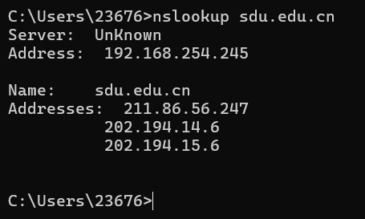
从图中可以看出www.sdu.edu.cn的服务器ip地址对应了三个值，分别是211.86.56.247、202.194.14.6、202.194.15.6
- Run nslookup to determine the authoritative DNS servers for a university in Europe.
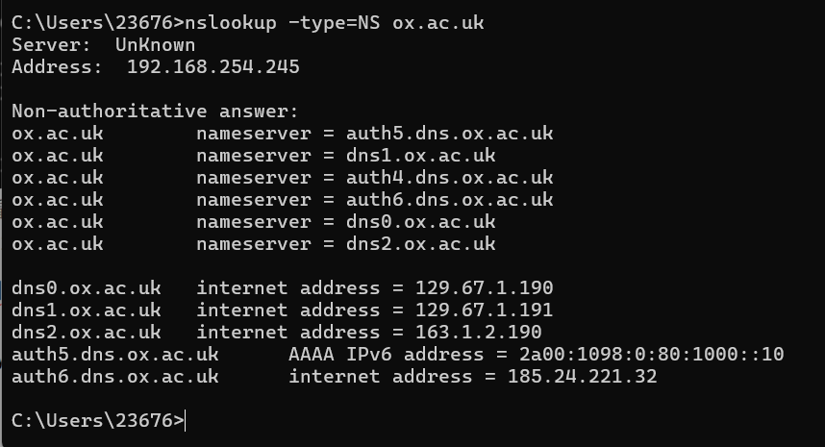
可以看出牛津大学的权威DNS服务器有auth5.dns.ox.ac.uk、dns1.ox.ac.uk、auth4.dns.ox.ac.uk、auth6.dns.ox.ac.uk、dns0.ox.ac.uk、dns2.ox.ac.uk
- Run nslookup so that one of the DNS servers obtained in Question 2 is queried for the mail servers for Yahoo! mail. What is its IP address?
很不幸牛津大学的权威DNS不允许我们使用它来解析域名：
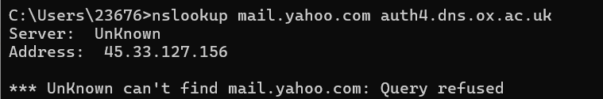
但是公共DNS解析的结果为：
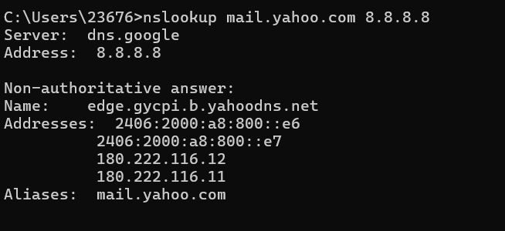
可以看出雅虎邮箱的IP地址为图中的四个，2406:2000:a8:800::e6、2406:2000:a8:800::e6、180
.222.116.12、180.222.116.11
- Locate the DNS query and response messages. Are then sent over UDP or TCP?
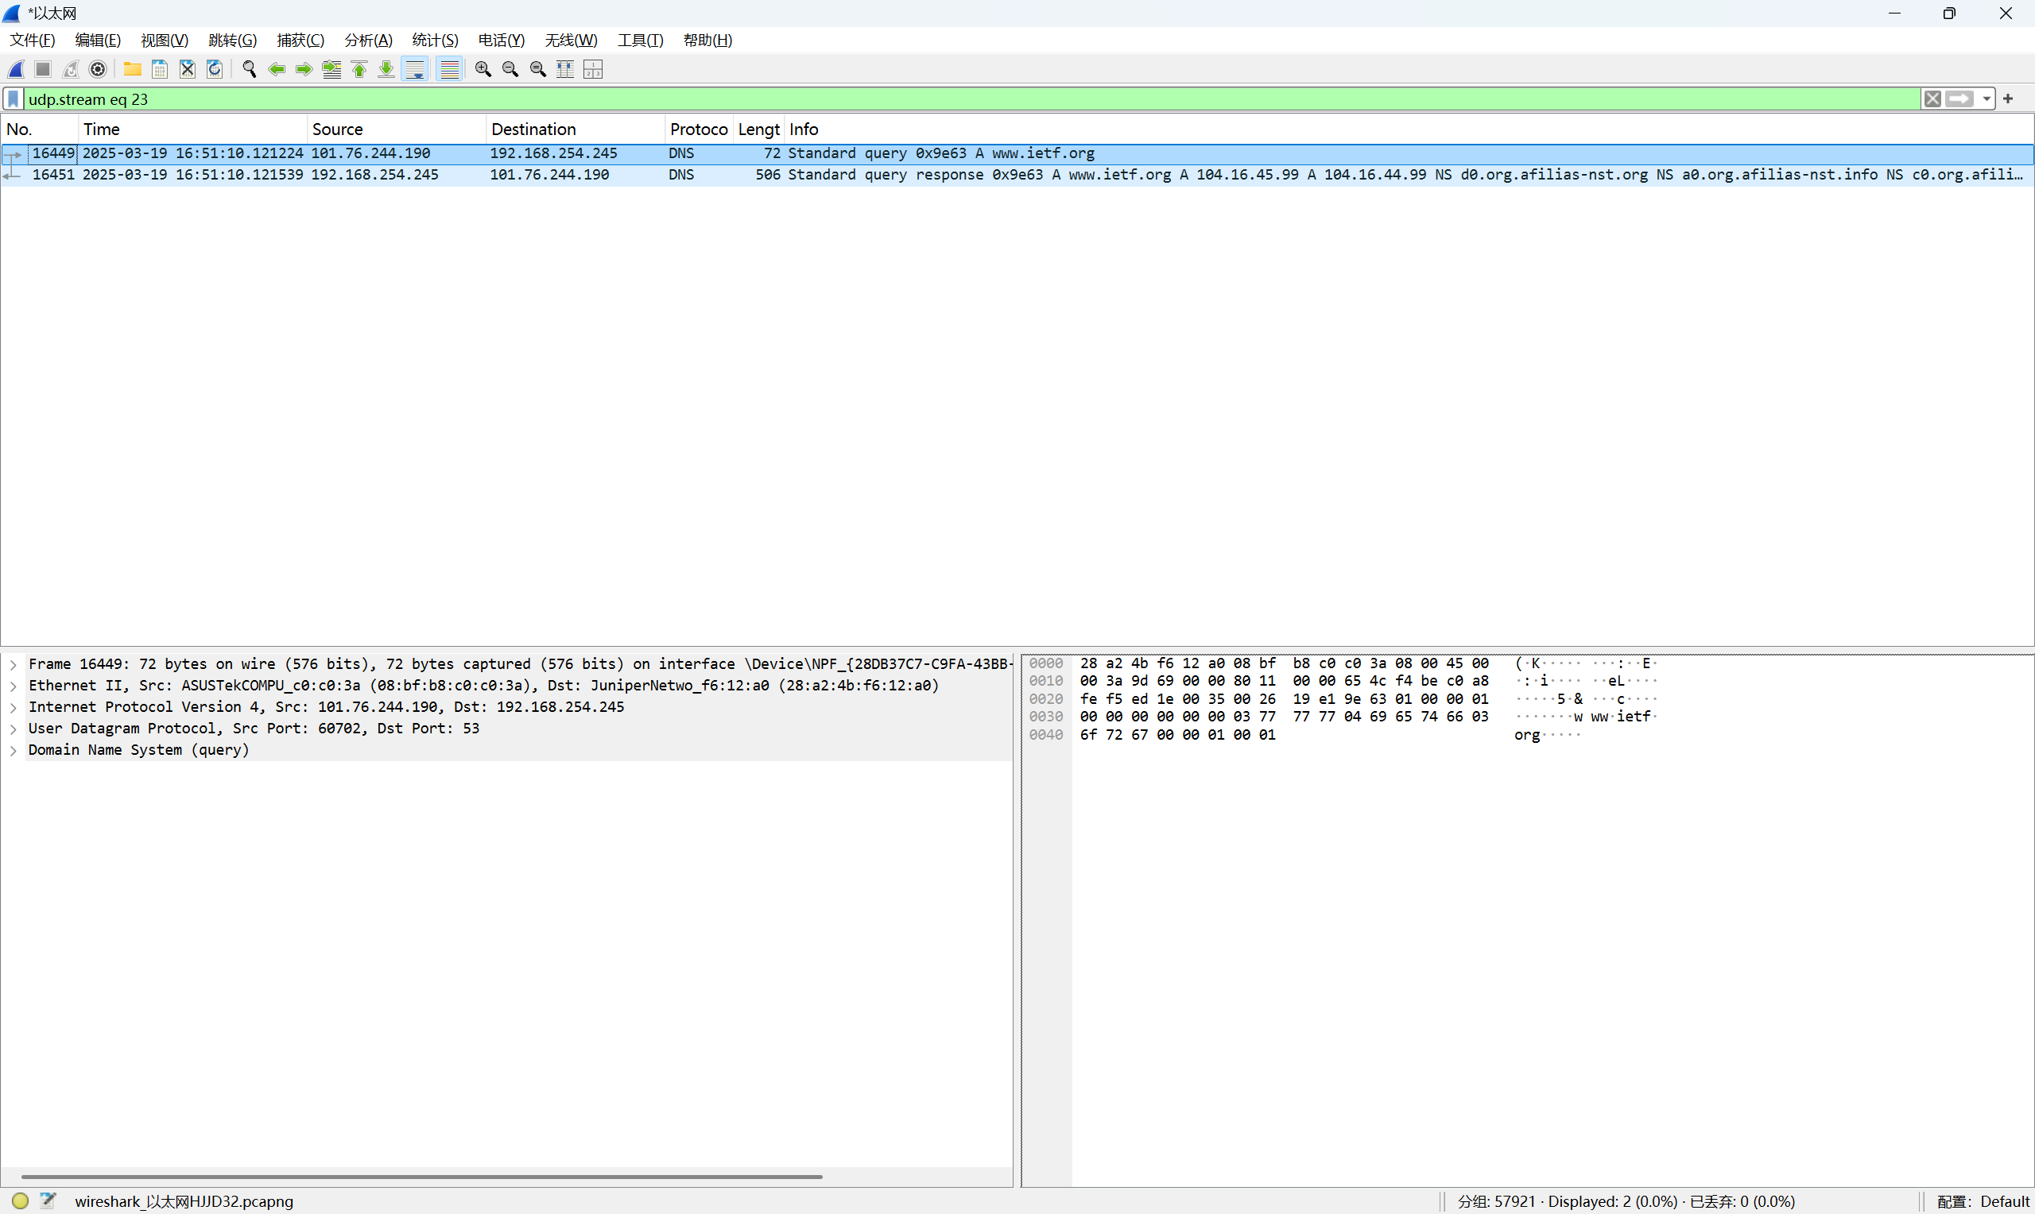
通过追踪流的方式，我们可以得知为我们服务的这个DNS是使用的UDP协议。
- What is the destination port for the DNS query message? What is the source port of DNS response message?
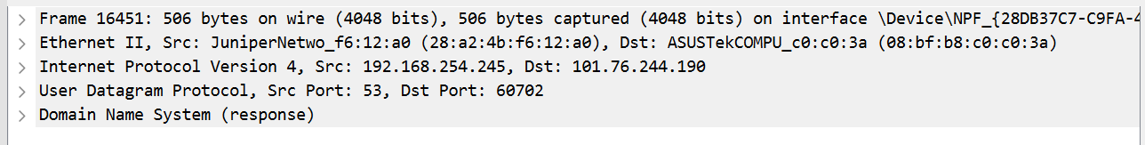
从这里的信息可以看出，源端口号是53，目的端口号是60702
- To what IP address is the DNS query message sent? Use ipconfig to determine the IP address of your local DNS server. Are these two IP addresses the same?
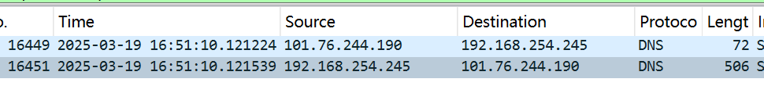
从上图中可以看出DNS query信息被发送到了192.168.254.245这个ip地址，这与上文图中我们的本地DNS服务器地址是一致的。
- Examine the DNS query message. What “Type” of DNS query is it? Does the query message contain any “answers”?
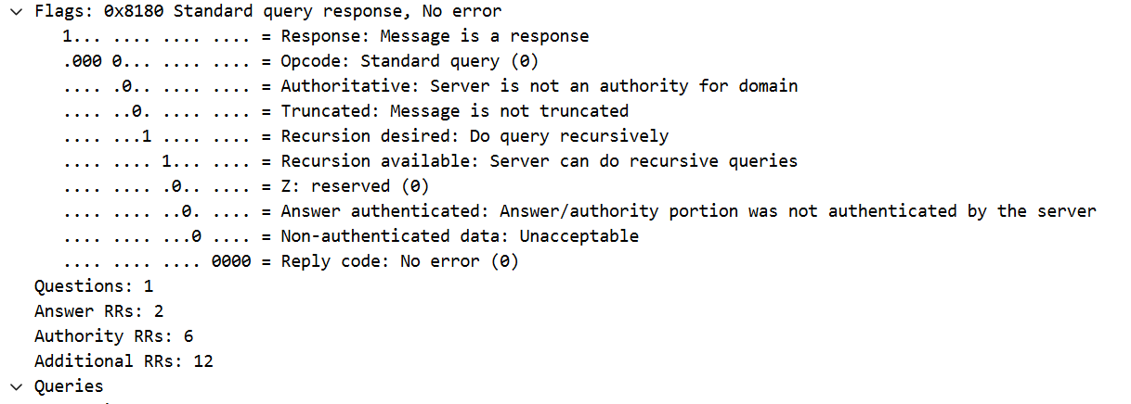
这个DNS query的类型是Standard query response,No error
Answers为
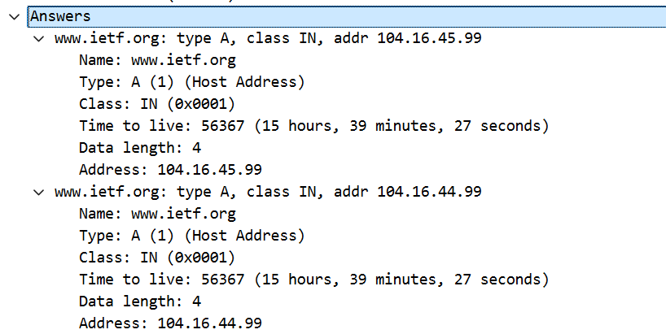
- Examine the DNS response message. How many “answers” are provided? What do each of these answers contain?
如上图，一共两个回复，每个回复包括域名、类型、类别、time to live、数据长度、域名解析出的地址。
- Consider the subsequent TCP SYN packet sent by your host. Does the destination IP address of the SYN packet correspond to any of the IP addresses provided in the DNS response message?
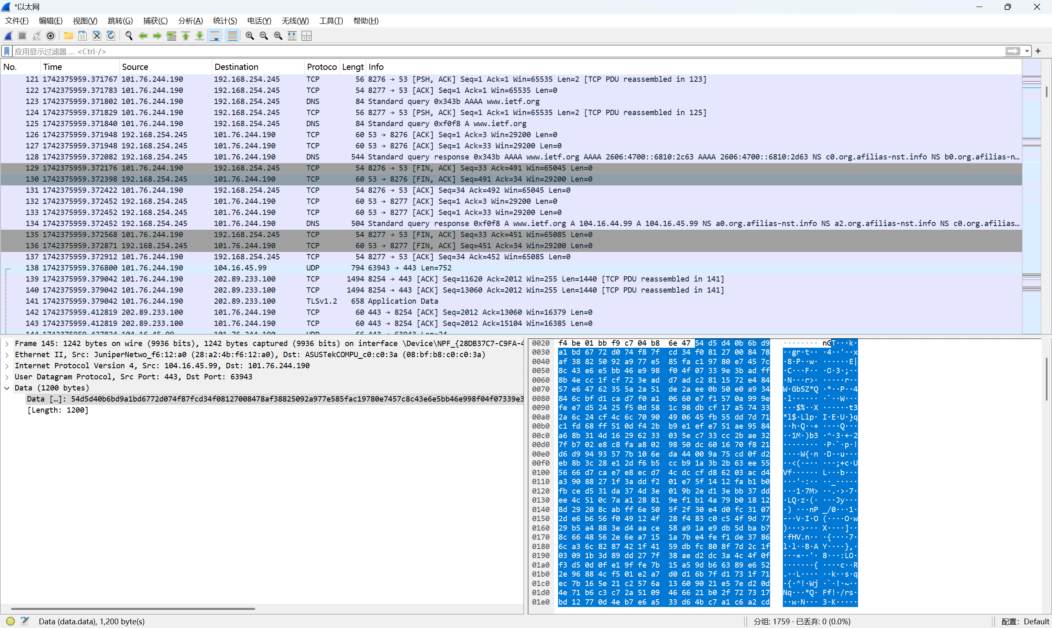
根据结果，TCP SYN并没有发生在主机与www.ietf.org之间，而是在主机与本地DNS服务器之间。
- This web page contains images. Before retrieving each image, does your host issue new DNS queries?
我们的主机在获取到图片之前，并没有在发出DNS事务。
- What is the destination port for the DNS query message? What is the source port of DNS response message?
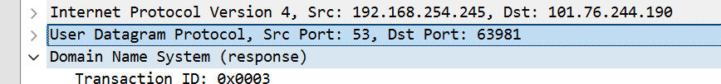
从这里的信息可以看出，源端口号是53，目的端口号是63981
- To what IP address is the DNS query message sent? Is this the IP address of your default local DNS server?
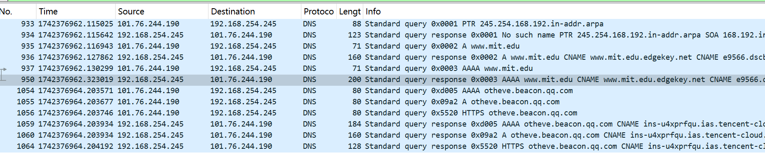
如图，这个192.168.254.245和我们本地的DNS服务器的IP是一致的。
- Examine the DNS query message. What “Type” of DNS query is it? Does the query message contain any “answers”?
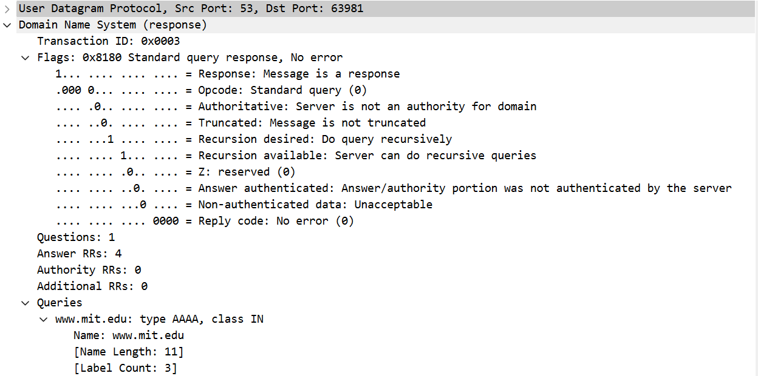
这个DNS query的类型是Standard query response,No error
Answers为
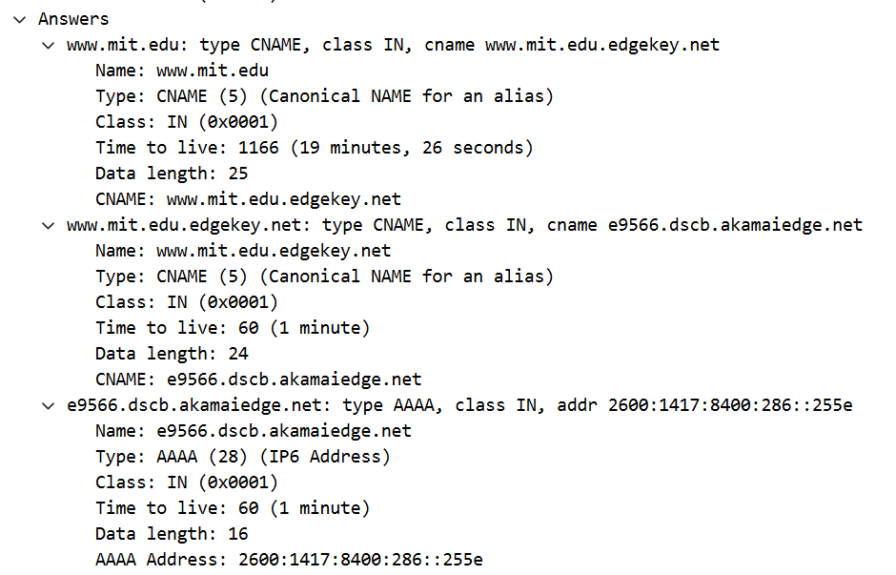
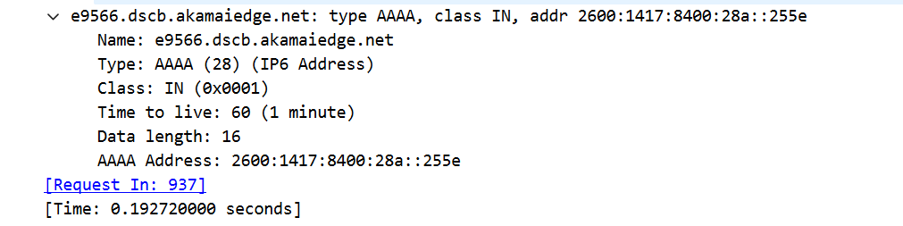
- Examine the DNS response message. How many “answers” are provided? What do each of these answers contain?
如上图，一共五个回复，每个回复包括域名、类型、类别、time to live、数据长度、域名别名、域名解析出的地址。
- Provide a screenshot.
截图均在上文文中。
- To what IP address is the DNS query message sent? Is this the IP address of your default local DNS server?
发送到了192.168.254.245，和本地DNS是一致的。
- Examine the DNS query message. What “Type” of DNS query is it? Does the query message contain any “answers”?
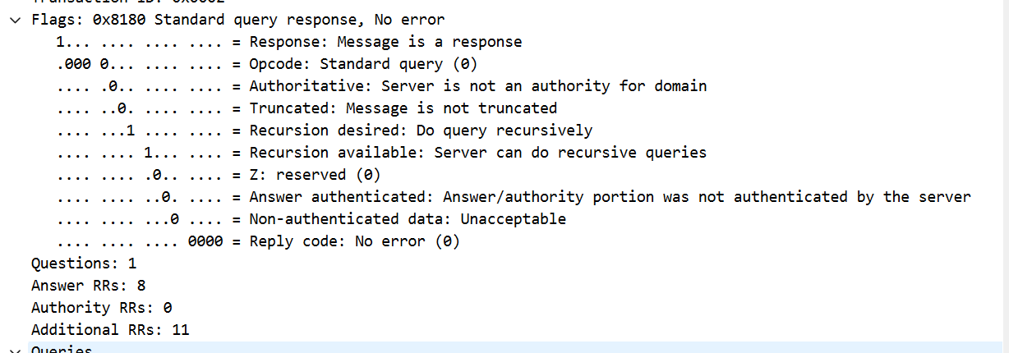
这个DNS query的类型是Standard query response,No error
Answers为
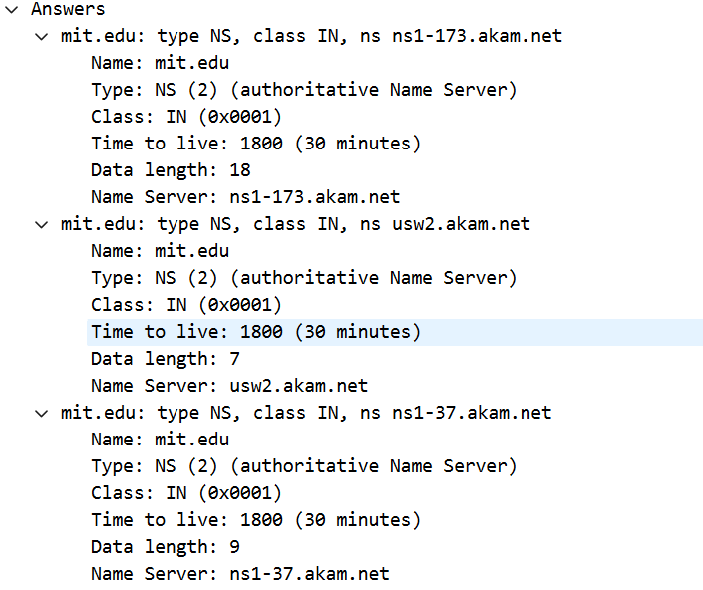
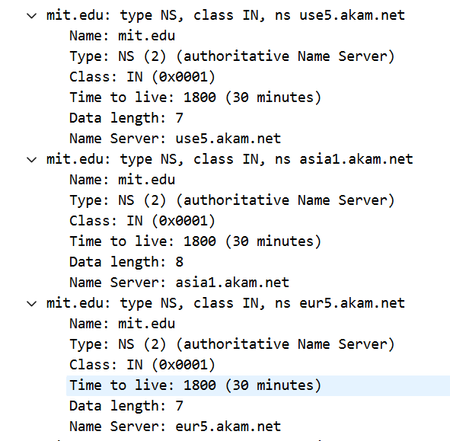
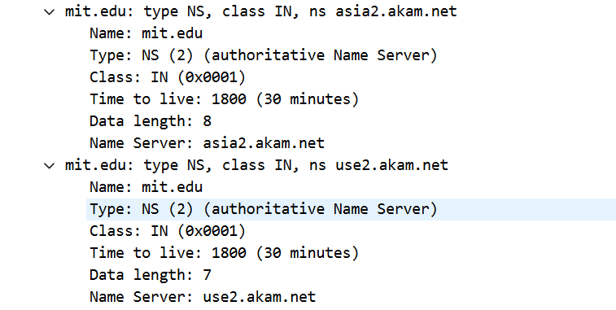
- Examine the DNS response message. What MIT nameservers does the response message provide? Does this response message also provide the IP addresses of the MIT namesers?
由上图可知，提供了ns1-173.akam.net、usw2.akam.net、ns1-37.akam.net、use5.akam.net、asia1.akam.net、eur5.akam.net、asia2.akam.net、use2.akam.net这些nameservers，且同时也在下文提供了这些nameservers的地址
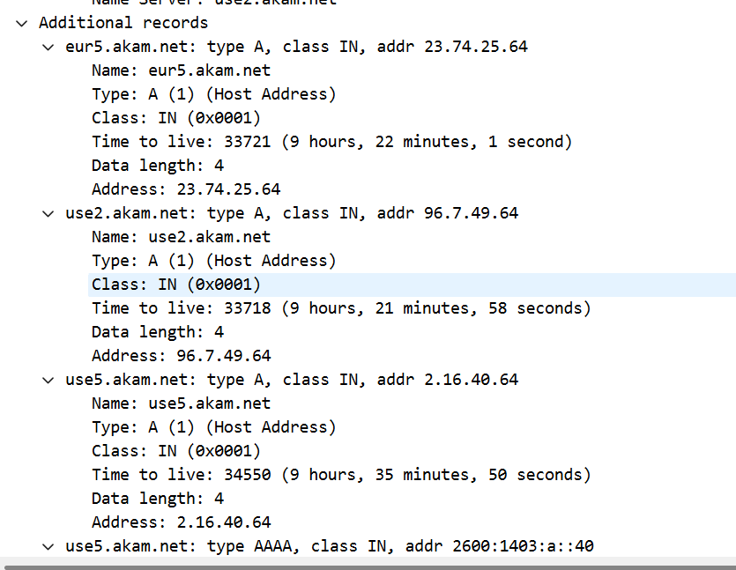
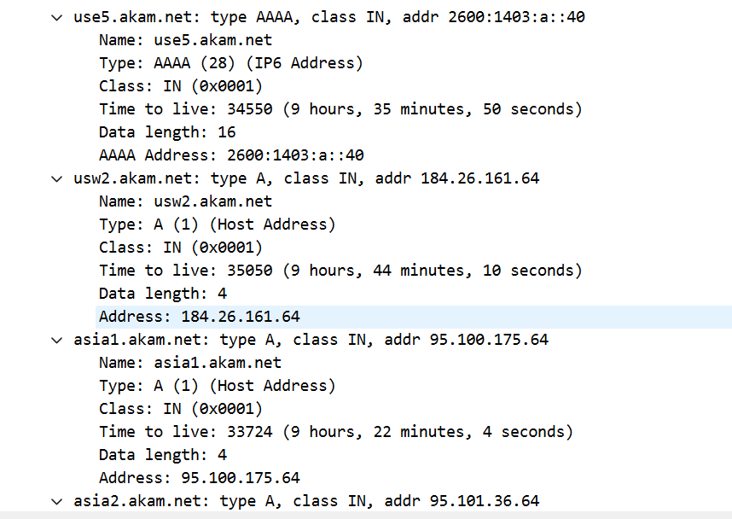
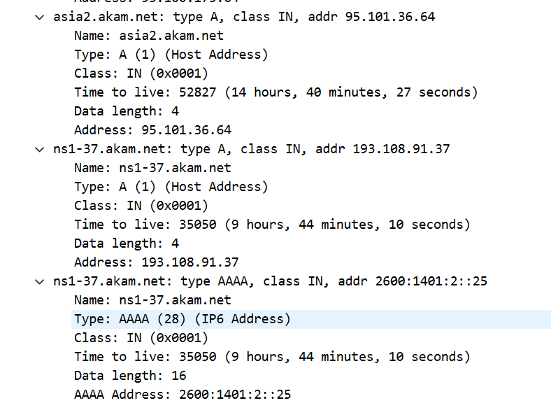
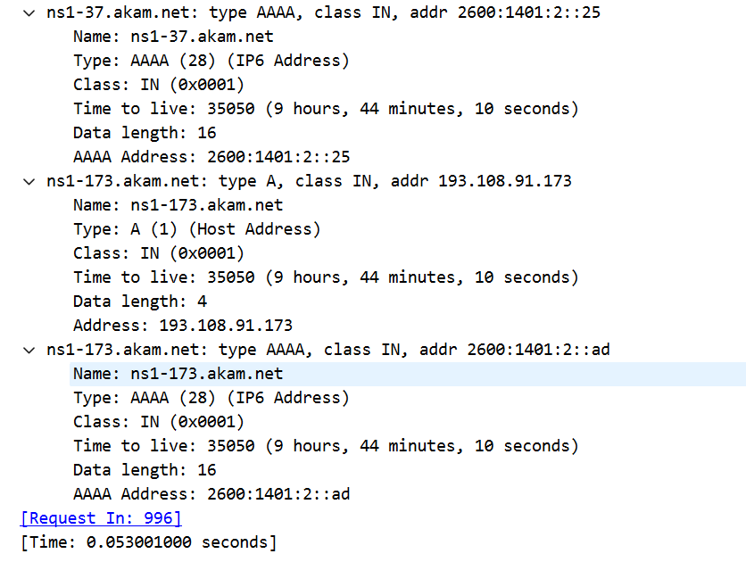
- Provide a screenshot.
截图均在上文文中。
- To what IP address is the DNS query message sent? Is this the IP address of your default local DNS server? If not, what does the IP address correspond to?
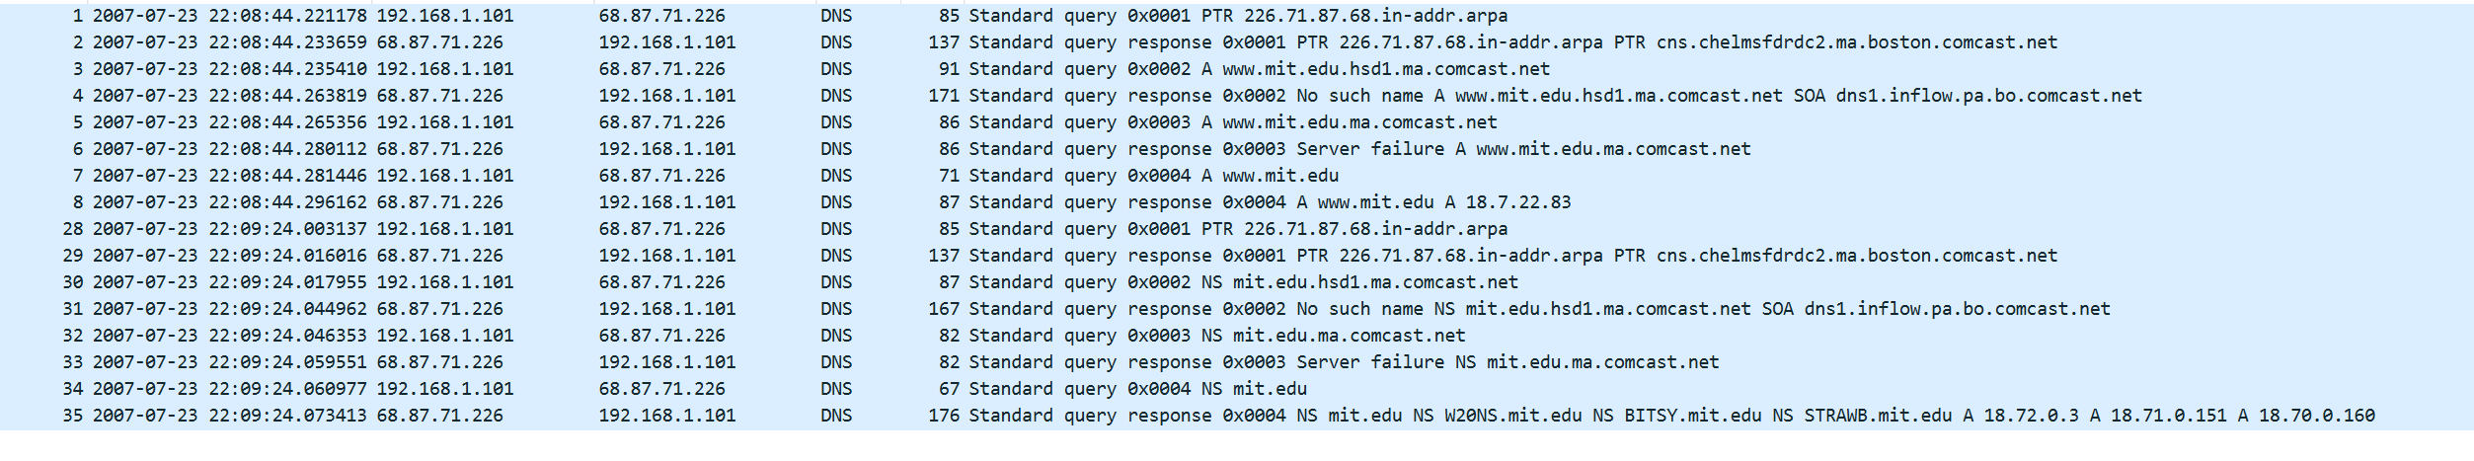
发到68.87.71.226了，这和我的本地DNS服务器是不一样的。他应该对应了bitsy.mit.edu的地址
- Examine the DNS query message. What “Type” of DNS query is it? Does the query message contain any “answers”?
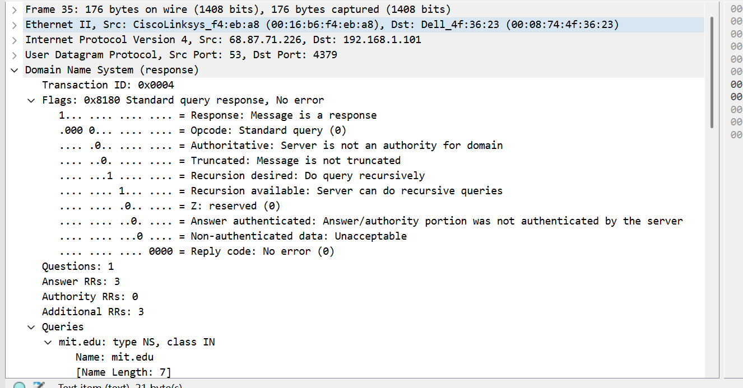
这个DNS query的类型是Standard query response,No error
Answers为
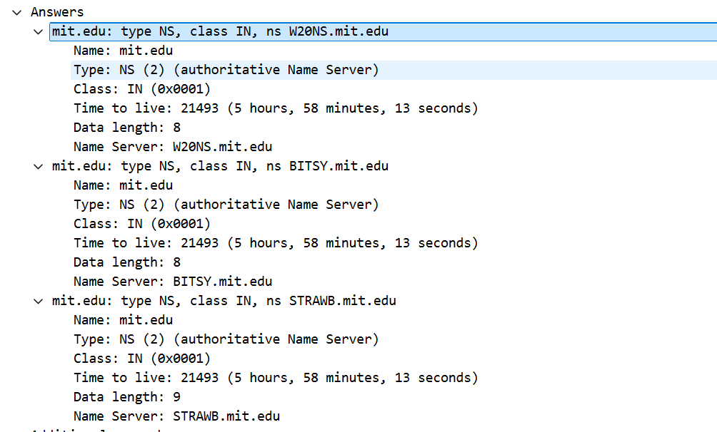
- Examine the DNS response message. How many “answers” are provided? What does each of these answers contain?
如上图，一共有3个answers，每个回复包括域名、类型、类别、time to live、数据长度、Name Server.
- Provide a screenshot.
截图均在上文文中。
问题及收获：
DNS是互联网的核心基础设施之一，它的主要功能是将人类可读的域名转换为计算机可识别的 IP 地址。DNS 的存在使得互联网用户能够更方便、更高效地访问网络资源，而无需记住复杂的数字 IP 地址。并且也可以提供灵活性和可管理性，能够实现负载均衡、故障转移，增强了安全性和隐私保护，促进了全球互联网的互联互通。

