山东大学 计算机科学与技术 学院
新兴网络技术与实践 课程实验报告

学号：202300130183 | 姓名：宋浩宇 |  | 班级：23级智能班
实验题目：Wireshark Lab: SSL v8.0
实验学时：2 |  | 实验日期：2025/6/11
实验目的：学习了解SSL
实验结果：
- For each of the first 8 Ethernet frames, specify the source ofthe frame (client or server), determine the number of SSL records that are included in the frame, and list the SSL record types that are included in the frame. Draw a timing diagram between client and server, with one arrow for each SSL record.
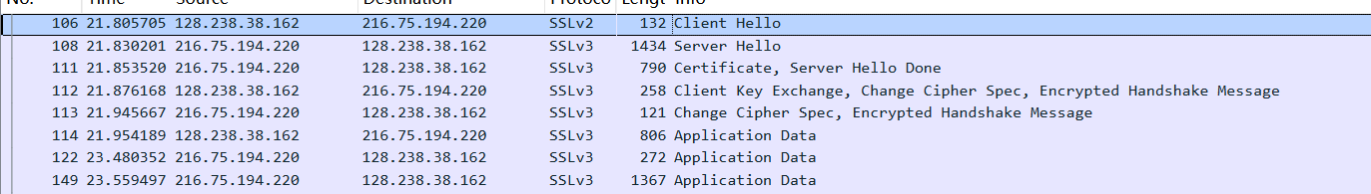
如图，前八个分别是客户端、服务端、服务端、客户端、服务端、客户端、服务端、服务端
有Client Hello、Server Hello、Certificate、Client Key Exchange、Change Cipher Spec、Hypertext Transfer Protocol这几种。
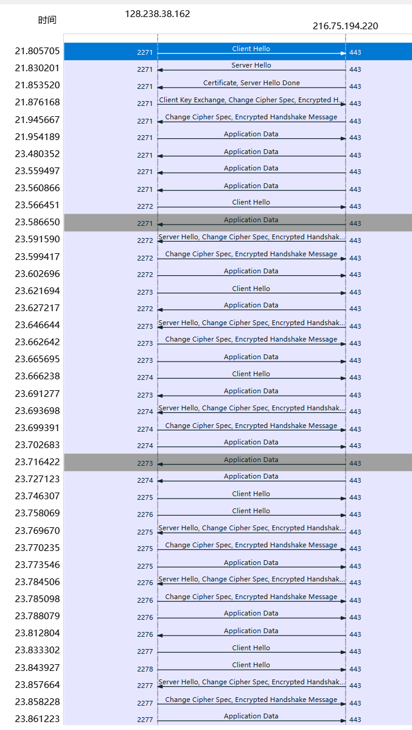
如图，这是SSL记录统计图
- Each of the SSL records begins with the same three fields (with possibly different values). One of these fields is “content type”and has length of one byte. List all three fields and their lengths.
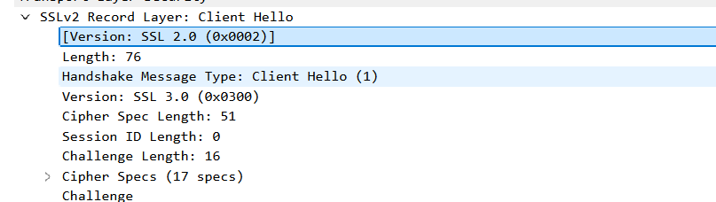
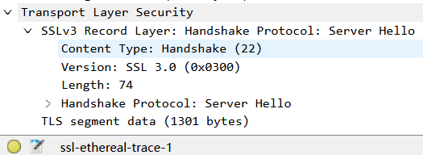
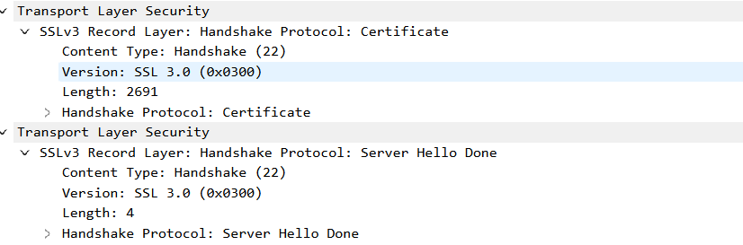
如图，content type、version、length字段均已列出

ClientHello Record:

- Expand the ClientHello record. (If your trace contains multiple ClientHello records, expand the frame that contains the first one.) What is the value of the content type?
Content type的值是22
- Does the ClientHello record contain a nonce (also known as a“challenge”)? If so, what is the value of the challenge in hexadecimal notation?
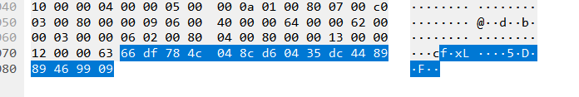
有这个字段，其十六进制值是66 df 78 4c 04 8c d6 04 35 dc 44 89 89 46 99 09
- Does the ClientHello record advertise the cyber suites it supports? If so, in the first listed suite, what are the public-key algorithm, the symmetric-key algorithm, and the hash algorithm?
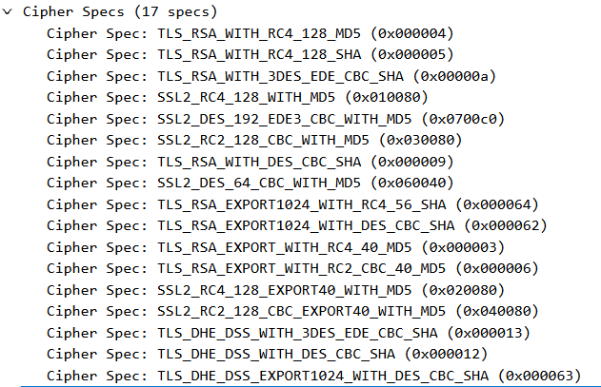
如图
TLS_RSA 表示密钥交换算法使用 RSA。
RC4_128 是对称加密算法，密钥长度为 128 位。
MD5 是哈希算法，用于消息认证。
ServerHello Record:

- Locate the ServerHello SSL record. Does this record specify a chosen cipher suite? What are the algorithms in the chosen cipher suite?
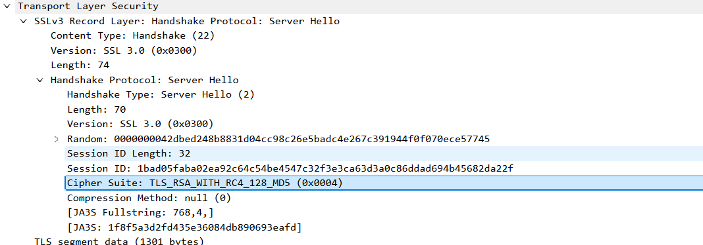
指定了，和客户端的第一条是一样的Cipher Spec: TLS_RSA_WITH_RC4_128_MD5 (0x000004)
TLS_RSA 表示密钥交换算法使用 RSA。
RC4_128 是对称加密算法，密钥长度为 128 位。
MD5 是哈希算法，用于消息认证。
- Does this record include a nonce? If so, how long is it? What is the purpose of the client and server nonces in SSL?
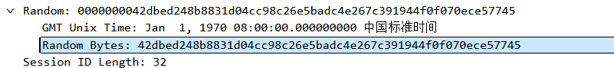
有随机数，27字节，目的是生成唯一的主密钥和会话密钥，防止重放攻击，确保通信的唯一性和不可预测性，验证通信双方的实时性。
- Does this record include a session ID? What is the purpose of the session ID?
有会话id，目的是用于会话恢复、会话管理、会话缓存、避免重复握手、避免重放攻击。
- Does this record contain a certificate, or is the certificate included in a separate record. Does the certificate fit into a single Ethernet frame?
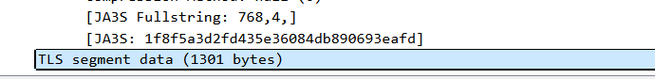
有协议，协议内容直接包含在了记录里。
协议内容被切片了，用了两个以太网帧。

Client Key Exchange Record:

- Locate the client key exchange record. Does this record contain a pre-master secret? What is this secret used for? Is the secret encrypted? If so, how? How long is the encrypted secret?
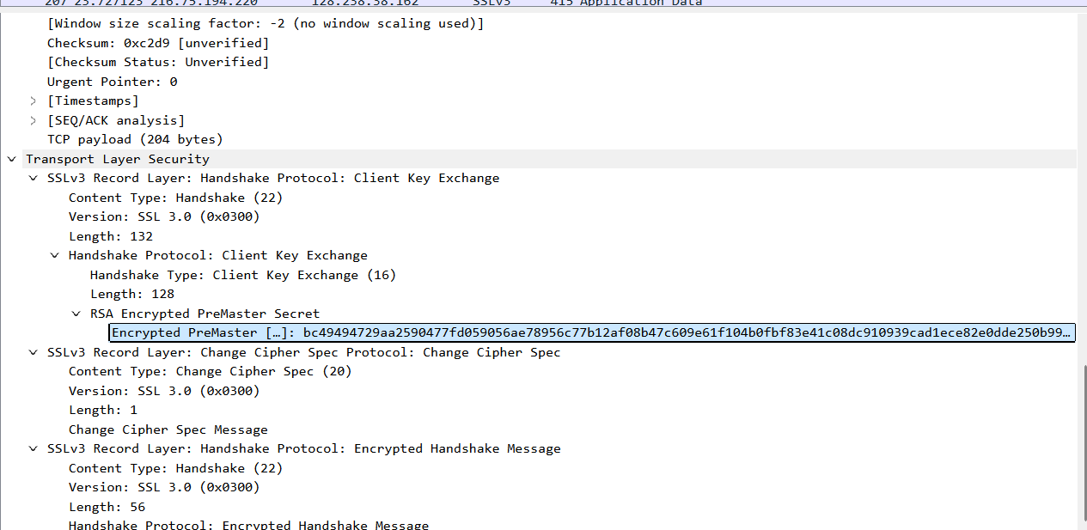
包含了，主要用于与客户端和服务器的nonce一起生成主密钥。主密钥随后被用于生成会话密钥，这些会话密钥将用于加密和认证通信数据。预主密钥在传输过程中是加密的。加密方式是RSA加密。长度是128字节。

Change Cipher Spec Record (sent by client) and Encrypted Handshake Record:

- What is the purpose of the Change Cipher Spec record? How many bytes is the record in your trace?
整个包的长度是121字节。
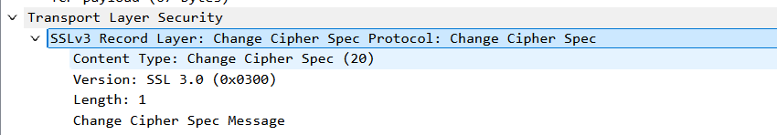
如果指的是具体的变更信息，那就是6字节
- In the encrypted handshake record, what is being encrypted? How?
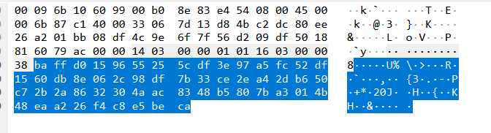
这是加密内容，通过RSA加密的。
- Does the server also send a change cipher record and an encrypted handshake record to the client? How are those records different from those sent by the client?
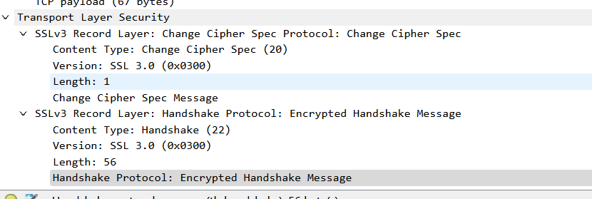
发送了，只看变更记录的话和客户端是一致的。
Application Data

- How is the application data being encrypted? Do the records containing application data include a MAC? Does Wireshark distinguish between the encrypted application data and the MAC?
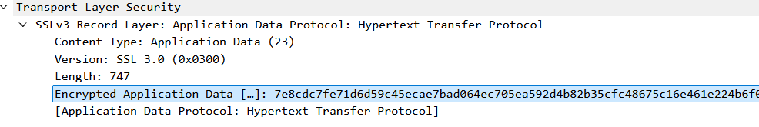
应用数据是通过RSA加密的，记录中不包含MAC，wireshark无法区分二者。
- Comment on and explain anything else that you found interesting in the trace.
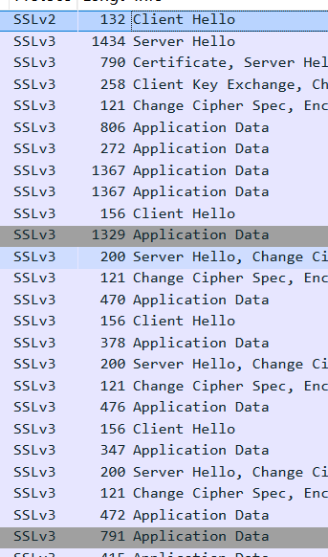
Client Hello在最初发送时是SSLv2，而在记录下服务端的SSL版本后，之后再建立链接使用的就是SSLv3了。
问题及收获：
SSL是一种网络安全协议，主要用于在互联网通信中保障数据传输的安全性和隐私性。它的核心作用是通过加密技术对客户端和服务器之间传输的数据进行加密，防止信息在传输过程中被窃取或篡改，比如我们在网上购物输入信用卡信息、登录邮箱或社交账号时，SSL 协议就能保护我们的账号密码、个人隐私等重要信息不被坏人窃取。同时，它还能验证服务器的身份，确保我们访问的网站是真实的、可信的，而不是假冒的钓鱼网站，就像给网络通信建立了一个安全通道，让我们在浏览互联网时更安心。

