山东大学 计算机科学与技术 学院
新兴网络技术与实践 课程实验报告

学号：202300130183 | 姓名：宋浩宇 |  | 班级：23级智能班
实验题目：
实验学时：2 |  | 实验日期：2025/4/23
实验目的：
实验结果：
1. What is the IP address of your host? What is the IP address of the destination
host?
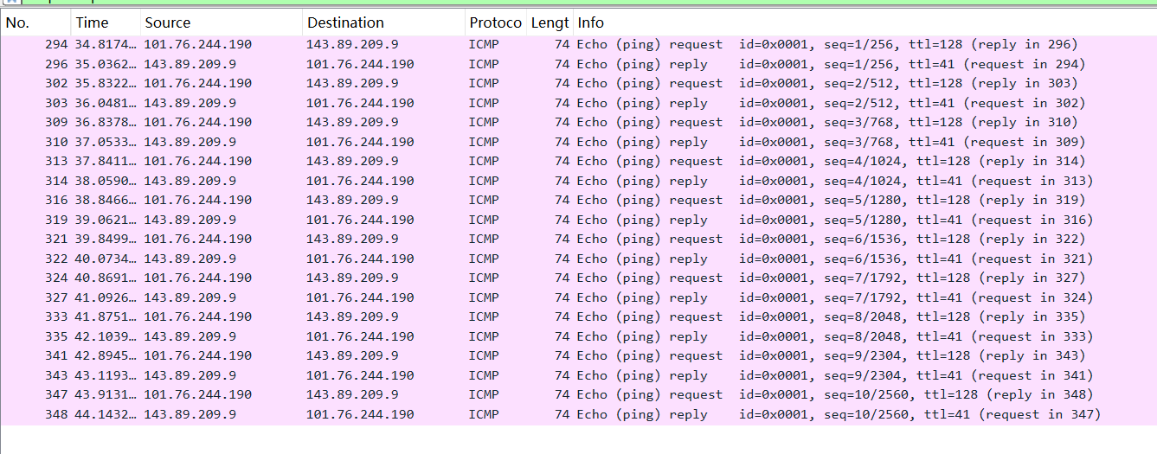
如图，这是十次ping的数据包捕获信息。
本地主机的IP地址式101.76.244.190，目标IP地址是143.89.209.9
2. Why is it that an ICMP packet does not have source and destination port
numbers?
ICMP（Internet Control Message Protocol，网络控制报文协议）主要用于在 IP 主机、路由器之间传递控制消息，属于网络层协议，其设计目的并非为应用程序提供数据传输服务，而是用于网络设备之间传递网络状态信息、差错报告等，所以无需像传输层的 TCP（传输控制协议）和 UDP（用户数据报协议）那样通过源端口和目的端口来区分不同的应用程序进程。
3. Examine one of the ping request packets sent by your host. What are the ICMP
type and code numbers? What other fields does this ICMP packet have? How
many bytes are the checksum, sequence number and identifier fields?
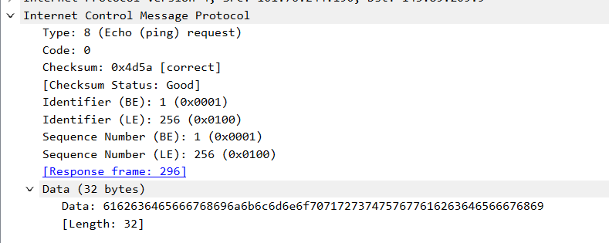
类型是8，代码号是0，校验和是0x4d5a，序列号是1（256），标识号是1（256）各占2字节。
4. Examine the corresponding ping reply packet. What are the ICMP type and code
numbers? What other fields does this ICMP packet have? How many bytes are the
checksum, sequence number and identifier fields?
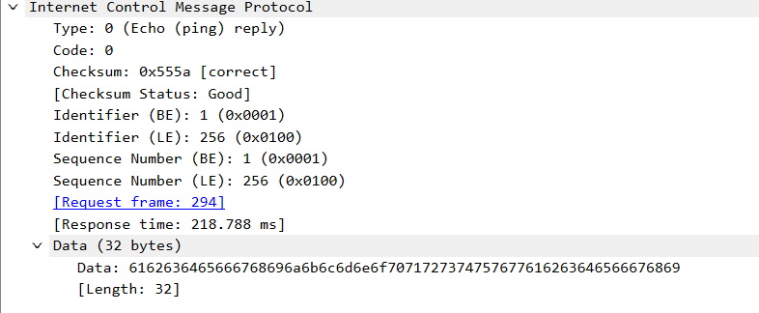
多了一个Response time字段。校验和、序列号和标识号也都是2字节。
5. What is the IP address of your host? What is the IP address of the target
destination host?
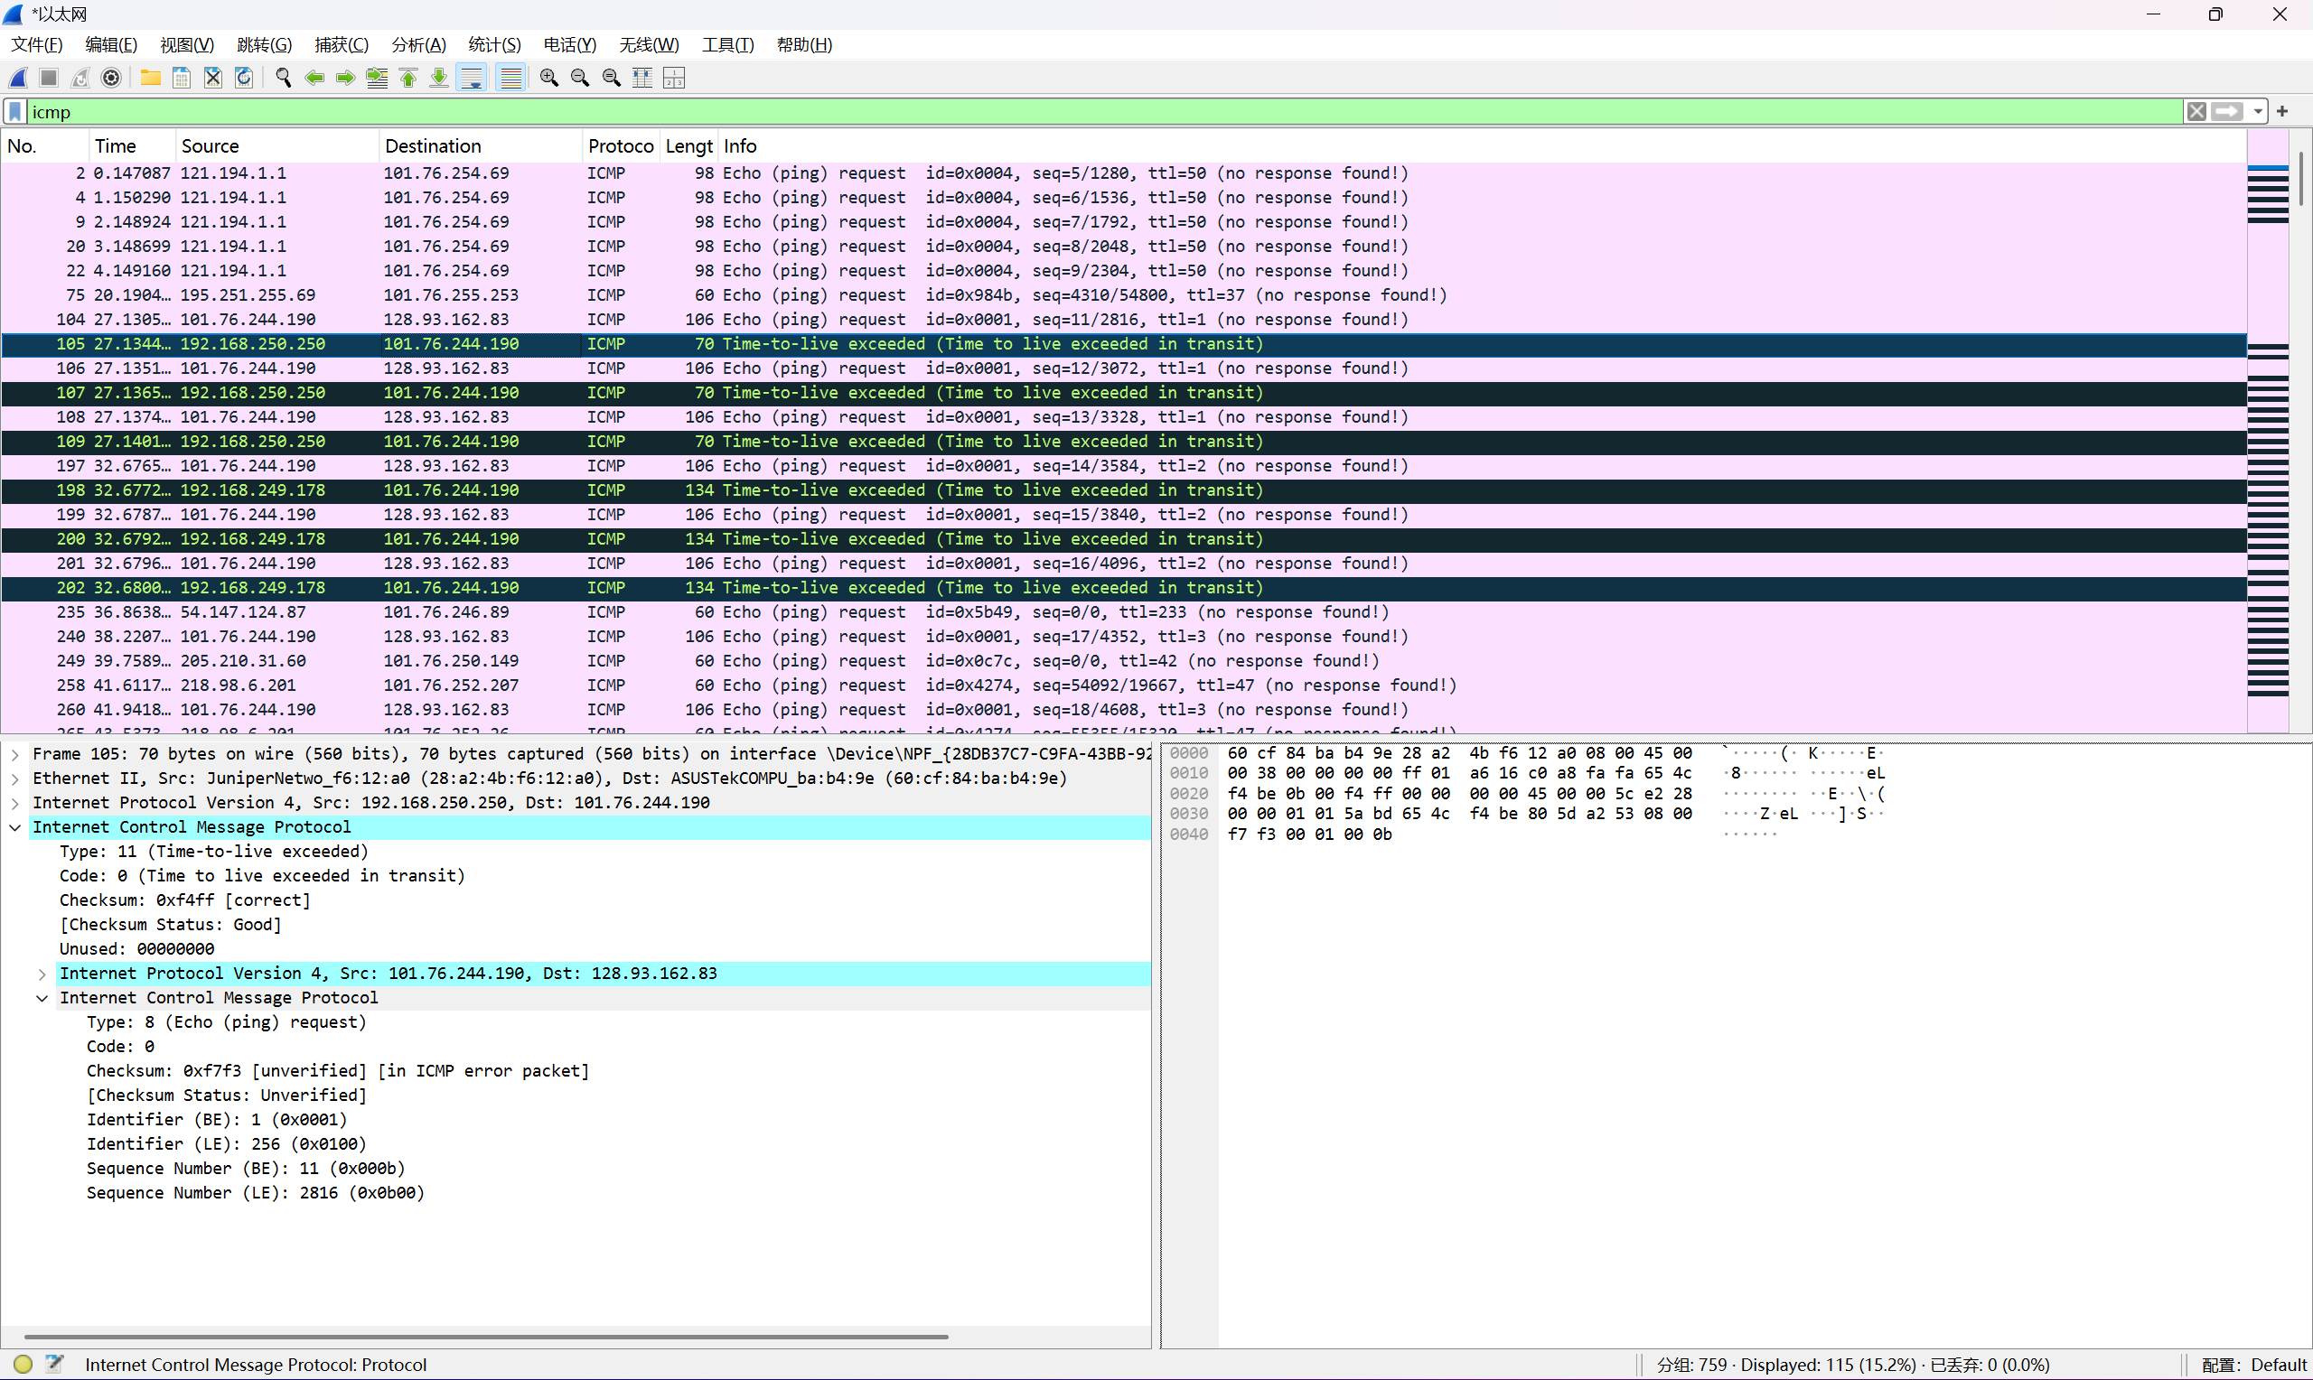
如图，这个是tracert的数据包捕获结果
我的主机地址是101.76.244.190，目的地址是128.93.162.83
6. If ICMP sent UDP packets instead (as in Unix/Linux), would the IP protocol
number still be 01 for the probe packets? If not, what would it be?
不会是1，应该是17
7. Examine the ICMP echo packet in your screenshot. Is this different from the
ICMP ping query packets in the first half of this lab? If yes, how so?
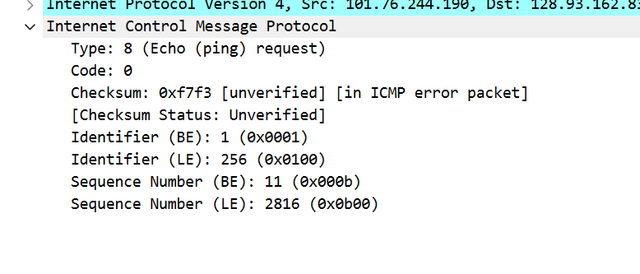
没有data段，也没有返回时间段。
8. Examine the ICMP error packet in your screenshot. It has more fields than the
ICMP echo packet. What is included in those fields?
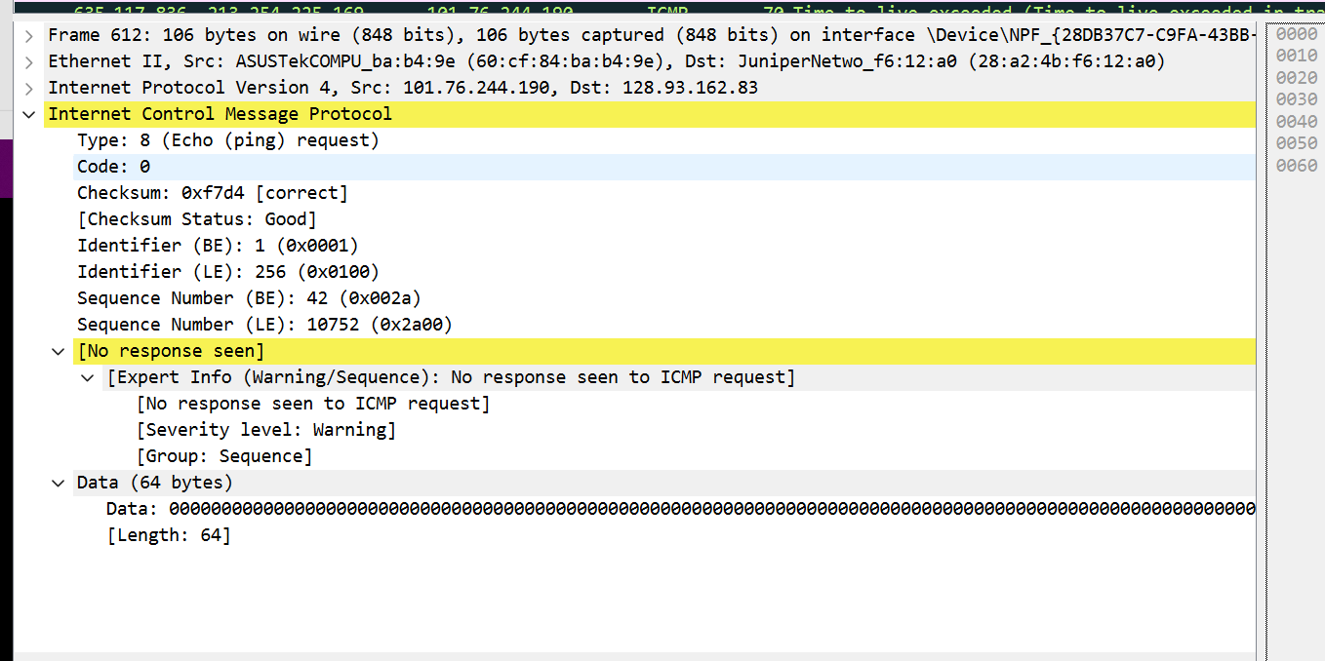
多了一个No response seen字段
9. Examine the last three ICMP packets received by the source host. How are these
packets different from the ICMP error packets? Why are they different?
与 ICMP 错误数据包不同，因为它们是目标主机对 ICMP 回显请求的响应，用于验证主机可达性，而 ICMP 错误数据包（如类型 11 的超时报文）则用于通知传输过程中的错误。
10. Within the tracert measurements, is there a link whose delay is significantly
longer than others? Refer to the screenshot in Figure 4, is there a link whose
delay is significantly longer than others? On the basis of the router names, can
you guess the location of the two routers on the end of this link?
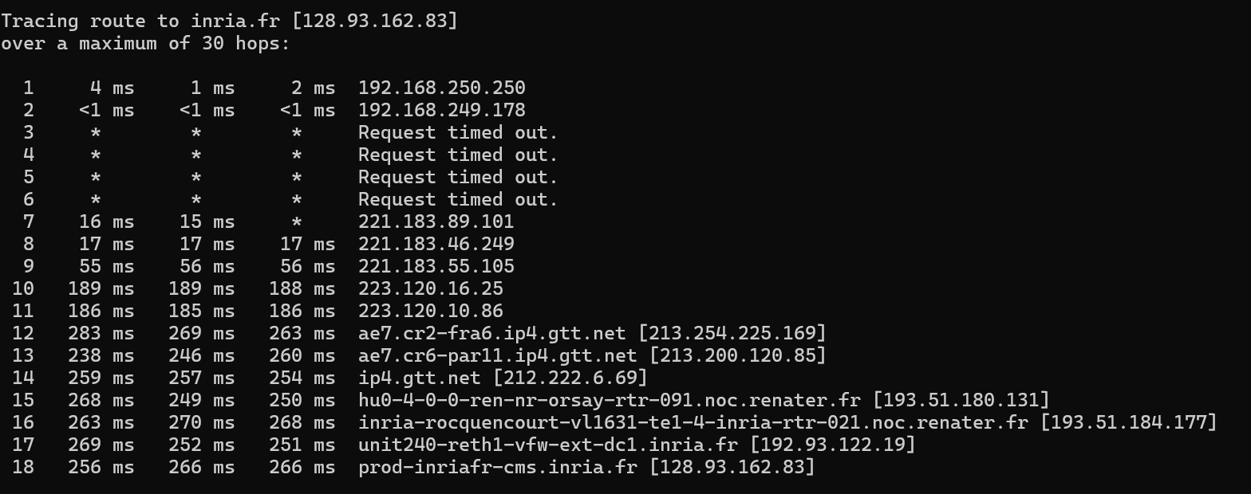
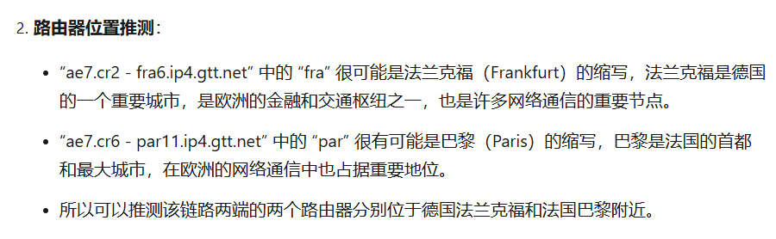
问题及收获：
ICMP（Internet Control Message Protocol）的意义在于辅助 IP 协议进行网络通信的控制与管理，其作用主要体现在网络诊断（如通过 Ping 检测主机可达性）、路径探测（如 Traceroute 查看数据包传输路径）、以及传递差错信息（如目的不可达或 TTL 超时）。ICMP 的特点包括无连接性、不可靠传输、与 IP 协议紧密集成、消息类型丰富（如回显请求/应答、差错消息等），且通常不面向高层用户，而是供网络设备和协议使用，其简单高效的机制有助于维护网络的正常运行和故障排查。

