山东大学 计算机科学与技术 学院
计算机视觉 课程实验报告

学号：202300130183 | 姓名：宋浩宇
实验题目：实验E7-基于学习的匹配
实验过程中遇到和解决的问题：
（记录实验过程中遇到的问题，以及解决过程和实验结果。可以适当配以关键代码辅助说明，但不要大段贴代码。）
问题1：无法通过pip从GitHub安装LightGlue官方包
执行pipinstallgit+https://github.com/cvg/LightGlue.git时，克隆阶段报错SSL_ERROR_SYSCALL/checkoutfailed，导致依赖安装中断，实验代码无法importlightglue。
解决1：改为使用kornia内置的LightGlue接口（kornia.feature.LightGlue），与官方算法和权重来源一致，无需clone整个GitHub仓库。在requirements-e7.txt中指定kornia>=0.8，实验脚本通过e7_common.py的detect_backend()自动选择kornia后端。若Releases权重下载仍受网络影响，可用下载匹配权重.ps1经ghproxy镜像预先下载到~/.cache/torch/hub/checkpoints/。

问题2：运行脚本时importtorch失败（c10.dll，WinError1114）
在IDE中使用F:\Project\BloodCultureInstrument\实验6\Scripts\python.exe运行实验7-1_compare.py时，尚未执行实验逻辑即在importtorch处崩溃，提示动态链接库初始化失败，错误指向torch\lib\c10.dll。重装PyTorch2.12CPU版后问题依旧，容易误判为“CPU环境不可用”。
解决2：排查发现该解释器为基于Anaconda派生的venv，与PyTorch2.12在当前Windows环境下存在DLL兼容问题。将torch固定降级为2.5.1+cpu并配套torchvision==0.20.1+cpu、numpy<2后，importtorch恢复正常。

问题3：SuperPoint特征提取阶段IndexError
环境修好后运行实验7-1_compare.py，在superpoint特征提取时报错：index2146isoutofboundsfordimension0withsize2048，堆栈指向实验6/vendor/superpoint.py的top_k_keypoints。
解决3：对比LightGlue官方`superpoint.py`发现，本仓库vendor版本中top_k_keypoints误将torch.topk之后的结果写成scores[indices]。topk返回的scores已是前k个分数，应直接返回。

问题4：互最近邻在大旋转角下匹配质量骤降
在实验7-2旋转sweep中，当旋转角增至30°时，部分特征+NN组合的内点率明显下降。例如DISK+NN：匹配335对、内点仅133，内点率约39.7%；ALIKED+NN内点率约49.9%。而同一角度下LightGlue仍能保持较高内点率，如DISK+LightGlue约98.5%，ALIKED+LightGlue约87.4%。
解决4：该现象属算法层面差异，而非环境错误。NN仅做描述子互最近邻，缺少LightGlue的几何一致性与置信度筛选；LightGlue在相同特征提取结果上通过学习型匹配与自适应计算，对旋转更鲁棒。实验流程上保持「同一特征、两种匹配器」的对照设计，用RANSAC内点数、内点率及figures/e72/中曲线图量化对比。
实验结果分析：
本次实验使用了和上一次实验相同的图片来做效果测试：

同样使用随机的旋转平移等数据增强手段来生成测试图像：
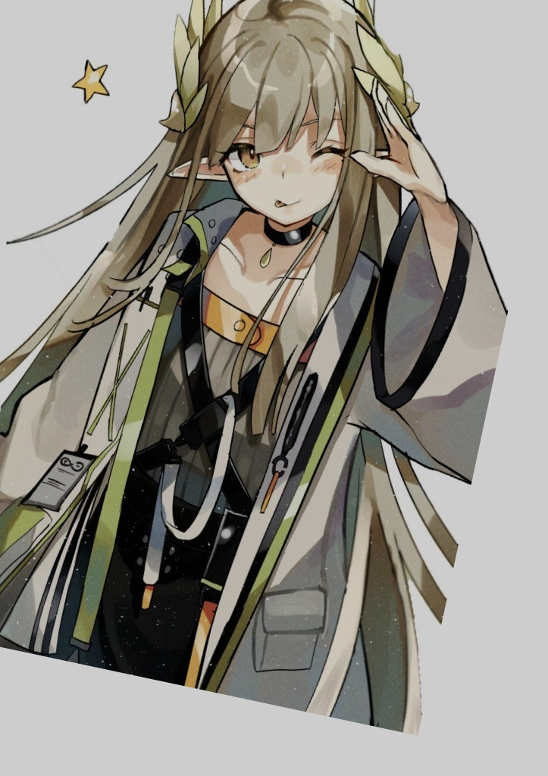
在SuperPoint、DISK、ALIKED、SIFT四种特征上，分别用互最近邻（NN）和LightGlue做匹配，再用RANSAC筛内点。定量数据如下：
feature | matcher | sweep_type | param_value | num_kp1 | num_kp2 | num_matches | num_inliers | inlier_ratio | mean_reproj_err | t_extract_ms | t_match_ms
superpoint | nn | pair | 0 | 2048 | 1993 | 1494 | 1235 | 0.8266398929049531 | nan | 2033.347300006426 | 15.46730000700336
superpoint | lightglue | pair | 0 | 2048 | 1993 | 1529 | 1515 | 0.9908436886854153 | nan | 2033.347300006426 | 401.13760001258925
disk | nn | pair | 0 | 2048 | 2048 | 1418 | 1376 | 0.9703808180535967 | nan | 1705.283600007533 | 13.406099998974241
disk | lightglue | pair | 0 | 2048 | 2048 | 1427 | 1380 | 0.9670637701471618 | nan | 1705.283600007533 | 503.4434999979567
aliked | nn | pair | 0 | 2048 | 1946 | 1368 | 1291 | 0.9437134502923976 | nan | 927.276600006735 | 12.214000002131797
aliked | lightglue | pair | 0 | 2048 | 1946 | 1404 | 1251 | 0.8910256410256411 | nan | 927.276600006735 | 518.2690000074217
sift | nn | pair | 0 | 2048 | 2048 | 1375 | 1117 | 0.8123636363636364 | nan | 2620.2221999992616 | 15.853000004426576
sift | lightglue | pair | 0 | 2048 | 2048 | 1320 | 1183 | 0.8962121212121212 | nan | 2620.2221999992616 | 968.5789999930421
从这组结果看，SuperPoint的差别最明显：NN有1494对匹配、1235个内点，内点率大约八成多；换成LightGlue以后是1529对匹配、1515个内点，内点率接近九成九，误匹配少了很多。DISK在这张图上两种方法已经比较接近，内点率都在九成六、九成七左右。SIFT用LightGlue也比NN好一些，内点从1117提到1183。时间上NN匹配只要十几毫秒，LightGlue要几百毫秒到接近一秒，慢不少，但换来的是更干净的几何对应。ALIKED在这对图上NN略高一点，属于个别情况，后面sweep里大旋转时还是LightGlue更稳。
SuperPoint用NN的匹配示意：
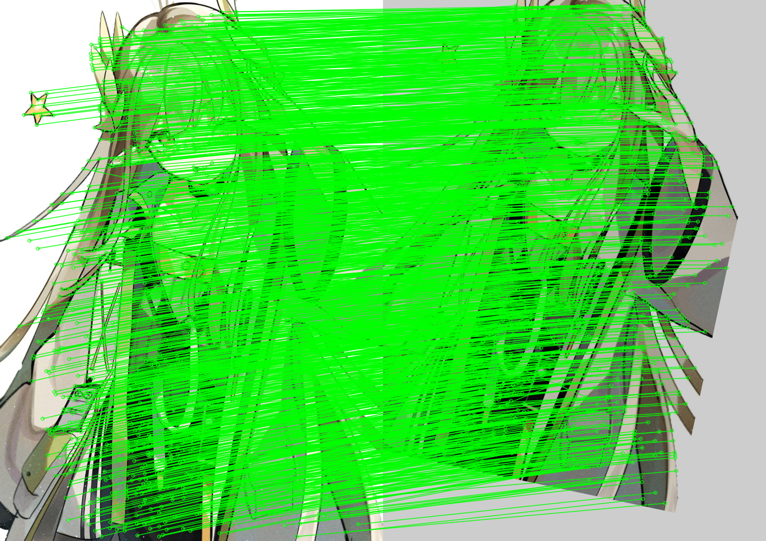
SuperPoint用LightGlue的RANSAC内点：
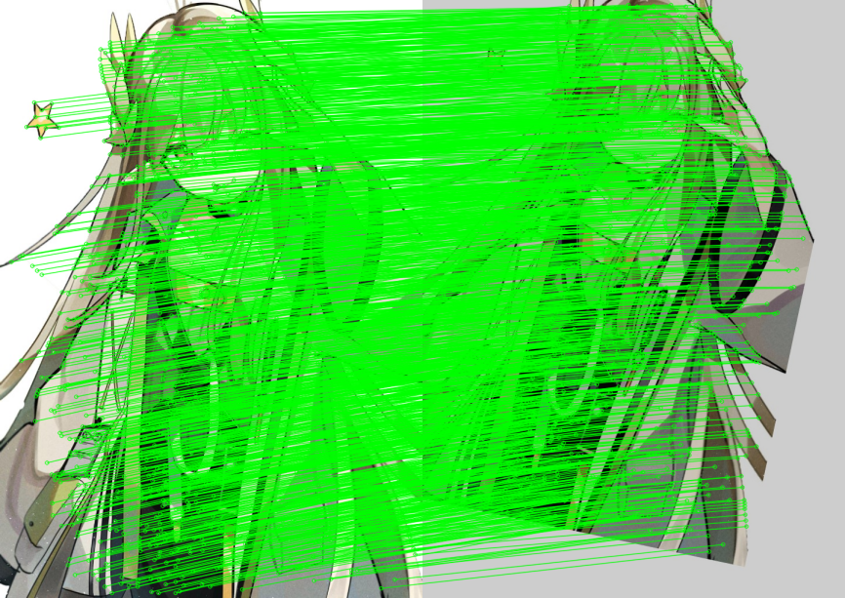
DISK用LightGlue的RANSAC内点：
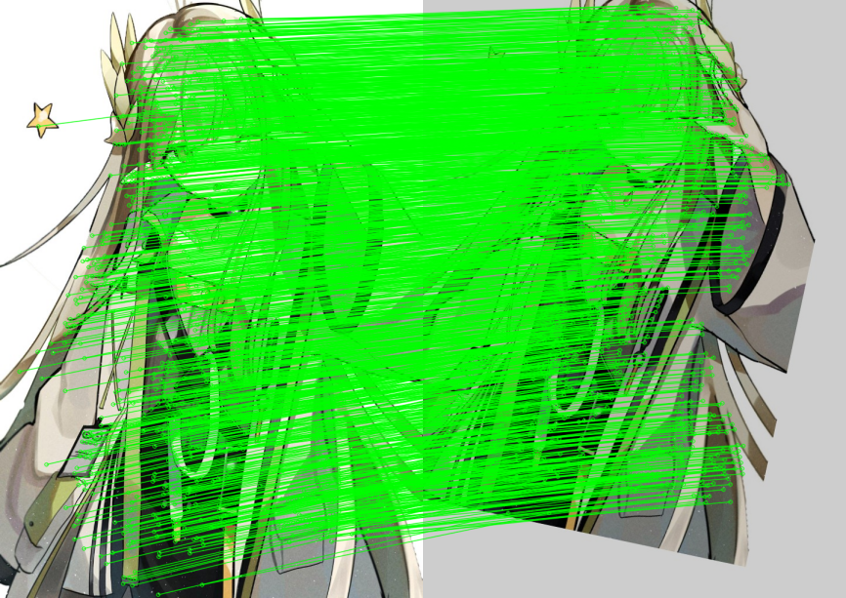
然后是实验第二部分，数据还是基于同一张mumu.jpg，旋转和尺度序列沿用实验6生成的sweep图和sweep_meta.json，定量指标如下：
feature | matcher | sweep_type | param_value | num_kp1 | num_kp2 | num_matches | num_inliers | inlier_ratio | mean_reproj_err | t_extract_ms | t_match_ms
superpoint | nn | rotation | 0 | 2048 | 2048 | 1993 | 1991 | 0.9989964877069744 | 0.1433863913045485 | 2018.296800000826 | 14.398900006199256
superpoint | lightglue | rotation | 0 | 2048 | 2048 | 1991 | 1990 | 0.9994977398292315 | 0.14608963470595773 | 2018.296800000826 | 346.13700000045355
disk | nn | rotation | 0 | 2048 | 2048 | 1983 | 1982 | 0.9994957135653051 | 0.055376592937669764 | 1514.2281000007642 | 14.702499989653006
disk | lightglue | rotation | 0 | 2048 | 2048 | 1982 | 1982 | 1 | 0.055376592937669764 | 1514.2281000007642 | 232.6007999945432
aliked | nn | rotation | 0 | 2048 | 2048 | 2000 | 1999 | 0.9995 | 0.08143103331607275 | 976.4400999993086 | 13.535799997043796
aliked | lightglue | rotation | 0 | 2048 | 2048 | 1999 | 1999 | 1 | 0.08143103331607275 | 976.4400999993086 | 412.3749999998836
sift | nn | rotation | 0 | 2048 | 2048 | 2001 | 1992 | 0.9955022488755623 | 0.07497358522977596 | 2357.716699989396 | 16.714700002921745
sift | lightglue | rotation | 0 | 2048 | 2048 | 1954 | 1947 | 0.996417604912999 | 0.07828747065972316 | 2357.716699989396 | 1039.0161000104854
superpoint | nn | rotation | 15 | 2048 | 2048 | 1552 | 1445 | 0.9310567010309279 | 1.1368948076423608 | 1861.842099999194 | 12.96629999706056
superpoint | lightglue | rotation | 15 | 2048 | 2048 | 1581 | 1506 | 0.952561669829222 | 1.1024587559460675 | 1861.842099999194 | 401.07970000826754
disk | nn | rotation | 15 | 2048 | 2048 | 1420 | 1376 | 0.9690140845070423 | 0.8226679142419218 | 1486.5901000011945 | 12.702099993475713
disk | lightglue | rotation | 15 | 2048 | 2048 | 1449 | 1419 | 0.979296066252588 | 0.8088606426857219 | 1486.5901000011945 | 523.9735999930417
aliked | nn | rotation | 15 | 2048 | 1835 | 1307 | 1075 | 0.8224942616679418 | 0.9592568893910329 | 922.7873000054387 | 11.887500004377216
aliked | lightglue | rotation | 15 | 2048 | 1835 | 1346 | 1315 | 0.9769687964338781 | 0.8871717933696616 | 922.7873000054387 | 512.7956999931484
sift | nn | rotation | 15 | 2048 | 2048 | 1537 | 1335 | 0.8685751463890696 | 1.1617535378790447 | 2088.7736000004224 | 16.303500000503846
sift | lightglue | rotation | 15 | 2048 | 2048 | 1465 | 1220 | 0.8327645051194539 | 1.17523022770346 | 2088.7736000004224 | 969.4389999931445
superpoint | nn | rotation | 30 | 2048 | 2039 | 1275 | 1078 | 0.8454901960784313 | 1.1912047506937036 | 1864.2806999996537 | 13.075399998342618
superpoint | lightglue | rotation | 30 | 2048 | 2039 | 1498 | 1473 | 0.9833110814419226 | 1.1644692964794536 | 1864.2806999996537 | 489.19730000488926
disk | nn | rotation | 30 | 2048 | 2048 | 335 | 133 | 0.3970149253731343 | 1.3964105598741943 | 1486.137100000633 | 11.716499997419305
disk | lightglue | rotation | 30 | 2048 | 2048 | 1287 | 1268 | 0.9852369852369852 | 1.1901731134197606 | 1486.137100000633 | 810.228600006667
aliked | nn | rotation | 30 | 2048 | 1798 | 723 | 361 | 0.49930843706777317 | 1.6683591007568523 | 916.9398999947589 | 10.5430000112392
aliked | lightglue | rotation | 30 | 2048 | 1798 | 1116 | 975 | 0.8736559139784946 | 1.4816692541931455 | 916.9398999947589 | 530.524299989338
sift | nn | rotation | 30 | 2048 | 2048 | 1464 | 1364 | 0.9316939890710383 | 1.1749247357043247 | 1980.2764999913052 | 15.855899997404777
sift | lightglue | rotation | 30 | 2048 | 2048 | 1329 | 1248 | 0.9390519187358917 | 1.1206041551835706 | 1980.2764999913052 | 952.9082000080962
superpoint | nn | rotation | 45 | 2048 | 1974 | 618 | 211 | 0.3414239482200647 | 1.2378246678575122 | 1850.5409999925178 | 12.310499994782731
superpoint | lightglue | rotation | 45 | 2048 | 1974 | 1425 | 1195 | 0.8385964912280702 | 1.1723152806321766 | 1850.5409999925178 | 691.0632999934023
disk | nn | rotation | 45 | 2048 | 2048 | 215 | 7 | 0.03255813953488372 | 244.41084622703428 | 1495.014700005413 | 13.480900001013651
disk | lightglue | rotation | 45 | 2048 | 2048 | 1149 | 1004 | 0.8738033072236727 | 1.6166253954385728 | 1495.014700005413 | 918.1700000044657
aliked | nn | rotation | 45 | 2048 | 2048 | 513 | 8 | 0.015594541910331383 | 90.7418247486118 | 962.5071000045864 | 11.917000010726042
aliked | lightglue | rotation | 45 | 2048 | 2048 | 987 | 792 | 0.8024316109422492 | 2.212821557525927 | 962.5071000045864 | 711.7840999999316
sift | nn | rotation | 45 | 2048 | 2048 | 1441 | 1079 | 0.7487855655794587 | 1.219063584021074 | 2131.164999998873 | 18.058900008327328
sift | lightglue | rotation | 45 | 2048 | 2048 | 1118 | 1030 | 0.9212880143112702 | 1.147753235785344 | 2131.164999998873 | 1073.229599991464
superpoint | nn | rotation | 60 | 2048 | 1613 | 459 | 7 | 0.015250544662309368 | 433.54092884249667 | 2065.7867999980226 | 14.542900011292659
superpoint | lightglue | rotation | 60 | 2048 | 1613 | 1194 | 970 | 0.8123953098827471 | 1.2210977172004156 | 2065.7867999980226 | 897.3522000014782
disk | nn | rotation | 60 | 2048 | 2048 | 177 | 6 | 0.03389830508474576 | 417.03478339585246 | 1536.5038000018103 | 12.741600003209896
disk | lightglue | rotation | 60 | 2048 | 2048 | 122 | 69 | 0.5655737704918032 | 2.499510980007291 | 1536.5038000018103 | 680.1651999994647
aliked | nn | rotation | 60 | 2048 | 2048 | 482 | 7 | 0.014522821576763486 | 279.32242890658017 | 947.7904999948805 | 14.72940000530798
aliked | lightglue | rotation | 60 | 2048 | 2048 | 729 | 484 | 0.663923182441701 | 3.000741449598971 | 947.7904999948805 | 795.6181000045035
sift | nn | rotation | 60 | 2048 | 2048 | 1366 | 1212 | 0.8872620790629575 | 1.176450994038248 | 2206.0539000085555 | 17.41780000156723
sift | lightglue | rotation | 60 | 2048 | 2048 | 784 | 658 | 0.8392857142857143 | 1.086158738822404 | 2206.0539000085555 | 968.0252999969525
superpoint | nn | scale | 0.6 | 2048 | 1519 | 1043 | 849 | 0.8139980824544583 | 1.532752358619642 | 1992.0184999937192 | 10.918899992248043
superpoint | lightglue | scale | 0.6 | 2048 | 1519 | 1092 | 1087 | 0.9954212454212454 | 1.1659960384723718 | 1992.0184999937192 | 427.436600002693
disk | nn | scale | 0.6 | 2048 | 2048 | 1111 | 1067 | 0.9603960396039604 | 0.8937675959192714 | 1520.745400004671 | 14.14719999593217
disk | lightglue | scale | 0.6 | 2048 | 2048 | 1173 | 984 | 0.8388746803069054 | 0.881618815844005 | 1520.745400004671 | 617.4093000008725
aliked | nn | scale | 0.6 | 2048 | 1100 | 899 | 831 | 0.9243604004449388 | 1.0492107081778277 | 876.9069999980275 | 10.54889999795705
aliked | lightglue | scale | 0.6 | 2048 | 1100 | 930 | 897 | 0.964516129032258 | 0.8706939250068846 | 876.9069999980275 | 414.5566999941366
sift | nn | scale | 0.6 | 2048 | 2048 | 720 | 537 | 0.7458333333333333 | 1.2294189565660363 | 2135.007700009737 | 15.299499995307997
sift | lightglue | scale | 0.6 | 2048 | 2048 | 34 | 27 | 0.7941176470588235 | 0.9995662594835184 | 2135.007700009737 | 806.536000003689
superpoint | nn | scale | 0.75 | 2048 | 1802 | 1342 | 1211 | 0.9023845007451565 | 1.24387302505146 | 2126.8152999982703 | 12.140199993154965
superpoint | lightglue | scale | 0.75 | 2048 | 1802 | 1382 | 1232 | 0.8914616497829233 | 1.1527841758298412 | 2126.8152999982703 | 369.2838999995729
disk | nn | scale | 0.75 | 2048 | 2048 | 1331 | 1256 | 0.9436513899323816 | 0.7866086681418044 | 1517.658599987044 | 15.252899989718571
disk | lightglue | scale | 0.75 | 2048 | 2048 | 1322 | 1250 | 0.9455370650529501 | 0.7608912349462349 | 1517.658599987044 | 373.7647000089055
aliked | nn | scale | 0.75 | 2048 | 1517 | 1265 | 1226 | 0.9691699604743083 | 0.7445977942908701 | 957.3278000025311 | 14.21439999830909
aliked | lightglue | scale | 0.75 | 2048 | 1517 | 1295 | 1288 | 0.9945945945945946 | 0.7011468955893195 | 957.3278000025311 | 445.72400000470225
sift | nn | scale | 0.75 | 2048 | 2048 | 1035 | 861 | 0.8318840579710145 | 1.1841887190204876 | 2275.3837000054773 | 17.394499998772517
sift | lightglue | scale | 0.75 | 2048 | 2048 | 985 | 853 | 0.8659898477157361 | 1.1568152278359836 | 2275.3837000054773 | 1096.1410000018077
superpoint | nn | scale | 0.9 | 2048 | 2048 | 1602 | 1493 | 0.931960049937578 | 1.1144449127050484 | 2133.4222000004956 | 17.53499999176711
superpoint | lightglue | scale | 0.9 | 2048 | 2048 | 1611 | 1418 | 0.8801986343885785 | 1.0921987717929946 | 2133.4222000004956 | 422.15490000671707
disk | nn | scale | 0.9 | 2048 | 2048 | 1631 | 1606 | 0.9846719803801349 | 0.616657120600669 | 1496.6502000024775 | 13.490600002114661
disk | lightglue | scale | 0.9 | 2048 | 2048 | 1618 | 1567 | 0.9684796044499382 | 0.6232651306601384 | 1496.6502000024775 | 271.2456999870483
aliked | nn | scale | 0.9 | 2048 | 1924 | 1659 | 1641 | 0.9891500904159132 | 0.48121664577019685 | 922.8605000098469 | 12.39650000934489
aliked | lightglue | scale | 0.9 | 2048 | 1924 | 1664 | 1650 | 0.9915865384615384 | 0.48169939916970295 | 922.8605000098469 | 407.6774000131991
sift | nn | scale | 0.9 | 2048 | 2048 | 1329 | 1050 | 0.7900677200902935 | 1.2188630316762827 | 2066.671300010057 | 15.781800000695512
sift | lightglue | scale | 0.9 | 2048 | 2048 | 1281 | 1206 | 0.9414519906323185 | 1.1839185216246524 | 2066.671300010057 | 1004.8133999953279
superpoint | nn | scale | 1 | 2048 | 2048 | 1993 | 1991 | 0.9989964877069744 | 0.1433863913045485 | 2094.1354999959003 | 17.034000004059635
superpoint | lightglue | scale | 1 | 2048 | 2048 | 1991 | 1990 | 0.9994977398292315 | 0.14608963470595773 | 2094.1354999959003 | 352.3170999978902
disk | nn | scale | 1 | 2048 | 2048 | 1983 | 1982 | 0.9994957135653051 | 0.055376592937669764 | 1525.277199994889 | 21.803699986776337
disk | lightglue | scale | 1 | 2048 | 2048 | 1982 | 1982 | 1 | 0.055376592937669764 | 1525.277199994889 | 258.1590000045253
aliked | nn | scale | 1 | 2048 | 2048 | 2000 | 1999 | 0.9995 | 0.08143103331607275 | 944.4578999973601 | 13.913999995565973
aliked | lightglue | scale | 1 | 2048 | 2048 | 1999 | 1999 | 1 | 0.08143103331607275 | 944.4578999973601 | 403.74680000240915
sift | nn | scale | 1 | 2048 | 2048 | 2001 | 1992 | 0.9955022488755623 | 0.07497358522977596 | 2062.1007999870926 | 16.423300010501407
sift | lightglue | scale | 1 | 2048 | 2048 | 1954 | 1947 | 0.996417604912999 | 0.07828747065972316 | 2062.1007999870926 | 1055.6431000004523
superpoint | nn | scale | 1.15 | 2048 | 2048 | 1516 | 1372 | 0.9050131926121372 | 1.15254055399714 | 1971.4281000051415 | 13.011600007303059
superpoint | lightglue | scale | 1.15 | 2048 | 2048 | 1530 | 1466 | 0.9581699346405229 | 1.150349560468479 | 1971.4281000051415 | 413.2495999947423
disk | nn | scale | 1.15 | 2048 | 2048 | 1495 | 1452 | 0.9712374581939799 | 0.6697862793114421 | 1499.9246999941533 | 13.774099992588162
disk | lightglue | scale | 1.15 | 2048 | 2048 | 1486 | 1477 | 0.993943472409152 | 0.6684267184356405 | 1499.9246999941533 | 255.40980001096614
aliked | nn | scale | 1.15 | 2048 | 2048 | 1612 | 1595 | 0.989454094292804 | 0.4737175573169209 | 1039.5089000085136 | 15.189899990218692
aliked | lightglue | scale | 1.15 | 2048 | 2048 | 1615 | 1566 | 0.9696594427244583 | 0.46496819814496204 | 1039.5089000085136 | 385.367100010626
sift | nn | scale | 1.15 | 2048 | 2048 | 1269 | 1112 | 0.876280535855004 | 1.1695775934117898 | 2147.070299994084 | 16.842900004121475
sift | lightglue | scale | 1.15 | 2048 | 2048 | 1261 | 905 | 0.7176843774781919 | 1.2967628320938083 | 2147.070299994084 | 1019.3159000045853
superpoint | nn | scale | 1.3 | 2048 | 1947 | 1297 | 1177 | 0.9074787972243639 | 1.303945256540818 | 2144.9368000030518 | 17.559699990670197
superpoint | lightglue | scale | 1.3 | 2048 | 1947 | 1313 | 1284 | 0.9779131759329779 | 1.353339828511805 | 2144.9368000030518 | 373.09530000493396
disk | nn | scale | 1.3 | 2048 | 2048 | 1220 | 1173 | 0.9614754098360656 | 0.8105061045926916 | 1536.286000002292 | 14.136099998722784
disk | lightglue | scale | 1.3 | 2048 | 2048 | 1205 | 1175 | 0.975103734439834 | 0.8209809977093672 | 1536.286000002292 | 243.23390000790823
aliked | nn | scale | 1.3 | 2048 | 2048 | 1312 | 1257 | 0.958079268292683 | 0.7016982118172378 | 1019.7681999998167 | 12.659899992286228
aliked | lightglue | scale | 1.3 | 2048 | 2048 | 1329 | 1298 | 0.9766741911211437 | 0.6857948235012841 | 1019.7681999998167 | 328.9879999938421
sift | nn | scale | 1.3 | 2048 | 2048 | 1109 | 829 | 0.7475202885482417 | 1.2811076114846585 | 2115.5887999921106 | 18.33390000683721
sift | lightglue | scale | 1.3 | 2048 | 2048 | 990 | 903 | 0.9121212121212121 | 1.2489283421607964 | 2115.5887999921106 | 992.409200000111
匹配方式同样是四种特征乘NN、LightGlue两种匹配器。
先说旋转。角度取0、15、30、45、60度，尺度固定1.0。0度的时候大家都很好，NN和LightGlue内点率基本都在九成九以上，差别不大。角度变大以后，NN掉得特别快，尤其是DISK和ALIKED。30度时DISK加NN只有三百多对匹配、一百三十多个内点，内点率不到四成；同一个特征换LightGlue能到一千二百多内点，内点率九成八以上。ALIKED在30度也是类似，NN大约五成内点率，LightGlue能到八成多。SuperPoint30度时NN大约八成五，LightGlue九成八。SIFT在大旋转上相对最扛打，30度两种方法都还在九成左右。45度、60度NN很多组合几乎废掉，内点率只有百分之几；LightGlue还能撑住一部分，比如45度SuperPoint还能有八成多内点率，但60度时大家都会变差，没有哪一种还特别稳。
四条旋转曲线：
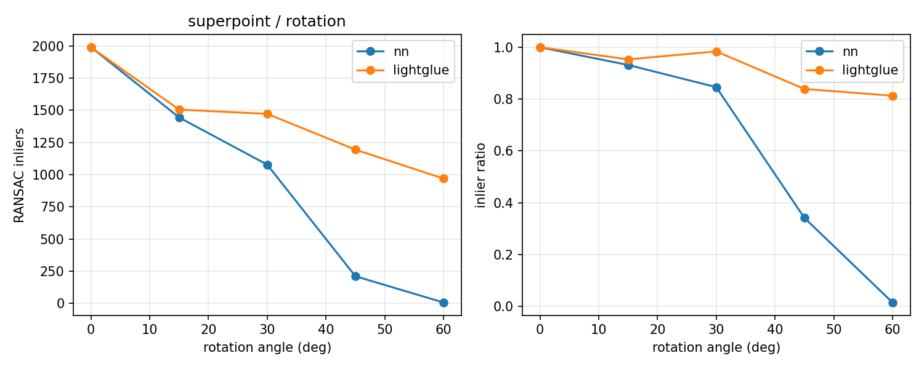
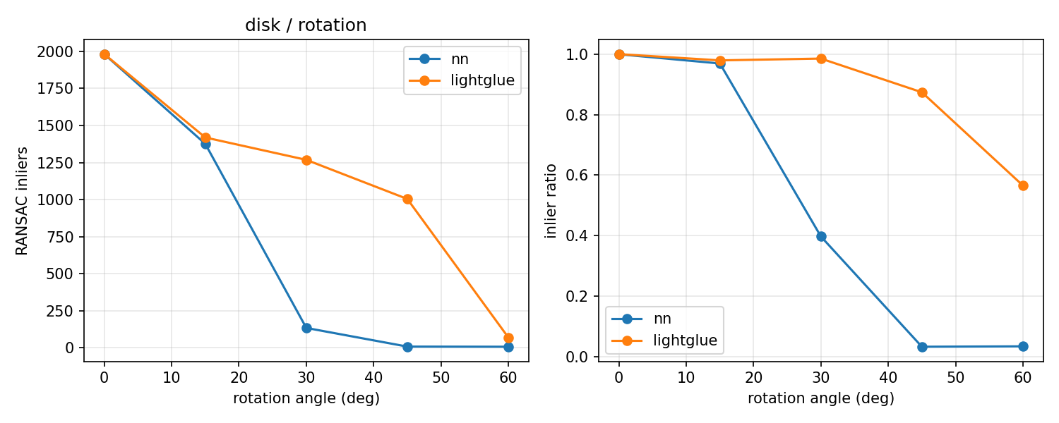
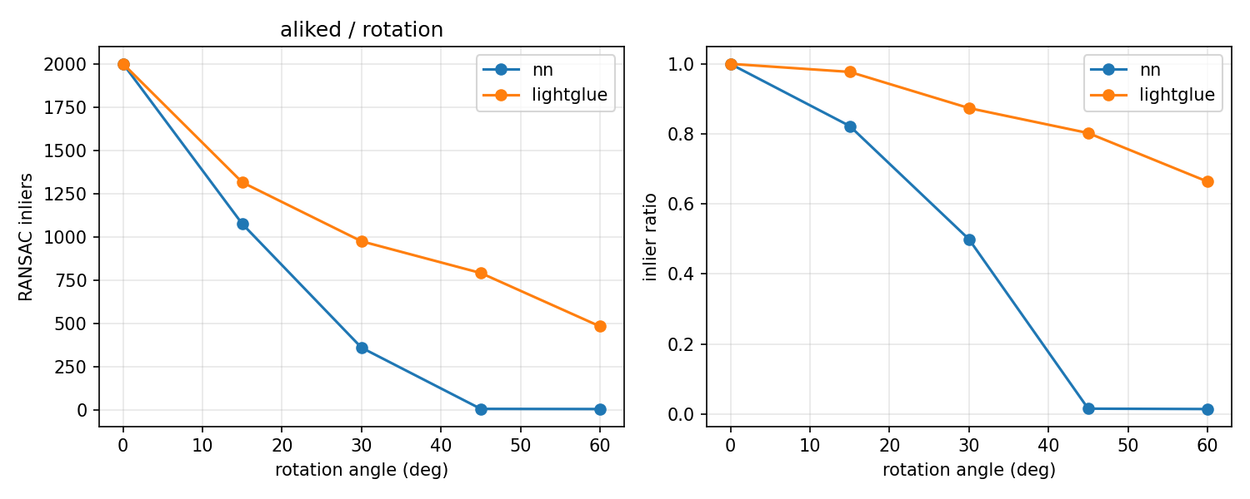
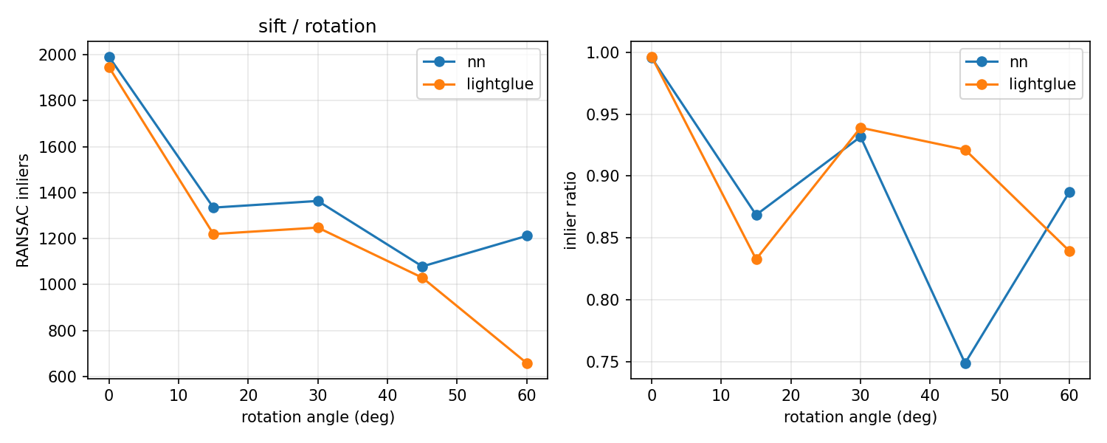
30度时DISK用NN，匹配很乱，可以说明最近邻在大旋转下不够用：
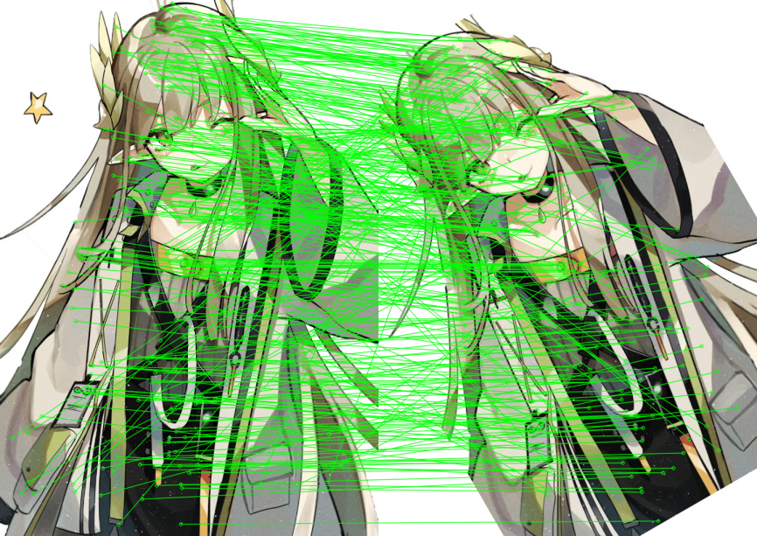
同一角度DISK用LightGlue的RANSAC内点，会整齐很多：
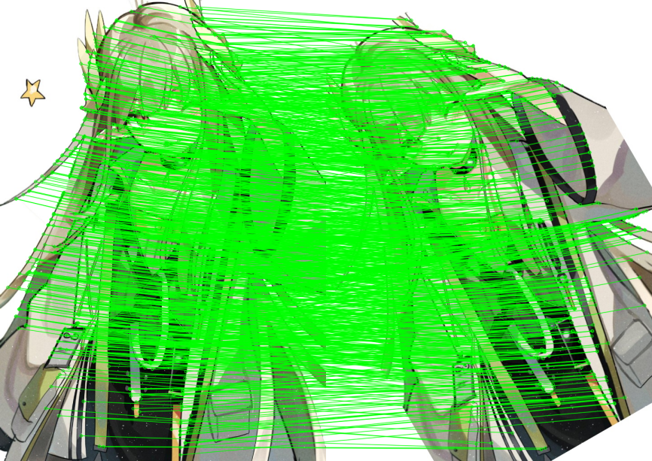
30度四种特征、两种匹配器的内点数汇总：
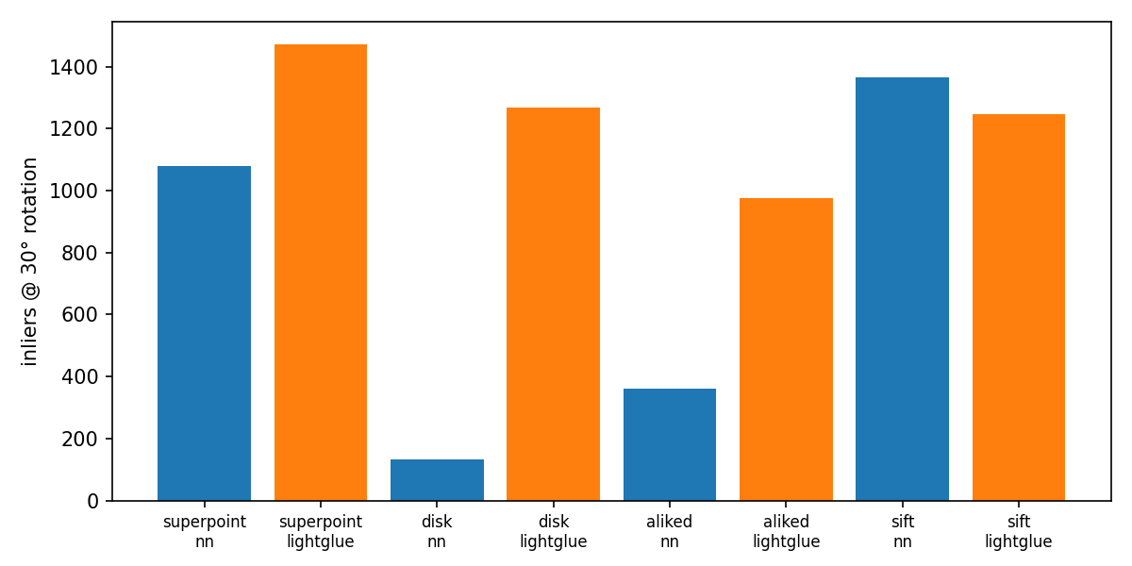
60度SuperPointNN的RANSAC（几乎没内点，可选作反面例子）：
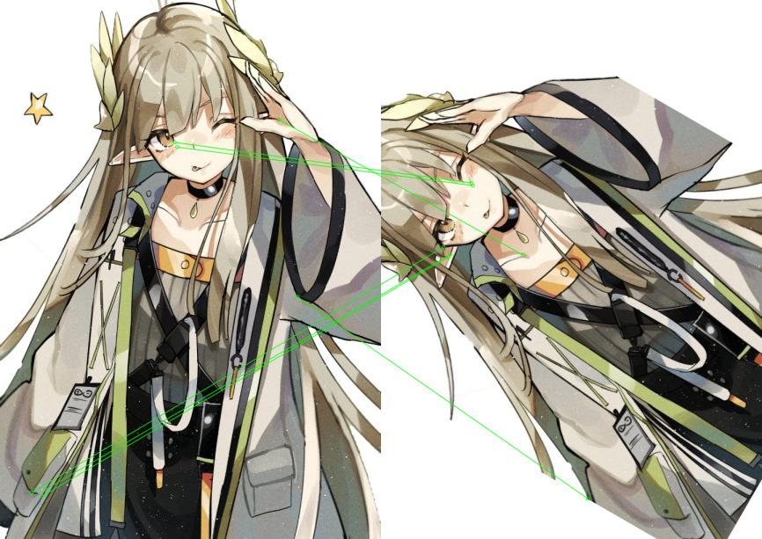
60度SuperPointLightGlue的RANSAC（同一角度改善明显，可选）：
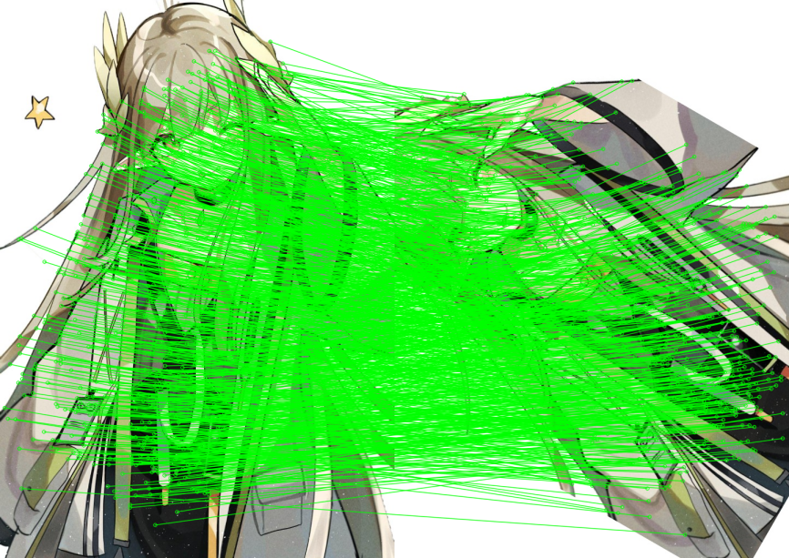
再说尺度。因子取0.6、0.75、0.9、1.0、1.15、1.3，没有旋转。整体比旋转温和很多，1.0时四种特征两种匹配器内点率几乎都是满的。缩到0.6时SuperPoint的LightGlue仍然接近满内点，NN大约八成一；DISK、ALIKED缩小后NN和LightGlue都还可以。放到1.3时多数也在九成以上。和实验6.2的结论有点像：纯缩放两者差距不大，一旦带上明显旋转，学习型匹配比直接最近邻稳得多。本实验里旋转比尺度更难测。
尺度曲线（选两张即可，例如SuperPoint和DISK）：
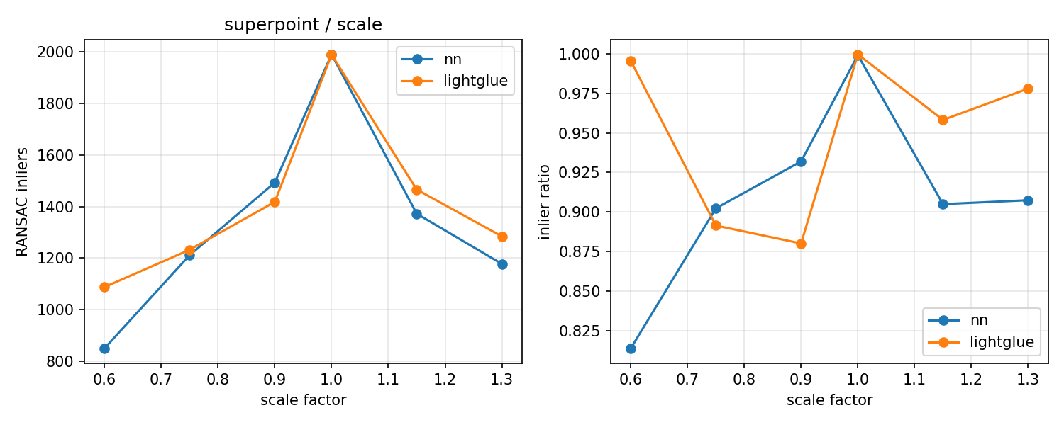
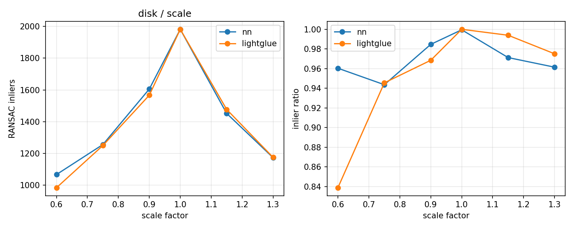
缩放到0.6时SuperPointNN的RANSAC：
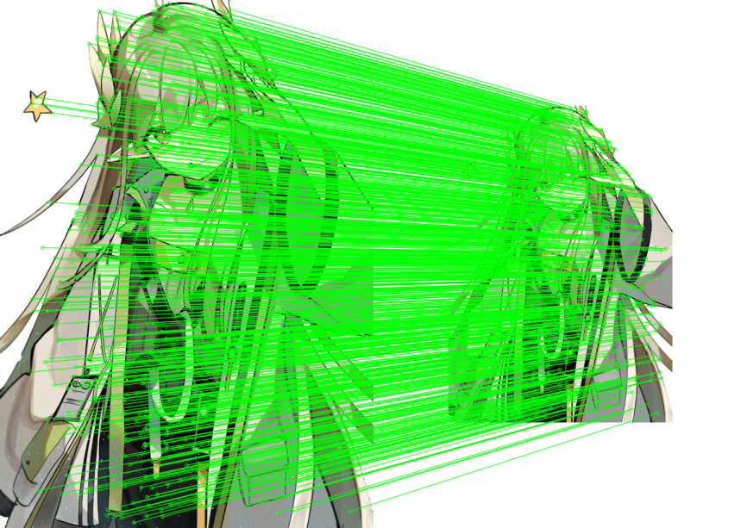
同一尺度SuperPointLightGlue的RANSAC：
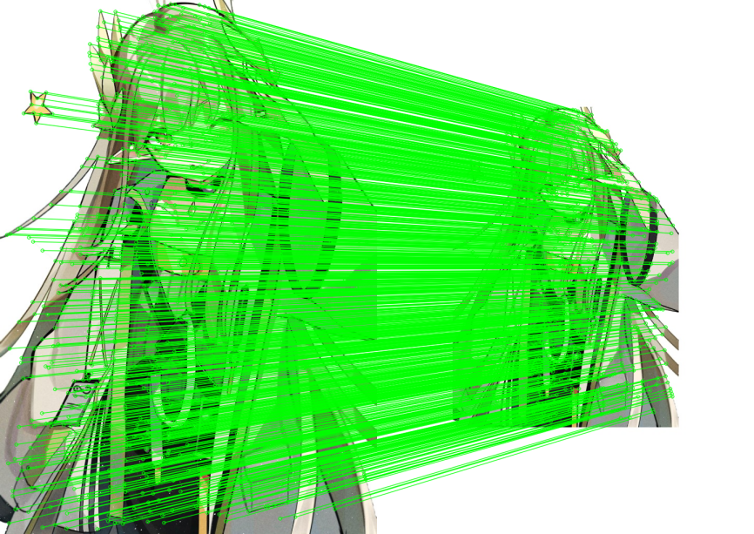
从特征本身比一下：ALIKED提特征最快，大概不到一秒；DISK、SuperPoint一两秒；SIFT最慢，两秒多。无变换或小角度时DISK、ALIKED、SuperPoint都挺好。大旋转加NN时DISK、ALIKED最容易崩，SIFT经典描述子反而稳一点。大旋转加LightGlue时SuperPoint和DISK恢复最好。和实验6对比的话，实验6已经看出旋转大时SuperPoint优于SIFT的NN匹配；实验7在此基础上说明，即使用同一套特征，换成LightGlue还能再抬一截，尤其DISK、ALIKED加NN在30度以后几乎不能用，加LightGlue又能回到可接受水平。
总的来说，互最近邻实现简单、速度快，图像之间只有轻微变化时够用；旋转一大或像实验7-1那种综合仿射，更应用LightGlue，内点和几何一致性明显更好，代价是CPU上匹配要慢一个数量级。

