首先完成代码的编写：
如果检查作业需要编译代码验证结果，可参考以下步骤：
在shell中运行
$cat /proc/bus/input/devices
先在这个里边找到自己使用的键盘对应的事件号，比如下图：
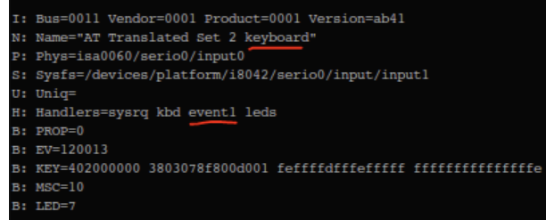
将代码中的键盘事件路径中的event的后缀编号改为对应的编号
编译这个文件，可以直接使用gcc编译
$gcc hw3.c -o hw3
然后使用root权限运行这个程序
sudo ./hw3
然后就可以看到结果了。
#include <linux/input.h>
#include <stdio.h>
#include <stdlib.h>
#include <string.h>
#include <unistd.h>
#include <fcntl.h>
#include <pthread.h>
int rows = 8;
int currentKey = 0;
char dir[256] = "/dev/input/event20";//键盘事件路径，请根据自己使用的keyboard对应的event号修改

void init_layout(int rows)
{
printf("\033[2J");
printf("\033[1;1H");
printf("最高兼容98配列按键\n");
printf("不支持组合按键\n");
printf("如果没有结果请检查虚拟机输入设置或更改事件路径\n");
printf("开始监听键盘输入(键入Ctrl + C退出，按下Enter键会清空输入行)");
printf("\033[%d;1H", rows);
fflush(stdout);
}
void get_input(char* input, int max_len, int rows)
{
printf("\033[%d;1H", rows);
printf("\033[2K");
fgets(input, max_len, stdin);
input[strcspn(input, "\n")] = 0;
}
void my_printf(const char* format, int rows, int cols)
{
printf("\033[%d;%dH", rows - 1,cols);
printf("\033[2K");
printf("%s\n", format);
printf("\033[%d;1H", rows);
fflush(stdout);
}

void listen_keyboard()
{
int fd = open(dir, O_RDONLY);
if (fd < 0)
{
perror("open event file failed!");
exit(1);
}
printf("%d",currentKey);
fflush(stdout);
struct input_event ev;
ssize_t n;
while (1)
{
n = read(fd, &ev, sizeof(ev));
if (n != -1)
{
if (ev.type == EV_KEY && ev.value == 1)
{
currentKey = ev.code;
}
}
}
close(fd);
}
void listen_currentKey()
{
static int lastKey = 0;
while (1)
{
if (lastKey != currentKey)
{
//printf("\033[10；1]CurrentKey: %d\n", currentKey);
fflush(stdout);
char output[128];
bool mark = true;
switch (currentKey)
{
case KEY_UP:
strcpy(output,"↑");
break;
case KEY_DOWN:
strcpy(output,"↓");
break;
case KEY_LEFT:
strcpy(output, "←");
break;
case KEY_RIGHT:
strcpy(output, "→");
break;
case KEY_ENTER:
strcpy(output, "Enter");
printf("\033[%d;1H", rows);
printf("\033[2K");
break;
case KEY_BACKSPACE:
strcpy(output, "Backspace");
break;
case KEY_DELETE:
strcpy(output, "Delete");
break;
case KEY_HOME:
strcpy(output, "Home");
break;
case KEY_END:
strcpy(output, "End");
break;
case KEY_PAGEUP:
strcpy(output, "PageUp");
break;
case KEY_PAGEDOWN:
strcpy(output, "PageDown");
break;
case KEY_1:
strcpy(output, "1");
break;
case KEY_2:
strcpy(output, "2");
break;
case KEY_3:
strcpy(output, "3");
break;
case KEY_4:
strcpy(output, "4");
break;
case KEY_5:
strcpy(output, "5");
break;
case KEY_6:
strcpy(output, "6");
break;
case KEY_7:
strcpy(output, "7");
break;
case KEY_8:
strcpy(output, "8");
break;
case KEY_9:
strcpy(output, "9");
break;
case KEY_0:
strcpy(output, "0");
break;
case KEY_A:
strcpy(output, "A");
break;
case KEY_B:
strcpy(output, "B");
break;
case KEY_C:
strcpy(output, "C");
break;
case KEY_D:
strcpy(output, "D");
break;
case KEY_E:
strcpy(output, "E");
break;
case KEY_F:
strcpy(output, "F");
break;
case KEY_G:
strcpy(output, "G");
break;
case KEY_H:
strcpy(output, "H");
break;
case KEY_I:
strcpy(output, "I");
break;
case KEY_J:
strcpy(output, "J");
break;
case KEY_K:
strcpy(output, "K");
break;
case KEY_L:
strcpy(output, "L");
break;
case KEY_M:
strcpy(output, "M");
break;
case KEY_N:
strcpy(output, "N");
break;
case KEY_O:
strcpy(output, "O");
break;
case KEY_P:
strcpy(output, "P");
break;
case KEY_Q:
strcpy(output, "Q");
break;
case KEY_R:
strcpy(output, "R");
break;
case KEY_S:
strcpy(output, "S");
break;
case KEY_T:
strcpy(output, "T");
break;
case KEY_U:
strcpy(output, "U");
break;
case KEY_V:
strcpy(output, "V");
break;
case KEY_W:
strcpy(output, "W");
break;
case KEY_X:
strcpy(output, "X");
break;
case KEY_Y:
strcpy(output, "Y");
break;
case KEY_Z:
strcpy(output, "Z");
break;
case KEY_F1:
strcpy(output, "F1");
break;
case KEY_F2:
strcpy(output, "F2");
break;
case KEY_F3:
strcpy(output, "F3");
break;
case KEY_F4:
strcpy(output, "F4");
break;
case KEY_F5:
strcpy(output, "F5");
break;
case KEY_F6:
strcpy(output, "F6");
break;
case KEY_F7:
strcpy(output, "F7");
break;
case KEY_F8:
strcpy(output, "F8");
break;
case KEY_F9:
strcpy(output, "F9");
break;
case KEY_F10:
strcpy(output, "F10");
break;
case KEY_F11:
strcpy(output, "F11");
break;
case KEY_F12:
strcpy(output, "F12");
break;
case KEY_ESC:
strcpy(output, "Esc");
break;
case KEY_TAB:
strcpy(output, "Tab");
break;
case KEY_SPACE:
strcpy(output, "Space");
break;
case KEY_MINUS:
strcpy(output, "-");
break;
case KEY_EQUAL:
strcpy(output, "=");
break;
case KEY_LEFTBRACE:
strcpy(output, "[");
break;
case KEY_RIGHTBRACE:
strcpy(output, "]");
break;
case KEY_BACKSLASH:
strcpy(output, "\\");
break;
case KEY_SEMICOLON:
strcpy(output, ");");
break;
case KEY_APOSTROPHE:
strcpy(output, "'");
break;
case KEY_GRAVE:
strcpy(output, "`");
break;
case KEY_COMMA:
strcpy(output, ",");
break;
case KEY_DOT:
strcpy(output, ".");
break;
case KEY_SLASH:
strcpy(output, "/");
break;
case KEY_CAPSLOCK:
strcpy(output, "CapsLock");
break;
case KEY_LEFTSHIFT:
strcpy(output, "Shift");
break;
case KEY_RIGHTSHIFT:
strcpy(output, "Shift");
break;
case KEY_LEFTCTRL:
strcpy(output, "Ctrl");
break;
case KEY_RIGHTCTRL:
strcpy(output, "Ctrl");
break;
case KEY_LEFTALT:
strcpy(output, "Alt");
break;
case KEY_RIGHTALT:
strcpy(output, "Alt");
break;
case KEY_SYSRQ:
strcpy(output, "SysRq");
break;
case KEY_SCROLLLOCK:
strcpy(output, "ScrollLock");
break;
case KEY_NUMLOCK:
strcpy(output, "NumLock");
break;
case KEY_PAUSE:
strcpy(output, "Pause");
break;
case KEY_INSERT:
strcpy(output, "Insert");
break;
case KEY_HOMEPAGE:
strcpy(output, "HomePage");
break;
case KEY_MENU:
strcpy(output, "Menu");
break;
case KEY_POWER:
strcpy(output, "Power");
break;
case KEY_SLEEP:
strcpy(output, "Sleep");
break;
case KEY_WAKEUP:
strcpy(output, "WakeUp");
break;
case KEY_MUTE:
strcpy(output, "Mute");
break;
case KEY_VOLUMEDOWN:
strcpy(output, "VolumeDown");
break;
case KEY_VOLUMEUP:
strcpy(output, "VolumeUp");
break;
case KEY_KP1:
strcpy(output, "1");
break;
case KEY_KP2:
strcpy(output, "2");
break;
case KEY_KP3:
strcpy(output, "3");
break;
case KEY_KP4:
strcpy(output, "4");
break;
case KEY_KP5:
strcpy(output, "5");
break;
case KEY_KP6:
strcpy(output, "6");
break;
case KEY_KP7:
strcpy(output, "7");
break;
case KEY_KP8:
strcpy(output, "8");
break;
case KEY_KP9:
strcpy(output, "9");
break;
case KEY_KP0:
strcpy(output, "0");
break;
case KEY_KPDOT:
strcpy(output, ".");
break;
case KEY_KPENTER:
strcpy(output, "Enter");
break;
case KEY_KPPLUS:
strcpy(output, "+");
break;
case KEY_KPMINUS:
strcpy(output, "-");
break;
case KEY_KPASTERISK:
strcpy(output, "*");
break;
case KEY_KPSLASH:
strcpy(output, "/");
break;
case KEY_KPCOMMA:
strcpy(output, ",");
break;
case KEY_KPEQUAL:
strcpy(output, "=");
break;
default:
strcpy(output, "没有按下的按键或者不是适配的按键");
mark = false;
break;
}
if (mark)
{
strcat(output," 键按下");
}
my_printf(output, rows, 1);
lastKey = currentKey;
}
}
}
void function()
{
pthread_t for_keyboard, for_currentKey;
pthread_create(&for_keyboard, NULL, (void*)listen_keyboard, NULL);
pthread_create(&for_currentKey, NULL, (void*)listen_currentKey, NULL);
pthread_join(for_keyboard, NULL);
pthread_join(for_currentKey, NULL);
}
int main() {
init_layout(rows);
function();
printf("\033[2J");
printf("\033[1;1H");
return 0;
}
以下为一些效果的参考图：
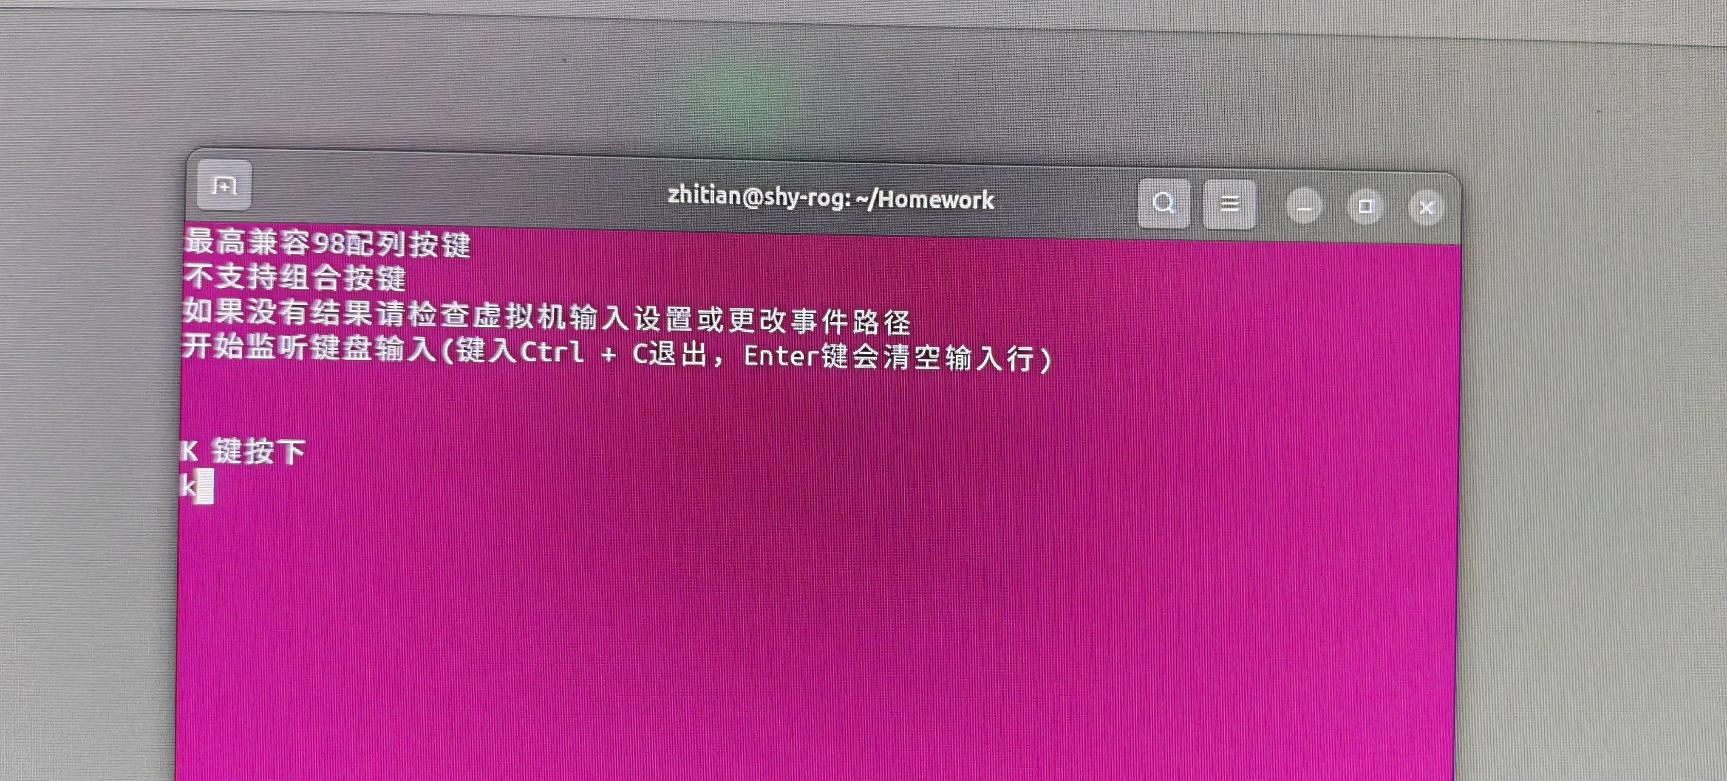
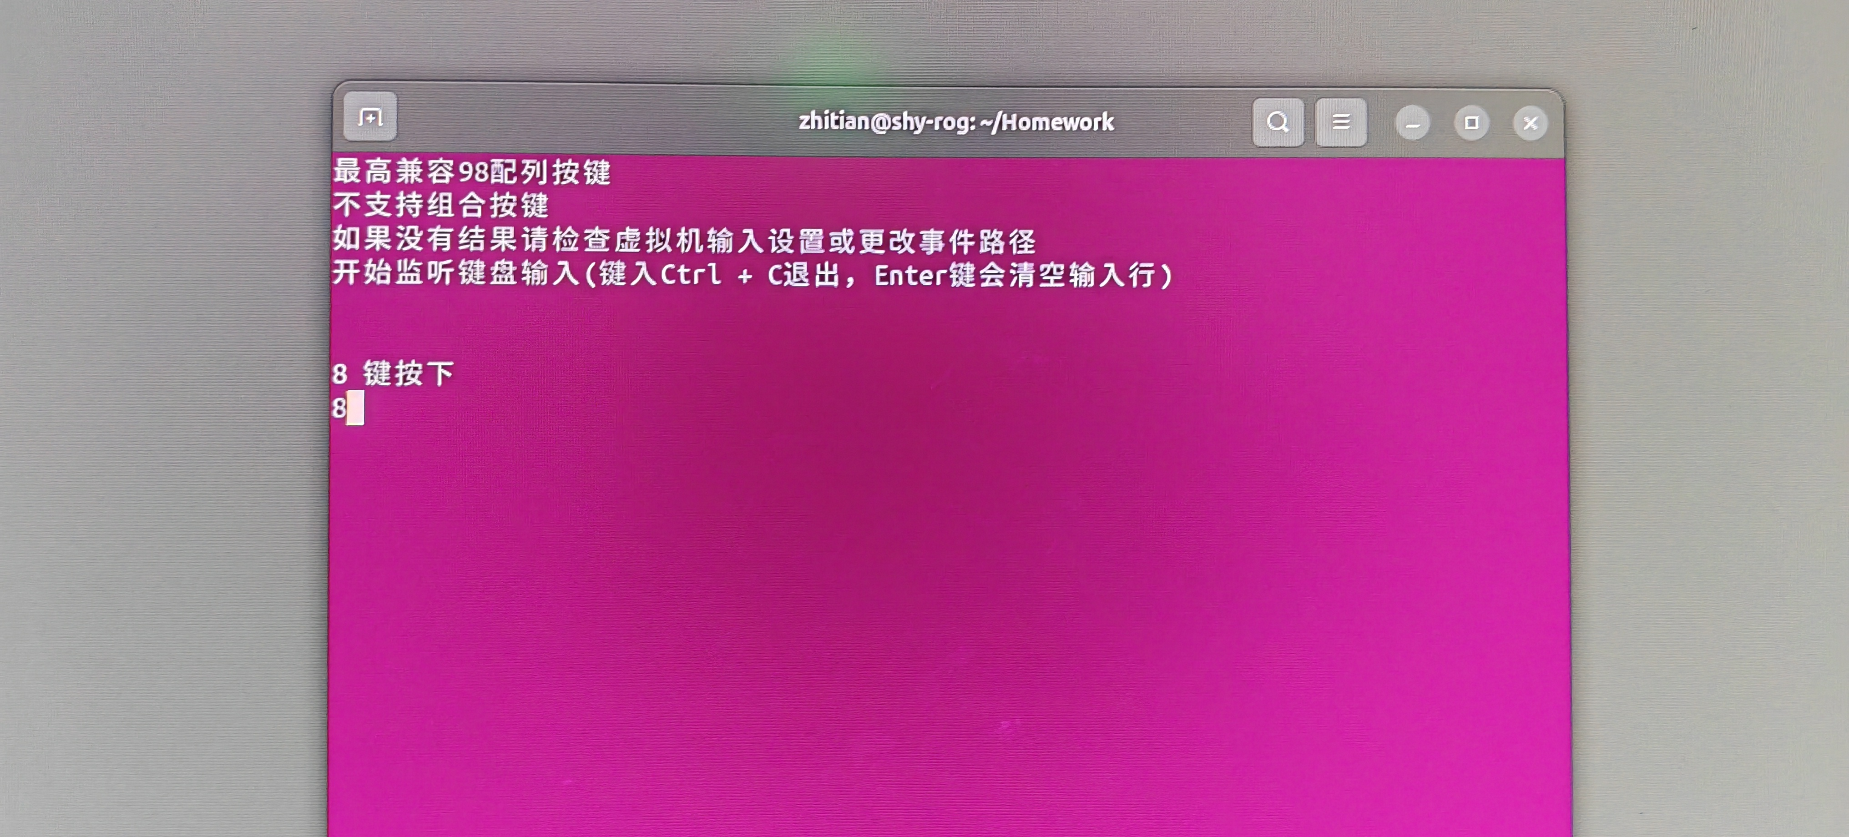
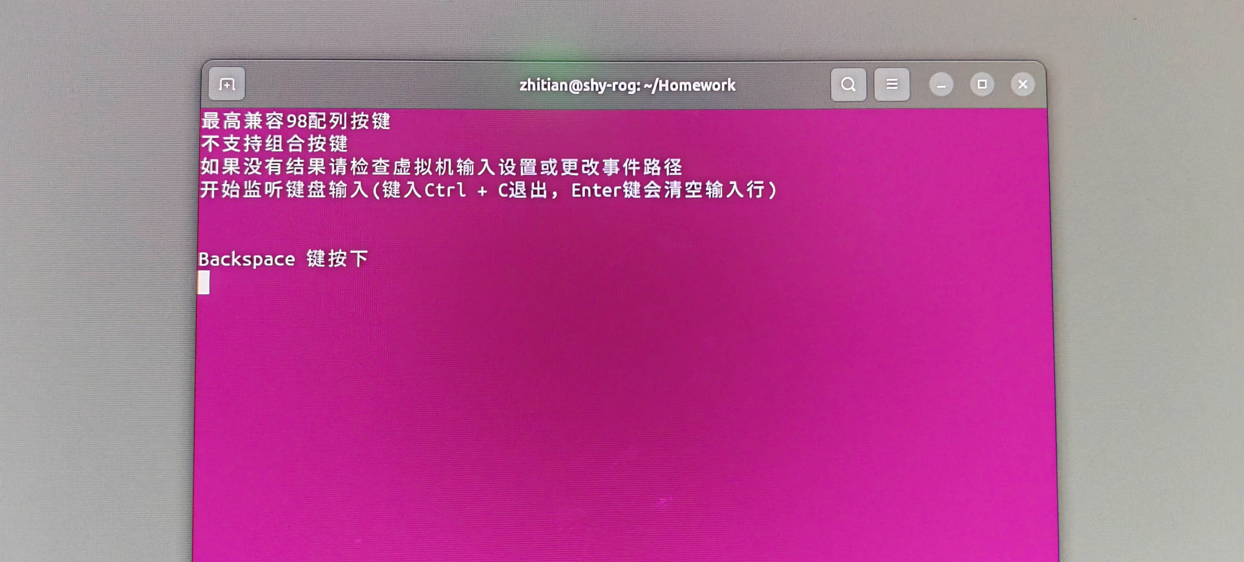
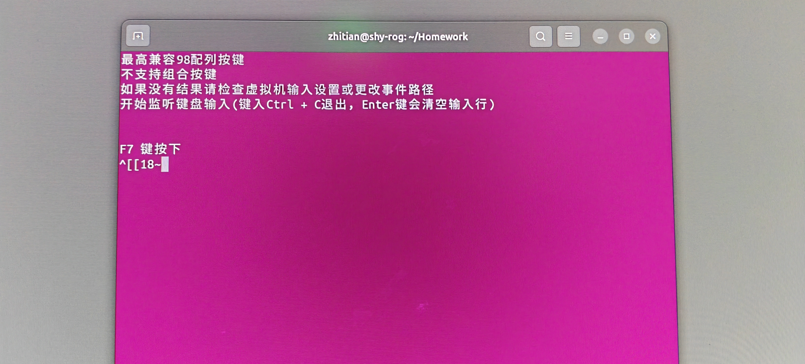
这个监听键盘输入不需要像这个程序输入任何内容，只需要按下按键即可，在系统的任何位置按键都可以，不需要给这个窗口焦点（缺点就是这种实现方式需要root权限运行程序）。

