山东大学 计算机科学与技术 学院
新兴网络技术与实践 课程实验报告

学号：202300130183 | 姓名：宋浩宇 |  | 班级：23级智能班
实验题目：Wireshark Lab: 802.11 WiFi v8.0
实验学时：4 |  | 实验日期：2025/5/28
实验目的：学习了解WiFi
实验结果：
- What are the SSIDs of the two access points that are issuing most of the beacon frames in this trace?
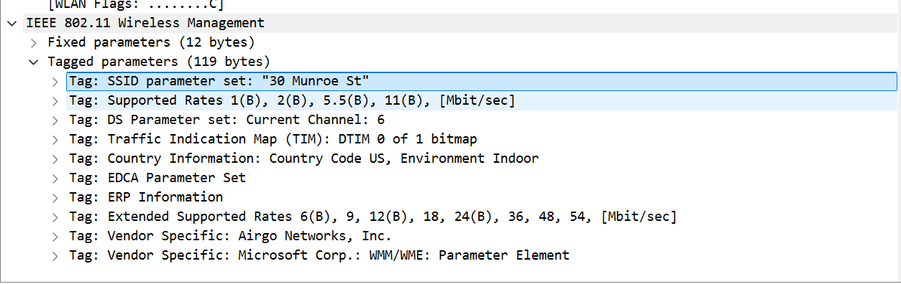
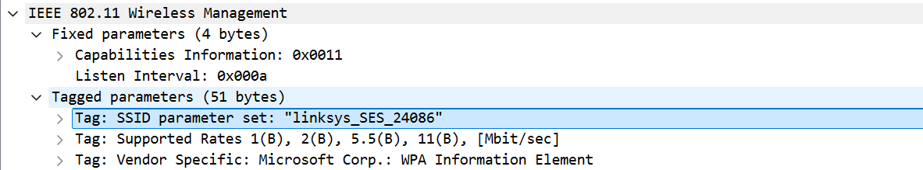
如图，是”39 Munroe St”和”linksys_SES_24086”
- What are the intervals of time between the transmissions of the beacon frames the linksys_ses_24086 access point? From the 30 Munroe St. access point? (Hint: this interval of time is contained in the beacon frame itself).
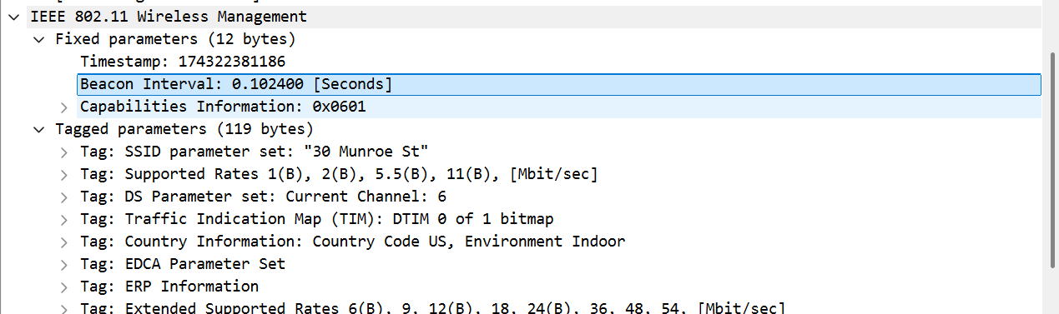
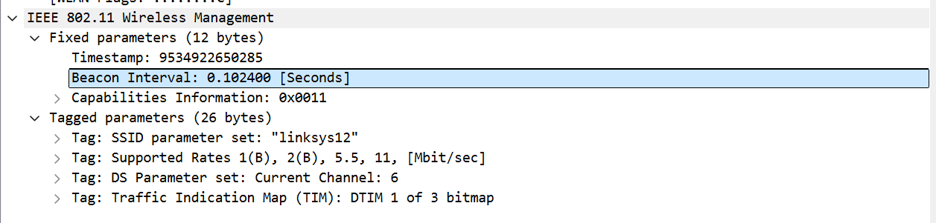
如图，两个的时间间隔都是0.102400s
- What (in hexadecimal notation) is the source MAC address on the beacon frame from 30 Munroe St? Recall from Figure 7.13 in the text that the source, destination, and BSS are three addresses used in an 802.11 frame. For a detailed discussion of the 802.11 frame structure, see section 7 in the IEEE 802.11 standards document (cited above).
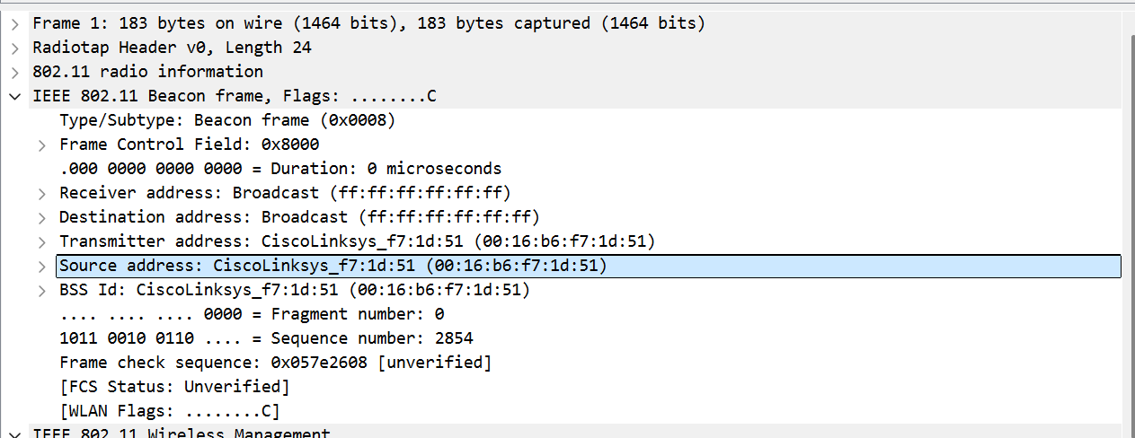
如图，源MAC地址是00:16:b6:f7:1d:51
- What (in hexadecimal notation) is the destination MAC address on the beacon frame from 30 Munroe St??
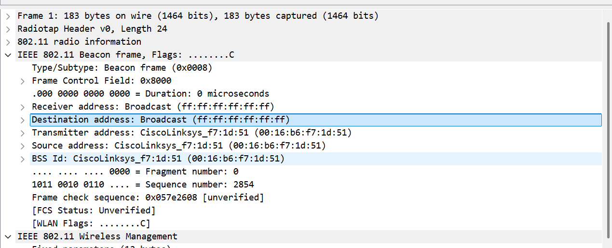
如图，目标MAC地址是ff:ff:ff:ff:ff:ff
- What (in hexadecimal notation) is the MAC BSS id on the beacon frame from 30 Munroe St?
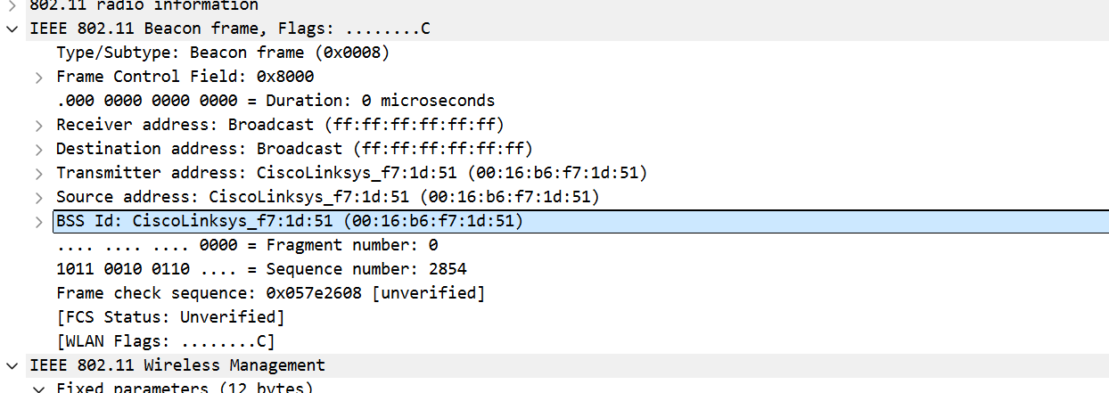
如图，BSS的地址是00:16:b6:f7:1d:51
- The beacon frames from the 30 Munroe St access point advertise that the access point can support four data rates and eight additional “extended supported rates.”What are these rates?
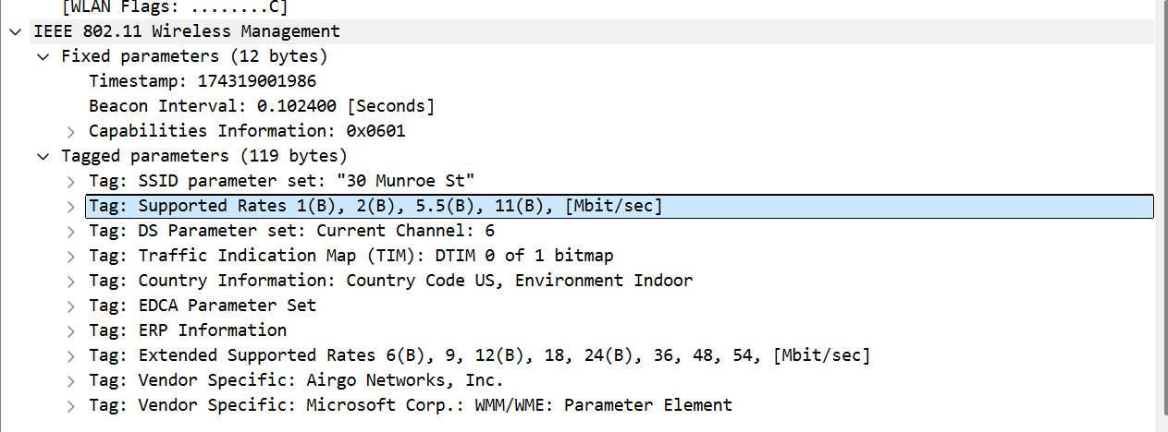
如图，这些速度分别是1Mbps、2Mbps、5.5Mbps、11Mbps、6Mbps、9Mbps、12Mbps、18Mbps、24Mbps、36Mbps、48Mbps、54Mbps
- Find the 802.11 frame containing the SYN TCP segment for this first TCP session (that downloads alice.txt). What are three MAC address fields in the 802.11frame? Which MAC address in this frame corresponds to the wireless host (give the hexadecimal representation of the MAC address for the host)? To the access point? To the first-hop router? What is the IP address of the wireless host sending this TCP segment? What is the destination IP address? Does this destination IP address correspond to the host, access point, first-hop router, or some other network-attached device? Explain.
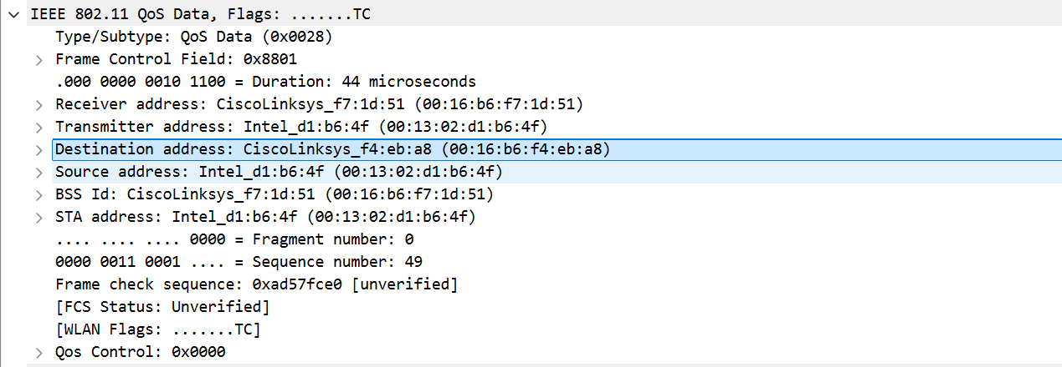
如图，主机是00:13:02:d1:b6:4f，接入点是00:16:b6:f7:1d:51，第一跳地址是00:16:b6:f4:eb:a8，
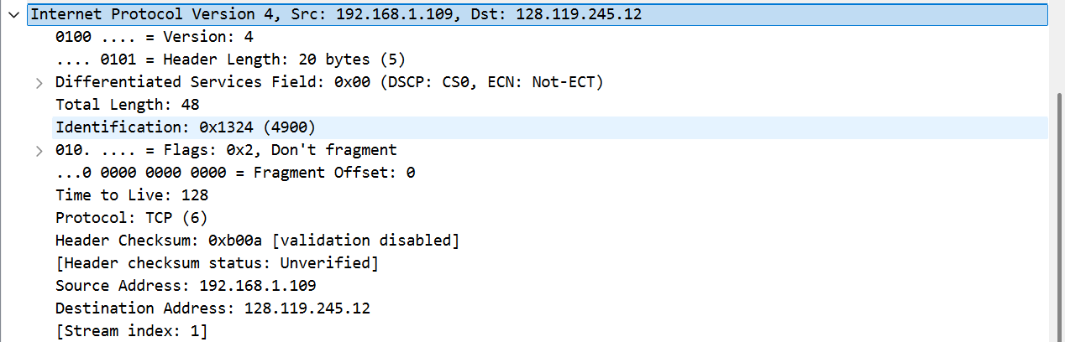
如图，发送这个TCP段的无线主机的ip地址是192.168.1.109，目的地址是128.119.245.12，该目的ip对应的应该是其他联网设备
- Find the 802.11 frame containing the SYNACK segment for this TCP session. What are three MAC address fields in the 802.11 frame? Which MAC address in this frame corresponds to the host? To the access point? To the first-hop router? Does the sender MAC address in the frame correspond to the IP address of the device that sent the TCP segment encapsulated within this datagram? (Hint: review Figure 6.19 in the text if you are unsure of how to answer this question, or the corresponding part of the previous question. It’s particularly important that you understand this).
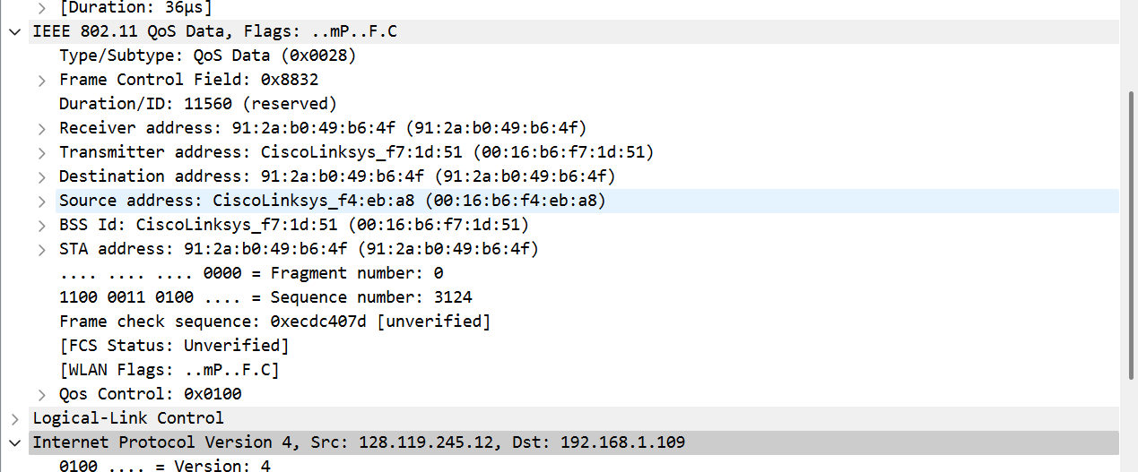
如图，源地址是00:16:b6:f4:eb:a8，接入点是00:16:b6:f7:1d:51，第一跳地址是91:2a:b0:49:b6:4f，发送此TCP段的无线主机的ip地址是128.119.245.12，目的ip地址是192.168.1.109，该目的ip地址是主机。
- What two actions are taken (i.e., frames are sent) by the host in the trace just after t=49, to end the association with the 30 Munroe St AP that was initially in place when trace collection began? (Hint: one is an IP-layer action, and one is an 802.11-layer action). Looking at the 802.11 specification, is there another frame that you might have expected to see, but don’t see here?
如图，在ip层进行了dhcp release
如图，在802.11层进行了Deauthentication
- Examine the trace file and look for AUTHENICATION frames sent from the host to an AP and vice versa. How many AUTHENTICATION messages are sent from the wireless host to the linksys_ses_24086 AP (which has a MAC address of Cisco_Li_f5:ba:bb) starting at around t=49? .
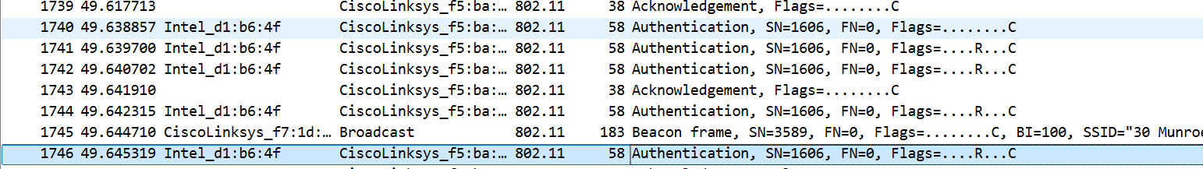
如图，发送了6个Authentication
- Does the host want the authentication to require a key or be open?
主机需要一个key
- Do you see a reply AUTHENTICATION from the linksys_ses_24086 AP in the trace?
yes
- Now let’s consider what happens as the host gives up trying to associate with the linksys_ses_24086 AP and now tries to associate with the 30 Munroe St AP. Look for AUTHENICATION frames sent from the host to and AP and vice versa. At what times are there an AUTHENTICATION frame from the host to the 30 Munroe St. AP, and when is there a reply AUTHENTICATION sent from that AP to the host in reply? (Note that you can use the filter expression “wlan.fc.subtype == 11and wlan.fc.type == 0 and wlan.addr == IntelCor_d1:b6:4f” to display only the AUTHENTICATION frames in this trace for this wireless host.)
如图，在时间63.168087主机向接入点发出认证，在时间63.169071主机从接入点收到回复
- An ASSOCIATE REQUEST from host to AP, and a corresponding ASSOCIATE RESPONSE frame from AP to host are used for the host to associated with an AP. At what time is there an ASSOCIATE REQUEST from host to the 30 Munroe StAP? When is the corresponding ASSOCIATE REPLY sent? (Note that you can use the filter expression “wlan.fc.subtype < 2 and wlan.fc.type == 0 and wlan.addr == IntelCor_d1:b6:4f” to display only the ASSOCIATE REQUEST and ASSOCIATE RESPONSE frames for this trace.)
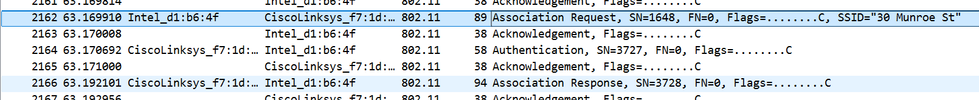
如图，关联请求帧是在时间63.169910发出的，关联是在时间63.192101建立的。
- What transmission rates is the host willing to use? The AP? To answer this question, you will need to look into the parameters fields of the 802.11 wireless LAN management frame.
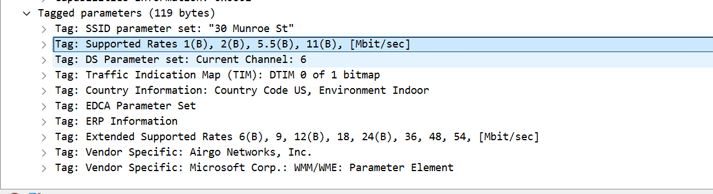
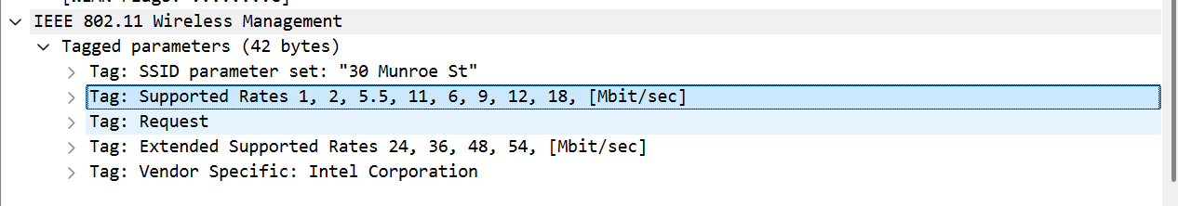
如图，主机支持1Mbps，2Mbps，5.5Mbps，11Mbps，6Mbps，9Mbps，12Mbps，18Mbps，24Mbps，36Mbps，48Mbps，54Mbps
AP支持1Mbps，2Mbps，5.5Mbps，11Mbps，6Mbps，9Mbps，12Mbps，18Mbps，24Mbps，36Mbps，48Mbps，54Mbps
- What are the sender, receiver and BSS ID MAC addresses in these frames? What is the purpose of these two types of frames? (To answer this last question, you’ll need to dig into the online references cited earlier in this lab).
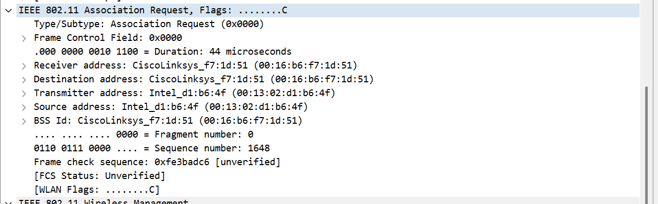
如图，在请求帧中，
发送方MAC地址是00:13:02:d1:b6:4f
接收方MAC地址是00:16:b6:f7:1d:51
BSS ID的MAC地址是00:16:b6:f7:1d:51
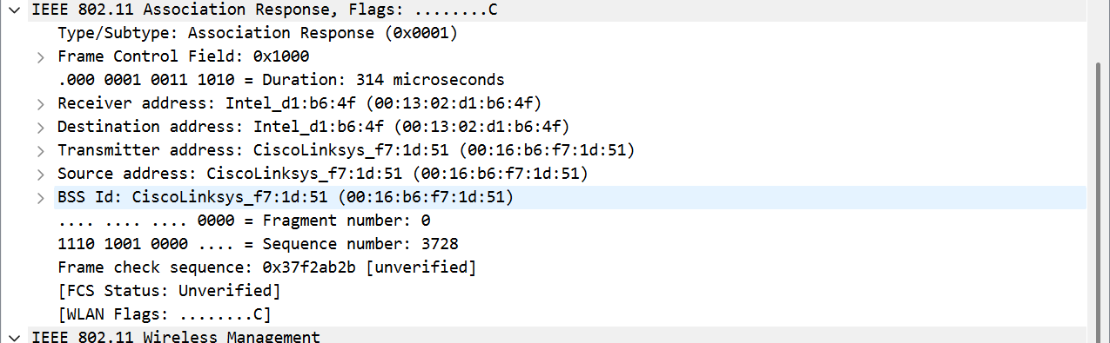
如图，在响应帧中，
发送方MAC地址是00:16:b6:f7:1d:51
接收方MAC地址是00:13:02:d1:b6:4f
BSS ID的MAC地址是00:16:b6:f7:1d:51
问题及收获：
802.11协议是一种无线局域网通信协议，它定义了无线网络的物理层和链路层的标准，使得不同厂商的设备能够进行互操作并实现无线通信。该协议支持多种频段和调制方式，提供了不同的传输速率和数据传输机制，如CSMA/CA（载波监听多路访问/冲突避免）。802.11协议的出现和发展，使得无线网络技术得到了广泛的普及，为人们提供了方便、灵活的网络接入方式。

建立在802.11协议上的WiFi技术，是目前最为普及的无线网络接入方式之一。WiFi使得用户可以在无线网络覆盖范围内，通过笔记本电脑、智能手机、平板电脑等移动设备随时随地接入互联网，进行数据传输、浏览网页、观看视频、在线游戏等活动。它不仅满足了人们对网络接入的便利性需求，还推动了移动互联网时代的到来，改变了人们的生活方式和工作模式，促进了信息的快速流通和交流，对社会的信息化发展起到了重要的推动作用。

