山东大学 计算机科学与技术 学院
新兴网络技术与实践 课程实验报告

学号：202300130183 | 姓名：宋浩宇 |  | 班级：23级智能班
实验题目：Wireshark Lab: DHCP v8.0
实验学时：2 |  | 实验日期：2025/4/9
实验目的： 学习DHCP
实验结果：
- Are DHCP messages sent over UDP or TCP?
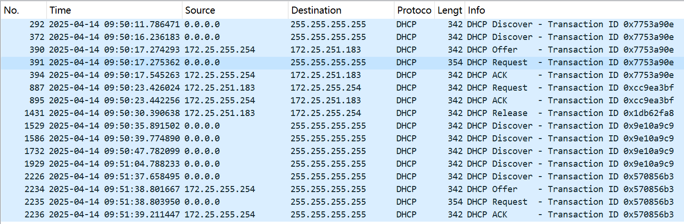
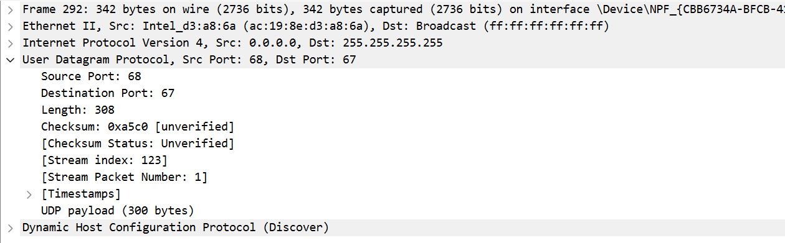
DHCP 消息是通过UDP发送的。
- Draw a timing datagram illustrating the sequence of the first four-packet Discover/Offer/Request/ACK DHCP exchange between the client and server. For each packet, indicated the source and destination port numbers. Are the port numbers the same as in the example given in this lab assignment?
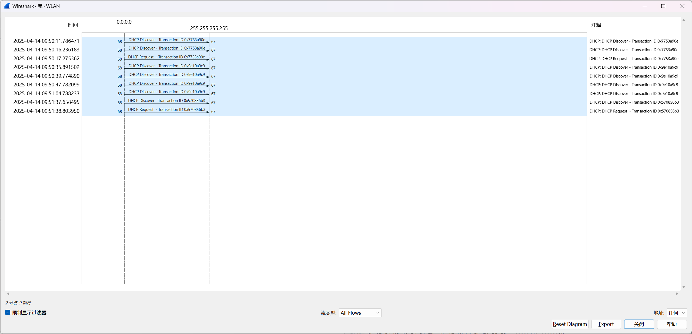
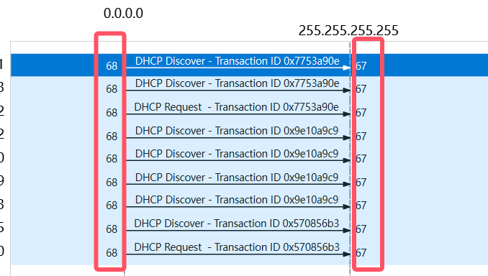
与课本是一致的。
- What is the link-layer (e.g., Ethernet) address of your host?
在局域网IP下，地址是255.255.255.255(ipv4)，实际公网上的地址为172.25.251.183(ipv4)、2001:250:5800:1002::1250(ipv6)、AC-19-8E-D3-A8-6A(MAC物理地址)。
- What values in the DHCP discover message differentiate this message from the DHCP request message?
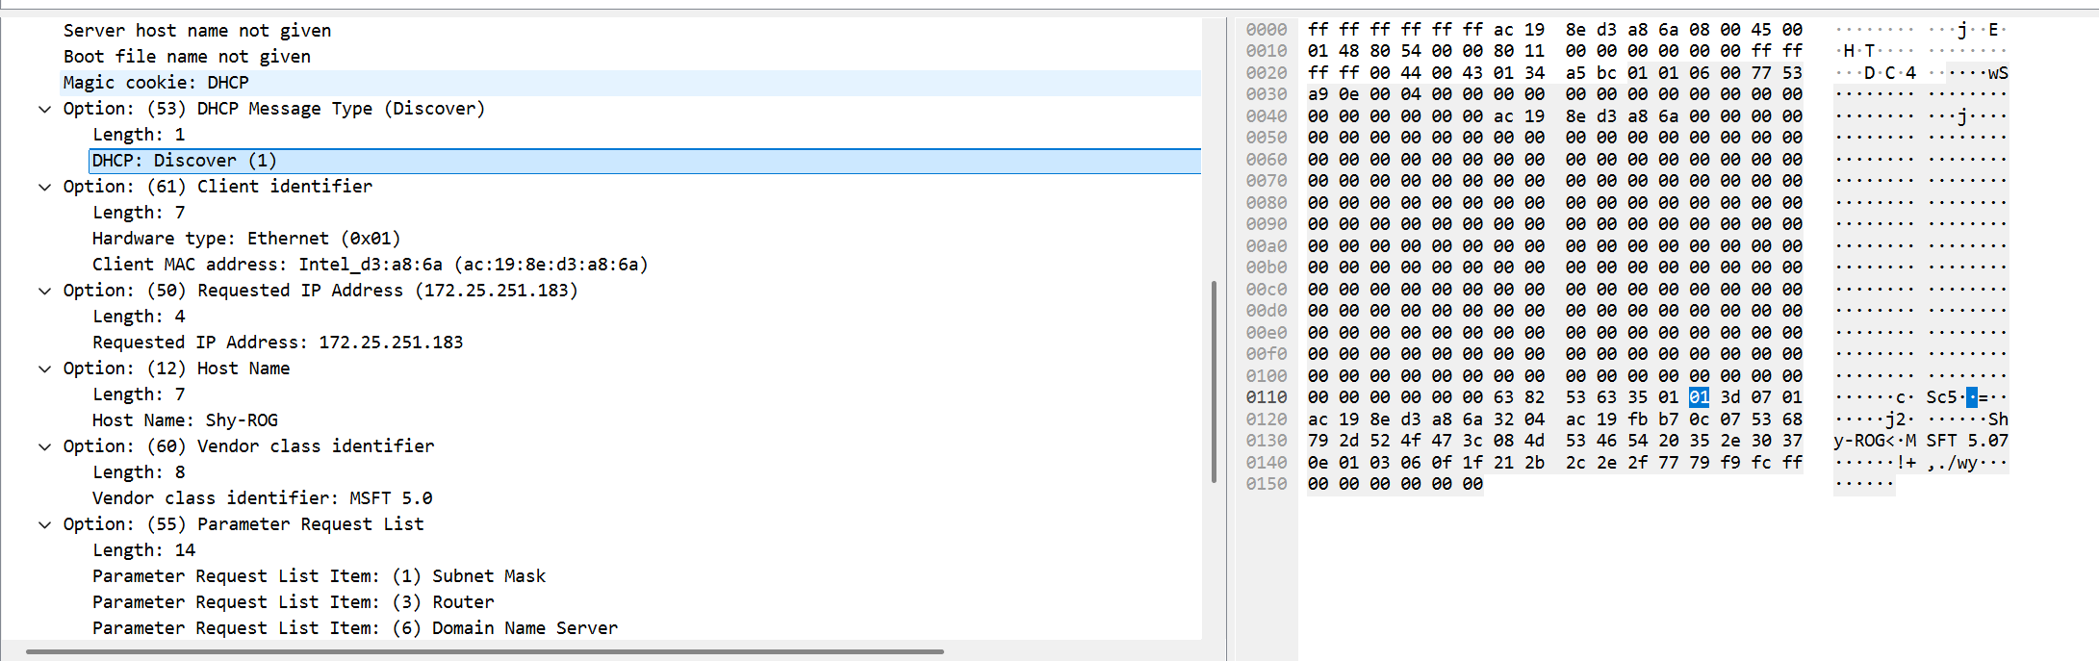
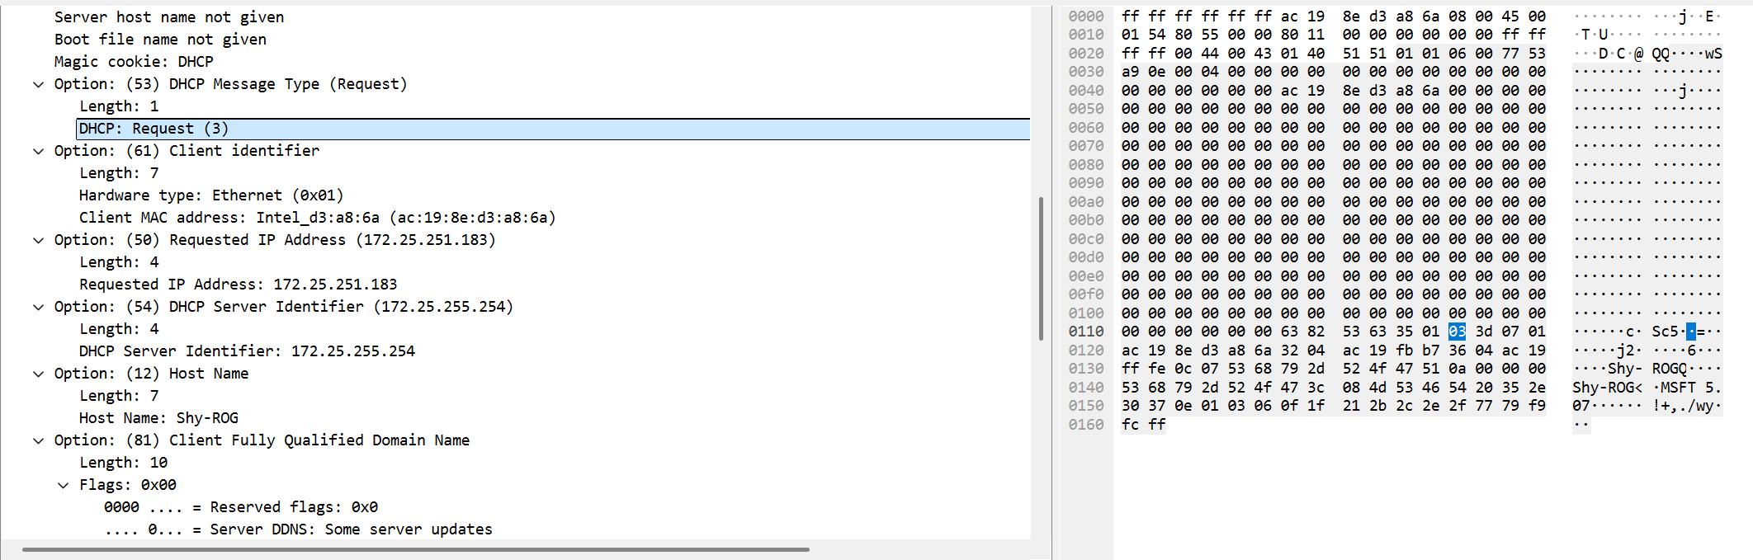
在这一位会有区别。
- What is the value of the Transaction-ID in each of the first four (Discover/Offer/Request/ACK) DHCP messages? What are the values of the Transaction-ID in the second set (Request/ACK) set of DHCP messages? What is the purpose of the Transaction-ID field?
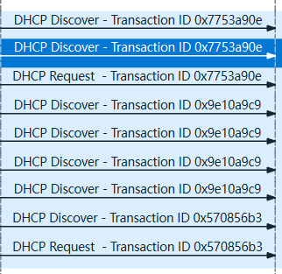
第一组是0x7753a90e，第二组是0x9e10a9c9
事务id是用于表明不同的事务的。
- A host uses DHCP to obtain an IP address, among other things. But a host’s IP address is not confirmed until the end of the four-message exchange! If the IP address is not set until the end of the four-message exchange, then what values are used in the IP datagrams in the four-message exchange? For each of the four DHCP messages (Discover/Offer/Request/ACK DHCP), indicate the source and destination IP addresses that are carried in the encapsulating IP datagram.
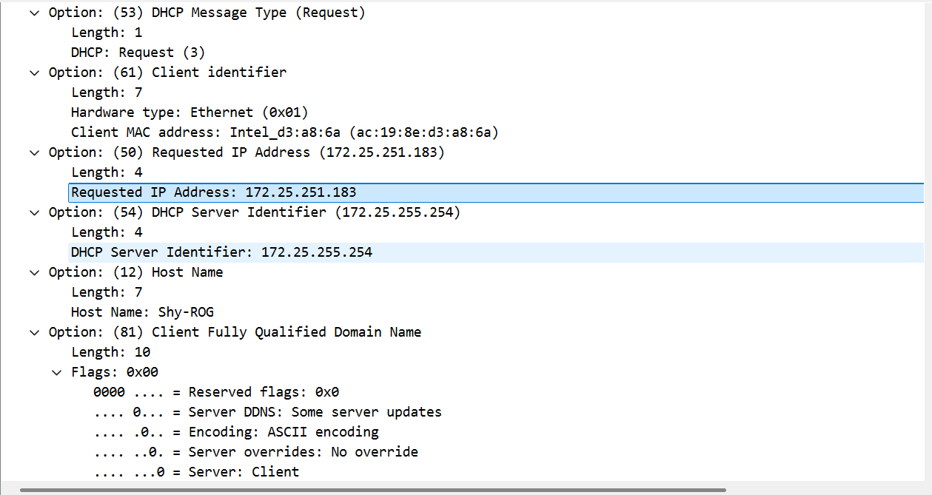
来自主机的源地址最开始是0.0.0.0，目标地址是255.255.255.255
之后来自DHCP服务器的源地址是172.25.255.254，目标地址是ac:19:8e:d3:a8:6a(mac)
之后主机源地址是172.25.251.183，目标地址是172.25.255.254
之后来自DHCP服务器的源地址是172.25.255.254，目标地址是172.25.251.183
- What is the IP address of your DHCP server?
172.25.255.254
- What IP address is the DHCP server offering to your host in the DHCP Offer message? Indicate which DHCP message contains the offered DHCP address.
这个标明了IP地址，地址是172.25.251.183
- In the example screenshot in this assignment, there is no relay agent between the host and the DHCP server. What values in the trace indicate the absence of a relay agent? Is there a relay agent in your experiment? If so what is the IP address of the agent?
这里标明了是没有relay agent的
- Explain the purpose of the router and subnet mask lines in the DHCP offer message.
路由器字段用于告诉设备如何访问其他子网。子网掩码字段用于帮助设备判断目标IP地址是否在本地子网内。
- In the DHCP trace file noted in footnote 2, the DHCP server offers a specific IP address to the client (see also question 8. above). In the client’s response to the first server OFFER message, does the client accept this IP address? Where in the client’s RESPONSE is the client’s requested address?
客户端接受了这个地址。客户端请求的地址在下图中
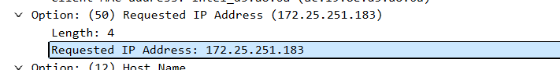
- Explain the purpose of the lease time. How long is the lease time in your experiment?
租约时间主要用途包括动态分配和回收IP地址，提高资源利用率。避免IP地址冲突，确保网络的稳定性。提供网络灵活性，支持设备在不同网络间切换。帮助网络管理员监控和管理网络资源等等。
我的IP的租约时间为12小时。
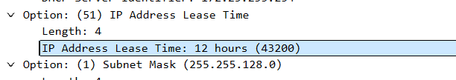
- What is the purpose of the DHCP release message? Does the DHCP server issue an acknowledgment of receipt of the client’s DHCP request? What would happen if the client’s DHCP release message is lost?
DHCP 释放的主要作用是回收IP地址,提高IP地址利用率,支持网络管理,避免IP地址冲突,支持网络配置更新等。
服务端接收到了请求。如果这个消息丢失了会造成IP地址无法立即回收,资源利用率降低,影响网络管理等。
- Clear the bootp filter from your Wireshark window. Were any ARP packets sent or received during the DHCP packet-exchange period? If so, explain the purpose of those ARP packets.
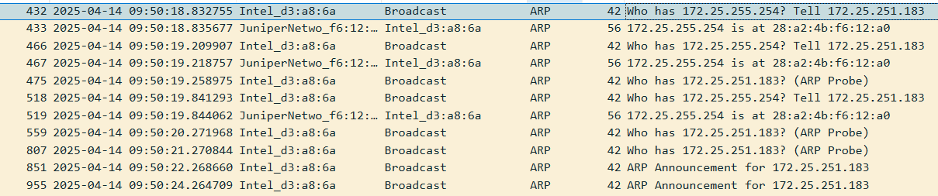
期间有ARP数据包的传输。ARP数据包的作用主要是解析DHCP服务器的MAC地址，检测IP地址冲突，更新ARP缓存，确保通信的准确性等。
问题及收获：
DHCP通信的意义在于为网络中的设备提供自动化的IP地址分配和网络配置管理。通过DHCP，网络管理员可以集中管理IP地址资源，避免手动配置带来的错误和冲突，同时提高网络的灵活性和可扩展性。CPDH协议通过动态分配IP地址，使得设备能够快速接入网络，并在需要时自动更新或释放IP地址，从而确保网络资源的高效利用和网络的稳定运行。

