山东大学 计算机科学与技术 学院
新兴网络技术与实践 课程实验报告

学号：202300130183 | 姓名：宋浩宇 |  | 班级：23级智能班
实验题目：Wireshark UDP
实验学时：2 |  | 实验日期：2025/3/26
实验目的：了解UDP的构成和运作机制
实验结果：
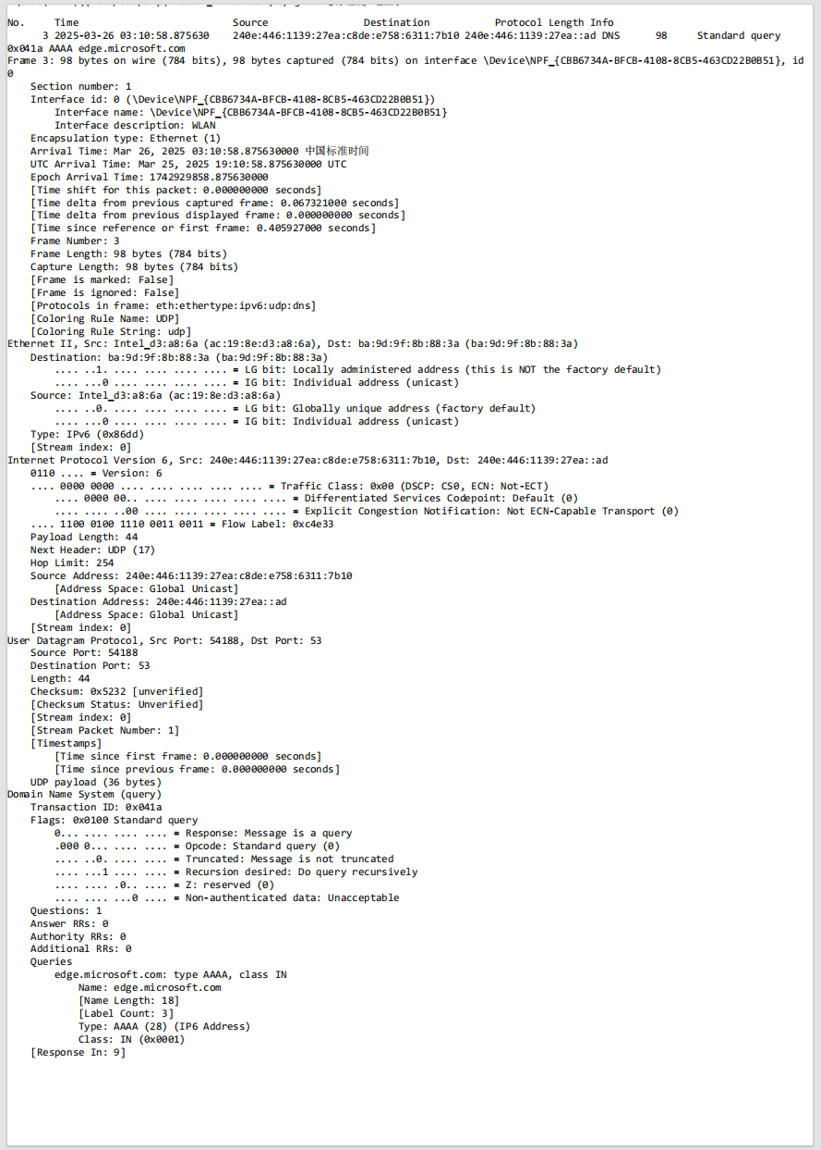
这是我们选中的UDP数据包的打印数据，接下来的问题会参照这个图里的内容回答。
- Select one UDP packet from your trace. From this packet, determine how many fields there are in the UDP header. (You shouldn’t look in the textbook! Answer these questions directly from what you observe in the packet trace.) Name these fields.
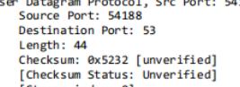
主要是这四部分，Source Port、Destination Port、Length、Checksum
- By consulting the displayed information in Wireshark’s packet content field for this packet, determine the length (in bytes) of each of the UDP header fields.
一共有8个bytes的长度.
- The value in the Length field is the length of what? (You can consult the text for this answer). Verify your claim with your captured UDP packet.
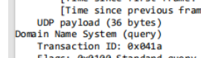
长度表明的是UPD头部和UDP数据的长度的和(以字节byte为单位)
- What is the maximum number of bytes that can be included in a UDP payload? (Hint: the answer to this question can be determined by your answer to 2. above)
2^16 - 1 = 65535
Max = 65535 - 8 = 65527
UDP payload最大65527个字节.
- What is the largest possible source port number? (Hint: see the hint in 4.)
2^16 - 1 = 65535
源端口号最大是65535
- What is the protocol number for UDP? Give your answer in both hexadecimal and decimal notation. To answer this question, you’ll need to look into the Protocol field of the IP datagram containing this UDP segment (see Figure 13 in the text, and the discussion of IP header fields).
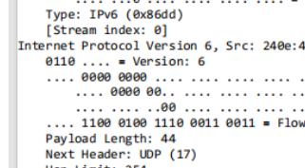
协议号是17(十进制),0x11(16进制)
- Examine a pair of UDP packets in which your host sends the first UDP packet and the second UDP packet is a reply to this first UDP packet. (Hint: for a second packet to be sent in response to a first packet, the sender of the first packet should be the destination of the second packet). Describe the relationship between the port numbers in the two packets
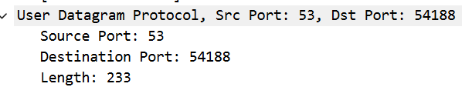
上方这个是发出的UDP数据包,下方这个是收到的UDP数据包.可以看出前一个的源端口号和后一个的目标端口号是一样的,前一个的目标端口号和后一个的源端口号是一样的.
问题及收获：
通过本次实验，我对 UDP 协议有了更直观的理解。实验让我清晰地看到了 UDP 数据包的结构，包括源端口、目的端口、长度和校验和等字段，也明白了它们的作用。同时，我观察到 UDP 数据包如何在 IP 层中传输，进一步理解了网络协议的分层协作机制。

