Operation Manual

SK7520 CNC Thread Grinding Machine

2018

Version：1.0

HANJIANG MACHINE TOOL CO., LTD.

May 2018

**Preface**

**Dear customer：**

**We feel greatly honored of you to choose our products of SK7520 CNC thread grinding machine.**

**Before proceeding with machine installation and operation of the machine, the operator should have a through understanding of this manual.**

**Safety Alarm**

**If any safety problem is arising, the operator or the person who in charge can smooth it away on this interface.**



Contents

Chapter 1 Basic Parameter 1

1、Power supply requirements 1

2、Definition for each axis 1

3、Main Movement 1

一、Machine Run & Important notice 2

1、Run a machine for the first time 2

2、Each axis returning to reference point 2

二、Introduction for panel function of CNC system 3

1、Start /stop of hydraulic pump 3

2、Selection for wheel dressing 3

3、Open /Close the function of DRF interpolation 3

4、Start/stop of coolant pump for grinding 4

5、Start/stop of coolant pump for dressing 4

6、Start/stop of grinding wheel 4

7、Dressing manually 4

8、Function of air-conditioner on E-cabinet 4

9、Start/stop of lubrication pump 5

10、Function of machine lighting 5

11、Function of oil mist exhauster 5

12、Axis X 5

13、Axis Z 5

14、Axis C 6

15、Function of program alignment 6

16、Turn off the machine 6

Chapter 3 Interface introduction & Parameter definition 7

一、Interface introduction 7

1、How to enter users’ interface 7

2、Serial No. query 8

3、Sub-menu introduction of HJ interface 8

3-1、Introduction for grinding parameter 9

3-2、Introduction for technology parameter 9

3-3、Introduction for dressing parameter setting 10

3-3-1、Homepage of main interface for dressing parameter 10

3-3-2、Dressing position on dressing parameter interface 11

二、Users’ interface parameter 12

1、Definition for grinding parameter 12

1-1、Machining selection 13

1-2、Machining mode(External/Internal） 13

1-3、Handedness of thread 14

1-4、No. of starts 14

1-5、Thread pitch 14

1-6、Left end & Right end of workpiece 15

1-7、Starting point of alignment 15

1-8、Clamping angle（internal thread） 15

1-9、Starting point of worktable（internal thread） 16

1-10、Taper setting 16

1-11、Safety position for grinding 16

2、Definition of technology parameter 17

2-1、One-way/Two-way grinding 17

2-2、Recycle times 17

2-3、Feeding depth 18

2-4、Grinding speed 18

2-5、Dressing setting 18

2-6、Wheel peripheral speed 19

2-7、Rotational speed of workhead 19

2-8、Rotational speed of wheel 19

2-9、Wheel diameter(internal thread) 20

2-10、Transmission ratio 20

3、Dressing parameter（External thread） 20

3-1、New/old grinding wheel 21

3-2、Dressing times(Rough) 21

3-3、Dressing amount (Rough) 21

3-4、Dressing speed(Rough) 22

3-5、Dressing times (Fine) 22

3-6、Dressing amount(Fine) 22

3-7、Dressing speed(Fine) 22

3-8、New wheel diameter 23

3-9、Current diameter of wheel 23

3-10、Rotational speed of wheel 23

3-11、Wheel peripheral speed 24

3-12、Min. grinding diameter 24

4、Definition for hydraulic dressing parameter 24

4-1、Setting tooth depth 25

4-2、Initial contact for CNC system 25

4-3、Initial contact 26

4-4、Current contact 26

4-5、Signal for initial position 26

4-6、Signal for ending position 26

# Chapter 1 Basic Parameter

# 1、Power supply requirements

* Voltage rated：3~380V/50Hz
* Capacity：23KVA
* Ambient temperature：0~45℃

## 2、Definition for each axis

This machine equipped with SIEMENS 828D system is a CNC thread grinding machine with 4 programmable axes. The programmable axes are described as following:

* Wheelhead approach & withdrawal (Cross-feed) ------------Axis X
* Table traverse --------------------------------Axis Z
* Rotation of workhead--------------------------Axis C
* Vertical movement of dresser------------------Axis V

## 3、Main Movement

* Rotation of workhead
* Table traverse
* Wheelhead approach & withdrawal
* Vertical movement of dresser

Basic operating methods

## 一、Machine Run & Important notice

### 1、Run a machine for the first time

Open the main power switch on the electric cabinet of the machine, and the CNC system start to self-check until having finished self-checking. Firstly, check whether the emergency stop loose or not, and then open the enabled switch .



### 2、Each axis returning to reference point

Choose a proper way to return to reference point in . In JOG mode, every axis return to its reference point in the order of axis Z, axis X and axis C. After one axis has returned to its reference point, the next axis can move then. Select the axis that need to return to its reference point in （eg: We select axis X）. Depress“+”in and finish this steps. When it appears the mark of in , it means that the step of returning reference point has been finished.



Note：When it has a power failure on the machine, it is necessary to return to its reference point once again!

## 二、Introduction for panel function of CNC system

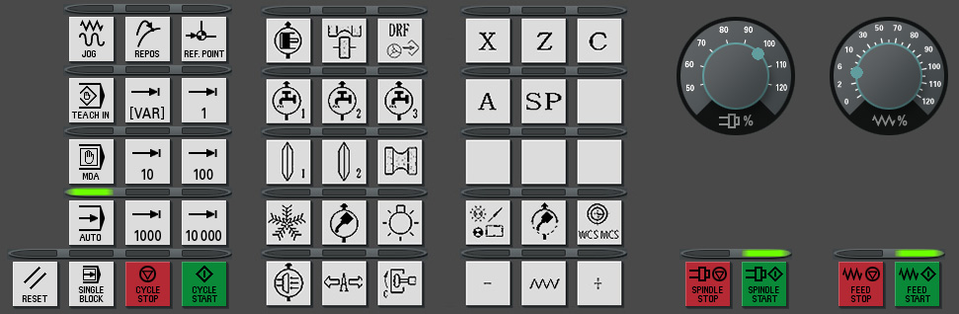

Fig. 2-1（It is for reference only）

### 1、Start /stop of hydraulic pump

After the machine runs, depressing the button in fig.2-1 can control the hydraulic pump.



### 2、Selection for wheel dressing

After the machine runs, depressing the button AUTO in fig. 2-1 can control whether the machine dressing wheel or not.



### 3、Open /Close the function of DRF interpolation

After the machine runs, depressing the button in fig. 2-1 can control the DRF interpolation.



### 4、Start/stop of coolant pump for grinding

After the machine runs, depressing the button in fig. 2-1 can control the coolant pump for grinding.



### 5、Start/stop of coolant pump for dressing

After the machine runs, depressing the button in fig. 2-1 can control the coolant pump for dressing.



### 6、Start/stop of grinding wheel

After the machine runs, depressing the button in fig. 2-1 can control the wheel in rough grinding or not.



### 7、Dressing manually

After the machine runs, depressing the button JOG in fig 2-1 can dress manually for a time.



### 8、Function of air-conditioner on E-cabinet

After the machine runs, depressing the button in fig 2-1 can control the air-conditioner.



### 9、Start/stop of lubrication pump

After the machine runs, depressing the button in fig.2-1 can control the lubrication pump.



### 10、Function of machine lighting

After the machine runs, depressing the button in fig. 2-1 can control the machine lighting.



### 11、Function of oil mist exhauster

After the machine runs, depressing the button in fig. 2-1 can control the oil mist exhauster.



### 12、Axis X

After the machine runs, depress the button in fig. 2-1, so the axis X can be selected.



### 13、Axis Z

After the machine runs, depress the button in fig. 2-1, so the axis Z can be selected.



### 14、Axis C

After the machine runs, depress the button in fig. 2-1, so the axis C can be selected.



### 15、Function of program alignment

After the machine runs, depress the button in fig. 2-1, so it can control the alignment function.



### 16、Turn off the machine

Before turning off the machine, make sure each axis has been stopped and each auxiliary function is closed, and then turn off the power.

# Chapter 3 Interface introduction & Parameter definition

## 一、Interface introduction

### 1、How to enter users’ interface

图3-1

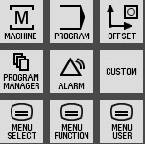

In the controlling zone of machine system (Fig 3-1), depress the button , and it can enter the homepage of users’ interface. （Fig.3-2）.

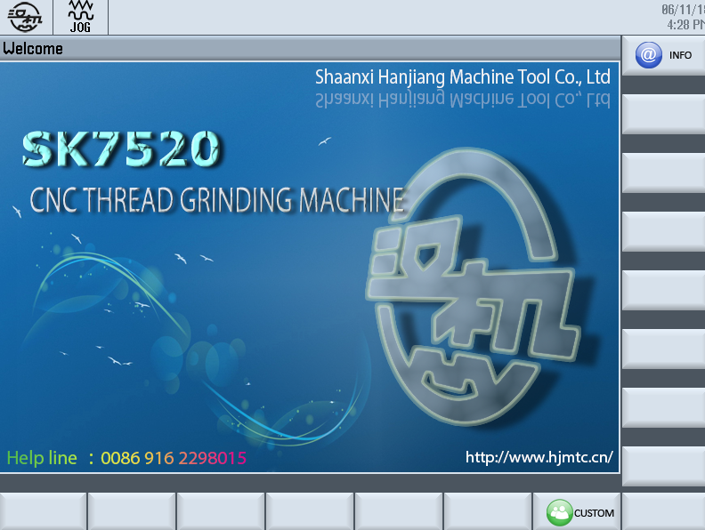

Fig. 3-2

### 2、Serial No. query

Depress the button ，enter into the details of serial No. of the machine（Fig. 3-3 is for reference only.）

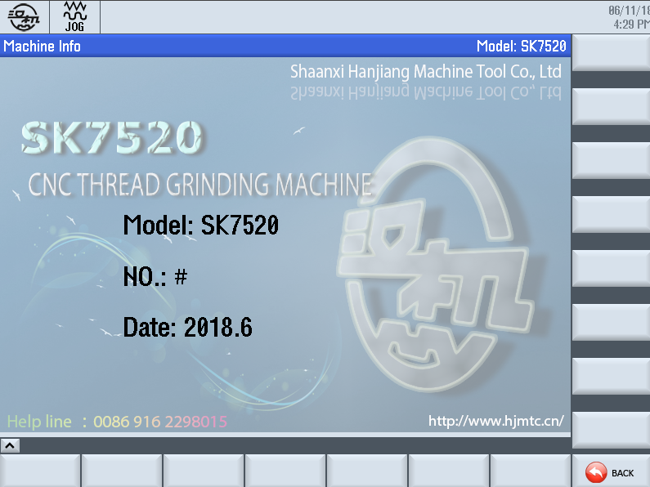

图3-3

Depress the button ， it will return to homepage of user interface。



### 3、Sub-menu introduction of HJ interface

Depress the button , enter the interface of grinding parameter, technology parameter and dressing parameter. (In red frame of fig. 3-4, it is for reference only.)

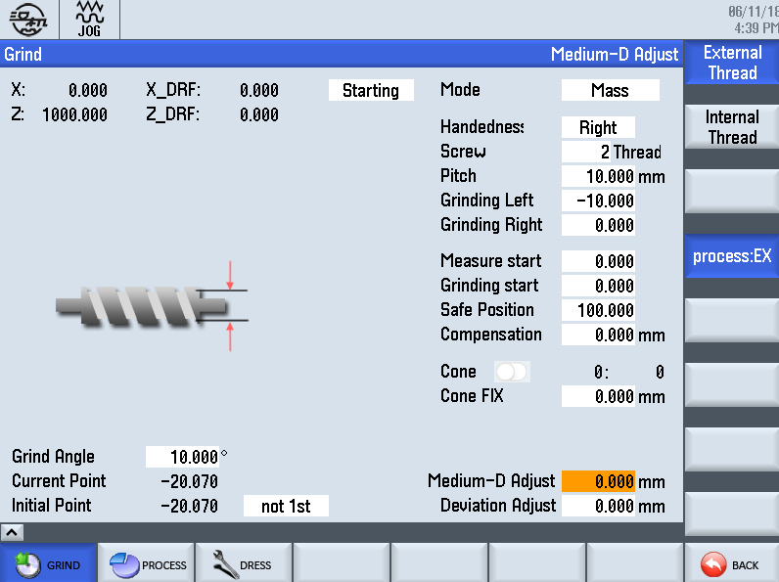

Fig. 3-4

#### 3-1、Introduction for grinding parameter

Depress the button ，it is firstly to enter the interface of “grinding parameter” as in the fig. 3-4.



Including：

Internal thread, External thread, Machining mode, Handedness of thread, No. of starts, Thread pitch, Left & Right end of workpiece, Starting point of alignment, Clamping angle of workpiece, Starting point of worktable, Taper, DRF in axis X & axis Z, Current contacting position for grinding wheel, Initial contact position.

#### 3-2、Introduction for technology parameter

Firstly, depress the button , and then depress the button , it will enter the interface of setting technology parameter in fig. 3-5.

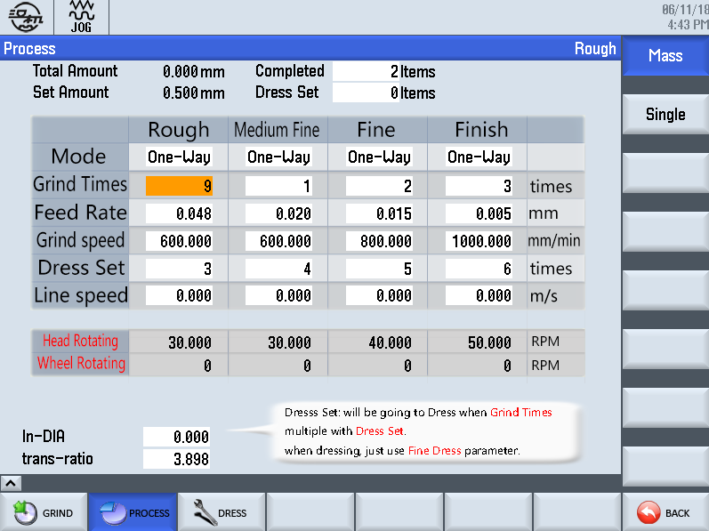

图3-5

Including：

Technology setting includes 4 steps, such as rough grinding, semi-fine grinding, fine grinding and finish grinding. Each step contains one-way & two-way grinding, recycle times, feeding depth, grinding speed, dressing setting, wheel peripheral speed, accumulative total grinding amount, setting total grinding amount, rotational speed of workhead and rotational speed of wheel.

#### 3-3、Introduction for dressing parameter setting

##### 3-3-1、Homepage of main interface for dressing parameter

Firstly depress the button , and then depress the button ，it will enter the homepage of dressing parameter setting in fig. 3-6.

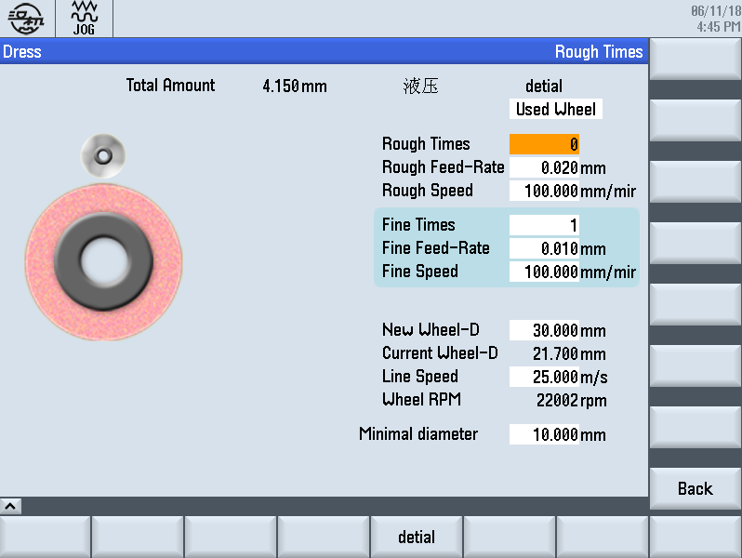

图3-6

If depress the button for two times，it will return the homepage of users’ interface.



If depress the button for one time, it can enter or .



Including：

Selection for new/old grinding wheel, Dressing times(rough), Dressing amount(rough), Dressing speed(rough), New wheel diameter, Current wheel diameter, Rotational speed of wheel, Min. grinding diameter, Max. grinding diameter.

Please read the hint carefully before input the value in the frame.

##### 3-3-2、Dressing position on dressing parameter interface

Firstly, depress the button , then depress , finally depress and enter the interface of dressing parameter setting in fig.3-7.

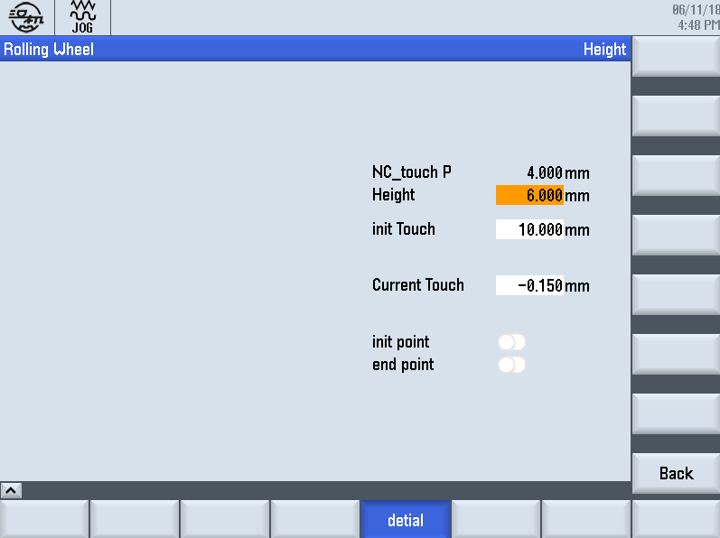

Fig. 3-7

Including：

Tooth depth, initial contact for CNC system, initial contact, current contact.

## 二、Users’ interface parameter

### 1、Definition for grinding parameter

The contents setting for grinding parameter is shown in fig. 3-8.

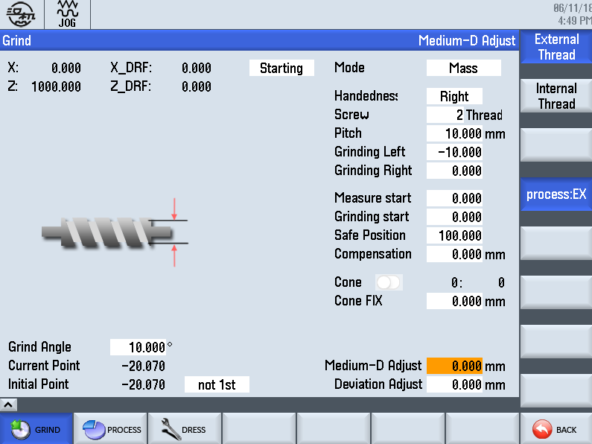

Fig. 3-8

#### 1-1、Machining selection

Depressing the button on right can shift from internal thread to external thread.

Optional：external machining, internal machining.

If choose a proper machining mode, it will run to the related grinding interface automatically.

#### 1-2、Machining mode(External/Internal）

There are two kinds of machining modes. One is and the other is .



Description：If the workpiece to be ground is for mass production (accumulative grinding amount), it should select mass production. Otherwise, if the workpiece to be ground is for single production, it should select single production.

Default value：mass production

Input range of parameter：It depends.

#### 1-3、Handedness of thread

There are two types of handedness. One is and the other is .



Description：According to the real handedness to select, if modify parameter, the handedness of thread will be changed.

Default value：RH

Input range of parameter：It depends on the drawing.

#### 1-4、No. of starts

Description：It refers to the No. of starts, and it is set by the drawing. If modify the value it will cause any risks.

Default value：1

Input range of parameter：1~99, it depends on the drawing.

#### 1-5、Thread pitch

Description：It refers to the pitch of thread, and it is set by the drawing. If modify the value it will cause any risks.

Default value：>0

Input range of parameter：>0~100, It depends on the drawing.

#### 1-6、Left end & Right end of workpiece

Description：Fix the workpiece to a special clamping device and test its rotational accuracy. Make axis Z run and record the coordinates on left-end and right-end respectively.

Default value：0

Requirement：Right end >Left end

Input range of parameter：It depends.

#### 1-7、Starting point of alignment

External thread：Fix the workpiece to workhead chuck and make axis X run firstly. Make wheel feeding to workpiece until the wheel stopped in a proper position, and then record the current coordinates of axis X.

Internal thread：Fix the workpiece to workhead chuck and make axis X run firstly. Then move the wheel to the center of workpiece, and finally record the current coordinates of axis X.

Default value：0

Input range of parameter：It depends.

#### 1-8、Clamping angle（internal thread）

Description：It refers to rotate the axis C to a proper angle that is convenience of clamping workpiece, to make sure the consistence for mass production.

Default value：0

Input range of parameter：0~360

#### 1-9、Starting point of worktable（internal thread）

Description：Move the worktable to the outside of the workpiece for a proper position, and record the coordinates of axis Z.

Default value：0

Input range of parameter：It depends.

#### 1-10、Taper setting

Description：When the workpiece to be ground with a taper, turn on this button of the taper and input the proper parameter. For example 。



Default value：0:000

Input range of parameter：It depends on the drawing. Input a negative value to numerator as its back taper.

#### 1-11、Safety position for grinding

Description：The axis X retreat to a safety position after finish grinding.

### 2、Definition of technology parameter

Set technology parameter following in fig. 3-9. The value in Fig 3-9 is only an example.

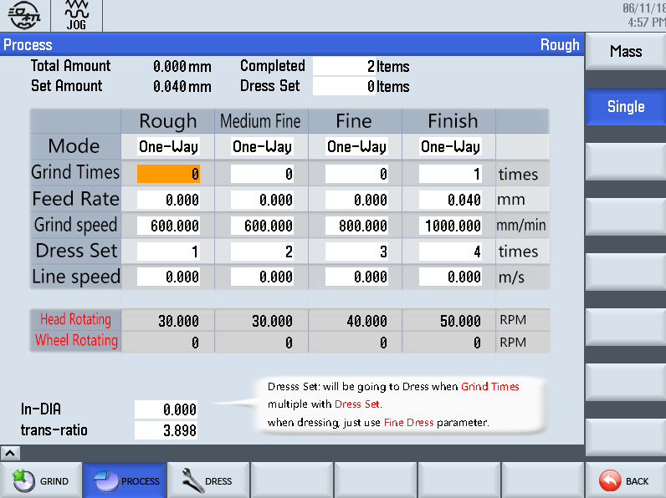

Fig. 3-9

Input the related parameter in Fig. 3-9 according to the features of workpiece to be ground.

#### 2-1、One-way/Two-way grinding

Description：It refers to the grinding way.

Default value：One-way

Input range of parameter：It depends on the length of the workpiece to be ground.

#### 2-2、Recycle times

Description：It refers to the recycle times in each step during grinding.

Default value：0

Input range of parameter：It depends.

#### 2-3、Feeding depth

Description：It refers to the feeding amount in each step during grinding, and it depends on the workpiece to be ground.

Default value：0

Input range of parameter：0~0.1

#### 2-4、Grinding speed

Description：It refers to the moving speed of worktable during grinding, and it depends on the allowance of workpiece to be ground, material of workpiece to be ground and wheel grain.

Default value：0

Input range of parameter：0~150

Recommended value：100

#### 2-5、Dressing setting

Description：It refers to dressing or not after finished grinding in each step. If not, this value is zero, if it is needed to dress, the proper dressing times is set. For example: if the value is 2, it means that after recycling 2 times grinding, the specific dressing parameter can reference the main interface of fine dressing.

Default value：0

Input range of parameter：It depends on the wheel material and grinding time.

#### 2-6、Wheel peripheral speed

Description：It refers to the real peripheral speed in each step during grinding. It is matched with the grinding speed.

Default value：0

Input range of parameter：10~40

Recommended value：20

#### 2-7、Rotational speed of workhead

Description ：It refers to the rotational speed set by users in current step during grinding.

Default value：0

Input range of parameter：>0

Recommended value：It depends on the grinding speed.

#### 2-8、Rotational speed of wheel

Description ：It refers to the rotational speed of wheel during grinding set by users in current step.

Default value：0

Input range of parameter：>0

Recommended value：It depends on wheel diameter, and the program can calculate automatically.

#### 2-9、Wheel diameter(internal thread)

Description：Input the value after having measured wheel diameter for the internal thread.

#### 2-10、Transmission ratio

Description：Input the current transmission ratio during internal thread grinding.

The rotational speed of wheel for internal thread is depends on the wheel diameter & transmission ratio.

### 3、Dressing parameter（External thread）

Set parameter following in fig. 3-10. The value in Fig 3-10 is only an example.

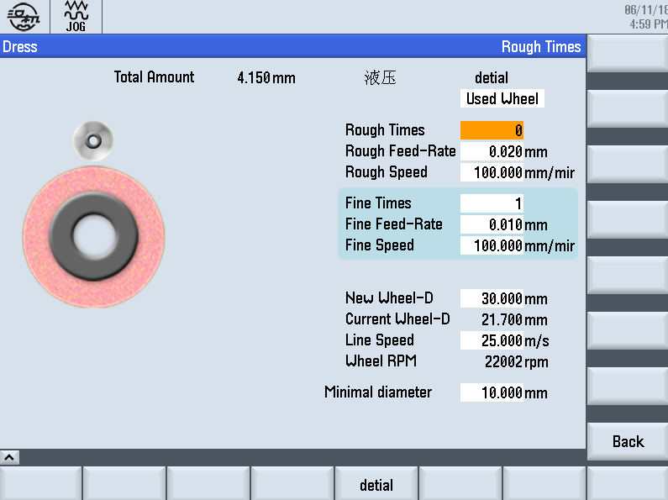

Fig. 3-10

#### 3-1、New/old grinding wheel

Description：Select new/ old grinding wheel for the first setting. Pay more attention on the hint on left once you select.

Default value：New wheel

#### 3-2、Dressing times(Rough)

Description：It refers to the recycle times for rough dressing.

Default value：0

Input range of parameter：It depends on the tooth profile.

#### 3-3、Dressing amount (Rough)

Description：It refers to the feeding amount in rough dressing.

Default value：0

Input range of parameter：0~0.05

Recommended value：0.02

#### 3-4、Dressing speed(Rough)

Description：It refers to the feeding speed in rough dressing.

Default value：0

Input range of parameter：0~150

Recommended value：100

#### 3-5、Dressing times (Fine)

Description：It refers to the recycle times in fine dressing

Default value：0

Input range of parameter：It depends on the grinding wheel.

#### 3-6、Dressing amount(Fine)

Description：It refers to the feeding amount in fine dressing.

Default value：0

Input range of parameter：0~0.02

Recommended value：0.01

#### 3-7、Dressing speed(Fine)

Description：It refers to the feeding speed in fine dressing.

Default value：0

Input range of parameter：0~150

Recommended value：100

#### 3-8、New wheel diameter

Description：It refers to the diameter of new wheel fixed on the current axis.

Default value：0

Input range of parameter：0~500

Recommended value：

#### 3-9、Current diameter of wheel

Description ：It refers to the diameter of wheel fixed on the current axis.

Default value：0

Input range of parameter：The program can calculate automatically.

#### 3-10、Rotational speed of wheel

Description：It refers to the rotational speed of wheel fixed on the current axis.

Default value：0

Input range of parameter：The program can calculate automatically. It depends on the wheel diameter & peripheral speed.

#### 3-11、Wheel peripheral speed

Description ：It refers to the peripheral speed of wheel fixed on the current axis.

Default value： 0

Input range of parameter：>0

#### 3-12、Min. grinding diameter

Description：It refers to the min. grinding diameter of wheel fixed on the current axis.

Default value：0

Input range of parameter：>0(input manually)

### 4、Definition for hydraulic dressing parameter

Enter the interface as in Fig. 3-11. The value in Fig 3-11 is only an example.

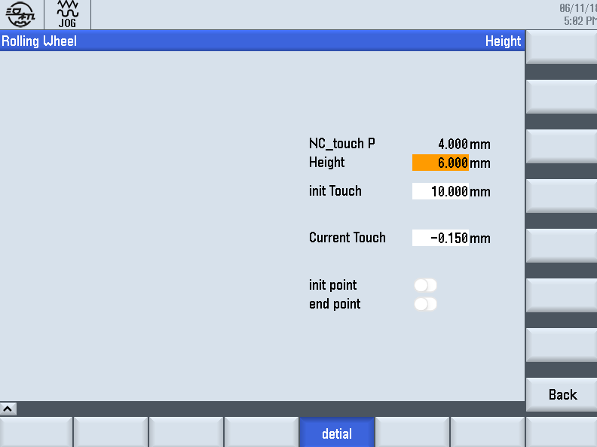

Fig. 3-11

#### 4-1、Setting tooth depth

Description ：It refers to the real depth of tooth profile.

Default value：0

Input range of parameter：It depends on the drawing.

#### 4-2、Initial contact for CNC system

Description ：It refers to the coordinates when the current wheel contacts with the diamond-pen, after new wheel have dressed a complete tooth profile.

Default value：0

Input range of parameter：by system

#### 4-3、Initial contact

Description：It refers to the coordinates on axis V when the new wheel contact with the diamond-pen for the first time.

Default value：0

Input range of parameter：

#### 4-4、Current contact

Description：It refers to the coordinates on axis V when the wheel contact with the diamond-pen.

Default value：0

Input range of parameter：

#### 4-5、Signal for initial position

It refers to the hint signal that diamond-pen controlled by hydraulic on dresser move its initial position.

#### 4-6、Signal for ending position

It refers to the hint signal that diamond-pen controlled by hydraulic on dresser get to its ending position.

