输出结果：

The sser weights of the model trained on Problem3 dataset is [[-0.00052543]  
 [ 0.19044879]  
 [ 0.0121187 ]]  
The sser model precision of label'-1', label'1', and the whole dataset is 100.00% 100.00% 100.00%.  
The lmsalg weights of the model trained on Problem3 dataset is [[-0.00302901]  
 [ 0.18658061]  
 [ 0.0127614 ]]  
The lmsalg model precision of label'-1', label'1', and the whole dataset is 100.00% 100.00% 100.00%.  
The sser weights of the model trained on Problem4 dataset is [[-0.04458755]  
 [ 0.39462652]  
 [ 0.02410489]]  
The sser model precision of label'-1', label'1', and the whole dataset is 97.50% 96.00% 96.75%.  
The lmsalg weights of the model trained on Problem4 dataset is [[-0.04334527]  
 [ 0.40031952]  
 [ 0.02372101]]  
The lmsalg model precision of label'-1', label'1', and the whole dataset is 97.50% 96.00% 96.75%.  
The sser weights of the model trained on Problem5 dataset is [[-0.02862249]  
 [ 0.50030749]  
 [ 0.0150165 ]]  
The sser model precision of label'-1', label'1', and the whole dataset is 84.00% 83.50% 83.75%.  
The lmsalg weights of the model trained on Problem5 dataset is [[-0.02650639]  
 [ 0.49969523]  
 [ 0.01728268]]  
The lmsalg model precision of label'-1', label'1', and the whole dataset is 84.00% 83.50% 83.75%.

具体图片结果为：

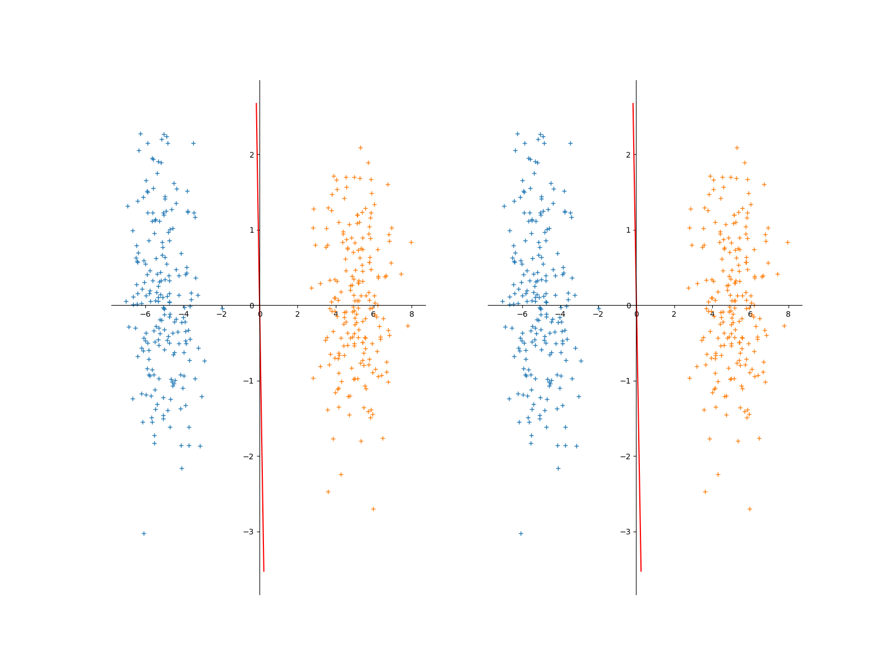

[-5, 0] [5, 0]

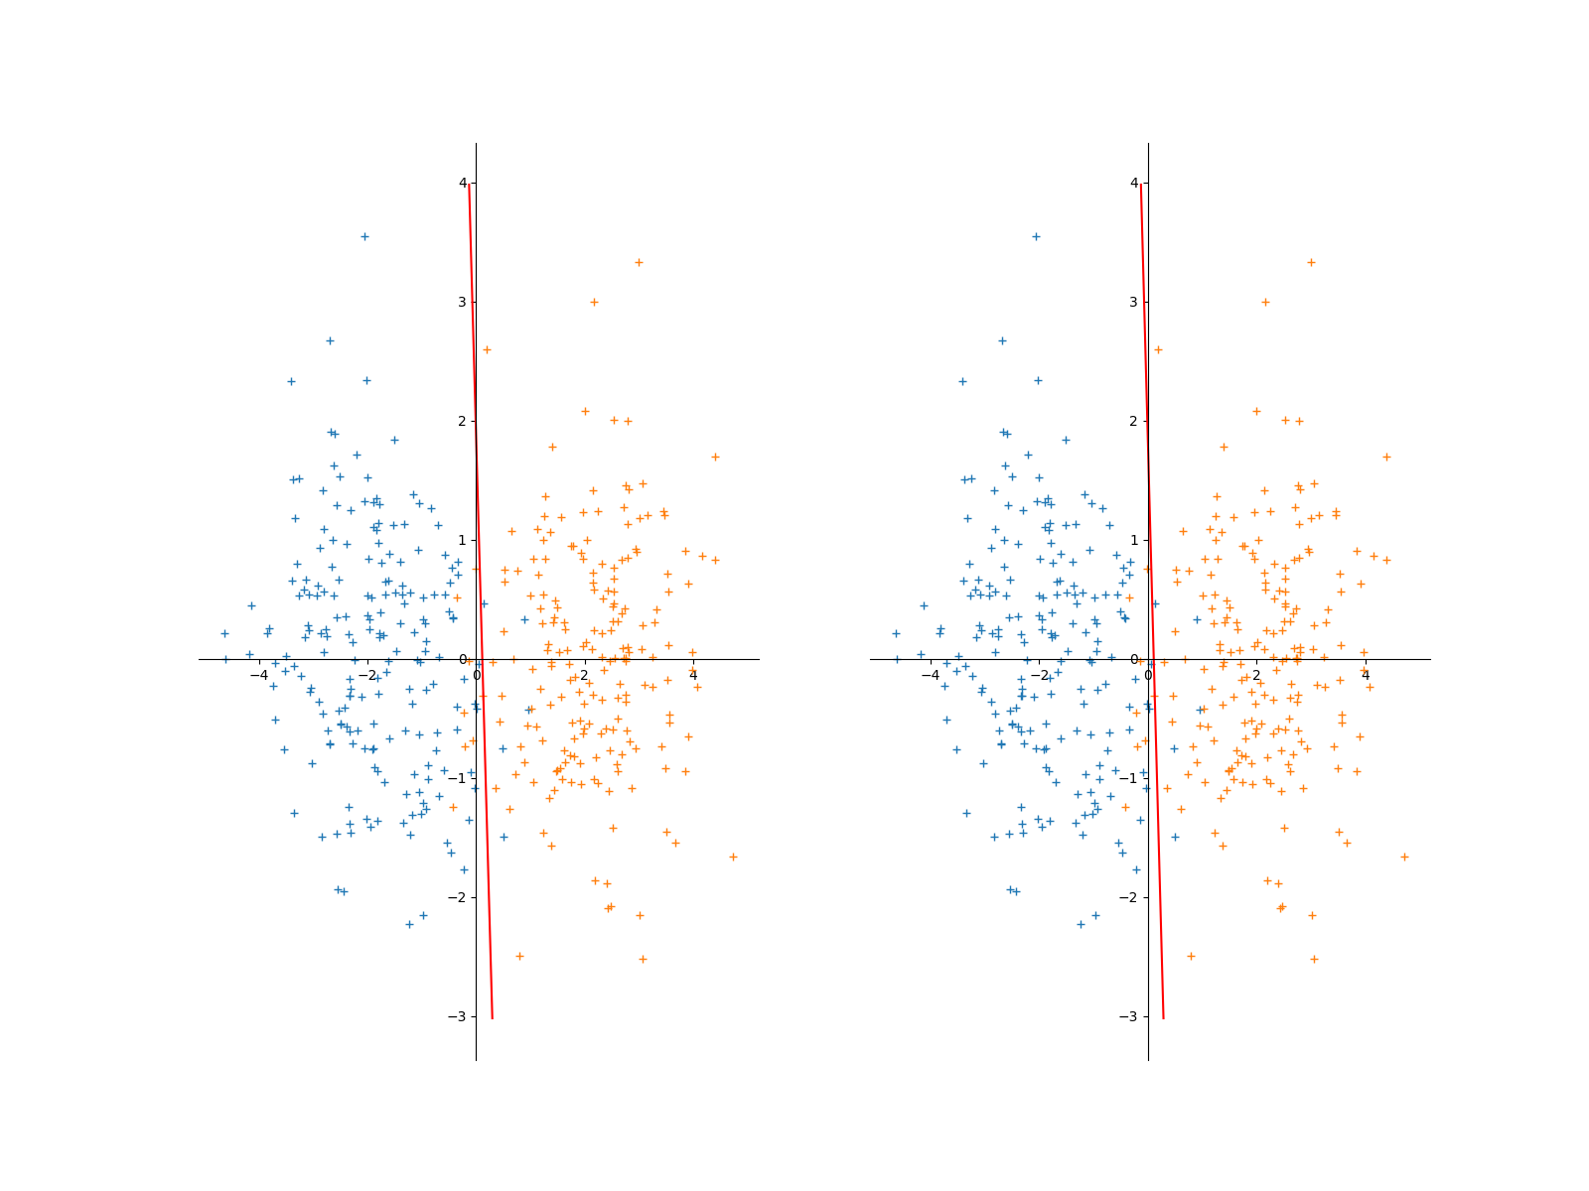

[-2, 0][2, 0]

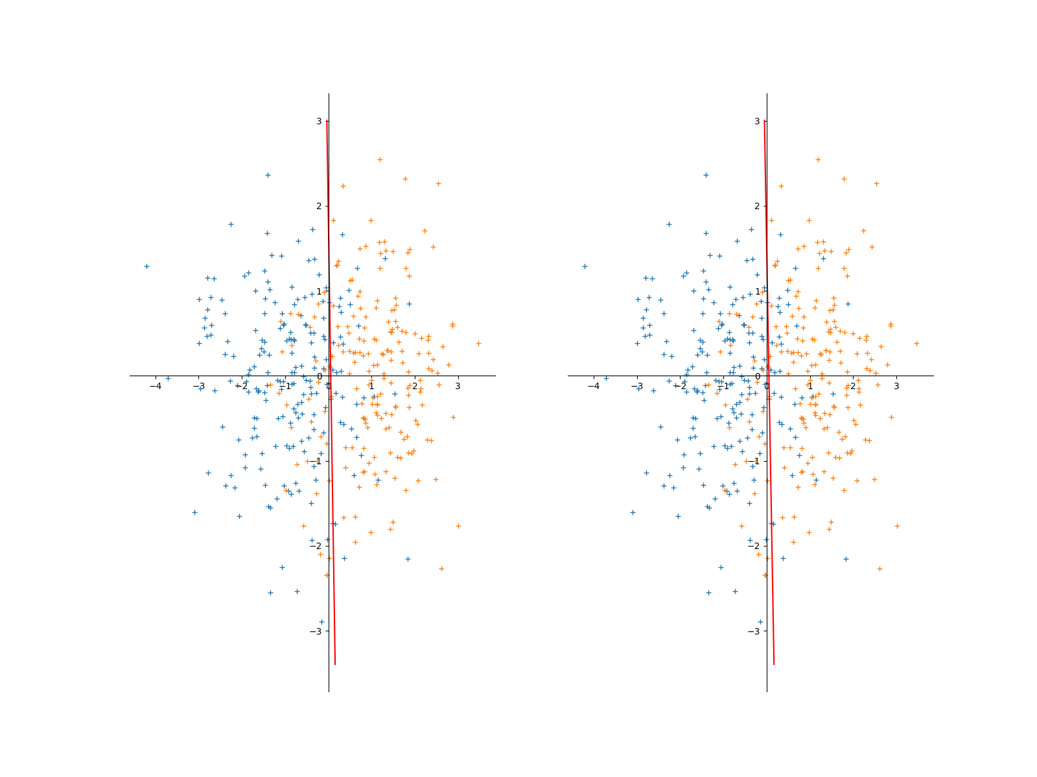

[-1, 0] [1, 0]

在3-5的结果中，lmsalg的w结果与sser的w结果是十分相似的、基本可以认同为一致。在进行此次试验中，对于learning rate有一定的要求。在初始时将lr设置为1，最后发现因为步长过大，导致w的权值很容易扩大到inf，最终导致程序无法继续计算下去，通过将lr设置为0.001，使得能够适当的进行跌到找到误差极小值所对应的w权值大小。

此次算法因最终都是通过线性二分类，最终结果准确度也与感知器算法相接近。