Mouse 2AFC decision-making: a compact literature map
Three task families address one question — how does the brain turn sensory evidence into a binary choice? They differ in what they isolate: rapid detection (Cortex lab / IBL), working memory and motor planning (Svoboda), and gradual evidence accumulation (Brody). Four key papers per line.
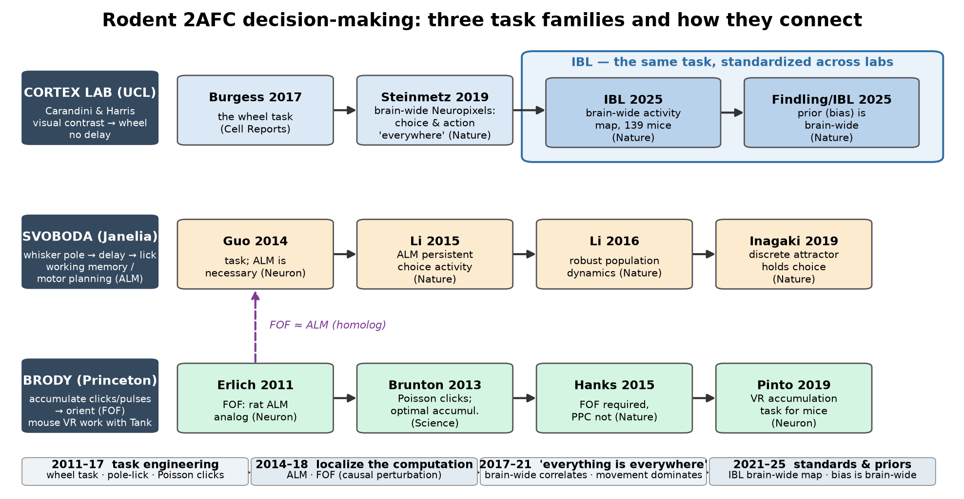

1. The three task families
Lineage | Task (sensory → report) | Memory demand | Core question
Cortex lab → IBL | visual contrast L/R → turn wheel | none (fast detection) | where are stimulus / choice / action coded?
Svoboda | whisker pole position → delay → lick L/R | delay-period memory | how is a planned movement held and executed?
Brody (+Tank) | Poisson clicks / VR pulses → orient | graded accumulation over time | how is noisy evidence integrated?

2. The papers, compactly

Cortex lab (UCL, Carandini & Harris) → IBL — visual contrast wheel task
Burgess et al. 2017, Cell Rep. | the task manual: contrast detection, wheel report, psychophysics
Steinmetz et al. 2019, Nature | brain-wide Neuropixels: choice/action signals are distributed, not localized
IBL 2025, Nature | the standardized task mapped brain-wide: 139 mice, whole-brain Neuropixels
Findling, Hubert et al. (IBL) 2025, Nature | prior expectations (bias) are represented brain-wide, not in one area
Further reading: IBL 2021, eLife (task standardization) · Zatka-Haas et al. 2021, Neuron (causal cortex narrower than correlates) · Lak et al. 2020, Neuron (reward/confidence bias)

Svoboda lab (Janelia) — whisker pole, delay, lick (ALM)
Guo et al. 2014, Neuron | establishes the task; ALM is causally necessary
Li et al. 2015, Nature | ALM persistent activity encodes the planned choice
Li et al. 2016, Nature | choice axis is robust despite complex single-neuron dynamics
Inagaki et al. 2019, Nature | discrete attractor dynamics hold the two choice states
Further reading: Chen et al. 2017, Neuron (anticipatory map) · Guo et al. 2017, Nature (thalamo-cortical loop) · Gao et al. 2018, Nature (cerebellar loop) · Economo et al. 2018, Nature (descending pathways) · Finkelstein et al. 2021, Nat. Neurosci. (gating)

Brody lab (Princeton; mouse VR work with Tank) — evidence accumulation (FOF)
Erlich et al. 2011, Neuron | FOF: rat analog of ALM, memory-guided orienting — bridge to Svoboda
Brunton et al. 2013, Science | Poisson-clicks task; rats/humans accumulate evidence optimally
Hanks et al. 2015, Nature | causal dissociation: FOF required for accumulation, PPC is not
Pinto et al. 2019, Neuron | VR visual-pulse accumulation task for mice (enables imaging)
Further reading: Scott et al. 2017, Neuron · Yartsev et al. 2018, Nature (striatum) · Pinto et al. 2022, Nat. Neurosci. · Koay et al. 2022, Neuron · context: Harvey et al. 2012, Nature; Musall et al. 2019, Nat. Neurosci. (movement dominates cortex)

3. How they relate: the four eras
- Task engineering (2011–17): Burgess (wheel), Guo (pole-lick), Brunton (clicks) build quantitatively controlled rodent 2AFC tasks.
- Localize the computation (2014–18): causal perturbation finds 'the' area — Svoboda: ALM; Brody: FOF (the two are homologous).
- Everything is everywhere (2017–21): correlates of choice and action turn out to be brain-wide and movement-dominated; causal necessity is narrower than correlation.
- Standards & priors (2021–25): IBL turns the wheel task into a reproducible consortium assay — delivering a brain-wide activity map and showing bias/priors are brain-wide too.

4. Suggested reading order (4 weeks)
- Week 1 — tasks & behavior: Burgess 2017 → Brunton 2013.
- Week 2 — causal localization: Guo 2014 → Li 2015 → Hanks 2015.
- Week 3 — brain-wide: Steinmetz 2019 → IBL 2025 → Findling/IBL 2025.
- Week 4 — dynamics & mechanism: Li 2016 → Inagaki 2019 → Pinto 2019.

5. Where Ye et al. 2023 fits
Ye et al. 2023 (this repository) runs the Burgess-style contrast-detection wheel task under cortex-wide widefield imaging and asks how traveling spiral waves relate to task processing — it belongs to the 'everything is everywhere' era.

