**User Manual:**

This Library Management System contains of 2 types of valid users which are librarian and students that are registered into the system.

**Librarian part**

For librarians, they have their user ID starting with **‘L’ with 5 more characters** indicating different positions they’re working in the library. Their password is **‘UNM’**. Once, the program recognised the user as librarian, the program will great the librarian and prompt the librarian to choose a number that access to the 5 functions within their access.

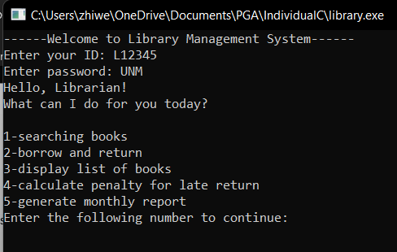

1. searching books

* after entering ‘1’ to continue the program to search for the registered books in the system.
* program will ask librarian to enter the ISBN number of the book to search for the book.
* if librarian enters a valid ISBN number, it will then show successful message indicating the book is found and display book title, author, ISBN number, year of publication, and number of copies available, total number of copies registered in the library. A screenshot of a computer program

  Description automatically generated

1. borrow and return.

* after entering ‘2’ to continue the program to borrow and return books.
* it will ask the librarian to enter a valid student ID,
* if a valid student ID is entered, it will show the previous record of the student by displaying title of books borrowed and date of borrow.
* it will then ask the librarian to enter his/her choice to borrow / return.
  + librarian will need to update all the files related manually.
  + librarian will need to manually type for the ‘Targeted files to replace’, which is showed above it.
  + librarian will need to copy the specific line of the targeted files and update the related information then paste it as the input for ‘Enter the content that you want to replace with’.
  + it will show successful message after librarian updates all the files.
  + after showing successful message it will redirect user back to main page

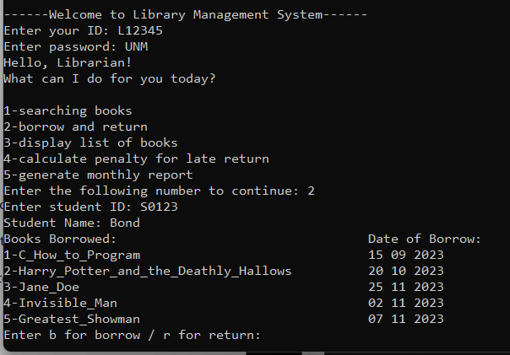

* if librarian chose b for borrow
  + program will ask the librarian to enter the exact tile of the book to be borrowed which is available and valid.
  + the program will then prompt the user to update the file information accordingly.

* for example, if John with student ID S4567 wants to borrow his first book in the library. Librarian will need to enter:

1. ‘book_list.txt’ is entered as the targeted file to change, ‘2’ is entered as the specific line number to change in ‘book_list.txt’ and ‘002 Brave Svetlana_Chmakova 2012 9 14’ is entered as the updated content in the file (changed number of books available in the library which is the last 2nd number of the content by decreasing one to the original value of number of book available in library).
2. ‘students.txt’ is entered as the targeted file to change, ‘2’ is entered as the specific line number to change in ‘students.txt’ and ‘S4567 John 1 2’ is entered as the updated content in the file (changed the number of books borrowed which is the last 2nd number of the content whereas the last number indicates the number of returned).
3. ‘student_borrow_list.txt’ is entered as the targeted file to change, ‘2’ is entered as the specific line number to change in ‘student_borrow_list.txt’ and ‘Brave’ entered as the updated content in the file (which indicates the total books borrowed by John is the book ‘Brave’, if the student have more than one books borrowed, librarian will need to update the content by entering ‘Brave Alice_in_Wonderland Invisible_Man’ according to the number of books borrowed by the student).
4. ‘date_borrowed.txt’ is entered as the targeted file to change, ‘2’ is entered as the specific line number to change in ‘date_borrowed.txt’ and ’08 12 2023’ entered as the updated content in the file (the date of the first book of John borrowed, it is similar to the student_borrow_list.txt if the student has borrowed more than one book. for example, 3 books are borrowed, the librarian will need to enter 3 dates such as ’05 05 2023 06 06 2023 07 07 2023’).

* if librarian chose r for return
  + program will ask librarian to enter the exact book title to be returned.
  + if the book title entered is a valid book to be returned, it will then prompt the user to update the following files accordingly like borrow case.

* for example, if Bond with student ID S0123 wants to return one of his borrowed book in the library. Librarian will need to enter:

1. ‘book_list.txt’ is entered as the targeted file to change, ‘10’ is entered as the specific line number to change in ‘book_list.txt’ and ‘010 Jane_Doe Charlotte_Bronte 1847 5 8’ is entered as the updated content in the file (changed the number of books available in the library which is the last 2nd number of the content by adding one to the original value).
2. ‘students.txt’ is entered as the targeted file to change, ‘4’ is entered as the specific line number to change in ‘students.txt’ and ‘S0123 Bond 4 3’ is entered as the updated content in the file (changed the number of books returned which is the last number of the content by adding one to the original value, and changed the number of book borrowed which is the last 2nd number of the content by decreasing one to the original value).
3. ‘student_borrow_list.txt’ is entered as the targeted file to change, ‘4’ is entered as the specific line number to change in ‘student_borrow_list.txt’ and ‘C_How_to_Program Harry_Potter_and_the_Deathly_Hallows Invisible_Man’ entered as the updated content in the file (which indicates the total books borrowed by Bond is now without the book he returned which is the book ‘Jane_Doe’)
4. ‘date_borrowed.txt’ is entered as the targeted file to change, ‘4’ is entered as the specific line number to change in ‘date_borrowed.txt’ and ’15 09 2023 20 10 2023 02 11 2023 07 11 2023’ entered as the updated content in the file (the corresponding date of borrow for the book Jane_Doe is no longer within the file).
5. display list of books

* after entering ‘3’ to continue the program to display list of books.
* it will show all the related information of the books.
* after finishing displaying list of books, it will redirect the librarian back to the main page. A screenshot of a computer program

  Description automatically generated

1. calculate the penalty for late return.

* after entering ‘4’ for the program to continue to calculate the penalty for late return
* it will prompt the librarian to enter date of borrow and date of return in the format of dd mm yyyy.
* if the student has paid the penalty for late return, it will show a successful message indicating the program have successfully update it to the monthly report.
* the below code shows the updated monthly report that is entered immediately after calculating the penalty that has been paid by the student.

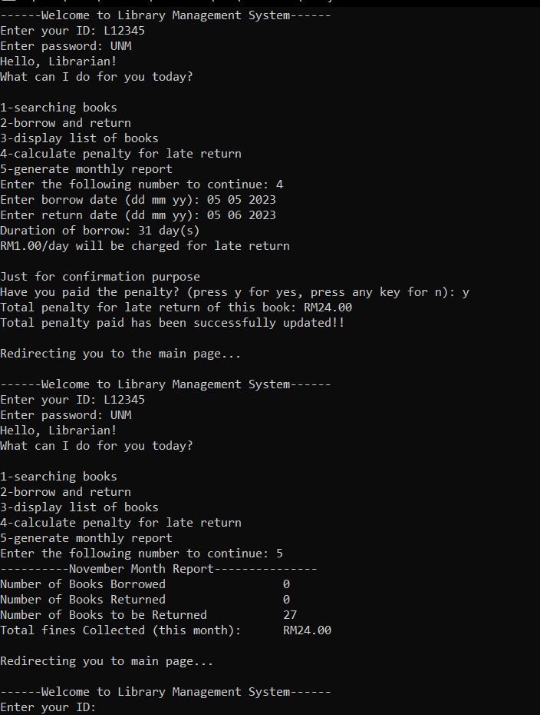

* if the student has not paid the penalty for late return, it will not update it to the monthly report, the following code is entered immediately after the code above to show that it doesn’t update the penalty paid in monthly report if the student has not paid it.

1. generate monthly report.

* after entering ‘5’ for the program to continue to generate monthly report
* it will show the information that is being keep track since the starting of the program.
* the information such as number of book borrowed, number of books returned, number of books to be returned and total fines collected will automatically be discarded if the program is restarted.

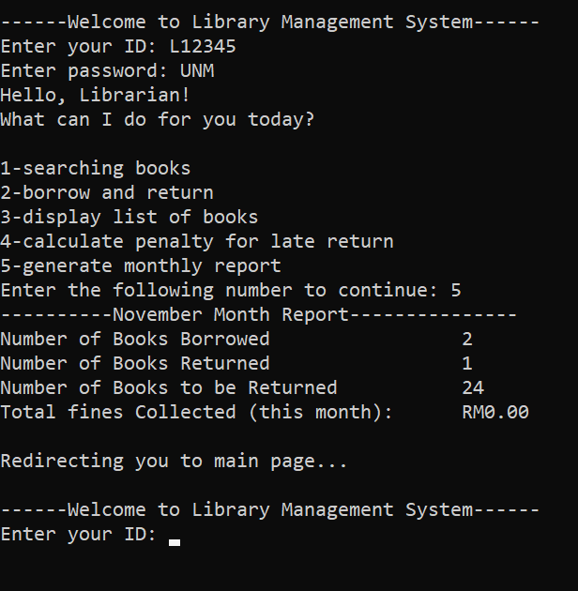

**Student part:**

For students that are registered, they will need to enter their student ID. Once the program recognised the student ID, it will great the student and continue asking the student to choose a number to continue execution.

1. searching books

* after entering ‘1’, the program continues to search books registered in the system by showing related information such as book title, book author, ISBN number, year of publication, number of copies available, total number copies of the book.
* after finishing displaying the related information, the program redirects the student back to the main page.

1. display list of books

* after entering ‘2’, the program continues to display all the books registered in the system.
* after finishing displaying the related information of the books registered in the system such as ISBN number, book title, book author, year of publication, number of copies available, number of total copies of the book registered in the system.
* it will automatically redirect the student back to the main page.

1. calculate the penalty for late return.

* after entering ‘3’, the program continues to calculate the penalty for late return.
* the program prompts the user to enter date of borrow and date of return in the format of (dd mm yyyy)
* it will then show the duration of borrow and the penalty will be charged when the duration of borrow have exceeded 7 days.
* assume that the student will answer the question ‘have you paid the penalty’ honestly, so that the total penalty updated is accurate.
* the below code shows the student have paid the penalty and updated to the monthly report.

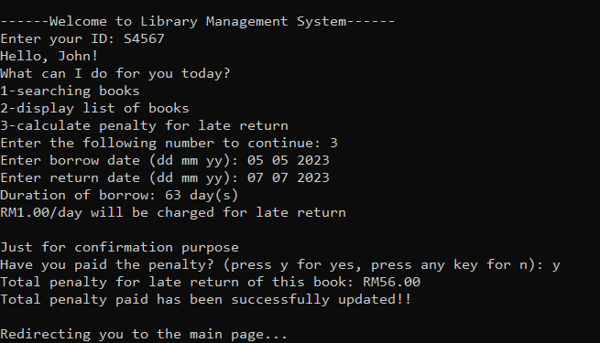

* the below code shows the student have not paid the penalty and it will not be updated to the monthly report.

Test Case Result:

1. if the current user has entered the wrong user ID, it will show error message and prompt user to enter user ID again:

1. If the current user is librarian, he/she has entered the wrong password, it will show error message and prompt user to enter user ID again:

1. if librarian enters an invalid ISBN number for searching books function, it will show error message indicating book is not found and ends the searching by redirecting the user back to the main page.

1. if invalid student ID is entered while executing borrow_return function, the program will prompt librarian to enter again until a valid student ID is entered. A computer screen shot of a program

   Description automatically generated
2. if librarian accidentally entered the wrong title of the book to be borrowed during the execution of borrow_return function, program will ask the librarian again until the librarian has entered a valid book that is available to be borrowed.  
   A computer screen shot of a program

   Description automatically generated
3. during execution of borrow_return function, if librarian accidentally enters a book that is not been borrowed by the student which is an invalid input, program will show error message indicating book is not borrowed by the student. Program will prompt the librarian to enter again, until a valid and available book to be returned is entered.

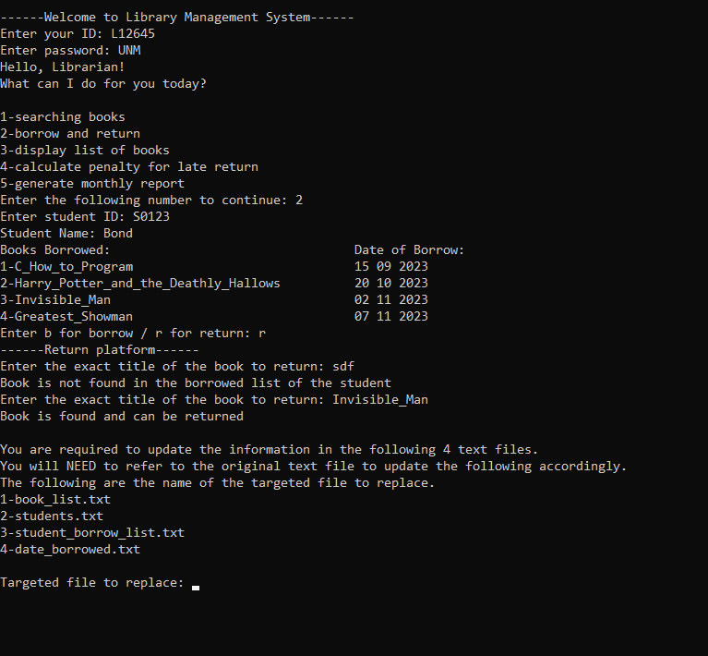

1. if librarian accidentally entered an invalid choice for return or borrow during borrow_return function, it will prompt the librarian to enter again until ‘b’ or ‘r’ is entered.

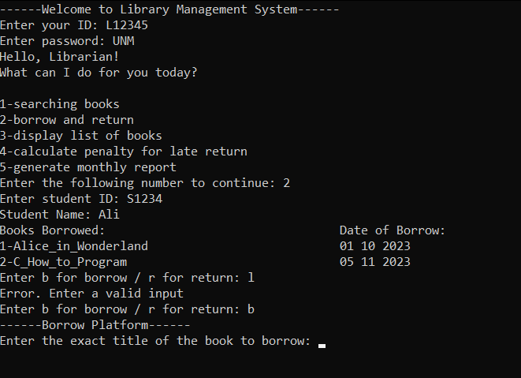

1. during execution of penalty function, if user entered date such as:

* if the date of return is smaller than date of borrow, it will show error message indicating invalid date is entered and redirects the librarian back to the main page.

* if the date of return and date of borrow is zero, it will not show the penalty   
  A screenshot of a computer program

  Description automatically generated
* if the duration of borrowing is within the deadline which is one week, it will not assign the penalty to the student and it will show the reason to the librarian.

The below is the original version of text files used in the library management system:

book_list.txt indicates book ISBN, book title, book author, publication year, number of books available, total copies of the corresponding book

001 Alice_in_Wonderland Lewis_Carroll 1865 8 9

002 Brave Svetlana_Chmakova 2012 10 14

003 C_How_to_Program Harvey_Deitel_and_Paul_Deitel 1992 15 19

004 Da_Vinci_Code Dan_Brown 2003 5 5

005 Ender's_Game Shannon_Hale 1992 5 6

006 Farenheit_451 Simone_Beck 1961 6 8

007 Greatest_Showman Jenny_Bicks 2017 5 6

008 Harry_Potter_and_the_Deathly_Hallows J_K_Rowling 2007 10 15

009 Invisible_Man Isaac_Asimov 1950 5 9

010 Jane_Doe Charlotte_Bronte 1847 4 8

date_borrowed.txt indicates the date of borrow of each book in dd mm yyyy format

01 10 2023 05 11 2023

10 10 2023

15 09 2023 20 10 2023 25 11 2023 02 11 2023 07 11 2023

12 01 2023 17 11 2023 22 11 2023

27 09 2023 03 11 2023

08 11 2023 13 09 2023 18 10 20223 23 09 2023

28 10 2023

04 11 2023 09 11 2023 14 11 2023 19 11 2023 24 10 2023

29 10 2023 06 11 2023 11 10 2023

student_borrow_list.txt indicates the books borrowed by the corresponding student

Alice_in_Wonderland C_How_to_Program

Brave

C_How_to_Program Harry_Potter_and_the_Deathly_Hallows Jane_Doe Invisible_Man Greatest_Showman

Brave Harry_Potter_and_the_Deathly_Hallows Jane_Doe

Ender's_Game Harry_Potter_and_the_Deathly_Hallow

C_How_to_Program Harry_Potter_and_the_Deathly_Hallows Jane_Doe Invisible_Man

Brave

C_How_to_Program Harry_Potter_and_the_Deathly_Hallows Invisible_Man Brave Fahrenheit_451

Fahrenheit_451 Jane_Doe Invisible_Man

students.txt indicates student ID, student name, number of books borrowed, number of books returned

S1234 Ali 2 0

S4567 John 0 2

S8910 Mary 1 1

S0123 Bond 5 2

S3456 Abu 3 0

S7891 Fin 2 1

S0234 Ahboy 4 2

S5678 Muhammad 1 3

S9102 Ahmad 5 0

S3455 Zara 3 1