Part B(Individual)

Muhammad Amsyar bin Abdul Malek

2022020070028

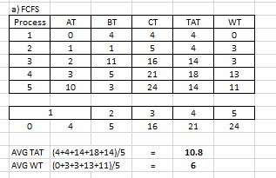

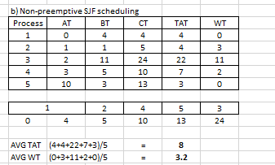

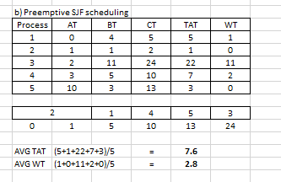

Part B(Individual)

Indra bin Isman

2022019070041