Name: Zhiyan Liu

Student ID:29008123

fit5046 assignment 3 screen shots

# Home screen:

This the first screen when open the App, it displays the date, time, user name and the set goal button. If there is no user log in, the user name will display “not log in”. user can navigate all the screens by the navigation drawer.

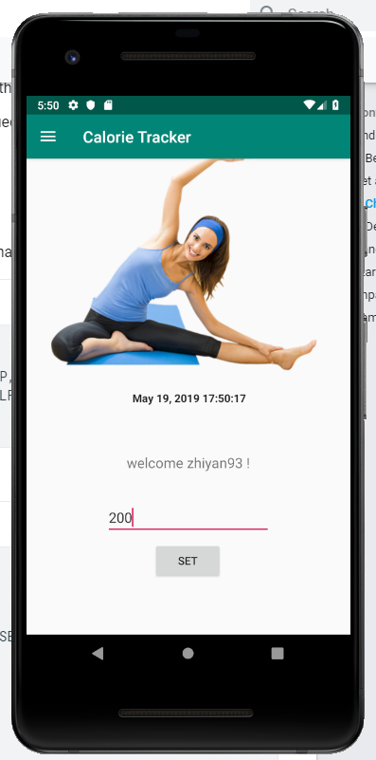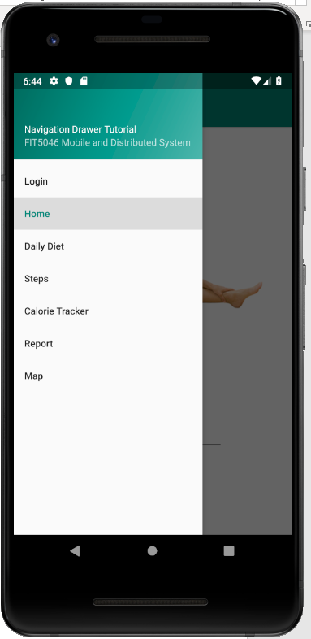

I validate the input number can not be greater than 500 and only can input number

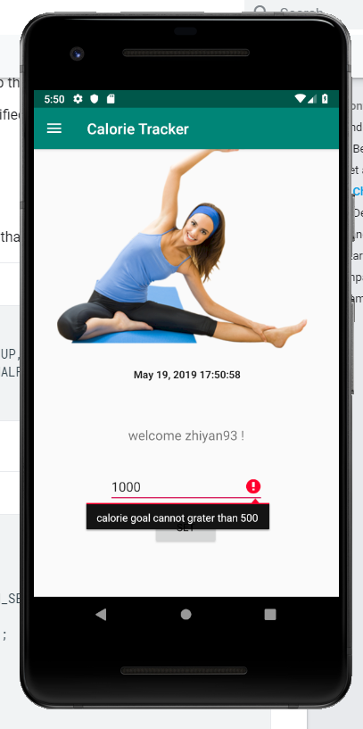

# Log in and sign up screen:

User can sign in by log in name and pass word matched in the database.

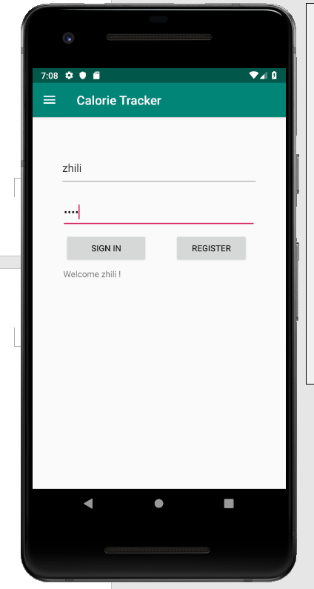

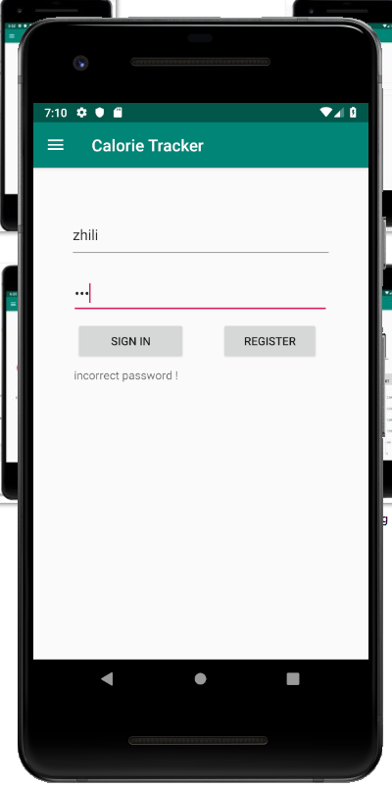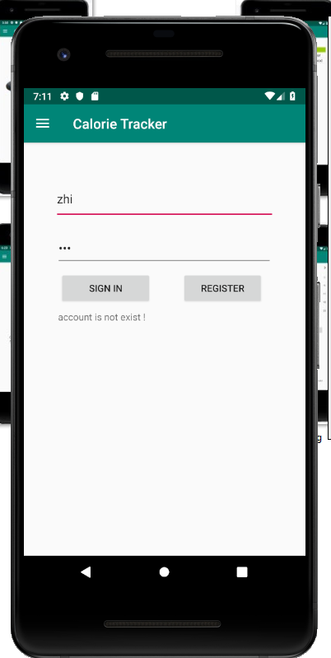And it can check if the account not exist or incorrect password

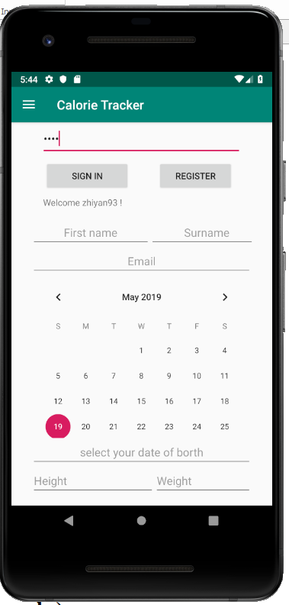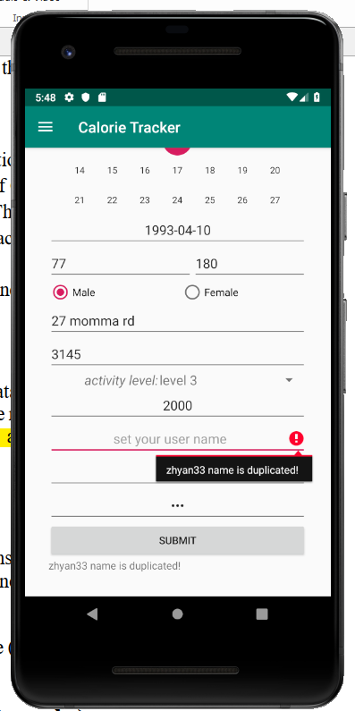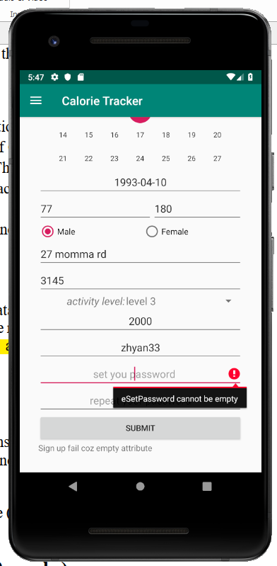User can click register button to register account and the register part of screen will display after click the register button. I validate each information edittext can not be empty, and the log in name can not be duplicated and shorter than 4 characters.

I use the radio button and spinner for gender and level of activity selection.

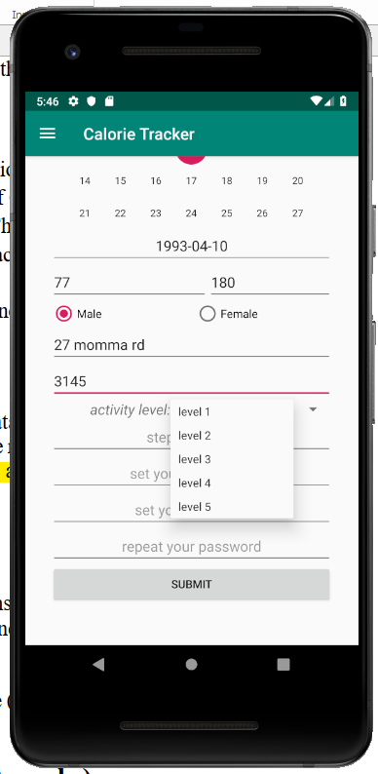

When user fill all the required information, he can press the submit button to sign up and it will be posted to credential table and user table.

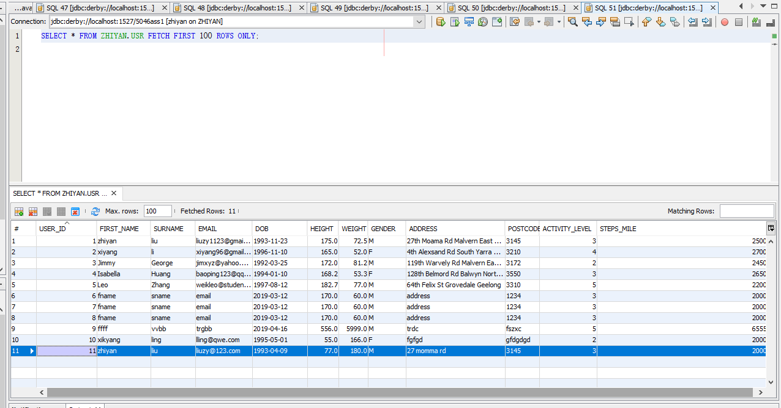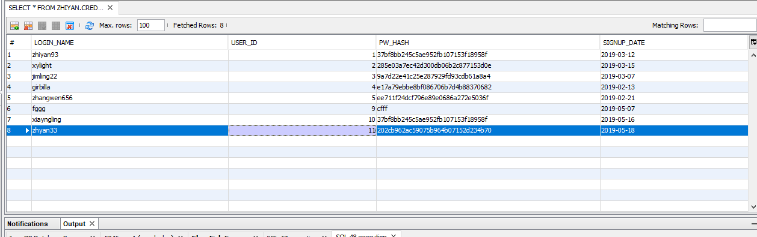

# Daily diet screen:

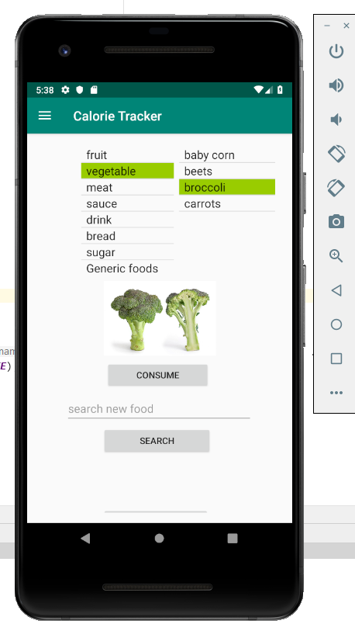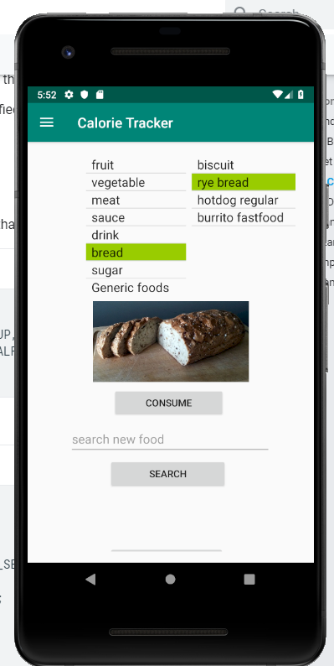This screen shows all the food category and the foods under the category in two separate listviews.

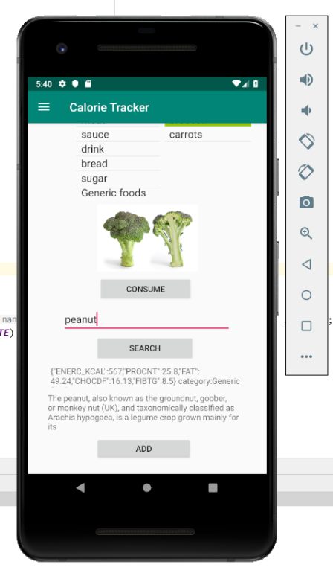User can click the food, the food image will display and user can click consume to consume the food one unit. User can also add new foods that not existed in the food table by search food.

# Steps screen:

The steps screen use the SQLite database to persistently store and display the steps data. User can click clear all button to clear all the steps data.

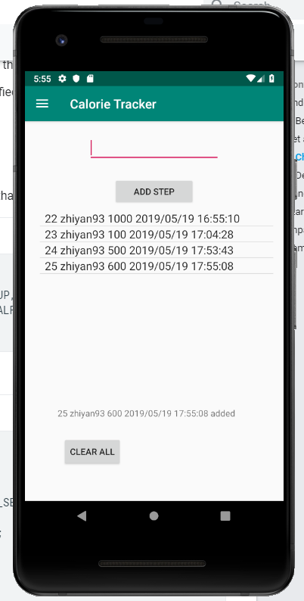

# Calorie tracker screen:

The calorie tracker screen display the data of calorie burn, goal, calorie consumption and steps. The new report record will be post from the data in this screen. I calculate the number of (calorie burn-calorie consumption) and compare with the goal to figure out if the daily goal is finished. If finished, the color of total calorie burn font will be green, otherwise is will be red.

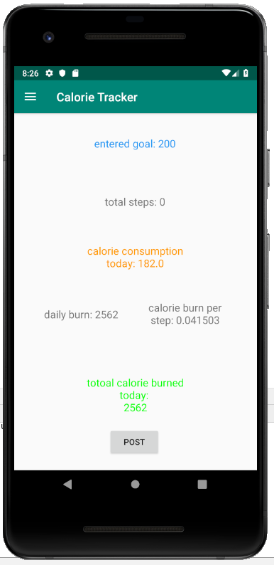

The report can be posted to report table(I did not complete the function that post the report at 23:55, It can only be posted manually by press the post button)

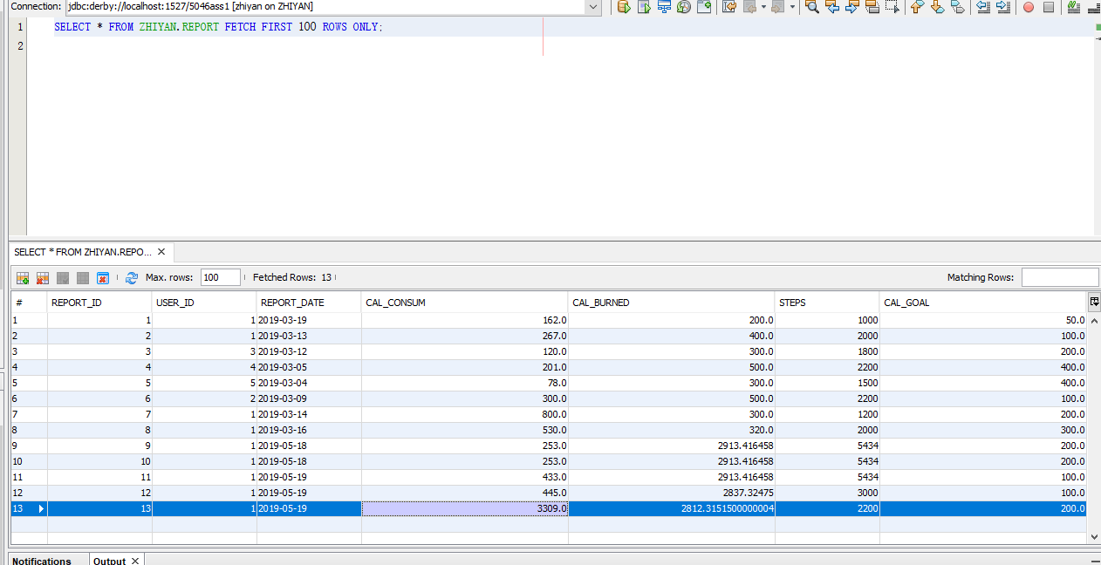

# The report screen:

The report screen can display a pie chart and a bar chart to visualize the calorie consumption and burn data.

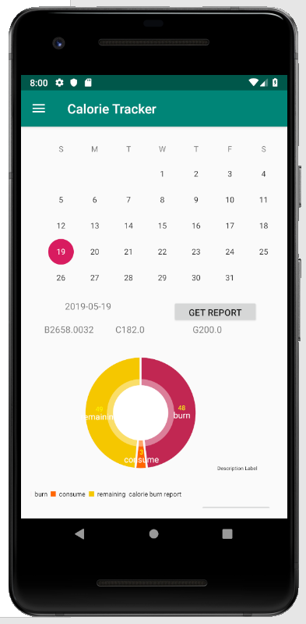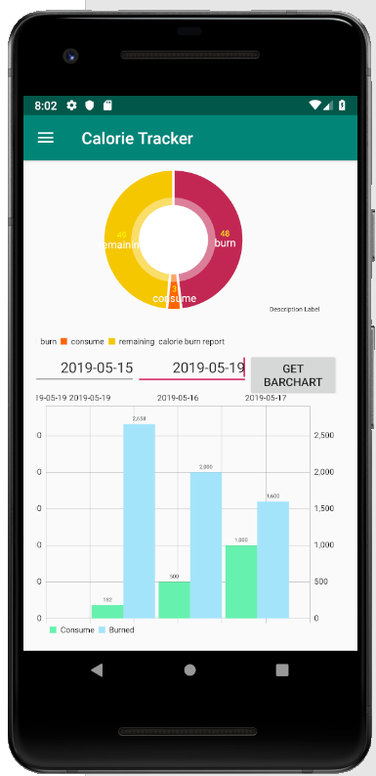

# Map screen:

The map screen displays the location of the user and the parks nearby his home in 5km. The user can click the park on the screen and the park name will be displayed.

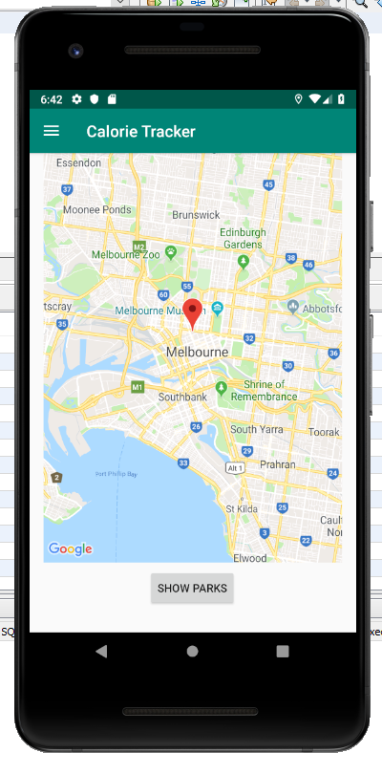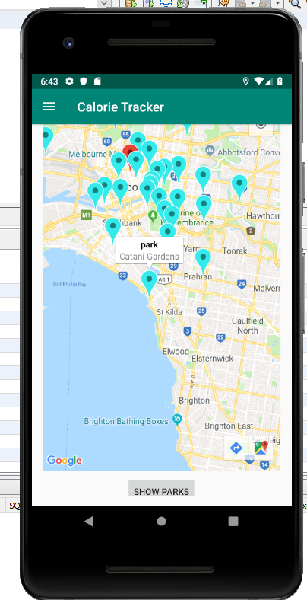

# API specification:

The configuration of Google Custom Search API:

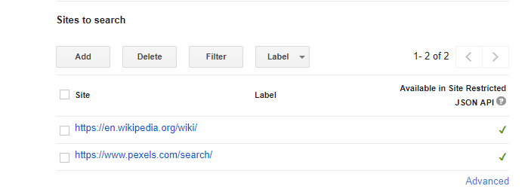

I used the Wikipedia for word search and the pexels.com for image search.

For the food database API, I used the API provided by Edamam.

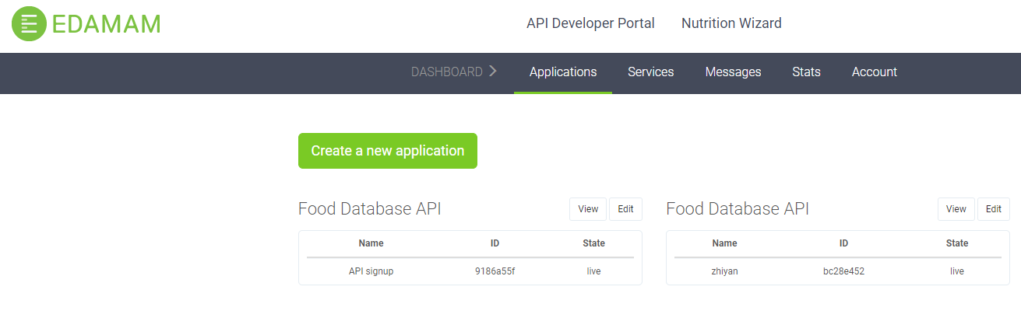

For the park search, I used the API that provided by Foursquare.com

