DAC Top level cell

DAC_CORE Capacitor array

DFF D-type flip-flop

DFF_N D-type flip-flop with inverted clock

INV Inverter

NAND NAND

opamp 2-stage operational amplifier

REF Reference voltages

RingOsc Ring oscillator

SR_N Shift register with inverted clock

SW NANDs for pull inputs low during resetting

TB_DAC DAC test cell

test_DAC DAC test bench

Figure 1: Top level schematic

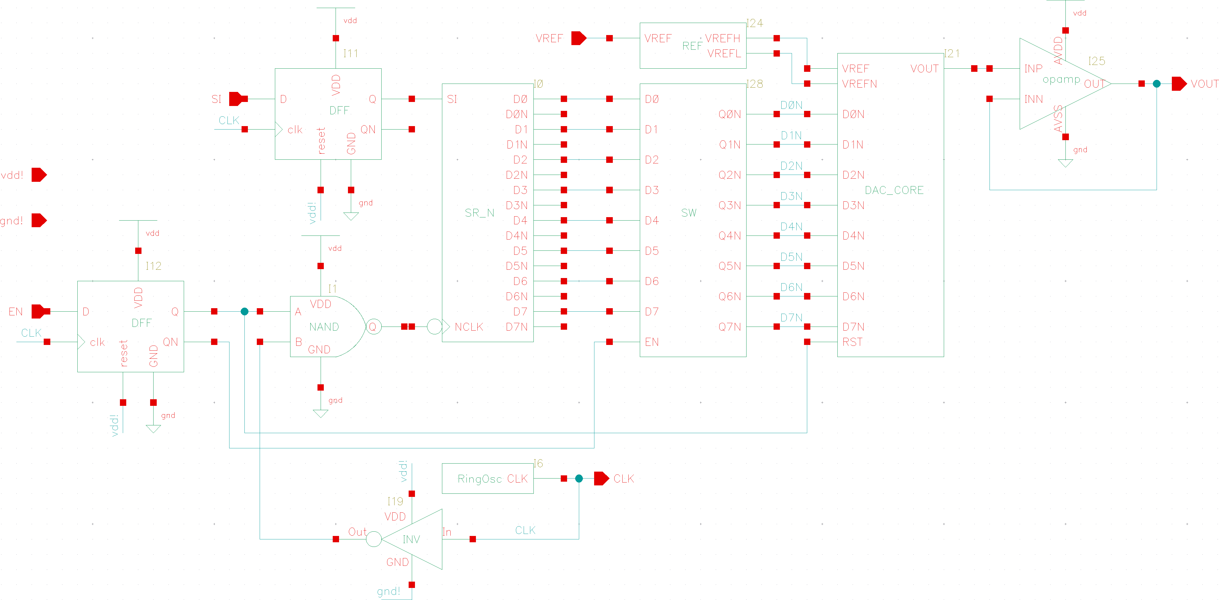

Figure 2: Capacitor array

