**ELEC2221 D1 – Design and test of a sequential multiplier**

Yubo Zhi

yz39g13

BEng Electronic Engineering

Professor Alun S Vaughan

Group 29

November 21st 2014

**ABSTRACT:** Design an n-bit unsigned multiplier, where, by using SHIFT-ADD sequential algorithm with SystemVerilog, then implement on MachXO2 Pico Kit. Majority of coding and simulations are done before the lab, then finish the encapsulation modules and implement each part of the design on the CPLD during the lab. Extensions achieved are combined SHIFT and ADD states for faster operation, bi-directional shared data port for multiplier input and output, push button signal debouncing and combinational multiplier.

1. **Adder design, simulation and synthesis**

The provided adder code [1] works well for any bit, by specify the parameter n, so it is not changed.

* 1. **Adder simulation**

Adder testbench:

module adder_test;

parameter n = 4;

logic [n - 1:0] A, M, Sum;

logic C;

adder #(.n(n)) a0 (.*);

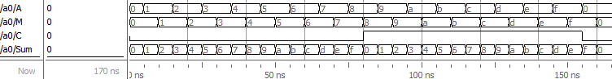

initial

begin

A = 'b0;

M = 'b0;

do

begin

Figure 1 Modelsim 4-bit adder simulation, shows all possible outputs

#5ns A++;

#5ns M = A;

end

while (A != 'b0);

end

endmodule

1. **Register design, simulation and synthesis**

The code for register is modified. The signal add is changed to add_shift, which modified to do both add and shift operations in 1 clock cycle, thus Creg register becomes unnecessary, so removed.

Register modified code:

module register #(parameter n = 4)

(input logic clock, reset, add_shift, shift, C,

input logic[n - 1:0] Qin, Sum, output logic[n * 2 - 1:0] AQ);

always_ff @ (posedge clock)

if (reset) // clear C,A and load Q

begin

AQ[n * 2 - 1:n] <= 0;

AQ[n - 1:0] <= Qin; // load multiplier into Q

end

else if (add_shift) // add, then shift

AQ <= {C,Sum,AQ[n - 1:1]};

else if (shift) // shift AQ

AQ <= {1'b0,AQ[n * 2 - 1:1]};

endmodule

* 1. **Simulation of registers**

Register testbench:

module register_test;

parameter n = 4;

logic clock, reset, add_shift, shift, C;

logic[n - 1:0] Qin, Sum;

logic[n * 2 - 1:0] AQ;

register #(.n(n)) r0 (.*);

// Clock

initial

begin

clock = 1'b0;

forever #5ns clock = ~clock;

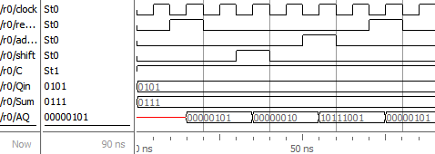end

// Test sequence

initial

begin

reset = 'b0;

add_shift = 'b0;

shift = 'b0;

C = 'b1;

Qin = 'hE5;

Sum = 'h47;

#10ns reset = 'b1;

Figure 2 Modelsim 4-bit register simulation.

Qin loaded at 15ns by reset signal, AQ shifted to right 1 bit at 25ns by shift signal, C and Sum loaded to highest 4 bits of AQ then shifted to right 1 bit at 55ns by add_shift signal.

#10ns reset = 'b0;

#10ns shift = 'b1;

#10ns shift = 'b0;

#10ns add_shift = 'b1;

#10ns add_shift = 'b0;

#10ns reset = 'b1;

#10ns reset = 'b0;

end

endmodule

1. **Sequencer design, simulation and synthesis**

Instead of separate add and shift states, these two steps are combined into one shifting state, and add signal is changed to add_shift, implemented in register. Therefore in shifting state, the sequencer check if Q0 is 1 than assert add_shift signal, otherwise assert shift signal.

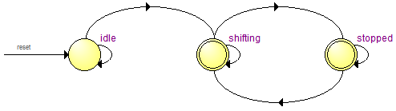Sequencer code:

module sequencer #(parameter n = 4)

(input logic start, clock, Q0,

output logic add_shift, shift, ready, reset);

enum logic [1:0] {idle, shifting, stopped} present, next;

*Figure 3 Sequencer state machine diagram, produced from Quartus*

logic [$clog2(n) - 1:0] count, next_count;

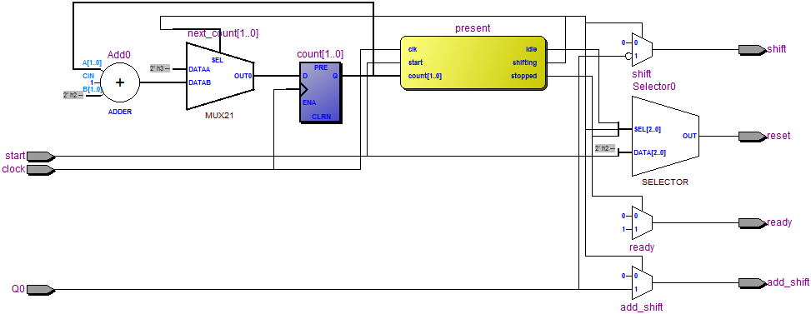always_ff @(posedge clock)

begin

present <= next;

count <= next_count;

end

always_comb

begin

add_shift = 1'b0;

shift = 1'b0;

ready = 1'b0;

reset = 1'b0;

*Figure 4 Sequencer RTL diagram, produced from Quartus*

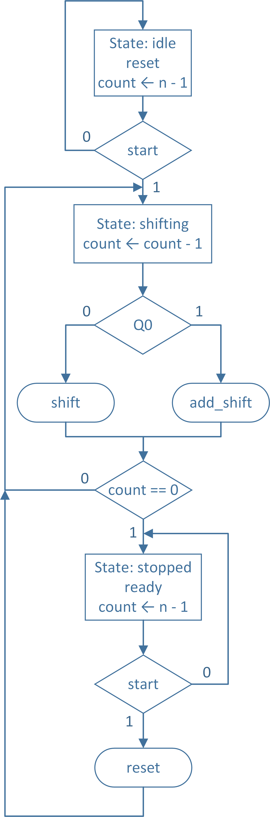 next = present;

next_count = count;

case (present)

idle: // State after reset

begin

reset = 1'b1;

next_count = n - 1;

if (start)

next = shifting;

end

shifting: // Shifting, n cycle

begin

next_count = count - 1;

if (Q0)

add_shift = 1'b1;

else

shift = 1'b1;

if (count == 0)

next = stopped;

end

stopped: // Finished

begin

ready = 1'b1;

next_count = n - 1;

if (start)

begin

reset = 1’b1;

next = shifting;

end

end

default:

next = idle;

endcase

end

endmodule

* 1. **Simulation of sequencer**

Sequencer testbench:

module sequencer_test;

parameter n = 4;

Figure 5 Sequencer ASM chart

logic start, clock, Q0;

logic add_shift, shift, ready, reset;

sequencer #(.n(n)) s0 (.*);

// Clock

initial

begin

clock = 1'b0;

forever #5ns clock = ~clock;

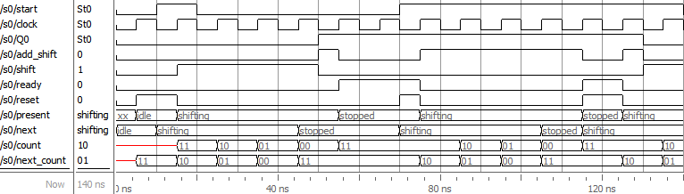end

// Test sequence

initial

begin

start = 'b0;

Q0 = 'b0;

#10ns start = 'b1;

#10ns start = 'b0;

#10ns Q0 = 'b0;

#20ns Q0 = 'b1;

*Figure 6 4-bit sequencer simulation, 2 cycles.*

reset signal asserted after start signal to load data in register. Then in shifting state, add_shift signal asserted if Q0=1, otherwise shift signal asserted. After 4 shifting state, operation finished, enter stopped state, ready signal asserted.

#20ns start = 'b1;

#40ns Q0 = 'b1;

#20ns Q0 = 'b0;

#10ns start = 'b0;

end

endmodule

1. **Multiplier design, simulation and synthesis**

For be able to input and output n-bit data, I designed a bi-directional data port, with 2-bit port function selection, and two n-bit register for store M and Qin. Therefore, multiplicand M will be loaded from data port at function ‘00’, multiplier Qin will be loaded from data port at function ‘01’, lower n-bit from result AQ will output at ‘10’, higher n-bit from result AQ will output at ‘11’. For avoid bus contention, an output enable signal OE is also added.

There is a debounce module for debounce start signal, if it is signalled by a push button.

Some compiler directives added to select from combinational multiplier or sequencer multiplier.

Multiplier code:

module multiplier #(parameter n = 4, freq = 3330000)

(input logic startPB, input logic [1:0] func,

input logic oe, output logic ready, inout [n - 1:0] data);

//// Internal Oscillator 3.33MHz

logic clock;

defparam OSCH_inst.NOM_FREQ = "3.33";

OSCH OSCH_inst (

.STDBY(1'b0), // 0=Enabled, 1=Disabled also Disabled with Bandgap=OFF

.OSC(osc_clk),

.SEDSTDBY() // this signal is not required if not using SED

);

//counter #(.n(24)) c(.*); // produces slow clock

assign clock = osc_clk;

//// Debounce

logic start;

debounce #(.n(freq / 1000)) d0(.clk(osc_clk), .in(~startPB), .out(start));

//// Blocks

logic C, reset, shift, add_shift;

logic [n - 1:0] Sum, M, Qin;

logic [n * 2 - 1:0] AQ;

//`define combinational

`ifndef combinational

adder #(.n(n)) A(.A(AQ[n * 2 - 1:n]), .*);

register #(.n(n)) R(.*);

sequencer #(.n(n)) S(.Q0(AQ[0]), .*);

`else

combmultiplier #(.n(n)) c0 (.A(M), .B(Qin), .Q(AQ));

assign ready = 'b1;

`endif

//// Port

assign data = oe ? (func == 2'b10 ? AQ[n - 1:0] : (func == 2'b11 ? AQ[n * 2 - 1:n] : 'bz)) : 'bz;

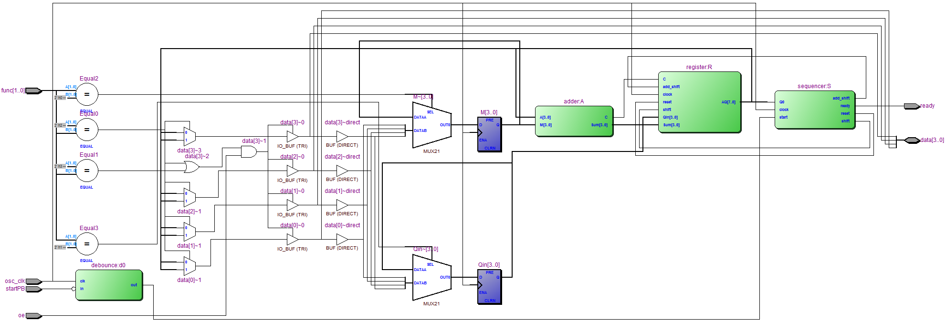

always_ff @(posedge osc_clk)

case (func)

2'b00:

M <= data;

2'b01:

Qin <= data;

endcase

endmodule

Figure 7 4-bit multiplier RTL diagram, produced from Quartus

* 1. **Simulation of multiplier**

Sequencer testbench:

module test;

parameter n = 4;

logic start;

logic [1:0] func;

logic oe, ready;

wire [n - 1:0] data;

multiplier #(.n(n)) m(.*);

logic op;

logic [n - 1:0] dataop;

assign data = op ? dataop : 'bz;

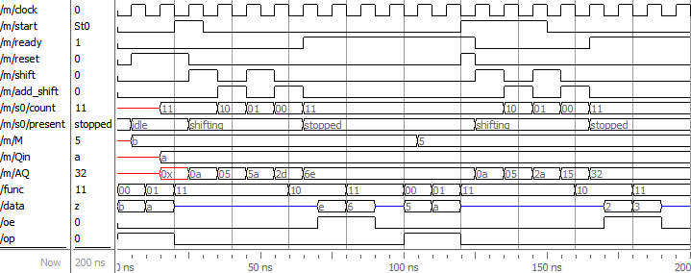

initial

begin

start = 1'b0;

oe = 1'b0;

func = 'b00;

op = 1'b1;

dataop = 'd123;

#10ns func = 'b01;

dataop = 'd234;

#10ns func = 'b11;

op = 1'b0;

start = 1'b1;

#10ns start = 1'b0;

#30ns func = 'b10;

Figure 8 4-bit multiplier Modelsim simulation, bi-directional data input and output.

op is a signal in testbench to control data output from dataop setting signals to data bus, for input M and Qin. First, M loaded into the multiplier through the data bus, by selecting func at function 00. After 1 clock cycle, Qin loaded into the multiplier by using function 01. Change func to function 11, without assert oe signal to prevent M and Qin change during computation. Then assert the start signal, let the multiplier start computation. 8 clock cycles later, ready signal been asserted, means computation finished. Then, by selecting function 10 and assert the oe signal, the lower 8-bit from the AQ result register will appear on the data bus. Selecting function 11 and assert the oe signal will let the higher 8-bit from the AQ result register appear on the data bus. There is another computation cycle in the simulation.

#10ns oe = 1'b1;

#10ns func = 'b11;

#10ns oe = 1'b0;

#10ns start = 1'b0;

oe = 1'b0;

func = 'b00;

op = 1'b1;

dataop = 'h55;

#10ns func = 'b01;

dataop = 'hAA;

#10ns func = 'b11;

op = 1'b0;

start = 1'b1;

#30ns start = 1'b0;

#10ns func = 'b10;

#10ns oe = 1'b1;

#10ns func = 'b11;

#10ns oe = 1'b0;

end

endmodule

1. **Extensions** 
   1. **Combine add and shift state**

Add and shift state combination already done by modifying the register code and combine the two states into a single shifting state in the state machine.

* 1. **8-bit multiplier**

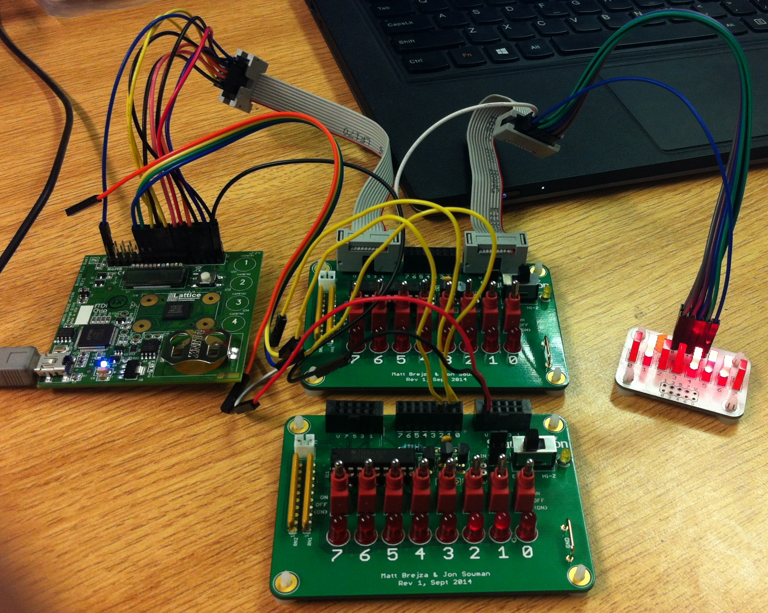Building an 8-bit multiplier is easy, as the parameter n to set the bit length is used in every module, so change the parameter n in the encapsulation multiplier module to 8 is the only thing needed to build an 8-bit multiplier.

e.g. the first line of multiplier module defination:

module multiplier #(parameter n = 8, freq = 3330000)

For simulation, change the paramter line (line 2) in testbench:

parameter n = 8;

Figure 9 8-bit multiplier implemented on MachXO2 CPLD. Data bus shared for data inputs and outputs. Top switch board with high-z mode for data input, bottom switch board for control signals, LED board for data output.

Change following lines in testbench for 4 more computation clock cycles:

Line 27:

#70ns func = 'b10;

Line 43:

#50ns func = 'b10;

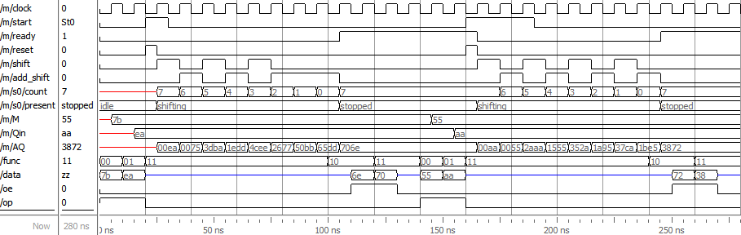Modelsim simulation:

Figure 10 8-bit multiplier Modelsim simulation, bi-directional data input and output.

Operations are the same as described previously in section 4.1, Figure 8.

* 1. **Button debouncing**

Button debouncing for start signal might be needed, if the start signal is controlled by a push button. Debouncing is done by make sure the signal from push button doesn’t change during a specific amount of time, basically a counter.

Code for debouncing a push button:

module debounce #(parameter n = 12500000)

(input logic clk, in, output logic out);

logic [$clog2(n) - 1:0] count;

assign out = count == n - 1;

always_ff @(posedge clk) begin

if (~in)

count <= 0;

else if (count != n - 1)

count <= count + 1;

end

endmodule

The push button featured by the MachXO2 Pico is active low, so it need to be inverted first.

Relative code in multiplier encapsulation module:

//// Debounce

logic start;

debounce #(.n(freq / 1000)) d0(.clk(osc_clk), .in(~startPB), .out(start));

The code has been tested on the MachXO2 CPLD by change the debouncing time to a big amount, then the start button need to be push for a longer time to activate the computation.

* 1. **Combinational multiplier**

For a variable n-bit combinational multiplier, the ‘generate’ block will be quite useful for generate hardware using for loops.

Combinational multiplier code:

module combmultiplier #(parameter n = 4)

(input logic [n - 1:0] A, B, output logic [n * 2 - 1:0] Q);

logic a[n][n];

logic c[n][n];

logic s[n][n];

// Generate full adder matrix

genvar x, y;

generate

for (y = 0; y < n; y++)

for (x = 0; x < n; x++)

fulladder a0 (.A(a[y][x]), .B(A[x] & B[y]), .Cin(x == 0 ? '0 : c[y][x - 1]), .S(s[y][x]), .Cout(c[y][x]));

endgenerate

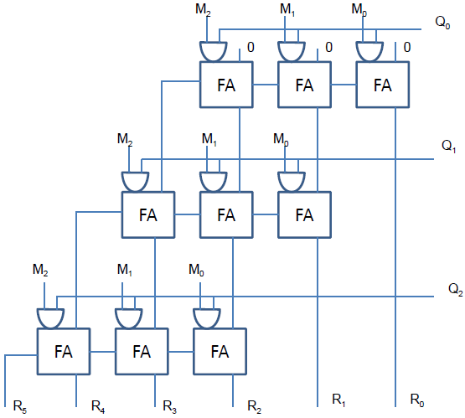// Connections

generate

for (x = 0; x < n; x++)

assign a[0][x] = 'b0;

for (y = 1; y < n; y++)

assign a[y][n - 1] = c[y - 1][n - 1];

for (y = 1; y < n; y++)

for (x = 0; x < n - 1; x++)

assign a[y][x] = s[y - 1][x + 1];

assign Q[n * 2 - 1] = c[n - 1][n - 1];

for (y = 0; y < n; y++)

assign Q[y] = s[y][0];

for (x = 0; x < n - 1; x++)

assign Q[n + x] = s[n - 1][x + 1];

Figure 11 Graphical representation of unsigned combinational multiplier.

endgenerate

endmodule

The full adder module used in the combinational multiplier:

module fulladder (input logic A, B, Cin, output logic S, Cout);

assign {Cout,S} = A + B + Cin;

endmodule

Relative code in multiplier encapsulation module:

`define combinational

`ifndef combinational

adder #(.n(n)) A(.A(AQ[n * 2 - 1:n]), .*);

register #(.n(n)) R(.*);

sequencer #(.n(n)) S(.Q0(AQ[0]), .*);

`else

combmultiplier #(.n(n)) c0 (.A(M), .B(Qin), .Q(AQ));

assign ready = 'b1;

`endif

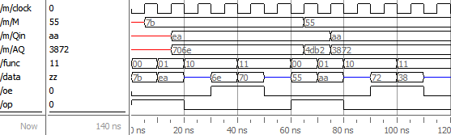Modelsim testbench:

module comb_test;

parameter n = 8;

logic start, oe, ready;

logic [1:0] func;

wire [n - 1:0] data;

multiplier #(.n(n)) m(.*);

logic op;

Figure 12 8-bit combinational multiplier Modelsim simulation, bi-directional data input and output.

clock is used by input data storage register M and Qin.

start and ready signals are unnecessary for combinational multiplier, and they were set to always 1, so omitted from simulation diagram.

Operations for data input and output are the same as described previously in section 4.1, Figure 8, the difference is combinational multiplier doesn’t need to wait for ready signal before getting the results.

logic [n - 1:0] dataop;

assign data = op ? dataop : 'bz;

initial

begin

start = 1'b1;

oe = 1'b0;

func = 'b00;

op = 1'b1;

dataop = 'd123;

#10ns func = 'b01;

dataop = 'd234;

#10ns func = 'b10;

op = 1'b0;

#10ns oe = 1'b1;

#10ns func = 'b11;

#10ns oe = 1'b0;

#10ns func = 'b00;

op = 1'b1;

dataop = 'h55;

#10ns func = 'b01;

dataop = 'hAA;

#10ns func = 'b10;

op = 1'b0;

#10ns oe = 1'b1;

#10ns func = 'b11;

#10ns oe = 1'b0;

end

endmodule

1. **Conclusion**

In this project, a sequential unsigned n-bit multiplier was implemented on MachXO2 Pico Dev Kit. The multiplier uses SHIFT-ADD algorithm, with the SHIFT and ADD states combined for faster operation. A debouncing module is developed for debounce the on-board push button used for signalling the start signal. For be able to input to and output from the multiplier within limited IO ports, a bi-directional data port has also been developed. Furthermore, an n-bit combinational multiplier is also developed, which is very fast compare to sequential multiplier, but will require a large amount of logic for larger n.

By finishing this project, I’ve learnt using SystemVerilog to design finite state machine, digital hardware design, generate block [2] for generate hardware by for loops, Synthesis and program a MachXO2 device using Lattice Diamond.

To extend it further, a signed multiplier may be a reasonable choice. There are some other combinational multiplier design available as well [3].

1. **References**
2. Tom J Kazmierski (17, Oct. 13). *Suggested SystemVerilog source files* [Online]. Available: https://secure.ecs.soton.ac.uk/notes/elec2221/tjk2014/D1
3. Jeff Johnson (Jul 18, 2011). *Code templates: Generate for loop* [Online]. Available: http://www.fpgadeveloper.com/2011/07/code-templates-generate-for-loop.html
4. *Multipliers & Pipelining* [Online]. Available: http://web.mit.edu/6.111/www/f2011/handouts/L09.pdf