Test1,vue:

<template>

<div class="test">

<h2>{{title}}</h2>

<h3 v-if="showName">姓名：{{user.name}}</h3>

<h3 v-else="showName">地址：{{user.address}}</h3>

<h3>年龄：{{user.age}}</h3>

<ul>

    <li v-for="item in items">{{item.title}}</li>

    </ul>

<button v-on:click="greet()" class="btn btn-primary">Say Greeting</button>

<h4>监听键盘事件</h4>

<input type="text" v-on:keyup="pressKeybord" id="input"/>

<h4>监听键盘指定单个按钮事件——输入Enter进行监听</h4>

<input type="text" v-on:keyup.enter="pressKeybord_enter" id="input_enter"/>

<h4>监听键盘指定多个按钮事件——输入Alt+Enter进行监听</h4>

<input type="text" v-on:keyup.alt.enter="pressKeybord_alt_enter" id="input_alt_enter"/>

<h3>bootstrap的使用</h3>

<div class="row">

<div class="col-md-1">.col-md-1</div>

<div class="col-md-1">.col-md-1</div>

<div class="col-md-1">.col-md-1</div>

<div class="col-md-1">.col-md-1</div>

<div class="col-md-1">.col-md-1</div>

<div class="col-md-1">.col-md-1</div>

<div class="col-md-1">.col-md-1</div>

<div class="col-md-1">.col-md-1</div>

<div class="col-md-1">.col-md-1</div>

<div class="col-md-1">.col-md-1</div>

<div class="col-md-1">.col-md-1</div>

<div class="col-md-1">.col-md-1</div>

</div>

<h3>Computed计算属性</h3>

<form>

<div class="form-group">

<label for="exampleInputEmail1">姓名：</label>

<input type="text" class="form-control" id="exampleInputEmail1" v-model="user.name">

</div>

<div class="form-group">

<label for="exampleInputPassword1">地址：</label>

<input type="text" class="form-control" id="exampleInputPassword1" v-model="user.address">

</div>

<div class="form-group">

<label for="exampleInputPassword1">姓名&地址：</label>

<input type="text" class="form-control" id="exampleInputPassword1" v-model="nameAndaddress">

</div>

</form>

<h3>props属性</h3>

<h4>{{msg}}</h4>

</div>

</template>

<script>

//引入jquery

import $ from "jquery";

import "../assets/css/bootstrap.min.css";

import "../assets/css/bootstrap-theme.min.css";

import "../assets/js/jquery-3.3.1.min.js";

import "../assets/js/bootstrap.min.js";

export default {

name: "test",

data() {

return {

user: {

name: "zhuxu",

age: 12,

address: "江苏南京"

},

title: "Hello Word Vue.js!",

showName: true,

items: [{ title: "item1" }, { title: "item2" }, { title: "item3" }]

};

},

methods: {

greet: function() {

alert("Hello Word");

},

pressKeybord: function() {

var content = $("#input").val();

console.log(content);

},

pressKeybord_enter: function() {

var content = $("#input_enter").val();

console.log("input_enter=" + content);

},

pressKeybord_alt_enter: function() {

var content = $("#input_alt_enter").val();

console.log("input_alt_enter=" + content);

}

},

computed: {

nameAndaddress: function() {

return this.user.name + " " + this.user.address;

}

},

props: {

msg: {

type: String,

default: "默认就是当前内容"

}

}

};

</script>

<!-- Add "scoped" attribute to limit CSS to this component only -->

<!--scope只会影响到当前组件的样式-->

<style scoped>

</style>

App.vue:

<template>

<div id="app">

<img src="./assets/logo.png">

<Test1 msg="这是新的属性"></Test1>

</div>

</template>

<script>

import Test1 from './components/Test1.vue'

export default {

name: 'App',

components:{

Test1,

}

}

</script>

<style>

#app {

font-family: 'Avenir', Helvetica, Arial, sans-serif;

-webkit-font-smoothing: antialiased;

-moz-osx-font-smoothing: grayscale;

text-align: center;

color: #2c3e50;

margin-top: 60px;

}

</style>

运行结果：

v-on语句的使用:

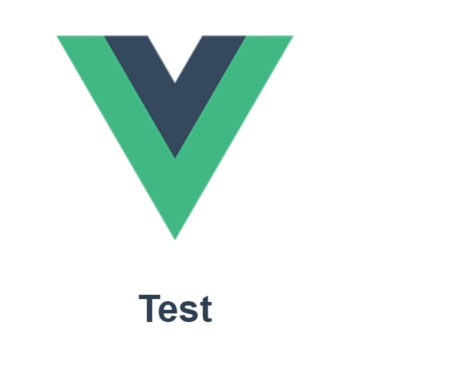

Computed计算属性:

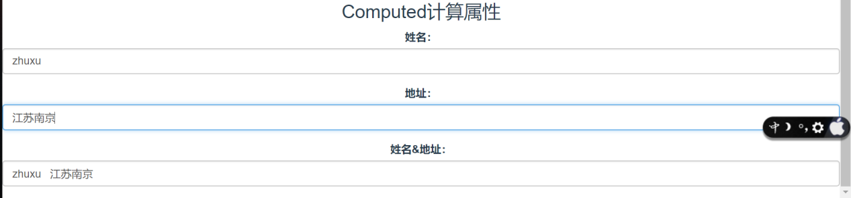

props属性：

