**任务一：（数据库CAP）**

1. 创建数据库CAP，包含4张表Customers、Products、Agents和Orders。

if exists (select *from sys.databases where name ='CAP')

drop database CAP--有重名就删除

CREATE DATABASE CAP

ON --数据文件

(NAME=CAP_DATA,

FILENAME='C:\SQLDATA\CAP_DATA.mdf',

SIZE=10MB, --初始大小

MAXSIZE=UNLIMITED,

FILEGROWTH=10% --增长方式

)

LOG ON --日志文件

(NAME=CAP_LOG,

FILENAME='C:\SQLDATA\CAP_DATA.ldf',

SIZE=3MB,

MAXSIZE=5MB,

FILEGROWTH=1MB

) --建数据库

use CAP

CREATE TABLE Customers (

cid varchar(10) primary key not null,

cname varchar(10) not null,

city varchar(10) not null,

discnt float not null

)

CREATE TABLE Products (

pid varchar(10) primary key,

pname varchar(10),

city varchar(10),

quantity int,

price float

)

CREATE TABLE Agents (

aid varchar(10) primary key,

aname varchar(10),

city varchar(10),

percent1 int

)

CREATE TABLE Orders (

ordon int primary key,

month varchar(10),

cid varchar(10),

aid varchar(10),

pid varchar(10),

qty int,

dollor float

)--建表

select * from Customers

select * from Products

select * from Agents

select * from Orders

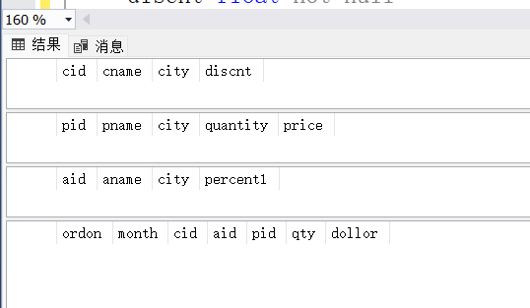

1. 利用SQL语句向4张表中增加一些示例数据。

USE CAP

insert into Customers(cid,cname,city,discnt)

values('C001','TipTop','Duluth',10.00)

insert into Customers(cid,cname,city,discnt)

values('C002','Basics','Dallas',12.00)

insert into Customers(cid,cname,city,discnt)

values('C003','Allied','Dallas',8.00)

insert into Customers(cid,cname,city,discnt)

values('C004','ACME','Duluth',8.00)

insert into Customers(cid,cname,city,discnt)

values('C006','ACME','Kyoto',0.00)

--Customers数据

insert into Products(pid,pname,city,quantity,price)

values('P01','comb','Dallas',111400,0.50)

insert into Products(pid,pname,city,quantity,price)

values('P02','brush','Newark',203000,0.50)

insert into Products(pid,pname,city,quantity,price)

values ('P03','razor','Duluth',150600,1.00)

insert into Products(pid,pname,city,quantity,price)

values ('P04','Pen','Duluth',125300,1.00)

insert into Products(pid,pname,city,quantity,price)

values ('P05','pencil','Dallas',221400,1.00)

insert into Products(pid,pname,city,quantity,price)

values ('P06','folder','Dallas',123100,2.00)

insert into Products(pid,pname,city,quantity,price)

values ('P07','case','Newark',100500,null)

--Products数据

insert into Agents(aid,aname,city,percent1)

values('A01','Smith','New York',6)

insert into Agents(aid,aname,city,percent1)

values('A02','Jones','Newark',6)

insert into Agents(aid,aname,city,percent1)

values('A03','Brown','Tokyo',7)

insert into Agents(aid,aname,city,percent1)

values('A04','Gray','New York',6)

insert into Agents(aid,aname,city,percent1)

values('A05','Otasi','Duluth',5)

insert into Agents(aid,aname,city,percent1)

values('A06','Smith','Daalas',5)

--Agents数据

insert into Orders(ordon,month,cid,aid,pid,qty,dollor)

values(1011,'Jan','C001','A01','P01',1000,450.00);

insert into Orders(ordon,month,cid,aid,pid,qty,dollor)

values(1012,'Jan','C001','A01','P01',1000,450.00);

insert into Orders(ordon,month,cid,aid,pid,qty,dollor)

values(1019,'Feb','C001','A02','P02',400,180.00);

insert into Orders(ordon,month,cid,aid,pid,qty,dollor)

values(1017,'Feb','C001','A06','P03',600,540.00);

insert into Orders(ordon,month,cid,aid,pid,qty,dollor)

values(1018,'Feb','C001','A03','P04',600,540.00);

insert into Orders(ordon,month,cid,aid,pid,qty,dollor)

values(1023,'Mar','C001','A04','P05',500,450.00);

insert into Orders(ordon,month,cid,aid,pid,qty,dollor)

values(1022,'Mar','C001','A05','P06',400,720.00);

--Orders数据

select * from Customers

select * from Products

select * from Agents

select * from Orders

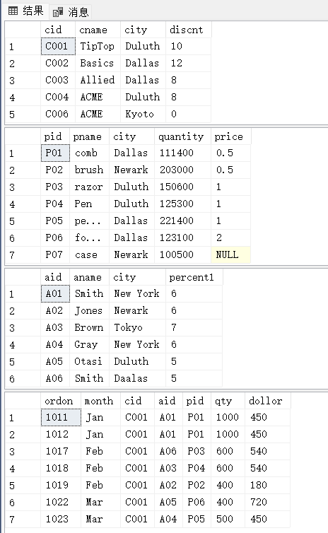

1. 创建一张表Orders_Jan，表的结构与Orders相同，将Orders表中month为‘Jan’的订单记录复制到表Orders_Jan中。

CREATE TABLE Orders_Jan (

ordon int,

month char(5),

cid varchar(10),

aid varchar(10),

pid varchar(10),

qty int,

dollor float

);

INSERT INTO Orders_Jan

select * FROM Orders WHERE Orders.month = 'Jan';

use CAP

select * from Orders_Jan

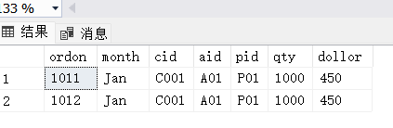

1. 将Orders表中month为‘Jan’的订单记录全部删掉。

use CAP

delete

FROM Orders WHERE Orders.month = 'Jan';

select * from Orders

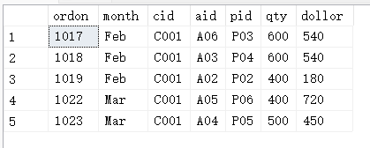

1. 对曾经下过金额（dollars）大于500的订单的客户，将其discnt值增加2个百分点（+2）。

use CAP

update Customers set Customers.discnt=Customers.discnt+2

where Customers.cid in (select distinct Orders.cid from Orders where Orders.dollor>500)

select * from Customers

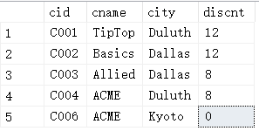

**任务二：（数据库GlobalToyz）**

1. 对GlobalToyz，创建数据库关系图。

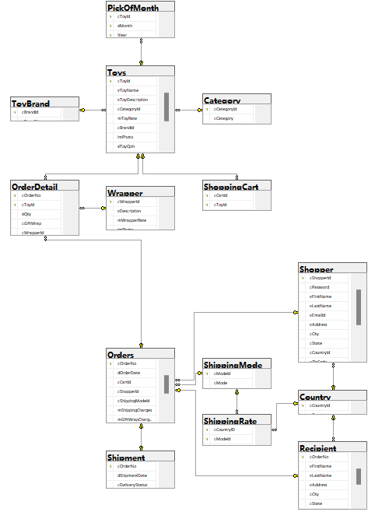

1. 查找属于California州并且使用MasterCard支付的购物者的名、姓和邮件地址。

use GlobalToyz

select s.vFirstName,s.vLastName,s.vEmailId

from Shopper s

where s.cState= 'California' and s.vCreditCardType='Master Card'

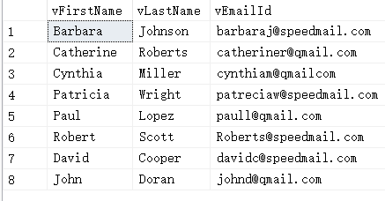

1. 查找2021年，每个购物者的ID和定单总额，并以定单总额的升序排列。

use GlobalToyz

select o.cShopperId,SUM(o.mTotalCost) as total

from Orders o

WHERE dOrderDate LIKE '%2021%'--注意时间格式，不然查询不出来

GROUP BY o.cShopperId

ORDER BY total ASC--升序

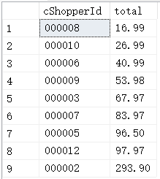

1. 查找在orderDetail表中vMessage为空值的行。

select *

from orderDetail od

where od.vMessage is null

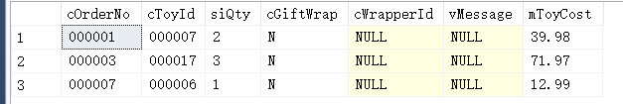

1. 查找密码（password）长度不足6个字符的购买者的ID和姓名。

SELECT s.cShopperId,s.vFirstName,s.vLastName

from Shopper s

where len(s.cPassword) < 6;

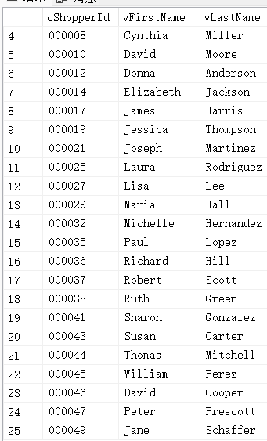

1. 查找电话号码以“123”开头的收货人（Recipient）的姓名和所在的国家。

SELECT DISTINCT r.vFirstName ,r.vLastName ,c.cCountry

FROM Recipient r ,Country c

WHERE r.cCountryId = c.cCountryId AND r.cPhone LIKE '123%';

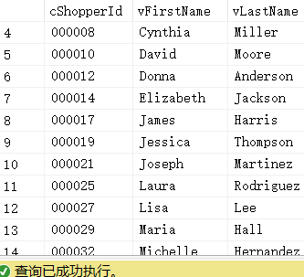

1. 根据pickofmonth表，查找2020年销售总量排在前三名的玩具的ID。

SELECT top(3)p.cToyId --sql service没有limit函数

FROM PickOfMonth p

WHERE p.iYear = 2020

group by p.cToyId

ORDER BY SUM(p.iTotalSold) DESC

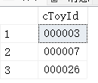

1. 根据OrderDetail表，查找玩具总价值大于￥50的定单的号码和玩具总价值。

SELECT od.cOrderNo ,SUM(od.mToyCost) as Total

FROM OrderDetail od

group by od.cOrderNo

having SUM(od.mToyCost) >50;--sql service不能用total别名,having放在group by后面

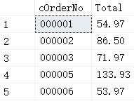

1. 查找一份包含所有装运信息的报表，包括：Order Number, Shipment Date, Actual Delivery Date, Days in Transit. (提示：Days in Transit = Actual Delivery Date – Shipment Date)

SELECT s.cOrderNo ,s.dShipmentDate ,s.dActualDeliveryDate ,DATEDIFF(day,s.dActualDeliveryDate,s.dShipmentDate) as DaysInTransit;--sql service的DATEDIFF需要三个参数

FROM OrderDetail od ,Shipment s

WHERE od.cOrderNo = s.cOrderNo ;

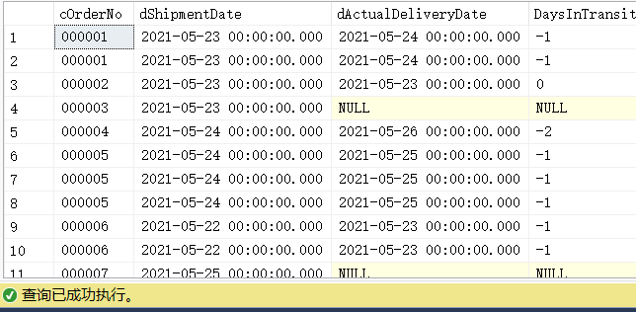

1. 查找所有玩具的名称、品牌和类别（Toy Name, Brand, Category）。

SELECT t.vToyName ,tb.cBrandName ,c.cCategory

FROM Toys t ,ToyBrand tb ,Category c

WHERE t.cBrandId = tb.cBrandId AND t.cCategoryId = c.cCategoryId ;

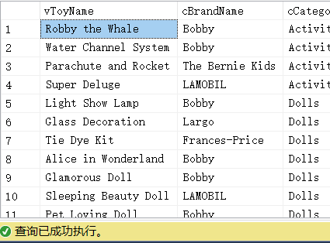

1. 查找“Activity”这个类别的玩具的最高价格、最低价格和平均价格。

SELECT MAX(t.mToyRate) as maxprice,MIN(t.mToyRate) as minprice, AVG(t.mToyRate) as avgprice

FROM Toys t ,Category c

WHERE t.cCategoryId = c.cCategoryId AND c.cCategory = 'Activity';

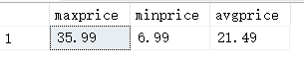

1. 查找玩具的名称和所有玩具的购物车ID。如果玩具不在购物车中，也需在结果中出现。

SELECT t.vToyName ,sc.cCartId

FROM Toys t

LEFT JOIN ShoppingCart sc

ON t.cToyId =sc.cToyId ;

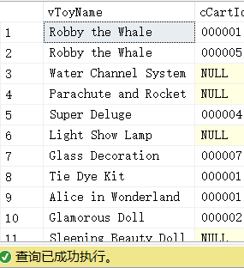

1. 以下列格式查找所有购物者的名字和他们的简称：（Initials, vFirstName, vLastName）,例如Angela Smith的Initials为A.S。

SELECT CONCAT(left(s.vFirstName,1),'.',left(s.vLastName,1)) as Initials, s.vFirstName ,s.vLastName

FROM Shopper s ;--concat() 函数，连接字符串

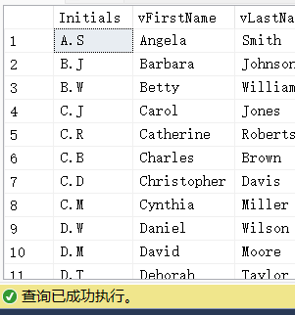

1. 查找“Standard Shipping”这种快递模式的单价最低的国家的名称。

SELECT top(1)c.cCountry

FROM ShippingRate sr ,ShippingMode sm ,.Country c

WHERE sr.cModeId = sm.cModeId AND sr.cCountryId = c.cCountryId AND sm.cMode = 'Standard Shipping'

ORDER BY sr.mRatePerPound ASC;



1. 查找买过名称为“Kitchen Set”的玩具的购物者的ID、姓名、邮件地址及所在的城市。

SELECT DISTINCT

s.cShopperId ,s.vFirstName ,s.vLastName ,s.vEmailId ,s.cCity

FROM

Shopper s

JOIN

Orders o ON s.cShopperId = o.cShopperId

JOIN

OrderDetail od ON o.cOrderNo = od.cOrderNo

JOIN

Toys t ON od.cToyId = t.cToyId

WHERE

t.vToyName = 'Kitchen Set'

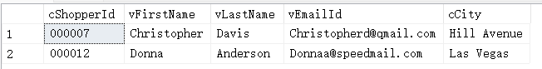

1. 查找所有购物者和收货人的名、姓、地址和所在城市，要求保留结果中的重复记录。

SELECT s.vFirstName ,s.vLastName ,s.vAddress ,s.cCity

FROM Shopper s

UNION ALL --union all和union

select r.vFirstName,r.vLastName,r.vAddress,r.cCity

FROM Recipient r ;

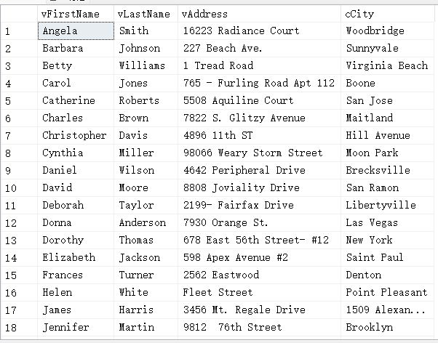

1. 查找没有包装的所有玩具的名称。（要求用子查询实现）

SELECT t.vToyName

FROM Toys t

WHERE t.cToyId NOT IN (SELECT od.cToyId

FROM OrderDetail od

WHERE od.cGiftWrap = 'Y');

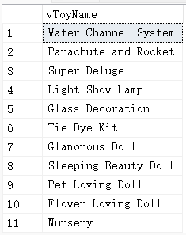

1. 查找已收货定单的定单号码以及下定单的时间。（要求用子查询实现）

SELECT o.cOrderNo ,o.dOrderDate

FROM Orders o ,Shipment s1

WHERE o.cOrderNo = s1.cOrderNo AND s1.cOrderNo IN (SELECT s2.cOrderNo

FROM Shipment s2

WHERE s2.cDeliveryStatus = 'd');

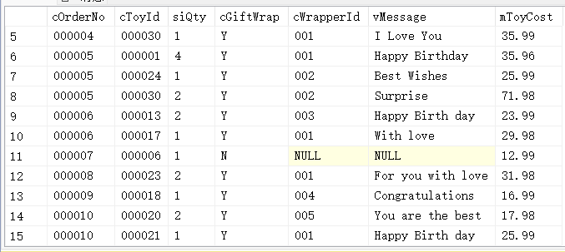

1. 查找从来没有下过订单的购物者。

SELECT *

FROM Shopper s

WHERE s.cShopperId NOT IN (SELECT o.cShopperId

FROM Orders o

);

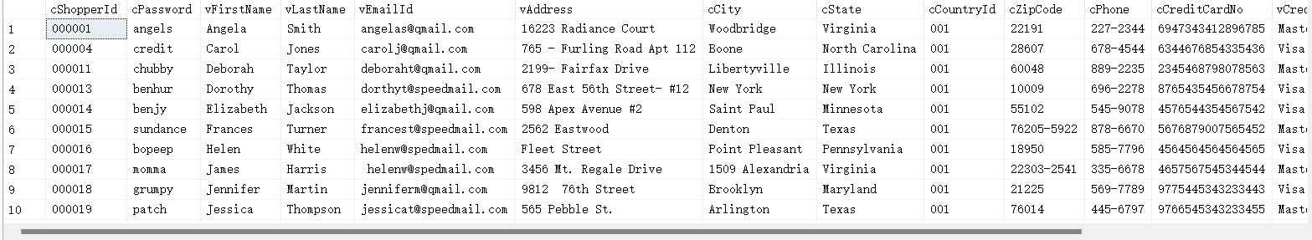

1. 删除“Largo”牌的所有玩具。

EXEC sp_MSforeachtable 'ALTER TABLE ? NOCHECK CONSTRAINT ALL';

DELETE FROM Toys

WHERE Toys.cBrandId IN (SELECT tb.cBrandId

FROM ToyBrand tb

WHERE tb.cBrandName = 'Largo');

EXEC sp_MSforeachtable 'ALTER TABLE ? WITH CHECK CHECK CONSTRAINT ALL';

select *from Toys

WHERE Toys.cBrandId IN (SELECT tb.cBrandId

FROM ToyBrand tb

WHERE tb.cBrandName = 'Largo');

查询后结果为空



第二个实验表太多了，写起来比较费力，而且sql service的语法和mysql有所区别。

2.3 转化后时间格式需要注意，不然查询不出来

2.5 sql service不支持length只有len

2.7 sql service没有limit函数，只支持top函数

2.8 having SUM(od.mToyCost) >50;--sql service不能用total别名

2.9 sql service的DATEDIFF需要三个参数

2.13 concat() 函数，连接字符串

2.20 不允许删除含有外键的数据

关掉外键约束检查：

EXEC sp_MSforeachtable 'ALTER TABLE ? NOCHECK CONSTRAINT ALL';

重新启用外键约束检查：

EXEC sp_MSforeachtable 'ALTER TABLE ? WITH CHECK CHECK CONSTRAINT ALL';