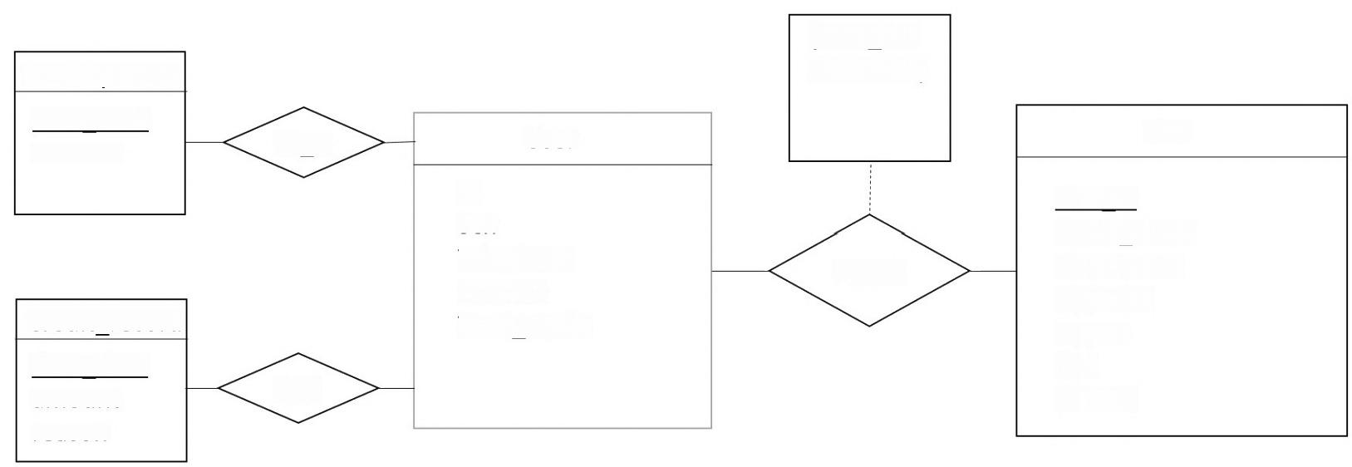**{date_tim e,amount}**

Wallet_record

date time amount

Bike

User

W_U

**Bike id**

**ld**

**Sex**

**Telephone Balance**

**Total_credit**

**Break_down Description In_order**

**record**

Credit record

**In_use Gps**

**In_lock**

date time amount

C_U

reason