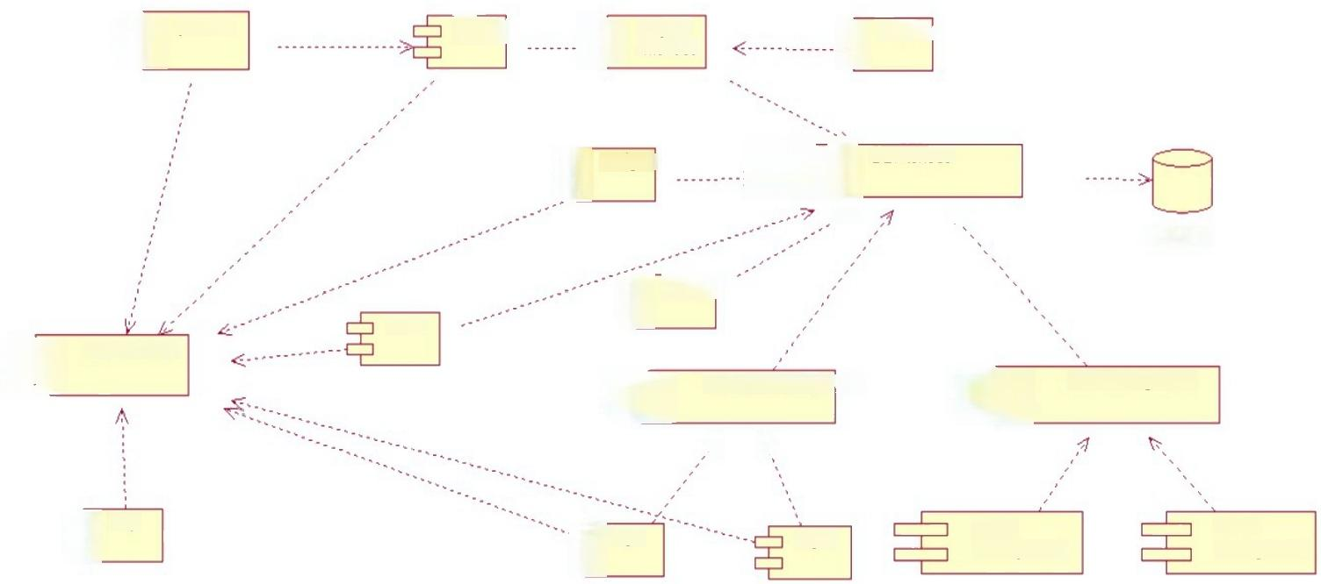字 **preorder** unlock bicycle bicycle

启 interface 点

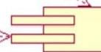

上己

DBinterface

navigate

7 

**database**

analyss

report

臣

user interface

三

acccount managment

**user management**

3

3

才 

中克

login

help

**credit**

**management**

wallet

**management**

regist

臣