**user interface**

**send query request**

**database interface**

**(from Use Case View)**

**(from Use Case View)**

**(from Use Case View)**





**UI chartView**

**(from Use Case View)**

**generate analysis chart**

**(from Use Case View)**

**fetch query result**

**(from Use Case View)**

|  |  |
| --- | --- |
| **trip date**  **(from Use Case View)** | **trip time**  **(from Use Case View)** |
| **date : String** |

**File: E:\Project\**软件开发实践项目**\Time-sharing-car-Managing-System\**阶段提交**\**需求阶段**\**软件需求说明书**_**分析模型**\sharing-bicycle.mdl 13:03:05 2017**年**6**月 星期一 **Class Diagram: classDiagram per usecase / Analysis Class Diagram Page 1**

**use guide text**

**(from Use Case View)**

**guide : Stri...**

**user interface**

**(from Use Case View)**

**get help type**

**(from Use Case View)**

**database interface**

**(from Use Case View)**

**File: E:\Project\**软件开发实践项目**\Time-sharing-car-Managing-System\**阶段提交**\**需求阶段**\**软件需求说明书**_**分析模型**\sharing-bicycle.mdl 13:03:05 2017**年**6**月 星期一 **Class Diagram: classDiagram per usecase / Help class diagram Page 2**

**get bicycle realtime**

**location**

**(from Use Case View)**

**database interface**

 **(from Use Case View)**

|  |
| --- |
| **bicycle interface (from Use Case View)** |
| **longitude : stri...**  **latitude : string**  **bicycleID : stri...** |

**sendData()**

**getData()**

**user interface**

**(from Use Case View)**

**fetch bicycle location**

**info**

**(from Use Case View)**

**File: E:\Project\**软件开发实践项目**\Time-sharing-car-Managing-System\**阶段提交**\**需求阶段**\**软件需求说明书**_**分析模型**\sharing-bicycle.mdl 13:03:05 2017**年**6**月 星期一 **Class Diagram: classDiagram per usecase / location class diagram Page 3**

**user interface**

**(from Use Case View)**

**get account and**

**password**

**(from Use Case View)**

**user id and password**

**(from Use Case View)**

**fetch query result**

**(from Use Case View)**

**database interface**

**(from Use Case View)**

**File: E:\Project\**软件开发实践项目**\Time-sharing-car-Managing-System\**阶段提交**\**需求阶段**\**软件需求说明书**_**分析模型**\sharing-bicycle.mdl 13:03:06 2017**年**6**月 星期一 **Class Diagram: classDiagram per usecase / Login Class Diagram Page 4**

**BDNavigation interface**

**(from Use Case View)**





**user interface**

**from Use Case View)**

**get destiny and user**

**location**

**(from Use Case View)**







**user current location**

**(from Use Case View)**

**longtitude : double**

**latitude;double**

**description**：**String**

**rangeradius : dou ...**

**getlocation()**

**File: E:\Project\**软件开发实践项目**\Time-sharing-car-Managing-System\**阶段提交**\**需求阶段**\**软件需求说明书**_**分析模型**\sharing-bicycle.mdl 13:03:06 2017**年**6**月 星期一 **Class Diagram: classDiagram per usecase / Navigation class diagram Page 5**

**modify bicycle state**

**user interface get choosed bicycle id query bicycle state**

**m Use Case View)**  **(from Use Case View)**

**(from Use Case View)**

/



**bicycle interface**

**(from Use Case View)**

**longitude : stri... bicycle state**

 **(fr**

|  |  |
| --- | --- |
| **sendData()**  **getData()** | **longitude : string**  **latitude : string**  **lock : boolean** |

**fetch query result**

**(from Use Case View)**





**database interface**

**(from Use Case View)**







**update bicycle state**

**(from Use Case View)**

**preorder : boole...**

**(from Use Case View)**

**File: E:\Project\**软件开发实践项目**\Time-sharing-car-Managing-System\**阶段提交**\**需求阶段**\**软件需求说明书**_**分析模型**\sharing-bicycle.mdl 13:03:06 2017**年**6**月 星期一 **Class Diagram: classDiagram per usecase / Preorder class diagram Page 6**

**user id and password**

**(from Use Case View)**

**user interface get account and password add new user m Use Case View) (from Use Case View) (from Use Case View)**

**database interface**

**(from Use Case View)**

**File: E:\Project\**软件开发实践项目**\Time-sharing-car-Managing-System\**阶段提交**\**需求阶段**\**软件需求说明书**_**分析模型**\sharing-bicycle.mdl 13:03:06 2017**年**6**月 星期一 **Class Diagram: classDiagram per usecase / register class diagram Page 7**

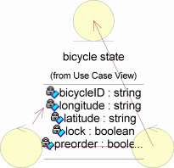

**report description**

**(from Use Case View)**

**get report description modify bicycle state fetch query result**

**user interface m Use Case View)**

**(from Use Case View)**







**(from Use Case View) (from Use Case View)**



/

**database interface**

**modify user credit (from Use Case View)**

**(from Use Case View)**

**File: E:\Project\**软件开发实践项目**\Time-sharing-car-Managing-System\**阶段提交**\**需求阶段**\**软件需求说明书**_**分析模型**\sharing-bicycle.mdl 13:03:06 2017**年**6**月 星期一 **Class Diagram: classDiagram per usecase / Report class diagram Page 8**



**record into database**

**(from Use Case View)**

**tirp start time**

**(from Use Case View)**

**starttime : String**

**bicycle interface**

**(from Use Case View)**

**longitude : stri...**

**calculate bicycle unlock time**

**latitude : string**

**(from Use Case View)**

**bicycleID : stri...**

， <**sendD** **ata()** **getD****ata()**

**unlock bicycle**

**(from Use Case View)**





**users**

**Use Case View)**

**tirp end time**

**(from Use Case View)**

**endtime : Stri...**

**ccount : string**

**user interface**

**ssword : String**

**rs : UserVec ...**

**database interface (from Use Case View)**

**(from Use Case View)**

**File: E:\Project\**软件开发实践项目**\Time-sharing-car-Managing-System\**阶段提交**\**需求阶段**\**软件需求说明书**_**分析模型**\sharing-bicycle.mdl 13:03:07 2017**年**6**月 星期一 **Class Diagram: classDiagram per usecase / Trip record class diagram Page 9**

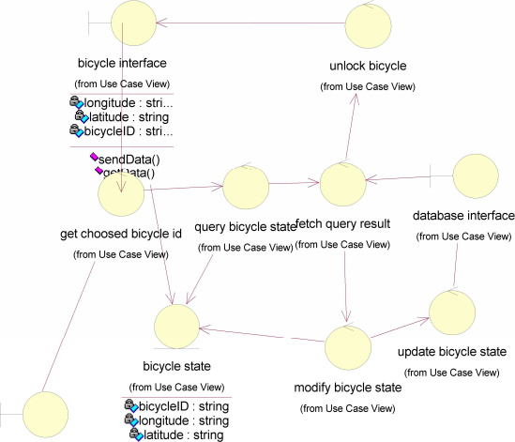

**user interface**

**rom Use Case View)**

**lock : boolean**

**preorder : boole...**

**File: E:\Project\**软件开发实践项目**\Time-sharing-car-Managing-System\**阶段提交**\**需求阶段**\**软件需求说明书**_**分析模型**\sharing-bicycle.mdl 13:03:07 2017**年**6**月 星期一 **Class Diagram: classDiagram per usecase / Use bicycle class diagram Page 10**

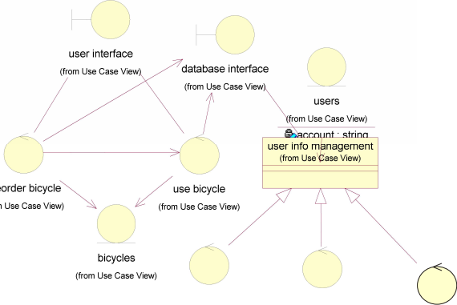

**amount : dou ...**

**account : string**

**time : string**

**manage user credit**

**manage user wallet**

**(from Use Case View)**

**(from Use Case View)**

**manage user trip**

**(from Use Case View)**





**user credit records**

**user balance (from Use Case View)**

**(from Use Case View) trip date**

**credit : int (from Use Case View)**

**date : Stri...**

**trip time**

**(from Use Case View)**

**File: E:\Project\**软件开发实践项目**\Time-sharing-car-Managing-System\**阶段提交**\**需求阶段**\**软件需求说明书**_**分析模型**\sharing-bicycle.mdl 13:03:07 2017**年**6**月 星期一 **Class Diagram: classDiagram per usecase / User info class diagram Page 11**