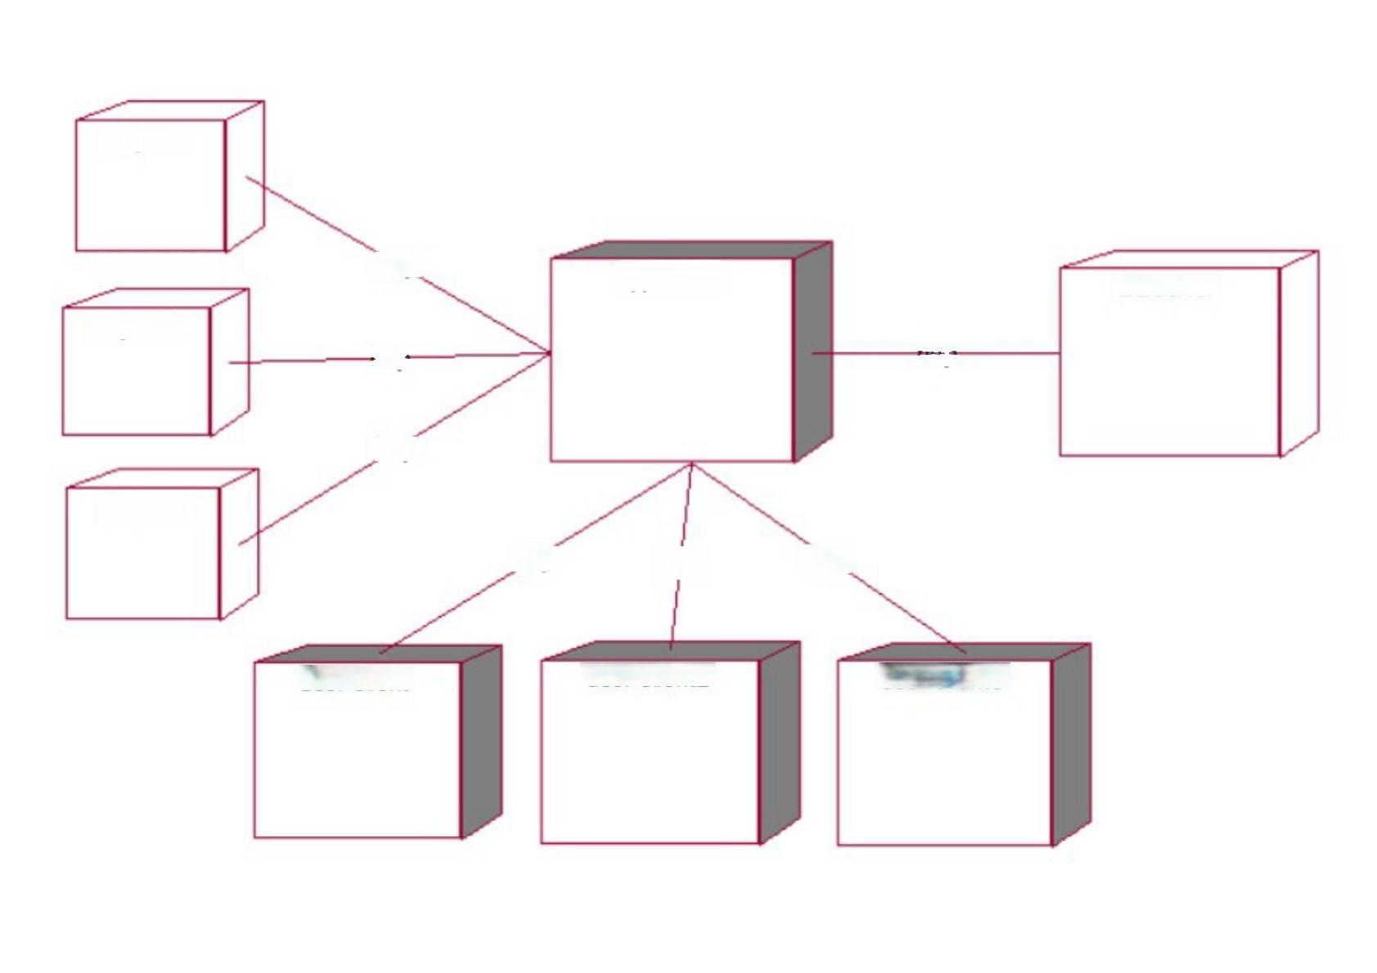bicycle3

http

appServer

DBserver

bicycle2

http

http

http

bicycle

http

http

http

user client3

user client2

user client