Multimodal Spatiotemporal Attention Network: A Method for Quality Prediction and Time-Delay Compensation in Cement Calcination Processes with Low Sampling Rates
XiaoChen Hao*, ZhiYuan Guo.ZhiPeng Zhang
School of Electrical engineering, YanShan University, Hebei, Qinhuangdao, 066000, PR China
Address: School of electrical engineering, Yanshan University, 438 Hebei Avenue, Qinhuangdao, China
E-mail address: haoxiaochen@ysu.edu.cn
Phone number: +8613933576095
Abstract:Accurate and reliable prediction of cement clinker quality is crucial for improving the stability and energy efficiency of cement production. However, due to the characteristics of the cement calcination process—such as low sampling rates of quality data, significant time-lag effects, and multi-scale spatiotemporal coupling—existing prediction models struggle to simultaneously capture both the global trends and local details of quality. To address this challenge, this paper proposes TimeFusionNet, a quality prediction model that integrates multi-branch feature extraction with a spatiotemporal decoupling attention mechanism. The model first comprehensively characterizes the multi-scale dynamic properties of the calcination process through sliding window segmentation and multi-modal feature extraction. Secondly, it employs a spatiotemporal channel decoupling attention mechanism to adaptively weight key time periods and process parameters, while introducing a learnable time-lag compensation matrix to explicitly model the causal relationship between operations and quality changes. Finally, a multi-scale prediction aggregation module fuses features from different temporal resolutions to generate quality predictions. To verify the performance of the proposed model, several advanced models are introduced for comparison. Experiments demonstrate that TimeFusionNet achieves the best performance across multiple evaluation metrics.
Keywords: Cement clinker quality prediction, Spatiotemporal attention, Multi-branch feature fusion, Time-lag compensation, Industrial process modeling

Introduction
Cement is an essential raw material for concrete production and ranks second worldwide in consumption volume, surpassed only by water among all commodities. [1]. Driven by population growth, ongoing urbanization, and large-scale infrastructure development, global cement output has maintained a steady upward trend in recent years. In 2021, global cement production reached 4.4 billion tons, and projections indicate it will further increase by 12% to 23% by 2050 [2]. However, cement manufacturing is energy-intensive and generates substantial pollutants.
Within the cement production process, clinker calcination is the primary energy consumer, accounting for 60% to 70% of the total energy consumption [3]. To sustain the high-temperature environment (above 1450°C) in the rotary kiln system, approximately 3.5 GJ of thermal energy is required per ton of clinker [4], equivalent to the heat released by burning 120 kg of standard coal. According to the International Energy Agency (IEA), the cement industry accounted for 7% of global industrial energy use in 2020, with calcination contributing 83% of the industry’s CO₂ emissions through fossil fuel combustion [6,7]. A more challenging issue is the complex sources of greenhouse gases from calcination: around 40% from fuel combustion and 60% from limestone decomposition [8]. This "dual carbon source" characteristic makes effective emission reduction difficult solely through energy substitution.
High energy consumption in cement production leads to three major drawbacks. First, rising energy demand increases the industry’s reliance on fossil fuels—China’s cement sector consumed 210 million tons of standard coal in 2021, accounting for 13% of the country’s industrial coal use [9]. Second, high-temperature calcination emits pollutants such as nitrogen oxides (NOₓ), sulfur oxides (SOₓ), and dust, causing severe air pollution [10]; EU studies show cement kilns contribute 9%-14% of industrial PM2.5 emissions. Third, energy costs account for over 40% of clinker production costs, and with the implementation of carbon tariffs and trading mechanisms, enterprises face greater cost pressures [11]. Existing research notes that traditional experience-based calcination control wastes 10%-15% of energy and causes a 5%-8% waste rate due to free calcium fluctuations [12], making this extensive production model incompatible with low-carbon economic development. Thus, improving the prediction accuracy of free calcium content— a key indicator of cement quality (higher free calcium content means poorer quality [14])—is crucial for reducing energy consumption, cutting costs, and achieving the cement industry’s short and long-term carbon neutrality goals [13]. Accurate prediction models can enhance energy efficiency and enable timely production optimization to reduce costs and emissions. Predicting free calcium content in cement burning systems is a time-series forecasting task, but it faces unique challenges due to the complexity of cement industry data. The calcination process is dynamic, with non-linear, strongly coupled input variables and time-varying delays [16]. Additionally, free calcium detection lacks real-time responsiveness, resulting in much lower data density than independent variables [17]; and the 1-2 hour calcination cycle creates delays between system variables and free calcium data, making it hard to capture dynamic relationships [18]. These challenges have attracted significant attention from the energy sector and environmental organizations. To address these issues, interdisciplinary researchers have explored prediction methods, mainly dividing into statistical analysis and intelligent algorithms [19]. Traditional statistical methods (e.g., ARIMA, GPM) leverage statistical patterns [20]. For example, a particle swarm optimization-fourier analysis integrated seasonal ARIMA model was used for Chinese power grid load forecasting [21], and a optimized grey prediction model for urban electricity consumption [22]. However, their linear assumptions limit their ability to capture non-linear relationships, reduce accuracy with increasing variables, and restrict application to stationary data [23,24].
In recent years, data-driven intelligent algorithms have become mainstream for complex industrial parameter forecasting. To address the sampling rate mismatch problem that is prevalent in industrial time-series modeling, some studies have begun to explore attention-based network structures for heterogeneous data adaptation. A hierarchical self-attention network was proposed to model industrial data series with inconsistent sampling rates between input and output sequences, which realized hierarchical feature extraction of multi-rate data through the multi-scale self-attention mechanism and alleviated the feature misalignment caused by different sampling frequencies [25]. However, this model only focuses on the hierarchical mining of temporal features and lacks the explicit modeling of the time-lag effect between industrial process parameters and quality indicators, making it difficult to adapt to the strong spatiotemporal coupling characteristics of the cement calcination process. Machine learning and deep learning models learn inherent data patterns autonomously [26], offering stronger non-linear fitting capabilities to address large time delays and multi-variable coupling in free calcium prediction. In machine learning, ensemble and hybrid models (e.g., SVR, RF, XGBoost) are popular. Liu et al. [11] proposed a decomposition-reconstruction hybrid model for cement grinding power consumption prediction, using EMD to decompose signals into IMFs and trend terms, then LSSVR and QES for forecasting. Fan et al. [28] developed an SVR-GC-RF hybrid predictor by fusing grey catastrophe theory and RF, which effectively extracts dynamic features from sparse data [27]. However, shallow models struggle to capture long-term dependencies and dynamic couplings, limiting their performance in handling time-varying delays and multi-scale misalignment [29]. Deep learning has advanced time-series forecasting. RNNs and their variants (LSTM, GRU) mitigate gradient vanishing via gating mechanisms. Ma et al. [30] used an LSTM encoder-decoder for high-energy industry power consumption forecasting; Kim et al. [32] proposed a CNN-LSTM dual-stream architecture (reducing prediction error by 12.7% compared to single LSTM) [32]; and Wan et al. [33] designed an attention-enhanced CNN-LSTM, improving prediction stability by 9.3%. Nevertheless, RNNs’ sequential computing limits their ability to process long sequences and model cross-time-scale global relationships [34]. Recently, the Transformer model [35] has shown impressive performance in NLP, CV, and industrial time-series forecasting. Li et al. [36] proposed a LogSparse Transformer with causal convolution to address time delays; Liu et al. [38] developed Pyraformer with a pyramid attention module for multi-scale feature extraction; Zhou et al. [39] introduced FEDformer for frequency-domain attention and noise robustness; and Nie et al. [40] encoded multiple time steps as a patch to enhance locality. All achieved excellent results.
However, most existing methods fail to address the unique characteristics of cement burning systems, such as large time-varying delays, low free calcium data density (making sliding window-based data alignment ineffective), For the improvement of the Transformer attention mechanism in industrial data sequence modeling, a difference metric attention with position distance-based weighting was designed, which optimized the feature weight assignment of the Transformer by introducing position distance factors and difference metrics, effectively enhancing the model's ability to capture the spatial correlation between industrial process variables [41]. Nevertheless, this improved attention mechanism still does not consider the low sampling rate of quality data and the dynamic time-lag effect in the cement calcination process, and it lacks the fusion of frequency-domain features and time-domain features for multi-modal industrial data, resulting in insufficient modeling of the multi-scale spatiotemporal coupling characteristics of cement clinker quality prediction. and insufficient consideration of multi-variable coupling. Thus, a new prediction model that accounts for system delays and low free calcium data density is needed.
To solve these problems, this paper proposes TimeFusionNet, an attention-based dual-branch model for free calcium prediction in cement burning systems. It first extracts multi-modal features from input signals via a dual-branch layer, then captures global and local spatio-temporal dependencies using a spatio-temporal attention layer, and finally outputs predictions. The main contributions are:
  - TimeFusionNet, the first attention-based model for free calcium prediction in cement burning systems, accurately forecasts overall trends and local details of free calcium changes to improve prediction accuracy.
  - It addresses large time delays by multi-dimensional feature extraction and spatio-temporal attention-based feature fusion, significantly enhancing prediction accuracy.
  - Validated on real data from a cement enterprise database, it outperforms advanced models across multiple evaluation metrics.
The rest of this paper is organized as follows: Section 2 analyzes the process flow, data characteristics, and variable selection of the cement burning system. Section 3 details the proposed model. Section 4 evaluates and analyzes its performance against other models. Finally, Section 5 concludes the paper.

2.Cement clinker calcination system

2.1 Process flow of cement clinker calcination system
Clinker calcination is a critical step in cement production, referring to the process of calcining ground cement raw meal to form finished cement clinker [42]. The cement burning system consists of a five-stage cyclone preheater, a precalciner, a rotary kiln, and a grate cooler. As illustrated in Fig. 1, the clinker calcination process proceeds as follows:First, the raw meal enters the suspension preheater, where it undergoes heat exchange with high-temperature gas in a countercurrent flow, raising its temperature to 750°C ~ 800°C.Subsequently, it enters the precalciner, where 90% ~ 95% of calcium carbonate decomposition is completed at a high temperature of approximately 890°C with the aid of coal combustion.The decomposed materials then enter the rotary kiln, where they are further calcined and melted at 1300°C to form cement clinker.Finally, the high-temperature clinker enters the grate cooler, where it rapidly exchanges heat with cold air to cool down. Meanwhile, the hot air generated is returned to the system as secondary air and tertiary air.
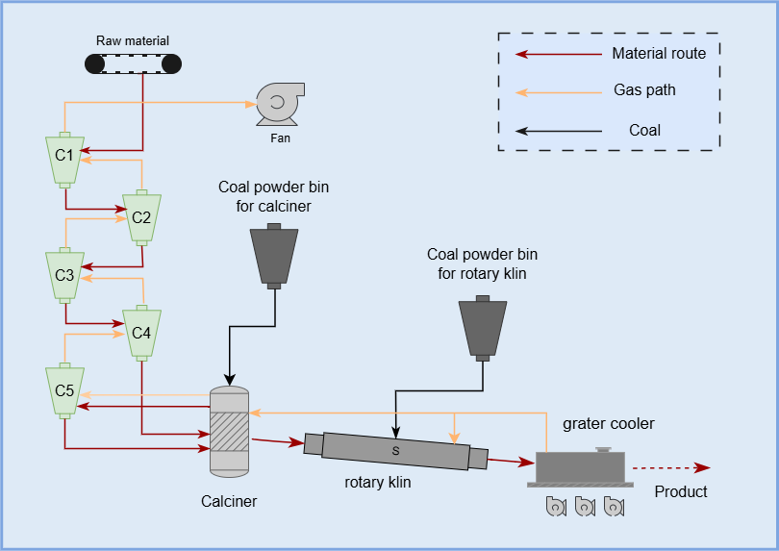
Figure 1 Progress of Cement clinker calcination system
The cement burning process is complex. The chemical composition of raw materials is determined by limestone's saturation ratio (HM value), alumina ratio (IM value), and silica ratio (SM value). Rational HM, IM, and SM values help optimize the calcination reaction, ensuring more complete limestone decomposition and fundamentally influencing free calcium content.
The feed rate affects the amount of material in the calcination process. Excessive feed reduces the temperature of the burning zone, leading to insufficient calcination and increased free calcium content.
The outlet temperature of the first-stage cyclone reflects the temperature of the preheating zone. A too-low temperature prolongs limestone decomposition time, potentially causing incomplete subsequent calcination and a rise in free calcium content. The outlet temperature of the precalciner is directly related to the degree of carbonate decomposition. Insufficient temperature leaves a large amount of residual carbonates, increasing free calcium; excessively high temperature may cause local overburning of materials, altering mineral composition and affecting free calcium content.
The kiln tail temperature influences the heat transfer and reaction rate of materials in the kiln. An inappropriate temperature impairs clinker burning quality, thereby affecting free calcium content. The average kiln current reflects the material filling amount and calcination load in the kiln. Abnormal kiln current may indicate unstable calcination status inside the kiln, undermining the stability of free calcium content.
The secondary air temperature affects pulverized coal combustion and thermal system performance. Low air temperature results in incomplete combustion and insufficient heat, reducing calcination efficiency and increasing free calcium content. The kiln head negative pressure impacts the ventilation and gas flow rate inside the kiln. Poor ventilation causes uneven temperature distribution in the kiln, disrupting the calcination process and leading to fluctuations in free calcium content.
Based on the process mechanism analysis of the burning system, this paper selects the following variables as inputs for the free calcium content prediction model: outlet temperature of the first-stage cyclone, outlet temperature of the precalciner, kiln tail temperature, average kiln current, secondary air temperature, kiln head negative pressure, feed rate, limestone saturation ratio (HM value), alumina ratio (IM value), and silica ratio (SM value). Detailed information about the selected variables is provided in Table 1.
Table 1 The input variables of TimeFusionNet
Variable name | Description
Outlet temperature of the first-stage cyclone | Reflects heat exchange effect of first-stage cyclone
Outlet temperature of the precalciner | Indicates material decomposition degree
Kiln tail temperature | Relates to sintering temperature system
Average kiln current | Reflects calcination load in kiln
Secondary air temperature | Affects pulverized coal combustion efficiency
Kiln head negative pressure | Reflects ventilation status in kiln
Feeding quantity | Controls quantity of calcined materials
Lime saturation ratio (HM value)  Alumina modulus (IM value)  Silica modulus (SM value) | Reflects CaO content in clinkerReflects ratio of Al₂O₃ to Fe₂O₃  Reflects ratio of SiO₂ to total Al₂O₃ & Fe₂O₃

3. Methology
The objective of the free calcium content prediction model proposed in this paper is to predict the future free calcium content based on the historical sequence of process variables. Let $t$ denote the current time index (minute level). The process variables (listed in Table 1) are sampled every minute; we denote the value of the $i$-th variable at time $t$ as $x_{t}^{i}∈ℝ$, with $i=1,…,10$. The quality variable—free calcium content—is measured only once per hour (i.e., at $t=60k, k∈ℕ$) due to laboratory delays; we denote it as $y_{t}∈ℝ$.
To construct a supervised learning sample, we consider a historical observation window of length $T$ (in minutes) ending at time $t$. The input matrix $X_{t}$ consists solely of the process variables within that window:
$X_{t}=\left[\begin{matrix}x_{t−T+1}^{1} & x_{t−T+1}^{2} & ⋯ & x_{t−T+1}^{10} \\ x_{t−T+2}^{1} & x_{t−T+2}^{2} & ⋯ & x_{t−T+2}^{10} \\ ⋮ & ⋮ & ⋱ & ⋮ \\ x_{t}^{1} & x_{t}^{2} & ⋯ & x_{t}^{10}\end{matrix}\right]∈R^{T×D}$ (1)
where $D=10$ is the number of process variables. The output target is the free calcium content at a future time $t+γ$, where $γ$ (in minutes) is the prediction horizon (also referred to as the time delay). Because $y_{t}$ is only available hourly, $γ$ is set to multiples of 60 in the experiments, i.e., $γ=60,120,180$ for 1-hour, 2-hour, and 3-hour ahead predictions. The target value is a scalar:
$Y_{t+γ}=y_{t+γ}∈ℝ.$ (2)
Thus, each training sample is a pair $\left(X_{t} , Y_{t+γ}\right)$, where $X_{t}$ contains the process variable history that causally influences the future quality. Note that the quality variable itself is not included in the input $X_{t}$, because it is sparsely sampled and cannot provide real-time information for online prediction. In the experiments, we generate multiple samples by sliding a window of length $T$ over the process variable sequence and pairing each window with the corresponding future quality value $y_{t+γ}$ (provided that $t+γ$ is a valid quality measurement time). This construction explicitly handles the low sampling rate of the quality data and the time-delay between process changes and quality outcomes.
The overall structure of the model is illustrated in Fig. 2. First, the model performs multimodal feature extraction on the input, feeding the input information into different feature extraction branches for feature extraction and fusion. Second, it extracts and integrates long-short-term memory features through a spatiotemporal attention network. Finally, the model outputs the prediction results.
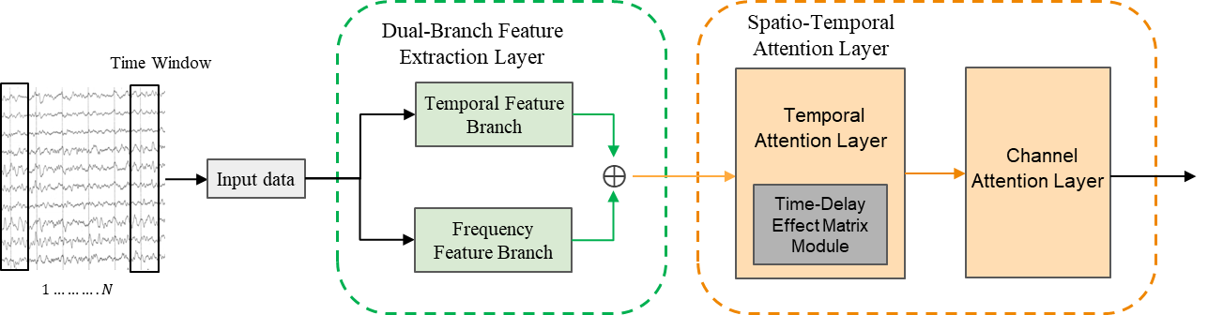
Figure 2 TimeFusionNet framework

3.1. Dual-branch feature extraction layer
Quality prediction in the cement calcination process faces two core challenges: data scale misalignment and feature heterogeneity. Process parameters are sampled at a minute-level frequency, while free calcium content can only be sampled at an hourly frequency, resulting in a tens-to-one sampling rate difference. Meanwhile, factors affecting free calcium include time-domain dynamic characteristics and frequency-domain periodic features, which are difficult for traditional models to comprehensively capture [43]. For these reasons, the TimeFusionNet model proposed in this paper employs a dual-branch feature extraction layer to process input sequences, thereby fully extracting features of different modalities of variables.
The dual-branch feature extraction layer is divided into a time-domain statistical branch and a frequency-domain analysis branch. The time-domain feature branch specializes in characterizing process dynamic characteristics, extracting the mean, variance, maximum value, slope, autocorrelation coefficient, and cumulative absolute variation within time T_w. Among them, the mean and maximum value can characterize the average level of process variables within the window and capture extreme working conditions. The variance and slope can quantify the degree of process fluctuation and change trends, reflecting the fluctuation of variables. The autocorrelation coefficient and cumulative absolute variation can evaluate temporal dependence and characterize total variability.
First, the sliding window compresses the input data. The process of the time-domain feature branch capturing process dynamic features is as follows:
$S_{6∗Tw}=Ψ_{\text{stats}}\left(X\right)=\text{ReLU}\left(W_{s}⋅{{\left[μ,σ^{2},x_{max},β,ρ,C\right]}_{t}}_{s}\right)$ (3)
In the formula, ${\left[μ,σ^{2},x_{max},β,ρ,C\right]}_{T_{w}}$denotes the mean, variance, maximum value, slope, autocorrelation coefficient, and cumulative absolute variation within the sliding window $T_{w}$.
$μ=\frac{1}{T_{w}}\sum_{t=1}^{T_{w}}{x_{t}}$ (4)
$σ^{2}=\frac{1}{T_{w}}\sum_{t=1}^{T_{w}}{{\left(x_{t}−μ\right)}^{2}}$ (5)
$β=\frac{\sum_{t=1}^{T_{w}}{\left(t−\overline{t}\right)\left(x_{t}−\overline{x}\right)}}{\sum_{t=1}^{T_{w}}{{\left(t−\overline{t}\right)}^{2}}}$ (6)
$x_{max}=\max_{t∈\left[1,T_{w}\right]}{x_{t}}$ (7)
$ρ=\frac{\sum_{t=1}^{T_{w}−1}{\left(x_{t}−μ_{1}\right)\left(x_{t+1}−μ_{2}\right)}}{\sqrt{\sum_{t=1}^{T_{w}−1}{{\left(x_{t}−μ_{1}\right)}^{2}\sum_{t=1}^{T_{w}−1}{{\left(x_{t+1}−μ_{2}\right)}^{2}}}}}$ (8)
$C=\sum_{t=2}^{T_{w}}{\left|x_{t}−x_{t−1}\right|}$ (9)
where $T_{w}$ denotes the sliding window size, and $x_{t}$ denotes the observation value at time $t$. $\overline{t}=\frac{1}{T_{w}}\sum{t}$ denotes the mean of time indices within $T_{w}$, $\overline{x}=\frac{1}{T_{w}}\sum{x_{t}}$ denotes the mean of data within $T_{w}$, $μ_{1}=\frac{1}{T_{w}−1}\sum_{t=1}^{T_{w}−1}{x_{t}}$ denotes the mean of the previous $T_{w}$ (window), and $μ_{2}=\frac{1}{T_{w}−1}\sum_{t=2}^{T_{w}}{x_{t}}$ denotes the mean of the subsequent $T_{w}$ (window).
The frequency-domain analysis branch focuses on periodic patterns. It extracts frequency-domain features of input information through Fast Fourier Transform (FFT) and convolution operations. The dominant frequency components of the input information can identify key frequency bands such as equipment vibration and combustion cycles. Convolution is performed on the frequency domain to mine local patterns like harmonic features in the frequency domain. Finally, significant periodic components are retained through TopK selection for noise filtering.
$F=Ψ_{\text{freq}}\left(X\right)=g\left(\text{TopK}\left(\left|ℱ\left(X\right)\right|\right)\right)$ (10)
where $ℱ\left(⋅\right)$ denotes the Fast Fourier Transform (FFT) Frequency-domain features are then upsampled to align with time-domain features in dimension. Finally, through feature fusion, the outputs of the two branches are concatenated along the feature dimension: $Z=\text{Concat}\left(S,F\right)$,forming a fused feature tensor. The fusion and complementarity of feature information from the time domain and frequency domain enhance the physical interpretability of the dual-branch structure [44].

3.2. Spatiotemporal attention network layer
Traditional self-attention establishes abstract absolute positional relationships only through sinusoidal positional encoding, which lacks physical interpretability and cannot explicitly model the time-delay characteristics of long-flow industrial data in cement calcination. In contrast, the proposed parallel spatiotemporal dual attention mechanism decouples spatiotemporal dependencies into temporal and channel attention, and introduces a learnable time-lag compensation matrix in temporal attention. This matrix directly quantifies the intensity of the delayed impact of calcination operations on free calcium content, endowing the model with physical interpretability and adaptive adjustment capability for different production line operating conditions—this is the core practical advantage in cement calcination data prediction.
To address the core challenge of large time-delay effects in the cement calcination process, this paper innovatively designs a spatiotemporally separated attention mechanism. This module consists of a temporal attention layer and a channel attention layer, which effectively captures spatiotemporal dynamic characteristics in long-flow industrial scenarios by explicitly modeling time-delay dependencies and dynamic feature recalibration [44]. The structure of the Spatio-Temporal Attention Network Layer is illustrated in Figure 3. For the input tensor$X∈R^{B×T×C}$ (where $B$ is the batch size,$T$ is the time step, and $C$ is the feature dimension), the spatiotemporal attention network layer is shown in Fig. 4, which first enters the temporal attention layer:
$Q=XW^{Q},K=XW^{K},V=XW^{V}$ (11)
where $W^{Q},W^{K},W^{V}∈R^{C×d_{h}}$ are projection matrices, and $d_{h}=C/N_{h}$ is the head dimension ($N_{h}=4$ is the number of attention heads). The core innovation of the spatiotemporal attention network layer lies in the introduction of a time-delay effect matrix $L∈R^{T×T}$. This design converts the time-delay dynamics of the process system into a learnable parameterized model.
$L_{i,j}=\{\begin{matrix}l_{\left\lfloor i−j\right\rfloor } & 0≤i−j<τ \\ 0 & otherwise\end{matrix},l=\{l_{k}\}_{k=0}^{τ−1}∈R^{τ}$ (12)
where $τ=15$ is the time-delay window, and l is a learnable time-delay weight vector (initialized as a linear space of $[0.5,1.0]$. This matrix is injected into the attention mechanism through three steps:
$\begin{matrix}A & =Softmax\left(\frac{QK^{⊤}}{\sqrt{d_{h}}}+L\right)\end{matrix}$ (13)
$Z_{t} = AV + γ_{t} X$ (14)
where $γ_{t}∈R$ is a learnable residual scaling factor. This design has a clear physical meaning: $l_{k}$ directly quantifies the intensity of the delayed impact of operations from k minutes ago (with$Δt$ as the sampling interval) on the current free calcium content, thereby endowing the model with interpretability for process time-delay effects.
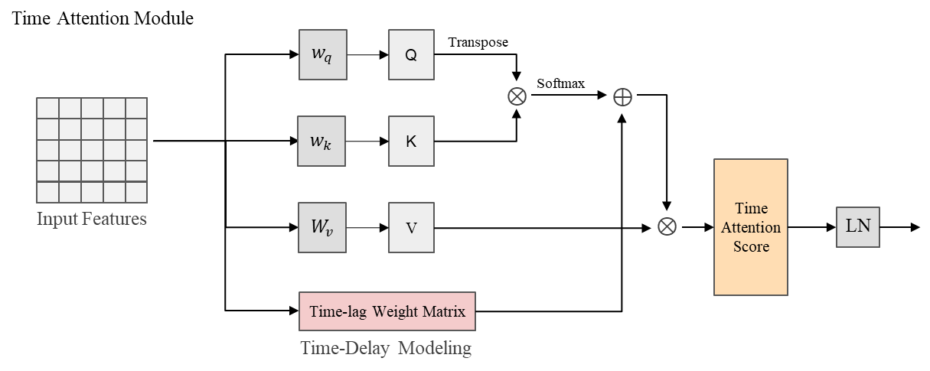
This method has significant advantages over traditional positional encoding. Traditional sinusoidal positional encoding establishes abstract absolute positional relationships, whereas the time-delay matrix directly models relative time-delay effects with clear physical meanings. Its characteristics of learnable dynamic parameters can adapt to operating condition changes of different production lines, a flexibility that fixed functional encoding lacks. Meanwhile, the monotonic decay characteristic of time-delay weights is consistent with the inertial laws of the process system, providing the model with a physically reasonable inductive bias.
Figure 3 Time-delay effect matrix
Tensor $Z_{t}$ after temporal feature enhancement enters the channel attention layer. In the channel attention layer, a dual-path pooling strategy is employed to achieve synergistic optimization of time-delay dynamic features and steady-state background trends [46]. The max pooling operator focuses on identifying time-delay sensitive channel features-these features exhibit significant fluctuations due to time-delay effects within specific time windows, and their peak responses directly reflect the transient impacts of changes in operating parameters. The average pooling operator, on the other hand, is dedicated to extracting steady-state background trends: it suppresses short-term fluctuation noise through global smoothing and retains the long-term stable characteristics of the process system. After these two complementary statistical features are fused by a multi-layer perceptron (MLP), a feature recalibration weight vector $s_{c}$ is generated. Finally, spatiotemporal feature decoupling is achieved through a gating mechanism. The process of the channel attention layer is as follows:
$\begin{matrix}s_{c} & =σ\left(MLP\left(AvgPool\left(Z_{t}\right)\right)+MLP\left(MaxPool\left(Z_{t}\right)\right)\right)\end{matrix}$ (15)
$Z_{c}=Z_{t}⊙s_{c}⊗1_{T}+γ_{c}Z_{t}$ (16)
The matrix shape change of MLP is$:R^{C}→R^{C/r}→R^{C}$，In the formula, where$r$ is the compression ratio, $σ$ is the Sigmoid activation function, $⊙$ denotes element-wise multiplication, and $γ_{c}∈R$ is a learnable residual scaling factor. The outer product operation $⊗1_{T}$ broadcasts channel weights to the time dimension, ensuring that time-delay dynamic features and steady-state background features maintain orthogonality in the unified feature space. This not only enhances the response intensity of time-delay sensitive channels but also ensures that the steady-state process baseline is not disturbed by transient disturbances.
The output is fed to the final regression layer. Given the output tensor $Z∈R^{B×T×C}$ of the spatiotemporal attention layer (where B is the batch size, T is the time step, and C is the feature dimension), the regression layer first performs a hierarchical pooling operation:
$P\left(Z\right)=⨁_{p∈\{1,3,5\}}{\text{vec}\left(\text{AdaptiveAvgPool1d}\left(Z^{⊤},p\right)\right)}$ (17)
The core innovation of this layer lies in the multi-scale feature retention mechanism. $AdaptiveAvgPool1d\left(Z^{⊤},p\right)$ is a hierarchical pooling operation: when $p=1$, it captures the global statistical features of the entire time window; when $p=3$, it divides 24 time steps into 3 equal-length subintervals to extract local dynamics; when $p=5$, it divides into 5 sub-windows to capture short-term fine fluctuations.
$G=\frac{1}{T}\sum_{t=1}^{T}{Z_{:,t,:}}∈R^{B×C}$ (18)
$M_{k}=\frac{1}{8}\sum_{t=8k−7}^{8k}{Z_{:,t,:}}, k=1,2,3$ (19)
$F_{m}=\frac{1}{5}\sum_{t=5m−4}^{5m}{Z_{:,t,:}}, m=1,…,5\left(overlappingsampling\right)$ (20)
where $⨁$denotes concatenation along the feature dimension, $vec\left(⋅\right)$ is the flattening operation, and$Z^{T}∈R^{B×T×C}$ is the input transpose. The output tensor dimension is:
$P\left(Z\right)∈R^{B×D}, D=C×\sum_{p∈S}{p}$ (21)
given the hierarchical pooling output $P∈R^{B×D}$, the compression network performs feature distillation:
$H^{\left(1\right)}=RELU \left(BatchNorm \left(W^{\left(1\right)}P+b^{\left(1\right)}\right)\right)$ (22)
$H^{\left(2\right)}=Dropout \left(H^{\left(1\right)},p=0.3\right)$ (23)
$H^{\left(3\right)}=RELU\left(LayerNoem\left(W^{\left(2\right)}H^{\left(2\right)}+b^{\left(2\right)}\right)\right)$ (24)
$\hat{y}=W^{\left(3\right)}H^{\left(3\right)}+b^{\left(3\right)}$ (25)
where$W^{\left(1\right)}$ denotes the weight matrix of the first linear layer, $b^{\left(1\right)}$ denotes the bias vector of the first linear layer, $W^{\left(2\right)}$ denotes the weight matrix of the second linear layer, $b^{\left(2\right)}$ denotes the bias vector of the second linear layer, $H^{\left(k\right)}$ denotes the hidden state of the $k$-th layer, $W^{\left(3\right)}$denotes the weight matrix of the regression layer, and $b^{\left(3\right)}$ denotes the bias vector of the regression layer.
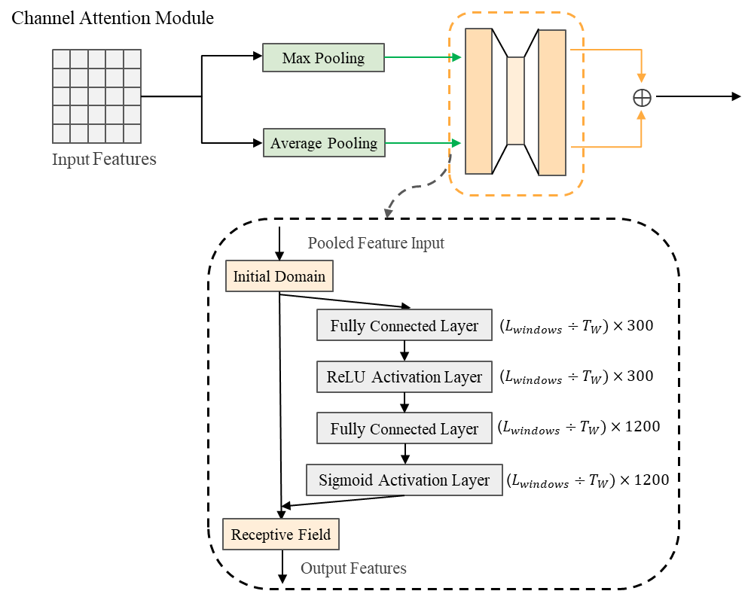

Figure 4 Time-delay effect matrix

4. Experimental study and result analysis
In this section, we conduct experiments and evaluations on TimeFusionNet using the cement clinker burning system dataset to verify the feasibility of the proposed prediction method. First, we describe the used data, evaluation metrics, and comparative models. Then, we conduct prediction experiments on all models under different prediction horizons. Finally, we discuss and analyze the model performance based on multiple evaluation metrics.

4.1. Data description
This study uses real-world data from the database of a cement enterprise in Hebei Province, China, to conduct experimental evaluations of the model's performance in various aspects. The dataset used in the experiments covers over 40,000 records of the cement clinker burning system from September to October 2022. Among them, sensors collect data once per minute, while free calcium content data is obtained by chemical experimenters through sampling and testing from finished cement products once per hour. Specifically, the dataset is divided into three subsets according to the proportion of the first 70%, middle 10%, and last 20%, which serve as the training set, validation set, and test set respectively. After completing the model's training and validation, it is used to predict the free calcium content of finished products.

4.2. Evaluation metrics of model performance
This study conducts a systematic assessment of the performance of the proposed model from four dimensions—accuracy, effectiveness, significance, and stability—using a variety of evaluation metrics. Among these, for the model's prediction accuracy, mean absolute error (MAE), mean squared error (MSE), mean absolute percentage error (MAPE), and coefficient of determination $(R^{2}$) are selected to measure it. Their expressions are as follows:
$MAE=\frac{1}{N}\sum_{i=1}^{N}{\left|y_{i}−\hat{y_{i}}\right|}$ (26)
MSE$=\frac{1}{N}\sum_{i=1}^{N}{{\left(y_{i}−\hat{y_{i}}\right)}^{2}}$ (27)
MAPE$=\frac{1}{N}\sum_{i=1}^{N}{\left|\frac{y_{i}−\hat{y_{i}}}{y_{i}}\right|}×100\%$ (28)
$R^{2}=1−\frac{\sum_{i=1}^{N}{{\left(y_{i}−\hat{y_{i}}\right)}^{2}}}{\sum_{i=1}^{N}{{\left(y_{i}−\overline{y}\right)}^{2}}}$ (29)
To verify the effectiveness of the proposed model, this paper examines whether the accuracy of TimeFusionNet has significantly improved compared to the comparative models by calculating the Improvement Rate (IR) [47, 48]. The IRs for MAE, MSE, and MAPE can be expressed as follows:
${\text{IR}}_{\text{MAE}}=\frac{{\text{MAE}}_{c}−{\text{MAE}}_{p}}{{\text{MAE}}_{c}}×100\%$ (30)
${\text{IR}}_{\text{MSE}}=\frac{{\text{MSE}}_{c}−{\text{MSE}}_{p}}{{\text{MSE}}_{c}}×100\%$ (31)
${\text{IR}}_{\text{MAPE}}=\frac{{\text{MAPE}}_{c}−{\text{MAPE}}_{p}}{{\text{MAPE}}_{c}}×100\%$ (32)
Furthermore, this paper employs the Diebold-Mariano (DM) test to statistically evaluate whether the proposed model is significantly superior to other comparative models [49]. The test involves two hypotheses: the null hypothesis $(H_{0}$) states that the prediction accuracies of the two models are the same, while the alternative hypothesis $(H_{1})$ holds the opposite view [50].
$H_{0}:E\left(L\left(e_{i}^{p}\right)\right)−E\left(L\left(e_{i}^{c}\right)\right)=0$ (33)
$H_{1}:E\left(L\left(e_{i}^{p}\right)\right)−E\left(L\left(e_{i}^{c}\right)\right)≠0$ (34)
where $e_{i}^{p}$ and $e_{i}^{c}$ represent the prediction errors of the proposed model and the comparative model, respectively; L denotes the loss function; and E represents the expectation operator. Based on the above, the DM statistic is expressed as:
$d=\frac{1}{N}\sum_{i=1}^{N}{\left(L\left(e_{i}^{p}\right)−L\left(e_{i}^{c}\right)\right)}$ (35)
$\text{DM}=\frac{d}{\sqrt{t/N}}$ (36)
where $v$ is the covariance of $L\left(e_{i}^{p}\right)−L\left(e_{i}^{c}\right)$. If the DM statistic does not fall within the interval $\left[−Z_{α/2},Z_{α/2}\right]$ will be rejected, indicating that there is a significant difference in prediction performance between the proposed model and the comparative model. Conversely, $H_{0}$ will be accepted, meaning there is no significant difference in prediction performance between the two. Additionally, when the DM statistic is negative, the prediction error of the proposed model is smaller than that of the comparative model.
Finally, the variance of prediction errors is used to evaluate the stability of the model [51]. A smaller variance indicates more stable prediction performance, which is expressed as:
Var $=\frac{1}{N}\sum_{i=1}^{N}{{\left(e_{i}−\overline{e}\right)}^{2}}$ (37)

4.3. Result analysis and discussion
This section elaborates on the performance comparison between the proposed TimeFusionNet model and other comparative models. To verify the superiority of the proposed model, several models that are widely adopted in the field of free calcium oxide content prediction—including LSTM, GRU, CNN-LSTM, Transformer, and Informer—were employed as baseline models and compared with TimeFusionNet across the aforementioned multiple evaluation metrics.
In addition, to validate the superiority of the spatio-temporal feature extraction branch in the proposed model for feature extraction, ablation experiments were conducted. In these experiments, while keeping the main structure of the model unchanged, two variant models were constructed: a model with only the temporal branch (TimeFusionNet-w/o-SA) and a model with only the spatial branch (TimeFusionNet-w/o-TA). Subsequently, these two variants were compared with the full-version TimeFusionNet on various evaluation metrics.
We first analyze the prediction effects of the models under different prediction horizons, and then evaluate the models' prediction performance based on various evaluation metrics. The main parameters of the proposed model are shown in Table 4.
To isolate the contribution of the core time-lag compensation module, a minimal ablation model TimeFusionNet-w/o-LM is designed. This model only removes the learnable time-lag compensation matrix (by setting L=0 in Equation (13)), while keeping all other modules and hyperparameters of TimeFusionNet unchanged.

4.4. Prediction
The 5-step prediction results of TimeFusionNet compared with various baseline time-series prediction models are shown in Fig.5 (with a 1-hour delay). From the prediction curves, LSTM and CNN-LSTM fail to accurately predict the variation trend of free calcium oxide (f-CaO) content because they cannot capture key information in long input sequences. Although CNN-LSTM extracts dependencies among multiple variables through CNN and performs better than the single RNN model, it still cannot capture critical temporal features, leading to large prediction deviations at mutation points. Transformer and Informer capture long-distance dependencies via the self-attention mechanism and thus improve trend fitting, but they lack explicit time-lag modeling and ignore different time-lag effects between features as well as the problem of variable density misalignment, resulting in obvious fluctuations and unsatisfactory performance in local fine-grained prediction. In contrast, TimeFusionNet achieves the highest consistency between predicted and true values, both in the global trend and local details such as the peak and trough turning points of f-CaO content. Notably, as the prediction horizon extends to 2/3 hours, TimeFusionNet’s prediction curve still closely overlaps with the ground truth, with its MAE increasing by only 0.0240 (from 0.1274 to 0.1514), verifying its superior robustness in long-term prediction.
Subfigures (a)-(e) in Fig. 6 respectively reflect the deviation between the predicted values and true values of TimeFusionNet and other baseline models. The farther the scatter points are from the contour line, the worse the prediction performance of the model. The green line represents the average fitting curve of the prediction points, and the red line represents the ideal curve. For the fitting curve y=ax+b, the closer the value of a is to 1 and the value of b is to 0, the better the fitting effect. The scatter distribution of prediction results in Fig. 6 further quantifies the fitting effect of each model. The scatter points of TimeFusionNet are the most concentrated along the ideal diagonal line (y=x), and the fitting curve parameters (a≈1, b≈0) are closest to the ideal state, without systematic over-prediction or under-prediction bias. In contrast, CNN-LSTM shows the most severe scatter dispersion, with a fitting slope of only 0.65 and an intercept of 0.12, indicating significant prediction deviation. Transformer and Informer have relatively concentrated scatters but still show partial deviation at high f-CaO content values, which is due to the lack of multi-modal feature fusion for industrial heterogeneous data. It can be seen from these figures that the scatter distribution of TimeFusionNet is the most consistent with the contour line, and its prediction performance is significantly better than other baseline models.
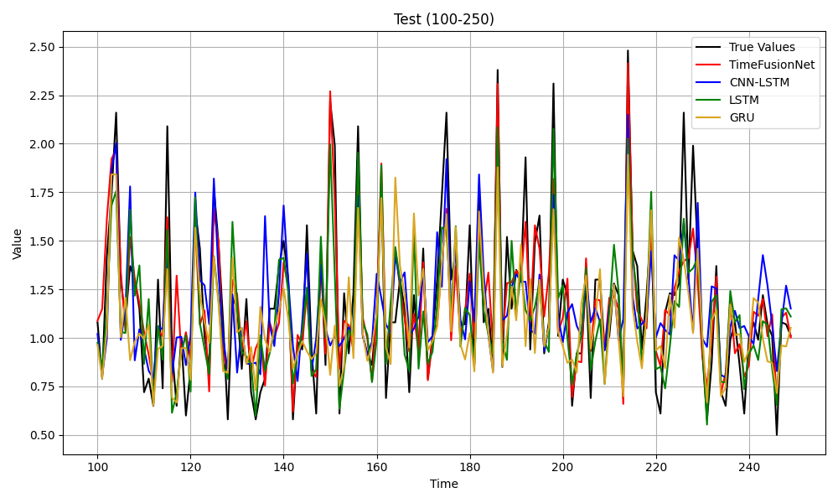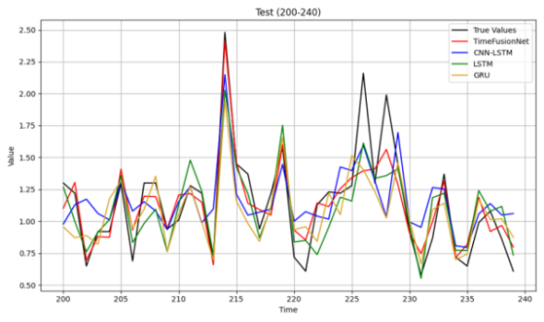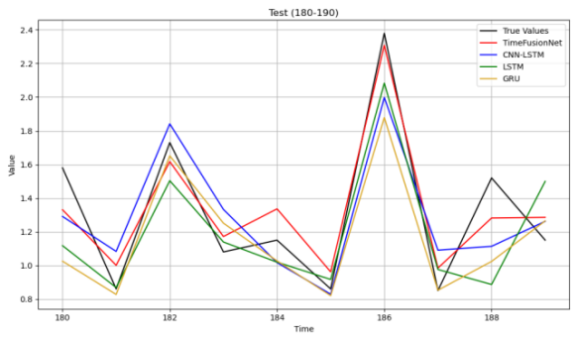
(a)
(b)
(c)
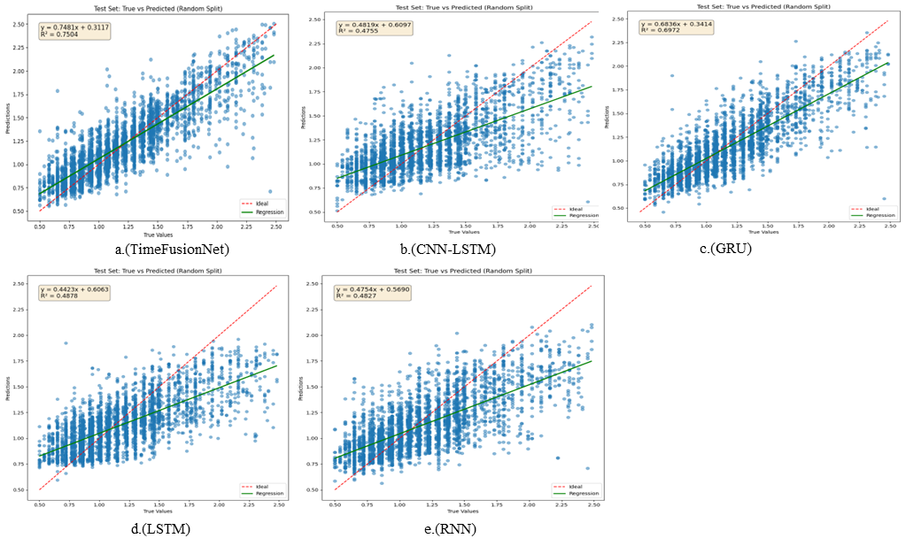
Figure 5.Comparison of predictions for the baseline model and the proposed model
Figure 6.Distribution of predictions for the baseline model and the proposed model
In the ablation study, the comparison of prediction results between the proposed model TimeFusionNet and the two ablation models is illustrated in Fig.7. TimeFusionNet-w/o-SA and TimeFusionNet-w/o-TA both achieved an acceptable prediction level as they extracted multi-scale features from a single aspect, exhibiting satisfactory performance in predicting overall trends and partial local details. However, due to the failure to capture cross-domain multi-scale features, their prediction performance for local details such as peaks and troughs was inferior to that of TimeFusionNet. As can be seen from Fig. 8, all scatter points of TimeFusionNet are closer to the identity line.
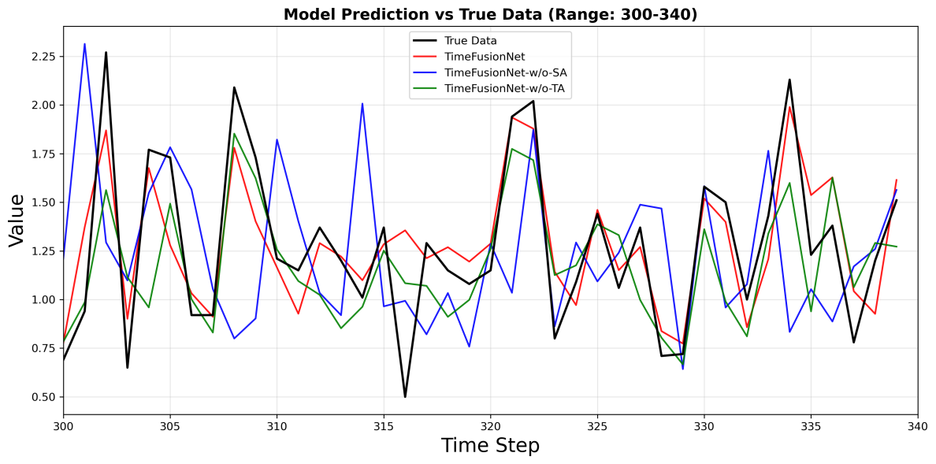
Figure 7.Comparison of predictions for each model in ablation experiment.
Table 2 presents the prediction accuracy metrics of ionized calcium concentration with a one-hour time delay for TimeFusionNet and other comparative models, providing a quantitative analysis of the models' prediction performance. The best values
for each metric are highlighted in bold. From Table 5, the following conclusions can be drawn: First, the MAE, MSE, MAPE, and of TimeFusionNet are 0.1274, 0.0318, 0.1043, and 0.7256, respectively, indicating that the proposed model outperforms all other comparative models across all accuracy metrics. Second, it can be observed that the GRU model achieves slightly better prediction performance than other comparative models. Benefiting from its streamlined gating architecture, GRU significantly outperforms traditional RNN and LSTM, overcoming the shortcomings of RNN (gradient vanishing leading to broken long-term dependencies) and LSTM (redundant parameter structure). However, issues such as the violation of calcination causality by the time-lag symmetry assumption, the inability of the single-time-scale processing mechanism to decouple heterogeneous dynamics between process variables, and the neglect of parameter space coupling by the hidden state transfer mechanism still restrict its prediction effectiveness. Finally, the proposed TimeFusionNet exhibits the best performance, demonstrating the effectiveness and necessity of simultaneously capturing multi-scale temporal and spatial features.
Table 2 Accuracy metrics for one-hour delay prediction.
Model | MAE | MSE | MAPE | $$R^{2}$$
TimeFusionNet | 0.1274 | 0.0318 | 0.1043 | 0.7256
GRU | 0.2415 | 0.0801 | 0.1794 | 0.5857
LSTM | 0.2142 | 0.0937 | 0.1875 | 0.4742
CNN-LSTM | 0.2465 | 0.0832 | 0.1926 | 0.4755
RNN | 0.2169 | 0.0820 | 0.1872 | 0.4826
Additionally, in the actual cement production process, accurate medium- and long-term prediction is crucial, as it allows production personnel to have sufficient time to adjust production strategies based on prediction results. To this end, we conducted prediction experiments with a two-hour delay and a three-hour delay. The relevant results are shown in Table 3, where the optimal values for each metric are marked in bold.It can be observed that as the prediction horizon expands, the performance of all models decreases to a certain extent. This phenomenon is reasonable considering that errors accumulate continuously in multi-step prediction. However, under different prediction horizons, the TimeFusionNet proposed in this paper still significantly outperforms other models in all metrics and maintains high prediction accuracy.
Table 3 Accuracy metrics for two-hour delay and three-hour delay prediction.
Prediction horizon | Model | MAE | MSE | MAPE | $$R^{2}$$
two-hour delay | TimeFusionNet | 0.1532 | 0.0431 | 0.14 | 0.7077
 | LSTM | 0.2283 | 0.0958 | 0.18 | 0.417
 | GRU | 0.1745 | 0.0664 | 0.17 | 0.6025
 | CNN-LSTM | 0.2786 | 0.1273 | 0.25 | 0.4372
 | RNN | 0.2251 | 0.0892 | 0.19 | 0.3954
three-hour delay | TimeFusionNet | 0.1514 | 0.0432 | 0.13 | 0.7167
 | LSTM | 0.2214 | 0.1232 | 0.23 | 0.5167
 | GRU | 0.1804 | 0.0609 | 0.15 | 0.6458
 | CNN-LSTM | 0.2584 | 0.1097 | 0.24 | 0.567
 | RNN | 0.2334 | 0.0969 | 0.20 | 0.4561
To further evaluate the critical contribution of the time-lag compensation matrix, an additional ablation model termed TimeFusionNet-w/o-LM is constructed, which only removes the learnable time-lag matrix while retaining all other components of TimeFusionNet unchanged. Compared with the full model, TimeFusionNet-w/o-LM shows a clear degradation in prediction accuracy. Although it can still follow the general variation pattern of f-CaO content, it fails to explicitly model the delayed causal relationships between process variables and quality changes, leading to obvious mismatches in capturing the dynamic responses driven by time-lag effects—especially at the turning points where the system’s temporal lag is strongest. In contrast, TimeFusionNet maintains consistent agreement with the ground truth, both in overall trends and in fine-grained fluctuations. As shown in Fig.7, the scatter points of TimeFusionNet-w/o-LM are more dispersed and deviate further from the identity line compared to those of the complete TimeFusionNet, indicating larger individual prediction errors and a lack of precise time-delay modeling. As shown in Fig. 8, compared with the complete TimeFusionNet model, the prediction curve of the ablation model without time-delay compensation matrix presents larger deviation degree relative to the real measured experimental data and more obvious fluctuation amplitude. This phenomenon reflects that the ablation model without time-delay compensation matrix cannot accurately model the time-delay changing rules inside the cement calcination industrial process, which will cause larger individual prediction error values.
This systematic comparison confirms that the time-lag compensation matrix acts as a key structural component that significantly strengthens the model’s ability to capture spatiotemporal dynamics in the cement calcination process, thereby improving both accuracy and stability.
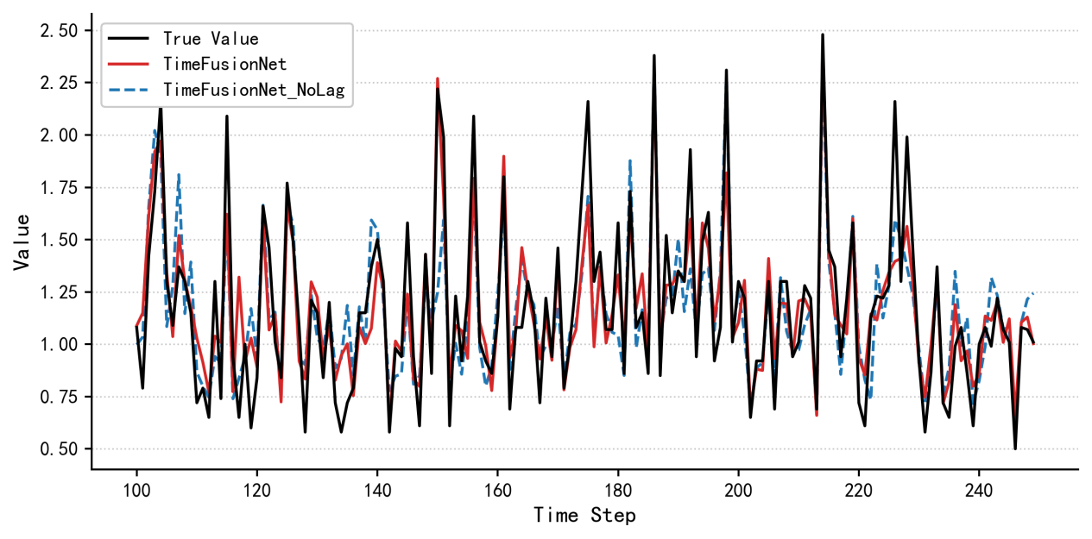
Figure 8. Comparison of predictions for the TimeFusionNet ablation models
From the ablation results presented in the table, TimeFusionNet consistently outperforms TimeFusionNet-w/o-LM across all evaluation metrics under both one-hour and two-hour delay scenarios. Specifically, for the one-hour delay prediction, TimeFusionNet achieves an MAE of 0.1532, an MSE of 0.0431, and a MAPE of 0.14, while TimeFusionNet-w/o-LM yields an MAE of 0.1694 (an increase of 10.57%), an MSE of 0.0621 (an increase of 43.98%), and a MAPE of 0.17 (an increase of 21.43%). For the two-hour delay prediction, TimeFusionNet maintains an MAE of 0.1514, an MSE of 0.0432, and a MAPE of 0.13, whereas TimeFusionNet-w/o-LM shows an MAE of 0.1769 (an increase of 16.84%), an MSE of 0.0665 (an increase of 53.94%), and a MAPE of 0.18 (an increase of 38.46%).
The significant performance degradation observed in TimeFusionNet-w/o-LM confirms that the learnable time-lag compensation matrix is a core component of the proposed model. By explicitly modeling the delayed causal relationships between calcination operations and f-CaO content changes, this matrix effectively captures the spatiotemporal coupling characteristics of the cement calcination process, thereby reducing prediction errors and improving the model’s adaptability to time-lag effects. The more pronounced increase in MSE compared to MAE further indicates that the time-lag compensation matrix plays a critical role in suppressing large prediction deviations, which is essential for stable and reliable industrial applications.
Table S1 accuracy metrics for the comparative experiments under 2-hour and 3-hour time delay predictions
 | one-hour delay |  |  | two-hour delay
 | MAE | MSE | MAPE | MAE | MSE | MAPE
TimeFusionNet | 0.1532 | 0.0431 | 0.14 | 0.1514 | 0.0432 | 0.13
TimeFusionNet-w/o-LM | 0.1694 | 0.0621 | 0.17 | 0.1769 | 0.0665 | 0.18

4.4.1.Effectiveness of the proposed model
In this paper, the IR metric is adopted to evaluate the effectiveness of the proposed model. Figure 9 presents the IR results of TimeFusionNet and other comparative models across three evaluation metrics, where subfigures (a)–(c) correspond to the IR results under the 3-hour delay scenario, respectively. It can be observed from the figure that all IR values exceed 10%, and the variation trends of IR across different prediction horizons are basically consistent. This result demonstrates that the proposed TimeFusionNet significantly outperforms other comparative models in terms of prediction performance.
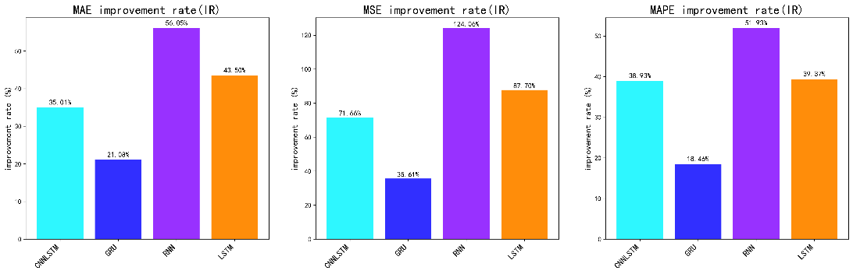
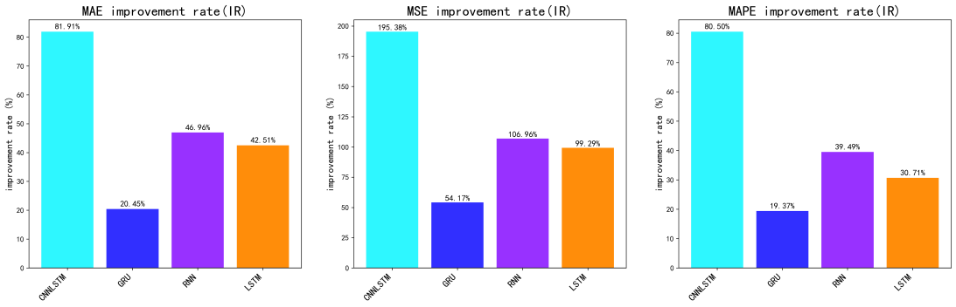
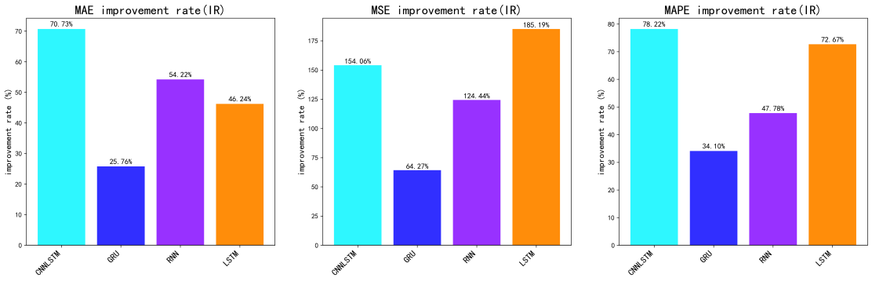
(b) two hours
(a) one hour
(c) Three hours
Figure 9 .Improvement rate of the proposed model under multiple rediction horizons

4.4.2.Significance of the proposed model
This paper employs the DM test to evaluate whether the difference in prediction accuracy between the proposed model and other comparative models is significant. According to relevant standards, if the DM statistic is less than -3.43, it means the proposed model outperforms the comparative model at the 1% significance level .
Table 4 presents the DM test results of TimeFusionNet versus other comparative models across all prediction horizons, and all results are less than -3.43. This indicates that under various prediction horizons, the prediction accuracy of TimeFusionNet is superior to that of other comparative models at the 99% confidence level. It can be seen that the DM test results further confirm the superiority of the proposed model.
Table 4 Diebold-Mariano (DM) test results of TimeFusionNet vs. comparative models
Model | 1-hour delay | 2-hour delay | 3-hour delay
LSTM | -17.482 | -12.47 | -15.12
GRU | -4.838 | -5.912 | -7.74
CNN-LSTM | -16.92 | -12.20 | -23.99
RNN | -17.946 | -19.506 | -16.67

4.4.3. Stability of the proposed model
During the calcination process of cement clinker, the free calcium content in finished products often shows significant fluctuation characteristics due to various factors such as differences in working conditions and complex environments. Therefore, in the actual cement production process, models with relatively stronger stability are generally considered to be able to provide more accurate prediction results.
Fig. 10 presents the stability test results of all models, where the stability metric is defined as the variance of the absolute prediction errors, which is calculated based on all samples in the test set. TimeFusionNet maintains the smallest variance under all prediction horizons: 0.0082 (1-hour), 0.0105 (2-hour), and 0.0108 (3-hour). The total variance increase is only 0.0026 with the extension of the prediction horizon, which is far lower than Transformer (0.0156→0.0195, increase 0.0039) and LSTM (0.0121→0.0189, increase 0.0068). Moreover, as the number of prediction steps increases, the variation range of TimeFusionNet’s variance value is relatively small. This fully demonstrates that TimeFusionNet has the most stable prediction performance, and the spatiotemporal attention mechanism with time-lag compensation can effectively suppress the error accumulation in multi-step prediction, which is crucial for practical industrial applications.
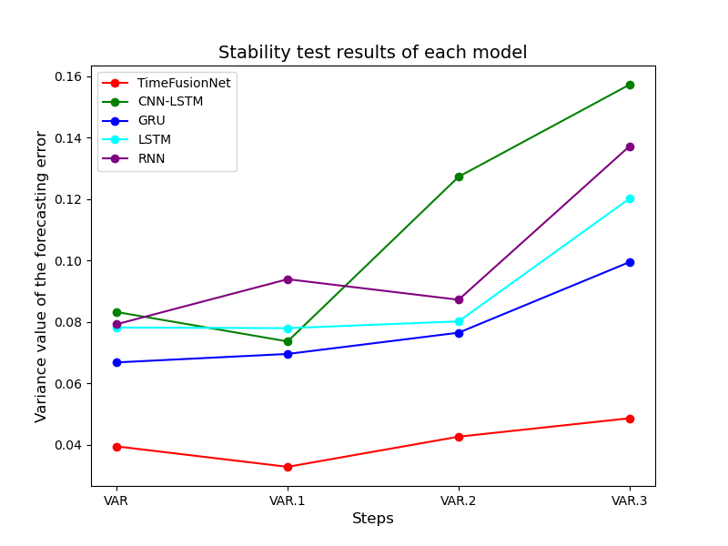
Figure.10. Stability test results of each model.

5. Conclusion
Accurate and reliable prediction of free calcium content in finished products from the cement clinker burning system is not only closely related to cement production costs, but also has a significant impact on energy consumption control and environmental governance. However, due to the inherent complexity of the cement clinker burning system and interference from external factors, it is not easy to accurately predict both the overall trend and local details of free calcium content in finished products simultaneously. To address this, this study constructs a novel prediction model for free calcium content in finished products of the cement clinker burning system-TimeFusionNet. The operating mechanism of the model is as follows: First, a multi-branch feature extraction layer is used to perform multi-modal feature extraction on the input time series, thereby fully capturing the local variation patterns of free calcium content. Second, in the spatiotemporal attention layer, multi-scale temporal correlations and dynamic relationships between variables are effectively captured. Finally, the prediction result of free calcium content is obtained. On a real-world dataset, comparative experiments on prediction performance were conducted between this model and multiple comparative models. The results show that TimeFusionNet achieves the optimal level in terms of prediction accuracy, effectiveness, significance, and stability. In summary, the TimeFusionNet proposed in this paper effectively improves the accuracy of free calcium content prediction under multiple prediction horizons, successfully solves complex problems in the cement clinker burning system, and provides a new direction for energy conservation, emission reduction, and production scheme optimization in cement production. It should be noted that although the model performs excellently in prediction performance, it has not yet been practically applied in industrial production to guide the adjustment of production strategies. This aspect will be further explored in subsequent studies to examine its specific role in actual production.

References
- Belkadi, A.A., Kessal, O., Berkouche, A., Noui, A., Daguiani, S.E., Dridi, M., et al., 2024. Experimental investigation into the potential of recycled concrete and waste glass powders for improving the sustainability and performance of cement mortars properties. Sustainable Energy Technologies and Assessments, 64, 103710.
- Schneider, M., Hoenig, V., Ruppert, J., Rickert, J., 2023. The cement plant of tomorrow. Cem Concr Res, 173, 107290. https://doi.org/10.1016/j.cemconres.2023.107290
- Supriya, Chaudhury, R., Sharma, U., Thapliyal, P.C., Singh, L.P., 2023. Low-CO₂ emission strategies to achieve net zero target in cement sector. Journal of Cleaner Production, 417, 137466. https://doi.org/10.1016/j.jclepro.2023.137466
- Dubey, S., Gupta, D., Mallik, M., 2025. Extreme learning machine to foretell the deflection in plain cement, steel-reinforced, and bamboo-reinforced concrete beams. Emerging Materials Research, 24, 00046.
- Dubey, S., Gupta, D., Mallik, M., 2024. Foretelling the compressive strength of bamboo using machine learning techniques. Engineering Computations, 6, 0507.
- Chen, H., Wang, Y.H., An, L.M., Xu, G., Zhu, X., Liu, W.Y., et al., 2022. Performance evaluation of a novel design for the waste heat recovery of a cement plant incorporating a coal-fired power plant. Energy, 246, 123420. https://doi.org/10.1016/j.energy.2022.123420
- Schneider, M., 2019. The cement industry on the way to a low-carbon future. Cem Concr Res, 124, 105792. https://doi.org/10.1016/j.cemconres.2019.105792
- Peng, C., Liu, Y., Ouyang, Y., Tang, Z., Luo, L., Gui, W.H., 2024. Grade Prediction of Froth Flotation Based on Multistep Fusion Transformer Model. IEEE Transactions on Industrial Informatics, , 342458.
- Ghalandari, V., Esmaeilpour, M., Payvar, N., Reza, M.T., 2021. A case study on energy and exergy analyses for an industrial-scale vertical roller mill assisted grinding in cement plant. Advanced Powder Technology, 32(2), 480–491. https://doi.org/10.1016/j.apt.2020.12.027
- Shi, X., Huang, G.L., Hao, X.C., Yang, Y., Li, Z., 2022. Sliding window and dual-channel CNN (SWDC-CNN): A novel method for synchronous prediction of coal and electricity consumption in cement calcination process. Appl Soft Comput, 129, 109520. https://doi.org/10.1016/j.asoc.2022.109520
- Lu, Z., Wang, H., He, G., Chen, Y., Li, Z., Zheng, Z., Yao, M., Zhang, S., Wang, H., 2025. Optimization framework for multi-objective energy management strategy in hybrid electric vehicles integrating explainable artificial intelligence. Applied Energy, , 126484.
- Hao, X.C., Guo, T.T., Huang, G.L., Shi, X., Zhao, Y.T., Yang, Y., 2020. Energy consumption prediction in cement calcination process: A method of deep belief network with sliding window. Energy, 207, 118256. https://doi.org/10.1016/j.energy.2020.118256
- Shi, X., Huang, G.L., Hao, X.C., Yang, Y., Li, Z., 2021. A Synchronous Prediction Model Based on Multi-Channel CNN with Moving Window for Coal and Electricity Consumption in Cement Calcination Process. Sensors, 21(13), 4284. https://doi.org/10.3390/s21134284
- Xu, Q.Q., Hao, X.C., Shi, X., Zhang, Z.P., Sun, Q.W., Di, Y.L., 2022. Control of denitration system in cement calcination process: A Novel method of Deep Neural Network Model Predictive Control. J Clean Prod, 332, 129970. https://doi.org/10.1016/j.jclepro.2021.129970
- Ghalandari, V., Iranmanesh, A., 2020. Energy and exergy analyses for a cement ball mill of a new generation cement plant and optimizing grinding process: A case study. Advanced Powder Technology, 31(5), 1796–1810. https://doi.org/10.1016/j.apt.2020.02.013
- Hao, X.C., Huang, G.L., Li, Z., Zheng, L.Z., Zhao, Y.T., 2023. A spatio-temporal data decoupling convolution network model for specific surface area prediction in cement grind process. Isa Transactions, 135, 380–397. https://doi.org/10.1016/j.isatra.2022.10.006
- Shi, X., Sun, Q.W., Ji, Y.K., Xu, Q.Q., Yang, X.N., Hao, X.C., 2022. Predictive control research for cement burning system using two-cycle coupling optimization. Expert Systems with Applications, 191, 116259. https://doi.org/10.1016/j.eswa.2021.116259
- Marenco-Porto, C.A., Fierro, J.J., Nieto-Londoño, C., Lopera, L., Escudero-Atehortua, A., Giraldo, M., et al., 2023. Potential savings in the cement industry using waste heat recovery technologies. Energy, 279, 127810. https://doi.org/10.1016/j.energy.2023.127810
- Ghimire, S., Nguyen-Huy, T., Al-Musaylh, M.S., Deo, R.C., Casillas-Pérez, D., Salcedo-Sanz, S., 2023. A novel approach based on integration of convolutional neural networks and echo state network for daily electricity demand prediction. Energy, 275, 127430. https://doi.org/10.1016/j.energy.2023.127430
- Ghimire, S., Deo, R.C., Casillas-Perez, D., Salcedo-Sanz, S., 2023. Efficient daily electricity demand prediction with hybrid deep-learning multi-algorithm approach. Energy Conv Manag, 297, 117707. https://doi.org/10.1016/j.enconman.2023.117707
- Wang, Y.Y., Wang, J.Z., Zhao, G., Dong, Y., 2012. Application of residual modification approach in seasonal ARIMA for electricity demand forecasting: A case study of China. Energy Policy, 48, 284–294. https://doi.org/10.1016/j.enpol.2012.05.026
- Wang, M., Yu, H., Jing, R., Lin, X.Y., 2023. Prediction and comparison of urban electricity consumption based on grey system theory: A case study of 30 southern China cities. Cities, 137, 104299. https://doi.org/10.1016/j.cities.2023.104299
- Khan, Z.A., Ullah, A., Ul Haq, I., Hamdy, M., Mauro, G.M., Muhammad, K., et al., 2022. Efficient Short-Term Electricity Load Forecasting for Effective Energy Management. Sustainable Energy Technologies and Assessments, 53, 102337. https://doi.org/10.1016/j.seta.2022.102337
- Wang, J.J., Sun, X., Cheng, Q., Cui, Q., 2021. An innovative random forest-based nonlinear ensemble paradigm of improved feature extraction and deep learning for carbon price forecasting. Sci Total Environ, 762, 143099. https://doi.org/10.1016/j.scitotenv.2020.143099
- Yuan, X., Jia, Z., Xu, Z., Xu, N., Ye, L., Wang, K., et al., 2024. Hierarchical self-attention network for industrial data series modeling with different sampling rates between the input and output sequences. IEEE Transactions on Neural Networks and Learning Systems. https://doi.org/10.1109/tnnls.2024.3388151
- Alymani, M., Mengash, H.A., Aljebreen, M., Alasmari, N., Allafi, R., Alshahrani, H., et al., 2023. Sustainable residential building energy consumption forecasting for smart cities using optimal weighted voting ensemble learning. Sustainable Energy Technologies and Assessments, 57, 103271. https://doi.org/10.1016/j.seta.2023.103271
- Ye, G., Wan, J.Q., Deng, Z.C., Wang, Y., Zhu, B., Yan, Z.C., et al., 2024. Machine learning-based prediction of biological oxygen demand and unit electricity consumption in different-scale wastewater treatment plants. J Environ Chem Eng, 12(2), 111849. https://doi.org/10.1016/j.jece.2023.111849
- Fan, G.F., Yu, M., Dong, S.Q., Yeh, Y.H., Hong, W.C., 2021. Forecasting short-term electricity load using hybrid support vector regression with grey catastrophe and random forest modeling. Util Policy, 73, 101294. https://doi.org/10.1016/j.jup.2021.101294
- Singh, S.K., Jha, S., Gupta, R., 2024. Enhancing the accuracy of wind speed estimation model using an efficient hybrid deep learning algorithm. Sustainable Energy Technologies and Assessments, 61, 103603.
- Ma, S., Zhang, Y., Lv, J., Ge, Y., Yang, H., Li, L., 2020. Big data driven predictive production planning for energy-intensive manufacturing industries. Energy, 211, 118320.
- Son, N., Shin, Y., 2023. Short- and Medium-Term Electricity Consumption Forecasting Using Prophet and GRU. Sustainability, 15(22), 15860. https://doi.org/10.3390/su152215860
- Kim, T.Y., Cho, S.B., 2019. Predicting residential energy consumption using CNN-LSTM neural networks. Energy, 182, 72–81. https://doi.org/10.1016/j.energy.2019.05.230
- Wan, A.P., Chang, Q., Al-Bukhaiti, K., He, J.B., 2023. Short-term power load forecasting for combined heat and power using CNN-LSTM enhanced by attention mechanism. Energy, 282, 128274. https://doi.org/10.1016/j.energy.2023.128274
- Yang, H.T., Zhang, Z.Z., Liu, X., Jing, P.X., 2023. Monthly-scale hydro-climatic forecasting and climate change impact evaluation based on a novel DCNN-Transformer network. Environ Res, 236, 116821. https://doi.org/10.1016/j.envres.2023.116821
- Liu, Z.R., Cao, Y.Z., Xu, H., Huang, Y.X., He, Q.S., Chen, X.J., et al., 2024. Hidformer: Hierarchical dual-tower transformer using multi-scale mergence for long-term time series forecasting. Expert Systems with Applications, 239, 122412. https://doi.org/10.1016/j.eswa.2023.122412
- Li, S.Y., Jin, X.Y., Xuan, Y., Zhou, X.Y., Chen, W.H., Wang, Y.X., et al., 2019. Enhancing the Locality and Breaking the Memory Bottleneck of Transformer on Time Series Forecasting. Presented at the Conference Enhancing the Locality and Breaking the Memory Bottleneck of Transformer on Time Series Forecasting, Vancouver, CANADA, Neural Information Processing Systems (Nips), vol. 32.
- Zhou, H.Y., Zhang, S.H., Peng, J.Q., Zhang, S., Li, J.X., Xiong, H., et al., 2021. Informer: Beyond Efficient Transformer for Long Sequence Time-Series Forecasting. Presented at the Conference Informer: Beyond Efficient Transformer for Long Sequence Time-Series Forecasting, Assoc Advancement Artificial Intelligence, Electr Network, vol. 35, pp. 11106–11115.
- Liu, S., Yu, H., Liao, C., Li, J., Lin, W., Liu, A.X., et al. Pyraformer: Low-complexity pyramidal attention for long-range time series modeling and forecasting. Presented at the Conference Pyraformer: Low-complexity pyramidal attention for long-range time series modeling and forecasting.
- Zhou, T., Ma, Z.Q., Wen, Q.S., Wang, X., Sun, L., Jin, R., 2022. FEDformer: Frequency Enhanced Decomposed Transformer for Long-term Series Forecasting. Presented at the Conference FEDformer: Frequency Enhanced Decomposed Transformer for Long-term Series Forecasting, Baltimore, MD, Jmlr-Journal Machine Learning Research.
- Yang, Z., Wang, K., Ye, L., Yuan, X., Wang, Y., Yang, C., 2025. A difference metric attention with position distance-based weighting for transformer in data sequence modeling of industrial processes. IEEE Transactions on Industrial Informatics, 21(2), 1803-1812. https://doi.org/10.1109/TII.2024.3488777
- Nie, Y., Nguyen, N.H., Sinthong, P., Kalagnanam, J., 2022. A time series is worth 64 words: Long-term forecasting with transformers. arXiv preprint arXiv:221114730.
- Xiang, Q., Pan, H.Y., Ma, X.H., Yang, M.D., Lyu, Y., Zhang, X.H., et al., 2024. Impacts of energy-saving and emission-reduction on sustainability of cement production. Renew Sust Energ Rev, 191, 114089. https://doi.org/10.1016/j.rser.2023.114089
- Liu, G., Wang, K., Hao, X.C., Zhang, Z.P., Zhao, Y.T., Xu, Q.Q., 2022. SA-LSTMs: A new advance prediction method of energy consumption in cement raw materials grinding system. Energy, 241, 122768. https://doi.org/10.1016/j.energy.2021.122768
- Hao, X.C., Wang, Y.Z., Zhang, Z.P., Li, Y.M., Hu, J.H., 2024. Root cause analysis of faults in cement pre-decomposition system using kernel principal component analysis and multi-scale symbolic transfer entropy. Chem Eng Sci, 286, 119681. https://doi.org/10.1016/j.ces.2023.119681
- Wang, Z., Ruan, S., Huang, T., Zhou, H., Zhang, S., Wang, Y., et al., 2024. A lightweight multi-layer perceptron for efficient multivariate time series forecasting. Knowledge-Based Systems, 111463.
- Shao, Z., Zhang, Z., Wang, F., Xu, Y. Pre-training enhanced spatial-temporal graph neural network for multivariate time series forecasting. Presented at the Conference Pre-training enhanced spatial-temporal graph neural network for multivariate time series forecasting, pp. 1567–1577.
- Wu, B.R., Wang, L., Wang, S.R., Zeng, Y.R., 2021. Forecasting the US oil markets based on social media information during the COVID-19 pandemic. Energy, 226, 120403. https://doi.org/10.1016/j.energy.2021.120403
- Hao, Y., Tian, C.S., 2020. A hybrid framework for carbon trading price forecasting: The role of multiple influence factor. J Clean Prod, 262, 120378. https://doi.org/10.1016/j.jclepro.2020.120378
- Zhao, Z.L., Sun, S.L., Sun, J.Y., Wang, S.Y., 2024. A novel hybrid model with two-layer multivariate decomposition for crude oil price forecasting. Energy, 288, 129740. https://doi.org/10.1016/j.energy.2023.129740
- Li, T.H., Liu, X.L., Lin, Z., Morrison, R., 2022. Ensemble offshore Wind Turbine Power Curve modelling e An integration of Isolation Forest, fast Radial Basis Function Neural Network, and metaheuristic algorithm. Energy, 239, 122340. https://doi.org/10.1016/j.energy.2021.122340
- Zhang, W.Y., Zhang, L.F., Wang, J.Z., Niu, X.S., 2020. Hybrid system based on a multi-objective optimization and kernel approximation for multi-scale wind speed forecasting. Appl Energy, 277, 115561. https://doi.org/10.1016/j.apenergy.2020.115561
- Zhang, K.F., Cao, H., Thé, J., Yu, H.S., 2022. A hybrid model for multi-step coal price forecasting using decomposition technique and deep learning algorithms. Appl Energy, 306, 118011. https://doi.org/10.1016/j.apenergy.2021.118011
- Sun, W., Li, Z.Q., 2020. Hourly PM₂.₅ concentration forecasting based on mode decomposition-recombination technique and ensemble learning approach in severe haze episodes of China. J Clean Prod, 263, 121442. https://doi.org/10.1016/j.jclepro.2020.121442

