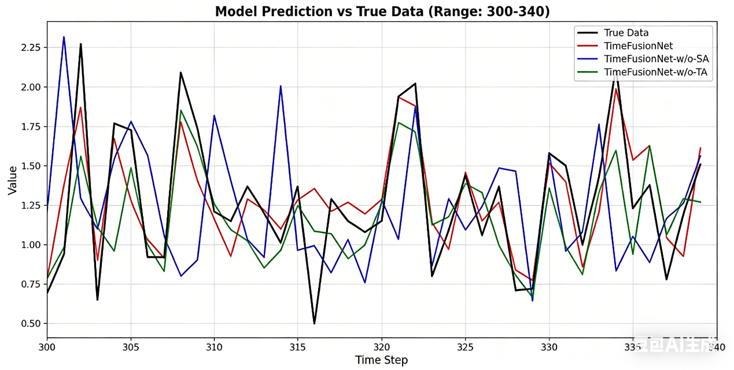
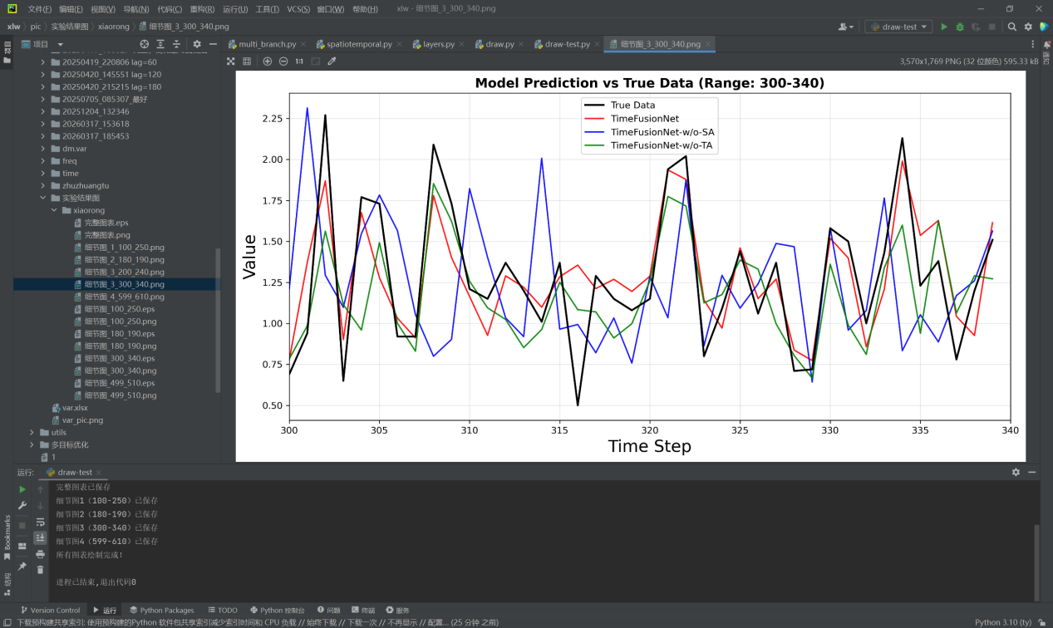
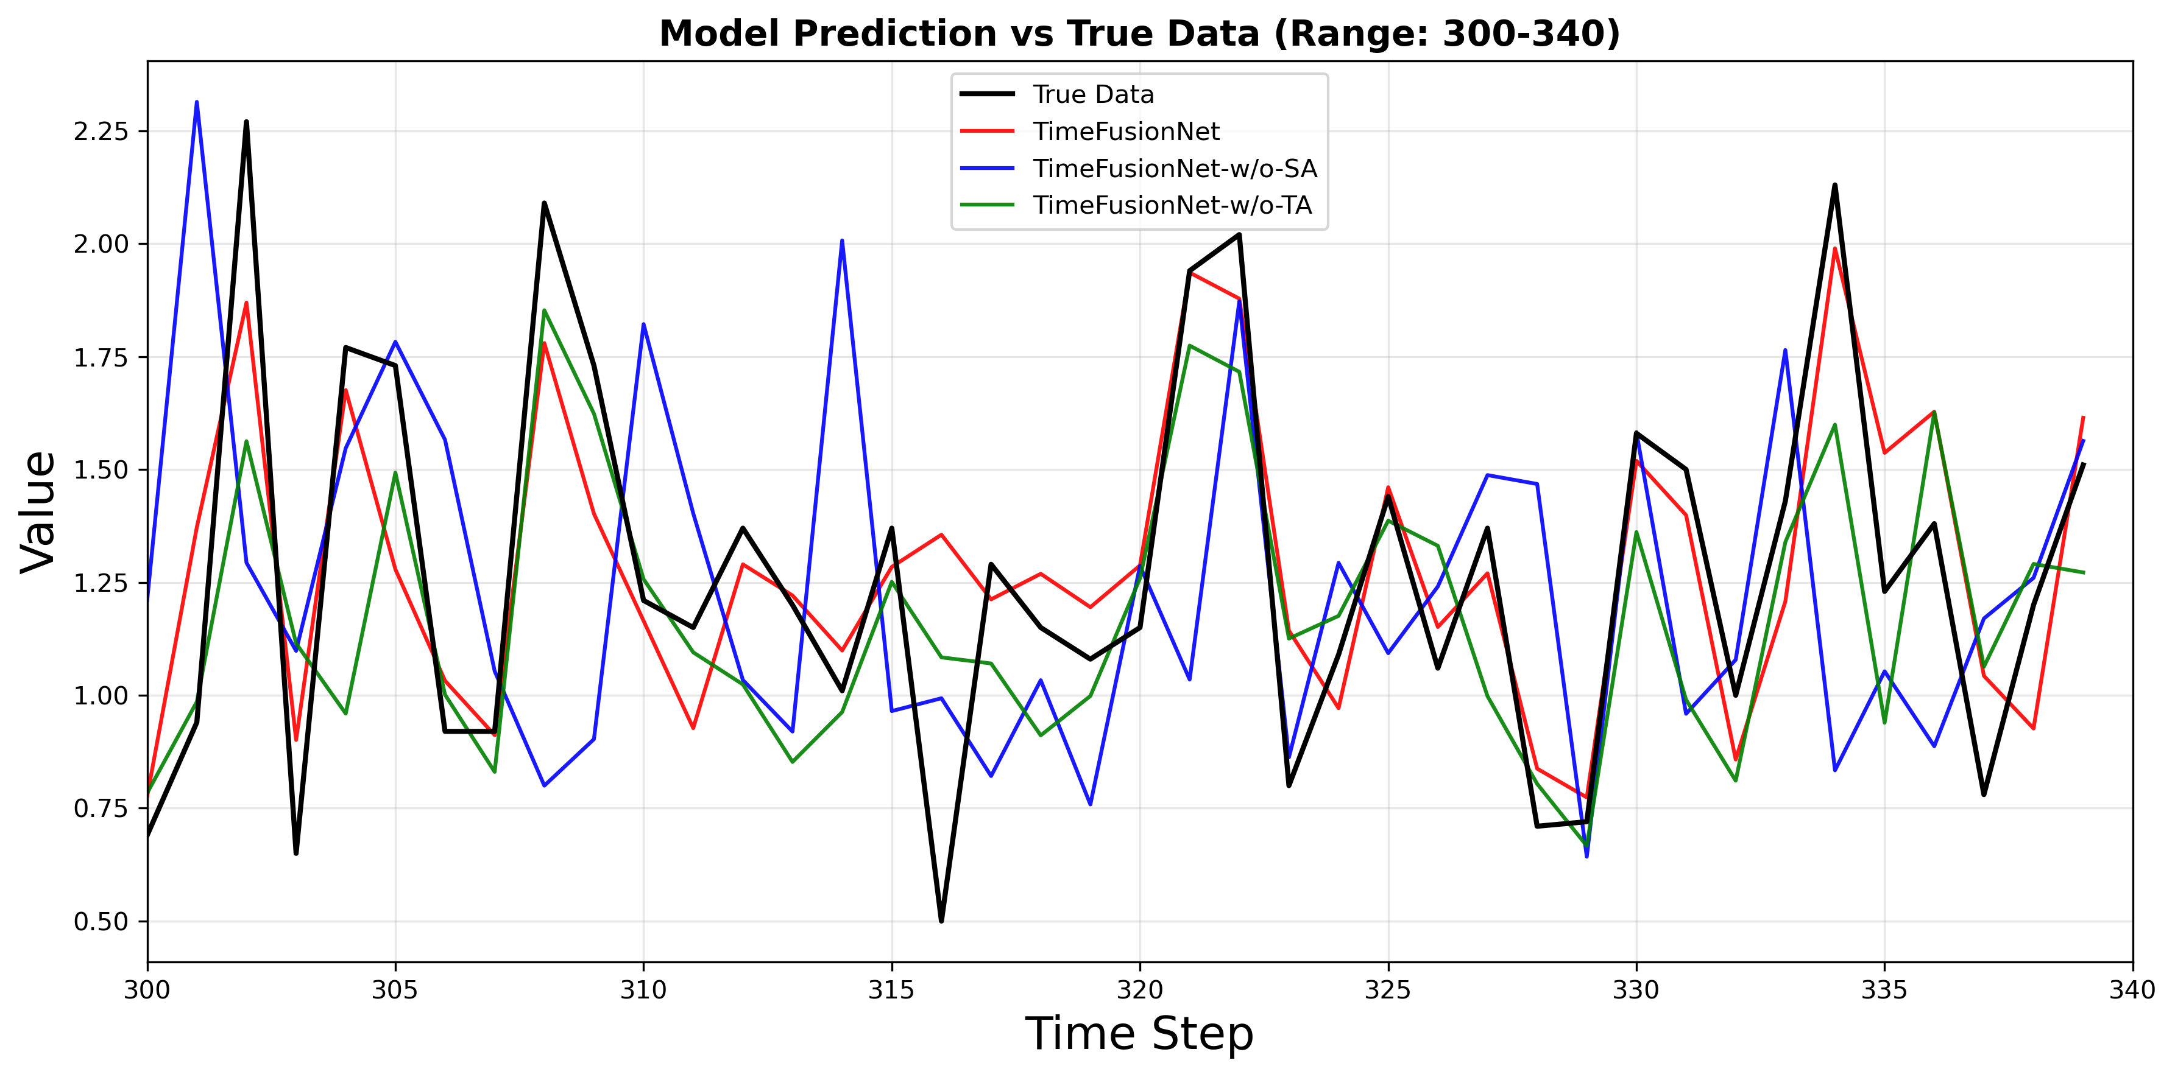
Fig.7
Program Source File Directory：xlw\draw-test.py
Raw Data Directory：\xlw\pic\TimeFusionNetwoSA，xlw\pic\TimeFusionNetwoTA

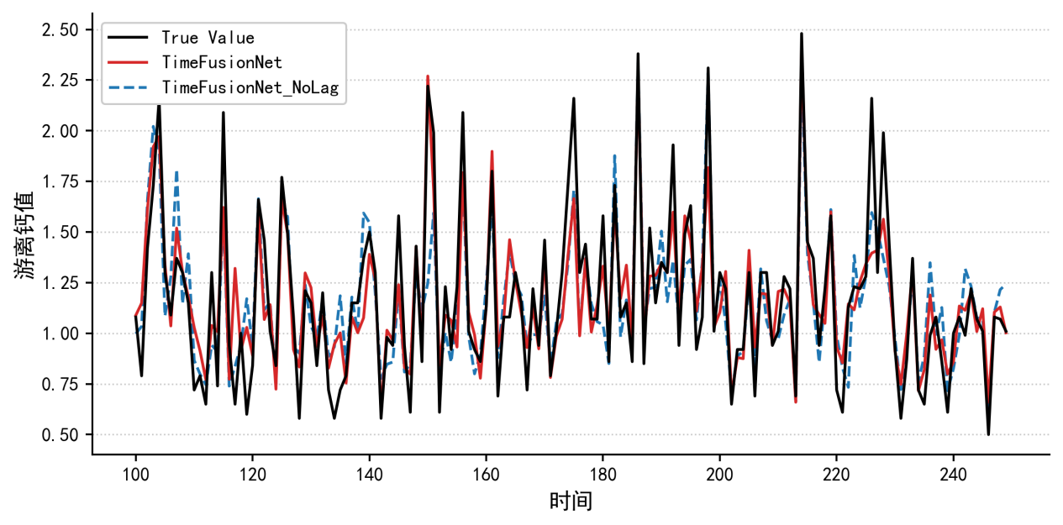
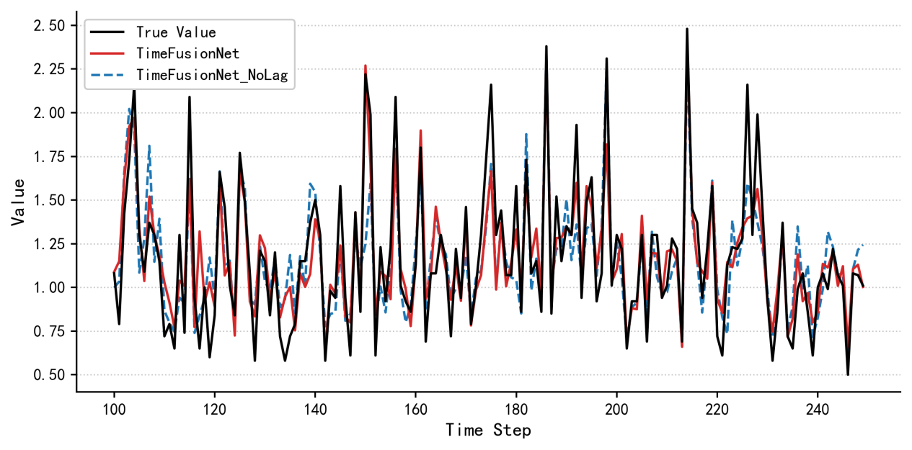
Fig.8
Program Source File Directory：xlw\draw.py
Raw Data Directory：xlw\pic\TimeFusionNet_NoLag

