Coding Directory

/mnt/c/Users/lzhiyuan/OneDrive\ -\ Cadence\ Design\ Systems\ Inc/Desktop/0-Self_Learn_Online_Classes/Coursera-Data-Structure/my_codes

Run C++ file

g++ -std=c++11 XXX.cpp

./a.out

### How to do stress test

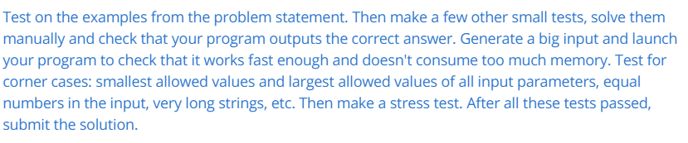

Class 1

Week 1

### 0-big-O notation

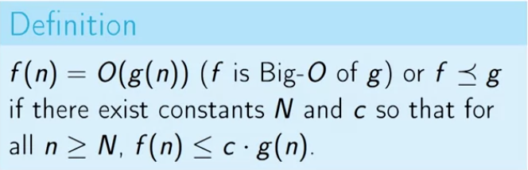

big-O means ‘upper bounded’

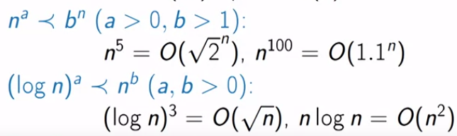

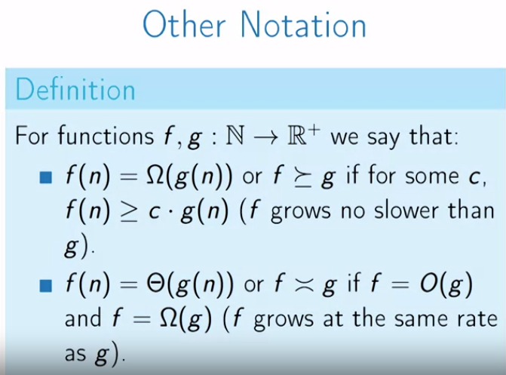

### 1-Maximal pairwise product

1 billion is roughly number of basic operations modern machine can do in 1 sec.

Similar to problem:

**Find the largest three elements in an array**

<https://www.geeksforgeeks.org/find-the-largest-three-elements-in-an-array/>

// This **order of assignment is important**

third = second

second = first

first = x

}

### 2-Finanocci Numbers

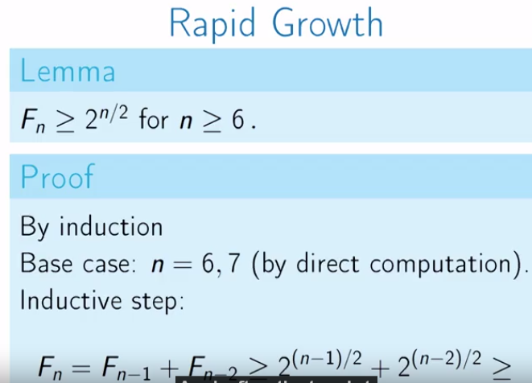

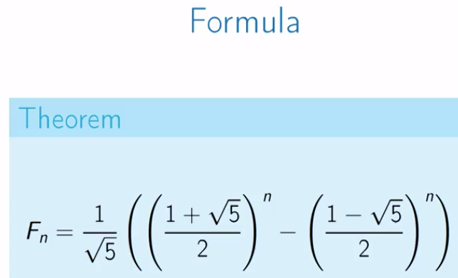

Slow solution:

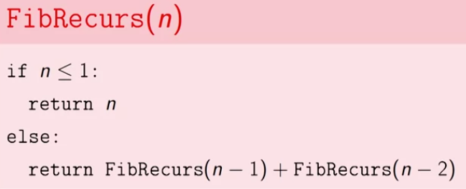 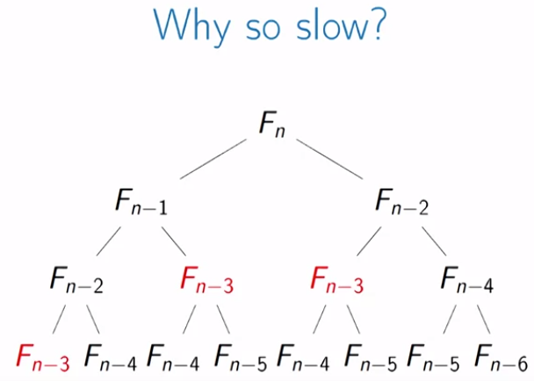

### 3-Greatest Common Divisor & Least Common Factor

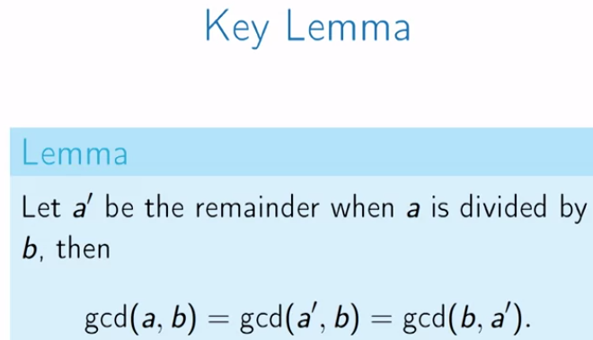 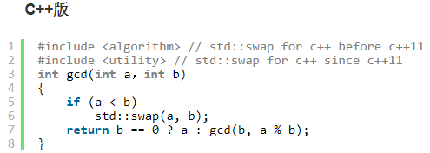

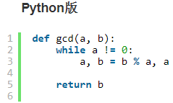

最小公倍数 = n1 * n2 / 最大公约数