Mechanistic Modeling and Early-Warning-Enabled Proactive Dispatch for Power Systems under Cooling-Water Supply Contingencies

Abstract
Cooling-water supply interruptions can cause progressive cold-end degradation, reduce generator output, and leave electricity demand unserved. Existing studies have largely focused on fleet- and regional-scale water constraints, while the use of plant-level cooling-water dynamics to determine a time window for proactive grid dispatch remains insufficiently explored. This study uses the time difference between rapid information transfer and slower cooling-water disturbance evolution to support early warning and proactive dispatch under a complete makeup-water interruption. A reduced-order mechanistic model describes basin inventory, pump hydraulics, and condenser heat transfer, distinguishing the exhaustion of usable water from the subsequent protection trip. At the warning trigger, the available adjustment time (AAT) to the low-water boundary is estimated from the remaining usable water and the current net loss rate. The AAT estimate is used to schedule the affected unit’s planned shutdown. The resulting shutdown time is incorporated into a nodal direct-current optimal power flow model to coordinate generation dispatch. Passive response (PR), one-shot static proactive dispatch (SPD), and dynamic proactive dispatch (DPD), updated every 60 s, are compared on the IEEE 30-bus and 59-bus Shelby County systems. Under PR, the estimated AAT is 30.46 and 25.59 min, respectively, while the modeled protection lag after the low-water boundary is 2.42 and 1.73 min. Relative to PR, SPD reduces energy not served by 94.15% and 98.70%, from 18.886 to 1.104 MWh and from 62.267 to 0.811 MWh, respectively; DPD yields approximately 0 and 0.104 MWh. These results suggest that early warning based on cold-end dynamics can support proactive dispatch to reduce energy not served during cooling-water supply interruptions, subject to the uncalibrated cold-end model and lossless direct-current network assumptions. In practice, plant-level cooling-water information and the estimated AAT could inform coordination between plant operators and grid dispatchers, allowing them to plan the affected unit’s shutdown and adjust other generators before usable cooling water is exhausted.
Keywords: Cooling-water interruption; Thermoelectric power generation; Cold-end dynamics; Available adjustment time; Proactive dispatch; Energy not served

1. Introduction
Cooling-water availability is essential to thermoelectric generation, yet the response of a plant and its power system to an acute interruption requires further examination. Much of the water–energy nexus literature has focused on fleet- and regional-scale resource constraints. Freshwater withdrawal and consumptive use vary substantially across cooling technologies and operating conditions [1–4], motivating grid-scale analyses of virtual water transfers [5] and the decoupling of electricity growth from freshwater withdrawal [6]. Studies of droughts, heat waves, and intake-temperature limits have quantified reductions in thermal generation capacity [7–9] and identified regions facing substantial or increasing water stress [10, 11]. Other investigations have highlighted the importance of plant design, cooling options, and technology-specific weather responses in assessing unit-level vulnerability [12–15]. These studies provide important insights into water-related generation risks, but they do not directly resolve the short-term physical trajectory of an individual closed-loop wet-cooled unit during the minutes to hours after external makeup water ceases. Understanding this trajectory is important not only for assessing the affected unit’s response, but also for determining whether the power system has time to act before cooling-water exhaustion.
Research on interdependent infrastructures has examined the propagation of localized disruptions across coupled networks [16, 17], while power-system resilience studies have considered infrastructure hardening, operational strategies, and post-event recovery [18–22]. Within the water–power nexus, studies have analyzed outage propagation between electric and water distribution networks [23] and reviewed the challenges of quantifying integrated system resilience [24]. Related critical-transition warning concepts also motivate proactive responses [25]. In coupled gas–electricity systems, Yu et al. [26] use the faster transmission of failure information relative to gas-pressure propagation to initiate redispatch; other studies coordinate power scheduling with gas-network dynamics and storage [27, 28]. For cooling-water constraints, Wang et al. [29] incorporate unit-level cooling-water requirements and water availability into regional power-system operation. Together, these studies motivate proactive management of coupled infrastructure disruptions, but they do not directly derive a dispatch time window from the cold-end response of an individual unit following a complete makeup-water interruption.
Applying the time-gap principle demonstrated in gas–electricity systems [26] to cooling-water interruptions requires an estimate tied to the affected unit’s cooling system. Whereas gas networks can use linepack as a buffer, the relevant buffer in the present study is the usable water in the cooling-tower basin. Information on the evolving cold-end state can therefore support an estimate of the time remaining before this buffer is exhausted. Such an estimate provides a physical basis for proactive dispatch, rather than relying on a predetermined warning lead time.
When external makeup water stops at a closed-loop wet-cooled unit, evaporative, blowdown, and drift losses progressively reduce the cooling-tower basin inventory. The resulting changes in pump hydraulics and circulating-water flow affect condenser heat rejection and turbine exhaust backpressure. In the model considered here, the hydraulic exhaustion of usable basin water at the pump-cutoff boundary and the downstream trip triggered by excessive condenser backpressure are distinct events, separated by a thermal–hydraulic transient. The interval after the usable-water boundary is therefore a protection lag, not an additional water-backed dispatch window. Proactive curtailment before that boundary may reduce system-wide energy not served (ENS), but it can also increase the affected unit’s exposure to low-load operation. These characteristics raise two questions: what estimate of the time to the usable-water boundary can be obtained from the cold-end state at an early warning, and how does dispatch informed by that estimate affect both ENS and low-load exposure?
To address these questions, this study couples a reduced-order mechanistic cold-end model with early-warning-enabled nodal direct-current optimal power flow (DC-OPF). The cold-end model represents basin inventory, pump hydraulics, and condenser heat transfer, and distinguishes the usable-water boundary from the later protection trip. At the warning trigger, the available adjustment time (AAT) is estimated from the remaining usable inventory and its current net loss rate; it is a conditional estimate to the water boundary, rather than an estimate to the protection trip. This estimate informs the affected unit’s planned shutdown, which is incorporated into the network dispatch model. The study compares passive response (PR), one-shot static proactive dispatch (SPD), and dynamic proactive dispatch (DPD), refreshed every 60 s, over a common water budget. The warning fraction and generation-cost weight are selected from finite candidate sets using the chord-distance criteria described in Section 4. The methods are applied to the IEEE 30-bus and 59-bus Shelby County systems to evaluate both ENS and the affected unit’s exposure to operation below a diagnostic minimum-output threshold.

2. System Architecture and Study Cases

2.1. System boundary and interfaces
The study links the physical cooling-water loop to an early-warning and dispatch pathway, as shown in Fig. 1. In the physical loop [Fig. 1(a)], circulating water leaves the basin, passes through the pump and condenser tube side, and returns from the cooling tower. Following an external makeup-water interruption, evaporation, blowdown, and drift deplete the basin inventory. The resulting decline in usable water and circulating flow reduces condenser heat rejection, causing condenser backpressure to rise and available electrical output to fall. Within this physical boundary, backpressure affects the turbine–generator solely as a performance coupling; boiler, steam-side flow, condensate-return, and Rankine-cycle dynamics are not explicitly represented. Hydraulic pump cutoff at the usable-water boundary and the subsequent condenser-backpressure trip are treated as separate events, with setpoints specified in Section 3. The information pathway uses the evolving cold-end states to estimate the time available before the usable-water boundary.
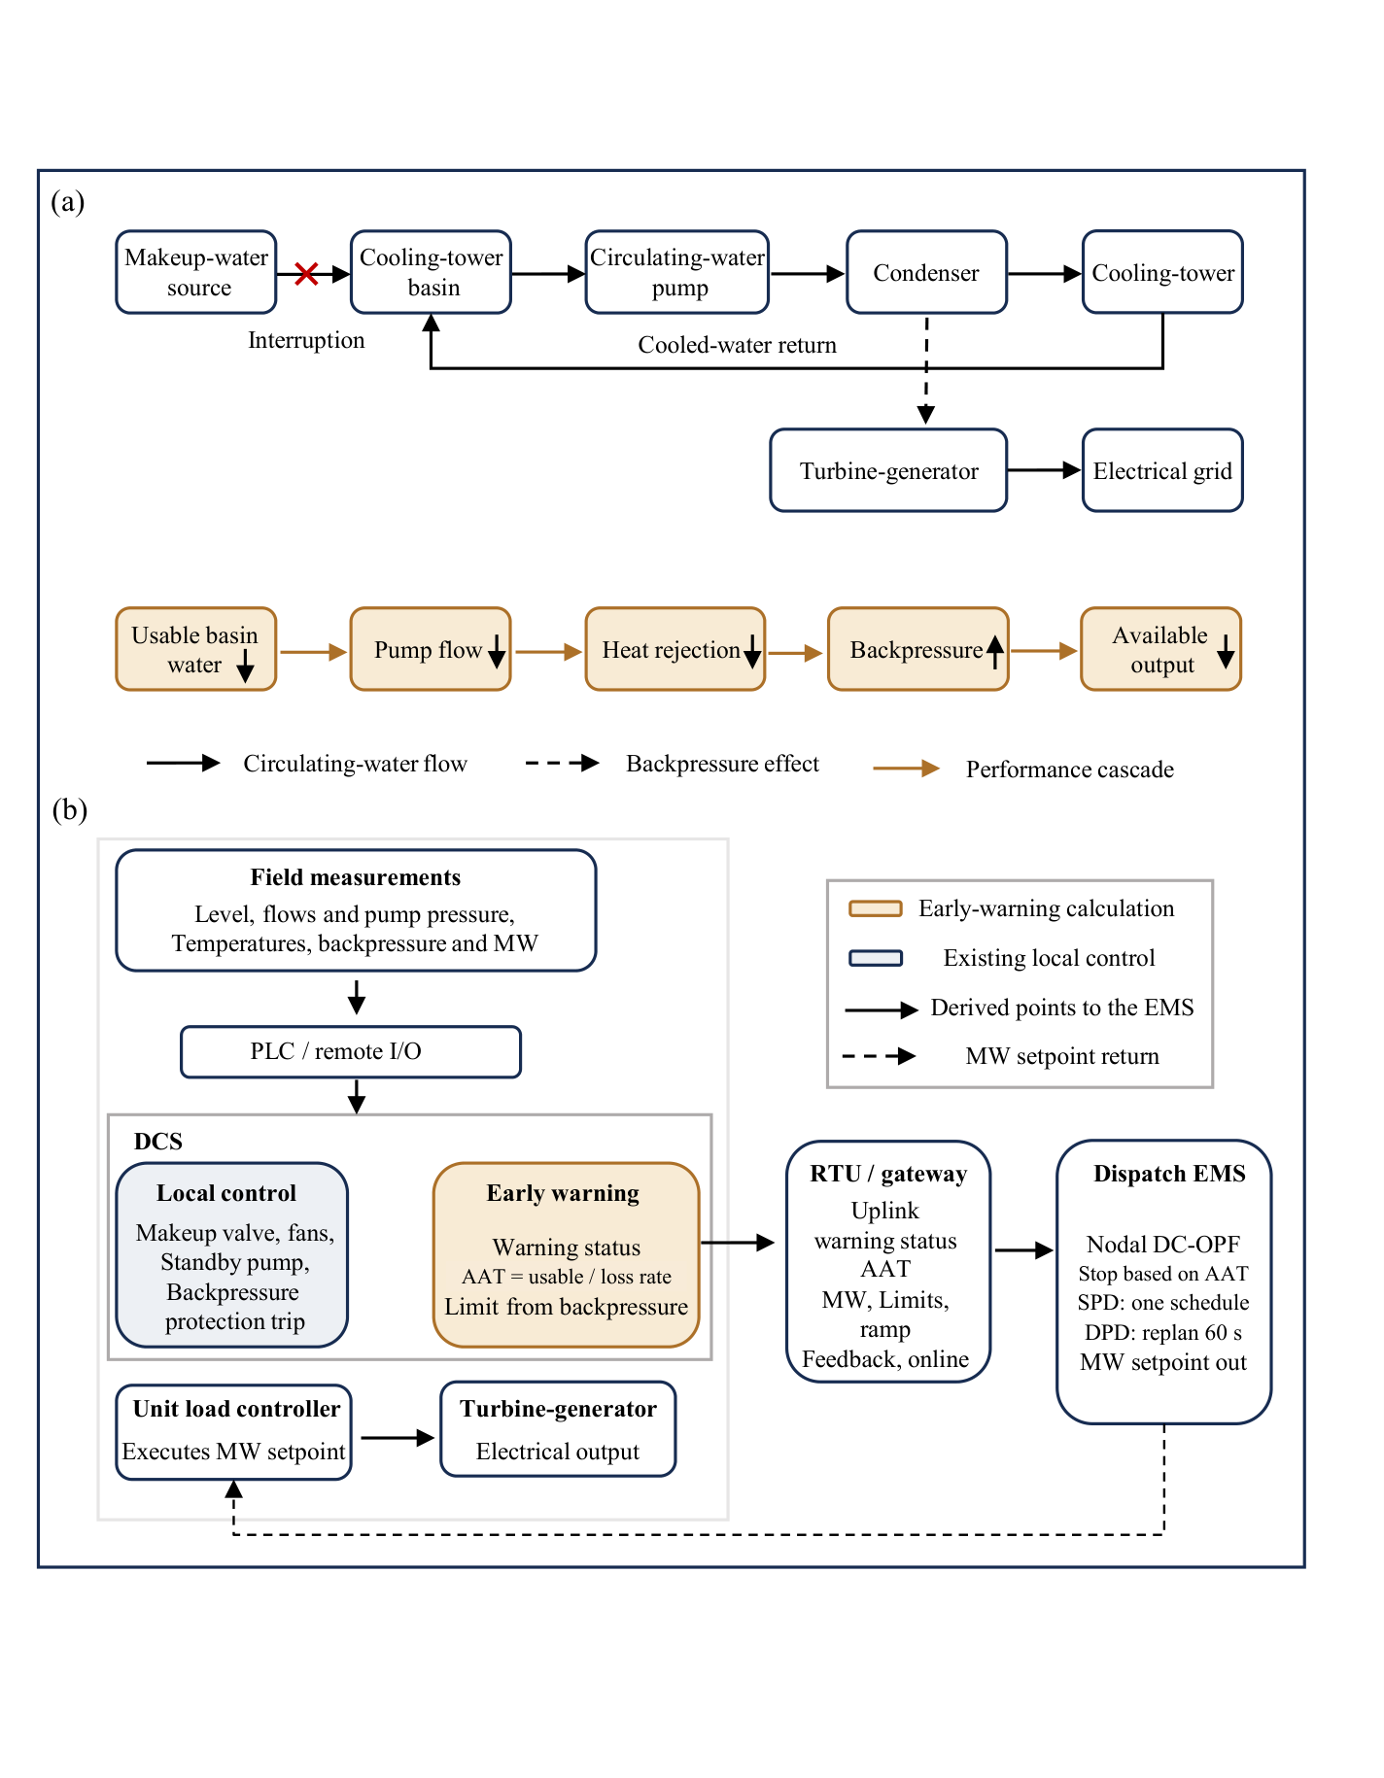
Fig. 1. Physical cooling-water loop and automated early-warning–dispatch pathway. (a) Physical circulating-water circuit and sequential performance cascade following a makeup-water interruption, where black solid arrows denote water flow, the dashed arrow represents backpressure coupling on the turbine–generator, and amber arrows trace the performance cascade. (b) Plant-to-grid cyber-physical pathway across the programmable logic controller (PLC), distributed control system (DCS), remote terminal unit (RTU), and dispatch energy management system (EMS). Local control executes internal plant actions (pump cutoff and backpressure trip), whereas the early-warning routine uplinks the warning status, available adjustment time (AAT), and active-power limits to the EMS for static proactive dispatch (SPD) or dynamic proactive dispatch (DPD). The backpressure-derived limit in the diagram represents a conceptual interface; the reported LP uses the rated upper bound and a full evaluation horizon with a planned shutdown based on AAT, while backpressure capability is checked in physical replay.
At the plant level, process measurements support local protection and early-warning estimation in parallel [Fig. 1(b)], with a distributed control system (DCS) providing the conceptual interface. Although the exact instruments depend on plant design, the required measurements belong to sensor classes already used in automatic plant control. For example, the AP1000 service-water design regulates makeup from basin level and starts the standby pump on low discharge pressure [30], while the U.S. EPR circulating-water system records pump discharge pressure, condenser inlet and outlet temperatures, flow, and basin level [31]. These measurements enter the DCS through a programmable logic controller (PLC) or a remote input/output module [32].
Local control remains responsible for makeup regulation, standby-pump starting, the usable-water pump cutoff, and the backpressure protection trip. In parallel, the early-warning module computes a warning status and the available adjustment time (AAT) without operating valves, pumps, or unit trips. AAT is a conditional estimate of the time to the usable-water boundary, calculated from the remaining usable water and the instantaneous net loss rate. The module can also represent a backpressure-derived active-power limit as a conceptual plant-to-grid interface; its role in the reported simulations is distinguished below.
The AAT estimate is passed through a conceptual plant-to-grid interface to support proactive scheduling by the dispatch energy management system (EMS). Raw hydraulic and thermal states—level, flow, pressure, and temperature—remain inside the plant, while a remote terminal unit (RTU) or gateway uplinks the warning status, AAT, measured power, operating limits, ramp rate, setpoint feedback, and online status. This interface draws on the established use of supervisory control and data acquisition (SCADA) and automatic generation control within dispatch energy management systems [33].
When a warning is active, the EMS uses an AAT-based planned shutdown in a nodal direct-current optimal power flow (DC-OPF) formulation. In the reported simulations, the optimization extends to the evaluation horizon rather than ending at AAT. It uses the rated output upper bound; the backpressure-limited capability shown conceptually in Fig. 1 is checked in the subsequent physical replay, rather than imposed as the LP upper bound.
Static proactive dispatch (SPD) solves once, whereas dynamic proactive dispatch (DPD) refreshes the schedule at intervals of at most 60 s, returning only an active-power setpoint to the unit load controller. In the simulations, the setpoint is imposed directly on the cold-end model without resolving communication protocols or actuation latency, as summarized in Supplementary Table S1.

2.2. Study cases and capacity scaling
The study is evaluated on two power networks with contrasting scales and initial loading conditions. Fig. 2 compares their topologies, and Table 1 summarizes the affected units, demand, basin volumes, simulation window, and evidence status. The first case is the IEEE 30-bus system [34], comprising 30 buses, 41 branches, and 6 generators serving a total active demand of 189.2 MW. The water-constrained thermal unit is located at bus 2, with P₀ = 60.969 MW and P_{max} = 80 MW, corresponding to an initial loading of 76.2%.
The second case is the 59-bus Shelby County power network [35], comprising 73 branches and 8 generators with an aggregate demand of approximately 1,434 MW. The water-constrained unit is Generator G2 at node 2, with P₀ = 319 MW and P_{max} = 344.865 MW, corresponding to an initial loading of 92.5%.
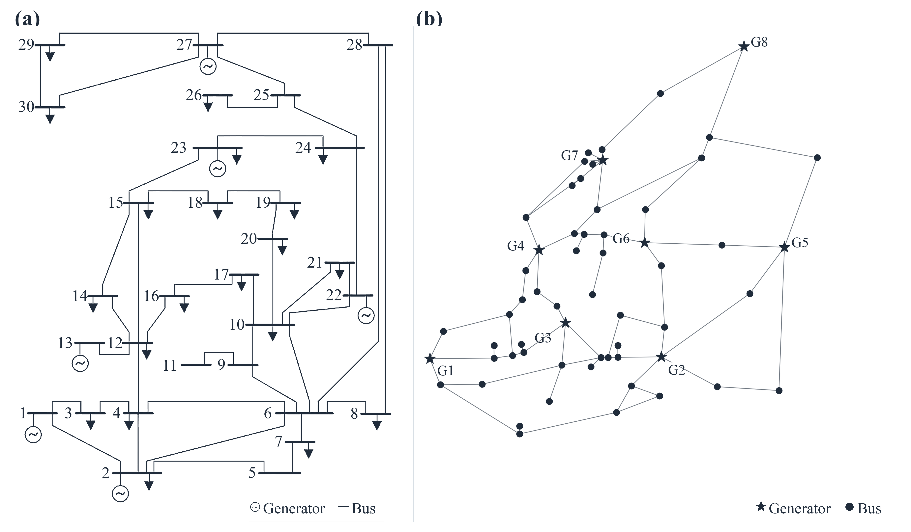
Fig. 2. Topologies of the two test systems: (a) the IEEE 30-bus system [34], where the water-constrained unit is located at bus 2; and (b) the Shelby County 59-bus power network [35], where the water-constrained unit is Generator G2 at node 2.
Table 1. Case inputs, evidence class, and simulation window.
Case | Network / affected unit | Demand (MW) | V_{norm} / V_{prot} / V_{warn} (m³) | Window; update | Evidence status
IEEE 30-bus | IEEE 30-bus; bus 2, P₀ = 60.969 MW, P_{max} = 80 MW | 189.2 | 896 / 256 / 332.8 | 18,000 s; 60-s LP knots; 60-s DPD replan | Standard benchmark; cold-end template not plant-calibrated; DC-OPF, not AC validation
Shelby County | Source network data [35]; Generator G2 (node 2), P₀ = 319 MW, P_{max} = 344.865 MW | ≈ 1,434 | 3,862.486 / 1,103.568 / 1,434.638 | 18,000 s; 60-s LP knots; 60-s DPD replan | Source network data; cold-end template not plant-calibrated; DC-OPF, not AC validation

A common cold-end template provides a consistent basis for comparing the affected units at different capacities. The template uses a 500 MW reference unit and a design circulating-water flow of 250,000 US gpm, approximately 15.77 m³·s⁻¹; these values are consistent with the closed-cycle wet-cooling design example reported by EPRI [36]. The template is not a site-calibrated representation of either case.
The design circulating-water flow rate and cooling-tower basin area are scaled linearly with the capacity ratio s = P_{max}/500 MW, while the thermal, hydraulic, and time-constant parameters retain their baseline template settings (Supplementary Table S2). This scaling gives normal and low-water boundary volumes of 896 and 256 m³ for the IEEE 30-bus unit, and 3,862.486 and 1,103.568 m³ for the Shelby County unit, respectively. These volumes are derived from the reference template rather than site-specific field measurements. The warning volume is determined by the warning fraction specified in Section 4.4, and the same makeup-water interruption is applied to both cases.

2.3. Contingency and initial conditions
Disruptions to the external makeup-water supply may arise from failures in the supply infrastructure, including the water source, conveyance pipeline, or makeup-water pump. In this study, the initiating cause is not modeled explicitly; instead, its consequence is represented by a complete loss of external makeup flow at t = 0 s (Q_{makeup} = 0). No restoration of makeup supply is modeled within the 18,000 s simulation horizon, and cooling-tower blowdown is not automatically isolated. Starting from the normal basin level h_{norm} = 3.5 m, the simulated disturbance progresses through early warning, the usable-water boundary, and the subsequent condenser protection trip.
The warning fraction selected in Section 4.4 is α = 0.12, giving a trigger level of hwarn = 1.30 m. The corresponding warning volumes are 332.8 m³ for the IEEE 30-bus system and 1,434.638 m³ for the Shelby County system (Table 1). The low-water level hprot = 1.0 m defines the usable-water and pump-flow cutoff boundary. Unit protection is a separate downstream event triggered at a condenser backpressure of 15 kPa(a).
Within each case, the three control policies are compared from the same balanced pre-contingency state and under the same network-model assumptions. Passive response (PR) holds the affected unit at its initial setpoint until protection; SPD and DPD use the warning to schedule proactive adjustments, as detailed in Section 4.3. Before the interruption, generator outputs are balanced to the system’s active demand. The closed-loop physical replay defined in Section 4.3 then tracks the trajectories from the common starting state.
At optimization knots, the nodal DC-OPF formulation in Section 4 enforces nodal active-power balance, lossless DC branch flow, branch thermal limits, generator capacity bounds, and upward ramp limits on healthy units using the network data described in Section 2.2. To focus on active-power adequacy and cold-end endurance coupling, the model omits reactive power, voltage-magnitude limits, transmission losses, frequency response, unit commitment, and an enforced technical minimum output (P_{min}). Consequently, online duration below that threshold is reported only as a post-hoc operability diagnostic, not as a certified operating regime. Section 3 specifies the cold-end dynamics used to estimate the warning horizon.

3. Mechanistic cold-end system model

3.1. Basin inventory and water balance
The cooling-tower basin provides the finite water buffer; its depletion determines the time remaining before the usable-water boundary. Let V(t) denote the water volume stored in the cooling-tower basin and h(t) represent the water level above the basin floor. Under the baseline contingency defined in Section 2.3, external makeup flow ceases completely at t₀ = 0 s (Q_{makeup} = 0). Afterward, evaporation E(t), blowdown B(t), and windage drift D(t) deplete the stored inventory according to the volumetric water balance in Eq. (1):
$\frac{dV}{dt}=Q_{makeup}\left(t\right)-E\left(t\right)-B\left(t\right)-D\left(t\right), Q_{makeup}\left(t\right)=0 \text{for} t≥t_{0}$ (1)
Because the horizontal basin cross-sectional area A remains constant within each study case, the water level h(t) is proportional to the instantaneous volume V(t). Evaluating this geometric relation at the normal operating level (h_{norm} = 3.5 m) and the low-water pump-cutoff boundary (h_{prot} = 1.0 m) defines the corresponding threshold volumes in Eq. (2):
$h\left(t\right)=\frac{V\left(t\right)}{A}, V_{norm}=A h_{norm}, V_{prot}=A h_{prot}$ (2)
where the volumetric difference V_{norm} - V_{prot} defines the total usable cooling-water buffer. As the water level falls, it also changes the hydraulic conditions governing circulating flow, as described in Section 3.2.

3.2. Pump hydraulics and NPSH limits
The basin level determines the hydraulic target for circulating-water flow through static-lift and cavitation constraints. At the low-water boundary, the target is set to zero without directly tripping the generator. The instantaneous circulating flow rate is expressed as Q_{cw}(t) = Q_{design} x(t), where x(t) ∈ [0, 1] is the normalized flow fraction, which relaxes toward a hydraulic target x_{hyd} over the pump time constant τ_{p} (Eq. (3)):
$Q_{cw}\left(t\right)=Q_{design} x\left(t\right), τ_{p}\frac{dx}{dt}=x_{hyd}\left(h, T_{in}\right)-x\left(t\right)$ (3)
As the basin level h drops or the condenser inlet water temperature T_{in} rises, x_{hyd} is governed by the more restrictive of the static-lift limit x_{head} and the NPSH limit x_{NPSH} (Eq. (4)):
$\begin{matrix}x_{hyd} & =min\left\{x_{head}, x_{NPSH}\right\}, \\ x_{head} & =\sqrt{\frac{max\left\{H_{shut}-H_{static}, 0\right\}}{H_{shut}-H_{static,design}}}, \\ x_{NPSH} & =clip\left(\frac{{NPSH}_{A}}{{NPSH}_{R}+M_{req}}, 0, 1\right), {NPSH}_{R}={NPSH}_{R,design} x_{head}^{2}\end{matrix}$ (4)
Here, the static lift H_{static} = H_{static,design} + (h_{norm} - h) increases as the basin depletes, while the available suction head NPSH_{A} combines atmospheric pressure head, vapor-pressure head, submergence above the pump eye, and suction friction loss against the required head NPSH_{R} plus margin M_{req}. Once h ≤ h_{prot} = 1.0 m, the model sets the flow target to zero; under the first-order pump response in Eq. (3), the actual flow fraction relaxes toward zero rather than necessarily vanishing at that instant. In the passive response, the turbine–generator remains online until condenser backpressure triggers protection in Section 3.5; active schedules can instead terminate through a planned shutdown. The resulting circulating flow also enters the heat-rejection and water-loss relationships described next.

3.3. Heat rejection and water losses
Electrical output and circulating-water flow influence condenser heat transfer and water losses in the reduced-order model. This coupling allows proactive output adjustment to affect basin depletion. In the cold-end thermal balance, electrical output P determines the unit part-load thermal efficiency η(P) and the resulting lumped heat rate Q_{cond,in} rejected to the condenser (Eq. (5)):
$η\left(P\right)=\frac{η_{design}}{1+β{\left[1-min\left(P/P_{rated}, 1\right)\right]}^{2}}, Q_{cond,in}=P\left[\frac{1}{η\left(P\right)}-1\right]φ_{cond}$ (5)
where η_{design} is the design efficiency, β is the part-load penalty coefficient, and φ_{cond} represents the fraction of total rejected heat entering the condenser. The water-side transfer is coupled to the tower and condenser dynamics formulated in Section 3.4. Together with the circulating flow Q_{cw}, the condenser-to-water heat transfer Q_{water} (defined in Section 3.4) governs the total volumetric water loss rate q_{loss} across evaporation, drift, and blowdown [37] (Eq. (6)):
$\begin{matrix}E & =\frac{φ_{E} max(Q_{water}, 0)×{10}^{6}}{ρ_{w} L_{v}\left(T_{in}\right)}, D=δ Q_{cw}, B=max\left\{\frac{E}{CoC-1}-D, 0\right\}, \\ q_{loss} & =E+B+D\end{matrix}$ (6)
In Eq. (6), φ_{E} denotes the heat fraction removed by latent evaporation, ρ_{w} is water density, Lv(Tin) = max[2.20 × 10⁶, 1000(2501 − 2.43T_{in})] J·kg⁻¹ is the modeled latent heat, δ is the tower drift fraction, and CoC is the fixed cycles-of-concentration parameter. The nonnegative part of Q_{water} is used for evaporation, while the fixed-CoC blowdown rule provides a simplified loss proxy rather than a dynamic salt-balance model. The resulting q_{loss} supplies the instantaneous loss rate for the water-only endurance estimator in Section 4. The coupled heat transfer and circulating-water states evolve as described in Section 3.4.

3.4. Cooling-tower and condenser dynamics
The cooling-tower and condenser dynamics couple circulating flow and heat transfer to the evolution of saturation temperature and backpressure. On the tower side, the target cooled-water outlet temperature Ttarget depends on the ambient wet-bulb temperature T_{wb}, the water-side temperature range R_{T}, and an effectiveness–number of transfer units (ε_{T}–NTU) relation that varies with the air-to-water ratio r_{air}/x_{eff} (Eq. (7)), where x_{eff} = max(x, 10⁻⁹) for positive flow and r_{air} = 1 in the reported cases:
$NTU={NTU}_{design} C_{t}{\left(\frac{r_{air}}{x_{eff}}\right)}^{m}, ε_{T}=min(0.999, 1-e^{-NTU}), T_{target}=T_{wb}+R_{T}\frac{1-ε_{T}}{ε_{T}}$ (7)
At the reference design point, the water temperature range R_{design} follows from the design heat rejection and water flow; ε_{design} = R_{design}/(R_{design} + approach_{design}), and NTU_{design} = −ln(1 − ε_{design}). The 0.999 cap in Eq. (7) is a numerical safeguard. For the condenser, circulating flow affects the overall heat-transfer conductance UA and terminal temperature difference (TTD), linking cooling conditions to turbine backpressure. Related studies address cooling-water flow optimization for variable-load and indirect dry-cooling systems [38, 39], but do not validate the present wet-cooling transient. For positive circulating flow and positive water-side heat transfer, the water-side temperature range, corresponding steady saturation temperature T_{sat,ss}, and saturation pressure function p_{sat}(T) are given by Eq. (8):
$\begin{matrix}R_{T} & =\frac{Q_{water}×{10}^{6}}{ρ_{w} c_{p} Q_{cw}}, T_{out}=T_{in}+R_{T}, UA={UA}_{design} C_{clean} x^{n}, \\ TTD & =\frac{R_{T}}{exp\left(UA R_{T}/Q_{water}\right)-1}, T_{sat,ss}=T_{out}+TTD, \\ p_{b,ss} & =p_{sat}\left(T_{sat,ss}\right)+p_{air}, p_{sat}\left(T\right)=0.6108 exp\left(\frac{17.27 T}{T+237.3}\right) kPa\end{matrix}$ (8)
The transient condenser model closes the water-side transfer using the water heat-capacity rate W = ρw cp Q_{cw}/10⁶ in MW·K⁻¹. For W > 0, the effective conductance is G_{c} = W[1 − exp(−UA/W)] and Q_{water} = G_{c}(T_{sat} − T_{in}), in MW. The design conductance is evaluated at design flow with clean tubes, and the lumped thermal capacitance is C_{c} = τ_{c} G_{design} in MJ·K⁻¹. The design UA is calculated from the design heat rejection divided by the design logarithmic mean temperature difference: UA_{design} = Q_{cond,design}/[R_{design}/ln((R_{design} + TTD_{design})/TTD_{design})]. These relationships define a reduced-order closure, not a plant-calibrated condenser model.
To represent thermal lag as circulating flow declines, the condenser inlet temperature T_{in} relaxes toward T_{target} with the tower time constant τ_{T}, while the dynamic saturation temperature T_{sat} and instantaneous backpressure p_{b}(t) evolve according to the lumped condenser thermal capacitance C_{c} and conductance G_{c} (Eq. (9)):
$\begin{matrix}τ_{T}\frac{dT_{in}}{dt} & =T_{target}-T_{in}, C_{c}\frac{dT_{sat}}{dt}=Q_{cond,in}-G_{c}\left(T_{sat}-T_{in}\right), \\ p_{b}\left(t\right) & =p_{sat}\left(T_{sat}\left(t\right)\right)+p_{air}\end{matrix}$ (9)
At zero circulating flow, the implementation sets W = G_{c} = Q_{water} = 0 and sets the target for condenser inlet temperature equal to its current value; the condenser thermal state continues to evolve under the heat input and nonzero capacitance. For positive flow when the nonnegative water-side heat transfer is zero, the tower target is T_{wb} and the steady condenser outlet and saturation temperatures are T_{in}. The tower and evaporation calculations use max(Q_{water}, 0), whereas the condenser energy balance retains the signed conductance term. The equations involving division by flow or heat transfer in Eq. (8) are therefore not evaluated directly at these zero limits.

3.5. Capability derating and protection logic
The modeled condenser backpressure determines the available active-power capability and the protection trip condition. As exhaust pressure increases above the design reference p_{ref}, thermodynamic expansion efficiency declines, restricting the maximum deliverable electrical output P_{avail} = P_{rated} f_{PB}(p_{b}) through the piecewise-linear derating factor f_{PB} in Eq. (10):
$\begin{matrix}f_{PB} & =max\left\{0, 1-0.007min\left(Δp, 5\right)-0.014max\left(Δp-5, 0\right)\right\}, \\ Δp & =p_{b}-p_{ref}>0, P_{avail}=P_{rated} f_{PB}, \\ p_{b} & ≤p_{ref}⇒f_{PB}=min\left\{1.02, 1+0.002\left(p_{ref}-p_{b}\right)\right\}\end{matrix}$ (10)
Under this capability law, the derating slope steepens from 0.007 kPa⁻¹ to 0.014 kPa⁻¹ once the backpressure excursion Δp exceeds 5 kPa, whereas output gains below the reference pressure are capped at 2%. In Section 4, the dispatch optimizer uses the rated upper bound. In the subsequent physical replay, the passive output moves at the modeled ramp rate toward a target limited by the initial setpoint and thermal capability. For active strategies, replayed output is limited by the requested dispatch and the lower of the initial setpoint and thermal capability. Exceedances of that capability by the requested dispatch are recorded. In Eq. (11), unit protection remains a physical event distinct from the 1.0 m hydraulic flow cutoff:
$t_{trip,PB}=inf\left\{t:p_{b}\left(t\right)≥15 kPa\left(a\right)\right\} \text{(first resolved model step)}$ (11)
The generator trips at the first resolved integration step where p_{b}(t) reaches 15 kPa(a), without an added persistence delay.

3.6. Parameterization and numerical integration
The cold-end model is parameterized using a 500 MW closed-loop wet-cooling reference template and evaluated at the numerical time steps summarized in Supplementary Table S2. The template uses a baseline design circulating-water flow of 15.77 m3·s-1 (250,000 US gpm) and an associated condenser temperature rise. The reference capacity and flow are consistent with an EPRI closed-cycle wet-cooling design example [36]; other studies provide general context on thermoelectric cooling and water use [1, 37, 40]. These values are treated as reference-template assumptions rather than independently validated plant measurements. While only the extensive design flow Q_{cw,design} and basin area A scale linearly with the capacity factor s = P_{max}/500 MW, basin depths, pump head and NPSH curves, hydraulic coefficients, and the lumped time constants (τ_{T} = 300 s, τ_{c} = 90 s, and τ_{p} = 10 s) retain their uncalibrated template settings, so all predicted event times are conditional on these baseline choices. For numerical verification, passive cold-end trajectories are integrated at a fine step of 0.25 s and cross-checked against 1.0 s runs. Closed-loop policy replays employ a 1.0 s physical integration step driven by optimization knots spaced at most 60 s apart, with exact threshold-crossing event times dynamically inserted as specified in Section 4.

4. Early-warning-enabled proactive dispatch

4.1. Warning trigger and AAT estimation
The early-warning trigger uses the remaining basin inventory to determine when proactive scheduling begins. Within the usable water buffer above the pump-cutoff volume Vprot, a dimensionless fraction α ∈ (0, 1) defines the warning threshold volume Vwarn (Eq. (12)):
$V_{warn}=V_{prot}+α\left(V_{norm}-V_{prot}\right), α=\frac{V_{warn}-V_{prot}}{V_{norm}-V_{prot}}$ (12)
The initial warning time is the first instant at which V(t) falls to Vwarn. The selected value, α = 0.12, is described in Section 4.4 and Table 1. At either the initial warning or a subsequent replanning instant, ta denotes the current decision time in Eq. (13). The available adjustment time, AAT(ta), extrapolates the remaining usable inventory to the low-water boundary h_{prot} = 1.0 m using the contemporaneous net loss rate q_{loss}(ta) = E + B + D > 0:
$AAT\left(t_{a}\right)=\frac{V\left(t_{a}\right)-V_{prot}}{q_{loss}\left(t_{a}\right)}, q_{loss}\left(t_{a}\right)>0$ (13)
Reaching this boundary denotes depletion of the usable water buffer, not an empty basin. The estimate is conditional on the current loss rate and excludes the subsequent backpressure protection lag. For the passive baseline, that lag is reported separately as the simulated interval between the low-water boundary and the protection trip.
Unlike statistical remaining-useful-life estimates for mechanical degradation [41, 42], the present indicator extrapolates a current modeled loss rate rather than a historical wear process. Its use of a physical buffer to support proactive control is analogous to the gas–electric warning concept in Ref. [26]. Because output adjustment changes heat rejection and can alter subsequent water loss, the instantaneous estimate need not equal realized endurance. The estimated horizon and remaining water budget are passed to the dispatch model.

4.2. Water-constrained dispatch formulation
The water-constrained nodal DC optimal power flow (DC-OPF) model minimizes a weighted combination of energy not served (ENS) and a generation redispatch cost proxy, subject to power-system and cooling-water constraints. At optimization knots k ∈ {0, …, K}, separated by intervals Δtₖ, let P_{i,k} denote generator i’s active output, Dn the fixed active demand at bus n, s_{n,k} ≥ 0 nodal load shedding, θ_{n,k} the bus voltage angle, and f_{l,k} the active flow on branch l.
The objective in Eq. (14) sums one-second left-endpoint samples of the linearly interpolated trajectories. It weights load shedding by c_{shed} = 1 and generator energy dispatch by the case-specific parameter ρ: 0.45 for IEEE 30-bus and 0.20 for Shelby County. The parameter selection is described in Section 4.4.
min J=cshed ENS+ρi​ciEi,ENS=13600k=0K-1n​wk-sn,k+wk+sn,k+1, Ei=13600k=0K-1wk-Pi,k+wk+Pi,k+1 (14)
The generation-cost coefficients express relative dispatch weights rather than measured operating costs. For IEEE 30-bus, the normalized marginal coefficient c̃_{i} is obtained by dividing each unit’s initial MATPOWER quadratic marginal cost by the fleet maximum. It is therefore a local linear redispatch proxy, not a monetary cost.
For an interval of integer duration Δtₖ in seconds and a sampling step Δtₛ = 1 s, the left- and right-knot weights in Eqs. (14) and (18) are wₖ⁻ = (Δtₖ + Δtₛ)/2 and wₖ⁺ = (Δtₖ − Δtₛ)/2, respectively. These weights sum the linearly interpolated values at one-second left endpoints; the right endpoint of each interval is excluded.
Nodal active-power balance and load-shedding bounds are enforced using the oriented bus–branch incidence matrix Anl, which is distinct from the scalar basin area A in Section 3 (Eq. (15)). The lossless DC branch-flow equations include branch phase shifts φ_{l}, susceptances b_{l}, and thermal ratings F_{l} (Eq. (16)):
i∈Gn​Pi,k+sn,k-Dn=l​Anl fl,k, 0≤sn,k≤Dn (15)
$f_{l,k}=b_{l}\left(θ_{from\left(l\right),k}-θ_{to\left(l\right),k}-φ_{l}\right), -F_{l}≤f_{l,k}≤F_{l}, θ_{ref,k}=0$ (16)
The dispatch model also imposes asymmetric output and ramping constraints. Healthy units are nondecreasing, with an assumed up-ramp limit of 0.007 times rated power per minute in both cases. The water-constrained unit F is nonincreasing. Its nominal down-ramp limit is set to rated power per second, consistent with the affected-unit constraint in the authors’ released code for the gas–electric example [26]. The healthy-unit rate is expressed in MW/min, whereas optimization intervals are measured in seconds.
Given the zero-to-rated output bounds and integer-second intervals, the affected unit’s nominal down-ramp limit is redundant in Eq. (17); it is not a calibrated normal operating ramp rate. The resulting constraints are:
$\begin{matrix} & 0≤P_{i,k}≤P_{i}^{max}, 0≤P_{i,k}-P_{i,k-1}≤{RU}_{i}\frac{Δt_{k}}{60} \left(∀ i∈H\right) \\ & 0≤P_{F,k}≤P_{F}^{max}, P_{F,k}≤P_{F,k-1}\end{matrix}$ (17)
To couple dispatch with the remaining basin inventory, the nonlinear water loss rate is represented in the linear program by the local affine approximation q̃_{loss}(P_{F,k}) = a + bP_{F,k}. The coefficients are constructed from steady-state loss estimates at zero output and at the current affected-unit output, then scaled to match the observed loss rate at the current decision state.
Equation (18) constrains the approximated loss over the active window to the remaining usable volume V(ta) - V_{prot}, using the same one-second left-endpoint weights as the objective. The planned shutdown time is t_{stop} = min(T, ta + ⌊AAT(ta)⌋). When t_{stop} < T, the affected-unit output is set to zero at and after that time.
$\begin{matrix} & {\tilde{q}}_{loss}\left(P_{F,k}\right)=a+b P_{F,k}, \\ & \sum_{k=k_{a}}^{K_{stop}-1}{\left[w_{k}^{-}{\tilde{q}}_{loss}\left(P_{F,k}\right)+w_{k}^{+}{\tilde{q}}_{loss}\left(P_{F,k+1}\right)\right]}≤V\left(t_{a}\right)-V_{prot}, \\ & P_{F,k}=0 \left(∀ t_{k}≥t_{stop}\right), t_{stop} < T\end{matrix}$ (18)
The affine water budget is evaluated within the linear program, whereas each resulting schedule is subsequently replayed with the nonlinear cold-end model of Section 3 at a 1 s integration step. The replay records requested output above the backpressure-limited capability. No such truncation occurs in the selected SPD and DPD trajectories for either case. The policy definitions and rolling implementation are described next.

4.3. Control policies and rolling replanning
Passive response (PR), static proactive dispatch (SPD), and dynamic proactive dispatch (DPD) start from identical pre-contingency states and are evaluated using high-resolution physical replay. Under PR, the initial affected-unit setpoint is retained until the 15 kPa(a) backpressure protection trip. The cold-end replay determines the physical output and trip. Healthy units remain at their pre-trip outputs until the trip, after which a DC-feasible emergency program ramps them upward to mitigate load shedding.
PR is a specified benchmark response, not a claim about all real-world emergency practices. Its post-trip program uses the same case-specific generation-cost weights and healthy-unit up-ramp limits as the proactive programs. ENS is evaluated over the same 18,000 s horizon using one-second left-endpoint samples. In the Shelby input, the 3.1 × 10⁻⁶ MW initial generation–demand rounding mismatch is not counted as pre-trip load shedding under PR.
SPD solves one open-loop schedule at the initial warning and retains that schedule through its planned shutdown. DPD starts from the same initial schedule, then periodically replays the executed trajectory to update basin inventory and loss rate before solving a new plan. If a replan is infeasible, the active schedule is retained.
For each scenario, the fixed DPD replanning interval is the smaller of 60 s and half the initial planned window rounded down, subject to a minimum of 1 s. Here, static therefore denotes a single optimization rather than constant output; dynamic denotes state updates and rolling reoptimization.
The physical cold-end replay uses a 1 s step. Active schedules use primary 60 s optimization knots augmented by event-time knots; the PR emergency program instead begins its post-trip optimization grid at the physical trip time. SPD is also evaluated at knot spacings of 5, 15, 30, and 120 s.
For the selected SPD and DPD trajectories, an independent DC feasibility reconstruction fixes the replayed generator outputs and total load shedding. It solves for nodal shedding and network variables at piecewise-linear breakpoints and verifies interpolated witnesses at every one-second sample, including replanning and shutdown boundaries.

4.4. DC-specific finite-grid parameter selection
A two-stage finite-grid search selects the warning fraction α and relative generation-cost weight ρ independently for each test system. The search uses primary optimization knots spaced 60 s apart and a 60 s DPD replanning interval.
Stage 1 fixes ρ = 0 and evaluates the discrete warning fractions α ∈ {0.04, 0.12, 0.20, 0.28, 0.36}. It compares the AAT at warning, used as a timing-burden proxy, with the mean ENS of SPD and DPD. Both metrics are min–max normalized across all candidate fractions. All candidates enter the subsequent chord-distance selection in ascending grid order, without prior non-dominance filtering.
Stage 2 fixes the selected α and scans ρ ∈ {0.001, 0.01, 0.1, 0.2, 0.3, 0.35, 0.375, 0.4, 0.425, 0.45, 0.5, 0.6, 1.0, 2.0}. Only candidates with 0 < ρ ≤ 0.5 are eligible for the operational selection; larger values are retained for sensitivity diagnostics.
Eligible candidates are screened for non-dominance using mean active-policy ENS and an unweighted generation-cost index. The latter is the mean generation objective of SPD and DPD divided by ρ.
Both stages use a chord-distance criterion in normalized objective space. The selected candidate i* maximizes the perpendicular Euclidean distance d_{⟂,i} from (f̂_{1,i}, f̂_{2,i}) to the chord connecting the relevant endpoint candidates a and b (Eq. (19)). Multiobjective optimization [43], knee-oriented front estimation [44], interval Pareto analysis [45], and normal-boundary intersection (NBI) and knee characterization [46, 47] provide methodological context. The present procedure is a discrete chord-distance heuristic, not an NBI solver.
$\begin{matrix}d_{⊥,i} & =\frac{\left|\left({\hat{f}}_{2,b}-{\hat{f}}_{2,a}\right){\hat{f}}_{1,i}-\left({\hat{f}}_{1,b}-{\hat{f}}_{1,a}\right){\hat{f}}_{2,i}+{\hat{f}}_{1,b}{\hat{f}}_{2,a}-{\hat{f}}_{2,b}{\hat{f}}_{1,a}\right|}{\sqrt{{\left({\hat{f}}_{1,b}-{\hat{f}}_{1,a}\right)}^{2}+{\left({\hat{f}}_{2,b}-{\hat{f}}_{2,a}\right)}^{2}}}, \\ i^{*} & =arg\max_{i} d_{⊥,i}\end{matrix}$ (19)
The rule selects among evaluated grid points and does not establish a continuous global optimum. Stage 1 selects the first maximum in ascending α order. In Stage 2, distances within the numerical tie tolerance of 10⁻¹² are resolved in favor of the lower ρ. The selected values are α = 0.12 for both networks, ρ = 0.45 for IEEE 30-bus, and ρ = 0.20 for Shelby County; the results are presented in Section 5.4.
A separate test assesses the sensitivity of SPD to the temporal resolution of the linear program. Equation (20) defines Δ_{grid} as the maximum relative ENS departure across alternative knot spacings Δt ∈ {5, 15, 30, 120} s from the 60 s baseline:
$Δ_{grid}=\max_{Δt∈\left\{5, 15, 30, 120\right\} s}\frac{\left|{ENS}_{Δt}-{ENS}_{60}\right|}{max\left({ENS}_{60}, ε\right)}×100\%$ (20)
A modest spread across the tested spacings is interpreted as a sensitivity bound within that grid, not as formal proof of numerical convergence.

5. Results and discussion

5.1. Passive cold-end response
Under passive response (PR), both test systems exhibit the same sequence of cold-end degradation following the makeup-water interruption (Fig. 3). The basin level falls steadily toward the 1.0 m low-water boundary, while normalized circulating flow declines gradually before falling rapidly. The subsequent transient is accompanied by sharp increases in saturation temperature and condenser backpressure.
The affected unit holds its initial active-power setpoint, with P₀/P_{max} = 76.2% in IEEE 30-bus and 92.5% for Generator G2 in Shelby County. The usable basin buffer reaches the 1.0 m boundary at approximately 15,231 s and 12,797 s, respectively. The earlier crossing in Shelby County is consistent with its heavier initial loading, although this comparison alone does not establish causality.
Before the boundary is reached, Q_{cw}/Q_{design} decreases gradually, whereas the condenser inlet temperature Tin remains within 24.33–24.40 °C in IEEE 30-bus and 25.15–25.23 °C in Shelby County. Over the full run, the corresponding ranges are 22.83–24.40 °C and 23.86–25.23 °C, with the minima occurring at the protection trip.
At the boundary, the pump-flow target becomes zero, but the modeled flow approaches that target over a finite response time. The lumped saturation temperature T_{sat}, initially 35.96 °C and 38.98 °C in the two systems, respectively, reaches 54.08 °C at protection in both cases. Backpressure reaches the 15 kPa(a) threshold at 15,376 s and 12,900 s, with recorded values of 15.065 kPa and 15.062 kPa, respectively.
During the simulated transient, passive output remains at its initial setpoint and does not exceed the modeled available capability before the trip. The gradual flow decline followed by a rapid reduction illustrates how depletion of hydraulic margin precedes the fast thermal response in this model. Circulating-water adjustment has also been considered in cold-end optimization studies [38, 39], although those studies do not validate the present transient.
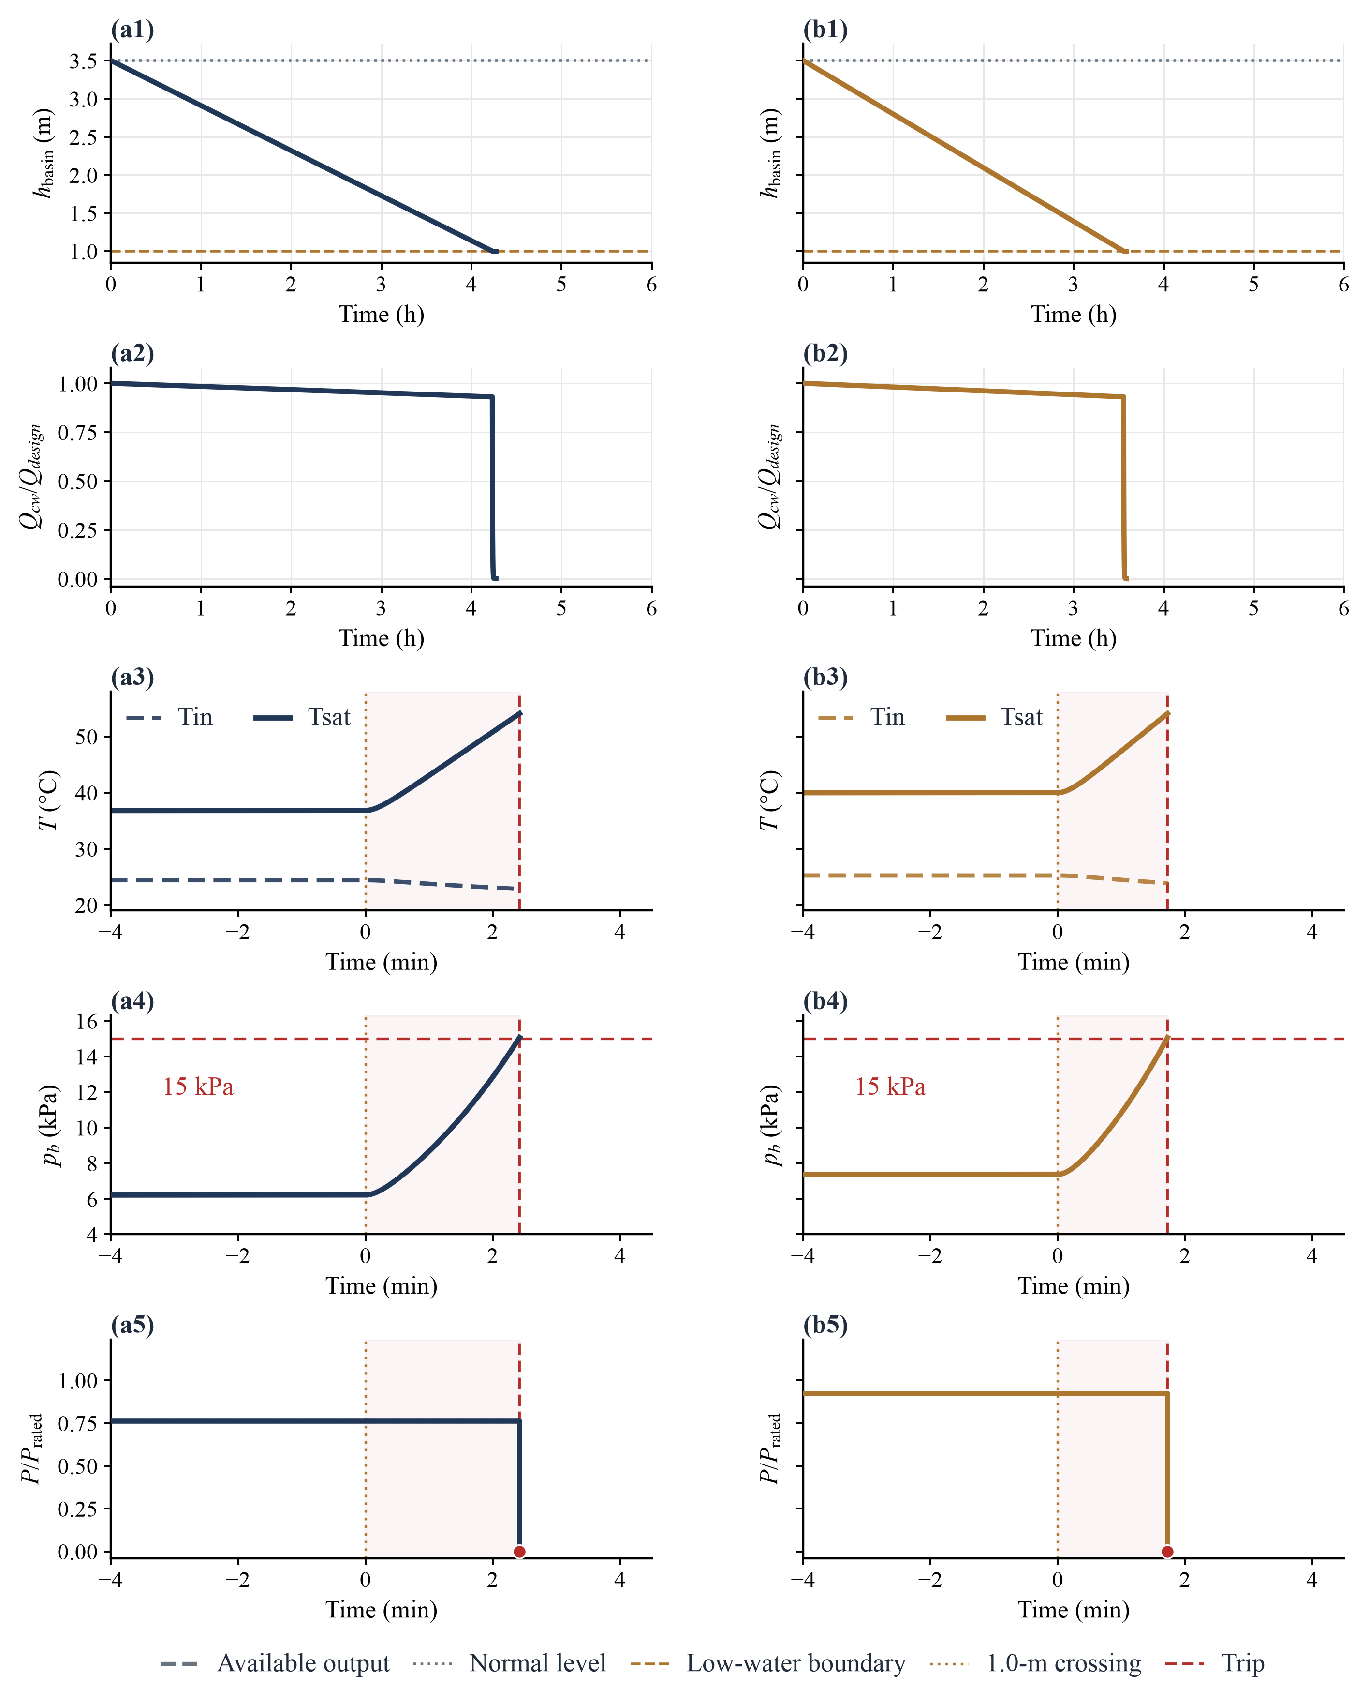
Fig. 3. Passive cold-end thermal–hydraulic trajectories for the (a1–a5) IEEE 30-bus and (b1–b5) Shelby County systems following a makeup-water interruption at t = 0 h. Panels trace basin water level h_{basin}, normalized circulating flow Q_{cw}/Q_{design}, condenser inlet and saturation temperatures (T_{in}, T_{sat}), condenser backpressure p_{b}, and normalized unit power P/P_{rated} around the 1.0 m zero pump-flow-target boundary (t = 0 min in the lower zoomed panels) and the subsequent 15 kPa(a) protection trip.

5.2. AAT and protection lag
At the selected warning fraction α = 0.12, corresponding to hwarn = 1.30 m, the passive timeline separates the warning-to-boundary window from the subsequent protection lag (Fig. 4 and Table 2). Following the interruption at t = 0 s, warning occurs at 13,403 s (223.383 min) in IEEE 30-bus and 11,261 s (187.683 min) in Shelby County.
At warning, the estimated AAT is 1,827.66 s (30.461 min) in IEEE 30-bus and 1,535.46 s (25.591 min) in Shelby County. The subsequent simulated interval from the low-water boundary to the backpressure trip, ΔtPB = t_{trip} - t1.0m, is 2.422 min and 1.726 min, respectively.
Adding the warning-time water estimate and the simulated protection lag gives 32.883 min and 27.317 min, respectively; these sums are not the directly observed warning-to-trip intervals. Proactive dispatch uses the water-only estimate for its planned window and does not add the passive protection lag. Under DPD, the estimate and planned shutdown time can be updated as the operating state changes.
Table 2. Early-warning timing, available adjustment time (AAT), and post-boundary protection lag under passive response for both study cases.
Case | First warning after interruption (min) | Available adjustment time (AAT) to 1.0 m (min) | 1.0 m crossing to PB trip (min) | Water estimate + protection lag (min)
IEEE 30-bus | 223.383 | 30.461 | 2.422 | 32.883
Shelby County | 187.683 | 25.591 | 1.726 | 27.317

Note: Warning times and AAT values are obtained from the baseline 60-s knot run with 1-s physical replay. The forecast crossing time is the warning time plus AAT; it is close to, but not identical to, the interpolated passive replay crossing in these cases. The protection lag is the simulated interval from the low-water boundary to the backpressure trip under the passive baseline. The final column adds this lag to the warning-time water estimate; it is not the directly observed warning-to-trip interval.
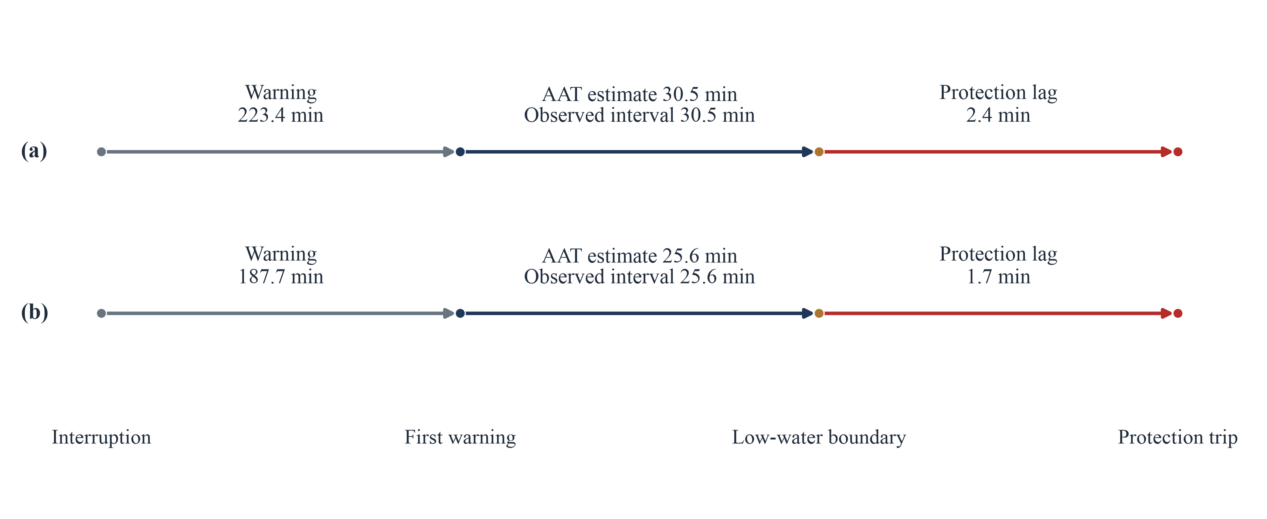
Fig. 4. Schematic timeline of the passive warning-to-protection sequence for the (a) IEEE 30-bus and (b) Shelby County systems. Segmented bars distinguish the pre-warning depletion phase (interruption to first warning), the AAT forecast and observed warning-to-boundary interval, and the post-boundary protection lag to the 15 kPa(a) backpressure trip (interval lengths are not drawn to scale).

5.3. Proactive dispatch outcomes
Both static proactive dispatch (SPD) and dynamic proactive dispatch (DPD) reduce system-wide energy not served (ENS) and peak unmet power relative to PR in the two study networks. Figure 5 shows the generation trajectories, Fig. 6 compares service outcomes, and Table 3 reports the full results.
At α = 0.12, with ρ = 0.45 for IEEE 30-bus and ρ = 0.20 for Shelby County, PR produces 18.886360 MWh of ENS and a 60.969 MW peak deficit in IEEE 30-bus. The corresponding values in Shelby County are 62.266927 MWh and 319.000 MW.
The one-shot SPD schedule reduces ENS to 1.104328 MWh in IEEE 30-bus and 0.811486 MWh in Shelby County, with peak deficits of 13.591 MW and 25.791 MW, respectively. These values represent ENS reductions of 94.15% and 98.70% relative to PR.
With 59 and 51 rolling updates in the two systems, respectively, DPD reduces load shedding by effectively 100% in IEEE 30-bus, yielding approximately 0 MWh and 0 MW at solver precision. In Shelby County, it reduces ENS by 99.83% to 0.103592 MWh, with a peak deficit of 4.143 MW.
The generation trajectories illustrate how the service improvements arise. The affected generator is proactively curtailed under SPD and DPD, while healthy units ramp upward and total generation approaches demand (Fig. 5). A residual deficit nevertheless remains in some cases. The curtailment extends modeled physical endurance but also increases exposure to low-load operation.
In the 1 s physical replay, SPD brings the affected unit to its planned zero output at 15,230 s in IEEE 30-bus and 12,796 s in Shelby County. DPD extends the affected-unit trajectory through periodically updated depletion estimates. In IEEE 30-bus, output reaches zero at 16,943 s, but no trip is recorded within the 18,000 s window; the minimum modeled basin volume is 262.944 m³. In Shelby County, the scheduled shutdown occurs at 14,363 s, where water-side integration terminates.
The service gains are accompanied by longer operation below the diagnostic threshold Pmin = 0.40 Pmax, which is not enforced in the dispatch model. The online sub-Pmin duration rises from 673 s under SPD to 2,321 s under DPD in IEEE 30-bus, and from 559 s to 1,755 s in Shelby County. This unit-level outcome is considered alongside ENS in Section 5.6.
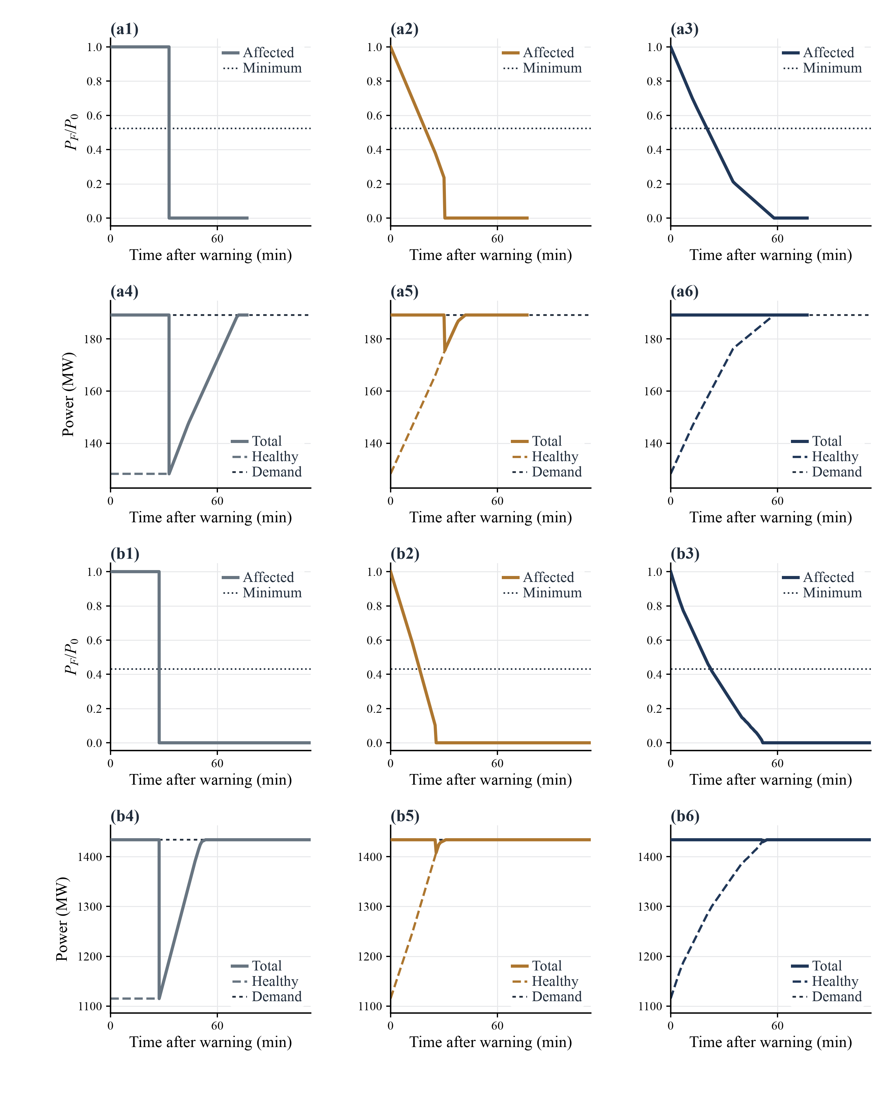
Fig. 5. Generation trajectories under passive response (PR), static proactive dispatch (SPD), and dynamic proactive dispatch (DPD) at 60-s optimization knot spacing. Panels (a1–a6) and (b1–b6) show the IEEE 30-bus and Shelby County systems, respectively. From left to right, the columns show PR, SPD, and DPD. For each case, the upper row shows affected-unit output normalized by its initial output, and the lower row shows total generation, healthy-unit generation, and demand. Dotted lines in the upper rows mark the diagnostic minimum-output threshold, which is not enforced in the dispatch model. Zero output does not by itself indicate a recorded shutdown.
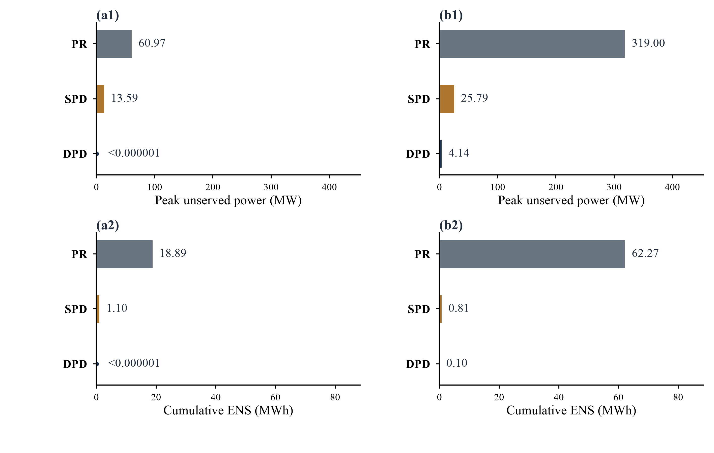
Fig. 6. Service adequacy outcomes under passive response (PR), static proactive dispatch (SPD), and dynamic proactive dispatch (DPD) at 60-s optimization knot spacing. Panels (a1) and (b1) show peak unserved power, and panels (a2) and (b2) show cumulative energy not served (ENS), for the IEEE 30-bus and Shelby County systems, respectively. Each metric uses a common horizontal scale across the two cases. Near-zero values are reported at solver precision.
Table 3. Service adequacy and unit operability outcomes across PR, SPD, and DPD under the selected parameters.
Case | Policy | ENS (MWh) | Peak unmet power (MW) | ENS / (demand × duration) (%) | Online time below reference P_{min} (s) | Dynamic replans
IEEE 30-bus | PR | 18.886360 | 60.969 | 1.996 | — | —
IEEE 30-bus | SPD | 1.104328 | 13.590667 | 0.117 | 673 | One-shot
IEEE 30-bus | DPD | ≈ 0 | ≈ 0 | ≈ 0 | 2,321 | 59 updates; 60 LP checks
Shelby County | PR | 62.266927 | 319.000 | 0.868 | — | —
Shelby County | SPD | 0.811486 | 25.790793 | 0.0113 | 559 | One-shot
Shelby County | DPD | 0.103592 | 4.143307 | 0.00144 | 1,755 | 51 updates; 52 LP checks

5.4. Parameter selection and sensitivity
The two-stage finite-grid search selects a common warning fraction and network-specific generation-cost weights using a chord-distance criterion motivated by Pareto-knee studies [44, 47]. Figure 7 shows the candidates and selected points; Supplementary Table S3 reports the objectives, selections, and qualifications.
In Stage 1, with ρ = 0 and no prior Pareto filtering, the maximum perpendicular chord distance selects α = 0.12 for both systems. In IEEE 30-bus, this point gives AAT = 1,827.66 s, mean active-policy ENS = 0.430678 MWh, and d⟂ = 0.499078. The corresponding Shelby County values are 1,535.46 s, approximately 0.00000970 MWh, and 0.530286.
With α = 0.12 fixed, Stage 2 yields discrete non-dominated fronts of 9 and 11 eligible candidates for the two networks, respectively. The knee rule selects ρ = 0.45 for IEEE 30-bus, with mean active ENS of 0.552164 MWh, an unweighted cost index of 757.952063, and d⟂ = 0.046726. For Shelby County, it selects ρ = 0.20, with corresponding values of 0.457539 MWh, 5,579.126969, and 0.222029. These are discrete-grid selections, not continuous global optima.
A separate test examines the sensitivity of the IEEE 30-bus SPD result to optimization-knot spacing. SPD is re-solved at Δt ∈ {5, 15, 30, 60, 120} s, while the cold-end physical replay remains at 1 s. Across these spacings, ENS is 1.117469, 1.123620, 1.147424, 1.104328, and 1.122450 MWh, respectively. The corresponding PR ENS remains between 18.883834 and 18.894518 MWh. Figure 7(a3) and (b3) also summarize the active-policy ENS reductions at the selected primary grid.
The maximum departure from the 60 s SPD baseline is Δgrid = 3.90%, occurring at the 30 s spacing. Because the ENS sequence varies non-monotonically with refinement, this spread characterizes sensitivity within the tested grid rather than proving numerical convergence. All tested SPD results remain below their corresponding PR ENS values, but DPD is evaluated only at the 60 s primary setting. The test therefore does not establish the three-policy ranking at every knot spacing.

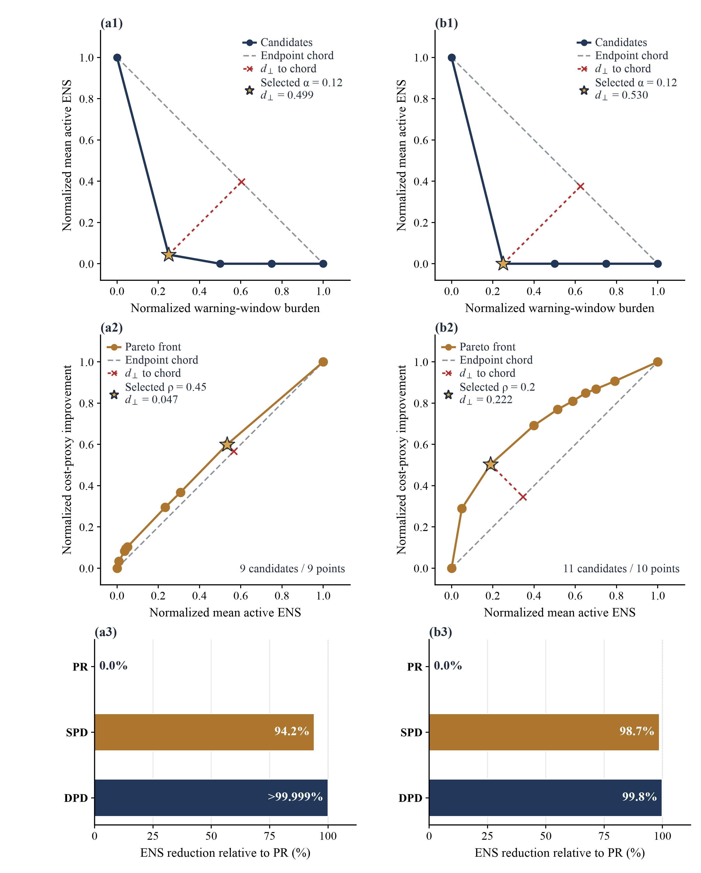
Fig. 7. Two-stage finite-grid parameter selection of α and ρ alongside resulting ENS reductions for the (a1–a3) IEEE 30-bus and (b1–b3) Shelby County systems. Panels (a1, b1) display Stage 1 warning-fraction candidates, and panels (a2, b2) show Stage 2 cost-weight Pareto fronts, where stars mark selected knee points and dashed lines indicate endpoint chords and perpendicular distances d⟂. Panels (a3, b3) summarize relative ENS reductions achieved by SPD and DPD over PR.

5.5. Physical meaning of AAT
The distinction between usable-water depletion and the subsequent protection trip clarifies the physical meaning of AAT. In both systems, the basin reaches the 1.0 m zero pump-flow-target boundary before backpressure reaches the 15 kPa(a) trip threshold. The intervening lag is a thermal–hydraulic transient following the reduction in circulating flow.
Adding this lag to the scheduling horizon would combine usable inventory with an unmitigated post-boundary transient. Conversely, treating the 1.0 m boundary as an immediate generator trip would truncate the modeled physical timeline. The conversion of a depleting physical buffer into operating lead time is analogous to gas-network-induced blackout warning [26]; here, the buffer is cooling-water inventory coupled to heat rejection.
AAT is also state dependent. The affected units initially operate at 76.2% and 92.5% of Pmax, with passive warning-time AAT values of 30.46 min and 25.59 min, respectively; initial loading alone does not determine the subsequent estimated depletion trajectory. Because AAT extrapolates the current loss rate, it can change as proactive curtailment reduces heat rejection and slows water depletion.
Prescribed unloading trajectories replayed from a common warning-time state provide an additional illustration of this coupling (Supplementary Sections S4–S6, Fig. S1, and Tables S4–S7). They are not PR, SPD, or DPD dispatch solutions.

5.6. Service–operability trade-off
The policy comparison reveals a trade-off between system service and unit-level low-load exposure. Relative to SPD, DPD further reduces ENS but extends the online duration below the diagnostic P_{min} = 0.40 P_{max} threshold: from 673 to 2,321 s in IEEE 30-bus and from 559 to 1,755 s in Shelby County. ENS alone therefore does not capture the full plant-level consequence of the modeled schedules.
This trade-off follows from the tested formulation: because Pmin is not enforced as a hard constraint, the linear program can use deep partial-load curtailment to conserve basin inventory while healthy units ramp upward. The observed sub-P_{min} durations do not establish that rolling replanning inherently requires unstable operation. Similarly, near-zero DC-OPF ENS does not guarantee secure AC voltage, frequency, reactive power, or spinning reserves. Grid service and plant operating states should therefore be evaluated separately in resilience assessments [19, 48].

5.7. Transferability and limitations
The same two-stage selection procedure is applied to both networks, but the selected weights and event times remain conditional on network structure and the cold-end template. The chord-distance rule [47] selects α = 0.12 in both cases and different generation-cost weights: ρ = 0.45 for IEEE 30-bus and ρ = 0.20 for Shelby County. Proactive dispatch substantially reduces ENS in both cases.
These applications illustrate the use of a common selection workflow; they do not establish that the selected parameters transfer directly between systems or isolate topology and ramping as the causes of the different weights. The selected ρ values are discrete-grid compromises between ENS and a cost proxy, not universal or continuous optima.
At the plant level, simulated event times depend on the 500 MW reference template, including the assumed basin geometry, pump head and NPSH curves, 15 kPa(a) protection threshold, and lumped time constants τ_{p} = 10 s, τ_{T} = 300 s, and τ_{c} = 90 s. Water-side integration terminates at generator shutdown without representing post-trip auxiliary cooling. Plant disturbance records would therefore be needed to assess whether a distinct backpressure lag persists after usable-water depletion in field installations.
A one-factor sensitivity analysis re-solves PR, SPD, and DPD over a common 27,000 s window for changes in basin area, the CoC loss proxy, cold-end time constants, and condenser cleanliness (Supplementary Sections S7–S9, Fig. S2, and Tables S8–S10). Across the tested cases and discrete perturbations, both proactive policies have lower ENS than their corresponding PR outcomes, and DPD has lower ENS than SPD. This conditional ranking does not establish robustness to joint parameter variations or field conditions.
Two IEEE 30-bus DPD trajectories reach numerical zero output without a recorded shutdown or protection event by the end of the window; their subsequent cold-end states are therefore not validated post-shutdown behavior.
At the grid level, the lossless DC power-flow approximation omits AC voltage magnitudes, reactive power, transmission losses, frequency dynamics, spinning reserves, unit commitment, and enforced minimum stable output constraints. Sensor, communication, and actuation latencies are not explicitly modeled. The 60 s DPD update interval is a control setting, not a measured communication delay.
A supplementary experiment isolates a single delay between initial warning and the start of proactive control (Supplementary Sections S10–S12, Fig. S3, and Table S11). Longer delays increase ENS in the successfully solved tested scenarios. Subsequent DPD updates remain delay-free, so these results do not establish a field-validated latency tolerance.
The objective and linearized water budget use one-second left-endpoint weights, and their approximation errors relative to nonlinear physical replay require separate assessment. The non-monotonic 3.90% ENS spread in the IEEE 30-bus knot-spacing test characterizes sensitivity over the tested grid but does not establish formal convergence.
The schedules therefore provide a mechanistic proof of concept rather than evidence of field-ready deployment. A mixed-integer unit commitment formulation [49] that enforces technical minimum output and represents explicit shutdown trajectories [50] could test whether the ENS reductions persist when low-load operability thresholds become hard constraints, linking unit-level cold-end endurance with regional power-system studies under cooling-water shortages [29].

6. Conclusions
This study examined how timely information about a cooling-water makeup interruption can enable power-system dispatch to use the adjustment window created by gradual depletion of the cooling-water buffer. A reduced-order cold-end model links the remaining usable water to an available adjustment time (AAT), which informs generation adjustments and planned shutdown under network constraints. The AAT horizon ends at the usable-water boundary and is distinct from the subsequent condenser protection trip. By representing the coupling between water depletion and generation capability, the model provides a physical basis for early warning rather than treating the affected unit as an immediate outage.
In both simulated systems, proactive dispatch reduced energy not served (ENS) relative to passive response. Static proactive dispatch reduced ENS by 94.15% in IEEE 30-bus and 98.70% in Shelby County. Dynamic proactive dispatch reduced ENS further, to approximately zero at solver precision and 0.103592 MWh, respectively. These service gains were accompanied by longer online operation below the diagnostic minimum-output threshold: from 673 to 2,321 s in IEEE 30-bus and from 559 to 1,755 s in Shelby County when moving from static to dynamic dispatch.
The results suggest that cooling-water inventory and loss-rate information from a plant could support an AAT estimate for coordination with system operators. Together with network and unit operating information, this estimate may help operators schedule affected-unit curtailment and healthy-unit ramping earlier, while considering both supply adequacy and low-load exposure.
These findings are conditional proof-of-concept results rather than field-validated operating recommendations. The selected warning fraction and cost weights are finite-grid, case-dependent choices. Event timings depend on the cold-end template, while the electrical model and scheduling assumptions do not represent all grid-security and unit-operating requirements.
Future work should quantify errors in the linearized water budget, validate cold-end dynamics and the separation between water depletion and protection events using plant disturbance records, and reassess the scheduling gains under more complete network and unit commitment models. Explicit minimum-output and shutdown rules, together with modeled information and actuation delays, would help determine how the demonstrated service improvements translate to operational settings.

References
[1] Feeley III TJ, Skone TJ, Stiegel Jr GJ, McNemar A, Nemeth M, Schimmoller B, et al. Water: A critical resource in the thermoelectric power industry. Energy 2008;33(1):1-11.
[2] Macknick J, Newmark R, Heath G, Hallett KC. Operational water consumption and withdrawal factors for electricity generating technologies: a review of existing literature. Environ Res Lett 2012;7(4):045802.
[3] Sanders KT. Critical Review: Uncharted Waters? The Future of the Electricity-Water Nexus. Environ Sci Technol 2015;49(1):51-66.
[4] Pan SY, Snyder SW, Packman AI, Lin YJ, Chiang PC. Cooling water use in thermoelectric power generation and its associated challenges for addressing water-energy nexus. Water-Energy Nexus 2018;1(1):26-41.
[5] Chini CM, Djehdian LA, Lubega WN, Stillwell AS. Virtual water transfers of the US electric grid. Nat Energy 2018;3(12):1115-23.
[6] Zhang C, Zhong L, Wang J. Decoupling between water use and thermoelectric power generation growth in China. Nat Energy 2018;3(9):792-9.
[7] van Vliet MTH, Yearsley JR, Ludwig F, Vögele S, Lettenmaier DP, Kabat P. Vulnerability of US and European electricity supply to climate change. Nat Clim Change 2012;2(9):676-81.
[8] van Vliet MTH, Wiberg D, Leduc S, Riahi K. Power-generation system vulnerability and adaptation to changes in climate and water resources. Nat Clim Change 2016;6(4):375-80.
[9] Cook MA, King CW, Davidson FT, Webber ME. Assessing the impacts of droughts and heat waves at thermoelectric power plants in the United States using integrated regression, thermodynamic, and climate models. Energy Rep 2015;1:193-203.
[10] Zhang C, Yang J, Urpelainen J, Chitkara P, Zhang J, Wang J. Thermoelectric Power Generation and Water Stress in India: A Spatial and Temporal Analysis. Environ Sci Technol 2021;55(8):4314-23.
[11] Jin Y, Scherer L, Sutanudjaja EH, Tukker A, Behrens P. Climate change and CCS increase the water vulnerability of China's thermoelectric power fleet. Energy 2022;245:123339.
[12] Tidwell VC, Gunda T, Gayoso N. Plant-level characteristics could aid in the assessment of water-related threats to the electric power sector. Appl Energy 2021;282:116161.
[13] Tidwell V. A cool water option for thermoelectric power generation. Nat Water 2023;1(5):420-1.
[14] Sergio A, Colelli FP. Weather-induced power plant outages: Empirical evidence from hydro and thermal generators in Europe. Energy Econ 2025;148:108549.
[15] Tadrous M, Novog D, Calic G. Cooling under fire: Can nuclear power remain thermodynamically resilient in a warming, water-constrained world? Energy Policy 2026;217:115412.
[16] Rinaldi SM, Peerenboom JP, Kelly TK. Identifying, understanding, and analyzing critical infrastructure interdependencies. IEEE Control Syst Mag 2001;21(6):11-25.
[17] Ouyang M. Review on modeling and simulation of interdependent critical infrastructure systems. Reliab Eng Syst Saf 2014;121:43-60.
[18] Panteli M, Trakas DN, Mancarella P, Hatziargyriou ND. Power Systems Resilience Assessment: Hardening and Smart Operational Enhancement Strategies. Proc IEEE 2017;105(7):1202-13.
[19] Panteli M, Mancarella P, Trakas DN, Kyriakides E, Hatziargyriou ND. Metrics and Quantification of Operational and Infrastructure Resilience in Power Systems. IEEE Trans Power Syst 2017;32(6):4732-42.
[20] Xu L, Feng K, Lin N, Perera ATD, Poor HV, Xie L, et al. Resilience of renewable power systems under climate risks. Nat Rev Electr Eng 2024;1(1):53-66.
[21] Grochowicz A, Bloomfield HC, Victoria M. Resilience metrics to guide back-up investments in the power system during extreme weather. Nat Sustain 2026;9(10):1534-45.
[22] He Z, Li Z, Xiao X, Wang C, Ju P. Dynamic Resilience Region-Based Proactive Scheduling for Enhancing the Power System Resilience. IEEE Trans Power Syst 2025;40(3):2336-48.
[23] Rodriguez-Garcia L, Hosseini MM, Mosier TM, Parvania M. Resilience Analytics for Interdependent Power and Water Distribution Systems. IEEE Trans Power Syst 2022;37(6):4244-57.
[24] Roni MS, Mosier T, Feinberg TD, McJunkin T, Toba AL, Boire LD, et al. Integrated water-power system resiliency quantification, challenge and opportunity. Energy Strategy Rev 2022;39:100796.
[25] Scheffer M, Carpenter SR, Lenton TM, Bascompte J, Brock W, Dakos V, et al. Anticipating Critical Transitions. Science 2012;338(6105):344-8.
[26] Yu F, Guo Q, Wu J, Qiao Z, Sun H. Early warning and proactive control strategies for power blackouts caused by gas network malfunctions. Nat Commun 2024;15:4714.
[27] Bao Z, Ye Y, Wu L. Multi-timescale coordinated schedule of interdependent electricity-natural gas systems considering electricity grid steady-state and gas network dynamics. Int J Electr Power Energy Syst 2020;118:105763.
[28] Hasanzad F, Rastegar H. Resilience enhancement of interdependent electricity-natural gas system considering gas storage and power to gas technology. J Energy Storage 2022;56:106025.
[29] Wang Y, Zhou Z, Betrie G, Zhang K, Yan E. Power generation-cooling water Nexus: Impacts of cooling water shortage on power system operation - a simulation case study in Illinois, U.S. Appl Energy 2025;377:124440.
[30] U.S. Nuclear Regulatory Commission. Westinghouse AP1000 design control document. Revision 16, Tier 2, Chapter 9, Section 9.2.1. Washington, DC: U.S. Nuclear Regulatory Commission; 2007. ADAMS accession No. ML071580932.
[31] U.S. Nuclear Regulatory Commission. AREVA U.S. EPR design control document. Revision 3, Tier 2, Chapter 10, Section 10.4.5. Washington, DC: U.S. Nuclear Regulatory Commission; 2011. ADAMS accession No. ML11231A469.
[32] Sandia National Laboratories. Reference model for control and automation systems in electrical power. Version 1.2. Albuquerque, NM: Sandia National Laboratories; 2005.
[33] North American Electric Reliability Corporation. Risks and mitigations for losing EMS functions reference document. Version 4. Atlanta, GA: North American Electric Reliability Corporation; 2024.
[34] Zimmerman RD, Murillo-Sanchez CE, Thomas RJ. MATPOWER: Steady-State Operations, Planning, and Analysis Tools for Power Systems Research and Education. IEEE Trans Power Syst 2011;26(1):12-9.
[35] [dataset] Rangrazjeddi A. Shelby County data. Figshare, v1; 2022.
[36] Electric Power Research Institute. Power plant cooling system overview for researchers and technology developers. Palo Alto, CA: Electric Power Research Institute; 2013. Report No. 3002001915.
[37] Diehl TH, Harris MA, Murphy JC, Hutson SS, Ladd DE. Methods for estimating water consumption for thermoelectric power plants in the United States. Reston, VA: U.S. Geological Survey; 2013. Scientific Investigations Report 2013-5188.
[38] Laskowski R, Smyk A, Rusowicz A, Grzebielec A. Optimization of the cooling water mass flow rate under variable load of a power unit. Appl Therm Eng 2021;191:116874.
[39] Zhang W, Ma L, Jia B, Zhang Z, Liu Y, Duan L. Optimization of the circulating cooling water mass flow in indirect dry cooling system of thermal power unit using artificial neural network based on genetic algorithm. Appl Therm Eng 2023;223:120040.
[40] Bauer D, Philbrick M, Vallario B. The water-energy nexus: challenges and opportunities. Washington, DC: U.S. Department of Energy; 2014. Report No. DOE/EPSA-0002.
[41] Si XS, Wang W, Hu CH, Zhou DH. Remaining useful life estimation – A review on the statistical data driven approaches. Eur J Oper Res 2011;213(1):1-14.
[42] Lei Y, Li N, Guo L, Li N, Yan T, Lin J. Machinery health prognostics: A systematic review from data acquisition to RUL prediction. Mech Syst Signal Process 2018;104:799-834.
[43] Deb K, Pratap A, Agarwal S, Meyarivan T. A fast and elitist multiobjective genetic algorithm: NSGA-II. IEEE Trans Evol Comput 2002;6(2):182-97.
[44] Tang J, Wang H, Xiong L. Surrogate-assisted multi-objective optimization via knee-oriented Pareto front estimation. Swarm Evol Comput 2023;77:101252.
[45] Yang C, Xia Y. Interval Pareto front-based multi-objective robust optimization for sensor placement in structural modal identification. Reliab Eng Syst Saf 2024;242:109703.
[46] Das I, Dennis JE. Normal-Boundary Intersection: A New Method for Generating the Pareto Surface in Nonlinear Multicriteria Optimization Problems. SIAM J Optim 1998;8(3):631-57.
[47] Das I. On characterizing the “knee” of the Pareto curve based on normal-boundary intersection. Struct Optim 1999;18(2-3):107-15.
[48] Zuloaga S, Vittal V. Quantifying Power System Operational and Infrastructural Resilience Under Extreme Conditions Within a Water-Energy Nexus Framework. IEEE Open Access J Power Energy 2021;8:229-38.
[49] Tejada-Arango DA, Lumbreras S, Sanchez-Martin P, Ramos A. Which Unit-Commitment Formulation is Best? A Comparison Framework. IEEE Trans Power Syst 2020;35(4):2926-36.
[50] Morales-España G, Latorre JM, Ramos A. Tight and compact MILP formulation of start-up and shut-down ramping in unit commitment. IEEE Trans Power Syst 2013;28(2):1288-96.

