Artificial Intelligence - CZ 3005

Problem Solving Lab Exercise

Submission Due: 5 days (before 5pm) after the completion of your lab session

Submission Location: Software Projects lab, N4-B1b-11

1 Question One [20 marks]

For each of the following, give a graph that is a tree (there is at most one arc into any node), contains at most 15 nodes, and has at most two arcs out of any node.

- Give a graph where depth-first search (DFS) is much more efficient (expands fewer nodes) than breadth-first search (BFS).
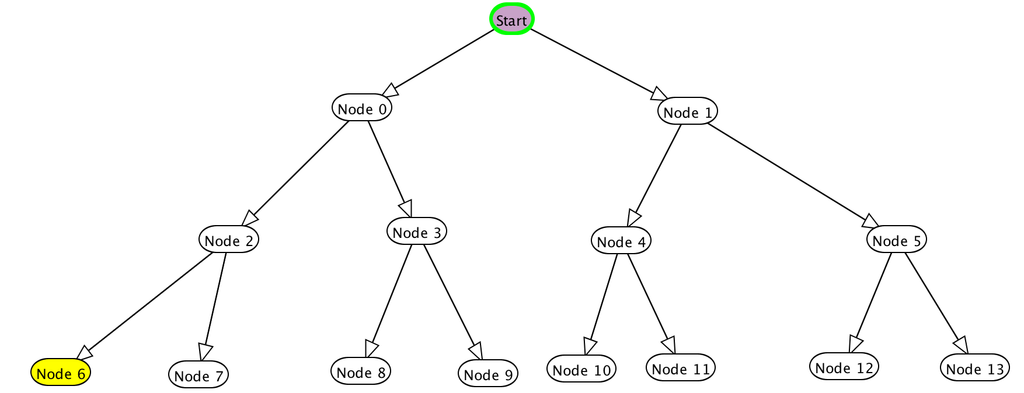
The above graph illustrate the structure of nodes.

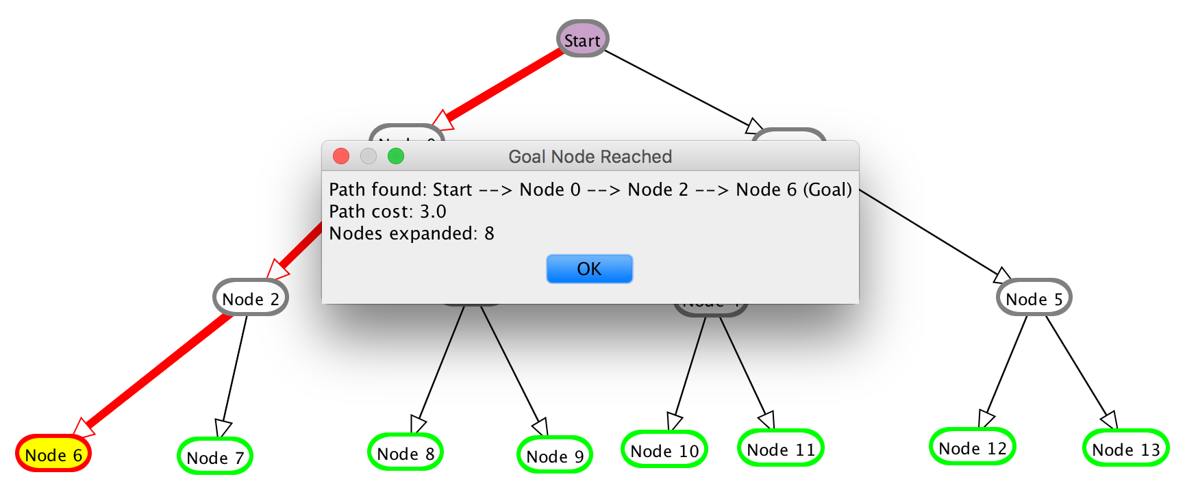
By using BFS search, the total number of nodes expanded is 8.
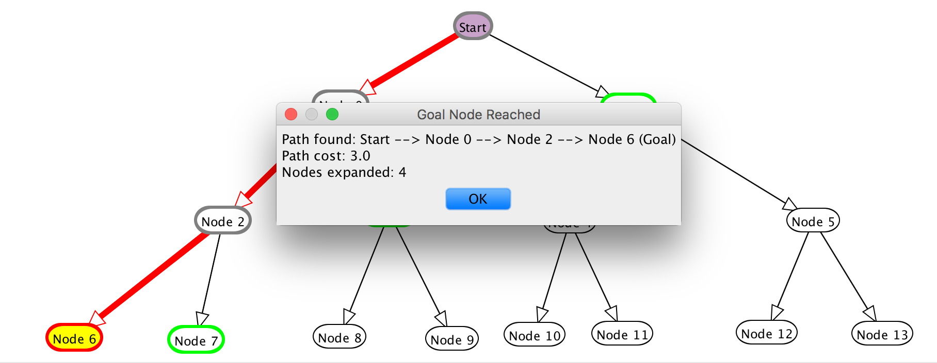
By using DFS, the total number of nodes expanded is 4, which is 4 nodes less than BFS.

The reason why DFS is much more efficient than BFS in this case is because the target node is the left most leaf node. By using DFS, the left most node from the parents are always the first to access. While BFS has to go through all the nodes in a level and then it can go to the next level.

- Give a graph where BFS is much better than DFS.
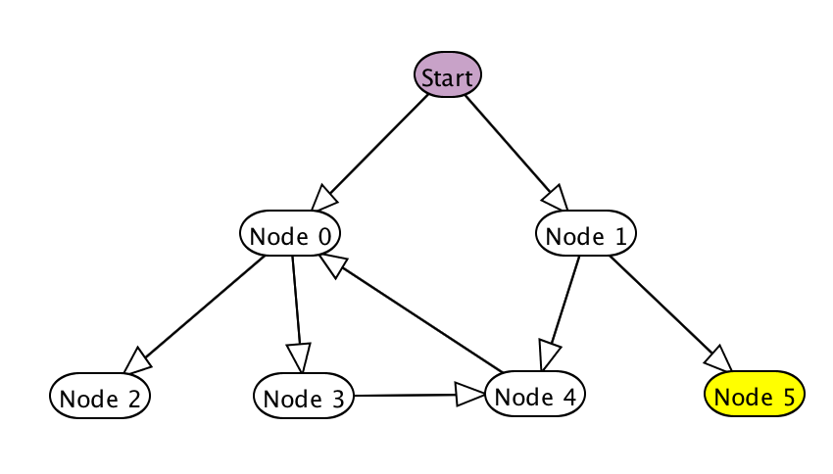
In this graph, there will be an infinite loop if DFS is using, where node 0, 4 and 1 inter-linked one another.
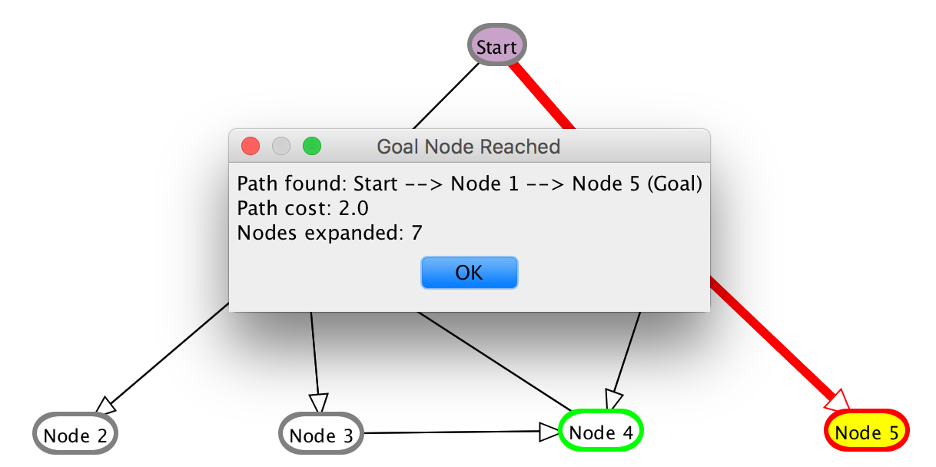
Therefore, BFS is much better than DFS because the target node, node 7 can be successfully found.

- Give a graph where A* search is more efficient than either DFS or BFS.
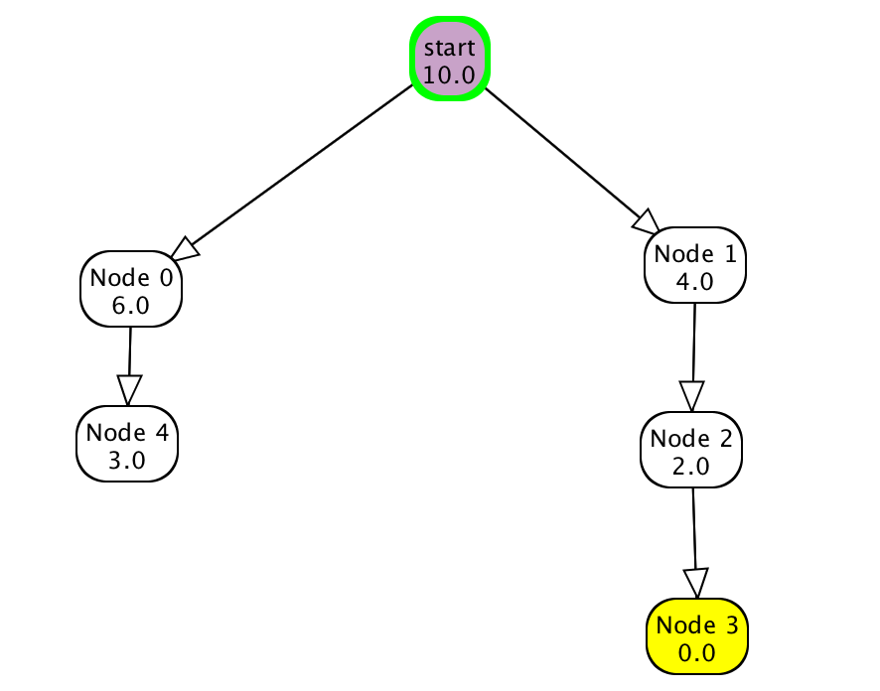
In this graph, A* is better than BFS and DFS, which only expands 4 nodes.

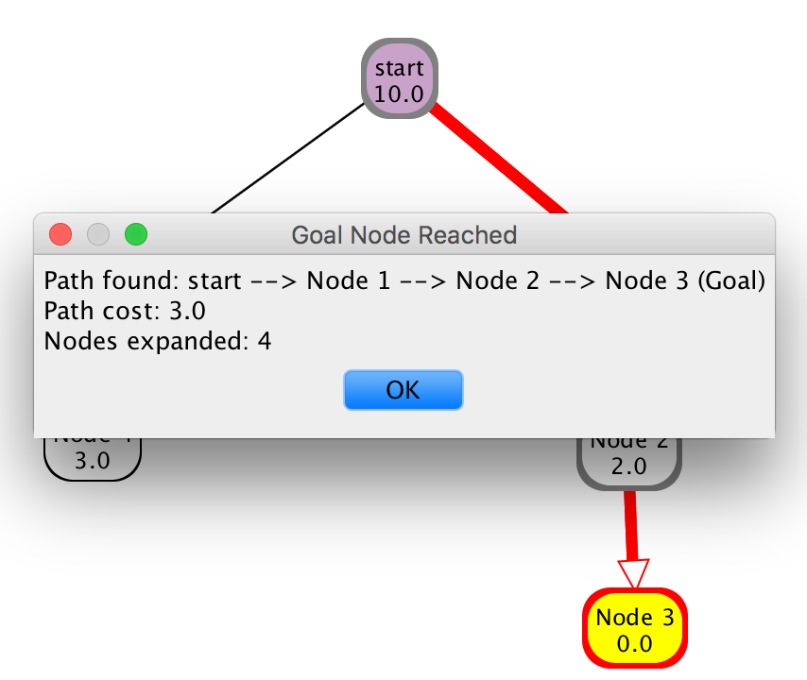
A*

In contrast, both BFS and DFS expands 6 nodes.
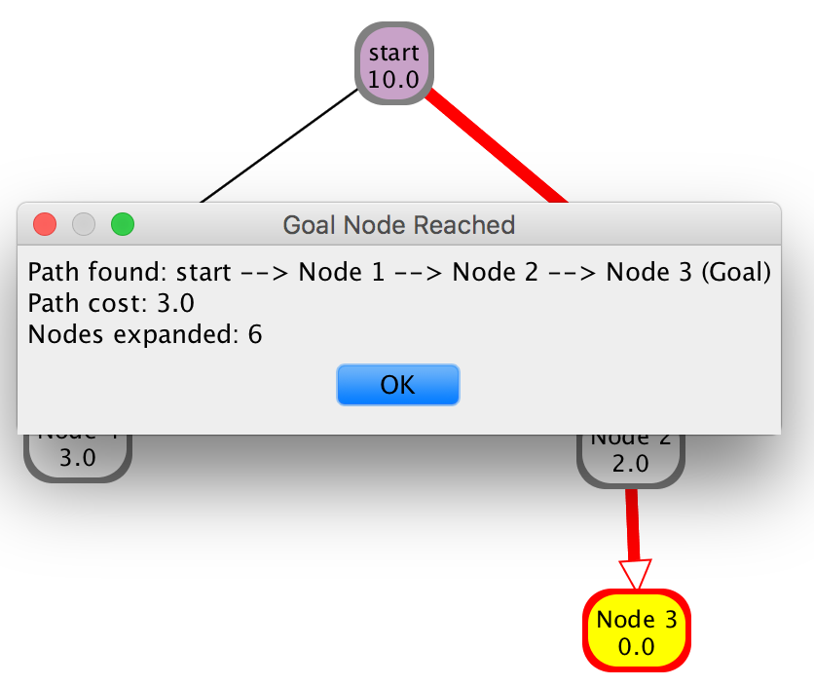 | 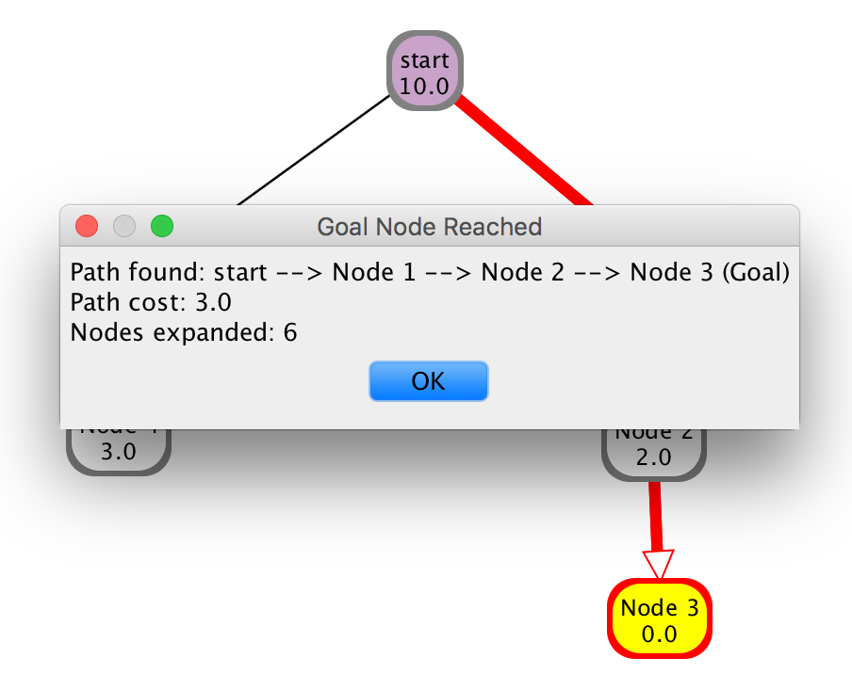
BFS | DFS

- Give a graph where DFS and BFS are both more efficient than A* search.
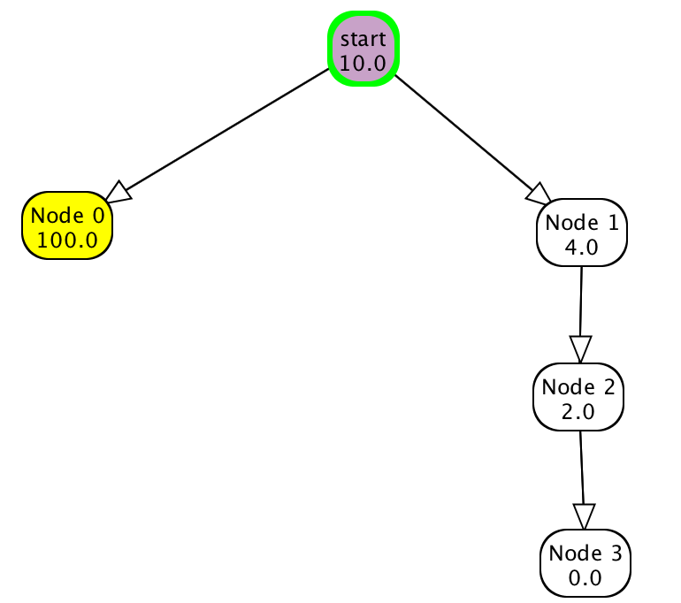
The above diagram illustrate the graph where BFS and DFS is better than A*.
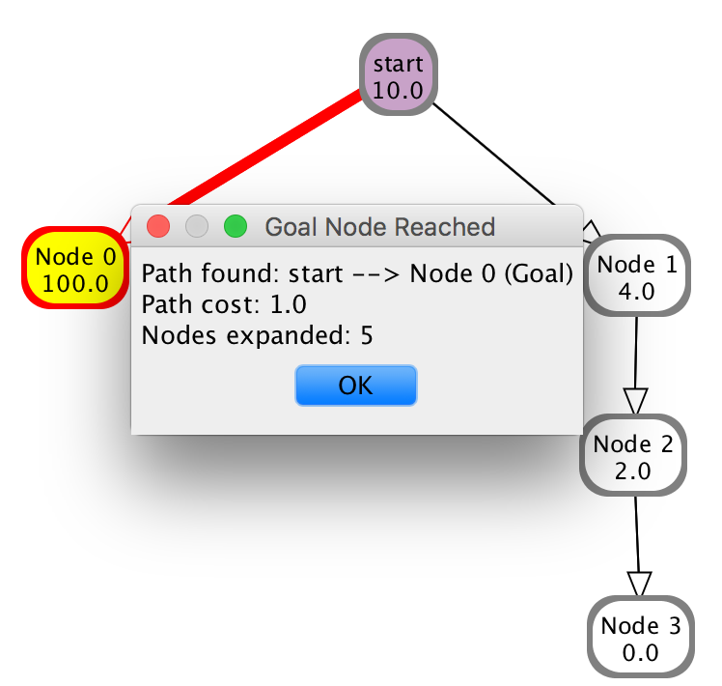
A*
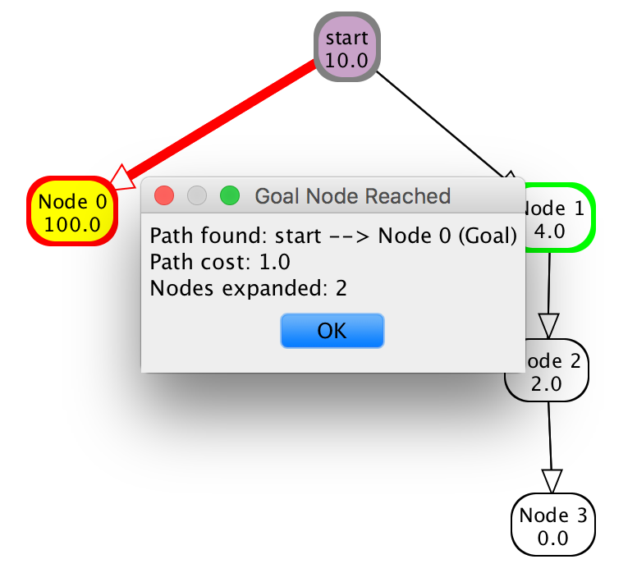 | 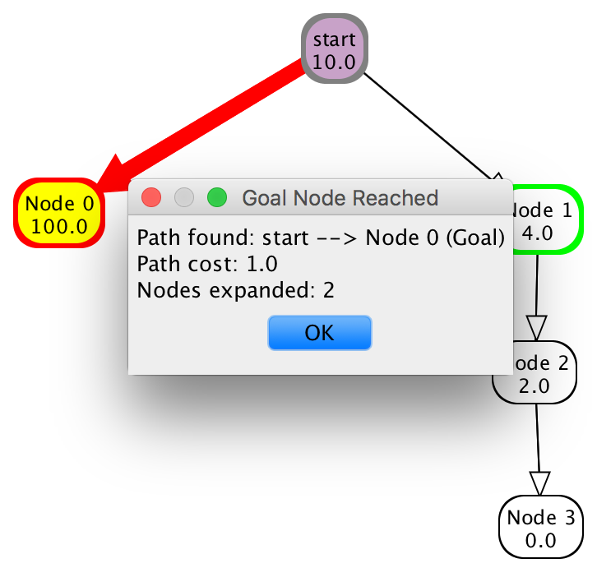
BFS | DFS

You must draw the graph and show the order of the neighbors (this is needed for the depth-first search). Either give the arc costs and heuristic function or state explicitly that you are drawing the graph to scale and are using Euclidean distance for the arc costs and the heuristic function. You should use the AIspace.org applets to draw the trees and do the comparisons. Please attach the screenshots from the applets.

2 Question Two [20 marks]

Consider a scheduling problem, where there are six variables A, B, C, D, E and F, each with domain {1, 2, 3, 4}. Suppose the constraints are: A < B, |A - C| = 1, B - C is even, B ≠ D, D > A, D ≠ C, E ≠ C, E < D - 1, E ≠ B - 2, A ≠ F, B ≠ F, C ≠ F , D ≠ F, E - F is odd.

- Draw this graph in AIspace.org as a CSP problem (constraint graph).
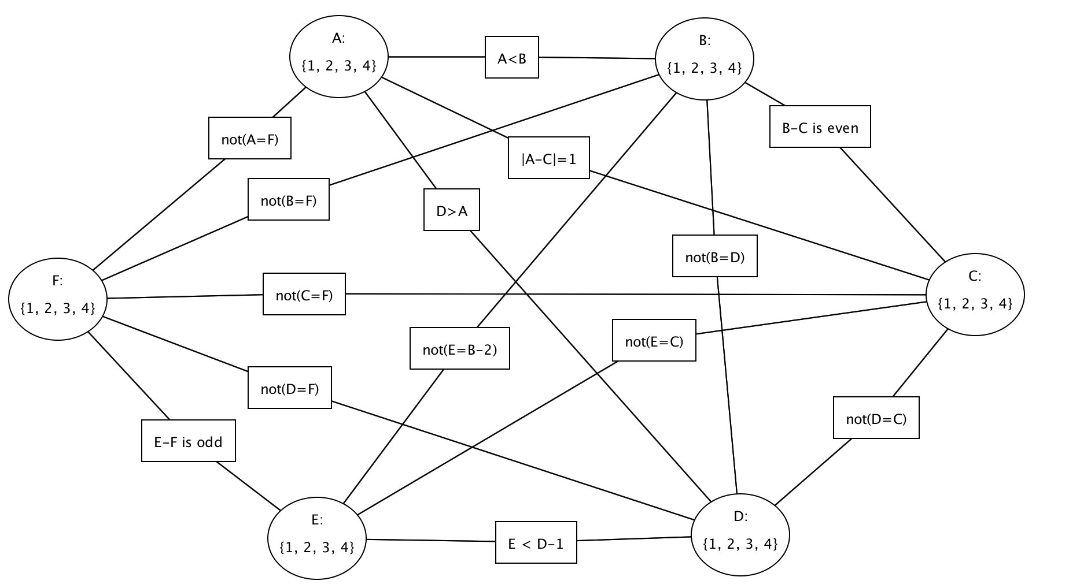

- For the first 5 instances of arc consistency, show which elements of a domain are deleted at each step, and which arc is responsible for removing the element.
- In constraint A < B, {4} is deleted from A, {1} is deleted from B
- In constraint | A - C | = 1, no element from A or C is deleted
- In constraint B – C is even, no element from B or C is deleted
- In constraint B ≠ D, no element from B or D is deleted
- In constraint D > A, no element from A is deleted but {1} is deleted from D

- Show explicitly the constraint graph after arc consistency has stopped.
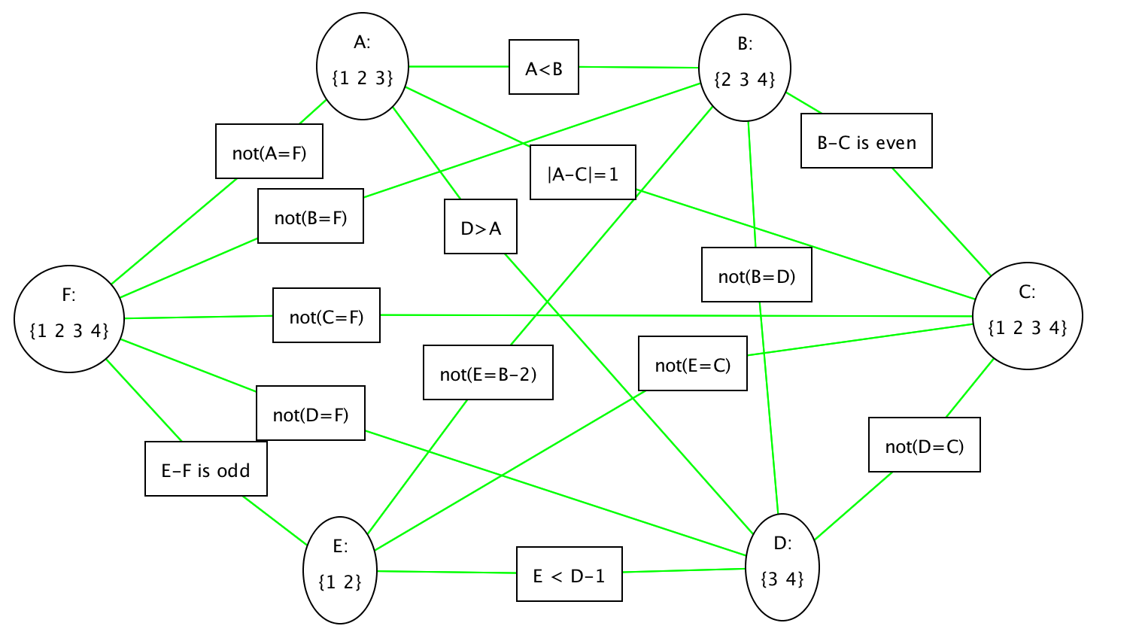
- Show how splitting domains can be used to solve this problem. Draw the tree of splits and show the solutions.
Split D to be {3} and {4}.
If {3} is removed,
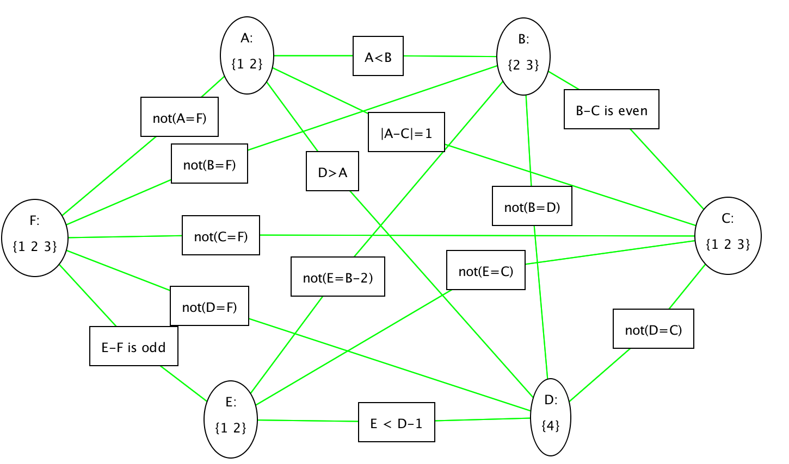
The domains of other nodes contains more than 1 value, so that further split on other nodes is needed.

If {4} is removed,
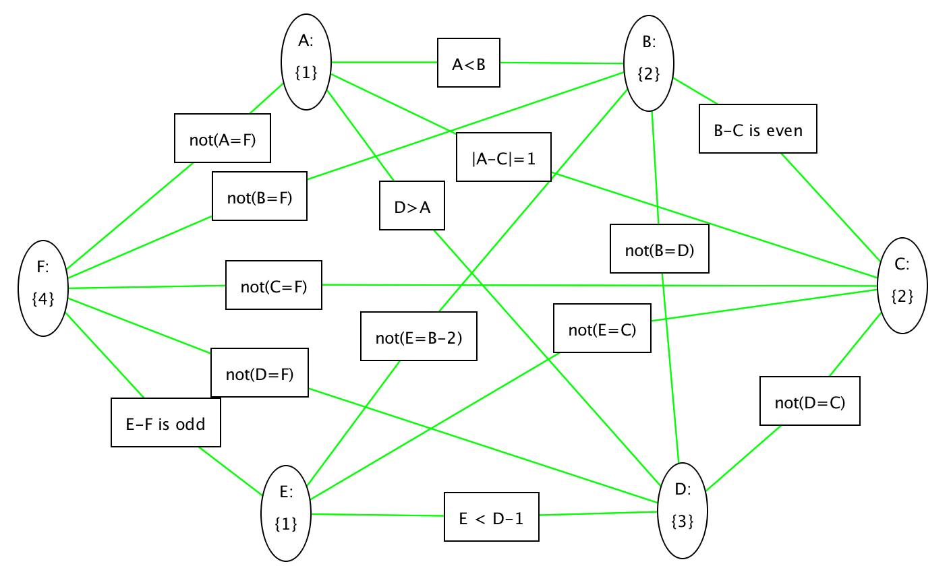
Now the solution is found, which is A = 1, B = 2, C = 2, D = 3, E = 1, F = 4

3 Question Three [15 marks]

Progress is made in science by observing a phenomenon of interest, making hypotheses and testing the hypothesis either empirically or by proving theorems.

For this question you are to think about the effect of heuristic accuracy on A* search. That is, you are to experiment with, and think about how close h(n) is to the actual distance from node n to a goal affects the efficiency and accuracy of A*. To get full marks you must at least invent one (plausible, nontrivial) conjecture and either prove it and show some empirical evidence for your answer or show that it is false. Your answers need to be precise (e.g, don’t say “it works better”, but say something like “it always works better”, “it sometimes works better” or “it works better in a majority of cases”).

- What is the effect of reducing h(n) when h(n) is already an underestimate?

It may result in more nodes to be explored, depending on which node has its h(n) underestimated.

If the h(n) of a node B is underestimated, it’s not on the path to the target and its actual h(n) is higher than the other node, A, node B will be explored first. But in fact, node A is nearer to the target.
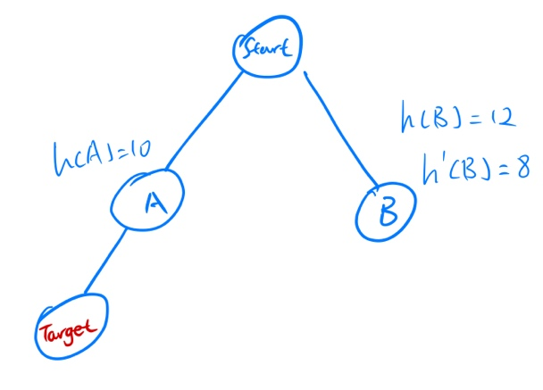
The above illustration shows that node A has h(n) = 10, node B has an underestimated h’(n) = 8 while its actual h(n) should be 12.

Since h(n) of node B underestimated, B is explored first. However, in fact node A should be explored first to reach the target earlier.

On the other hand, if node A is underestimated, it’s on the path to the target and its actual h(n) is higher than the other node, B, node A will be explored first. And in fact, node A is nearer to the target, so that it’s on the right path.
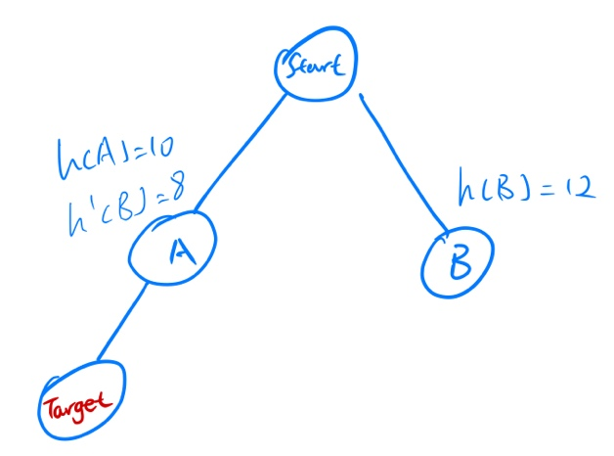

Therefore, if further reducing h(n) and the h(n) underestimated node is not on the path to the target, unnecessary nodes are more likely to be explored. Hence, it will sometimes result in worse performance.

- How does A* perform when h(n) is the exact distance from n to a goal?
If h(n) is the exact distance from n to a goal, the search algorithm will then only consider the cost of the edges. In that case, it is the same as uniform cost search algorithm which only cares about the cost of edges without the use of heuristic.

Therefore, the performance of the algorithm will remain unchanged.

- What happens if h(n) is not an underestimate?
If h(n) is not an underestimate, then the optimal path may not be found.

If the path towards to the target has its h(n) overestimated, it may be explored later than those nodes with lower h(n), which may actually cost higher to the target.

Therefore, the performance of the algorithm will be most likely poorer.

One way to vary h(n) is to use the AIspace.org search applet with the automatic node heuristics (under the search options menu) turned on, then turn it off and change heuristic values. There are ways to change all heuristic values.

4 Question Four [0 mark]

To help us in future planning with the lab exercise, please mention how much time you spent on each of the questions.

Question 1: 1 hour
Question 2: 1.5 hours
Question 3: 2 hours

