User Manual

OpenLayer3 Project

WWW.OLYMPICSAROUNDTHEWORLD.COM

Sarva Pulla and Drew Li

Mar 17, 2015

## Home Page Layout

The home page contains three parts (from top to bottom): the header, the map control panel and the map view. Using the links on the header, a user can switch between Home, About and Contact pages. The map control panel provides several useful tools to interact with the map view. The map view responds to map control panel events such as mouse click, drag and wheel scroll.

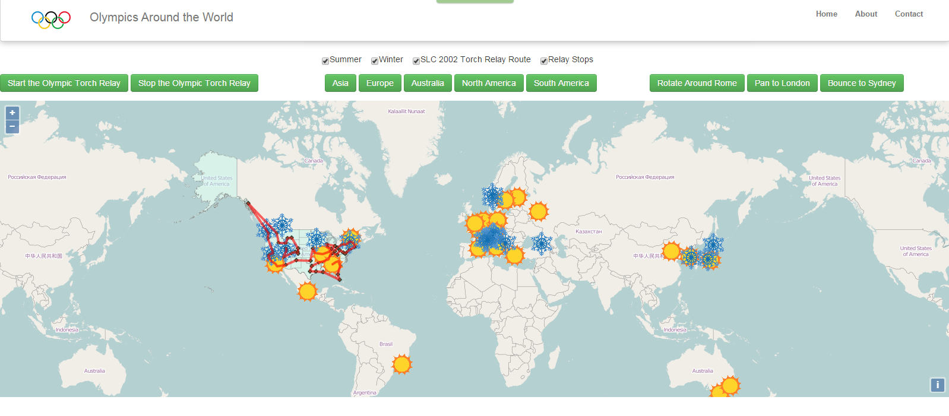

## Header Links

By default, the bowser will be navigated to the Home page when accessing the address www.olympicsaroundtheworld.com. The About page briefly states the background and purpose of this website. It also contains a funny video about the US swimming team. The Contact page provides the authors’ information. If you have any questions or suggestions feel free to contact us.

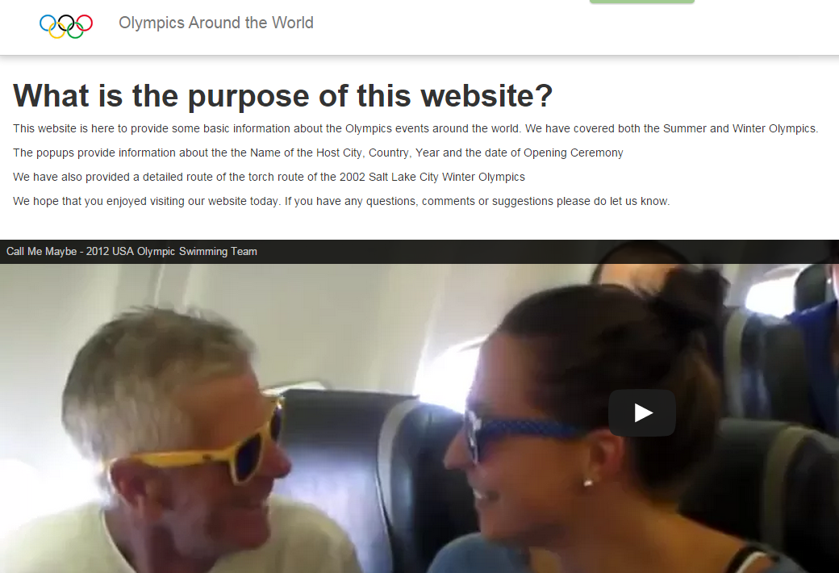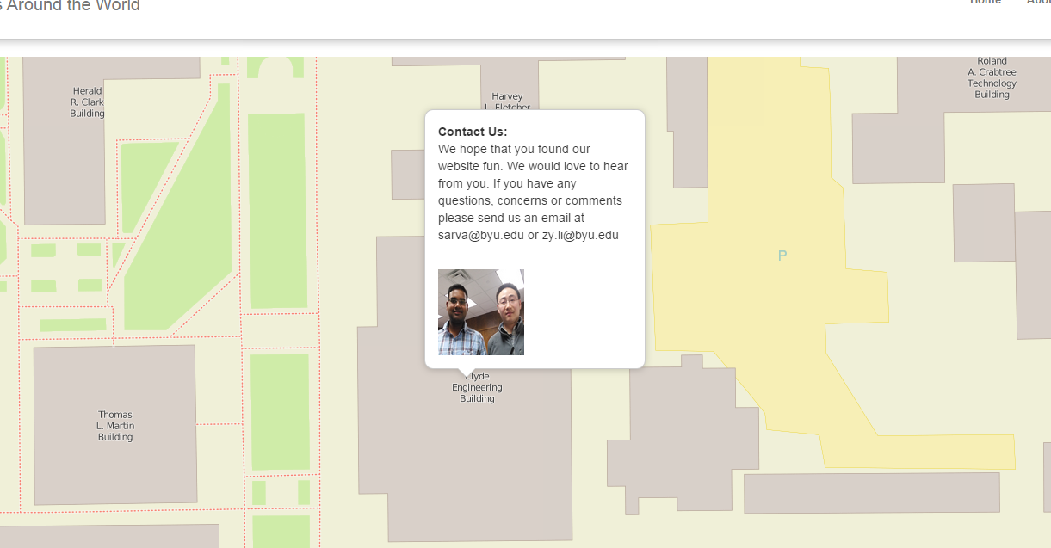

## Map Control Panel

The map control panel contains 4 parts: layer control (1), animation tool (2), continent view (3) and fancy tool (4).



### 3.1 Layer Control

User can display or hide a specified layer by checking or unchecking the box before the layer name. The layers are:

*Summer:* All the Summer Olympics events in the past and in the future (as far as we know).

*Winter:* All the Winter Olympics events in the past and in the future (as far as we know).

*SLC 2002 Torch Relay Route:* The torch relay route of the 2002 Salt Lake City Winter Olympics Game.

*Relay Stops:* The majors US cities where the torch relay made stops in the SLC 2002 event.

### 3.2 Animation Tool

The ‘Start the Olympic Torch Relay’ button will activate the animation feature. A popup will display at every relay stop successively and show the city names and the state names.

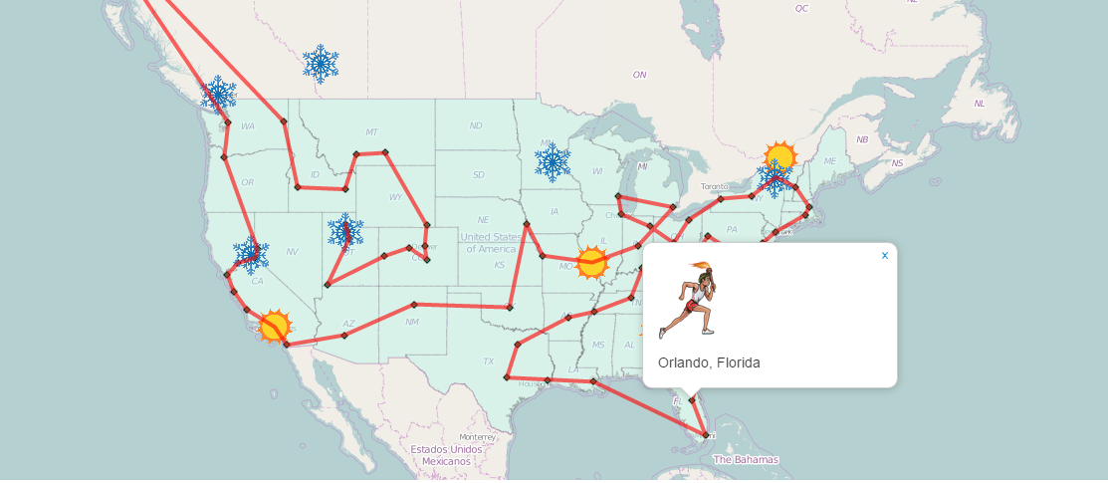

The ‘Stop the Olympic Torch Relay’ button will pause the animation. When you click on the Start button again, the animation will resume.

### 3.3 Continent View

The Continent View button will change current map view and zoom in to a specified continent. Five choices are available (Asia, Europe, Australia, North America and the South America) as no Olympics events happened or will be happening (as far as we have known) on other continents.

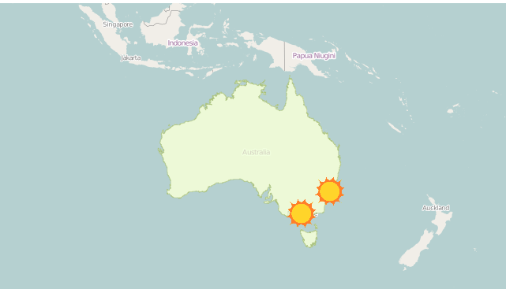

### 3.4 Fancy Tool

The Fancy Tool provides some special effects on the map view just for fun. User can change the current map view to specified places (Rome, London and Sydney) in different animated ways.

## Map View

The Map View takes up most of the place of the Home page and all the features mentioned above will be displayed on it. In addition, the map view enables the user to check out more detailed information on each Olympics event. When you click on an event icon (sun or snowflake), a popup will appear and show the city name, country name, year and the opening ceremony date.

