Surgical publication on hepatic alveolar echinococcosis, 2000–2026: output, collaboration, and a shift toward hepatectomy and ex vivo autotransplantation
Running title: Bibliometrics of surgery for hepatic alveolar echinococcosis
[Author input needed: author names in final order; affiliations; equal-contribution notes; corresponding author, postal address, email and ORCID.]
Article type: original research (bibliometric analysis). Target journal: not yet chosen.
Abstract: 370 words. Main text (Introduction through Conclusions): 4590 words. Tables: 5. Figures: 7.
Abstract
Background. Hepatic alveolar echinococcosis is treated by radical hepatectomy when resection is feasible, by long-term benzimidazoles when it is not, and, for selected end-stage disease, by liver transplantation or ex vivo liver resection and autotransplantation (ELRA). This study describes the English-language surgical publication record of that disease from 2000 through 31 October 2026. It does not estimate incidence, operative volume or survival.
Methods. One Web of Science Core Collection export dated 31 October 2026 (456 English-language articles and reviews; publication years 2000–2026; full record and cited references) was screened with a PRISMA 2020 flow adapted to bibliometric eligibility. Three retracted records and 91 ineligible records were removed. In the remaining 362 papers we harmonised authors, institutions, countries and keywords, then summarised output, citations, co-authorship, Bradford journal zones, co-citation, six prespecified keyword themes, Callon centrality and density, and a windowed log-likelihood burst screen of 20 prespecified terms.
Results. The 362 papers received 10,361 citations (mean 28.62 per paper; h-index 43) and cited 6,238 distinct reference strings. Mean annual output was 6.0 papers per year in 2000–2009, 11.6 in 2010–2018 and 24.8 in 2019–2026, and 198 papers (54.7%) were published from 2019 onward. China contributed 154 papers (42.5%). Among countries with at least 30 papers, France had the highest mean citations per paper (131.75); after papers with 500 or more citations were removed, that figure was 64.94 and France still ranked first in this group. The share of papers using an antiparasitic-therapy theme fell from 33.3% to 7.6%, while the hepatectomy theme rose from 21.7% to 45.5% and the ELRA/vascular theme from 3.3% to 24.2%. The strongest bursts were hepatectomy (16.33; 2016–2026), vascular reconstruction (11.90; 2018–2026) and ELRA (11.66; 2018–2026).
Conclusions. Later years of this indexed corpus contain more papers and a higher share of hepatectomy, ELRA and vascular-reconstruction terms. Those are properties of keywords, addresses and citation counts. They are not measures of operative quality or disease burden.
Keywords: alveolar echinococcosis; hepatectomy; liver transplantation; ex vivo liver resection and autotransplantation; bibliometrics; inferior vena cava
1. Introduction
Hepatic alveolar echinococcosis, caused by the larval stage of Echinococcus multilocularis, infiltrates liver parenchyma and the hepatic vasculature and bile ducts. The WHO-Informal Working Group on Echinococcosis consensus distinguishes it from cystic echinococcosis and sets the PNM stage together with the principles of diagnosis and treatment¹. Reviews of the parasite and of the clinical disease describe radical resection as the intervention associated with durable control when a complete resection can be done, and long-term benzimidazoles when it cannot²⁻⁴. In Switzerland, population survival improved markedly over the decades in which diagnosis and benzimidazole treatment became systematic⁵. European public-health accounts treat the infection as an expanding zoonosis rather than a historical curiosity⁶.
The surgical literature records several responses to disease that cannot be removed by a conventional hepatectomy. A 25-year prospective series compared benzimidazoles alone, curative resection plus adjuvant benzimidazoles, and palliative procedures⁷. A single-centre series from eastern France had already described the long course of 117 patients⁸. For otherwise incurable hepatic disease, a 45-patient European collaborative report evaluated allogeneic liver transplantation⁹. ELRA, complete removal of the liver with bench resection and reimplantation of the remnant, was then reported for end-stage hepatic alveolar echinococcosis with vascular invasion^{10,11}. Interventional and surgical choices were summarised for clinicians in 2016¹².
Publication counts do not substitute for those clinical series. They do show where surgical experience is being written down, which operations enter the indexed vocabulary, and which papers the field still cites. Two recent bibliometric analyses sit next to this question without answering it. Li and colleagues mapped hepatic echinococcosis across four decades, combining cystic and alveolar disease and medical with surgical work¹³. Abulaiti and colleagues mapped digestive-system autotransplantation, a technique used for several tumours as well as for alveolar echinococcosis¹⁴. Neither corpus was restricted to human hepatic alveolar disease with a surgical, transplant or interventional focus, and neither states that retracted records were removed before counting.
We therefore analysed an English-language, surgery-oriented hepatic alveolar echinococcosis corpus with publication years 2000 through 2026, exported on 31 October 2026. We asked four descriptive questions. How did annual output and citations change? Which countries, institutions and authors account for the papers? Which references are co-cited? Which operative and medical themes became more or less common in the keyword record? The answers describe the indexed literature. They do not estimate incidence, the proportion of patients who undergo resection, or survival.
2. Methods
2.1 Source and retrieval
On 31 October 2026 a single plain-text export was taken from the Web of Science Core Collection (Clarivate; full record and cited references; file label VR 1.0). All 456 records are tagged as English, have publication years 2000–2026, and carry the export date 31 October 2026 in the DA field. Document types were articles and reviews, including the dual types proceedings paper, early access and book chapter as assigned by Web of Science. The plain-text export does not store the topic-search string, the edition list, or the exact field tags.
[Author input needed: paste the saved Web of Science search history before submission. Include the edition (Science Citation Index Expanded and any other edition), the exact TS/TI/AB/AK string, language and document-type limits, and the timespan as entered. Until that string is inserted, the counts below can be reproduced from the deposited export plus the screening rules, not by re-running a search.]
2.2 Eligibility
Screening followed the PRISMA 2020 items for identification, screening, eligibility and inclusion¹⁵. The flow is a bibliometric eligibility flow: we did not assess risk of bias and we did not pool clinical outcomes. A record was excluded if Web of Science typed it as retracted or the title was marked retracted or withdrawn (n = 3; accession numbers WOS:000246982200023, WOS:000401125000020 and WOS:000507597800009). A record was excluded if the title matched a pre-specified veterinary or preclinical pattern covering dogs, sheep, primates, mice, rats, or named in-vitro antiparasitic experiments (n = 31). Fourteen accession numbers were pre-specified as exclusively extrahepatic (lung, spleen, adrenal, heart, brain or parotid) or as non-surgical allergy or nephrology, and those records were excluded. A further record was excluded if the title, abstract and author keywords contained none of a pre-specified alveolar expression (alveolar echinococcosis or hydatid, Echinococcus multilocularis, multilocular echinococcosis, Echinococcus alveolaris, alveococcosis, or the token HAE). Seven accession numbers were exempt from that expression rule because they are landmark papers on ex vivo liver surgery, vena cava reconstruction with major hepatectomy, or hepatic echinococcosis surgery that the export contained without the expression. Keywords Plus alone was not accepted as evidence of an alveolar topic. Reviews, case reports and small series were not excluded for those reasons. The strict corpus contains 362 records. The 453 non-retracted records were kept only as a sensitivity file and are not the denominator of the results.
Rules were applied by one script. There was no second clinical reviewer. Boundary decisions are therefore the coded rules and the two accession-number lists, which travel with the code. 7 included records do not themselves match the alveolar expression and are present because of the seven-item exemption list. A preclinical paper whose title did not match the veterinary pattern could remain. An extrahepatic paper that was not on the fourteen-item list could remain if the expression was present.
2.3 Harmonisation
Four thesauri were applied before counting. Author names join inverted and unpunctuated forms to one canonical name, including Wen H, Aji T and Ran B. Institutions are read from the first segment of each C1 address and from C3 enhanced organisations, and affiliated hospitals are folded into the parent university used in this study (West China Hospital with Sichuan University; affiliated hospitals of Xinjiang Medical University with that university; CHU Besançon with the University of Franche-Comté). Countries are the last segment of C1, with Peoples R China mapped to China, UK constituent countries to the United Kingdom, and Türkiye to Turkey. Author keywords and Keywords Plus were lower-cased and passed through a synonym list so that spelling variants of ELRA, radical resection and classification meet. Residual synonyms remain. Counts of authors, institutions and countries below are counts after this mapping, not counts of raw strings. A paper is credited to every country and institution on its addresses (full counting). An international paper is one with at least two countries on C1.
2.4 Indicators
Citations are Web of Science Times Cited on the export date. Papers from 2024–2026 have had little time to be cited, so recent productivity is not comparable with earlier citation totals. Citations per paper are Times Cited divided by the number of papers. The h-index of a set is the largest h such that h papers in the set have at least h citations¹⁶. Co-authorship links count each paper once for every pair of countries, institutions or authors on that paper. Median citations are reported beside means because means are pulled by consensus and review articles.
For the Bradford partition, journals were ordered by decreasing paper count. Zone 1 is the shortest prefix of that list whose papers reach one third of 362. Zone 2 continues until two thirds. Zone 3 is the remainder. Co-citation frequency is the number of the 362 bibliographies that contain a given cited-reference string. Reference strings were not disambiguated: one work split across two Web of Science strings is counted twice.
Keyword analyses use the union of author keywords and Keywords Plus after the thesaurus, counted once per paper. The average publication year of a term is the arithmetic mean of the publication years of papers that carry it. Six themes were specified before plotting, as term sets. A paper is counted in a theme if it carries at least one term from that set. Generic disease names, including alveolar echinococcosis, Echinococcus multilocularis, liver and disease, were left out of every set so that theme membership would not collapse toward the whole corpus. The sets are ELRA and vascular reconstruction; hepatectomy and postoperative outcomes; liver transplantation and recurrence; staging and imaging; antiparasitic therapy; and minimally invasive or interventional procedures. The term lists are those in the figure code and in source_data/fig6_theme_callon_metrics.csv. Phases were fixed as 2000–2009, 2010–2018 and 2019–2026 (10, 9 and 8 years). They are descriptive bins, not estimated change points. The year 2026 stops at the export date.
Callon centrality and density used keywords occurring at least three times. The equivalence index of two keywords is eij = cij squared, divided by ci times cj, where cij is the number of papers listing both and ci is the frequency of keyword i¹⁷. Centrality of a theme is 10 times the sum of eij over pairs with one keyword inside the theme and one outside. Density is 100 times the sum of eij over pairs inside the theme, divided by the number of theme keywords that passed the frequency threshold. Quadrant labels use the median centrality and the median density of these six themes. The diagram is a description of six prespecified themes, not a clustering solution.
For each of 20 prespecified clinical keywords, every window of 2 to 12 years within 2000–2026 in which the keyword occurred in both the first and the last year was scored. The score is the log-likelihood ratio of a two-proportion model (the rate inside the window against the rate in the whole corpus) and is set to zero when the inside rate does not exceed the corpus rate. We report the window with the largest score. The 20 terms were chosen. They are not the top 20 terms from an all-keyword ranking. The score is not a Kleinberg burst weight, and it is not a burst weight from CiteSpace.
2.5 Software and display
Cleaning and statistics used Python 3.11.17. Figures were drawn with Matplotlib 3.11.2 and NetworkX 3.6.1. Networks in the figures are radial diagrams of the top nodes, with edges inside the circle and labels outside it. They are not force-directed VOSviewer layouts. Thesaurus files were also written in a two-column form that VOSviewer can import, so a reader can redraw the maps. A language model assisted the code and the prose. Every count in the results was recomputed from the export by the scripts in this project. No numerical result was accepted from the model without that recomputation.
3. Results
3.1 The corpus
Of 456 exported records, 3 were retracted and 91 failed eligibility (46 with no alveolar expression in the title, abstract or author keywords, 31 veterinary or preclinical, and 14 exclusively extrahepatic). The strict corpus contains 362 records (Figure 1). Of these, 302 (83.4%) are articles, including those also typed as proceedings papers or early access, and 60 (16.6%) are reviews, including two also typed as book chapters. The papers received 10,361 citations (mean 28.62 per paper; h-index 43) and their bibliographies contain 6,238 distinct cited-reference strings. Reviews were cited more heavily (mean 78.2) than articles (mean 18.8), which is the expected direction for consensus and narrative reviews and is why citations per paper should not be read as a surgical-quality score. After name harmonisation the corpus has 1,716 authors (mean 7.39 author names per paper), addresses in 40 countries and 429 institutions, and 655 distinct author-keyword strings.
3.2 Growth across three phases
Annual output averaged 6.0 papers per year in 2000–2009 (60 papers), 11.6 in 2010–2018 (104 papers) and 24.8 in 2019–2026 (198 papers, 54.7% of the corpus) (Figure 2a, Table 1). The fullest calendar year in the file is 2021, with 30 papers. The 27 papers dated 2026 are a partial year ending on 31 October, so the third-phase mean is not a rate for a completed year and will change if later 2026 papers are added. Papers carrying a Chinese address were 8 of 60 in the first phase (13.3%), 34 of 104 in the second (32.7%) and 112 of 198 in the third (56.6%).
Citations summed by publication year peak in 2010 (1,955 citations across 7 papers), 2019 (1,145 across 20 papers) and 2003 (772 across 12 papers) (Figure 2b). These year totals are not the citation count of a single paper. Brunetti and colleagues account for 1,617 of the 2010 total¹. Wen and colleagues account for 918 of the 2019 total². The 2003 total is spread across 12 papers. The largest three are a national review of echinococcosis in Turkey (132 citations), a review of E. multilocularis (125) and the European transplantation report (120)⁹.
Table 1. Output in three prespecified phases.
Phase | Years | Papers | Papers/year | Share of corpus | Papers with a Chinese address
I | 2000–2009 | 60 | 6.0 | 16.6% | 8 (13.3%)
II | 2010–2018 | 104 | 11.6 | 28.7% | 34 (32.7%)
III | 2019–2026 | 198 | 24.8 | 54.7% | 112 (56.6%)
All | 2000–2026 | 362 | — | 100% | 154 (42.5%)

Phase III includes a partial year, 2026, ending on the export date of 31 October 2026. A Chinese address means at least one C1 affiliation mapped to China. Shares use full counting.
3.3 Countries and institutions
China contributed 154 papers (42.5%), followed by Germany (46), Switzerland (38), Turkey (37) and France (36) (Figure 3a, Table 2). Mean citations per paper were highest for France (131.75), then Germany (72.76) and Switzerland (55.26), and lowest among these five for China (17.44). Medians were much closer together: 42 for France, 24 for Germany, 39 for Switzerland, 13 for Turkey and 7 for China. Italy's mean of 266.75 rests on 8 papers and falls to 73.86 when papers with 500 or more citations are removed. Two papers with at least 500 citations carry a French address and account for the gap between the French mean of 131.75 and the mean of 64.94 on the remaining 34 papers. France still has the highest mean of the five countries with at least 30 papers after that removal.
56 papers (15.5%) list at least two countries. Of 154 papers with a Chinese address, 11 (7.1%) also list another country. The most frequent country pairs were France–Switzerland (13 papers), Germany–Switzerland (11), China–France (7), Australia–China (7) and France–Germany (6) (Figure 3b). The collaboration diagram is a count of shared addresses, not a map of referral pathways.
Table 2. The ten countries with the most papers.
Rank | Country | Papers | Citations | Mean | Median | h
1 | China | 154 (42.5%) | 2,685 | 17.44 | 7 | 23
2 | Germany | 46 (12.7%) | 3,347 | 72.76 | 24 | 23
3 | Switzerland | 38 (10.5%) | 2,100 | 55.26 | 39 | 23
4 | Turkey | 37 (10.2%) | 1,179 | 31.86 | 13 | 15
5 | France | 36 (9.9%) | 4,743 | 131.75 | 42 | 24
6 | Japan | 17 (4.7%) | 310 | 18.24 | 6 | 8
7 | USA | 15 (4.1%) | 1,040 | 69.33 | 22 | 10
8 | Poland | 14 (3.9%) | 240 | 17.14 | 13 | 9
9 | Iran | 9 (2.5%) | 287 | 31.89 | 12 | 6
10 | Austria | 9 (2.5%) | 199 | 22.11 | 14 | 6

Full counting: a paper is credited to every country on its addresses, and its full Times Cited value is added to each of those countries. Mean and median are citations per paper. h is the h-index of that country's papers in this corpus.
After institutional harmonisation, Xinjiang Medical University has 56 papers (mean citations 29.07; h-index 14), Sichuan University 37 (mean 12.38), the University of Franche-Comté/CHU Besançon 35 (mean 135.00; h-index 24), Qinghai University 29 (mean 6.24), Ulm 27 (mean 106.70) and Bern 23 (mean 49.09) (Figure 3c and 3d, Table 3). The Chinese centres account for more papers. The Franche-Comté/Besançon and Ulm series account for more citations per paper. Qinghai University's mean of 6.24 and the Qinghai Provincial People's Hospital mean of 3.67 sit on more recent papers, which have had less time to be cited. Folding a hospital into its university moves counts toward the parent label; centres that were not in the thesaurus remain separate and can be under-counted.
Table 3. The ten institutions with the most papers after harmonisation.
Rank | Institution | Country | Papers | Citations | Mean | h
1 | Xinjiang Medical University | China | 56 | 1,628 | 29.07 | 14
2 | Sichuan University | China | 37 | 458 | 12.38 | 13
3 | University of Franche-Comte / CHU Besancon | France | 35 | 4,725 | 135.00 | 24
4 | Qinghai University | China | 29 | 181 | 6.24 | 8
5 | Ulm University | Germany | 27 | 2,881 | 106.70 | 19
6 | University of Bern | Switzerland | 23 | 1,129 | 49.09 | 16
7 | Qinghai Provincial People's Hospital | China | 15 | 55 | 3.67 | 5
8 | Ataturk University | Turkey | 12 | 151 | 12.58 | 8
9 | University of Zurich | Switzerland | 11 | 1,068 | 97.09 | 10
10 | Medical University of Warsaw | Poland | 7 | 161 | 23.00 | 6

Affiliated hospitals listed in the thesaurus are counted with the parent university. Means are citations per paper under full counting.
3.4 Authors and journals
The largest author counts after disambiguation are Aji T (35 papers), Wen H (34), Shao YM (31), Vuitton DA (28), Wang WT (22) and Jiang TM (22) (Figure 4a and 4b, Table 4). Citation rate does not follow paper count. Vuitton DA has a mean of 160.36 citations per paper and an h-index of 22 inside this corpus; Kern P has 13 papers, a mean of 202.62 and an h-index of 13. Bresson-Hadni S has 21 papers (mean 51.95). These h-indices use only this corpus and only Times Cited on the export date. They are not career h-indices. The WoS spelling Gruener is retained where the record uses it.
The 362 papers appear in 169 journals (Figure 4c and 4d). World Journal of Gastroenterology published 15 (mean citations 41.67), Medicine 13 (mean 9.08), BMC Infectious Diseases and Pathogens 10 each, and PLoS Neglected Tropical Diseases 9. Acta Tropica published 8 papers with a mean of 232.75, a mean carried by the 2010 consensus. The Bradford partition places 122 papers in 16 journals (zone 1), 121 papers in the next 46 journals (zone 2) and 119 papers in the remaining 107 journals (zone 3).
Table 4. The twelve authors with the most papers after disambiguation.
Rank | Author (Web of Science form) | Papers | Citations | Mean | h
1 | Aji, Tuerganaili | 35 | 395 | 11.29 | 10
2 | Wen, Hao | 34 | 1,491 | 43.85 | 13
3 | Shao, Yingmei | 31 | 456 | 14.71 | 10
4 | Vuitton, Dominique Angele | 28 | 4,490 | 160.36 | 22
5 | Wang, Wentao | 22 | 358 | 16.27 | 11
6 | Jiang, Tiemin | 22 | 224 | 10.18 | 8
7 | Bresson-Hadni, Solange | 21 | 1,091 | 51.95 | 14
8 | Fan, Haining | 16 | 143 | 8.94 | 7
9 | Yang, Xianwei | 14 | 204 | 14.57 | 8
10 | Gottstein, Bruno | 14 | 754 | 53.86 | 12
11 | Gruener, Beate | 14 | 546 | 39.00 | 13
12 | Kern, Peter | 13 | 2,634 | 202.62 | 13

Each paper is counted once per harmonised author. The h-index is computed inside this 362-paper corpus only.
3.5 Co-cited references
The cited-reference strings that appear in the most bibliographies are Brunetti and colleagues, 2010, Acta Tropica (155 papers)¹; Kern and colleagues, 2006, Parasitology International volume 55, page S283 (109 papers); Wen and colleagues, 2019, Clinical Microbiology Reviews (81)²; Bresson-Hadni and colleagues, 2000 (74)⁸; and Koch and colleagues, 2003, Transplantation (67)⁹ (Figure 5). The 2006 Kern string is the PNM classification paper as recorded by Web of Science; we did not re-derive its title from a source outside this export, and we did not merge it with any later reprint. Strings for McManus and colleagues, 2003, Lancet (60) and for Deplazes and colleagues, 2017, Advances in Parasitology (56) follow. Because strings were not harmonised, these ranks are ranks of Web of Science strings, not of canonical works.
3.6 Keyword themes and bursts
Average publication year separates earlier medical and imaging terms from later operative terms (Figure 6b). Antiparasitic therapy averages 2011.6, albendazole 2013.0, PET/CT 2015.4 and liver transplantation 2016.6. Hepatectomy averages 2020.7, classification 2020.5, ELRA 2021.0 and vascular reconstruction 2021.5.
Theme membership, which is keyword presence rather than a procedure count, moved in the same direction (Figure 6c). The antiparasitic theme appears in 20, 19 and 15 papers across the three phases (33.3%, 18.3% and 7.6% of each phase). The hepatectomy theme appears in 13, 33 and 90 papers (21.7%, 31.7% and 45.5%). The ELRA and vascular theme appears in 2, 17 and 48 papers (3.3%, 16.3% and 24.2%). Liver-transplantation terms remain common (17, 53 and 71 papers) but their share of a growing corpus moves from 28.3% to 35.9%. The minimally invasive theme remains the smallest (6, 6 and 16 papers).
On the Callon diagram the six themes have median centrality 60.93 and median density 8.72 (Figure 6d). Staging and imaging sits above both medians (centrality 81.35, density 12.75). ELRA and vascular reconstruction sits above the density median and below the centrality median (47.15, 15.08). Liver transplantation and recurrence sits above the centrality median and below the density median (84.91, 7.07). Hepatectomy sits above the centrality median and just below the density median (74.72 against 8.72). Antiparasitic therapy sits just above the density median and below the centrality median. Minimally invasive and interventional terms sit below both. With only six hand-built themes, a theme that lies close to a median would change quadrant if the term list changed. The quadrant names are labels for this split. The decline in the antiparasitic share is a statement about the phase counts, not about the quadrant.
The windowed log-likelihood screen gives the highest scores to hepatectomy (16.33, 2016–2026), vascular reconstruction (11.90, 2018–2026), ELRA (11.66, 2018–2026), postoperative complications (11.18, 2014–2024), experience (10.76, 2009–2020) and classification (10.49, 2015–2026) (Figure 7a, Table 5). Albendazole scores 9.79 for 2002–2013, an earlier window. The heatmap uses the same keyword logic in five periods (Figure 7b). Papers whose keywords meet the hepatectomy or radical-resection set number 0, 1, 5, 25 and 45 across 2000–2005, 2006–2010, 2011–2015, 2016–2020 and 2021–2026. The corresponding ELRA counts are 0, 0, 3, 15 and 27. Laparoscopic or robotic terms occur in 1, 0, 0, 1 and 9 papers. A paper can fall in more than one row, and a row counts indexed terms, not operations performed.
Table 5. Highest-scoring window for each of 20 prespecified keywords.
Keyword | Score | Window start | Window end | Papers with the term
Antiparasitic therapy | 5.72 | 2000 | 2009 | 18
Antigen | 7.45 | 2001 | 2011 | 11
Hydatid disease | 7.3 | 2002 | 2009 | 75
Albendazole | 9.79 | 2002 | 2013 | 43
Echinococcus multilocularis | 5.47 | 2005 | 2014 | 142
Follow-up | 7.84 | 2008 | 2018 | 55
PET/CT | 7.15 | 2009 | 2017 | 19
Experience | 10.76 | 2009 | 2020 | 32
Management | 8.95 | 2013 | 2022 | 37
Clinical features | 6.09 | 2014 | 2018 | 10
Postoperative complications | 11.18 | 2014 | 2024 | 21
Living-donor liver transplantation | 5.95 | 2015 | 2023 | 9
Classification | 10.49 | 2015 | 2026 | 41
Outcomes | 6.31 | 2016 | 2023 | 13
Hepatectomy | 16.33 | 2016 | 2026 | 71
Hepatic alveolar echinococcosis | 7.0 | 2016 | 2026 | 68
Inferior vena cava | 6.44 | 2016 | 2026 | 24
Transplantation | 5.34 | 2018 | 2025 | 42
Vascular reconstruction | 11.9 | 2018 | 2026 | 21
ELRA | 11.66 | 2018 | 2026 | 45

The score is a two-proportion log-likelihood ratio for the best window of 2–12 years. Terms were prespecified. The score is not a Kleinberg burst weight and not a weight from CiteSpace. Windows are sorted by start year in the source file.
4. Discussion
In this English-language Web of Science corpus, surgical publication on hepatic alveolar echinococcosis accelerated after 2010 and again after 2018, and the later papers more often carry the keywords of hepatectomy, ELRA and vascular reconstruction. Antiparasitic terms did not disappear, but they account for a smaller share of a larger literature. That is the result the counts support.
The timing lines up with clinical series already in the corpus, without those series being re-analysed here. Long Asian resection cohorts were already in print before the hepatectomy keyword burst: a Hokkaido series of 188 patients treated from 1984 to 2009¹⁸ and a western-China series of 144 hepatectomies¹⁹. A Swiss tertiary-centre cohort described resection outcomes in an endemic region²⁰. ELRA for end-stage hepatic disease was reported as a case series in 2011 and 2016^{10,21}, as an alternative to allotransplantation in 2018¹¹, and with technical modifications in a 31-patient series²². A later single-centre comparison of ELRA with allotransplantation used 35 ELRA procedures and 6 allotransplants²³. A retrospective cohort of 228 patients with end-stage disease compared ELRA with non-surgical treatment²⁴. We cite these designs and sample sizes as the authors reported them. We do not import their survival estimates, and the keyword burst is not evidence that those estimates are unbiased.
The vascular-reconstruction burst has the same status. Reconstruction of the inferior vena cava during ELRA is described in a 114-patient series²⁵, material choice for that reconstruction in 91 patients²⁶, and use of the ligamentum teres hepatis for outflow in 24 patients²⁷. Three-dimensional reconstruction for operative planning is reported in a hepatectomy series in which 59 of 106 patients had a preoperative model²⁸. Classification terms burst from 2015, the period in which ultrasonographic and computed-tomography classifications of hepatic alveolar echinococcosis were proposed^{29,30}. None of these keyword coincidences validates a classification or a reconstruction technique.
Minimally invasive terms remain uncommon in the index. Laparoscopic hepatectomy for hepatic alveolar echinococcosis is reported from an endemic centre and from Bern^{31,32}. A robotic series of posterosuperior resections included both cystic and alveolar disease, so it is not an alveolar-only cohort³³. Associating liver partition and portal-vein ligation for staged hepatectomy is present as a single case report³⁴. The heatmap counts of laparoscopic or robotic terms (nine papers in 2021–2026) match a literature that has case series, not a literature that has replaced open resection. A systematic review of ELRA that is not restricted to alveolar echinococcosis was retained in this corpus by the exemption list; its presence should not be read as an alveolar-echinococcosis meta-analysis³⁵.
Two geographic patterns need a counting caveat. Paper volume is concentrated in Xinjiang, Sichuan and Qinghai and in a small set of European reference centres, which is consistent with where the clinical series above were written. Citation means are not a second copy of that map. Under full counting, a consensus or a widely cited review adds its entire Times Cited value to every country on the byline. Removing papers with 500 or more citations lowers the French mean from 131.75 to 64.94 and the Italian mean from 266.75 to 73.86, and it barely changes the Chinese mean. Rankings of citations per paper in this field are rankings of a handful of reviews plus a long tail of surgical reports. International co-authorship is uncommon (15.5% of papers; 7.1% of papers with a Chinese address). That is a statement about addresses in this index. It is not a measure of whether clinicians discuss cases across borders outside the byline.
The same boundary applies to the medical theme. Benzimidazoles remain the treatment of unresectable disease, and stopping rules based on PET/CT and serology have been studied in small prospective groups³⁶. A fall in the share of papers that use the words albendazole or antiparasitic therapy can mean that later papers treat medical therapy as background and put the new surgical noun in the keyword field. It cannot mean that benzimidazoles are used in a smaller fraction of patients. Immunosuppression-associated disease is a clinical concern documented in a patient series³⁷ and is not a keyword theme we specified. Recurrence after transplantation was the question of a 20-year follow-up study³⁸. Our transplantation theme mixes the words transplantation, recurrence, follow-up and immunosuppression, so it cannot separate a change in transplant practice from a change in follow-up vocabulary.
Several limits bound every claim above. The corpus is one database, English only, and the topic-search string was not stored in the export, so a reader cannot rebuild the 456 records from the Methods until that string is supplied. Screening was a script, not two reviewers, and the extrahepatic and landmark decisions used accession lists. Veterinary exclusion depended on the title. 7 included records lack the alveolar expression. Author, hospital and keyword synonyms that are not in the thesauri are still split. Citations favour older reviews and stop on 31 October 2026. Co-citation ranks unmerged reference strings. Themes, the 20 burst terms and the three phases were chosen by us; a different list would move the Callon medians, the heatmap and the phase means. Keywords Plus adds indexer terms the authors did not choose. Full counting double-credits multinational papers. Nothing in the design links a keyword to an operation actually performed, a margin, a complication or a survival time. A second database, fractional counting, or a registry of resections would be required before any of those clinical quantities could be discussed as results of this study. Overlap with the broader hepatic-echinococcosis map and with the autotransplantation map is real, and those papers remain the appropriate citations for questions wider than surgery for hepatic alveolar disease^{13,14,39}.
5. Conclusions
From 2000 to 31 October 2026, the English-language Web of Science record of surgery for hepatic alveolar echinococcosis grew from 6.0 papers per year to 11.6 and then to 24.8, with more than half of the 362 papers published from 2019 onward. Output is concentrated in a few Chinese and European centres. Citation means are dominated by consensus and review articles under full counting. In the keyword record, hepatectomy, ELRA and vascular reconstruction occupy a larger share of later years, and antiparasitic terms a smaller share. Laparoscopic and robotic terms are still rare. These statements describe indexed publications. They do not describe how often each operation is done, or how patients fare.
Declarations
Ethics approval and consent to participate
This study analysed published bibliographic records and did not enrol participants. [Author input needed: confirm with the authors' institution whether a formal waiver or exemption number must be stated.]
Consent for publication
Not applicable.
Availability of data and materials
The Web of Science records are subject to Clarivate's licence and are not republished as a bulk download. The screening log, thesauri, aggregated tables and figure source data used to produce the counts in this draft accompany the analysis code. [Author input needed: state the repository, the accession number and the access conditions that the licence allows. Do not write that the raw export is openly available unless Clarivate's terms and the institution agree.]
Competing interests
[Author input needed: a competing-interests statement for every author, or a confirmation that the authors declare none.]
Funding
[Author input needed: grant names, numbers and the funder's role. If there was no specific grant, write that explicitly.]
Authors' contributions
[Author input needed: CRediT roles. Do not leave a model-written contribution list in the submitted file.]
Acknowledgements
[Author input needed.]
Use of a language model
A language model assisted code for cleaning, counting and figure drawing, and assisted drafting of the English prose. The authors are responsible for the search string, the eligibility rules, the thesauri and every interpretation. Counts reported here were recomputed from the export. [Author input needed: keep, shorten or move this statement to match the target journal's policy on artificial-intelligence tools, and name the tool the journal requires.]
References
1. Brunetti E, Kern P, Vuitton DA, et al. Expert consensus for the diagnosis and treatment of cystic and alveolar echinococcosis in humans. Acta Trop. 2010;114:1-16. doi:10.1016/j.actatropica.2009.11.001
2. Wen H, Vuitton L, Tuxun T, Li J, Vuitton DA, Zhang WB, et al. Echinococcosis: Advances in the 21st Century. Clin Microbiol Rev. 2019;32:e00075-18. doi:10.1128/CMR.00075-18
3. Kern P, da Silva AM, Akhan O, Müllhaupt B, Vizcaychipi KA, Budke C, et al. The Echinococcoses: Diagnosis, Clinical Management and Burden of Disease. Adv Parasitol. 2017;96:259. doi:10.1016/bs.apar.2016.09.006
4. Kern P. Clinical features and treatment of alveolar echinococcosis. Curr Opin Infect Dis. 2010;23:505-512. doi:10.1097/QCO.0b013e32833d7516
5. Torgerson PR, Schweiger A, Deplazes P, Pohar M, Reichen J, Ammann RW, et al. Alveolar echinococcosis: From a deadly disease to a well-controlled infection.: Relative survival and economic analysis in Switzerland over the last 35 years. J Hepatol. 2008;49:72-77. doi:10.1016/j.jhep.2008.03.023
6. Gottstein B, Stojkovic M, Vuitton DA, Millon L, Marcinkute A, Deplazes P. Threat of alveolar echinococcosis to public health - a challenge for Europe. Trends Parasitol. 2015;31:407-412. doi:10.1016/j.pt.2015.06.001
7. Kadry Z, Renner EC, Bachmann LM, Attigah N, Renner EL, Ammann RW, et al. Evaluation of treatment and long-term follow-up in patients with hepatic alveolar echinococcosis. Br J Surg. 2005;92:1110-1116. doi:10.1002/bjs.4998
8. Bresson-Hadni S, Vuitton DA, Bartholomot B, Heyd B, Godart D, Meyer JP, et al. A twenty-year history of alveolar echinococcosis: analysis of a series of 117 patients from eastern France. Eur J Gastroenterol Hepatol. 2000;12:327-336. doi:10.1097/00042737-200012030-00011
9. Koch SP, Bresson-Hadni S, Miguet JP, Crumbach JP, Gillet M, Mantion GA, et al. Experience of liver transplantation for incurable alveolar echinococcosis: A 45-case European collaborative report. Transplantation. 2003;75:856-863. doi:10.1097/01.TP.0000054230.63568.79
10. Wen H, Dong JH, Zhang JH, Zhao JM, Shao YM, Duan WD, et al. Ex vivo liver resection followed by autotransplantation for end-stage hepatic alveolar echinococcosis. Chin Med J (Engl). 2011;124:2813-2817. doi:10.3760/cma.j.issn.0366-6999.2011.18.003
11. Aji T, Dong JH, Shao YM, Zhao JM, Li T, Tuxun TEHJ, et al. Ex vivo liver resection and autotransplantation as alternative to allotransplantation for end-stage hepatic alveolar echinococcosis. J Hepatol. 2018;69:1037-1046. doi:10.1016/j.jhep.2018.07.006
12. Vuitton DA, Azizi A, Richou C, Vuitton L, Blagosklonov O, Delabrousse E, et al. Current interventional strategy for the treatment of hepatic alveolar echinococcosis. Expert Rev Anti Infect Ther. 2016;14:1179-1194. doi:10.1080/14787210.2016.1240030
13. Li TE, Su W, Wang ZQ, Wang X, Ma XG, Cao YG, et al. Characterization of research trends and prospects on hepatic echinococcosis over the past forty years: a bibliometric analysis. Int J Surg. 2024;110:3654-3665. doi:10.1097/JS9.0000000000001319
14. Abulaiti A, Tuergan T, Tulahong A, Zhang RQ, Shao YM, Aji T. Advancements and trends in digestive system autotransplantation: a bibliometric and visualization analysis. Front Med (Lausanne). 2025;12:1537446. doi:10.3389/fmed.2025.1537446
15. Page MJ, McKenzie JE, Bossuyt PM, et al. The PRISMA 2020 statement: an updated guideline for reporting systematic reviews. BMJ. 2021;372:n71. doi:10.1136/bmj.n71
16. Hirsch JE. An index to quantify an individual's scientific research output. Proc Natl Acad Sci U S A. 2005;102(46):16569-16572. doi:10.1073/pnas.0507655102
17. Callon M, Courtial JP, Laville F. Co-word analysis as a tool for describing the network of interactions between basic and technological research: the case of polymer chemistry. Scientometrics. 1991;22(1):155-205. doi:10.1007/BF02019280
18. Kawamura N, Kamiyama T, Sato N, Nakanishi K, Yokoo H, Kamachi H, et al. Long-Term Results of Hepatectomy for Patients with Alveolar Echinococcosis: A Single-Center Experience. J Am Coll Surg. 2011;212:804-812. doi:10.1016/j.jamcollsurg.2011.02.007
19. Du CS, Liu ZN, Yang XW, Yan LN, Li B, Wen TF, et al. Hepatectomy for patients with alveolar echinococcosis: Long-term follow-up observations of 144 cases. Int J Surg. 2016;35:147-152. doi:10.1016/j.ijsu.2016.09.094
20. Joliat GR, Melloul E, Petermann D, Demartines N, Gillet M, Uldry E, et al. Outcomes After Liver Resection for Hepatic Alveolar Echinococcosis: A Single-Center Cohort Study. World J Surg. 2015;39:2529-2534. doi:10.1007/s00268-015-3109-2
21. Wen H, Dong JH, Zhang JH, Duan WD, Zhao JM, Liang YR, et al. Ex Vivo Liver Resection and Autotransplantation for End-Stage Alveolar Echinococcosis: A Case Series. Am J Transplant. 2016;16:615-624. doi:10.1111/ajt.13465
22. Yang XW, Qiu YW, Huang B, Wang WT, Shen S, Feng X, et al. Novel techniques and preliminary results of ex vivo liver resection and autotransplantation for end-stage hepatic alveolar echinococcosis: A study of 31 cases. Am J Transplant. 2018;18:1668-1679. doi:10.1111/ajt.14621
23. Shen S, Kong JJ, Qiu YW, Zhang SL, Qin Y, Wang WT. Ex vivo liver resection and autotransplantation versus allotransplantation for end-stage hepatic alveolar echinococcosis. Int J Infect Dis. 2019;79:87-93. doi:10.1016/j.ijid.2018.11.016
24. Qiu YW, Huang B, Yang XW, Wang T, Shen S, Yang Y, et al. Evaluating the Benefits and Risks of Ex Vivo Liver Resection and Autotransplantation in Treating Hepatic End-stage Alveolar Echinococcosis. Clin Infect Dis. 2022;75:1289-1296. doi:10.1093/cid/ciac195
25. Maimaitinijiati Y, Aji T, Jiang TM, Ran B, Shao YM, Zhang RQ, et al. Approaches to reconstruction of inferior vena cava by ex vivo liver resection and autotransplantation in 114 patients with hepatic alveolar echinococcosis. World J Gastroenterol. 2022;28:4351-4362. doi:10.3748/wjg.v28.i31.4351
26. Qiu YW, Yang XW, Huang B, Wei GF, Chen Y, Yang KM, et al. Outcomes of inferior vena cava reconstruction using artificial or autologous materials in ex vivo liver resection and autotransplantation. Asian J Surg. 2023;46:213-221. doi:10.1016/j.asjsur.2022.03.045
27. Jiang TM, Ran B, Guo Q, Zhang RQ, Duan S, Zhong K, et al. Use of the ligamentum teres hepatis for outflow reconstruction during ex vivo liver resection and autotransplantation in patients with hepatic alveolar echinococcosis: A case series of 24 patients. Surgery. 2021;170:822-830. doi:10.1016/j.surg.2021.03.040
28. He YB, Bai L, Aji T, Jiang Y, Zhao JM, Zhang JH, et al. Application of 3D reconstruction for surgical treatment of hepatic alveolar echinococcosis. World J Gastroenterol. 2015;21:10200-10207. doi:10.3748/wjg.v21.i35.10200
29. Kratzer W, Gruener B, Kaltenbach TEM, Ansari-Bitzenberger S, Kern P, Fuchs M, et al. Proposal of an ultrasonographic classification for hepatic alveolar echinococcosis: Echinococcosis multilocularis Ulm classification-ultrasound. World J Gastroenterol. 2015;21:12392-12402. doi:10.3748/wjg.v21.i43.12392
30. Graeter T, Kratzer W, Oeztuerk S, Haenle MM, Mason RA, Hillenbrand A, et al. Proposal of a computed tomography classification for hepatic alveolar echinococcosis. World J Gastroenterol. 2016;22:3621-3631. doi:10.3748/wjg.v22.i13.3621
31. Wan L, Ran B, Aji T, Shalayiadang P, Jiang TM, Shao YM, et al. Laparoscopic hepatectomy for the treatment of hepatic alveolar echinococcosis. Parasite. 2021;28:5. doi:10.1051/parasite/2021001
32. Gloor S, Candinas D, Beldi G, Lachenmayer A. Laparoscopic resection of hepatic alveolar echinococcosis: A single-center experience. PLoS Negl Trop Dis. 2022;16:e0010708. doi:10.1371/journal.pntd.0010708
33. Zhao ZM, Yin ZZ, Meng Y, Jiang N, Ma ZG, Pan LC, et al. Successful robotic radical resection of hepatic echinococcosis located in posterosuperior liver segments. World J Gastroenterol. 2020;26:2831-2838. doi:10.3748/wjg.v26.i21.2831
34. Akbulut S, Cicek E, Kolu M, Sahin TT, Yilmaz S. Associating liver partition and portal vein ligation for staged hepatectomy for extensive alveolar echinococcosis: First case report in the literature. World J Gastrointest Surg. 2018;10:1-5. doi:10.4240/wjgs.v10.i1.1
35. Zawistowski M, Nowaczyk J, Jakubczyk M, Domagala P. Outcomes of ex vivo liver resection and autotransplantation: A systematic review and meta-analysis. Surgery. 2020;168:631-642. doi:10.1016/j.surg.2020.05.036
36. Ammann RW, Stumpe KDM, Grimm F, Deplazes P, Huber S, Bertogg K, et al. Outcome after Discontinuing Long-Term Benzimidazole Treatment in 11 Patients with Non-resectable Alveolar Echinococcosis with Negative FDG-PET/CT and Anti-EmII/3-10 Serology. PLoS Negl Trop Dis. 2015;9:e0003964. doi:10.1371/journal.pntd.0003964
37. Chauchet A, Grenouillet F, Knapp J, Richou C, Delabrousse E, Dentan C, et al. Increased Incidence and Characteristics of Alveolar Echinococcosis in Patients With Immunosuppression-Associated Conditions. Clin Infect Dis. 2014;59:1095-1104. doi:10.1093/cid/ciu520
38. Bresson-Hadni S, Blagosklonov O, Knapp J, Grenouillet F, Sako Y, Delabrousse E, et al. Should Possible Recurrence of Disease Contraindicate Liver Transplantation in Patients With End-Stage Alveolar Echinococcosis? A 20-Year Follow-Up Study. Liver Transpl. 2011;17:855-865. doi:10.1002/lt.22299
39. Peters L, Burkert S, Gruener B. Parasites of the liver - epidemiology, diagnosis and clinical management in the European context. J Hepatol. 2021;75:202-218. doi:10.1016/j.jhep.2021.02.015

Figure legends

Figure 1. Eligibility flow for the hepatic alveolar echinococcosis surgery corpus.
The export contained 456 English-language records (articles and reviews; publication years 2000–2026; exported 31 October 2026). Three retracted records were removed. Ninety-one further records failed eligibility: 46 with no alveolar expression in the title, abstract or author keywords, 31 veterinary or preclinical records, and 14 exclusively extrahepatic records. The analysed set has 362 records (302 articles and 60 reviews), 10,361 citations, an h-index of 43 and 6,238 distinct cited-reference strings. The topic-search string is not stored in the export.
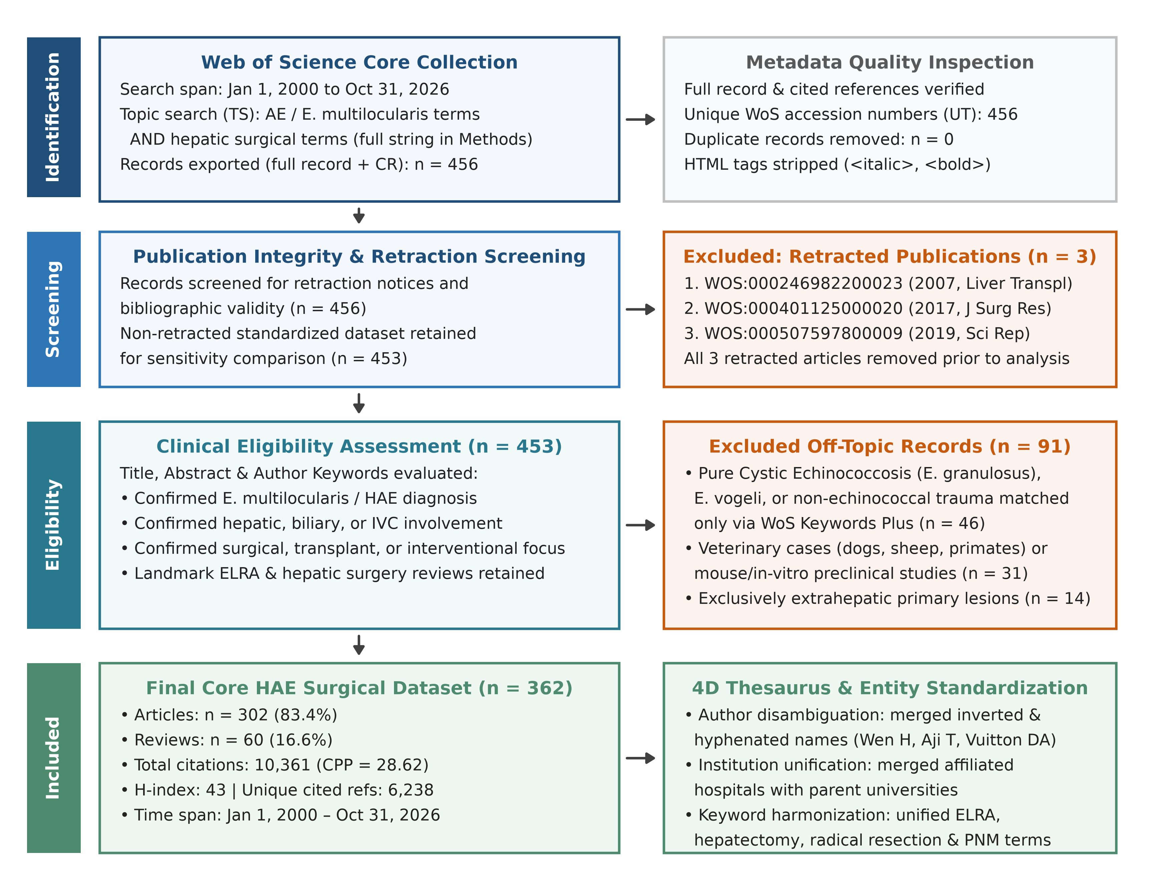

Figure 2. Annual output and citations, 2000–2026.
(a) Bars are annual papers and the line is the cumulative count. Means are 6.0 papers/year in 2000–2009 (60 papers), 11.6 in 2010–2018 (104 papers) and 24.8 in 2019–2026 (198 papers). The 2026 bar ends on 31 October 2026. (b) Bars are the sum of Times Cited for papers published in that year, and the line is citations per paper. Year totals are 772 citations across 12 papers in 2003, 1,955 in 2010 (1,617 of them Brunetti et al.) and 1,145 in 2019 (918 of them Wen et al.).
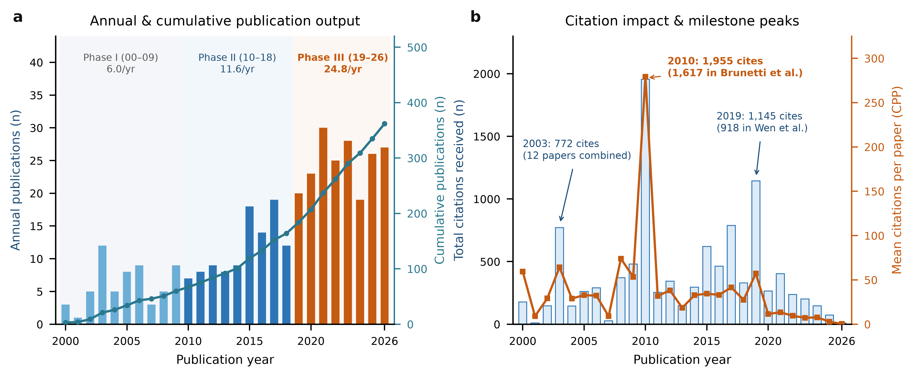

Figure 3. Countries and institutions.
(a) The ten countries with the most papers, with citations per paper. (b) Co-authorship among the twelve countries with the most papers. Node area scales with paper count and line width with the number of joint papers. (c) The ten institutions with the most papers after hospital-to-university harmonisation. (d) Co-authorship among those institutions. Full counting is used throughout.
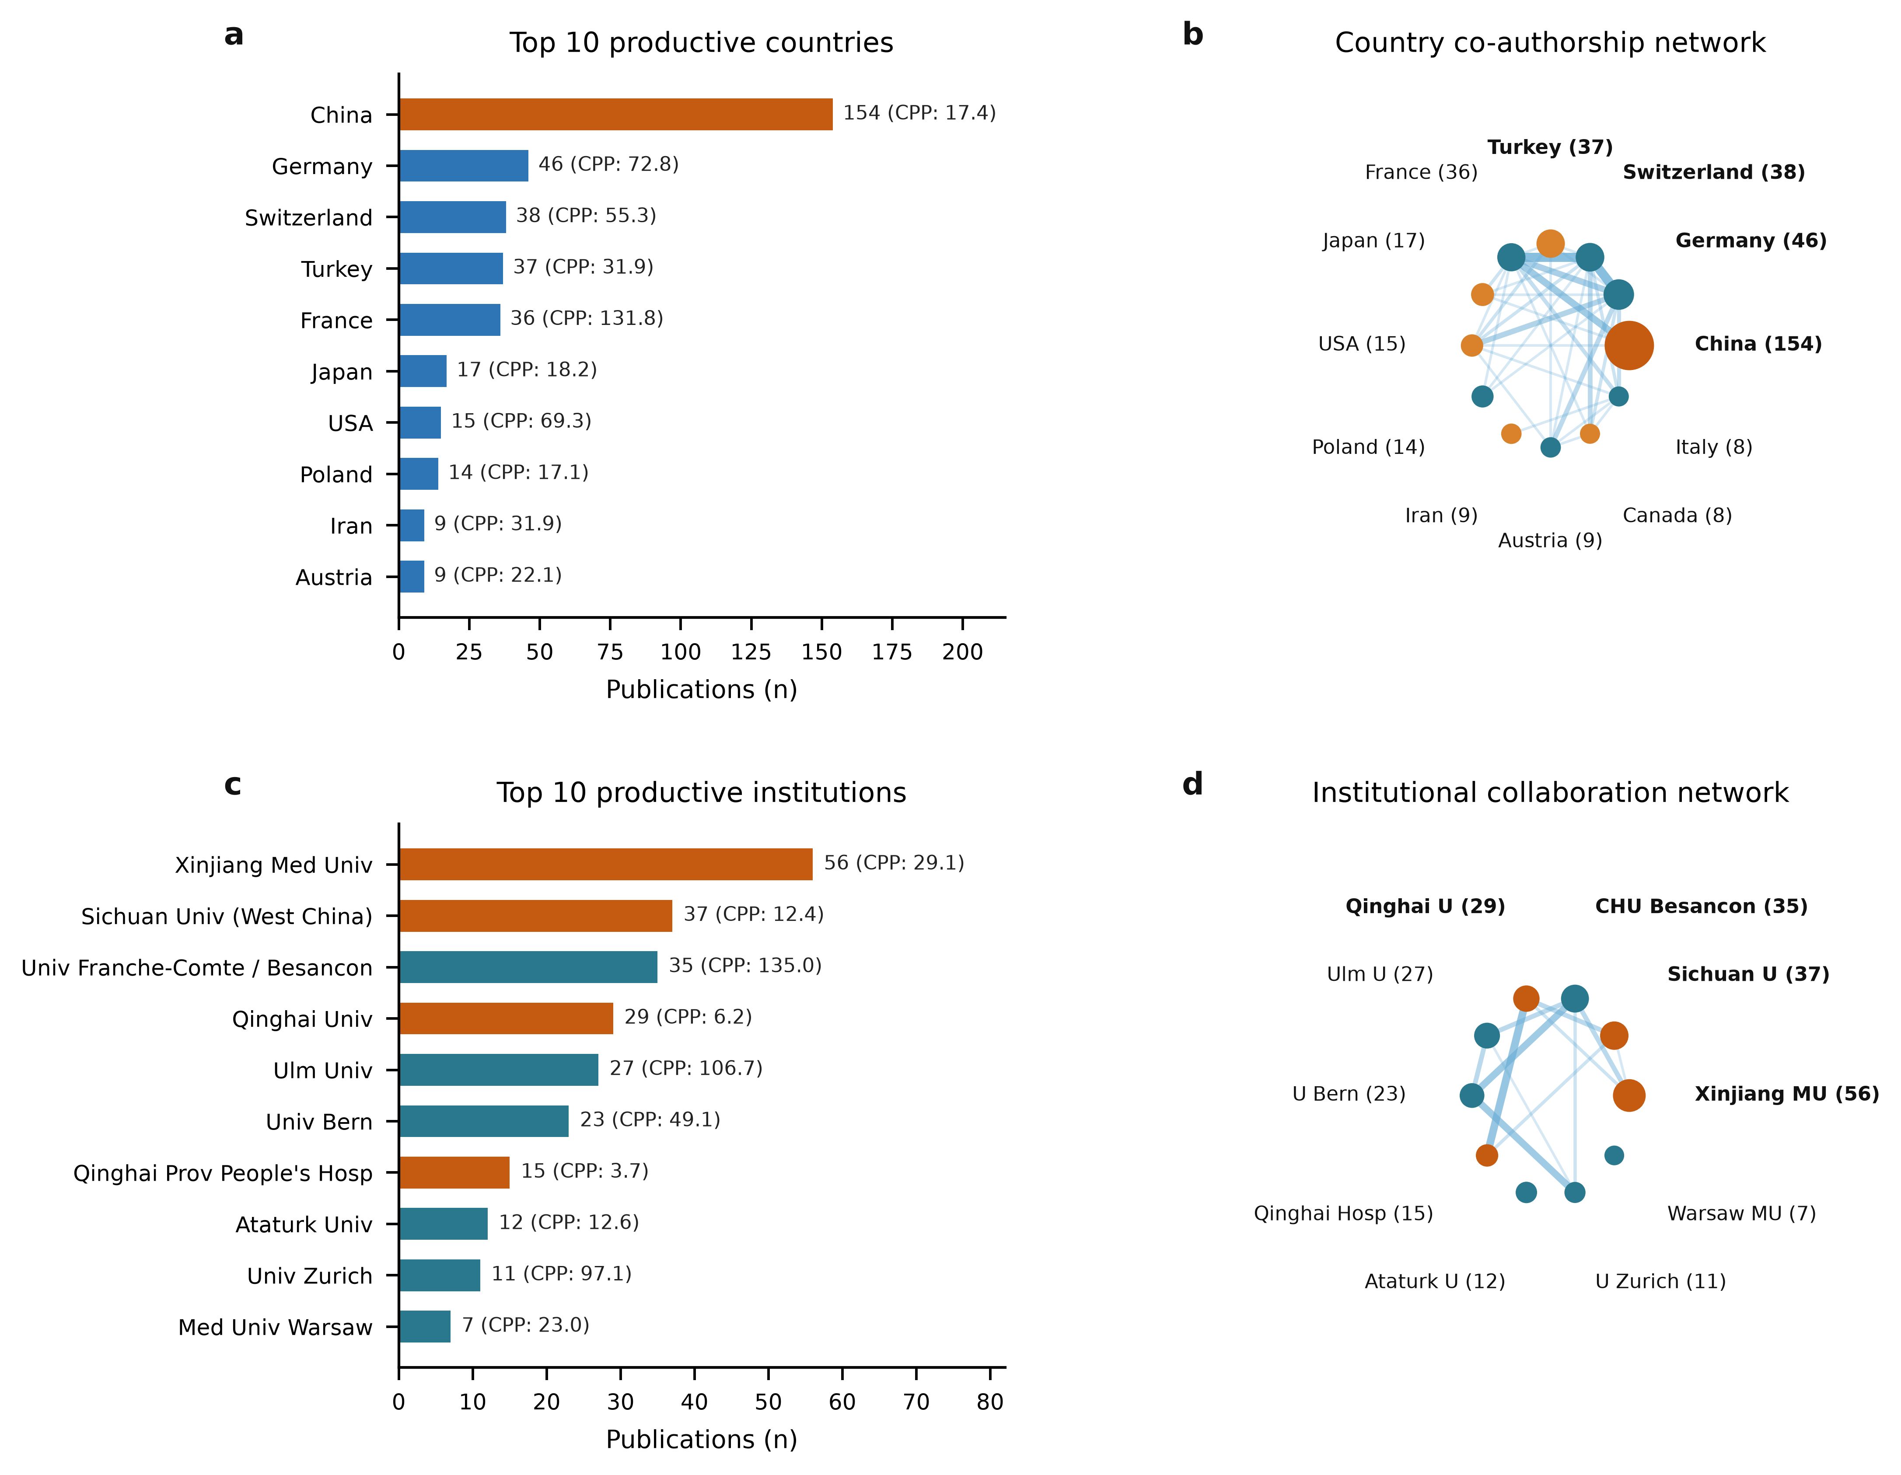

Figure 4. Authors, journals and the Bradford partition.
(a) Co-authorship among the twelve authors with the most papers. (b) Annual output of the ten authors with the most papers. Marker area scales with papers in that year and colour with citations accrued by those papers. (c) The ten journals with the most papers. (d) Cumulative papers against journal rank on a log axis, for 169 journals. Zone 1 contains 16 journals and 122 papers, zone 2 contains 46 journals and 121 papers, and zone 3 contains 107 journals and 119 papers.
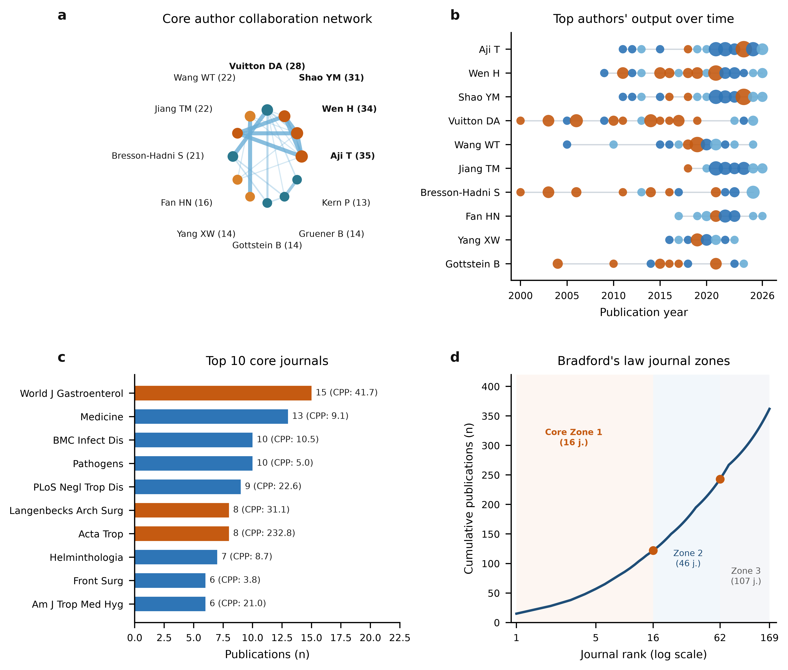

Figure 5. Co-cited reference strings.
(a) Links among the twelve most frequent cited-reference strings. (b) The same twelve strings ranked by the number of bibliographies that contain them. Strings were not merged across variant records. Colour in the figure groups strings only as a reading aid.
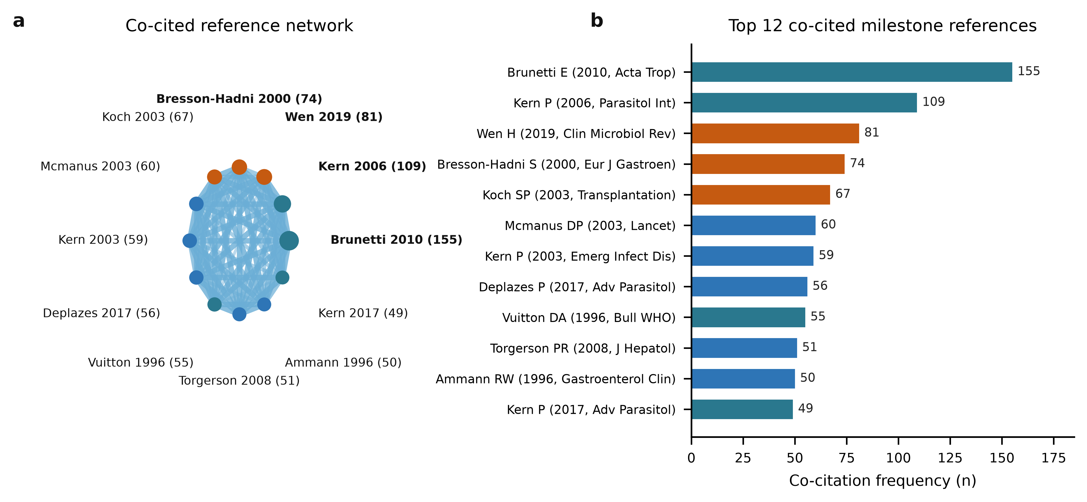

Figure 6. Prespecified keyword themes.
(a) Co-occurrence among twelve keywords. Colour marks a prespecified theme; grey means the keyword is in none of the six themes. (b) Average publication year. (c) Papers per phase that carry at least one term from each theme. Generic disease names were excluded from every theme. (d) Callon centrality against Callon density. Cross-hairs are the medians of the six themes. Quadrant names label that median split. They are not the output of a clustering algorithm.
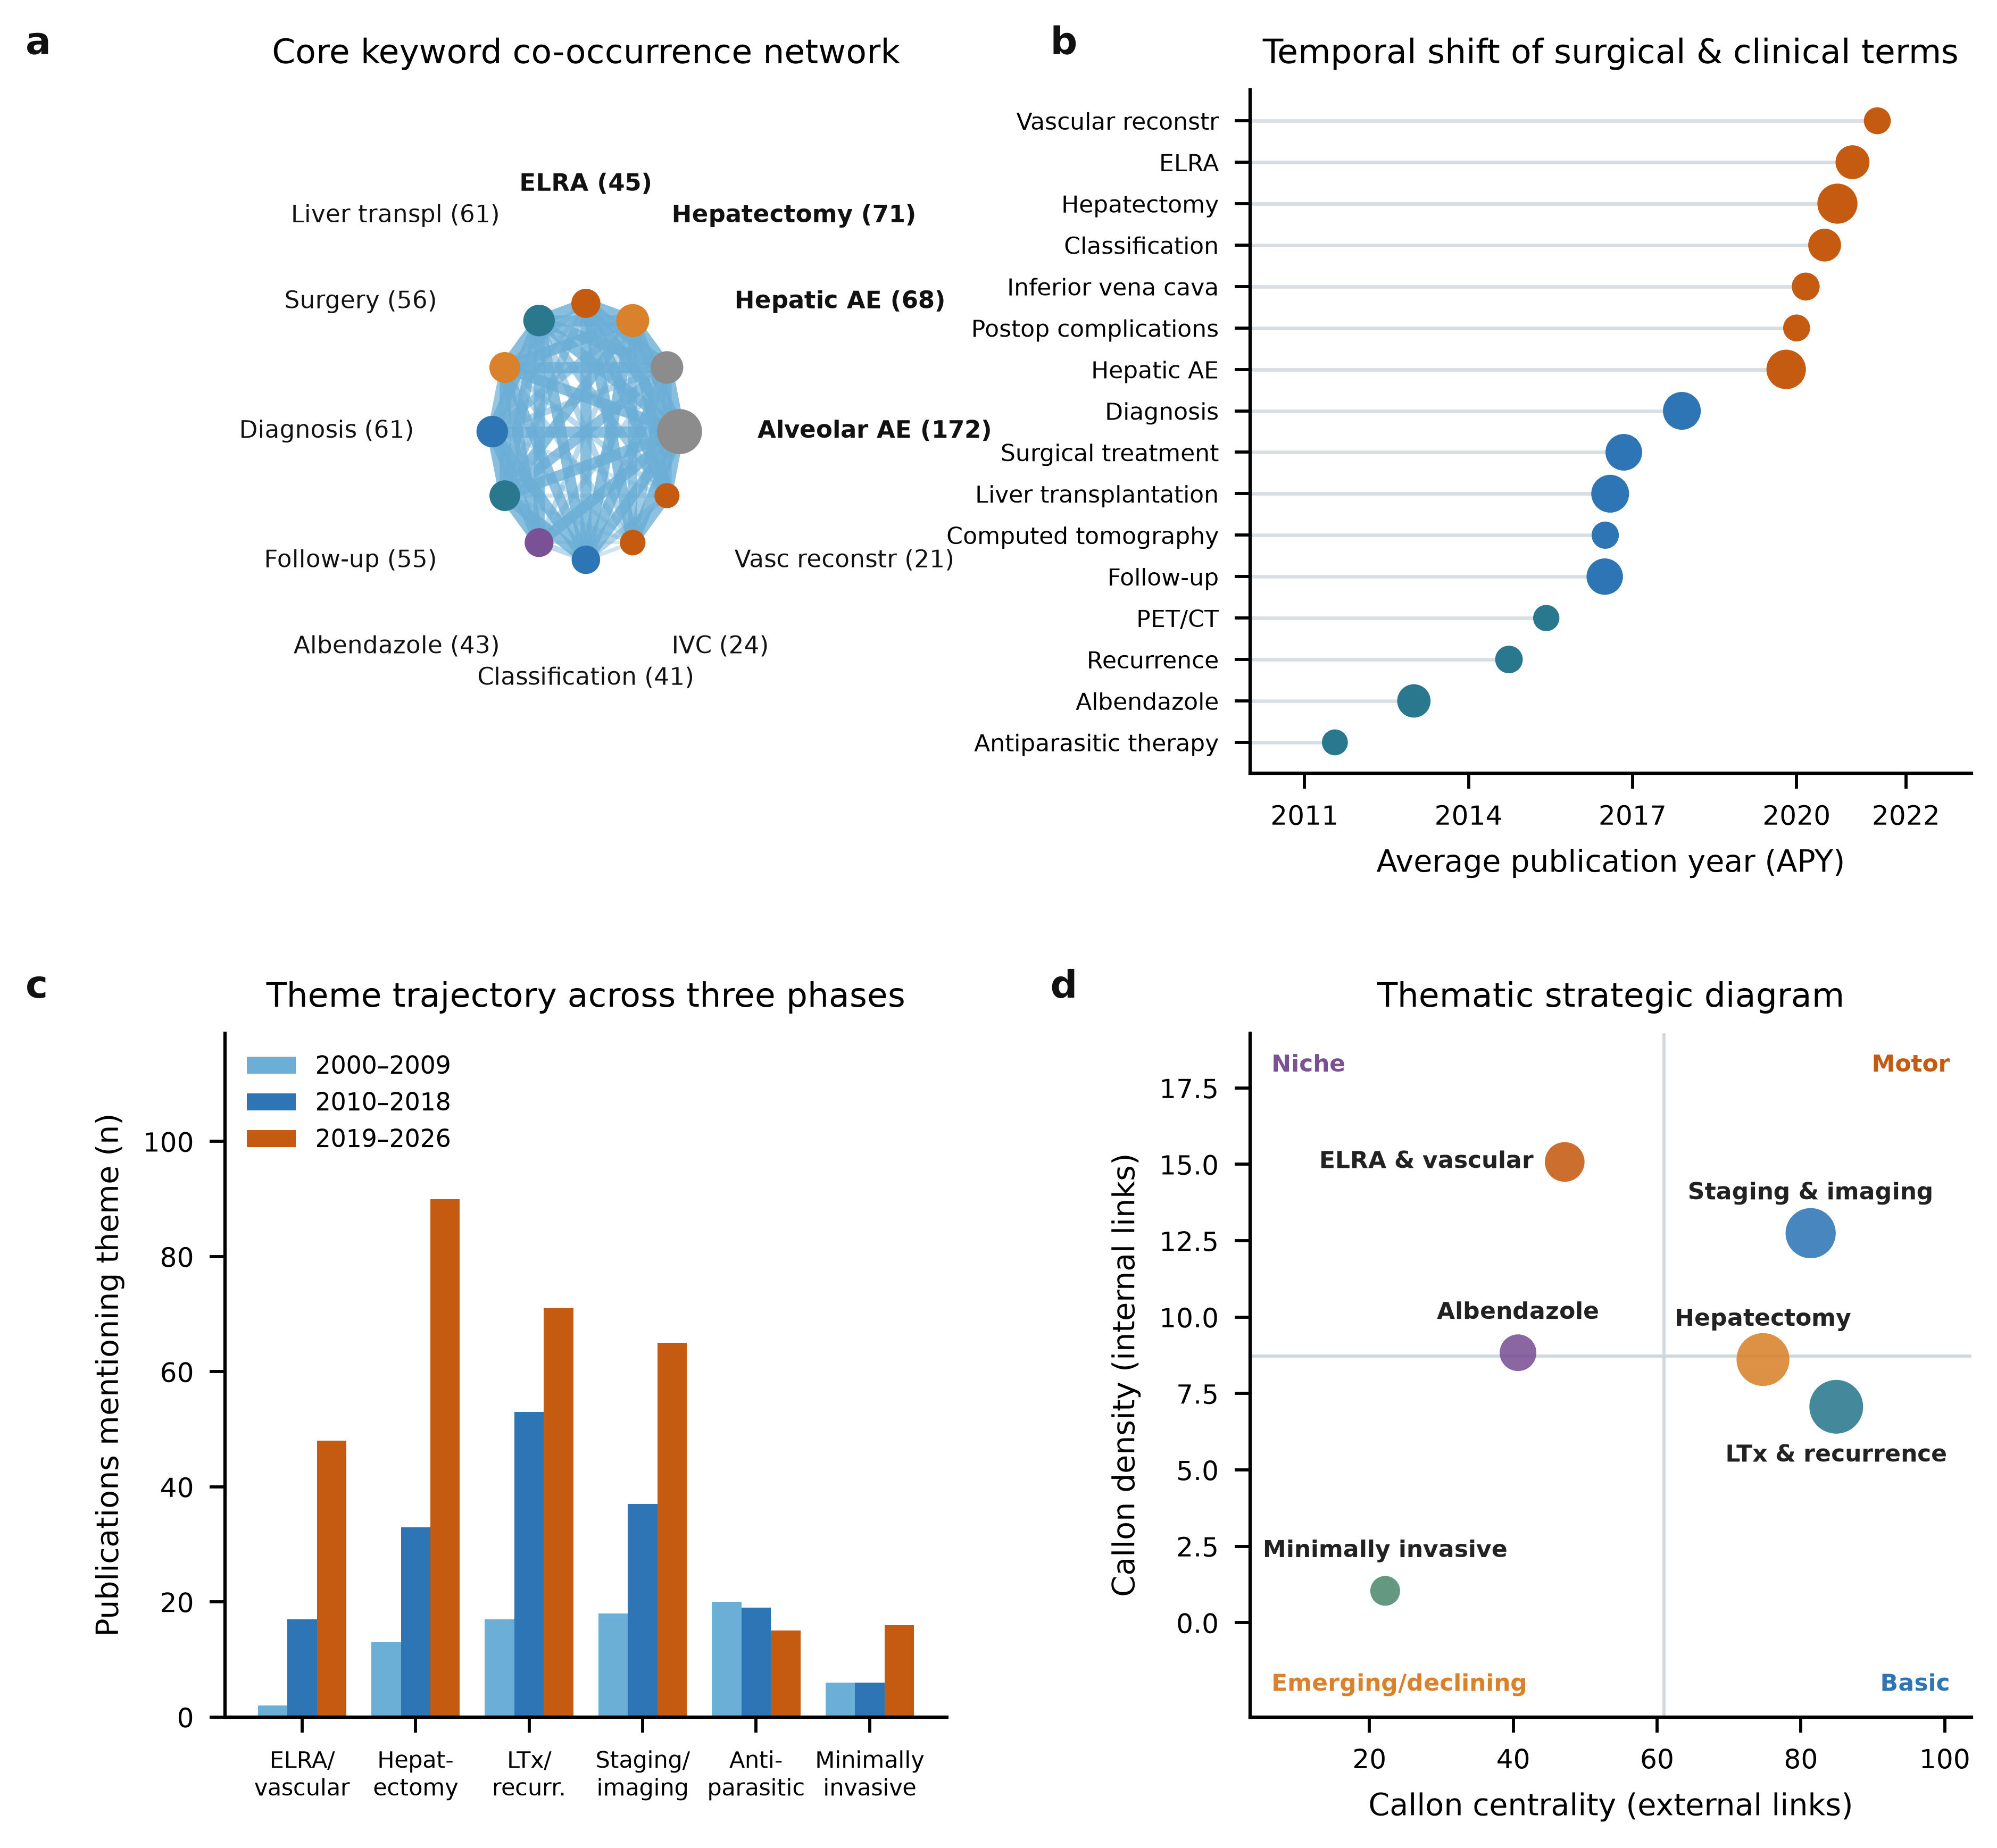

Figure 7. Keyword bursts and period counts.
(a) For each of 20 prespecified keywords, the window of 2–12 years with the highest two-proportion log-likelihood score. The terms were chosen, and the scores are not weights from CiteSpace. (b) Papers per period whose keywords intersect each operative or diagnostic group. Laparoscopic and robotic terms are separate from percutaneous, ablation and ERCP terms. A paper may contribute to more than one row.
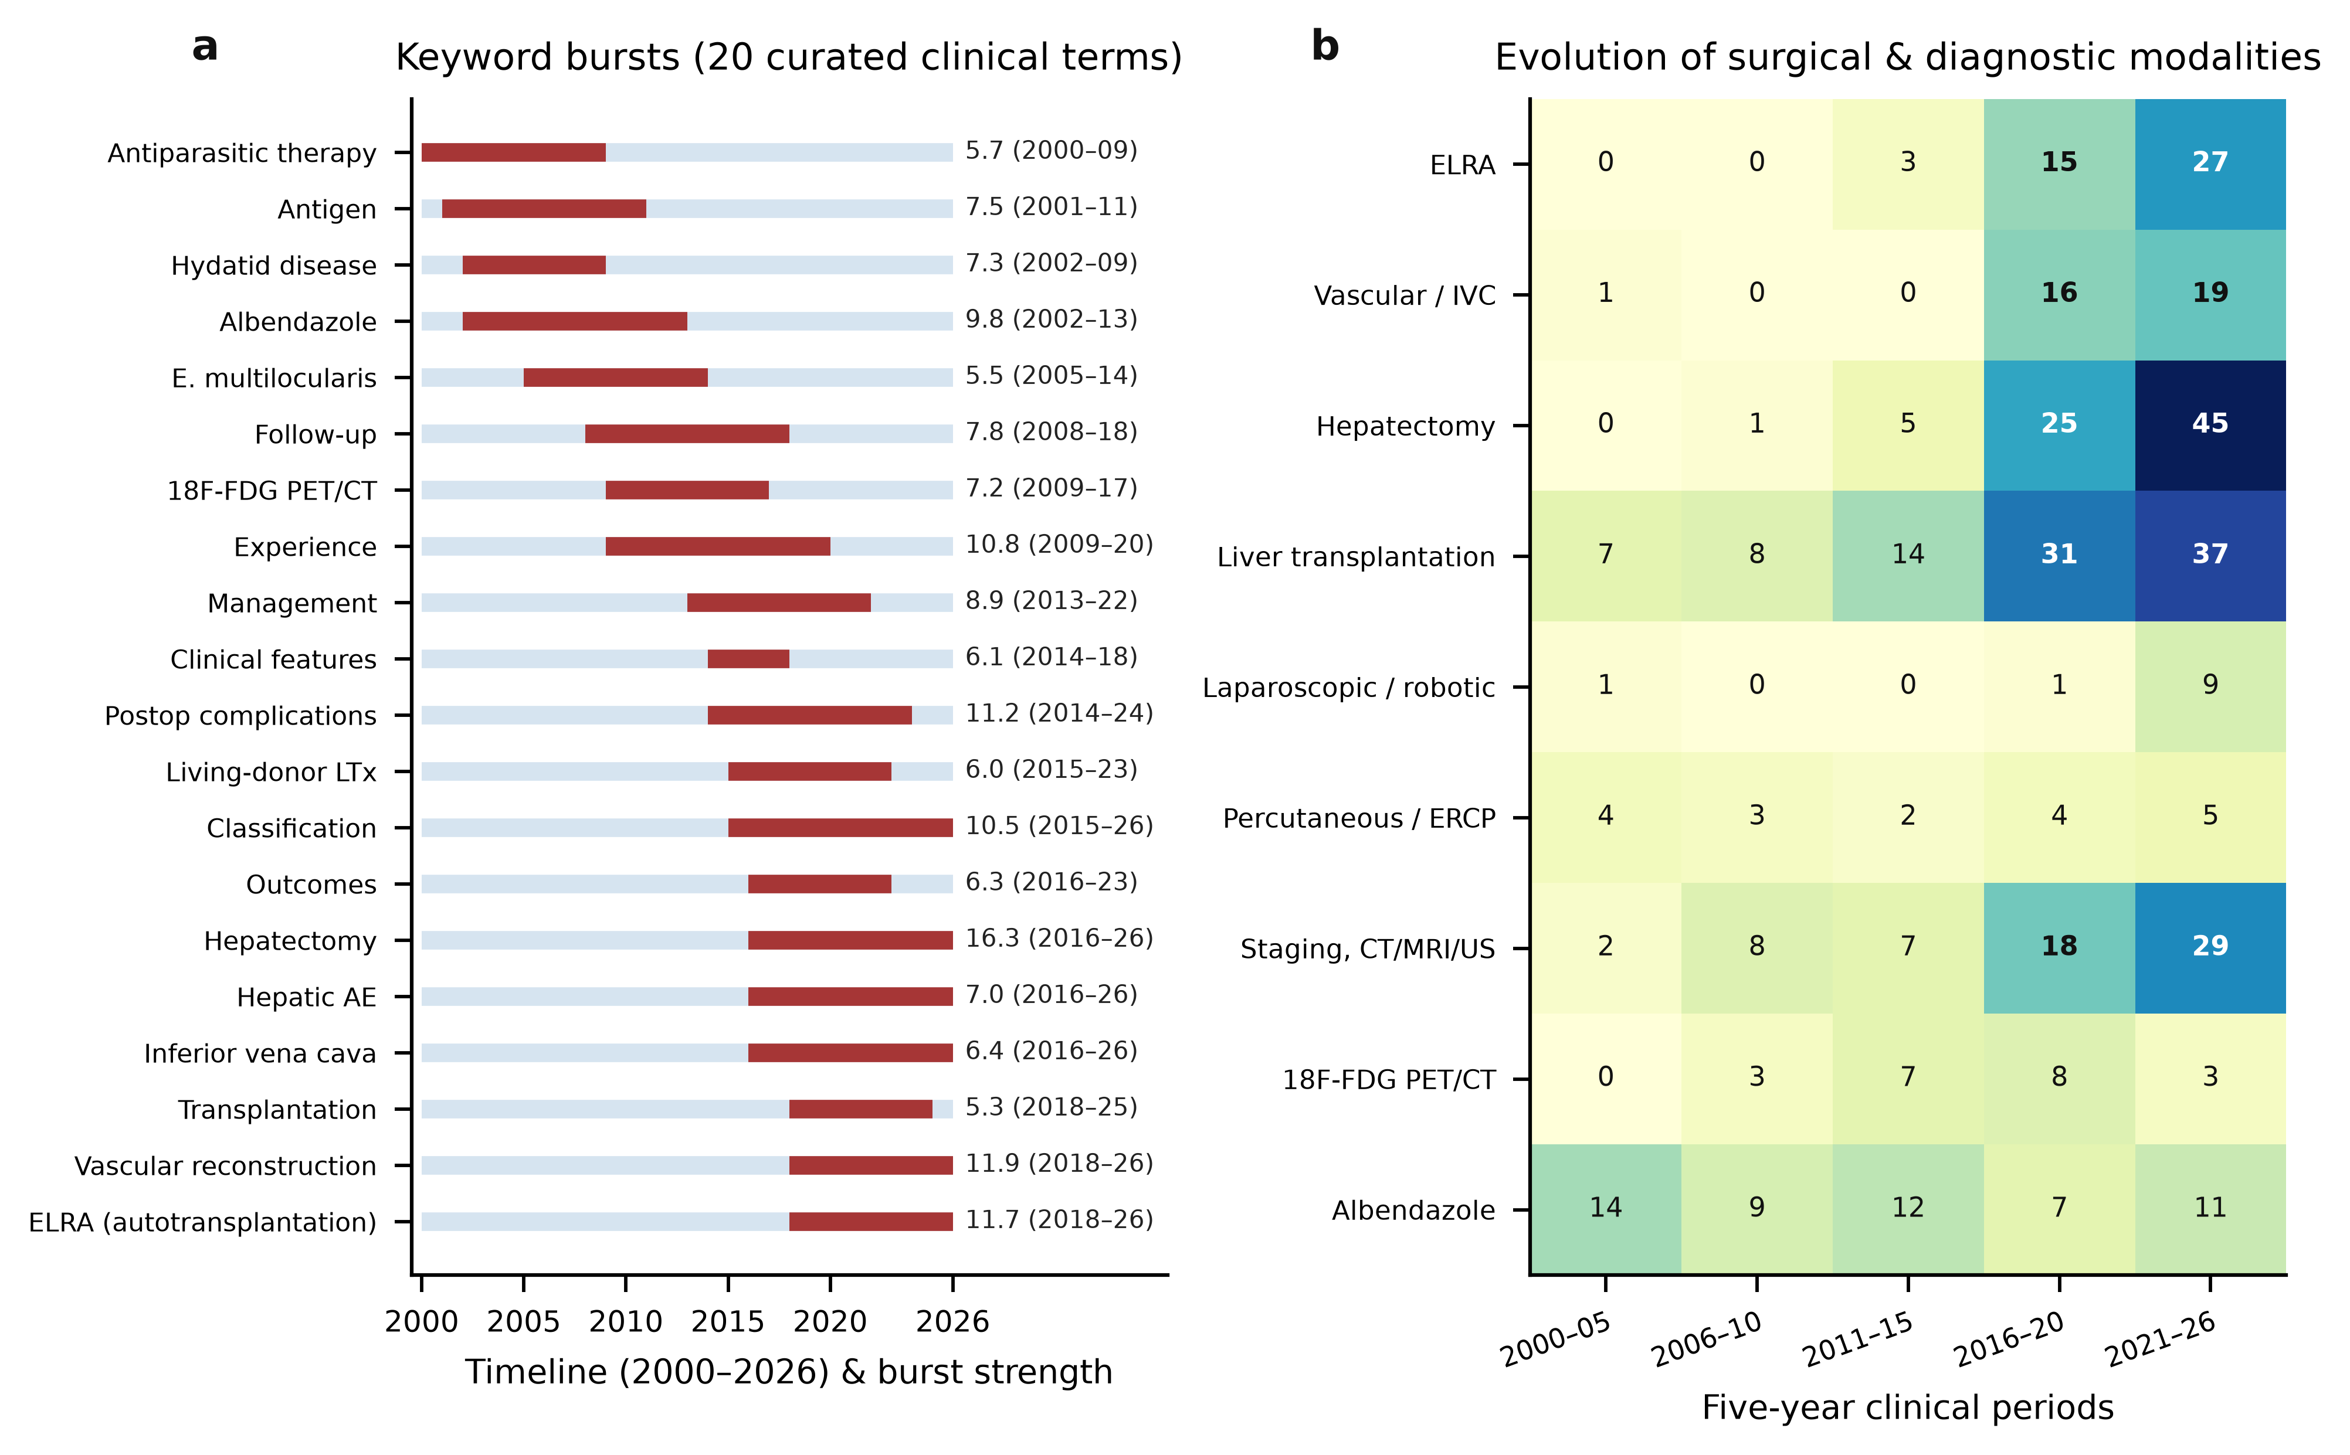

REMOVE BEFORE SUBMISSION — author checklist
1. Insert the saved Web of Science search history in section 2.1 and confirm that it returns 456 records on the stated export date.
2. Complete authors, affiliations, corresponding author, ORCID, funding, competing interests, contributions and acknowledgements.
3. Confirm the institutional position on ethics review for a bibliographic study, and the journal's rule on language-model assistance.
4. Decide what may be deposited under the Web of Science licence. Do not post the raw export unless that licence allows it.
5. Choose the target journal and apply its reference style, word limit, figure format (the source files include PDF, SVG and 600 dpi TIFF) and line-number requirement.
6. Re-read every citation against the PDF, especially sample sizes attributed to other studies in the Discussion. Those sizes were taken from the abstracts in this export.
7. This page and the red placeholder paragraphs are not part of the submitted manuscript.

