*
CST8506 - Lab 5
Clustering, Outlier Detection & Stacking

Student Name: Wang Peng

Student Number: 041107730

When you take screenshots of subprocesses, all operators must be visible.

Task 1
- Screenshot of DataPrep subprocess.
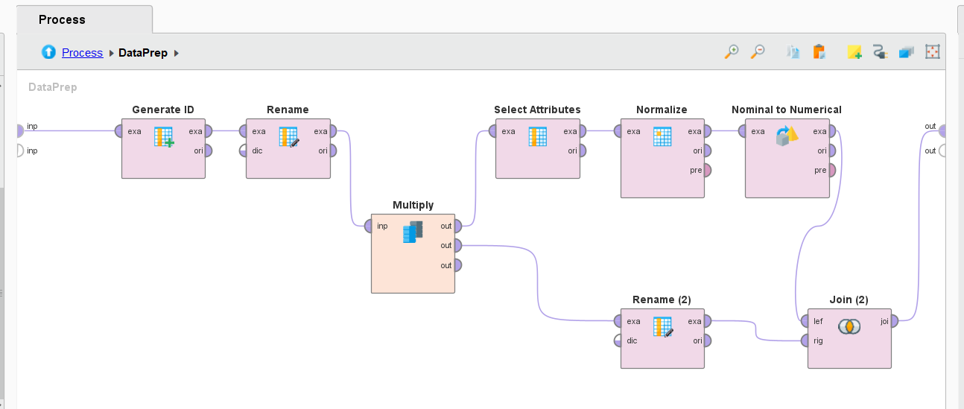

- Screenshot of 1-classSVM subprocess.
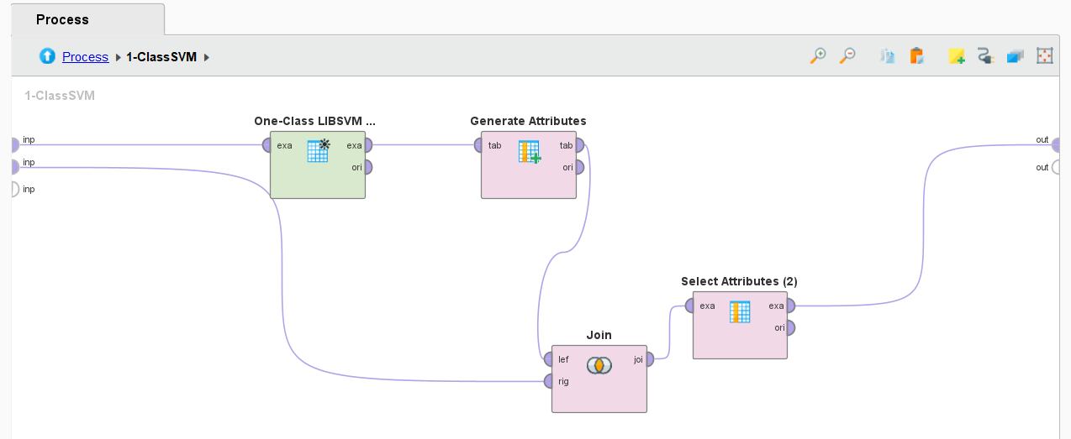

- Screenshot of outlier instances.
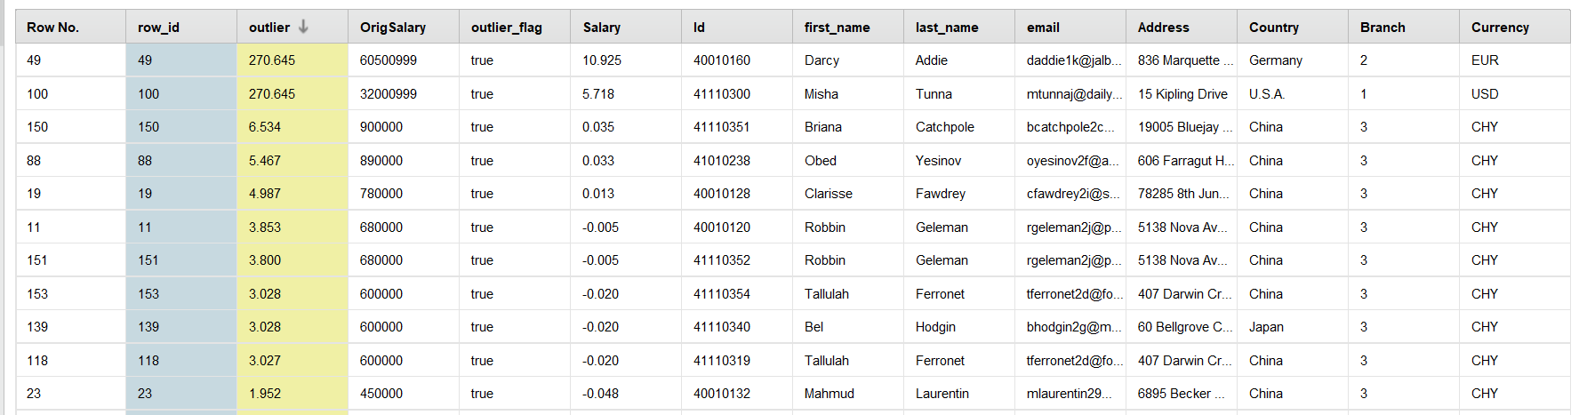

- Screenshot of DBSCAN subprocess.
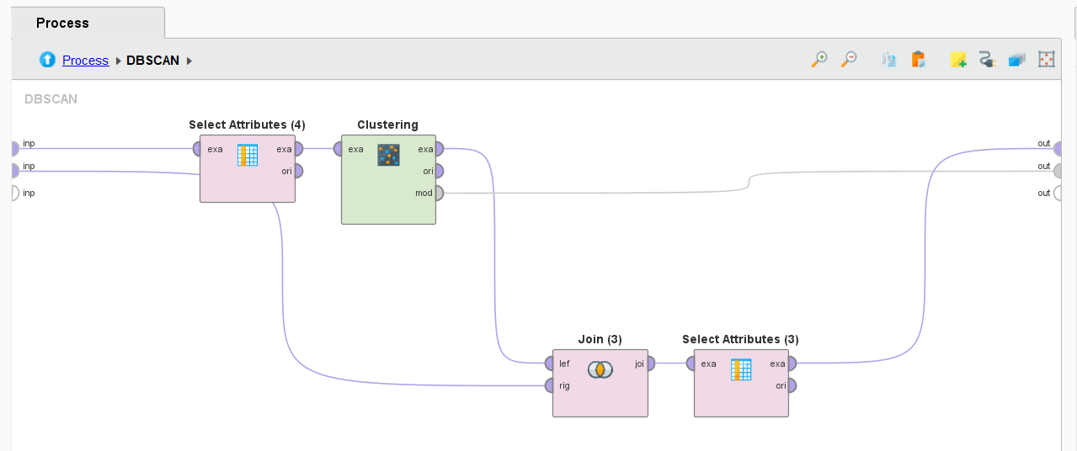

- Pattern of each cluster (which type of instances are clustered together)
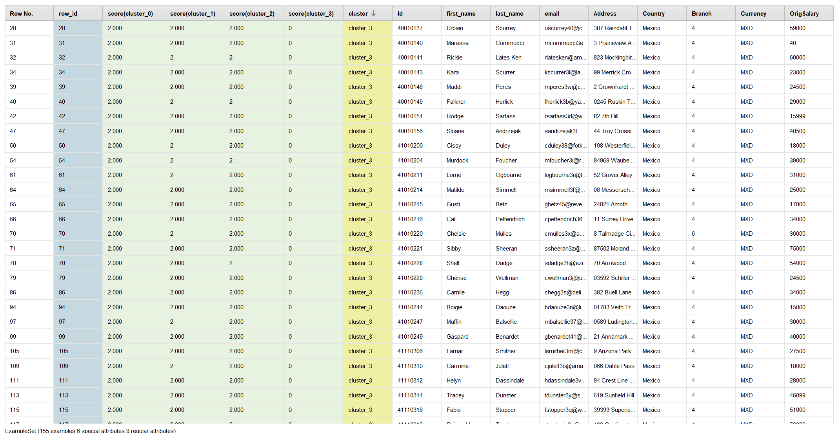

- Screenshot of noise instances.
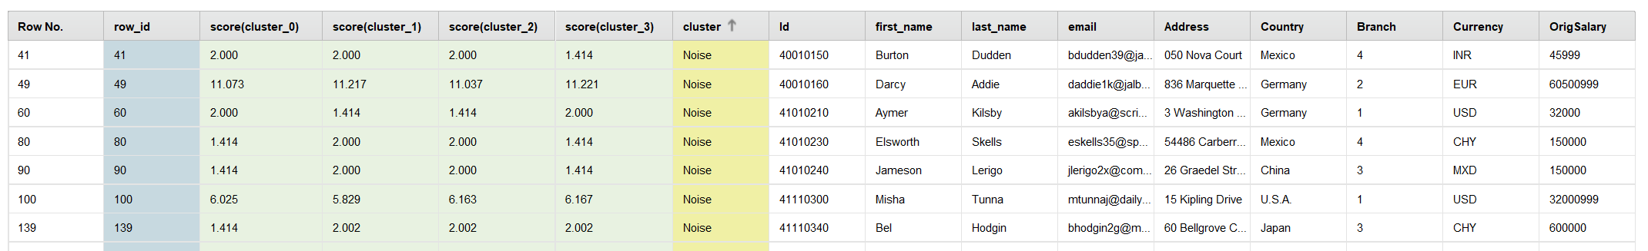
Task 2
- Screenshot of DataPrep subprocess.
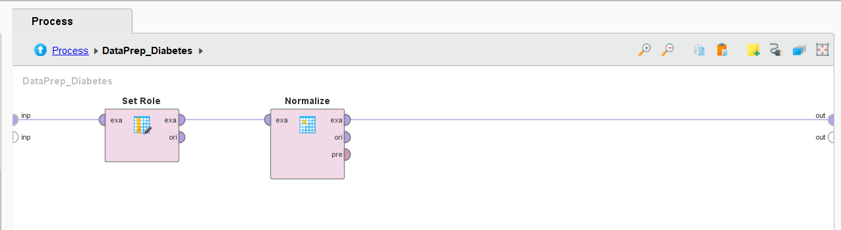

- Screenshot of Classifications subprocess.
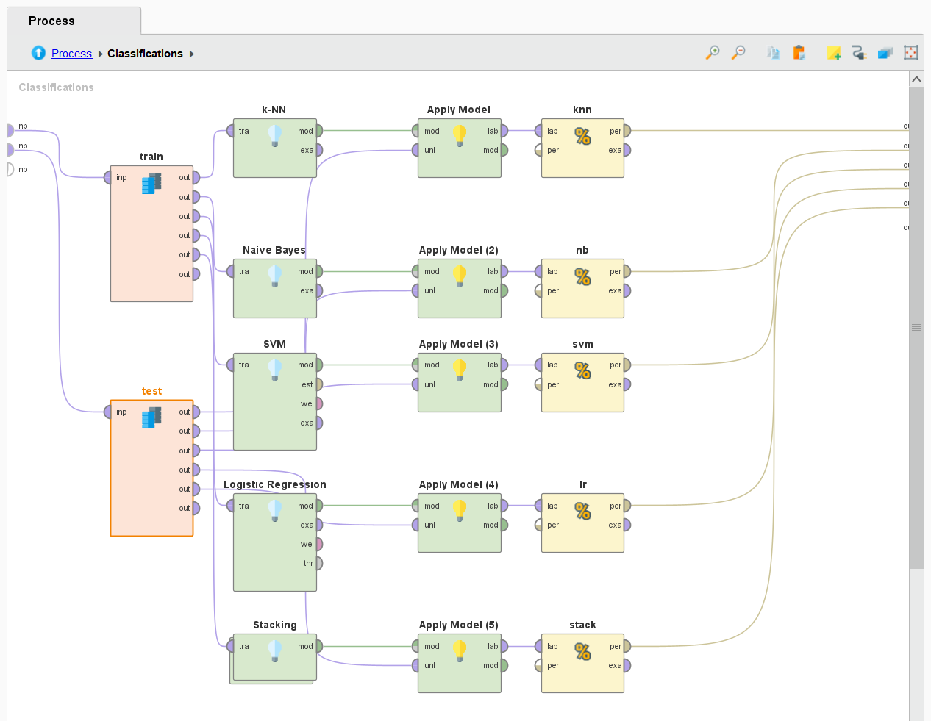

- Tabulated results of all models including stacked model.

Model | Accuracy | Rank
Naive Bayes | 77.83% | 1
SVM | 77.39% | 2
Stacking | 74.78% | 3
kNN | 73.48% | 4
LR | 73.48% | 5

