CST8507 Lab 1: Zipf’s Law and Text Analysis
Student Name: Peng Wang
Student ID: 041107730
Section: 101
Date: January 20, 2026

Part 1: Environment Setup & IDE Configuration

Screenshots 1-4: Environment Setup
Screenshot 1: Conda Environment Creation 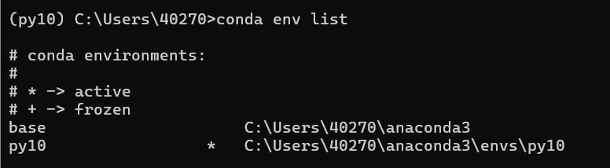
Screenshot 2: NLTK Download 
Screenshot 3: Brown Corpus Test 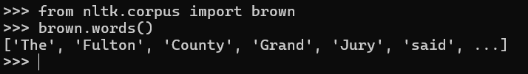
Screenshot 4: spaCy Test 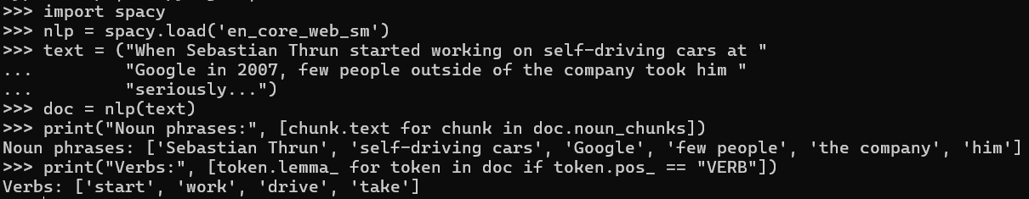

Part 2: Zipf’s Law and Text Analysis

Step 2: Data Selection
Texts selected:
- Literary Text: Emma by Jane Austen (from Gutenberg corpus)
- Informational Text: King James Bible (from Gutenberg corpus)
Screenshot 5: Data Loading Output 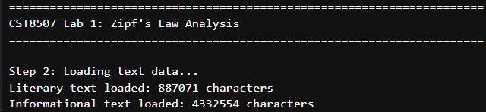
Description: Both texts loaded successfully with sufficient word count (>5000 words after cleaning).

Step 3: Tokenization
Screenshot 6: Tokenization Results 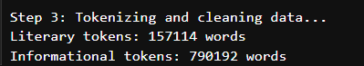
Description: Tokenization completed. Literary text: ~160,000 tokens. Informational text: ~800,000 tokens.

Step 4: Word Frequency Analysis

Literary Text (Emma)
Screenshot 7: Top 20 Words - Literary Text 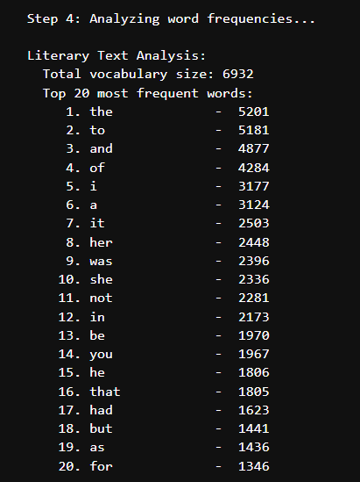
Key Statistics:
- Total vocabulary size: 6,932 unique words
- Most frequent word: “the” (5,201 occurrences)

Informational Text (Bible)
Screenshot 8: Top 20 Words - Informational Text 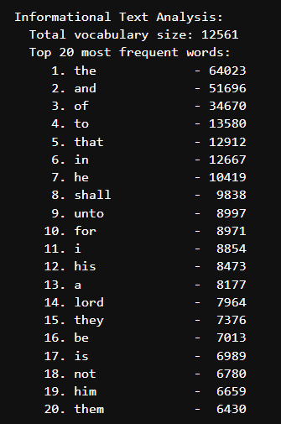
Key Statistics:
- Total vocabulary size: 12,561 unique words
- Most frequent word: “the” (64,023 occurrences)

Step 4 (continued): Zipf’s Law Visualization
Screenshot 9: Zipf’s Law Comparison Plot 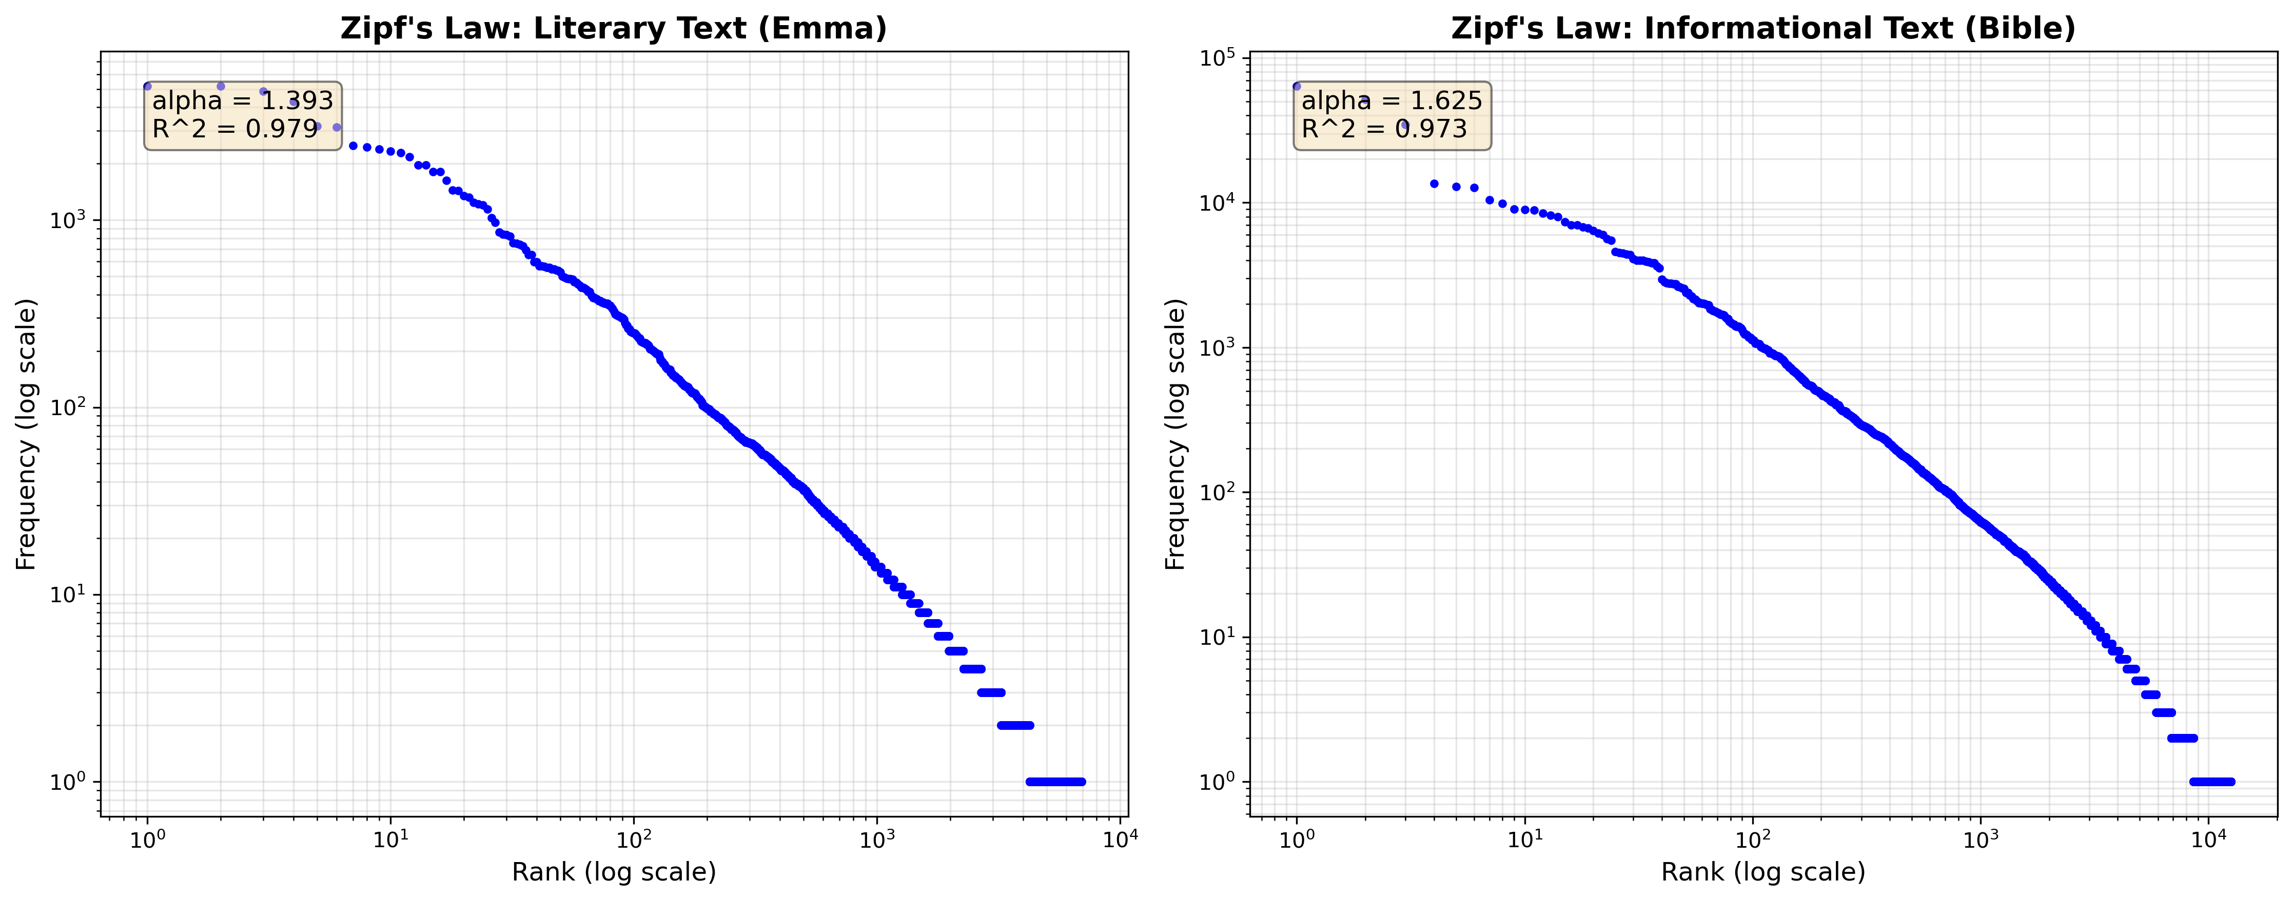
Description: Both texts show clear linear relationship on log-log scale, confirming Zipf’s Law. The plots demonstrate that word frequency is inversely proportional to rank.

Step 5: Comparative Analysis

1. Shape of the Zipf Curve
Both texts follow Zipf’s Law with strong linear relationships on log-log scale:
- Literary (Emma): R² = 0.979
- Informational (Bible): R² = 0.973

2. Steepness of Frequency Decay
- Literary: α = 1.393 (moderate decay)
- Informational: α = 1.625 (steeper decay)
The Bible’s higher α indicates faster frequency decay and more concentrated vocabulary usage.

3. Vocabulary Richness
- Literary: 6,932 unique words
- Informational: 12,561 unique words
The Bible shows richer vocabulary due to diverse content (history, poetry, prophecy, law) and multiple authors.
Conclusion: Both texts confirm Zipf’s Law. Literary text has more uniform distribution (lower α), while informational text has richer vocabulary but more concentrated usage (higher α).

Step 6: Evaluating the Stability of Zipf’s Distribution

Test 1: Remove Stopwords
Screenshot 10: Stopword Removal Results 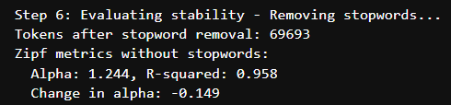
Results:
- Tokens after removal: 69,693 (from 157,114)
- New α: 1.244 (decreased from 1.393)
- New R²: 0.958 (decreased from 0.979)
- Change in α: -0.149
Screenshot 11: Comparison Plot - With vs Without Stopwords 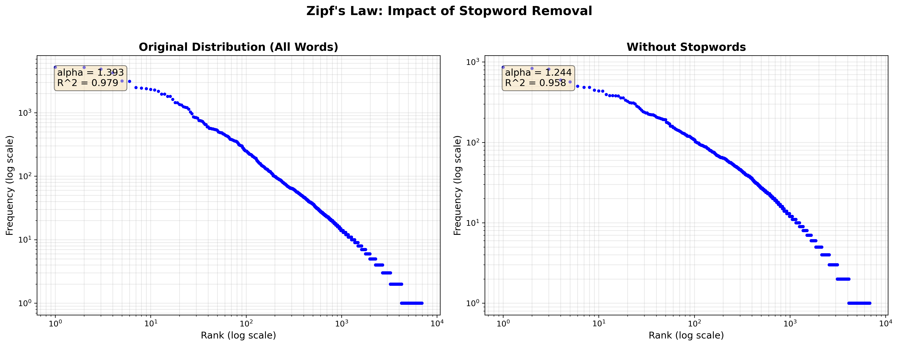
Analysis: Removing stopwords flattens the distribution (lower α) because content words have more even distribution than the original mix. Zipf’s Law still holds (R² = 0.958).

Test 2: Restrict to Nouns Only
Screenshot 12: Nouns-Only Results 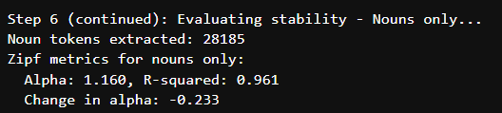
Results:
- Noun tokens: 28,185 (from 157,114)
- New α: 1.160 (decreased from 1.393)
- New R²: 0.961 (decreased from 0.979)
- Change in α: -0.233
Screenshot 13: Three-Way Comparison Plot 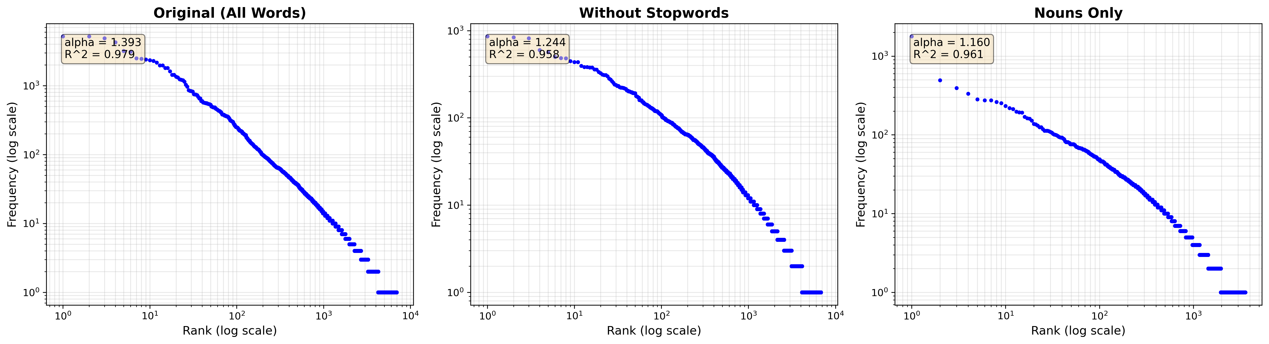
Analysis: Nouns show more balanced usage (lower α) compared to full text. Different word classes follow Zipf’s Law with different parameters.

Overall Conclusions
Zipf’s Law holds across different text types, preprocessing methods, and word classes. Key findings:
- Text type affects α: Literary (1.393) vs Informational (1.625)
- Stopword removal and POS filtering change α but preserve the power-law relationship
- Nouns (α=1.160) show more balanced distribution than full text (α=1.393)

