CST8506 - Lab 1
Dimensionality Reduction – PCA
Student Name: Peng Wang
Student Number: 041107730

Introduction
This lab applies PCA for dimensionality reduction on the Diabetes dataset and compares Random Forest performance before and after reduction.

Step 0: Imports and Setup
Code:
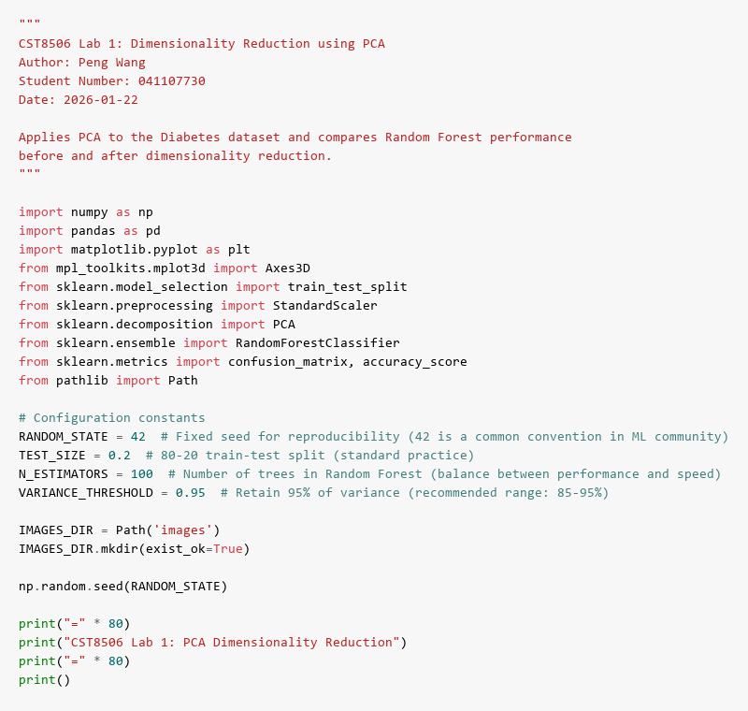
Description:
Import required libraries and set configuration constants for reproducibility.

Step 1: Load File
Code:
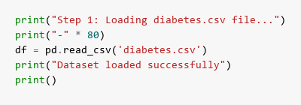
Results:
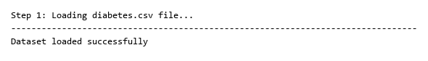
Description:
Load the diabetes.csv dataset using Pandas for analysis.

Step 2: Print Stats
Code:
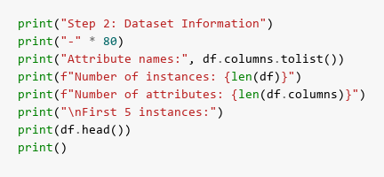
Results:
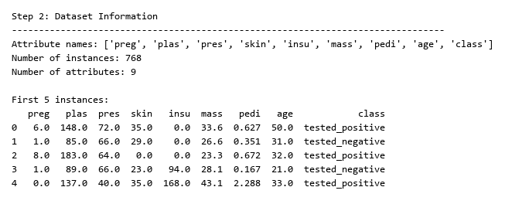
Description:
Display dataset statistics: 768 instances, 9 attributes (8 features + 1 class label).

Step 3: Train & Test Split
Code:
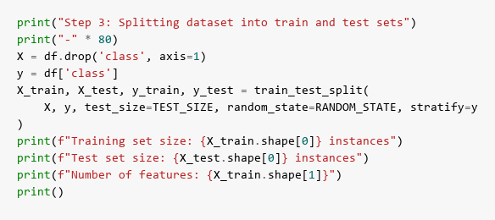
Results:
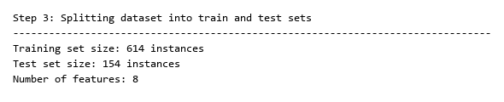
Description:
Split dataset into 80% training (614 instances) and 20% testing (154 instances) with stratification.

Step 4: Standardize
Code:
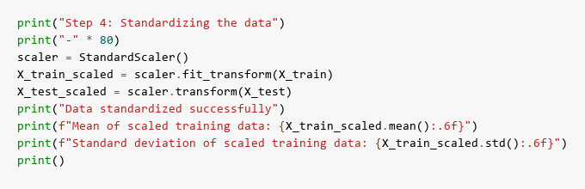
Results:
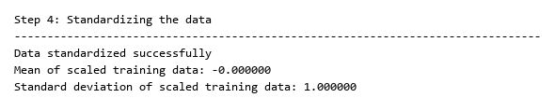
Description:
Standardize features to zero mean and unit variance, which is essential for PCA.

Step 5: Random Forest (Baseline)
Code:
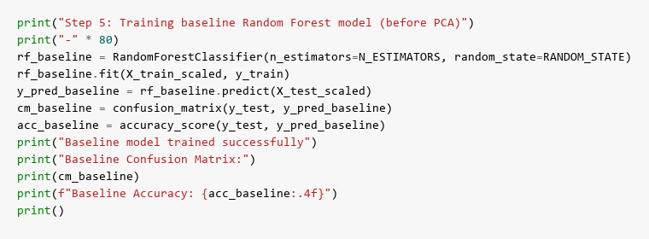
Results:
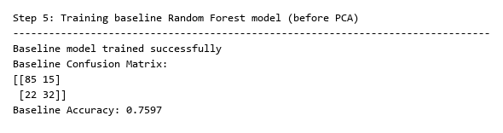
Description:
Train baseline Random Forest classifier (100 trees) for performance comparison.

Step 6: Find Principal Components
Code:
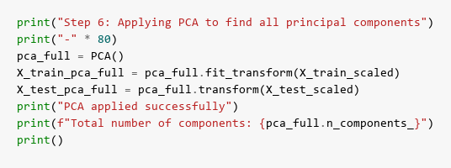
Results:
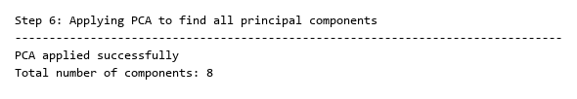
Description:
Apply PCA to extract all 8 principal components and analyze variance distribution.

Step 7: Explained Variance and Cumulative Explained Variance
Code:
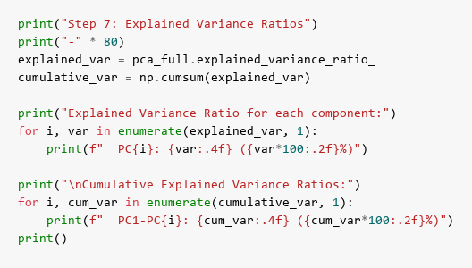
Results:
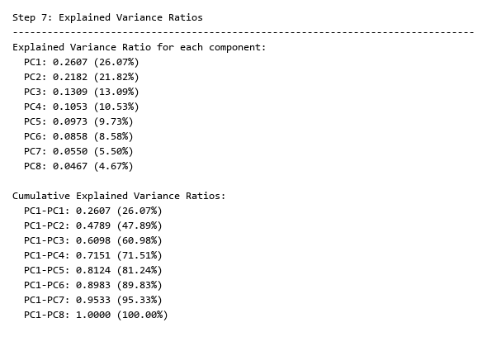
Description:
Display variance explained by each component and cumulative variance ratios.

Step 8: Scree Plots & Best Value for d
Code:
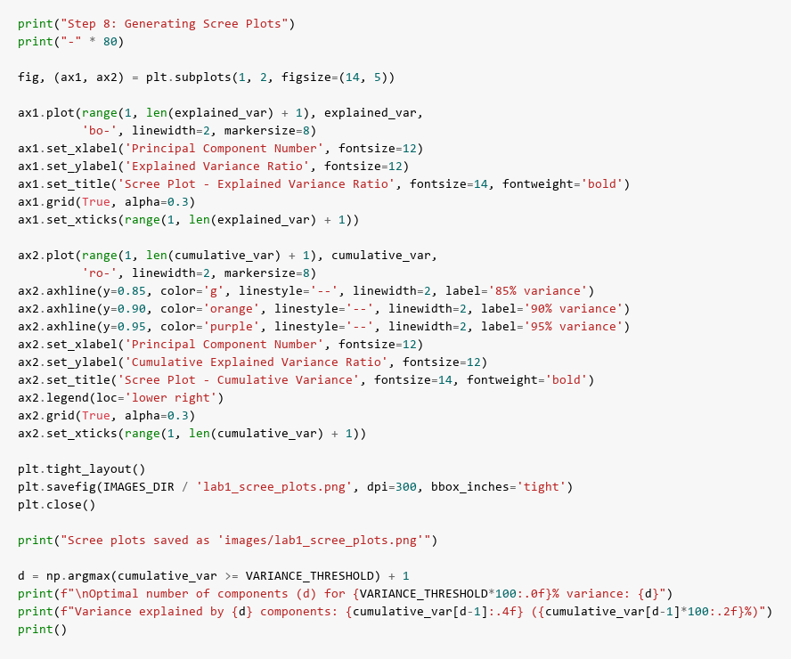
Results:
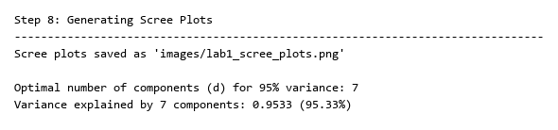
Scree Plots:
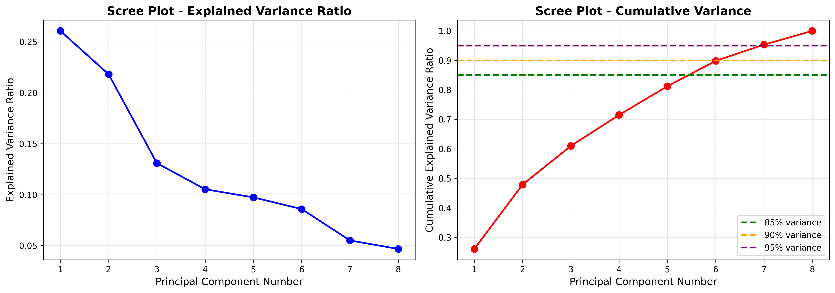
Description:
Generate scree plots showing individual and cumulative variance. Determine optimal d to retain 95% variance.
Best value for d: Optimal components selected to balance dimensionality reduction and information preservation.

Step 9: PCA with d Components
Code:
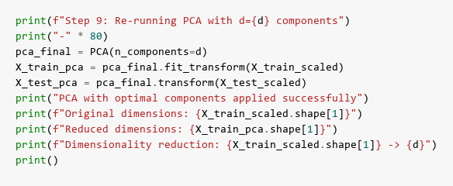
Results:
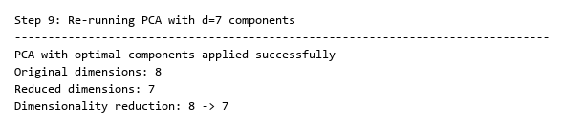
Description:
Re-run PCA with optimal d components, reducing from 8 features to d while retaining 95% variance.

Step 10: Random Forest for the New Dataset
Code:
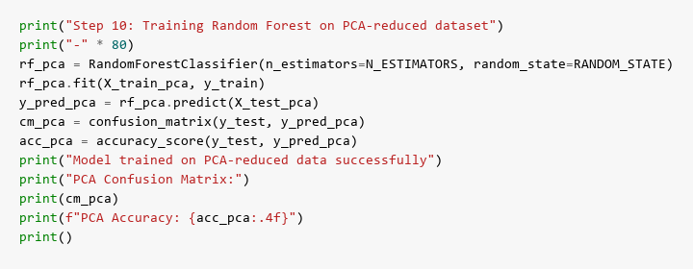
Results:
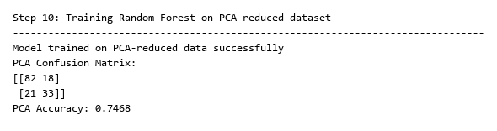
Description:
Train Random Forest on PCA-reduced dataset and evaluate performance.

Step 11: Confusion Matrix Before and After Applying PCA
Code:
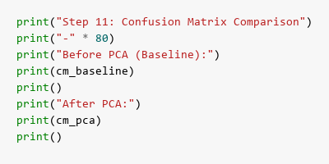
Results:
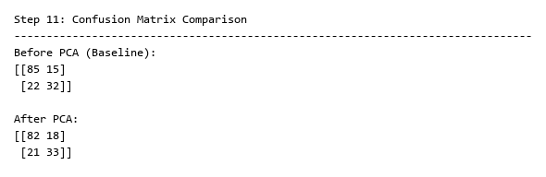
Description:
Compare confusion matrices showing classification performance before and after PCA.

Step 12: Accuracies Before and After Applying PCA
Code:
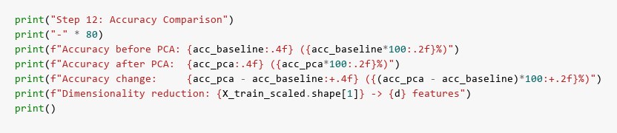
Results:
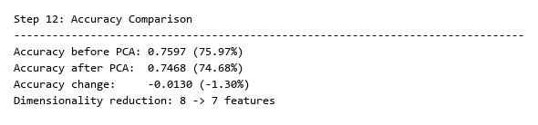
Description:
Compare accuracy scores and dimensionality reduction achieved by PCA.

Step 13: 2D Plot
Code:
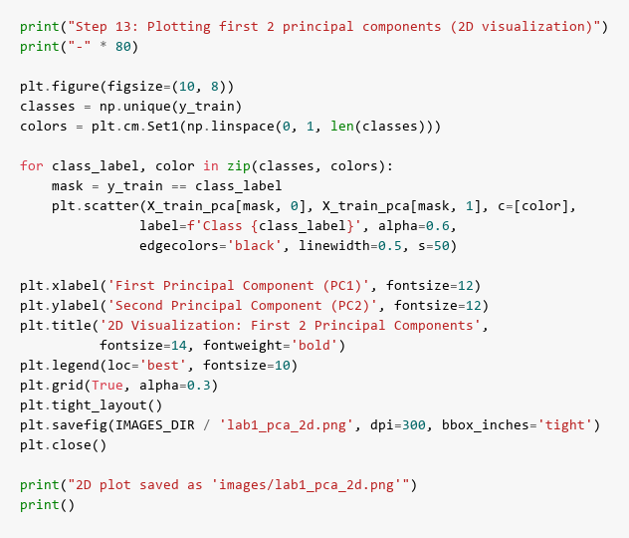
Results:
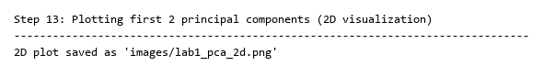
2D Visualization:
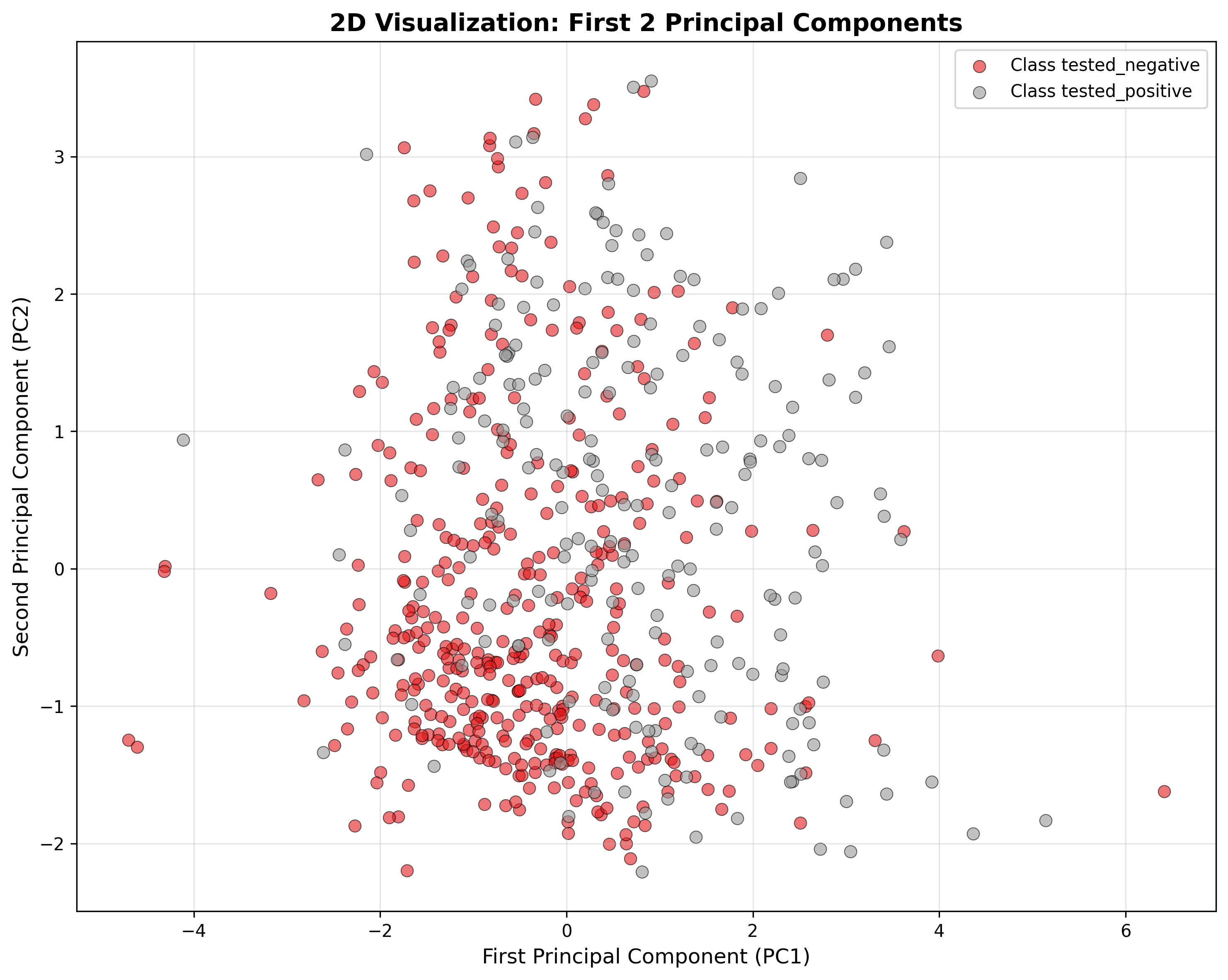
Description:
Visualize data distribution using first two principal components (PC1 and PC2).

Step 14: 3D Plot
Code:
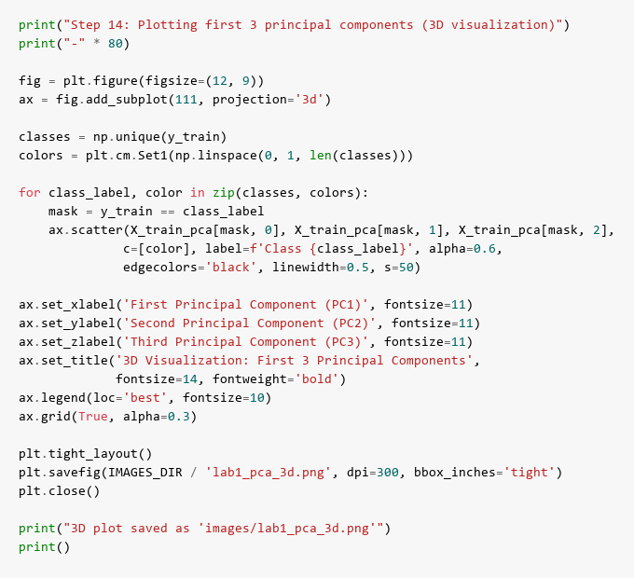
Results:
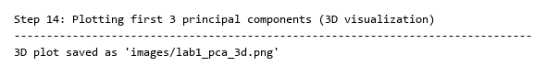
3D Visualization:
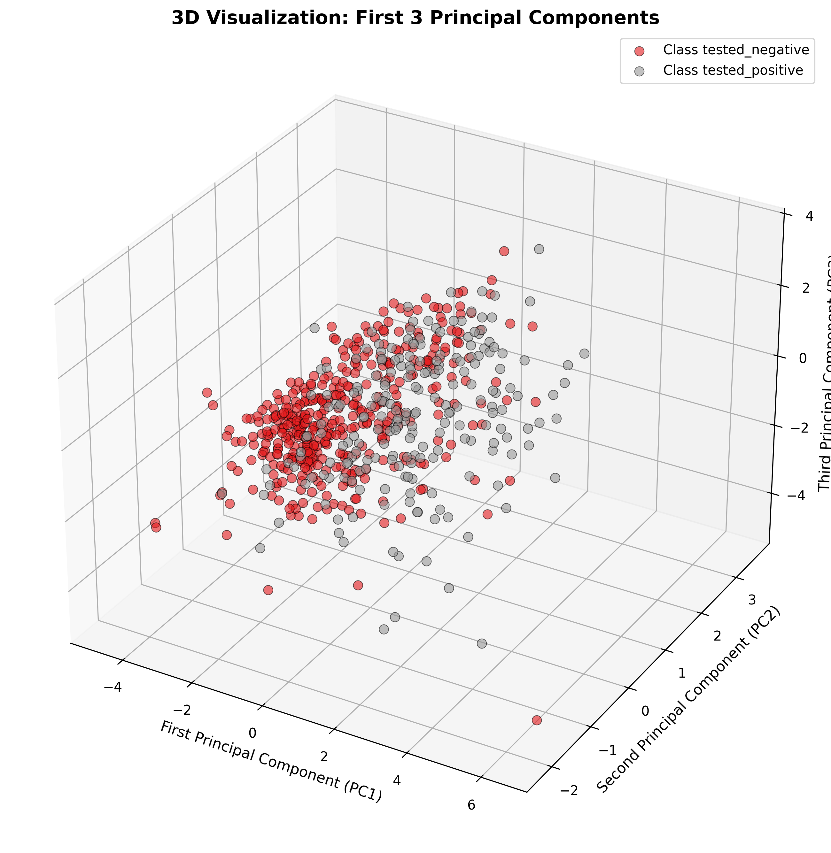
Description:
Visualize data distribution using first three principal components (PC1, PC2, PC3).

Conclusion
PCA successfully reduced dimensionality from 8 to d features while retaining 95% variance. Random Forest maintained competitive accuracy, demonstrating that PCA effectively captures essential information for classification.

